lab #6 – draft

Introduction

In this lab we will be experimenting with firewalls on both Linux and Windows systems and testing out firewalls with the various tools we had used before to find vulnerabilities. This includes nmap and nessus on the Linux machines and NeWT on the Windows machines. For the firewall we will use guarddog on Linux and the built in firewall in Windows XP SP2.

Guard Dog on Linux

For the Linux machines we took Guarddog and configured it so that only HTTP and DNS traffic was allowed. Everything else we set to be blocked. The only reason we allowed HTTP was simply so we could continue to use the web browsers to access external testing sites. We replicated the test for the Linux severs number 2 and 4.

We installed Guarddog using the following command as root:

#apt-get install guarddog

Then as a regular user we needed to allow connections from the Guarddog GUI to our X Server like so:

$xhost +

This allows connections from any host to our X server. For higher security it is recommended that you specify a specify host after the + such as +localhost. After this we run Guarddog as root:

#DISPLAY=:0.0 guarddog &

From this GUI control, we turn on DNS, HTTP and HTTPs and block everything else. Clicking apply will install the rules, or you can start and stop Guarddog manually by running /etc/init.d/guarddog {start|stop}.

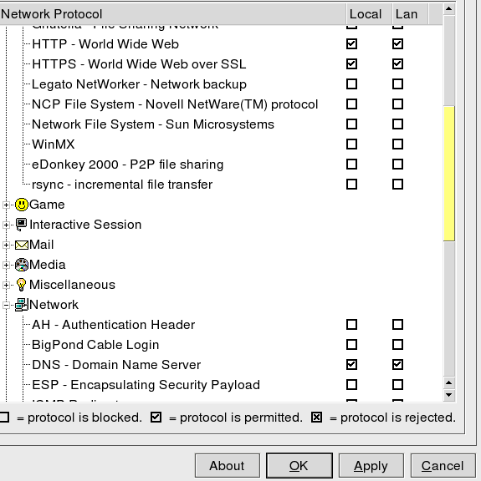

After setting up Guarddog, we took a look at the rules it created. It was a very long list. They can by viewed by running iptables -L -n as root (the list has been abbreviated):

Chain INPUT (policy DROP)
target prot opt source destination
ACCEPT all -- 0.0.0.0/0 0.0.0.0/0
ACCEPT all -- 10.170.1.7 10.170.255.255
ACCEPT all -- 10.170.23.1 10.255.255.255
logaborted tcp -- 0.0.0.0/0 0.0.0.0/0 state RELATED,ESTABLISHED tcp flags:0x04/0x04
ACCEPT all -- 0.0.0.0/0 0.0.0.0/0 state RELATED,ESTABLISHED
ACCEPT icmp -- 0.0.0.0/0 0.0.0.0/0 icmp type 3
ACCEPT icmp -- 0.0.0.0/0 0.0.0.0/0 icmp type 11
ACCEPT icmp -- 0.0.0.0/0 0.0.0.0/0 icmp type 12
.
.
.
Chain s2 (4 references)
target prot opt source destination
f2to1 all -- 0.0.0.0/0 10.170.1.7
f2to1 all -- 0.0.0.0/0 10.170.255.255
f2to1 all -- 0.0.0.0/0 10.170.23.1
f2to1 all -- 0.0.0.0/0 10.255.255.255

Testing

Now that we've established our firewall, we will test it from the local machine using nmap using the command nmap localhost. Here are the results:

Starting nmap 3.75 ( http://www.insecure.org/nmap/ ) at 2005-05-26 17:13 EDT
Interesting ports on server3 (127.0.0.1):
(The 1648 ports scanned but not shown below are in state: closed)
PORT STATE SERVICE
9/tcp open discard
13/tcp open daytime
22/tcp open ssh
25/tcp open smtp
37/tcp open time
53/tcp open domain
111/tcp open rpcbind
113/tcp open auth
139/tcp open netbios-ssn
445/tcp open microsoft-ds
631/tcp open ipp
701/tcp open unknown
953/tcp open rndc
1011/tcp open unknown
1241/tcp open nessus

As we can see, guarddog still allows us to access all network resources from the local machine (as it should). Next we will attempt to do the same from a remote machine. Here are the results of running nmap from another server:

Starting nmap 3.75 ( http://www.insecure.org/nmap/ ) at 2005-05-26 17:25 EDT
Interesting ports on server2.jknet.cs.utc.edu (10.170.1.6)
(The 1662 ports scanned but not show below are in state: filtered)
PORT STATE SERVICE
53/tcp open domain

As we can see, from a remote machine, Guarddog does an excellent job of protecting our local machine from vulnerable open ports.

Nessus

We scanned our host remotly using Nessus. The scan took a very long time, most likely due to the firewall. The results of the nessus scan are as follows:
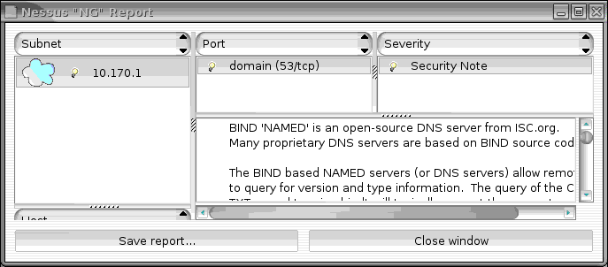

The only open port was for DNS which we had left open in the firewall configuration so we could still resolve DNS entires.

Gibson Research

Due to the fact that the professor wasn't present in the lab, we couldn't disable the lab firewall to run the Gibson “Shield's Up!” scan. On top of that, the website itself was down at the time of this lab.

Trusted Zones

Placing a client in the trusted zone is simple as seen in this screen shot:

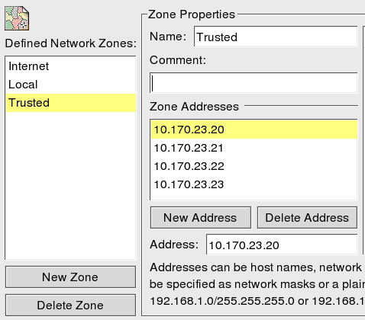

Firewall in Action

Here is a segment of our logs after the firewall was established to show that it did in fact work:

May 26 17:50:58 server3 kernel: DROPPED IN= OUT=eth0 SRC=10.170.1.7 DST=239.2.11.71 LEN=36 TOS=0x00 PREC=0x00 TTL=1 ID=36828 DF PROTO=UDP SPT=1027 DPT=8649 LEN=16
May 26 17:51:03 server3 kernel: DROPPED IN= OUT=eth0 SRC=10.170.1.7 DST=10.170.1.255 LEN=78 TOS=0x00 PREC=0x00 TTL=64 ID=15861 DF PROTO=UDP SPT=137 DPT=137 LEN=58
May 26 17:51:03 server3 kernel: DROPPED IN= OUT=eth1 SRC=10.170.23.1 DST=10.170.23.255 LEN=78 TOS=0x00 PREC=0x00 TTL=64 ID=15862 DF PROTO=UDP SPT=137 DPT=137 LEN=58
May 26 17:51:04 server3 kernel: DROPPED IN= OUT=eth0 SRC=10.170.1.7 DST=239.2.11.71 LEN=36 TOS=0x00 PREC=0x00 TTL=1 ID=36829 DF PROTO=UDP SPT=1027 DPT=8649 LEN=16

Windows Server

The windows server we setup using ZoneAlarm. We placed all the hosts in its subnet in the trusted zone as shown:

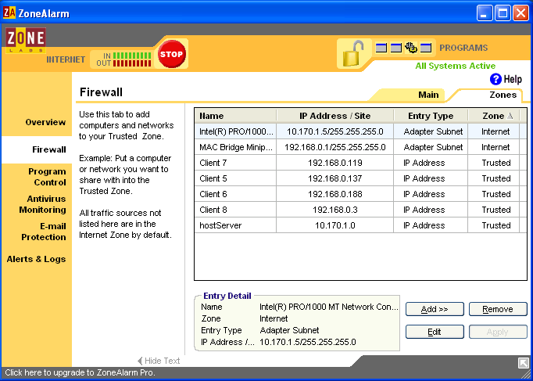
We configured the firewall and locked it down as high as we could and then hit it from a remote host using nmap 10.170.1.5

Starting nmap 3.75 ( http://www.insecure.org/nmap/ ) at 2005-05-26 18:08 EDT
Interesting ports on server1.jknet.cs.utc.edu (10.170.1.5):
(The 1657 ports scanned but not shown below are in state: closed)
PORT STATE SERVICE
135/tcp filtered msrpc
137/tcp filtered netbios-ns
138/tcp filtered netbios-dgm
139/tcp filtered netbios-ssn
445/tcp filtered microsoft-ds
5998/tcp filtered ncd-diag
MAC Address: 00:0D:56:23:6F:D3 (Dell Pcba Test)

As we can clearly see, with nmap, ZoneAlarm still allows several ports in. Next we tried running Nessus.

Nessus skipped the port scan and went stright to the checks section. After the checks were completed, it exited with a dialog that said “Nessusd returned an empty report.” ZoneAlarm must have detected the Nessus scan and blocked it from completing.

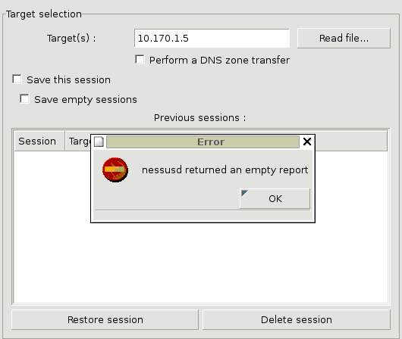

Additional Questions:

1)
    - TCP Protocol – Specifies which protocol the rule pertains to (TCP or UDP)
    - Direction – Indicates if the rule applies for incoming or outgoing packets
    - Local Host – indicates the address of the originating host, the port type (TCP/UDP) and the sending port number
    - Remote Host – indicates the address of the remote host, the port type (TCP/UDP) and the listening port number
2)
a) Remote Job Entry – port 71 tcp/udp
b) MPM Flags – 44 tcp/udp
c) Host name server – 101 tcp/udp
d) HTTP 80 tcp/udp
e) XNS Mail 58 tcp/udp
f) Finger 79 tcp/udp
g) SNA Gatway 108 tcp/udp
h) Sun Remote Call 111 tcp/udp
i) ISO-IPO 140 tcp/udp
j) SambaMS 137-139 tcp/udp

- Blocking port 71 (Remote Job Entry)
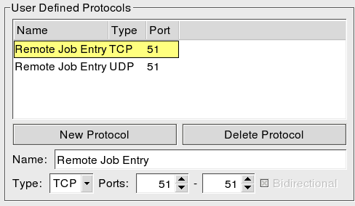
To generate the request to our site we go to a remote host and use the command telnet 10.170.1.6 51

We then see the following in our /var/log/messages

May 26 17:37:12 server3 /usr/sbin/gmond[3808]: mcast_thread() error multicasting
May 26 17:37:12 server3 kernel: DROPPED IN= OUT=eth0 SRC=10.170.1.7 DST=239.2.11.71 LEN=36 TOS=0x00 PREC=0x00 TTL=1 ID=36549 DF PROTO=UDP SPT=1027 DPT=8649 LEN=16

This log entry shows that the request I am making using telnet from the remote host is being dropped by the firewall.

