CPSC-526 / Client Server Systems
Assignment #3
Sumit Khanna

Installation

Installation was a fairly straightforward process. Using the Gentoo Linux distribution I use on all my personal computers, I ran the following command:

emerge -a ns

In Gentoo, the network similator package used in our class is in the standard portage tree (the portage tree is Gentoo's package management system). The -a indicates that emerge will “ask” me if I want to install the package after presenting a list of all the dependencies it will install to satisfy my request. I can also run emerge -a nam to install nam, the graphical tool used to display ns trace files. The latest version available of ns in Gennto is 2.29 and the version of nam in gentoo is 1.11

Creating a Network Topology

Using the tutorial, I created a simple network topology. I used the Running the output of the tcl script in nam gave me the follow:

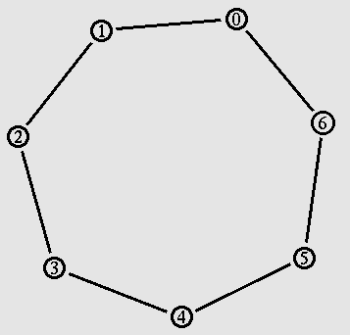

Continuing with the tutorial, the next step was to introduce a node failure. The following image shows the simulation of node failure with the failed link in red. Node 0 still sends packets to 1, but one must discard them since there is no means for it to forward the packets to node 2.
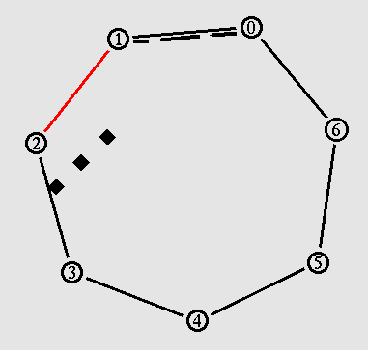

Finally, I added the line $ns rtproto DV at the top of the script after the simulation object is created. When I started the output in nam, the nodes started by exchanging routing information between each node. It is represented in nam by small blocks (packets) moving between each node.
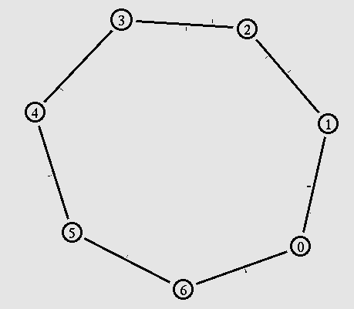
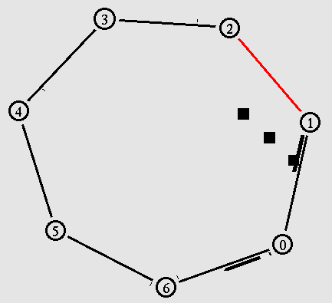
Now when the link failure occurs, the connection is still broken as seen here:

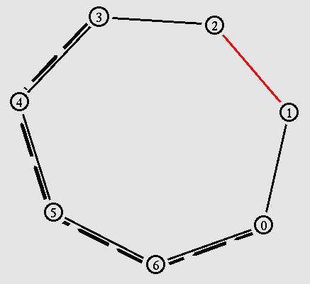
However, now the nodes use their routing information to find an alternate path around the broken link.

Creating a Wireless Topology

Part I

I followd the instructions in section 9 of the tutorial to create a wireless simulation. I used the default simulation tcl file, and attempted to add the following lines to generate a nam trace file:

set namtrace [open wireless1-out.nam w] ;# for nam tracing
$ns_ namtrace-all $namtrace

And although there is information in the trace file, nam generates a segmentation fault upon running the trace. After talking to other students and reading more in the tutorial, I discovered this particular task with wireless nodes does not produce a trace file that can be properly simulated with the current version of nam.

Part II

For this particular simulation, I had to modify the instructions provided in the tutorial to get the tcl file to work with Gentoo Linux. The tcl file references /mobility/scene/cbr-3-test as well as other files from the /mobility/scene directory. These are located in /usr/share/ns/tcl/mobility/scene/ in Gentoo. I could have simply created a symbolic link, but instead I added the following to the TCL script:

#setup directory for sample files in gentoo systems
set sampledir "/usr/share/ns/tcl/mobility/scene"

Then I modified each reference to a file from that directory to use the $sampledir variable like so:

set val(cp) "$sampledir/cbr-3-test"
set val(sc) "$sampledir/scen-3-test"

The tcl script is used by ns to simulate node-movement and traffic patterns. Unfortunately nam can not yet show traffic for wireless networks, however it can show the node movement. The simulation starts out with the nodes in a stationary position.

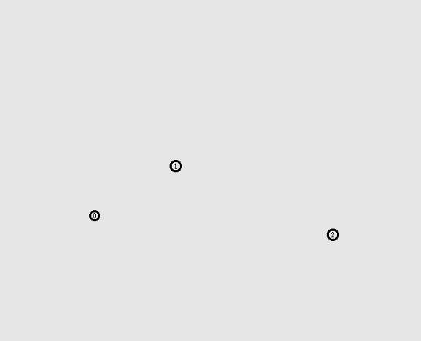

As time progresses, one of the nodes begins to move closer to the other two nodes.
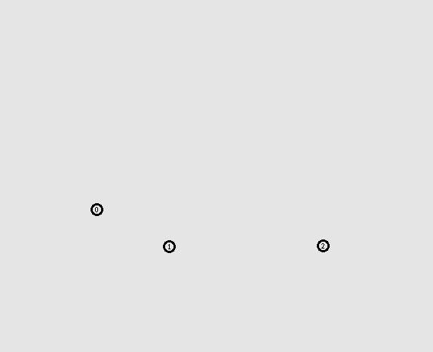

The node comes to a final position and stops.
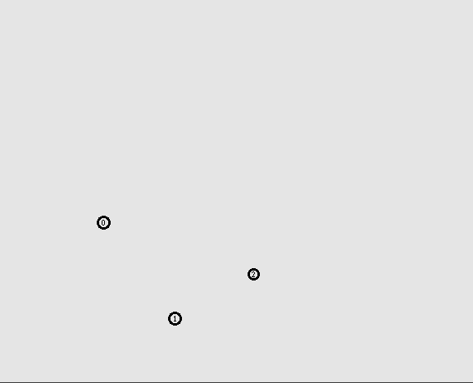

Apendix A – task2.tcl

#!/usr/bin/env ns
set ns [new Simulator]

#set dynamic routing on
$ns rtproto DV

set nf [open out.nam w]
$ns namtrace-all $nf

proc finish {} {
global ns nf
$ns flush-trace
close $nf
exec nam out.nam &
exit 0
}

#insert code for topology creation and agent definition

#create 7 nodes
for {set i 0} {$i < 7} {incr i} {
set n($i) [$ns node]
}

#place them in a circle topology
for {set i 0} {$i < 7} {incr i} {
$ns duplex-link $n($i) $n([expr ($i+1)%7]) 1Mb 10ms DropTail
}

#simulate UDP packets

#Create a UDP agent and attach it to node n(0)
set udp0 [new Agent/UDP]
$ns attach-agent $n(0) $udp0

# Create a CBR traffic source and attach it to udp0
set cbr0 [new Application/Traffic/CBR]
$cbr0 set packetSize_ 500
$cbr0 set interval_ 0.005
$cbr0 attach-agent $udp0

set null0 [new Agent/Null]
$ns attach-agent $n(3) $null0

$ns connect $udp0 $null0

$ns at 0.5 "$cbr0 start"
$ns at 4.5 "$cbr0 stop"

#let one node go down to see packet loss
$ns rtmodel-at 1.0 down $n(1) $n(2)
$ns rtmodel-at 2.0 up $n(1) $n(2)

ns at 5.0 "finish"
$ns run

Apendix B – task3.tcl

#!/usr/bin/ns

# ======================================================================
# Define options
# ======================================================================
set val(chan) Channel/WirelessChannel ;# channel type
set val(prop) Propagation/TwoRayGround ;# radio-propagation model
set val(ant) Antenna/OmniAntenna ;# Antenna type
set val(ll) LL ;# Link layer type
set val(ifq) Queue/DropTail/PriQueue ;# Interface queue type
set val(ifqlen) 50 ;# max packet in ifq
set val(netif) Phy/WirelessPhy ;# network interface type
set val(mac) Mac/802_11 ;# MAC type
set val(rp) DSDV ;# ad-hoc routing protocol
set val(nn) 2 ;# number of mobilenodes

#create simulator
set ns_ [new Simulator]

#setup output trace file
set tracefd [open simple.tr w]
$ns_ trace-all $tracefd

set namtrace [open wireless1-out.nam w] ;# for nam tracing
$ns_ namtrace-all $namtrace

#create topology
set topo [new Topography]
$topo load_flatgrid 500 500

#create General Operations Director
create-god $val(nn)

#API for configuring nodes
# $ns_ node-config -addressingType flat or hierarchical or expanded
# -adhocRouting DSDV or DSR or TORA
# -llType LL
# -macType Mac/802_11
# -propType "Propagation/TwoRayGround"
# -ifqType "Queue/DropTail/PriQueue"
# -ifqLen 50
# -phyType "Phy/WirelessPhy"
# -antType "Antenna/OmniAntenna"
# -channelType "Channel/WirelessChannel"
# -topoInstance $topo
# -energyModel "EnergyModel"
# -initialEnergy (in Joules)
# -rxPower (in W)
# -txPower (in W)
# -agentTrace ON or OFF
# -routerTrace ON or OFF
# -macTrace ON or OFF
# -movementTrace ON or OFF

#configure nodes
$ns_ node-config -adhocRouting $val(rp) \
-llType $val(ll) \
-macType $val(mac) \
-ifqType $val(ifq) \
-ifqLen $val(ifqlen) \
-antType $val(ant) \
-propType $val(prop) \
-phyType $val(netif) \
-topoInstance $topo \
-channelType $val(chan) \
-agentTrace ON \
-routerTrace ON \
-macTrace OFF \
-movementTrace OFF

#create 2 mobile nodes
for {set i 0} {$i < $val(nn) } {incr i} {
set node_($i) [$ns_ node ]
$node_($i) random-motion 0 ;# disable random motion
}

#
# Provide initial (X,Y, for now Z=0) co-ordinates for node_(0) and node_(1)
#
$node_(0) set X_ 5.0
$node_(0) set Y_ 2.0
$node_(0) set Z_ 0.0

$node_(1) set X_ 390.0
$node_(1) set Y_ 385.0
$node_(1) set Z_ 0.0

#Produce movement

# Node_(1) starts to move towards node_(0)
#
$ns_ at 50.0 "$node_(1) setdest 25.0 20.0 15.0"
$ns_ at 10.0 "$node_(0) setdest 20.0 18.0 1.0"

# Node_(1) then starts to move away from node_(0)
$ns_ at 100.0 "$node_(1) setdest 490.0 480.0 15.0"

# TCP connections between node_(0) and node_(1)

set tcp [new Agent/TCP]
$tcp set class_ 2
set sink [new Agent/TCPSink]
$ns_ attach-agent $node_(0) $tcp
$ns_ attach-agent $node_(1) $sink
$ns_ connect $tcp $sink
set ftp [new Application/FTP]
$ftp attach-agent $tcp
$ns_ at 10.0 "$ftp start"

#
# Tell nodes when the simulation ends
#
for {set i 0} {$i < $val(nn) } {incr i} {
$ns_ at 150.0 "$node_($i) reset";
}
$ns_ at 150.0001 "stop"
$ns_ at 150.0002 "puts \"NS EXITING...\" ; $ns_ halt"
proc stop {} {
global ns_ tracefd
close $tracefd
}

puts "Starting Simulation..."
$ns_ run

Apendix C – wireless3.tcl (2nd Part of Task 3)

#!/usr/bin/ns

#setup directory for sample files in gentoo systems
set sampledir "/usr/share/ns/tcl/mobility/scene"

# ======================================================================
# Define options
# ======================================================================

set val(chan) Channel/WirelessChannel
set val(prop) Propagation/TwoRayGround
set val(netif) Phy/WirelessPhy
set val(mac) Mac/802_11
set val(ifq) Queue/DropTail/PriQueue
set val(ll) LL
set val(ant) Antenna/OmniAntenna
set val(x) 670 ;# X dimension of the topography
set val(y) 670 ;# Y dimension of the topography
set val(ifqlen) 50 ;# max packet in ifq
set val(seed) 0.0
set val(adhocRouting) DSR
set val(nn) 3 ;# how many nodes are simulated
set val(cp) "$sampledir/cbr-3-test"
set val(sc) "$sampledir/scen-3-test"
set val(stop) 400.0 ;# simulation time

# =====================================================================
# Main Program
# ======================================================================

#
# Initialize Global Variables
#

# create simulator instance

set ns_ [new Simulator]

# setup topography object

set topo [new Topography]

# create trace object for ns and nam

set tracefd [open wireless1-out.tr w]
set namtrace [open wireless1-out.nam w]

$ns_ trace-all $tracefd
$ns_ namtrace-all-wireless $namtrace $val(x) $val(y)

# define topology
$topo load_flatgrid $val(x) $val(y)

#
# Create God
#
set god_ [create-god $val(nn)]

#
# define how node should be created
#

#global node setting

$ns_ node-config -adhocRouting $val(adhocRouting) \
-llType $val(ll) \
-macType $val(mac) \
-ifqType $val(ifq) \
-ifqLen $val(ifqlen) \
-antType $val(ant) \
-propType $val(prop) \
-phyType $val(netif) \
-channelType $val(chan) \
-topoInstance $topo \
-agentTrace ON \
-routerTrace OFF \
-macTrace OFF

#
# Create the specified number of nodes [$val(nn)] and "attach" them
# to the channel.

for {set i 0} {$i < $val(nn) } {incr i} {
set node_($i) [$ns_ node]
$node_($i) random-motion 0 ;# disable random motion
}

#
# Define node movement model
#
puts "Loading connection pattern..."
source $val(cp)

#
# Define traffic model
#
puts "Loading scenario file..."
source $val(sc)

# Define node initial position in nam

for {set i 0} {$i < $val(nn)} {incr i} {

# 20 defines the node size in nam, must adjust it according to your scenario
# The function must be called after mobility model is defined

$ns_ initial_node_pos $node_($i) 20
}

#
# Tell nodes when the simulation ends
#
for {set i 0} {$i < $val(nn) } {incr i} {
$ns_ at $val(stop).0 "$node_($i) reset";
}

$ns_ at $val(stop).0002 "puts \"NS EXITING...\" ; $ns_ halt"

puts $tracefd "M 0.0 nn $val(nn) x $val(x) y $val(y) rp $val(adhocRouting)"
puts $tracefd "M 0.0 sc $val(sc) cp $val(cp) seed $val(seed)"
puts $tracefd "M 0.0 prop $val(prop) ant $val(ant)"

puts "Starting Simulation..."
$ns_ run

