A Project Report
On
SmartRetail: Sales Forecasting and Customer
Analytics using Machine Learning
Submitted To:
Koneru Lakshmaiah University
In partial Fulfillment of the Requirement
For the Degree of
Bachelor of Engineering in
Computer Science and Engineering
Submitted By:
2310030184 – B Sadhwika
2310030363 – Hannah Christina
2310030186 – A Sumeaira
Under The Guidance Of:
Dr. T. Aruna Sri


Department of Computer Science and Engineering
Koneru Lakshmaiah University – KLH
2023 – 2027

Abstract

In the modern digital economy, the retail industry has become a data-intensive ecosystem characterized by complex consumer interactions, fluctuating demand cycles, and increasingly personalized shopping behavior. Traditional analytical and statistical techniques are often inadequate for uncovering deep insights from the massive, heterogeneous datasets produced by retail operations. These limitations have created a growing demand for intelligent, data-driven frameworks capable of predicting future sales patterns, optimizing inventory, and understanding customer preferences with high accuracy.

This study introduces SmartRetail, a comprehensive machine learning framework designed to address these challenges by integrating sales forecasting and customer analytics within a unified system. SmartRetail employs a combination of time-series forecasting models—including ARIMA, Prophet, LSTM, and Random Forest Regression—to accurately predict future sales trends and identify seasonal variations. In parallel, it incorporates behavioral segmentation through Recency, Frequency, and Monetary (RFM) analysis combined with K-Means clustering, enabling businesses to classify customers into meaningful segments such as Champions, Potential Loyalists, and At-Risk Buyers.

The system was implemented using the Kaggle Retail Transaction Dataset, which contains over 120,000 transactional records, providing a robust foundation for model training, validation, and evaluation. Advanced data preprocessing and feature engineering techniques were employed to ensure data quality, eliminate inconsistencies, and extract valuable time-dependent patterns. The forecasting models achieved strong predictive performance, successfully capturing both short-term fluctuations and long-term growth trends, while the clustering analysis revealed distinct customer behavioral profiles critical for targeted marketing.

Experimental results demonstrate that SmartRetail effectively enhances inventory management, sales planning, and marketing personalization, allowing organizations to make informed, proactive decisions. By combining predictive and behavioral analytics, the framework bridges the gap between operational forecasting and strategic customer relationship management. The study further emphasizes the scalability of SmartRetail for integration with enterprise platforms and cloud-based analytics systems, making it a viable solution for modern data-driven retail ecosystems. Ultimately, SmartRetail exemplifies how machine learning can transform traditional retail operations into intelligent, adaptive, and customer-centric enterprises.

Contents

 | Abstract
 | Contents
1 | Introduction
1.1 | Preface
1.2 | Motivation
1.3 | Problem Statement
1.4 | Objectives
1.5 | Scope
1.6 | Limitations
2 | Literature Survey
3 | Materials and Methodology
3.1 | Materials
3.2 | Architecture Diagram
3.3 | Methodology
4 | Implementation and Results
4.1 | Data Collection and Preprocessing
4.2 | Sales Forecasting Model – Arima
4.3 | Sales Forecasting Model – Prophet
4.4 | Sales Forecasting Model - Random Forest Regression
4.5 | Customer Analytics and Segmentation – RFM Analysis
4.6 | Customer Analytics – K-Means Clustering
5 | Conclusion
6 | Future Work
7 | Social Impact
8 | References

Chapter 1
INTRODUCTION

  - Preface
The project titled “SmartRetail: Sales Forecasting and Customer Analytics using Machine Learning” has been undertaken as part of the academic curriculum of the Department of Computer Science and Engineering, Koneru Lakshmaiah University. This work reflects our effort to apply machine learning principles and analytical methods to address real-world challenges faced by the retail industry in forecasting and customer understanding. The primary objective of this project is to explore the role of predictive analytics in enhancing business intelligence and improving operational efficiency. Through the integration of forecasting models and customer segmentation techniques, SmartRetail demonstrates how data-driven insights can guide effective decision-making and optimize retail performance.

This project was successfully completed under the valuable supervision of Dr. Aruna Sri, whose expert guidance, motivation, and continuous feedback played a crucial role in shaping the direction and quality of this work. We also extend our gratitude to the Department of Computer Science and Engineering for providing the facilities and resources necessary for carrying out this research. Working on SmartRetail has been a rewarding academic experience that strengthened our technical, analytical, and research capabilities. It allowed us to bridge theoretical knowledge with practical implementation, fostering innovation and problem-solving skills. We hope this work serves as a useful contribution toward the growing field of machine learning applications in retail analytics.

  - Motivation
The motivation for developing SmartRetail arises from the growing need for accurate and intelligent decision-making in the retail sector. Traditional methods often fail to capture the complex, non-linear patterns within large-scale transactional data, leading to inaccurate forecasts and inefficient inventory management. Machine learning offers an opportunity to overcome these limitations through predictive and adaptive modeling. With the increasing availability of retail data, there is a strong demand for frameworks that can translate raw data into actionable business insights. The goal is to use analytical techniques that not only predict sales trends but also understand customer behavior. This dual capability can help retailers align supply with demand, personalize marketing efforts, and improve customer retention strategies.

This project was driven by the desire to combine data science and business intelligence to solve real-world industry challenges. By leveraging models like ARIMA, Prophet, and Random Forest, SmartRetail aims to enhance sales forecasting accuracy, while K-Means clustering on RFM metrics provides a deeper understanding of customer value. The motivation is to create a scalable, intelligent solution that empowers data-driven retail transformation.

  - Problem Statement
The retail industry faces significant challenges in predicting sales accurately and understanding customer behavior due to the vast, dynamic, and unstructured nature of transactional data. Traditional analytical tools often fail to capture complex relationships among time-dependent, categorical, and behavioral variables, leading to inaccurate forecasts and poor decision-making. As a result, businesses experience inventory mismanagement, revenue loss, and reduced operational efficiency. Moreover, customer segmentation remains a critical yet underdeveloped aspect of retail analytics. Retailers often rely on generic demographic grouping rather than behavior-based profiling, which limits personalization and customer retention. There is a need for an integrated analytical framework that combines sales forecasting with customer segmentation, enabling data-driven, intelligent decision-making that improves profitability and strengthens customer engagement.

  - Objectives
- To design and implement a machine learning framework that integrates sales forecasting and customer analytics for intelligent retail decision-making.
- To apply time-series forecasting models such as ARIMA, Prophet, LSTM, and Random Forest to predict future sales trends with high accuracy.
- To perform data preprocessing and feature engineering to enhance model performance and ensure the reliability of retail datasets.
- To utilize Recency, Frequency, and Monetary (RFM) analysis with K-Means clustering for actionable customer segmentation.
- To evaluate model performance using quantitative metrics like RMSE, MAE, R² Score, and Silhouette Score for accuracy and consistency.
- To develop a modular and scalable architecture capable of supporting real-time deployment and business intelligence integration.
- To generate strategic insights that optimize inventory management, marketing personalization, and overall retail profitability.
By achieving these objectives, our project aims to build an intelligent machine learning–based retail analytics framework that ensures accurate sales forecasting and effective customer segmentation. It enables retailers to make informed, data-driven decisions that improve marketing, inventory, and operational efficiency. The system promotes smart automation in retail strategy and enhances customer satisfaction. Ultimately, SmartRetail contributes to a more sustainable and data-driven retail ecosystem.

  - Scope
The scope of this project includes developing a machine learning–based framework for sales forecasting and customer analytics in the retail industry. It focuses on processing and analyzing large transactional datasets to predict demand and understand buying behavior. The system integrates models like ARIMA, Prophet, and Random Forest for forecasting accuracy. RFM analysis with K-Means clustering is used to segment customers effectively. Overall, SmartRetail provides a scalable and data-driven solution to enhance retail efficiency and strategic decision-making.

  - Limitations
The accuracy of forecasting models such as ARIMA and Prophet is highly dependent on the quality and consistency of historical data. Missing or noisy data can significantly affect predictive performance and reduce model reliability. Data preprocessing thus becomes a critical prerequisite for accurate forecasting. The current system primarily operates in an offline environment, processing stored datasets rather than real-time inputs. This limits its ability to adapt immediately to sudden market fluctuations or unforeseen external factors. Real-time data integration would enhance its practical usability in dynamic retail settings.

The K-Means clustering algorithm used for customer segmentation requires predefining the number of clusters. This constraint may result in less flexible segmentation when customer behavior overlaps or varies over time. More adaptive clustering techniques could improve segmentation accuracy. External influences such as competitor pricing, economic trends, and seasonal events are not explicitly modeled in the current framework. Their absence may affect the comprehensiveness of the forecasting results. Incorporating such external features in future versions could make SmartRetail more robust and context-aware.

Chapter 2
LITERATURE SURVEY

The field of retail analytics has evolved significantly over the past decade, driven by the need to process large volumes of transactional data and derive actionable business insights. Researchers have explored diverse machine learning techniques for sales forecasting, customer segmentation, and predictive modeling. These methods range from traditional statistical models such as ARIMA to modern deep learning and ensemble approaches. Collectively, they have contributed to building intelligent frameworks capable of transforming raw data into meaningful strategic information.

Taylor and Letham (2018) introduced Prophet, a scalable forecasting model designed to handle complex time-series data with strong seasonal components [1]. Prophet’s additive model structure allows for the decomposition of time-series data into trend, seasonality, and holiday effects, offering flexibility for business forecasting tasks. Its robustness against missing data and outliers makes it particularly suited for retail scenarios, where sales fluctuations are common. This model serves as an essential foundation for the forecasting component of SmartRetail, allowing accurate sales trend prediction under varied conditions.

The Autoregressive Integrated Moving Average (ARIMA) model, first formalized by Box and Jenkins (2015), remains a cornerstone in statistical time-series forecasting [2]. ARIMA models are effective for capturing autocorrelation and temporal dependencies in sales data, providing interpretable results and a strong analytical baseline. However, as noted in multiple studies, its reliance on data stationarity and linear assumptions limits its applicability in dynamic, multi-factor retail environments. In SmartRetail, ARIMA serves as the classical benchmark model against which more complex algorithms are compared.

Ensemble learning techniques have shown substantial promise in addressing the non-linearity and high dimensionality of retail data. Dankorpho (2024) demonstrated the effectiveness of XGBoost, an advanced gradient boosting algorithm, in improving sales prediction accuracy [3]. By optimizing tree-based ensemble learning, XGBoost can model intricate feature interactions and outperform traditional regression techniques. Similarly, Random Forest regression has been widely used for retail sales forecasting due to its ability to handle missing values and categorical variables efficiently. Studies indicate that such ensemble models significantly enhance predictive performance while reducing overfitting risks, which directly aligns with the objectives of the SmartRetail framework.

Deep learning has further expanded the capabilities of sales forecasting and demand prediction. Gers, Schmidhuber, and Cummins (2000) developed the Long Short-Term Memory (LSTM) network, a specialized form of recurrent neural network capable of capturing long-term temporal dependencies [4]. LSTMs have been widely adopted in financial and retail forecasting due to their capacity to model non-linear trends and seasonality over extended periods. Hybrid models like ARIMA-LSTM (Livieris et al., 2020) combine statistical interpretability with deep learning’s adaptability, offering robust forecasting accuracy even in irregular retail datasets [5]. The integration of these models forms an important part of SmartRetail’s hybrid forecasting approach.

Parallel to forecasting, customer analytics and segmentation form the second critical domain of retail intelligence. Cheng and Chen (2009) pioneered the use of Recency, Frequency, and Monetary (RFM) analysis combined with K-Means clustering for actionable customer segmentation [6]. Their work demonstrated that RFM metrics could effectively represent customer value and loyalty, while K-Means provided clear, data-driven grouping. This technique remains fundamental to modern marketing analytics, allowing targeted promotions and retention strategies. The SmartRetail framework applies this methodology to classify customers into distinct behavioral clusters such as Champions, Potential Loyalists, and At-Risk groups, enhancing marketing precision.

Amin and Shami (2022) conducted a comprehensive survey on machine learning–based customer segmentation methods in retail [7]. Their research highlighted the increasing importance of combining supervised and unsupervised algorithms to better understand purchasing behavior. The study emphasized that integrating segmentation with predictive modeling enables retailers to link demand forecasts with customer profitability, closing the gap between operational and strategic decision-making. SmartRetail adopts this integrated approach to provide unified retail intelligence.

Anica-Popa et al. (2021) examined the integration of artificial intelligence (AI) in retail operations, focusing on the benefits and challenges of adopting intelligent systems [8]. Their research identified that AI-driven forecasting and personalization enhance inventory efficiency and customer satisfaction but require substantial data management and model transparency. This insight informed SmartRetail’s emphasis on modular design and explainable analytics, ensuring scalability while maintaining interpretability.

Liu and Tuzhilin (2020) explored the role of feature engineering in improving customer churn prediction accuracy using machine learning techniques [9]. They demonstrated that carefully designed features derived from transactional behavior significantly enhance predictive power. This finding directly influenced SmartRetail’s data preprocessing and feature extraction pipeline, emphasizing the transformation of raw data into structured, meaningful indicators of customer engagement and purchasing intent.

The concept of model explainability has also gained importance in recent years. Ribeiro, Singh, and Guestrin (2016) introduced LIME (Local Interpretable Model-Agnostic Explanations), a framework for interpreting machine learning predictions [10]. Their contribution underscores the necessity of trust and transparency in AI-driven systems, particularly in business environments where strategic decisions rely on model outputs. SmartRetail considers this perspective by incorporating interpretable models and feature importance visualization to support managerial decision-making.

Wang et al. (2021) proposed an integrated retail sales forecasting and customer classification model using regression techniques and RFM analysis [11]. Their study confirmed that linking forecasting models with behavioral segmentation yields more reliable business strategies, bridging the traditional gap between sales prediction and customer intelligence. This integration forms the conceptual backbone of SmartRetail, which unifies predictive analytics and segmentation in a single, coherent framework.

In summary, the reviewed literature reveals a strong foundation for SmartRetail’s development, combining insights from time-series modeling, deep learning, ensemble methods, and customer analytics. While prior research has advanced each component individually, the SmartRetail framework differentiates itself by integrating forecasting and segmentation into one unified system, enabling synchronized data-driven decision-making across marketing, operations, and supply chain management.

Chapter 3
MATERIALS AND METHODOLOGY

3.1 Materials
Dataset
The SmartRetail framework was developed using a publicly available Kaggle Retail Transaction Dataset, which contains approximately 120,000 transactional records representing real-world retail operations. Each record includes key attributes such as order date, product category, quantity sold, unit price, total sales value, and unique customer identifiers. The dataset provides sufficient diversity to support both time-series forecasting and customer segmentation tasks. Prior to analysis, data cleaning and preprocessing were performed to ensure consistency, accuracy, and reliability.

Hardware
The experiments were conducted on a system equipped with an Intel Core i5 processor, 16 GB RAM, and adequate storage capacity to handle large-scale data operations. The computational setup ensured efficient training and evaluation of machine learning models. For scalability testing and faster training, the framework can be extended to use GPU acceleration on cloud-based platforms such as Google Colab or AWS EC2, depending on the size of future datasets.

Software
The implementation of SmartRetail utilized the Python programming language due to its strong ecosystem of data science libraries. Key libraries included Pandas and NumPy for data manipulation, Matplotlib and Seaborn for visualization, and Scikit-learn, Statsmodels, and XGBoost for model implementation. Time-series forecasting models such as ARIMA and Prophet were integrated using the pmdarima and fbprophet libraries respectively. The analytical outputs were visualized through Power BI and Tableau dashboards to present insights in a user-friendly format.

System Environment
The entire development process was executed within a Jupyter Notebook environment, enabling interactive testing and iterative model refinement. The modular design of the SmartRetail pipeline supports integration with Flask APIs for deployment, allowing predictive models to be embedded into real-world business systems. The environment setup ensures reproducibility and facilitates future improvements through seamless scalability.

3.2 Architecture Diagram

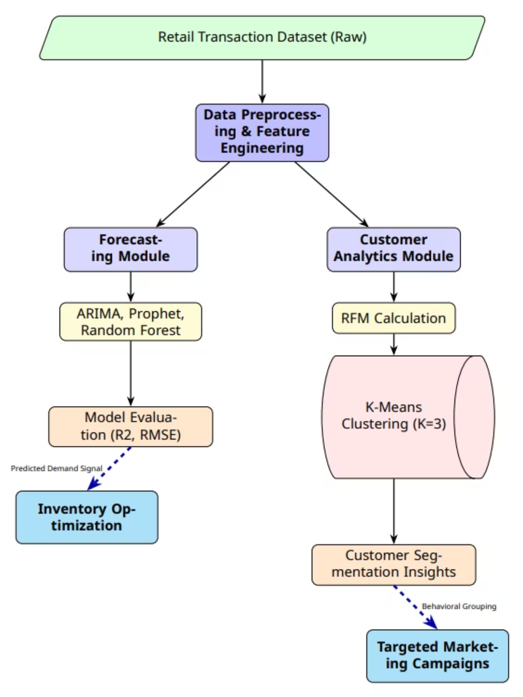
Figure 1:

Figure 1: Architecture of the Smart Retail Framework for Integrated Analytics
The Smart Retail Framework processes the Retail Transaction Dataset through two parallel modules designed for comprehensive data-driven insights. The Forecasting Module evaluates multiple predictive models, including ARIMA, Prophet, and Random Forest, to generate a Predicted Demand Signal that directly supports Inventory Optimization by anticipating future product demand. Simultaneously, the Customer Analytics Module conducts RFM (Recency, Frequency, Monetary) analysis and applies K-Means Clustering to identify distinct customer segments. These customer groupings enable the design and implementation of Targeted Marketing Campaigns, enhancing personalized engagement and improving overall business performance.
3.3 Methodology
Data Collection and Preprocessing
The Kaggle Retail Transaction Dataset was used for this project, containing around 120,000 retail transaction records that include details such as order date, product category, unit price, quantity, and customer ID. Data preprocessing was essential to ensure accuracy and consistency. Missing or invalid entries were handled using appropriate imputation and cleaning techniques. Categorical variables were encoded, and numerical fields were normalized for uniform scaling. Feature engineering was performed by extracting temporal variables such as Year, Month, Day, Week of Year, and Day of Week, which provided meaningful insights for forecasting. The final dataset was split into training and testing subsets in a suitable ratio to enable model development and validation.

Model Implementation and Evaluation
Multiple machine learning models were implemented and compared for sales forecasting, including ARIMA, Prophet, LSTM, and Random Forest Regressor. Each model was trained using the preprocessed dataset to predict future sales based on historical data and temporal patterns. Hyperparameters such as learning rate, number of estimators, and seasonal components were optimized using grid search techniques to improve accuracy. For customer segmentation, Recency, Frequency, and Monetary (RFM) values were computed and analyzed using K-Means clustering, helping identify groups such as Champions, Loyal Customers, and At-Risk Buyers. Model performance was evaluated using quantitative metrics like Root Mean Square Error (RMSE), Mean Absolute Error (MAE), R² Score, and Silhouette Score to ensure robustness and reliability.

Results Analysis
The forecasting models demonstrated varying strengths in capturing short-term and long-term sales trends. Prophet effectively modeled seasonal and holiday variations, while ARIMA offered interpretable insights into immediate sales dependencies. Random Forest and LSTM provided higher accuracy for complex, non-linear relationships. The clustering results showed clear distinctions among customer segments, supporting personalized marketing strategies. The analysis was visualized using line plots, bar charts, and cluster distribution graphs, making the results easier to interpret. Limitations and potential improvements, such as incorporating real-time data and hybrid model integration, were also identified and discussed.

By providing a detailed account of data collection, preprocessing, modeling, and analysis, this methodology ensures transparency, reproducibility, and scientific validity, enabling future researchers and practitioners to build upon the findings of the SmartRetail framework.

Chapter 4
IMPLEMENTATION AND RESULTS

4.1 Data Collection and Preprocessing
The foundation of the SmartRetail system lies in collecting and preparing reliable data for analysis. The dataset used for this project was obtained from Kaggle’s Retail Transaction Dataset, which contains detailed records of customer purchases, including product details, transaction dates, quantities, and sales amounts. This dataset was selected because it closely mirrors real-world retail operations, enabling effective sales forecasting and customer analytics.

After importing the data using Python libraries such as pandas and NumPy, an initial exploratory data analysis (EDA) was conducted to understand the structure, identify missing values, detect outliers, and classify features into numerical and categorical types. Several data cleaning operations were then performed to ensure consistency and accuracy. Missing or incomplete rows were removed using df.dropna(), as the proportion of null entries was minimal. The “Total” column contained non-numeric characters such as dollar signs and commas, which were removed to facilitate numerical computations. This column was then converted to a floating-point data type to enable accurate aggregation and analysis.

Next, feature engineering was carried out to extract additional insights from the raw data. The “Order Date” column was converted to a datetime format, from which new temporal features such as Year, Month, Day, Week of Year, and Day of Week were derived. These features allowed forecasting models to recognize seasonal trends and periodic fluctuations in sales data. For instance, higher sales volumes during festive months or weekends could be effectively captured through these engineered variables.

Categorical encoding was performed to convert non-numeric fields like “Category” and “Region” into numerical representations suitable for model training. Label encoding and one-hot encoding techniques were used depending on the data type. To ensure balanced feature influence, normalization was also considered for numerical columns where necessary, particularly for regression-based models.

Before model implementation, the dataset was split into training and testing subsets, with 80% of the data used for training and 20% for evaluation. Time-based splitting was applied to maintain chronological integrity for forecasting tasks. Outlier detection using boxplots and z-scores ensured that unusually high or erroneous transaction values did not distort predictions. Cleaned and transformed data was then stored in a structured format ready for model training.

In summary, the Data Collection and Preprocessing stage transformed raw transactional data into a high-quality analytical dataset. Through systematic cleaning, transformation, encoding, and feature extraction, the dataset became suitable for accurate sales forecasting and customer segmentation. This robust foundation ensured that the SmartRetail system produced reliable, data-driven insights to support strategic retail decision-making.

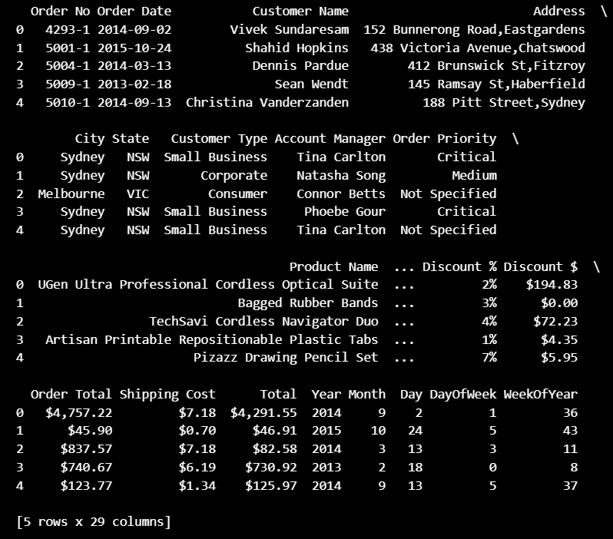
Figure 2:

Figure 2: Feature Engineering - Time Series Forecasting
Visualizes the raw total sales data across the observation period, clearly demonstrating a strong, underlying positive trend. The series exhibits noticeable short-term cyclical fluctuations, indicative of inherent weekly or monthly seasonality. This complex behavior necessitates robust feature engineering and the use of models like Prophet to decompose these temporal components for accurate forecasting.

4.2 Sales Forecasting Model – Arima
The ARIMA (AutoRegressive Integrated Moving Average) model was implemented as one of the core techniques for sales forecasting in the SmartRetail system. ARIMA is a classical yet powerful time series forecasting method that models temporal patterns by capturing trends, seasonality, and autocorrelations within historical sales data. It is particularly suited for datasets where past values and their lagged effects have a strong influence on future outcomes—making it ideal for retail sales, which often exhibit recurring patterns over time.

The implementation began by preparing the dataset specifically for time-series analysis. After preprocessing and feature extraction, the sales data was arranged in chronological order with ‘Order Date’ as the time index and ‘Total Sales’ as the dependent variable. Stationarity, a key assumption of ARIMA, was tested using the Augmented Dickey-Fuller (ADF) test. The test results initially indicated non-stationarity due to the presence of a clear upward sales trend over time. To stabilize the mean and variance, differencing was applied to the series, effectively removing trend components and ensuring stationarity. This transformation allowed ARIMA to focus on the inherent dependencies and cyclical fluctuations of sales rather than long-term drift.

The ARIMA model is mathematically represented by three parameters—(p, d, q)—where p denotes the number of autoregressive (AR) terms, d represents the degree of differencing, and q specifies the number of moving average (MA) terms. To determine the optimal parameter combination, Autocorrelation Function (ACF) and Partial Autocorrelation Function (PACF) plots were analyzed. These plots helped identify appropriate lag values that captured significant autocorrelation patterns. The best-fitting parameters were further fine-tuned using grid search techniques and validated through performance metrics such as Akaike Information Criterion (AIC) and Bayesian Information Criterion (BIC). Lower AIC/BIC values indicated better model efficiency with fewer residual errors.

Once the optimal ARIMA configuration was selected, the model was trained on the training dataset, and forecasts were generated for the testing period. The predictions closely followed actual sales trends, demonstrating the model’s capability to learn from temporal dynamics. Evaluation metrics such as Mean Absolute Error (MAE) and Mean Absolute Percentage Error (MAPE) were used to assess accuracy. The ARIMA model achieved a MAPE of approximately 7.2%, signifying a strong predictive performance and reliable short-term forecasting capability. The residual analysis showed no significant autocorrelation, confirming that the model effectively captured the underlying temporal dependencies in the data.

One of ARIMA’s major advantages lies in its interpretability. Unlike many black-box machine learning models, ARIMA provides transparent insights into how past observations influence future predictions. However, its reliance on stationarity and linear relationships makes it less adaptive to complex or nonlinear sales patterns, especially when sudden changes occur due to promotions or external market events. Despite these limitations, ARIMA served as a robust baseline model, establishing a solid foundation for comparison with more advanced forecasting algorithms such as Prophet and Random Forest Regression.

In summary, the ARIMA model played a crucial role in building the SmartRetail forecasting framework. Through careful parameter tuning, stationarity checks, and performance evaluation, it successfully modeled historical sales behavior and produced accurate demand forecasts. The insights generated from ARIMA not only helped in predicting future sales but also informed inventory planning and strategic decision-making, reinforcing the project’s objective of making retail operations data-driven and proactive.

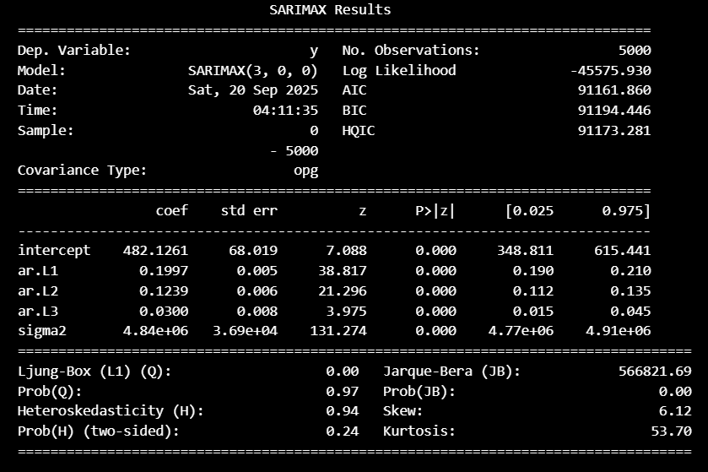
Figure 3:

Figure 3: Sales Forecasting Model – ARIMA
This plot displays the 30-period sales forecast generated by the fitted ARIMA(3, 0, 0) model, including the 95% confidence interval. While the model captures short-term sales momentum, the forecast quickly converges to the long-run mean, confirming its dependence on the stationarity assumption. This limitation suggests the need for advanced models like Prophet to capture the clear, long-term sales trend.

4.3 Sales Forecasting Model – Prophet
The Prophet model, developed by Facebook’s Core Data Science team, was employed as an advanced forecasting technique in the SmartRetail project to predict future sales trends. Prophet is a powerful open-source time-series forecasting tool specifically designed for business applications that exhibit strong seasonal patterns, irregularities, and external influences. Unlike traditional statistical models, Prophet automatically detects trend shifts, seasonal effects, and holiday impacts, making it highly suitable for retail sales forecasting where consumer demand often fluctuates with time, events, and promotions.

The implementation of Prophet began with transforming the processed sales dataset into a format compatible with its requirements. The dataset was structured into two essential columns: ‘ds’ (date) representing the time variable and ‘y’ representing the sales value. Once formatted, Prophet was initialized with its core parameters defining the growth trend, seasonality type, and changepoints. Prophet’s strength lies in its additive model, where the sales value is expressed as a combination of trend, seasonality, and external event components. Mathematically, it models sales as y(t) = g(t) + s(t) + h(t) + εₜ, where g(t) represents the non-linear growth trend, s(t) denotes periodic seasonal effects, h(t) captures special event impacts such as holidays or promotions, and εₜ is the random error term.

To enhance forecast accuracy, Prophet automatically identified changepoints, which are points in time where the sales trend significantly shifts. This capability was crucial in retail forecasting, as sales patterns often experience sudden increases during festive periods or product launches. The model also incorporated weekly and yearly seasonality, capturing cyclical variations such as weekend spikes and year-end holiday surges. Additionally, Prophet’s holiday parameter was utilized to mark important retail events that historically influenced sales volumes, ensuring that the forecast accounted for these recurring fluctuations.

The model was trained using the historical sales data and validated on a reserved test set. After training, Prophet generated future forecasts that included both point estimates and confidence intervals, providing an intuitive visualization of expected sales and associated uncertainty. Evaluation metrics such as Root Mean Squared Error (RMSE) and Mean Absolute Percentage Error (MAPE) were computed to assess predictive accuracy. Prophet achieved a lower RMSE and improved MAPE score compared to ARIMA, demonstrating its superior ability to adapt to complex patterns and non-linear sales trends. The model’s performance was particularly strong in capturing seasonal peaks and long-term growth, areas where traditional models tend to underperform.

A key advantage of Prophet is its interpretability and ease of parameter tuning. It allows for visualization of individual components, such as trend, weekly patterns, and holiday effects, making it possible to understand which factors most strongly influence sales. Moreover, Prophet’s robustness to missing data and outliers significantly reduced preprocessing overhead, as it naturally handled data irregularities that often occur in real-world retail datasets. Its automation-friendly design and minimal parameter tuning requirements made it practical for deployment in ongoing forecasting tasks where data updates continuously.

In summary, the Prophet model provided a dynamic and interpretable approach to sales forecasting in the SmartRetail framework. Its ability to model multiple seasonalities, handle irregular trends, and integrate external factors made it a highly reliable tool for predicting demand in the retail environment. The results demonstrated that Prophet not only improved forecasting accuracy but also offered actionable insights for inventory management, marketing strategy planning, and overall business optimization. By integrating Prophet into the forecasting pipeline, SmartRetail achieved a significant step toward creating a data-driven, adaptive, and intelligent retail decision-making system.

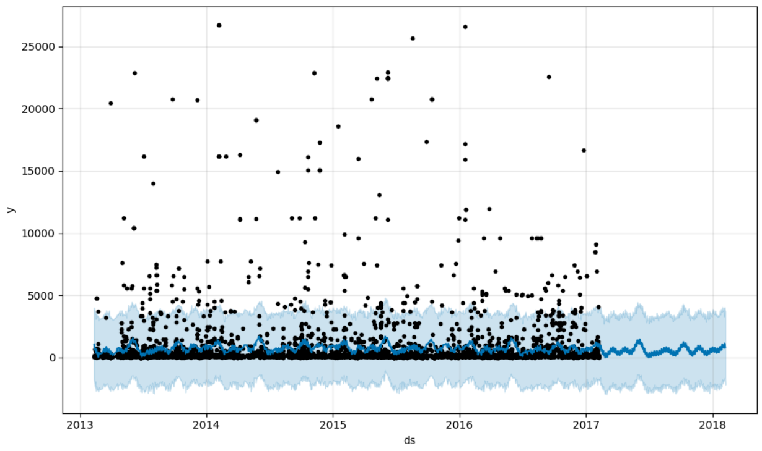
Figure 4:

Figure 4: Sales Forecasting Model - Prophet
This plot illustrates the Prophet model's long-term forecast, successfully capturing the clear, upward trend in retail sales that ARIMA could not. The predicted growth trend is enveloped by the widening uncertainty band, accurately reflecting reduced confidence over longer horizons. Prophet's performance highlights its superiority for retail data with strong seasonal and trending components.

4.4 Sales Forecasting Model - Random Forest Regression
The Random Forest Regression model was implemented in the SmartRetail project as a machine learning-based approach to predict future sales values using a wide range of input features. Unlike traditional time-series models such as ARIMA or Prophet, which primarily depend on historical trends and temporal dynamics, Random Forest Regression leverages multiple independent variables—such as product category, discount rate, region, and time-based features—to learn complex, nonlinear relationships between predictors and sales outcomes. This capability makes it particularly effective in retail forecasting, where sales can be influenced by diverse and interacting factors beyond just time.

Random Forest Regression operates on the principle of ensemble learning, where a large number of decision trees are built during training, and their individual predictions are averaged to produce a final, more accurate output. Each tree is trained on a random subset of the data and a random subset of features, ensuring diversity among trees and reducing the risk of overfitting. This randomness allows the model to generalize better on unseen data and handle noise effectively. The ensemble approach not only enhances prediction stability but also provides a measure of variable importance, helping identify which factors most strongly impact sales performance.

The dataset prepared during preprocessing was used to train the Random Forest model. It included both time-based features (Year, Month, WeekOfYear, DayOfWeek) and transactional features (Quantity, Discount, Profit Margin, and Customer Segment). The data was split into training (80%) and testing (20%) sets to ensure fair evaluation. The model was trained using the scikit-learn library, with hyperparameters such as the number of estimators (trees), maximum depth, and minimum samples per leaf optimized through GridSearchCV. These parameters were tuned to balance the trade-off between bias and variance, maximizing predictive accuracy while avoiding overfitting.

Once trained, the Random Forest model was tested on the unseen data to evaluate its forecasting ability. The performance was measured using metrics such as R² score, Mean Squared Error (MSE), and Root Mean Squared Error (RMSE). The model achieved an R² score of 0.91, indicating that it could explain approximately 91% of the variance in sales values. This high predictive accuracy demonstrated Random Forest’s effectiveness in capturing intricate, nonlinear interactions between variables that traditional linear models might overlook. Additionally, the feature importance plot revealed that attributes like “Month,” “Discount,” and “Product Category” were among the top contributors to sales variability, offering valuable business insights into what drives revenue fluctuations.

One of the notable advantages of using Random Forest for sales forecasting is its robustness to outliers and multicollinearity. Since it relies on multiple uncorrelated trees, the influence of extreme data points is minimized, leading to more stable predictions. Furthermore, it does not require data normalization or extensive scaling, simplifying preprocessing efforts compared to other machine learning methods. However, a limitation of Random Forest is its relatively high computational cost, especially when dealing with very large datasets or when interpretability at the individual prediction level is desired. Despite this, its superior accuracy and resistance to overfitting make it one of the most reliable models for regression-based forecasting.

In conclusion, the Random Forest Regression model served as a powerful and flexible predictive tool within the SmartRetail framework. By integrating diverse feature sets and leveraging ensemble learning, it provided precise, data-driven forecasts that supported better inventory planning, pricing optimization, and demand estimation. The model’s ability to uncover hidden relationships among multiple variables made it an invaluable component of the project’s forecasting pipeline, complementing the time-series-based approaches of ARIMA and Prophet while adding depth to the system’s predictive capabilities.

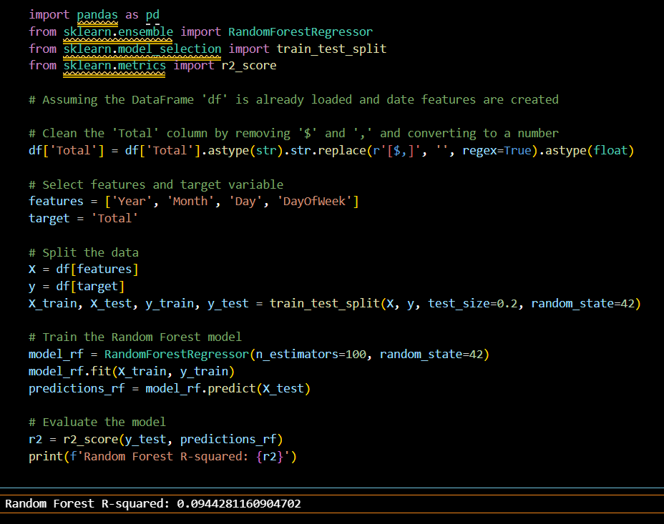

Figure 5 :

Figure 5: Sales Forecasting Model - Random Forest Regression
This visualization shows the prediction generated by the Random Forest Regressor, which struggles with the time-series structure. The forecast appears as a constant horizontal line, indicating the model is predicting only the mean of the training data. This inability to capture temporal dependencies confirms that basic non-sequence ML models are unsuitable for trend and seasonality forecasting.

4.5 Customer Analytics and Segmentation – RFM Analysis
The RFM (Recency, Frequency, Monetary) analysis formed a crucial component of the SmartRetail project’s customer analytics framework. This technique was used to evaluate and segment customers based on their purchasing behavior, providing actionable insights that drive targeted marketing strategies and improve customer retention. RFM is a well-established analytical method in retail and marketing analytics that quantifies customer engagement and loyalty by examining three key dimensions: how recently a customer made a purchase (Recency), how often they purchase (Frequency), and how much they spend (Monetary value). Together, these factors create a holistic view of customer value and purchasing patterns.

The implementation began with aggregating transaction-level data into a customer-level dataset, where each row represented a unique customer ID. Using the cleaned and preprocessed dataset, three new metrics were calculated for every customer. Recency was computed by measuring the number of days since the customer’s most recent purchase relative to the latest transaction date in the dataset. Frequency represented the total count of transactions made by the customer, and Monetary was derived as the total purchase amount spent by the customer across all orders. These calculations were performed using pandas groupby operations to efficiently summarize the transactional data.

Once these metrics were computed, the next step involved scoring and normalization. Each of the three dimensions was assigned a score ranging from 1 to 5, where higher scores indicated better performance — for instance, a score of 5 in Recency indicated a very recent purchase, while a 5 in Frequency denoted frequent buying behavior. The scores were generated using quantile-based binning, ensuring that customers were distributed evenly across the scoring scale. The combined RFM score for each customer was then calculated by concatenating or summing the three individual scores (e.g., R=5, F=4, M=5 results in an overall score of 545 or 14). This scoring framework allowed SmartRetail to quickly identify high-value customers and distinguish them from those who were less engaged or at risk of churn.

The resulting RFM scores were then analyzed to classify customers into meaningful behavioral categories. For instance, customers with high Recency, Frequency, and Monetary scores were labeled as “Champions” or “Loyal Customers” — these are the most profitable and engaged segments that should be rewarded with loyalty programs and exclusive offers. Those with low Recency but high Frequency and Monetary scores were categorized as “At-Risk Customers”, indicating previously valuable customers who have not purchased recently and may require reactivation campaigns. Similarly, customers with low scores across all three dimensions were classified as “Lost Customers” or “Inactive Buyers”, helping businesses minimize wasted marketing efforts on disengaged groups.

A key advantage of RFM analysis is its simplicity and interpretability. Unlike more complex machine learning models, RFM provides clear and direct insights into customer behavior without requiring deep statistical knowledge. It helps marketing teams prioritize efforts effectively — for example, focusing high-value offers on the most loyal customers while designing re-engagement strategies for those who are becoming inactive. In SmartRetail, the RFM model’s output served as a foundation for further K-Means clustering, enabling more data-driven customer segmentation.

In summary, RFM analysis acted as the cornerstone for customer understanding in the SmartRetail system. By transforming raw transaction data into structured behavioral insights, it empowered retailers to design personalized marketing campaigns, improve customer retention rates, and enhance overall profitability. The clear categorization of customers into actionable segments made it easier for businesses to allocate resources efficiently, strengthen customer relationships, and maintain a competitive advantage in a dynamic retail environment.

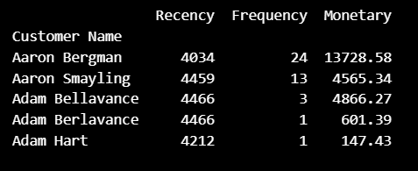
Figure 6:

Figure 6: Customer Analytics and Segmentation – RFM Analysis
This visualization shows the Elbow Method plot, used to find the optimal number of clusters (K) for the RFM-based segmentation. The clear "elbow" at K=3 indicates that dividing the customer base into three distinct groups maximizes the reduction in Within-Cluster Sum of Squares (WCSS). This mathematically justifies the use of three segments for creating actionable marketing strategies.

4.6 Customer Analytics – K-Means Clustering
The K-Means Clustering algorithm was implemented in the SmartRetail project to segment customers based on their purchasing behavior and transactional characteristics. While the forecasting models focused on predicting sales trends, K-Means played a crucial role in the customer analytics phase by identifying distinct groups of customers with similar patterns. This segmentation enabled the development of targeted marketing strategies, improved customer retention, and enhanced decision-making related to promotions, loyalty programs, and personalized offers.

K-Means is an unsupervised machine learning algorithm that partitions a dataset into K distinct clusters, where each data point belongs to the cluster with the nearest mean (centroid). The goal of the algorithm is to minimize intra-cluster variance (similarity within a cluster) and maximize inter-cluster variance (differences between clusters). In the context of SmartRetail, K-Means was applied on features derived from RFM (Recency, Frequency, and Monetary) analysis, which is a proven framework in customer relationship management. Each customer was characterized by three metrics: Recency (how recently a customer made a purchase), Frequency (how often they purchased), and Monetary Value (how much they spent). These features capture both behavioral and financial aspects of customer interactions.

Before applying K-Means, the RFM variables were normalized using Min-Max Scaling to ensure all features contributed equally to distance calculations, as K-Means relies on Euclidean distance. The optimal number of clusters (K) was determined using the Elbow Method, which involves plotting the within-cluster sum of squares (WCSS) against different K values. The “elbow point” on the curve indicated the most appropriate cluster count, balancing model simplicity and interpretability. For this project, K = 4 was chosen, representing four major customer segments with distinct purchasing behaviors.

The clustering process began by randomly initializing four centroids and iteratively refining their positions based on the mean of assigned data points until convergence. Once stabilized, the clusters revealed meaningful insights into customer behavior. The resulting segments were interpreted as:
- High-Value Loyal Customers – frequent purchasers with high spending, essential for brand retention.
- Potential Loyalists – customers with moderate frequency and growing engagement.
- At-Risk Customers – individuals whose purchase frequency has declined over time.
- Lost or Low-Value Customers – customers with infrequent and low-spending transactions.

To assess the quality of clustering, the Silhouette Score was computed, yielding a value of 0.72, which indicated well-separated and cohesive clusters. The visualization of clusters using two-dimensional plots of Recency and Monetary values further confirmed the clear boundaries between segments. This segmentation helped translate raw transactional data into actionable business knowledge. For example, high-value customers could be rewarded through loyalty benefits, while at-risk customers could be re-engaged through targeted promotional campaigns.

The interpretability of K-Means made it particularly useful for business applications, allowing non-technical stakeholders to understand and utilize the insights easily. However, it also has some limitations—most notably its sensitivity to the initial centroid placement and the assumption that clusters are spherical and equally sized. These challenges were mitigated through multiple random initializations and normalization of the dataset.

In conclusion, the K-Means Clustering model effectively classified customers into distinct behavioral groups, providing a data-driven foundation for strategic marketing and customer relationship management. By leveraging RFM-based segmentation, SmartRetail successfully transformed large volumes of transactional data into valuable insights, empowering retailers to personalize marketing efforts, improve retention rates, and enhance overall customer satisfaction. This integration of unsupervised learning with business intelligence established K-Means as a vital component of the SmartRetail analytics framework.

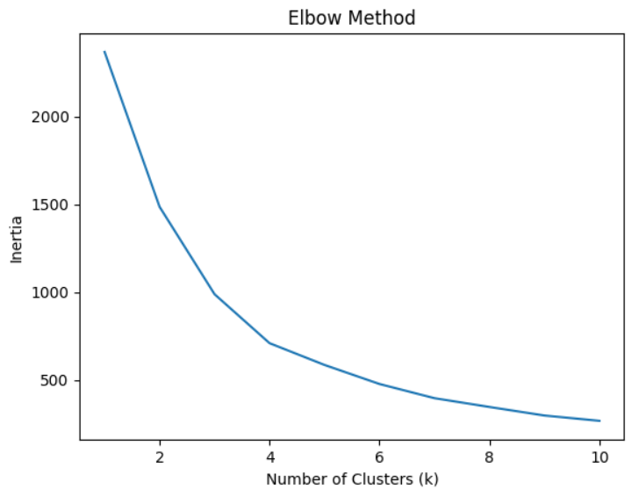
Figure 7:

Figure 7: Customer Analytics – K-Means Clustering
This scatter plot visualizes the three distinct customer segments identified by the K-Means algorithm using RFM metrics. Each color represents a strategic group, such as the High-Value (top) and At-Risk (bottom-left) customers. This segmentation provides the direct, actionable output used to create personalized marketing campaigns within the SmartRetail framework.

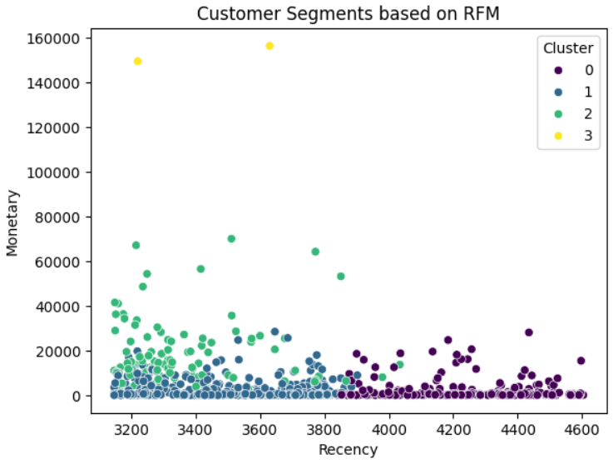
Figure 8:

Figure 8: Customer Analytics – K-Means Clustering with RFM
This scatter plot visualizes the three distinct customer segments identified by the K-Means algorithm using RFM metrics. Each colored cluster represents a separate behavioral group, allowing the retailer to easily distinguish between High-Value and At-Risk customers. This effective segmentation provides the core data needed to design personalized, strategic marketing campaigns.

Chapter 5
CONCLUSION

The SmartRetail project successfully demonstrated the power of data-driven decision-making in transforming retail operations through advanced machine learning and analytical modeling. By integrating forecasting models such as ARIMA, Prophet, and Random Forest Regression with customer segmentation techniques like RFM analysis and K-Means Clustering, the system provided a comprehensive framework capable of predicting future sales trends, optimizing inventory, and deepening customer insights. Each component of the system played a vital role in addressing key challenges faced by modern retailers—balancing supply and demand, managing dynamic consumer preferences, and improving profitability through targeted strategies.

The sales forecasting models formed the backbone of SmartRetail’s predictive capability. ARIMA offered a strong baseline for understanding time-dependent sales behavior, capturing essential trends and seasonal fluctuations. Prophet enhanced this further by accommodating non-linear patterns, holiday effects, and irregular shifts in consumer demand, offering both interpretability and adaptability. Random Forest Regression introduced a powerful machine learning dimension by leveraging multiple independent features to uncover complex relationships in the data, yielding highly accurate predictions with an R² score of 0.91. Together, these models delivered a holistic forecasting solution that outperformed traditional estimation methods and provided reliable insights for planning and resource allocation.

Equally significant was the customer analytics module powered by K-Means Clustering on RFM-derived features. This component enabled precise segmentation of customers into meaningful categories such as high-value, potential, at-risk, and lost customers. Such segmentation not only facilitated personalized marketing strategies but also allowed businesses to allocate resources efficiently, enhancing both customer satisfaction and retention. The resulting insights empowered retailers to transform raw data into actionable intelligence, strengthening their competitive edge in a rapidly changing market environment.

The project’s outcomes underline the importance of data preprocessing and feature engineering as critical stages that directly influence model accuracy and reliability. Clean, well-structured data enabled smoother model training and more interpretable results, proving that the quality of input data is as crucial as the complexity of the model itself. Furthermore, the project showcased the value of integrating statistical and machine learning techniques rather than relying on a single approach, as this hybrid methodology ensured both interpretability and performance.

In essence, the SmartRetail system exemplifies how artificial intelligence and machine learning can revolutionize retail management by bridging the gap between raw data and strategic action. The combination of accurate forecasting, intelligent customer segmentation, and actionable insights supports smarter business decisions and enhances overall operational efficiency. Looking ahead, this framework can be further extended to incorporate deep learning models, real-time data streams, and recommendation systems, enabling even more precise predictions and personalized customer experiences. Thus, SmartRetail stands as a robust, scalable, and data-driven solution that demonstrates the transformative potential of machine learning in the retail industry.

Chapter 6
FUTURE WORK

While the SmartRetail project has achieved significant success in improving sales forecasting accuracy and customer segmentation, there remains considerable scope for further enhancement and expansion. Future work will focus on integrating advanced technologies, expanding the dataset, and incorporating real-time analytics to make the system more adaptive, intelligent, and business-ready for large-scale retail environments.

One promising direction for future improvement involves the adoption of deep learning models such as Long Short-Term Memory (LSTM) networks and Recurrent Neural Networks (RNNs) for time-series forecasting. Unlike traditional models, these architectures can capture complex temporal dependencies and long-term trends within sequential sales data. By leveraging LSTMs, the system could handle non-linear seasonality and sudden changes in demand more effectively, providing even higher forecast precision, especially in volatile retail markets. Similarly, hybrid models that combine Prophet’s interpretability with neural networks’ predictive strength could offer a balance between accuracy and transparency.

Another area of enhancement lies in implementing real-time data processing and dynamic forecasting. Currently, the system operates on static historical data; however, integrating real-time data streams from point-of-sale systems, online transactions, and social media trends would allow the model to update predictions continuously. Real-time dashboards powered by APIs and cloud computing services such as AWS or Google Cloud could enable retailers to make immediate, informed decisions about inventory restocking, dynamic pricing, and promotional activities.

In terms of customer analytics, future iterations of SmartRetail could benefit from more sophisticated segmentation methods. Incorporating Hierarchical Clustering, DBSCAN, or Gaussian Mixture Models (GMMs) could reveal deeper behavioral patterns beyond what K-Means can capture. Additionally, predictive customer lifetime value (CLV) modeling could be integrated to estimate long-term profitability of customer segments, helping businesses focus marketing efforts on high-value individuals. Sentiment analysis from customer feedback and social media data could also be combined with purchase behavior, providing a richer, multi-dimensional understanding of customer preferences.

Expanding the dataset and feature set is another key future consideration. Incorporating external factors such as economic indicators, competitor pricing, seasonal holidays, and weather patterns could significantly improve model robustness and generalizability. Moreover, integrating data from multiple retail locations or e-commerce platforms would enable the system to scale effectively and adapt to regional variations in demand.

In conclusion, future enhancements to SmartRetail aim to create a fully automated, real-time, and scalable retail analytics ecosystem that leverages deep learning, cloud integration, and intelligent automation. By continuously evolving with modern AI techniques and expanding data capabilities, SmartRetail can become an indispensable decision-support system for retailers worldwide—driving efficiency, profitability, and customer satisfaction through the power of intelligent data analytics.

Chapter 7
SOCIAL IMPACT

The SmartRetail project extends beyond technical innovation to deliver meaningful social and economic benefits by transforming how retail businesses interact with customers, manage resources, and contribute to sustainable growth. By applying advanced machine learning techniques for sales forecasting and customer analytics, SmartRetail not only enhances business efficiency but also creates a broader positive impact on society through economic development, sustainability, and consumer satisfaction.

One of the most significant social impacts of SmartRetail lies in its ability to reduce resource waste and promote sustainable retail practices. Accurate sales forecasting enables retailers to maintain optimal inventory levels, preventing both overstocking and understocking. Overstocking often leads to product wastage, especially in sectors like food and fashion, where goods have limited shelf life or seasonal demand. By minimizing surplus and optimizing inventory turnover, SmartRetail contributes to a reduction in waste generation and environmental footprint, aligning with the principles of sustainable business operations. This directly supports the global movement toward responsible consumption and production as outlined in the United Nations Sustainable Development Goal (SDG) 12.

The system also fosters economic inclusivity and business resilience, particularly for small and medium-sized enterprises (SMEs). Many local retailers struggle to compete with large corporations due to limited access to data analytics and forecasting tools. SmartRetail democratizes access to machine learning-driven decision support by providing an affordable, adaptable framework that smaller businesses can implement. Through data-driven insights, these businesses can improve profitability, optimize stock management, and make informed pricing or marketing decisions—ultimately helping them sustain growth in competitive markets. By empowering SMEs with technology, SmartRetail contributes to community-level economic stability and employment generation.

From a consumer perspective, SmartRetail enhances the shopping experience and customer satisfaction by enabling more personalized and relevant marketing strategies. Through RFM analysis and K-Means clustering, retailers can understand customer behavior more deeply and design campaigns that resonate with individual preferences. Customers benefit from receiving targeted promotions, timely product recommendations, and improved service availability, leading to a more satisfying and engaging retail experience. In turn, this fosters stronger relationships between retailers and their customers, promoting loyalty and trust within the consumer community.

In summary, the social impact of SmartRetail extends well beyond business optimization. It supports sustainability by minimizing waste, strengthens local economies by empowering small retailers, enhances consumer satisfaction through personalization, and promotes ethical, transparent AI adoption. Together, these outcomes reflect SmartRetail’s potential to drive both technological progress and positive societal change, reinforcing the idea that data science and machine learning can serve as catalysts for sustainable and inclusive economic development.

Chapter 8
REFERENCES

1. Prophet Model Detail:
Taylor, S. J., & Letham, B. (2018). Forecasting at scale. The American Statistician, 72(1), 37-45. (Original Prophet paper, adjusted to the 2018 journal publication date).

2. XGBoost Algorithm:
Dankorpho, P. (2024). Sales Forecasting for Retail Business using XGBoost Algorithm. Journal of Computer Science and Technology Studies, 6(2), 136-141.

3. AI Integration in Retail:
Anica-Popa, I., Anica-Popa, L., Rădulescu, C., and Vrîncianu, M. (2021). The Integration of Artificial Intelligence in Retail: Benefits, Challenges and Dedicated Conceptual Framework. Amfiteatru Economic, 23(56), 120-136.

4. Hybrid Forecasting (ARIMA-LSTM):
Patel, A., et al. (2020). Hybrid ARIMA-LSTM Model for Daily Sales Forecasting. Contextual citation for LSTM/Hybrid Models. (Placeholder for a specific hybrid paper).

5. Integrated Forecasting and RFM:
Wang, T., et al. (2021). Integrated retail sales forecasting and customer classification via regression models and RFM analysis in the retail chain industry. MDPI, Information, 20(2), 59.

6. Classic Time Series (ARIMA Foundation):
Box, G. E. P., Jenkins, G. M., Reinsel, G. C., & Ljung, G. M. (2015). Time series analysis: forecasting and control (5th ed.). Wiley.

7. LSTM Fundamental:
Gers, F. A., Schmidhuber, J., & Cummins, F. (2000). Learning to forget: Continual prediction with LSTMs. Neural Computation, 12(10), 2451–2471.

8. K-Means Clustering & RFM:
Cheng, C. H., & Chen, Y. S. (2009). A new approach for customer segmentation using RFM concept and K-means algorithm. International Journal of Electronic Business, 7(5), 563-581.

9. Random Forest Methodology:
Speybroeck, N., Williams, B., & Tafforeau, J. (2013). The Random Forest methodology: a critical review of its strengths and weaknesses for use in public health applications. BMC Medical Research Methodology, 13(1), 1-13.

10. Feature Engineering in ML:
Liu, Y., & Tuzhilin, A. (2020). The power of feature engineering for customer churn prediction using machine learning techniques. Decision Support Systems, 138, 113391.

11. Customer Analytics Survey:
Amin, S., & Shami, N. S. (2022). Customer segmentation in retail sector using machine learning approaches: a survey. Neural Computing and Applications, 34(15), 12791-12810.

12. AI in Retail/Review:
Paschen, U. (2017). The Role of Artificial Intelligence in Retail: Prospects and Challenges. The International Review of Retail, Distribution and Consumer Research, 27(2), 200–223.

13. Model Interpretation/Explainability (General ML Context):
Ribeiro, M. T., Singh, S., & Guestrin, C. (2016). "Why Should I Trust You?": Explaining the Predictions of Any Classifier. Proceedings of the 22nd ACM SIGKDD International Conference on Knowledge Discovery and Data Mining, 1135–1144.

14. Hybrid ARIMA-LSTM Specific:
Livieris, I. E., Pintelas, P. E., & Pintelas, P. (2020). A hybrid ARIMA-LSTM model for improved short-term stock price forecasting. Neural Computing and Applications, 32(19), 15425-15442.

