
Mini project report on

Corporate Recruitment and
Candidate Resume Indexing System
RecruitIQ
Submitted in partial fulfilment of the requirements for the award of degree of
Bachelor of Technology
in
Computer Science and Engineering
DBMS Experiential Learning – Level 3 Project
Submitted by
Srujan Yalla PES2UG24CS527
Sumedh B Rao PES2UG24CS535
Team 10
under the guidance of
Guide name: ______________________________
AUG – DEC 2026
DEPARTMENT OF COMPUTER SCIENCE AND ENGINEERING
FACULTY OF ENGINEERING
PES UNIVERSITY
(Established under Karnataka Act No. 16 of 2013)
Electronic City, Hosur Road, Bengaluru – 560 100, Karnataka, India

PES UNIVERSITY
(Established under Karnataka Act No. 16 of 2013)
Electronic City, Hosur Road, Bengaluru – 560 100, Karnataka, India
CERTIFICATE
This is to certify that the mini project entitled
Corporate Recruitment and
Candidate Resume Indexing System
is a bonafide work carried out by
Srujan Yalla PES2UG24CS527
Sumedh B Rao PES2UG24CS535
In partial fulfilment for the completion of the fifth semester DBMS Project in the Program of Study, Bachelor of Technology in Computer Science and Engineering, under the rules and regulations of PES University, Bengaluru, during the period AUG 2026 – DEC 2026. It is certified that all corrections and suggestions indicated for internal assessment have been incorporated in the report. The project has been approved as it satisfies the fifth semester academic requirements in respect of project work.
Signature: ______________________________
Guide name: ____________________________
Department of Computer Science and Engineering
PES University

DECLARATION
We hereby declare that the DBMS Project entitled Corporate Recruitment and Candidate Resume Indexing System has been carried out by us under the guidance of our project guide and submitted in partial fulfilment of the course requirements for the award of the degree of Bachelor of Technology in Computer Science and Engineering of PES University, Bengaluru, during the academic semester AUG – DEC 2026.
Srujan Yalla
PES2UG24CS527
Signature: ______________________________
Sumedh B Rao
PES2UG24CS535
Signature: ______________________________

ACKNOWLEDGEMENT
We would like to express our gratitude to our project guide and the Department of Computer Science and Engineering, PES University, for their guidance, assistance and encouragement throughout the development of this DBMS Project.
We thank the faculty and staff of the department for the knowledge, resources and support that helped us design and implement RecruitIQ. We are grateful to PES University for providing the opportunity to apply database concepts through this project.
We also thank our family and friends for their continued support and encouragement during the completion of the project.
Srujan Yalla
Sumedh B Rao
Team 10

ABSTRACT
RecruitIQ is a Corporate Recruitment and Candidate Resume Indexing System that manages companies, departments, jobs, candidate profiles, resumes, applications, interviews and hiring. It combines a relational database with a vector database to support both structured recruitment operations and semantic matching between resumes and job descriptions.
MySQL 8 acts as the source of truth through a normalised 12-table schema, primary and foreign keys, integrity constraints, views, stored routines, triggers and indexes. Hiring is implemented as a transaction that marks an application as hired, rejects other active applicants and closes the job. Triggers enforce application rules and maintain an audit trail of status changes.
Qdrant stores derived 384-dimensional embeddings generated locally using all-MiniLM-L6-v2. Semantic retrieval returns relevant job or resume identifiers, which are filtered and enriched using MySQL. A Next.js 14 application provides Admin, Recruiter and Candidate workflows, with bcrypt password hashing, JWT sessions, role-based access and parameterised queries.
The report presents the ER model, relational mapping, SQL implementation, vector indexing, application screens and testing evidence. The 23 test cases include successful integrity and workflow checks, four pending application or semantic-search checks, and one cascade-delete test requiring a repeat run. Future work includes document parsing, combined ranking, notifications and automated end-to-end testing.

TABLE OF CONTENTS
Chapter | Title | Page
1 | INTRODUCTION | 12
2 | PROBLEM DEFINITION | 14
3 | ER MODEL | 16
4 | ER TO RELATIONAL MAPPING | 19
5 | DDL STATEMENTS | 26
6 | DML STATEMENTS | 30
7 | QUERIES | 33
8 | STORED PROCEDURES FUNCTIONS AND TRIGGERS | 44
9 | FRONT END DEVELOPMENT | 48
 | REFERENCES | 60
 | APPENDIX A DEFINITIONS ACRONYMS AND ABBREVIATIONS | 61
 | APPENDIX B TESTING RESULTS AND EVIDENCE | 62

LIST OF TABLES
Table | Title | Page
1 | Database choice and justification | 12
2 | Advanced database features | 13
3 | Functional requirements | 14
4 | Coverage of Level 3 requirements | 14
5 | Changes from the initial ER design | 16
6 | Referential actions | 21
7 | Company data dictionary | 22
8 | Department data dictionary | 22
9 | Job data dictionary | 22
10 | Skill and Job_Skill data dictionary | 23
11 | Candidate data dictionary | 23
12 | Resume and Candidate_Skill data dictionary | 24
13 | Application data dictionary | 24
14 | Interview data dictionary | 25
15 | Users and Application_Status_Log data dictionary | 25
16 | Database implementation scripts | 26
17 | Database views | 28
18 | Stored routines and triggers | 44
19 | System components | 48
20 | API endpoints | 49
21 | Role permissions | 50
22 | Qdrant design and retrieval pipeline | 50
23 | Team contributions | 59
24 | Test case results | 62

LIST OF FIGURES
Figure | Title | Page
1 | Initial hand-drawn ER diagram (design draft) | 16
2 | Updated ER diagram of the implemented database (10 entities, 12 relationships) | 18
3 | Relational schema with primary keys, foreign keys and references | 20
4 | Action output of script 02: all 19 statements executed (the two warnings are InnoDB adding the hidden FTS_DOC_ID column for the first FULLTEXT index) | 27
5 | SHOW INDEX FROM Job: primary key, foreign keys, composite index and FULLTEXT index ft_job | 27
6 | SHOW TABLES: the 12 tables of the final schema | 28
7 | Views created successfully | 28
8 | SHOW FULL TABLES WHERE Table_type = VIEW: the three views | 29
9 | Seed script output: all INSERT and UPDATE statements succeeded | 30
10 | Row count check: 6 candidates | 30
11 | Row count check: 8 applications | 30
12 | vw_job_summary with seeded data | 31
13 | vw_candidate_profile: skills concatenated per candidate | 31
14 | vw_interview_schedule | 31
15 | Application_Status_Log filled by triggers during seeding | 32
16 | Q15 output: all statements ran, then ROLLBACK | 32
17 | Q1 result | 33
18 | Q2 result | 34
19 | Q3 result | 34
20 | Q9 result | 35
21 | Q10 result | 36
22 | Q11 result | 36
23 | Q12 result | 37
24 | Q5 result | 38
25 | Q4 result | 39
26 | Q6 result | 40
27 | Q7 result | 41
28 | Q8 result: job search | 42
29 | Q8 result: resume search | 42
30 | Q13 statement | 42
31 | Q13 result | 43
32 | Script 04 output: function, procedures and six triggers created (yellow warnings are DROP … IF EXISTS on the first run) | 45
33 | SHOW FUNCTION STATUS: fn_match_percentage | 45
34 | SHOW PROCEDURE STATUS: sp_apply_for_job and sp_hire_candidate | 45
35 | SHOW TRIGGERS: the six triggers on Application and Interview | 46
36 | Q14: statuses of all applications to Job 1 after hiring | 47
37 | Q14: Job 1 is now Closed | 47
38 | System architecture: browser, Next.js server, MySQL and Qdrant | 48
39 | Qdrant dashboard: collections jobs (6 points) and resumes (7 points), 384-dimension cosine vectors | 51
40 | npm run seed:users: recruiter, candidate and admin accounts created | 51
41 | Login page | 52
42 | Recruiter dashboard: totals and applications by status | 52
43 | Recruiter dashboard: most-applied jobs (from vw_job_summary), average salary by industry, top skills | 53
44 | Posting a new job with required skills (job and Job_Skill rows inserted in one transaction, then indexed in Qdrant) | 53
45 | Applications screen with status, skill-match percentage and actions | 54
46 | Scheduling an interview for an application | 54
47 | Interview schedule page | 54
48 | Status changed to Shortlisted; the trigger records the change in the audit log | 55
49 | Candidate hired through sp_hire_candidate | 55
50 | Filtering candidates by skill and experience | 55
51 | Jobs a candidate can apply to, with the skill-match percentage from fn_match_percentage | 56
52 | Candidate profile: details, skills and resume upload | 56
53 | Applying to a job: application submitted | 57
54 | Recommended Jobs page (semantic search over the candidate’s resume) | 57
55 | My applications | 57
56 | A candidate calling a recruiter-only API receives 403 Forbidden | 58
57 | A logged-out request to a protected API receives 401 Unauthorized | 58
58 | T1: statement | 63
59 | T1: error returned | 63
60 | T2: statement | 63
61 | T2: error returned | 63
62 | T3: statement | 64
63 | T3: error returned | 64
64 | T4: statement | 64
65 | T4: error returned | 64
66 | T5: statement | 64
67 | T5: error returned | 64
68 | T6: statement | 64
69 | T6: error returned | 64
70 | T7: statement | 64
71 | T7: error returned | 64
72 | T8: statement | 65
73 | T8: error returned | 65
74 | T9: statement | 65
75 | T9: error returned | 65
76 | T10: a candidate without any resume is inserted (succeeds) | 65
77 | T10: insert output | 65
78 | T10: application for that candidate | 65
79 | T10: trigger error – resume required | 65
80 | T11: statement | 65
81 | T11: error returned | 65
82 | T12: statement | 66
83 | T12: error returned | 66
84 | T13: statement | 66
85 | T13: error returned | 66
86 | T14: statement | 66
87 | T14: error returned | 66
88 | P1: INSERT INTO Interview | 66
89 | P1: output | 66
90 | P1: Application 2 is now Interview Scheduled | 67
91 | P2: transaction statements | 67
92 | P2: output | 67
93 | P2: result | 68
94 | Audit log query | 68
95 | Audit log: output | 68
96 | Audit log: the hire, the two automatic rejections and earlier changes | 69
97 | Job 1 reopened for the application demo | 69
98 | Reopen: output | 69

1. INTRODUCTION
RecruitIQ is a recruitment platform that supports the hiring lifecycle from job creation and candidate registration to interview scheduling and hiring. It combines MySQL 8 for structured records and transactional integrity with Qdrant for semantic resume and job matching. The web application is built with Next.js 14 and provides separate Admin, Recruiter and Candidate workflows.

1.1 Objectives
• Model the hiring lifecycle (company, department, job, application, interview, hire) in a normalised MySQL schema with integrity enforced at the database level.
• Demonstrate advanced SQL: views, stored function and procedures, triggers, transactions with row locking, indexes and full-text search.
• Add semantic search with a vector database so that resumes and job descriptions can be matched on meaning rather than keywords.
• Provide a secure, role-based Next.js web application (Admin, Recruiter, Candidate) with no credentials hard-coded in the source.
• Keep the code in Git/GitHub with documented setup and test cases.

1.2 Database choice and justification
The project uses two database paradigms (Option 2: SQL + Vector database). Each type of data is stored where its nature fits best.
Table 1: Database choice and justification
Data | Store | Why
Companies, departments, jobs, candidates, applications, interviews, users, skills | MySQL 8 | Strongly structured and highly relational. Needs ACID transactions (hiring), foreign keys, CHECK/UNIQUE constraints, triggers, views and aggregate queries with joins.
Resume text and job descriptions (unstructured, text- heavy) | Qdrant (vector database) | Keyword search cannot match "ML engineer" with "builds recommendation models". Sentence embeddings with cosine similarity retrieve semantically similar resumes and jobs.

Why not a document database such as MongoDB?
The data is relational (a hire touches Application, Job and the audit log atomically) and needs enforced integrity. The only unstructured part needs similarity search rather than flexible documents, which a vector database provides directly.

How the two stores work together
MySQL remains the single source of truth. Qdrant holds a derived index of resume and job vectors, keyed by Resume_ID and Job_ID. A semantic query is answered in two steps: Qdrant returns the nearest IDs, then MySQL filters them (for example only open jobs) and enriches them with names, skills and the skill-match percentage. If the vector index is lost it can be rebuilt from MySQL with one command.

Why Qdrant and a local embedding model
• Qdrant is a purpose-built vector database with HNSW indexing, runs in one Docker container and has a web dashboard.
• The all-MiniLM-L6-v2 model (384 dimensions) runs locally through ONNX, so no API key or network service is required and no resume text leaves the machine.

1.3 Advanced database features
Table 2: Advanced database features
Concept | Where
Transactions and locking | sp_hire_candidate (FOR UPDATE, rollback handler); sp_apply_for_job; job posting and candidate registration use transactions in the API
Views | vw_job_summary, vw_candidate_profile, vw_interview_schedule
Stored function and procedures | fn_match_percentage, sp_apply_for_job, sp_hire_candidate
Triggers | Six triggers for integrity, audit logging and status automation
Indexing | Composite and single-column indexes on Job, Application, Candidate, Resume, Interview
Full-text search | FULLTEXT indexes ft_job and ft_resume queried with MATCH … AGAINST
Vector similarity search (vector database) | Qdrant cosine search over resume and job embeddings

2. PROBLEM DEFINITION

2.1 Problem statement
Companies receive hundreds of applications per opening, and recruiters struggle to find the right candidates in free-text resumes. Candidates, in turn, cannot easily tell which openings suit their skills. This project builds a recruitment platform that manages the full hiring lifecycle and goes beyond CRUD: business rules are enforced inside the database, hiring is transactional, jobs are scored against candidate skills, and resumes and job descriptions are matched by meaning using vector embeddings.

2.2 Functional requirements
Table 3: Functional requirements
ID | Requirement | Role
FR1 | Register and log in with hashed passwords; JWT session in an HttpOnly cookie | All
FR2 | Maintain profile and skills; upload multiple resumes | Candidate
FR3 | Search jobs (full-text, location, type, salary) and see skill-match percentage | Candidate
FR4 | Apply to a job (only open jobs, resume mandatory, no duplicate applications) | Candidate
FR5 | Post, close and reopen jobs with required skills | Recruiter
FR6 | Review applications, change status; every change is audit-logged | Recruiter
FR7 | Schedule, complete and cancel interviews | Recruiter
FR8 | Hire a candidate atomically (reject other applicants, close the job) | Recruiter
FR9 | Analytics dashboard: funnel, salary by industry, top skills | Recruiter, Admin
FR10 | Semantic search: recommended jobs for a resume; matching resumes for a job | Candidate, Recruiter
FR11 | Global visibility of all data; job deletion | Admin

2.3 Coverage of Level 3 requirements
Table 4: Coverage of Level 3 requirements
Requirement | Where it is satisfied
SQL + vector database (Option 2) | MySQL 8 for relational data; Qdrant for resume and job embeddings (Chapters 1 and 9)
ER diagram and relational schema | Chapters 3 and 4 (updated to match the implementation)
DDL: CREATE, ALTER, DROP, keys, constraints, indexes, views | Chapter 5
DML: INSERT, UPDATE, DELETE, SELECT and complex queries | Chapters 6 and 7
At least four advanced SQL concepts + one vector concept | Transactions, views, function and procedures, triggers, indexing, full-text search; vector similarity search (Chapters 5, 7, 8 and 9)
Next.js web interface and API layer | Chapter 9; 13 route handlers, 8 pages
Credentials not hard-coded | Environment variables in .env (Chapter 9)
Authentication and at least two roles | bcrypt + JWT; Admin, Recruiter, Candidate (Section 9.3)
Data validation and integrity at database level | NOT NULL, UNIQUE, CHECK, FK, triggers; tested in Appendix B
Testing | 23 test cases: constraints, triggers, procedures, security and semantic search (Appendix B)

3. ER MODEL

3.1 Initial design
The first design was drawn by hand during the planning phase. It identified the core entities (Company, Department, Job, Candidate, Resume, Skill, Application, Interview) and their relationships.
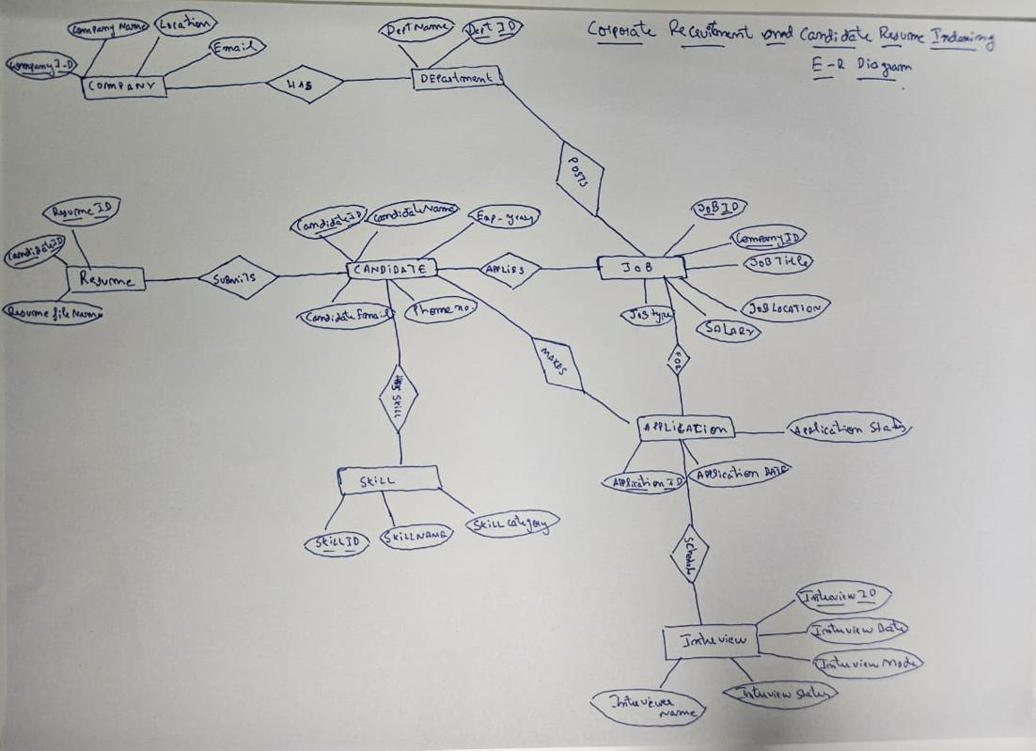
Figure 1: Initial hand-drawn ER diagram (design draft)

3.2 Changes made during implementation
While implementing the database, the design was refined. The table below lists every difference between the initial draft and the final, executed schema; the updated ER diagram in Section 3.3 reflects all of them.
Table 5: Changes from the initial ER design
Initial draft | Final implementation | Reason
Recruiter entity | Replaced by the Users entity (Role = Recruiter, linked to Company) | One authentication table serves all roles (RBAC)
Candidate_Phone, Education, Experience entities | Phone, Qualification and Experience_Years as Candidate attributes | Simpler 3NF design; matches the executed DDL
Job_Posting (Dept_ID, Recruiter_ID) | Job with Company_ID, optional Dept_ID, Posted_Date and Status | Open/closed lifecycle; company- level ownership
Skill relates to Candidate only | New Job_Skill (M:N between Job and Skill) | Enables the skill-match function
No authentication entity | New Users entity | Login with hashed passwords and roles
No history of status changes | New Application_Status_Log (filled by trigger) | Audit trail for every application
Interview (as drawn) | Interview with Interviewer_Name, Interview_Date, Mode, Status and Feedback | Matches the drawn ER; adds integrity constraints

3.3 Updated ER diagram
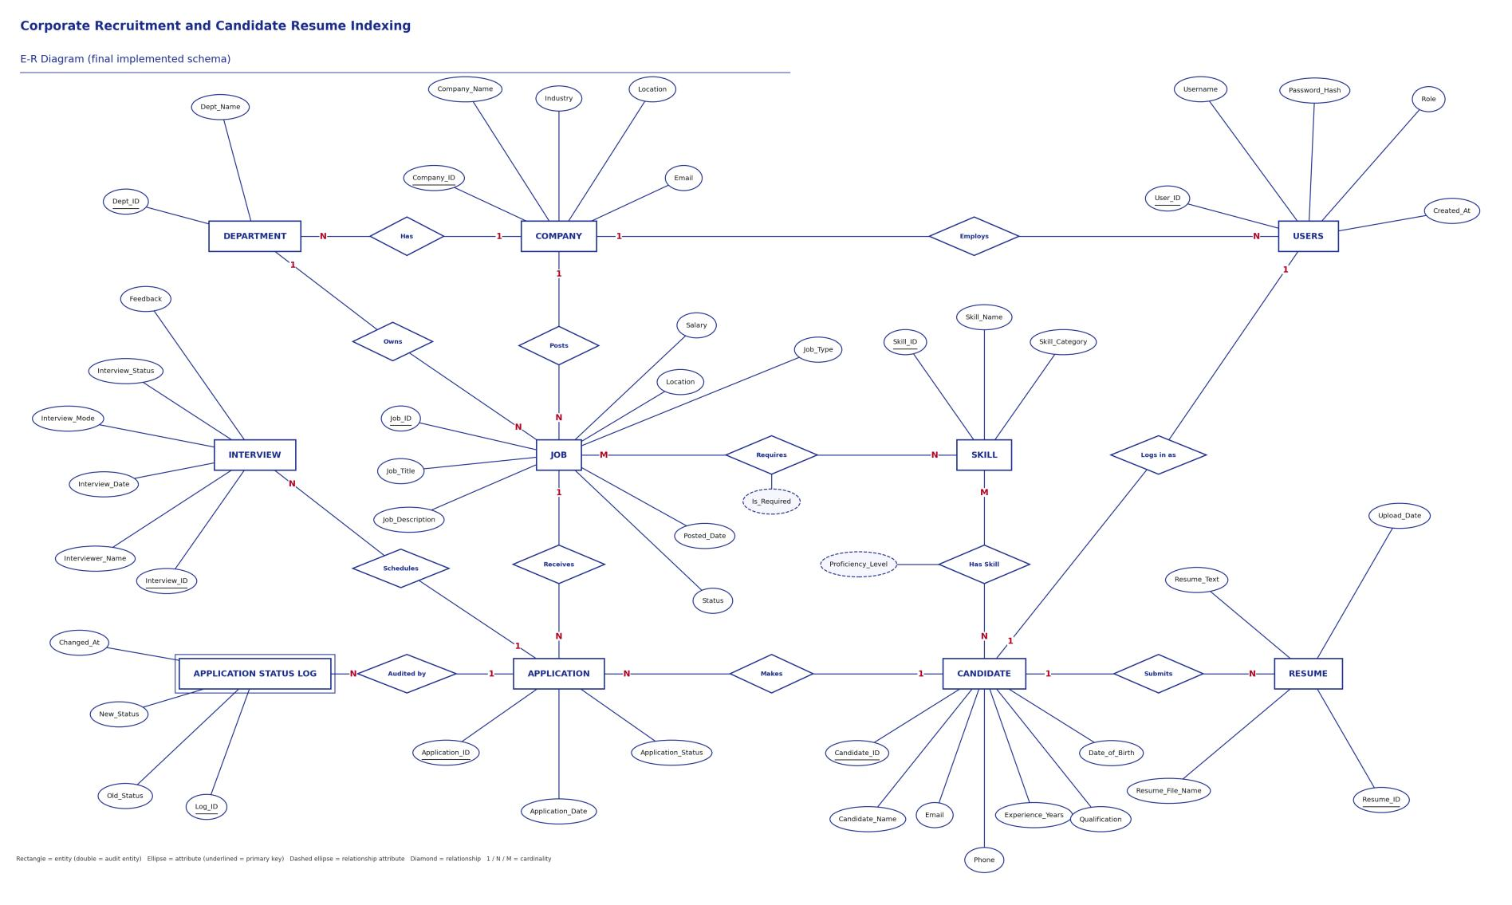
Figure 2: Updated ER diagram of the implemented database (10 entities, 12 relationships)

4. ER TO RELATIONAL MAPPING

4.1 Steps of algorithm for the chosen problem
1. Map each strong entity to a relation. Company, Department, Job, Candidate, Resume, Skill, Application, Interview, Users and Application_Status_Log each receive a primary key.
2. Map one-to-many relationships by placing the referenced key on the many side. Examples include Department.Company_ID, Job.Company_ID, Resume.Candidate_ID and Interview.Application_ID.
3. Resolve many-to-many relationships with junction relations. Candidate_Skill uses the composite key (Candidate_ID, Skill_ID), and Job_Skill uses (Job_ID, Skill_ID). Their relationship attributes are Proficiency_Level and Is_Required respectively.
4. Represent job applications with Application, which links Candidate and Job. The unique constraint (Candidate_ID, Job_ID) prevents duplicate applications while Application_ID supports interview and audit-log references.
5. Represent role-specific user links with nullable Candidate_ID and Company_ID references in Users. Candidate_ID is unique for candidate-linked accounts.
6. Apply domain and integrity constraints using NOT NULL, UNIQUE, DEFAULT, CHECK and foreign keys. Choose CASCADE, RESTRICT or SET NULL according to whether dependent information should be removed, protected or retained.
7. Separate multivalued skills, resumes and interviews into their own relations. Store shared company and skill details once to avoid update anomalies.

4.2 Complete diagram of relational mapping
The ER diagram was converted to the relational schema below. Many-to-many relationships (Job– Skill, Candidate–Skill) are resolved into junction tables with composite primary keys. Primary keys are bold and underlined, foreign keys are in italics, and arrows point from a foreign key to the table it references.
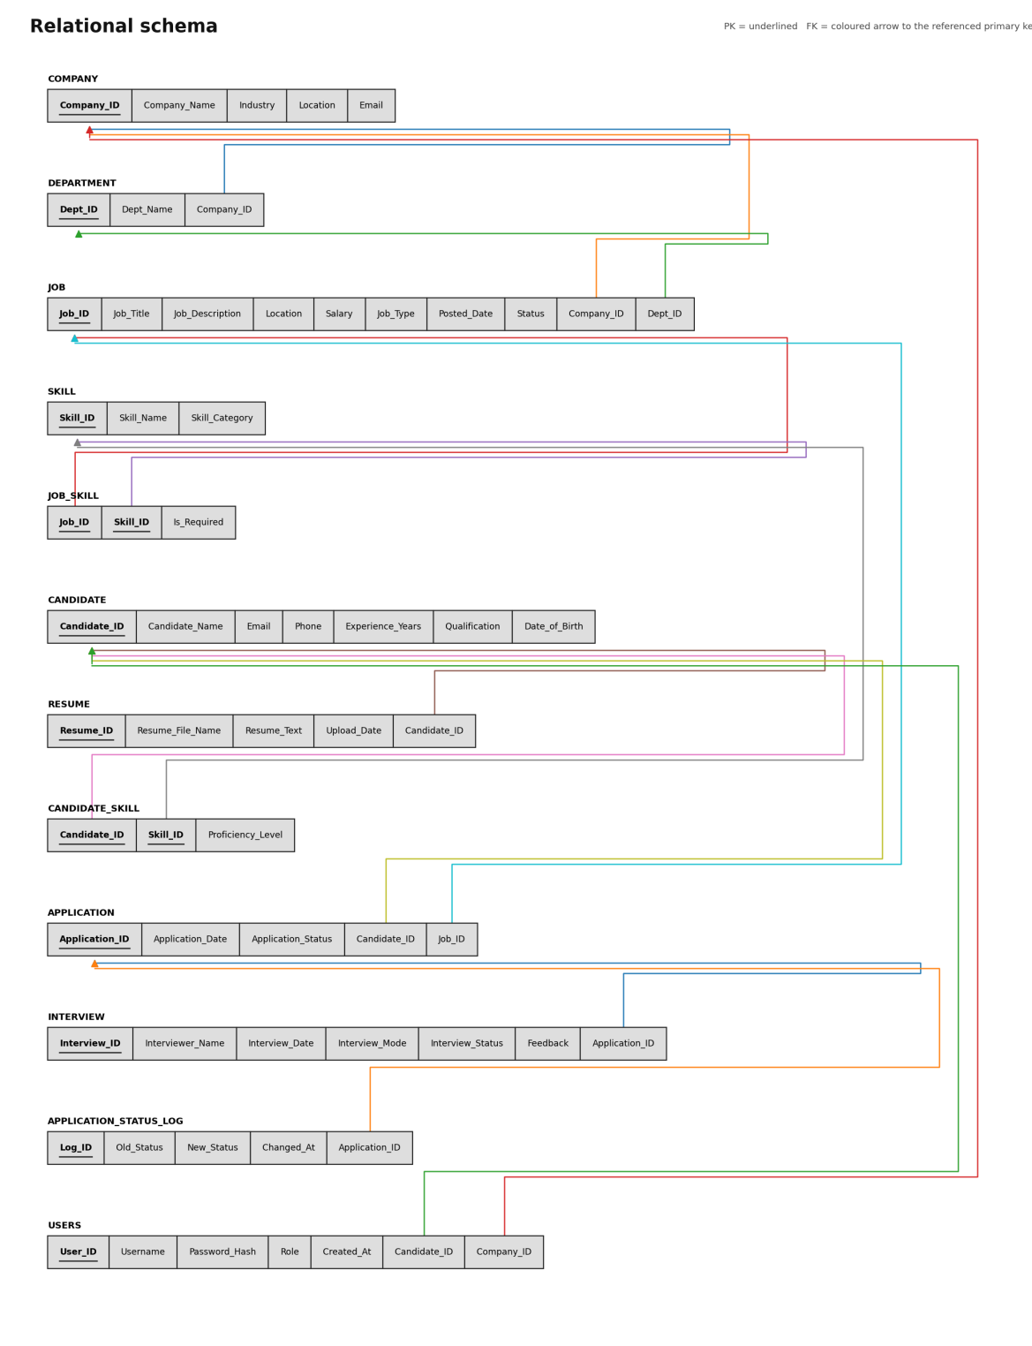
Figure 3: Relational schema with primary keys, foreign keys and references

4.3 Relational schema and referential actions

Schema in relational notation
Company(Company_ID PK, Company_Name, Industry, Location, Email UQ)
Department(Dept_ID PK, Company_ID FK, Dept_Name)
UQ(Company_ID, Dept_Name)
Job(Job_ID PK, Company_ID FK, Dept_ID FK null, Job_Title, Job_Description, Location,
Salary, Job_Type, Posted_Date, Status)
Skill(Skill_ID PK, Skill_Name UQ, Skill_Category)
Job_Skill(Job_ID FK, Skill_ID FK, Is_Required)
PK(Job_ID, Skill_ID)
Candidate(Candidate_ID PK, Candidate_Name, Email UQ, Phone UQ, Experience_Years,
Qualification, Date_of_Birth)
Candidate_Skill(Candidate_ID FK, Skill_ID FK, Proficiency_Level)
PK(Candidate_ID, Skill_ID)
Resume(Resume_ID PK, Candidate_ID FK, Resume_File_Name, Resume_Text, Upload_Date)
Application(Application_ID PK, Candidate_ID FK, Job_ID FK, Application_Date,
Application_Status)
UQ(Candidate_ID, Job_ID)
Interview(Interview_ID PK, Application_ID FK, Interviewer_Name, Interview_Date,
Interview_Mode, Interview_Status, Feedback)
Application_Status_Log(Log_ID PK, Application_ID FK, Old_Status, New_Status,
Changed_At)
Users(User_ID PK, Username UQ, Password_Hash, Role,
Candidate_ID FK null, Company_ID FK null, Created_At)

Referential actions
Table 6: Referential actions
Foreign key | ON DELETE | Reasoning
Job.Company_ID → Company | RESTRICT | A company with jobs cannot be deleted
Job.Dept_ID → Department | SET NULL | Removing a department keeps its jobs
Department.Company_ID → Company | CASCADE | Departments belong to a company
Resume.Candidate_ID → Candidate | CASCADE | Resumes have no meaning without the candidate
Candidate_Skill → Candidate / Skill | CASCADE | Junction rows removed with either parent
Job_Skill → Job / Skill | CASCADE | Junction rows removed with either parent
Application → Candidate / Job | RESTRICT | Hiring history must never be lost silently
Interview.Application_ID → Application | CASCADE | Interviews belong to an application
Users.Candidate_ID → Candidate | CASCADE | Login removed with the candidate
Users.Company_ID → Company | SET NULL | Recruiter account survives company removal

Normalisation
All tables are in third normal form (and BCNF): every non-key attribute depends on the key, the whole key and nothing but the key. Company data is stored once and referenced from Job; skill names are stored once in Skill and referenced from Candidate_Skill and Job_Skill; multi-valued facts (skills, resumes, interviews) live in their own tables.

4.4 Data dictionary
Constraint names in brackets are the names used in the DDL and shown in the error messages of Appendix B.

Company
Table 7: Company data dictionary
Column | Data type | Constraints | Description
Company_ID | INT | PK, AUTO_INCREMENT | Unique company identifier
Company_Name | VARCHAR(100) | NOT NULL | Registered name
Industry | VARCHAR(50) |  | Industry sector
Location | VARCHAR(100) |  | Head-office city
Email | VARCHAR(100) | UNIQUE | HR contact email

Department
Table 8: Department data dictionary
Column | Data type | Constraints | Description
Dept_ID | INT | PK, AUTO_INCREMENT | Department identifier
Company_ID | INT | NOT NULL, FK → Company, CASCADE | Owning company
Dept_Name | VARCHAR(80) | NOT NULL, UNIQUE(Company_ID, Dept_Name) | Department name

Job
Table 9: Job data dictionary
Column | Data type | Constraints | Description
Job_ID | INT | PK, AUTO_INCREMENT | Job identifier
Company_ID | INT | NOT NULL, FK → Company | Hiring company
Dept_ID | INT | FK → Department, SET NULL | Optional department
Job_Title | VARCHAR(100) | NOT NULL | Title of the opening
Job_Description | TEXT | FULLTEXT (ft_job) | Duties; embedded into Qdrant
Location | VARCHAR(100) | Index idx_job_status_location | Work location
Salary | DECIMAL(10,2) | CHECK ≥ 0 (CHK_Salary) | Annual salary
Job_Type | VARCHAR(30) | CHECK IN Full-time, Part-time, Contract, Internship (CHK_Job_Type) | Employment type
Posted_Date | DATE | NOT NULL, DEFAULT CURRENT_DATE | Posting date
Status | VARCHAR(10) | NOT NULL, DEFAULT Open, CHECK IN Open, Closed (CHK_Job_Status) | Opening lifecycle state

Skill and Job_Skill
Table 10: Skill and Job_Skill data dictionary
Column | Data type | Constraints | Description
Skill.Skill_ID | INT | PK, AUTO_INCREMENT | Skill identifier
Skill.Skill_Name | VARCHAR(50) | NOT NULL, UNIQUE | Skill name, stored once
Skill.Skill_Category | VARCHAR(50) |  | Programming, Database, AI, …
Job_Skill.Job_ID | INT | PK, FK → Job, CASCADE | Job requiring the skill
Job_Skill.Skill_ID | INT | PK, FK → Skill, CASCADE | Required skill
Job_Skill.Is_Required | BOOLEAN | NOT NULL, DEFAULT TRUE | Mandatory or preferred

Candidate
Table 11: Candidate data dictionary
Column | Data type | Constraints | Description
Candidate_ID | INT | PK, AUTO_INCREMENT | Candidate identifier
Candidate_Name | VARCHAR(100) | NOT NULL | Full name
Email | VARCHAR(100) | NOT NULL, UNIQUE | Contact email
Phone | VARCHAR(15) | UNIQUE, CHECK length ≥ 10 (CHK_Phone) | Contact number
Experience_Years | DECIMAL(4,1) | DEFAULT 0, CHECK ≥ 0 (CHK_Experience) | Total experience
Qualification | VARCHAR(100) |  | Highest qualification
Date_of_Birth | DATE | Added with ALTER TABLE | Date of birth

Resume and Candidate_Skill
Table 12: Resume and Candidate_Skill data dictionary
Column | Data type | Constraints | Description
Resume.Resume_ID | INT | PK, AUTO_INCREMENT | Resume identifier
Resume.Candidate_ID | INT | NOT NULL, FK → Candidate, CASCADE | Owner
Resume.Resume_File_Name | VARCHAR(150) | NOT NULL | Uploaded file name
Resume.Resume_Text | TEXT | FULLTEXT (ft_resume) | Extracted text; embedded into Qdrant
Resume.Upload_Date | DATE | NOT NULL | Upload date
Candidate_Skill.Candidate_ID | INT | PK, FK → Candidate, CASCADE | Candidate
Candidate_Skill.Skill_ID | INT | PK, FK → Skill, CASCADE | Skill known
Candidate_Skill.Proficiency_Level | VARCHAR(30) | CHECK IN Beginner, Intermediate, Advanced, Expert | Skill level

Application
Table 13: Application data dictionary
Column | Data type | Constraints | Description
Application_ID | INT | PK, AUTO_INCREMENT | Application identifier
Candidate_ID | INT | NOT NULL, FK → Candidate | Applicant
Job_ID | INT | NOT NULL, FK → Job, UNIQUE(Candidate_ID, Job_ID) | Applied job; one application per job
Application_Date | DATE | NOT NULL | Date applied
Application_Status | VARCHAR(30) | DEFAULT Applied, CHECK IN Applied, Shortlisted, Interview Scheduled, Rejected, Hired (CHK_App_Status) | Pipeline state

Interview
Table 14: Interview data dictionary
Column | Data type | Constraints | Description
Interview_ID | INT | PK, AUTO_INCREMENT | Interview identifier
Application_ID | INT | NOT NULL, FK → Application, CASCADE | Related application
Interviewer_Name | VARCHAR(100) | NOT NULL | Panel member
Interview_Date | DATETIME | NOT NULL, index idx_interview_date | Scheduled time
Interview_Mode | VARCHAR(10) | CHECK IN Online, Onsite, Phone | Mode
Interview_Status | VARCHAR(10) | CHECK IN Scheduled, Completed, Cancelled | State
Feedback | TEXT |  | Feedback after the interview

Users and Application_Status_Log
Table 15: Users and Application_Status_Log data dictionary
Column | Data type | Constraints | Description
Users.User_ID | INT | PK, AUTO_INCREMENT | Account identifier
Users.Username | VARCHAR(50) | NOT NULL, UNIQUE | Login name
Users.Password_Hash | VARCHAR(100) | NOT NULL | bcrypt hash, never plain text
Users.Role | VARCHAR(15) | CHECK IN Admin, Recruiter, Candidate | Access role
Users.Candidate_ID | INT | FK → Candidate, UNIQUE, CASCADE | Set for the Candidate role
Users.Company_ID | INT | FK → Company, SET NULL | Set for the Recruiter role
Log.Log_ID | INT | PK, AUTO_INCREMENT | Log entry
Log.Application_ID | INT | NOT NULL, FK → Application, CASCADE | Audited application
Log.Old_Status / New_Status | VARCHAR(30) | New_Status NOT NULL | Status before and after (written by trigger)
Log.Changed_At | TIMESTAMP | DEFAULT CURRENT_TIMESTAMP | When the change happened

5. DDL STATEMENTS
The database was built in stages using MySQL Workbench. Each script was executed against the CorporateRecruitmentDB database and the output captured below.
Table 16: Database implementation scripts
Script | Purpose | Demonstrates
01 | Base DDL: 7 tables, ALTER and DROP demonstrations | CREATE, ALTER, DROP, PK/FK, constraints
02 | Schema extensions and indexes | ALTER, new tables, CHECK constraints, indexes, FULLTEXT
03 | Views | Views over joins and aggregates
04 | Function, procedures, triggers | Functions, stored procedures, transactions, triggers
05 | Seed data | INSERT, UPDATE
06 | Important queries | SELECT, JOIN, GROUP BY, HAVING, subqueries, DML
07 | Test cases | Constraint and trigger validation

5.1 Base DDL
The seven base tables (Company, Candidate, Job, Resume, Skill, Candidate_Skill, Application) were created first, with primary keys, foreign keys, UNIQUE, NOT NULL, DEFAULT and CHECK constraints (screenshots are part of the separate DDL submission). The ALTER and DROP statements of this script:
ALTER TABLE Candidate ADD Date_of_Birth DATE;
ALTER TABLE Candidate
ADD CONSTRAINT CHK_Phone CHECK (Phone IS NULL OR CHAR_LENGTH(Phone) >= 10);
CREATE TABLE Temporary_Data (Temp_ID INT, Temp_Name VARCHAR(50));
DROP TABLE Temporary_Data;

5.2 Schema extensions and indexes
The schema was extended with ALTER TABLE and CREATE TABLE statements so that it matches the final design: Department, Job_Skill, Interview, Users and Application_Status_Log were created; Job received Dept_ID, Posted_Date and Status; CHECK constraints were added to Job, Application and Candidate_Skill.
ALTER TABLE Job
ADD COLUMN Dept_ID INT NULL,
ADD COLUMN Posted_Date DATE NOT NULL DEFAULT (CURRENT_DATE),
ADD COLUMN Status VARCHAR(10) NOT NULL DEFAULT 'Open',
ADD CONSTRAINT FK_Job_Dept FOREIGN KEY (Dept_ID)
REFERENCES Department(Dept_ID) ON DELETE SET NULL,
ADD CONSTRAINT CHK_Job_Status CHECK (Status IN ('Open','Closed')),
ADD CONSTRAINT CHK_Job_Type CHECK (Job_Type IS NULL OR
Job_Type IN ('Full-time','Part-time','Contract','Internship'));
CREATE INDEX idx_job_status_location ON Job(Status, Location);
CREATE INDEX idx_app_job_status ON Application(Job_ID, Application_Status);
CREATE INDEX idx_candidate_exp ON Candidate(Experience_Years);
CREATE INDEX idx_resume_cand_date ON Resume(Candidate_ID, Upload_Date);
CREATE INDEX idx_interview_date ON Interview(Interview_Date);
CREATE FULLTEXT INDEX ft_job ON Job(Job_Title, Job_Description);
CREATE FULLTEXT INDEX ft_resume ON Resume(Resume_Text);
CREATE INDEX idx_tmp ON Company(Industry); DROP INDEX idx_tmp ON Company;

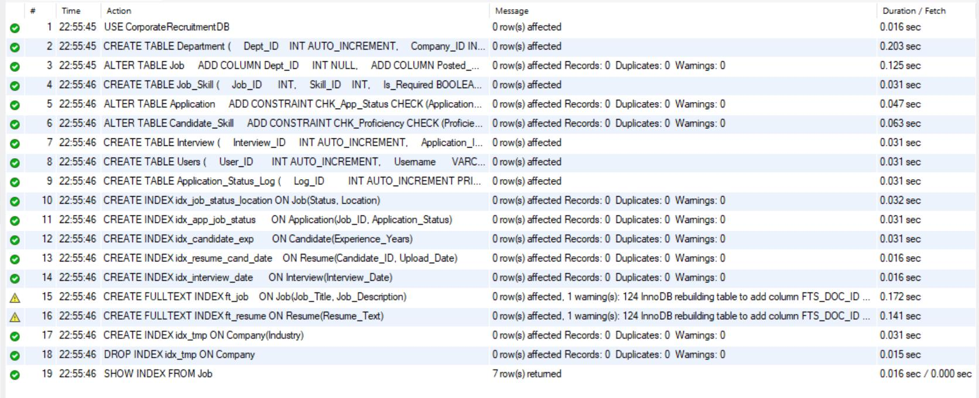
Figure 4: Action output of script 02: all 19 statements executed (the two warnings are InnoDB adding the hidden FTS_DOC_ID column for the first FULLTEXT index)
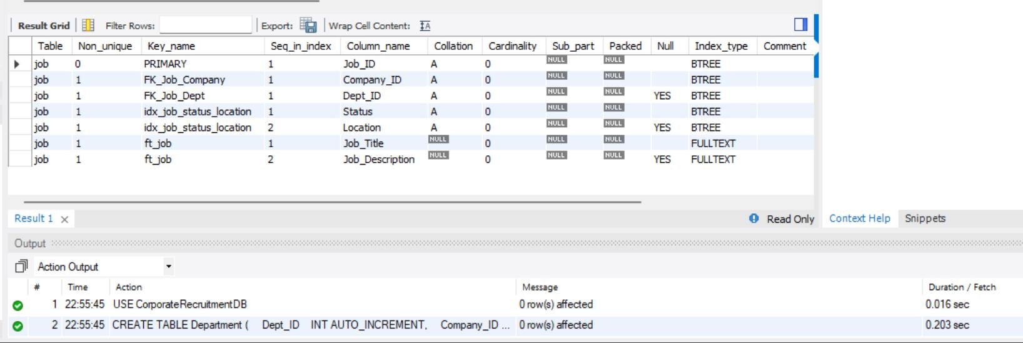
Figure 5: SHOW INDEX FROM Job: primary key, foreign keys, composite index and FULLTEXT index ft_job
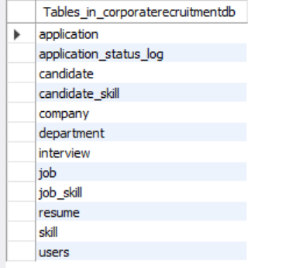
Figure 6: SHOW TABLES: the 12 tables of the final schema

5.3 Views
Three views encapsulate frequently used joins and aggregates. They are used directly by the application (dashboard, candidate search and interview schedule).
Table 17: Database views
View | Content
vw_job_summary | Job with company, department, number of applications and number of hires (JOIN, LEFT JOIN, GROUP BY, COUNT, SUM)
vw_candidate_profile | Candidate with all skills concatenated using GROUP_CONCAT and the number of applications (correlated subquery)
vw_interview_schedule | Interview joined with application, candidate, job and company

CREATE OR REPLACE VIEW vw_job_summary AS
SELECT j.Job_ID, j.Job_Title, c.Company_ID, c.Company_Name, d.Dept_Name,
j.Location, j.Salary, j.Status,
COUNT(a.Application_ID) AS Total_Applications,
COALESCE(SUM(a.Application_Status='Hired'),0) AS Hired_Count
FROM Job j
JOIN Company c ON c.Company_ID = j.Company_ID
LEFT JOIN Department d ON d.Dept_ID = j.Dept_ID
LEFT JOIN Application a ON a.Job_ID = j.Job_ID
GROUP BY j.Job_ID, j.Job_Title, c.Company_ID, c.Company_Name, d.Dept_Name,
j.Location, j.Salary, j.Status;

Figure 7: Views created successfully
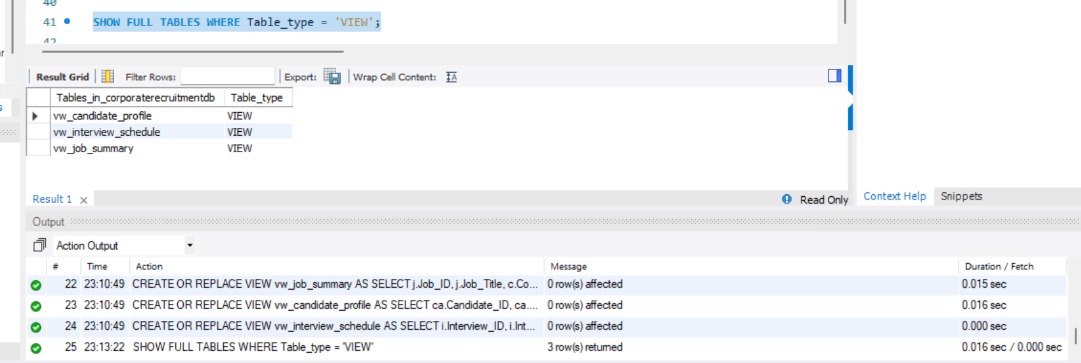
Figure 8: SHOW FULL TABLES WHERE Table_type = VIEW: the three views

6. DML STATEMENTS

6.1 Seed data and inserted values
Sample data was loaded with INSERT statements: 4 companies, 5 departments, 10 skills, 6 candidates, 7 resumes, 6 jobs with required skills, 18 candidate-skill rows, 8 applications and 2 interviews. UPDATE statements then shortlisted and rejected applications. Because the triggers fire during seeding, the audit log is populated automatically.
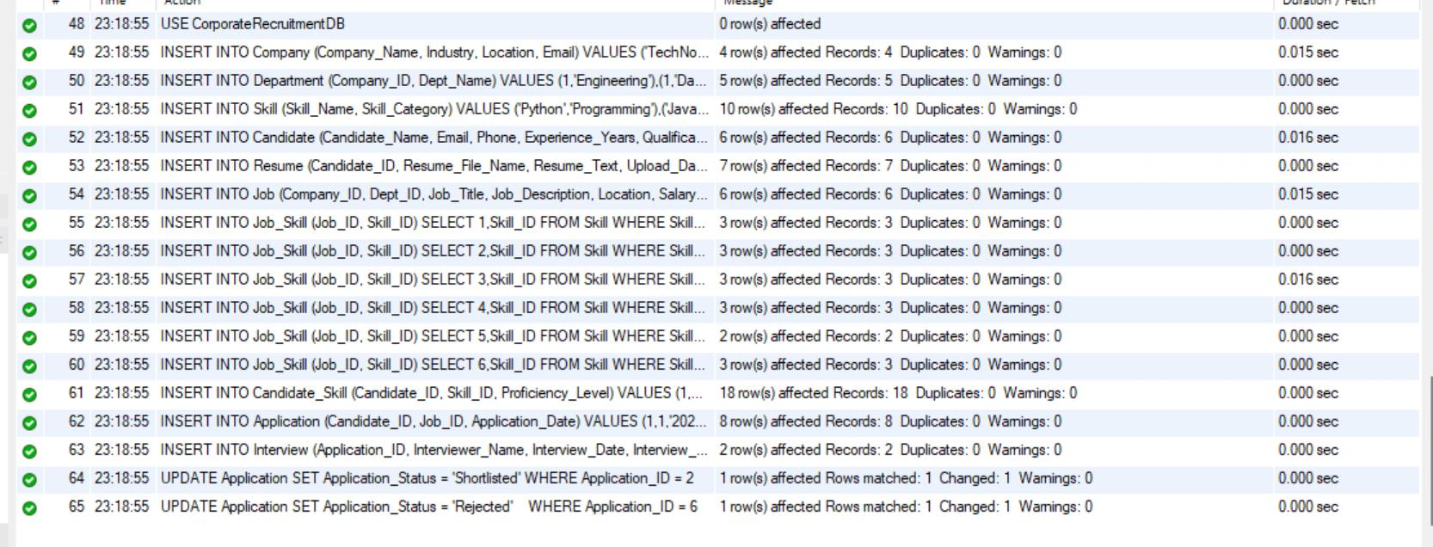
Figure 9: Seed script output: all INSERT and UPDATE statements succeeded
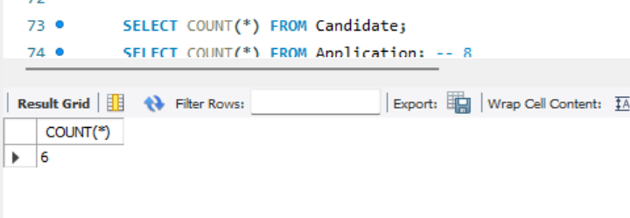
Figure 10: Row count check: 6 candidates
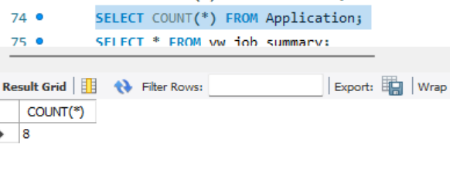
Figure 11: Row count check: 8 applications
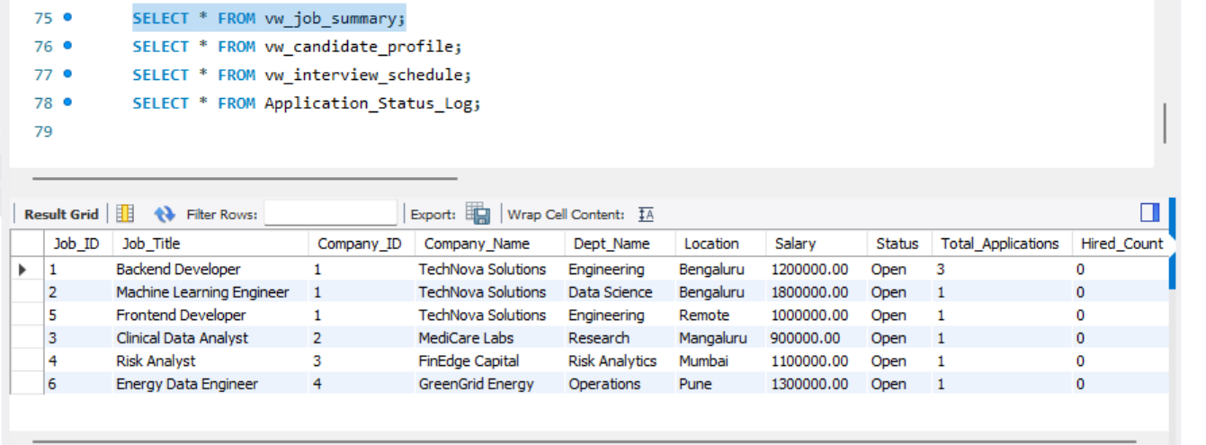
Figure 12: vw_job_summary with seeded data
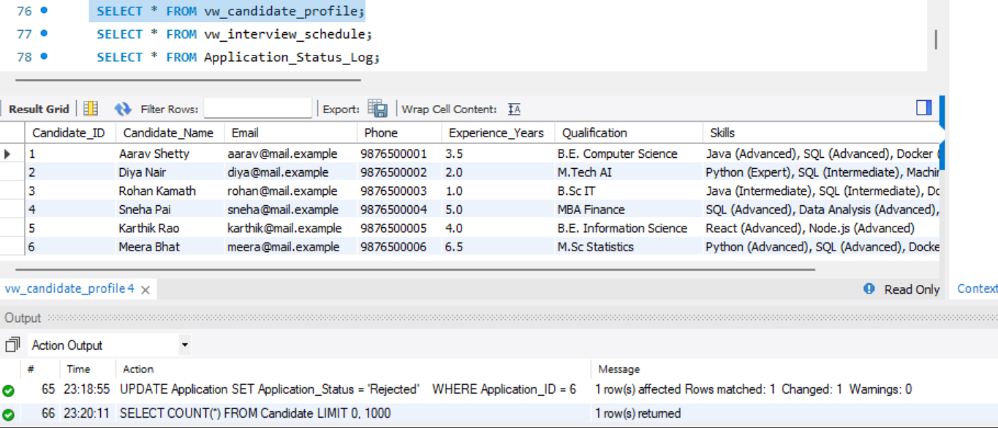
Figure 13: vw_candidate_profile: skills concatenated per candidate
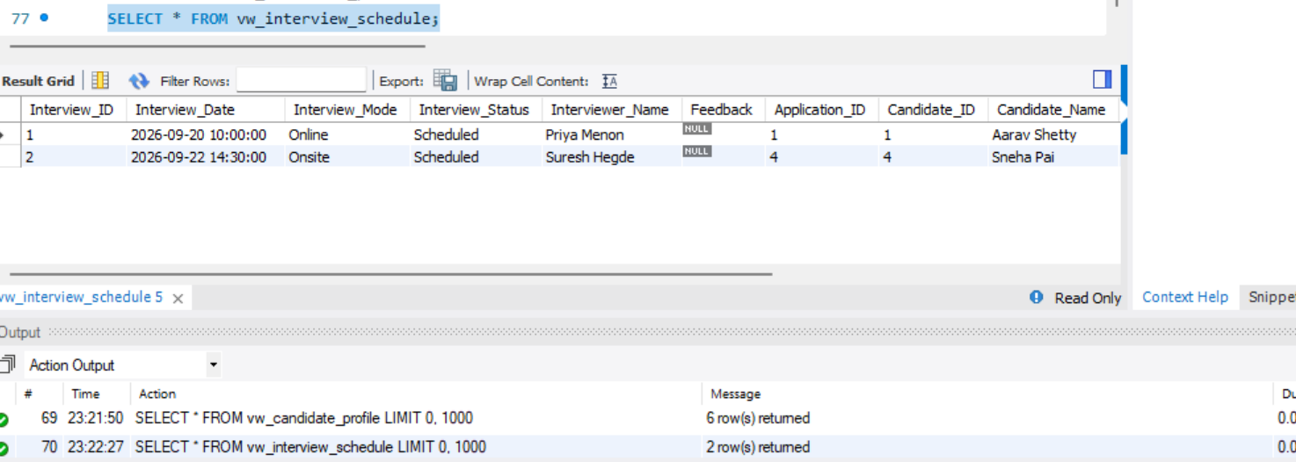
Figure 14: vw_interview_schedule
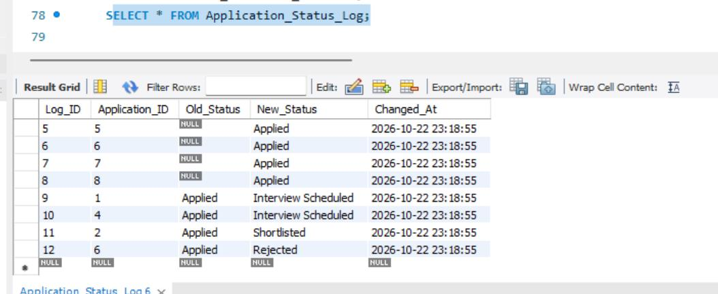
Figure 15: Application_Status_Log filled by triggers during seeding

6.2 Insert update and delete in a transaction
Demonstrates DML and rollback; the seed data is left untouched.
START TRANSACTION;
INSERT INTO Skill (Skill_Name, Skill_Category) VALUES ('Kubernetes','DevOps');
UPDATE Candidate SET Experience_Years = Experience_Years + 1 WHERE Candidate_ID = 3;
DELETE FROM Skill WHERE Skill_Name = 'Kubernetes';
ROLLBACK;

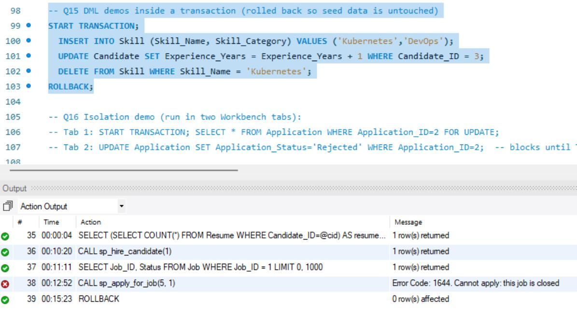
Figure 16: Q15 output: all statements ran, then ROLLBACK

7. QUERIES
The following queries (script 06) were executed on the seeded database. They cover joins, grouping, aggregation, subqueries, set-based division, full-text search, views, stored routines and DML inside a transaction.

7.1 Simple queries with group by and aggregates

Q1: Four-table JOIN
Lists every application with candidate, job and company.
SELECT a.Application_ID, ca.Candidate_Name, j.Job_Title, c.Company_Name,
a.Application_Status
FROM Application a
JOIN Candidate ca ON ca.Candidate_ID = a.Candidate_ID
JOIN Job j ON j.Job_ID = a.Job_ID
JOIN Company c ON c.Company_ID = j.Company_ID
ORDER BY a.Application_Date DESC;

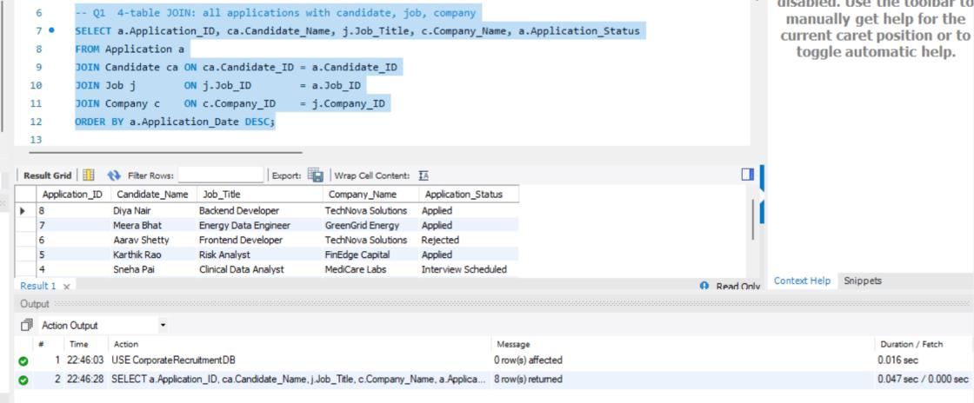
Figure 17: Q1 result

Q2: GROUP BY with HAVING
Jobs that received two or more applications.
SELECT j.Job_Title, COUNT(*) AS applicants
FROM Application a JOIN Job j ON j.Job_ID = a.Job_ID
GROUP BY j.Job_ID, j.Job_Title
HAVING COUNT(*) >= 2
ORDER BY applicants DESC;

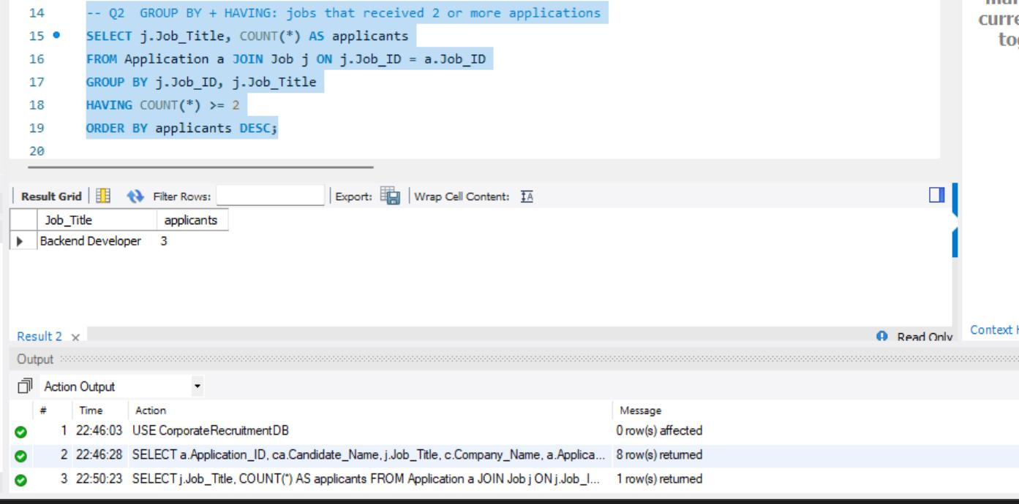
Figure 18: Q2 result

Q3: Aggregate functions
Number of openings, average and maximum salary per industry.
SELECT c.Industry, COUNT(*) AS openings, ROUND(AVG(j.Salary),0) AS avg_salary,
MAX(j.Salary) AS max_salary
FROM Job j JOIN Company c ON c.Company_ID = j.Company_ID
GROUP BY c.Industry ORDER BY avg_salary DESC;

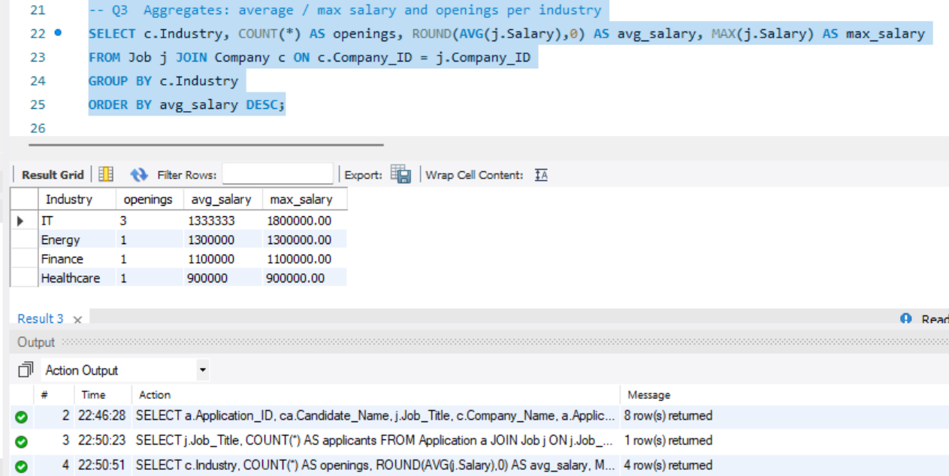
Figure 19: Q3 result

Q9: Skill demand
Most frequently required skills across all jobs.
SELECT s.Skill_Name, COUNT(*) AS jobs_requiring
FROM Job_Skill js JOIN Skill s ON s.Skill_ID = js.Skill_ID
GROUP BY s.Skill_ID, s.Skill_Name ORDER BY jobs_requiring DESC, s.Skill_Name;

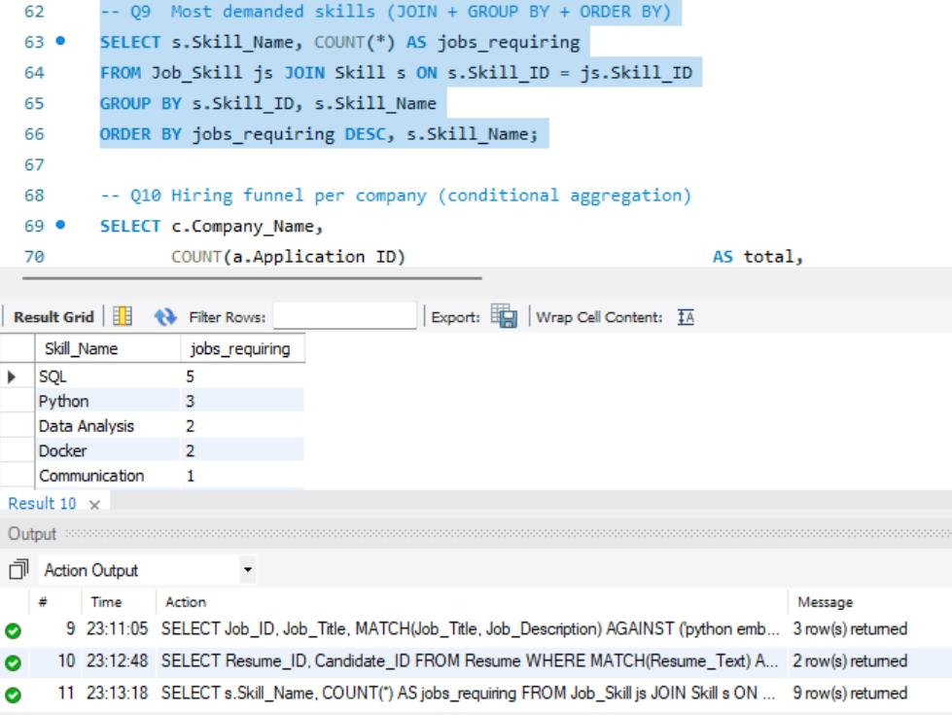
Figure 20: Q9 result

Q10: Hiring funnel with conditional aggregation
Applications, interviews, hires and hire rate per company.
SELECT c.Company_Name, COUNT(a.Application_ID) AS total,
SUM(a.Application_Status = 'Interview Scheduled') AS interviewing,
SUM(a.Application_Status = 'Hired') AS hired,
ROUND(100*SUM(a.Application_Status='Hired')/NULLIF(COUNT(a.Application_ID),0),1) AS
hire_rate_pct
FROM Company c
LEFT JOIN Job j ON j.Company_ID = c.Company_ID
LEFT JOIN Application a ON a.Job_ID = j.Job_ID
GROUP BY c.Company_ID, c.Company_Name;

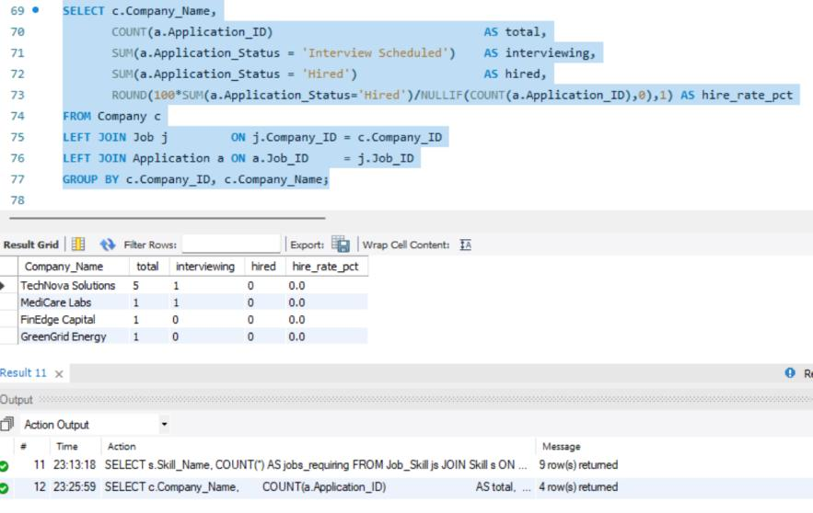
Figure 21: Q10 result

Q11: LEFT JOIN anti-join
Candidates who have never applied.
SELECT ca.Candidate_Name
FROM Candidate ca LEFT JOIN Application a ON a.Candidate_ID = ca.Candidate_ID
WHERE a.Application_ID IS NULL;

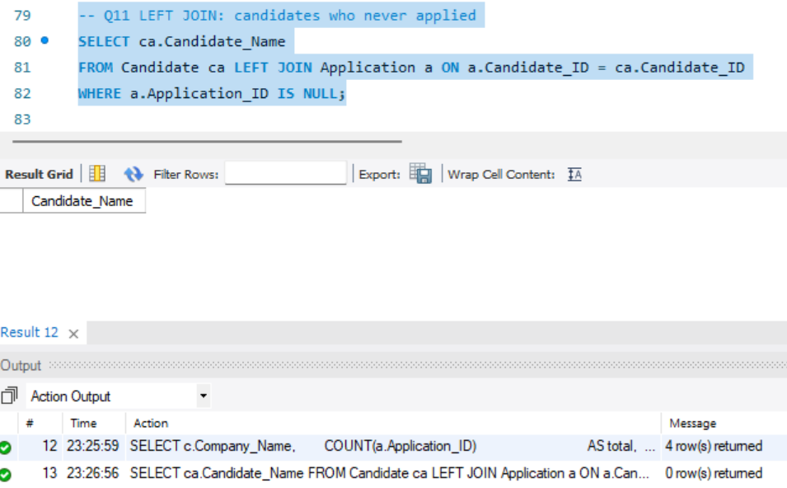
Figure 22: Q11 result

Q12: Querying the views
Views used like ordinary tables.
SELECT * FROM vw_job_summary ORDER BY Total_Applications DESC;
SELECT * FROM vw_candidate_profile WHERE Skills LIKE '%SQL%';
SELECT * FROM vw_interview_schedule;

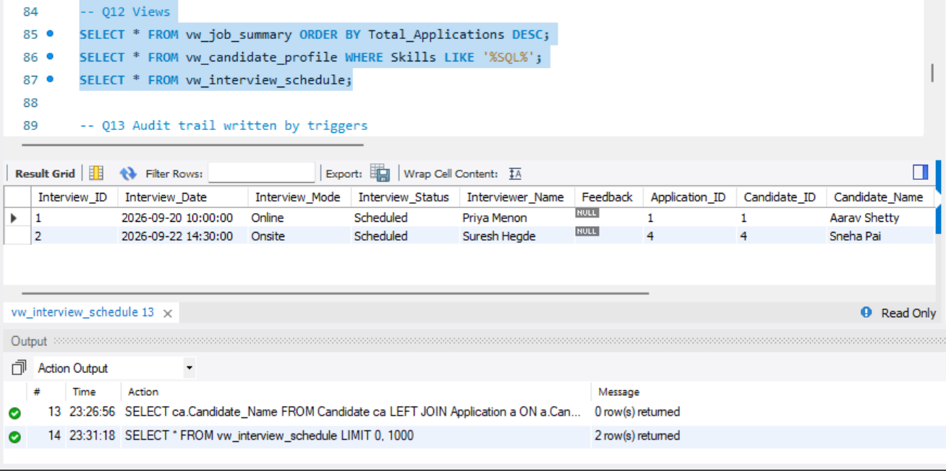
Figure 23: Q12 result

7.2 Update operation
The following UPDATE increases the experience of Candidate 3. It is executed inside the transaction in Section 6.2 and is rolled back with the other demonstration statements.
UPDATE Candidate
SET Experience_Years = Experience_Years + 1
WHERE Candidate_ID = 3;

7.3 Delete operation
The following DELETE removes the temporary Kubernetes skill inserted within the same transaction. ROLLBACK restores the original database state. The execution output is included in Section 6.2.
DELETE FROM Skill WHERE Skill_Name = 'Kubernetes';

7.4 Correlated query

Q5: Correlated subquery with NOT EXISTS
Jobs that nobody has applied to.
SELECT j.Job_ID, j.Job_Title FROM Job j
WHERE NOT EXISTS (SELECT 1 FROM Application a WHERE a.Job_ID = j.Job_ID);

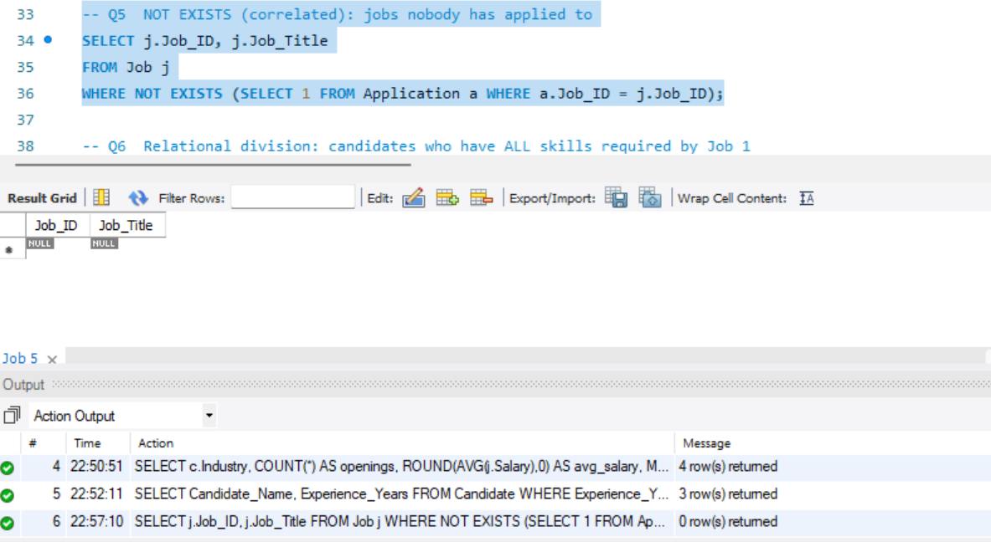
Figure 24: Q5 result

7.5 Nested query

Q4: Scalar subquery
Candidates whose experience is above the overall average.
SELECT Candidate_Name, Experience_Years FROM Candidate
WHERE Experience_Years > (SELECT AVG(Experience_Years) FROM Candidate)
ORDER BY Experience_Years DESC;

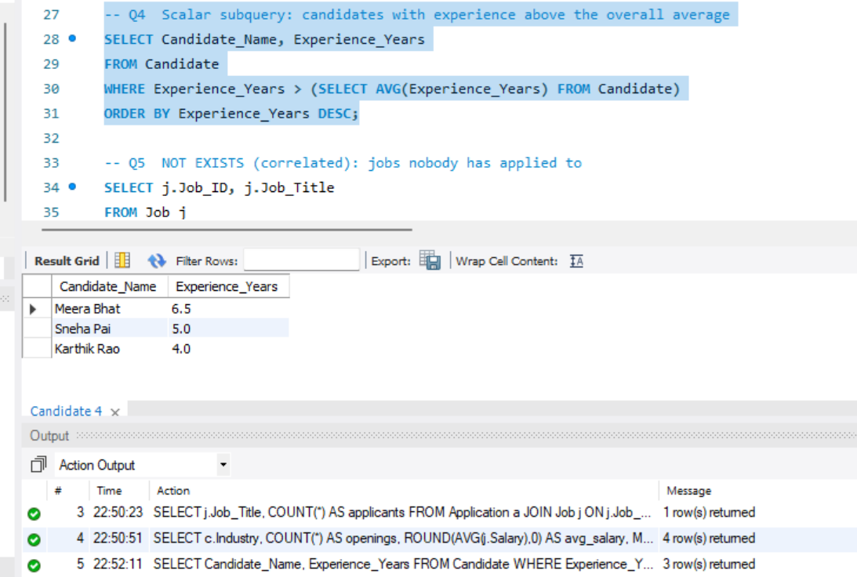
Figure 25: Q4 result

Q6: Relational division
Candidates who possess all skills required by Job 1.
SELECT ca.Candidate_Name
FROM Candidate ca
JOIN Candidate_Skill cs ON cs.Candidate_ID = ca.Candidate_ID
JOIN Job_Skill js ON js.Skill_ID = cs.Skill_ID AND js.Job_ID = 1
GROUP BY ca.Candidate_ID, ca.Candidate_Name
HAVING COUNT(*) = (SELECT COUNT(*) FROM Job_Skill WHERE Job_ID = 1);

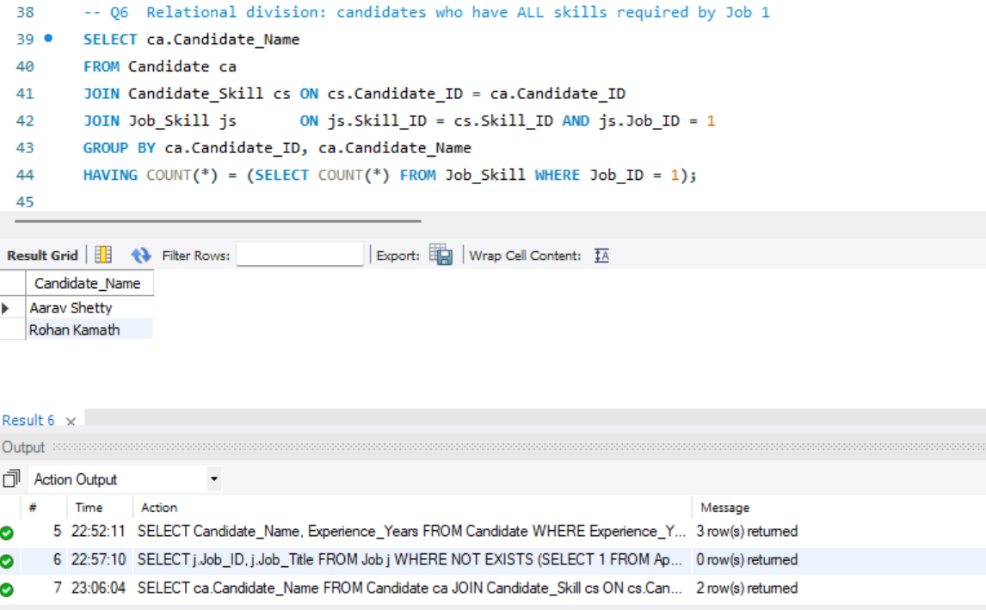
Figure 26: Q6 result

7.6 Stored function in a query
Ranks candidates for Job 2 by skill-match percentage.
SELECT ca.Candidate_Name, fn_match_percentage(ca.Candidate_ID, 2) AS match_pct
FROM Candidate ca
ORDER BY match_pct DESC, ca.Experience_Years DESC LIMIT 5;

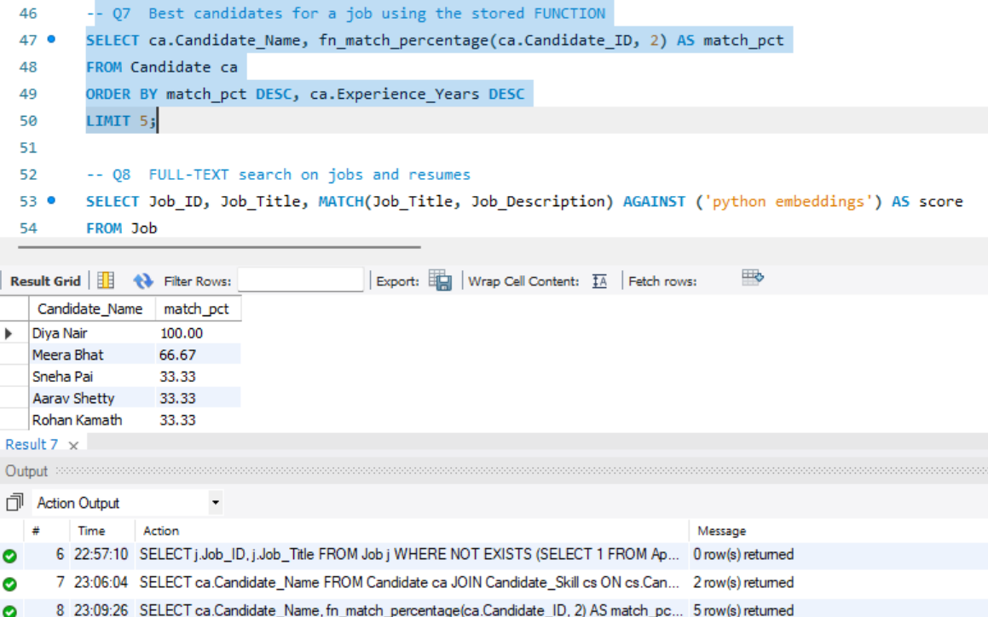
Figure 27: Q7 result

7.7 Full text search
Natural-language search on jobs and boolean-mode search on resumes.
SELECT Job_ID, Job_Title, MATCH(Job_Title, Job_Description) AGAINST ('python
embeddings') AS score
FROM Job
WHERE MATCH(Job_Title, Job_Description) AGAINST ('python embeddings' IN NATURAL
LANGUAGE MODE)
ORDER BY score DESC;
SELECT Resume_ID, Candidate_ID FROM Resume
WHERE MATCH(Resume_Text) AGAINST ('+Docker +SQL' IN BOOLEAN MODE);

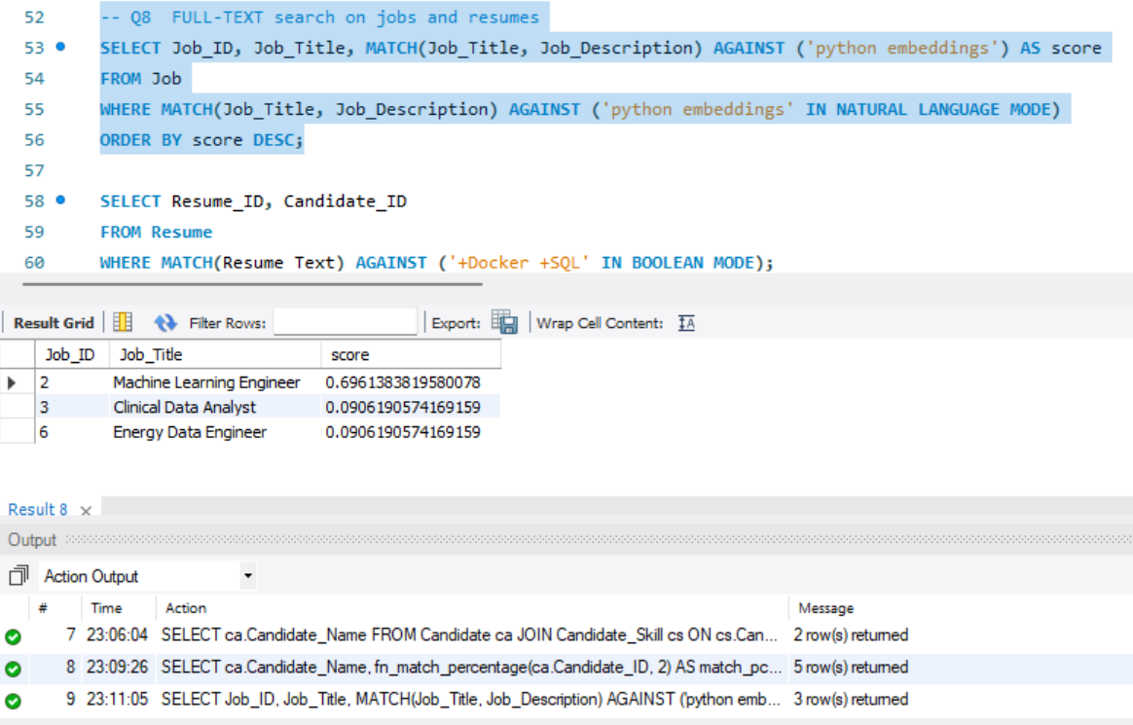
Figure 28: Q8 result: job search
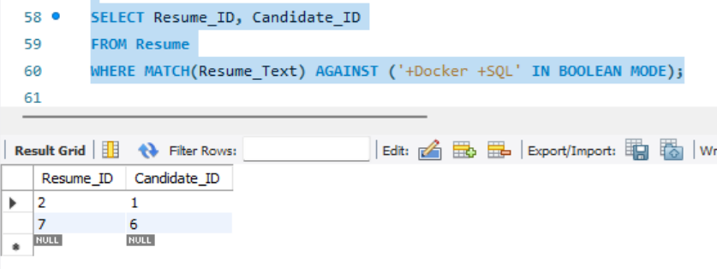
Figure 29: Q8 result: resume search

7.8 Audit trail query
Every status change is recorded without any application code.
SELECT * FROM Application_Status_Log ORDER BY Log_ID DESC LIMIT 10;

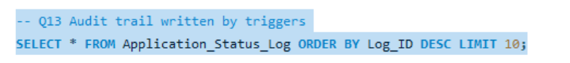
Figure 30: Q13 statement
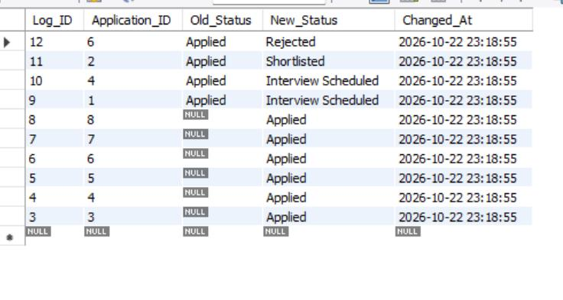
Figure 31: Q13 result

8. STORED PROCEDURES FUNCTIONS AND TRIGGERS

8.1 Stored procedures and functions
Table 18: Stored routines and triggers
Object | Purpose
fn_match_percentage(candidate, job) | Returns the percentage of a job’s required skills that the candidate has
sp_apply_for_job(candidate, job) | Inserts an application inside a transaction; rolls back on any error
sp_hire_candidate(application) | Locks the row (FOR UPDATE), marks it Hired, rejects all other open applicants and closes the job as one atomic transaction
trg_app_before_insert | Blocks applications to closed jobs and applications without a resume
trg_app_before_update | Makes “Hired” a final state
trg_app_after_insert / after_update | Writes every status change to Application_Status_Log (audit trail)
trg_interview_before_insert | Rejects an interview dated before the application date
trg_interview_after_insert | Moves the application to “Interview Scheduled” automatically

The hiring procedure shows how a transaction keeps data consistent. If any statement fails, the EXIT HANDLER rolls back everything, so a job can never be closed without a hired candidate or vice versa.
CREATE PROCEDURE sp_hire_candidate(IN p_app INT)
BEGIN
DECLARE v_job INT DEFAULT NULL; DECLARE v_status VARCHAR(30);
DECLARE EXIT HANDLER FOR SQLEXCEPTION BEGIN ROLLBACK; RESIGNAL; END;
START TRANSACTION;
SELECT Job_ID, Application_Status INTO v_job, v_status
FROM Application WHERE Application_ID = p_app FOR UPDATE;
IF v_job IS NULL THEN SIGNAL SQLSTATE '45000' SET MESSAGE_TEXT='Application not
found'; END IF;
IF v_status NOT IN ('Shortlisted','Interview Scheduled') THEN
SIGNAL SQLSTATE '45000' SET MESSAGE_TEXT=
'Only shortlisted / interviewed applications can be hired'; END IF;
UPDATE Application SET Application_Status='Hired' WHERE Application_ID = p_app;
UPDATE Application SET Application_Status='Rejected'
WHERE Job_ID=v_job AND Application_ID<>p_app AND Application_Status NOT IN
('Hired','Rejected');
UPDATE Job SET Status='Closed' WHERE Job_ID = v_job;
COMMIT;
END

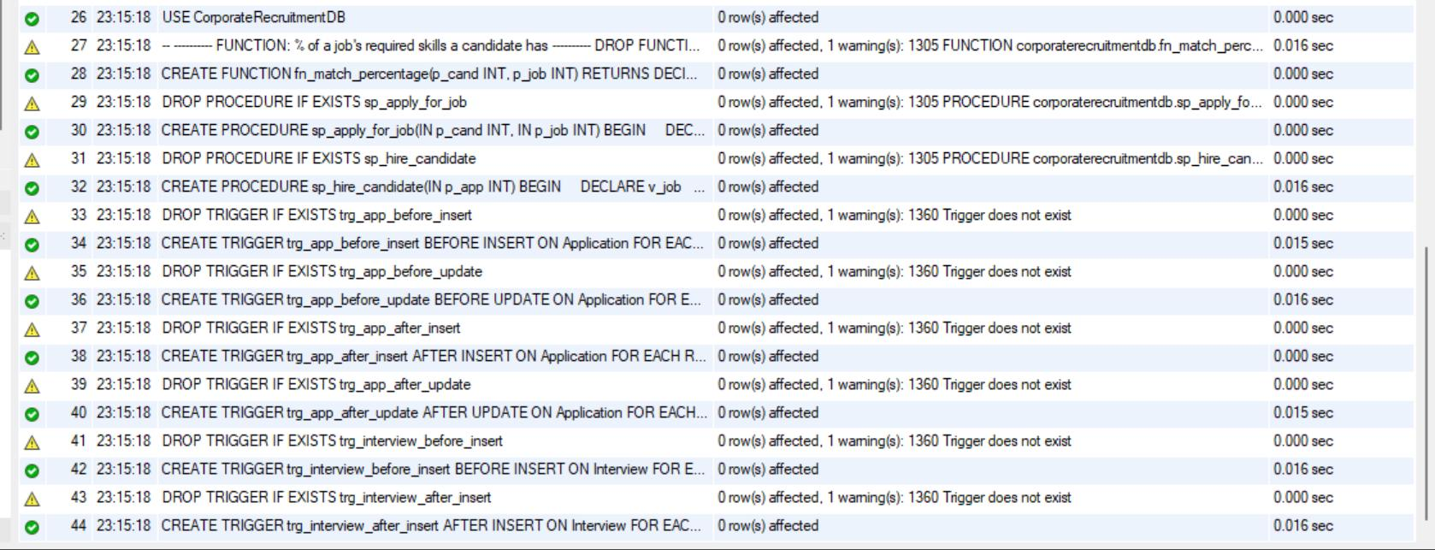
Figure 32: Script 04 output: function, procedures and six triggers created (yellow warnings are DROP … IF EXISTS on the first run)
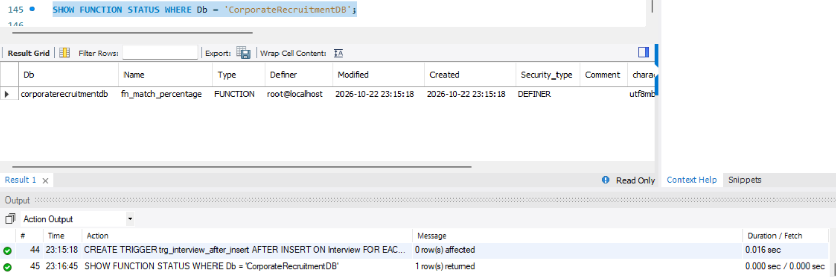
Figure 33: SHOW FUNCTION STATUS: fn_match_percentage
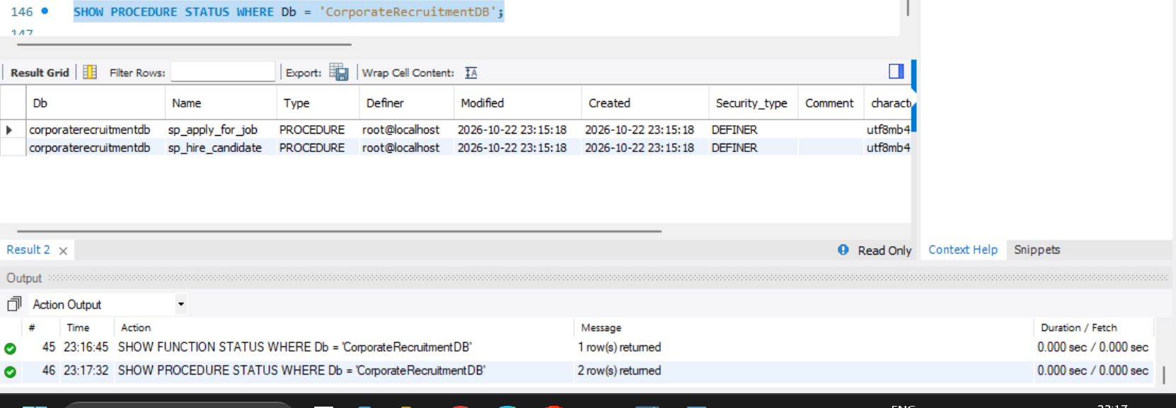
Figure 34: SHOW PROCEDURE STATUS: sp_apply_for_job and sp_hire_candidate

8.2 Triggers
Six triggers enforce business rules, record application status changes and automate interview-related transitions. Applications to closed jobs and applications without resumes are rejected before insertion. A hired application is treated as final. The after-insert and after-update application triggers maintain Application_Status_Log. Interview triggers validate the interview date and move the application to Interview Scheduled.
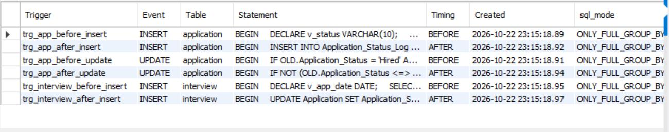
Figure 35: SHOW TRIGGERS: the six triggers on Application and Interview

8.3 Procedure execution and hiring transaction
A new application is created, then Candidate 1 is hired. The procedure rejects the other applicants and closes the job atomically.
CALL sp_apply_for_job(4, 1);
CALL sp_hire_candidate(1);
SELECT Application_ID, Application_Status FROM Application WHERE Job_ID = 1;
SELECT Job_ID, Status FROM Job WHERE Job_ID = 1;

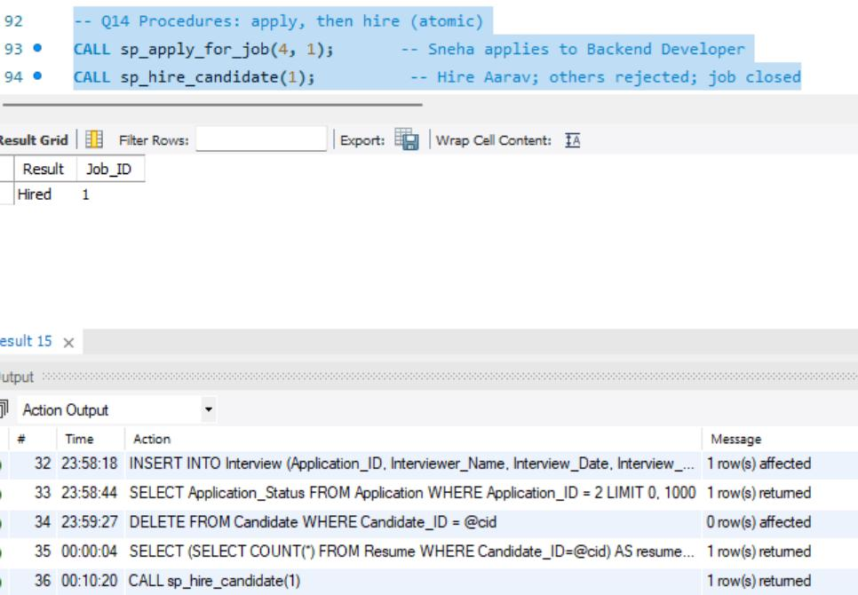
Figure 36: Q14: statuses of all applications to Job 1 after hiring
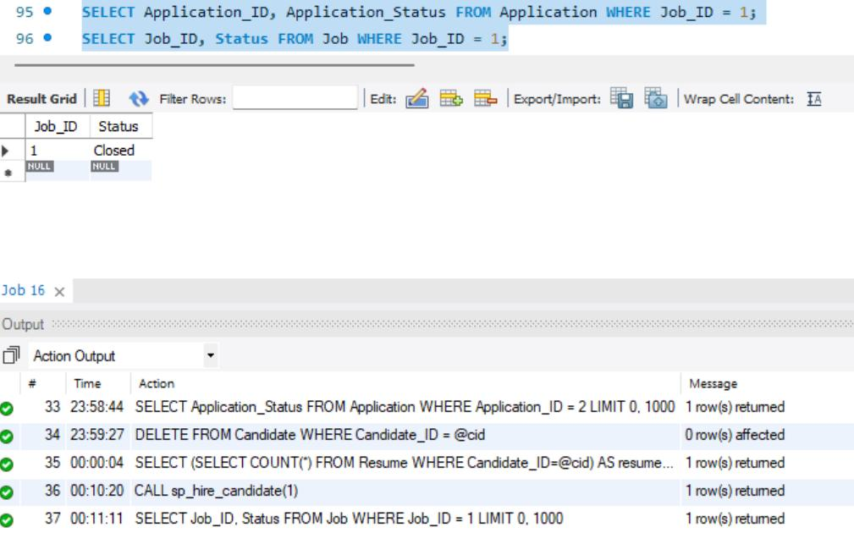
Figure 37: Q14: Job 1 is now Closed

9. FRONT END DEVELOPMENT

9.1 System architecture
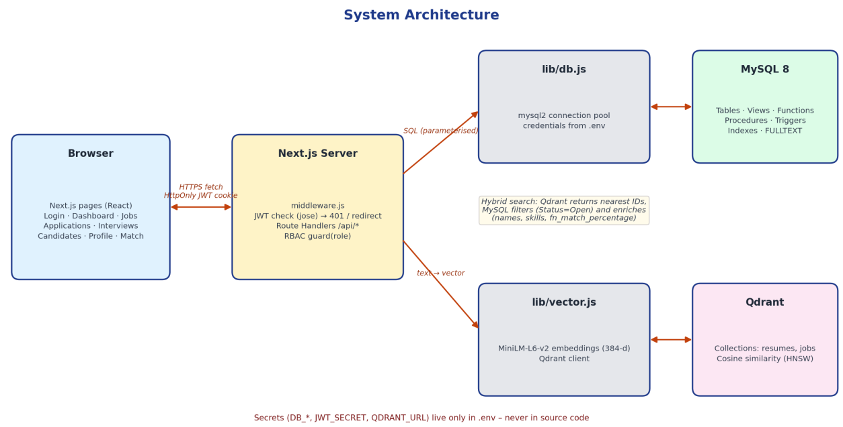
Figure 38: System architecture: browser, Next.js server, MySQL and Qdrant

9.2 Components and API endpoints
Table 19: System components
Component | Responsibility
Browser (React pages) | Login, dashboard, jobs, applications, interviews, candidates, profile, semantic match
middleware.js | Verifies the JWT cookie on every page and API request; returns 401 or redirects to /login
Route Handlers (/api/*) | Business logic; each handler calls guard(role) for role-based access and uses parameterised SQL only
lib/db.js | mysql2 connection pool configured from environment variables
lib/vector.js | Local embedding model and Qdrant client
MySQL 8 | Tables, constraints, views, function, procedures, triggers, indexes
Qdrant | Vector index of resumes and jobs

API endpoints
Table 20: API endpoints
Method | Endpoint | Roles | Purpose
POST | /api/auth/login, /logout | All | Authenticate (bcrypt compare) and set an HttpOnly JWT cookie
POST | /api/auth/register | Public | Create Candidate and Users rows in one transaction
GET / POST | /api/jobs | All / Recruiter | Full-text, location, type and salary search with skill-match; post a job with skills
PATCH / DELETE | /api/jobs/[id] | Recruiter, Admin | Close or reopen a job; delete (Admin only)
GET / POST / PATCH | /api/applications | Role-scoped | List; apply (calls sp_apply_for_job); change status
POST | /api/applications/hire | Recruiter, Admin | Calls sp_hire_candidate (transaction)
GET / POST / PATCH | /api/interviews | Role-scoped | View vw_interview_schedule; schedule; complete or cancel
GET | /api/candidates | Recruiter, Admin | Filter vw_candidate_profile by skill and experience
GET / POST | /api/profile | Candidate | Profile, skills, resume upload (also indexed in Qdrant)
GET | /api/search/semantic | Role-aware | Vector search in Qdrant enriched from MySQL
GET | /api/dashboard | Recruiter, Admin | Aggregate queries and views

9.3 Authentication authorisation and configuration
• Authentication: passwords are stored as bcrypt hashes (cost 10). A successful login issues a signed JWT (8 hours) in an HttpOnly, SameSite cookie, so scripts in the browser cannot read it.
• Authorisation: three roles. Recruiters only see and change data of their own company; candidates only see their own applications and interviews.
• SQL injection: every query uses placeholders; no user input is concatenated into SQL.
• Configuration: DB_HOST, DB_PORT, DB_USER, DB_PASSWORD, DB_NAME, JWT_SECRET and QDRANT_URL are read from the .env file, which is excluded from Git. Nothing sensitive is hard- coded.
Table 21: Role permissions
Capability | Admin | Recruiter | Candidate
View all companies’ data | Yes | Own company | Own data
Post, close, reopen jobs | Close / reopen | Own company | No
Delete a job | Yes | No | No
Apply to a job | No | No | Yes
Change status, schedule interviews, hire | Yes | Own company | No
Dashboard and candidate list | Yes | Yes | No
Edit profile, skills, resumes | No | No | Yes
Recommended jobs (semantic) | — | — | Yes
Matching candidates (semantic) | Yes | Yes | No

9.4 Vector database integration
Table 22: Qdrant design and retrieval pipeline
Aspect | Design
What is embedded | Resume.Resume_Text (one vector per resume) and Job_Title + Job_Description (one vector per job)
Embedding model | all-MiniLM-L6-v2 (sentence-transformers), 384 dimensions, executed locally with @xenova/transformers (ONNX)
Pre-processing | Text truncated to 2000 characters; mean pooling; vectors L2-normalised
Storage | Qdrant collections resumes (point id = Resume_ID, payload candidate_id, name) and jobs (point id = Job_ID, payload title, company_id)
Index and metric | HNSW index, cosine distance
Retrieval, candidate | Embed the latest resume (or a typed query), take the top 10 jobs, filter Status = Open in MySQL, add fn_match_percentage
Retrieval, recruiter | Embed a job description (or typed query), take the top 15 resumes, keep the best score per candidate, join vw_candidate_profile
Consistency | MySQL is the source of truth. New resumes and jobs are indexed on insert; npm run index:vectors rebuilds the index

export async function ensureCollections() {
const { collections } = await client.getCollections();
for (const name of ['resumes', 'jobs'])
if (!collections.find((c) => c.name === name))
await client.createCollection(name, { vectors: { size: 384, distance: 'Cosine' }
});
}
export async function embed(text) {
extractor ||= await pipeline('feature-extraction', 'Xenova/all-MiniLM-L6-v2');
const out = await extractor(text.slice(0, 2000), { pooling: 'mean', normalize: true
});
return Array.from(out.data);
}

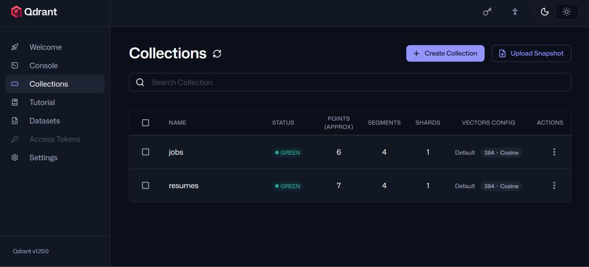
Figure 39: Qdrant dashboard: collections jobs (6 points) and resumes (7 points), 384-dimension cosine vectors

9.5 Setup and login
Demo accounts are created by a script that stores only bcrypt hashes in the Users table.
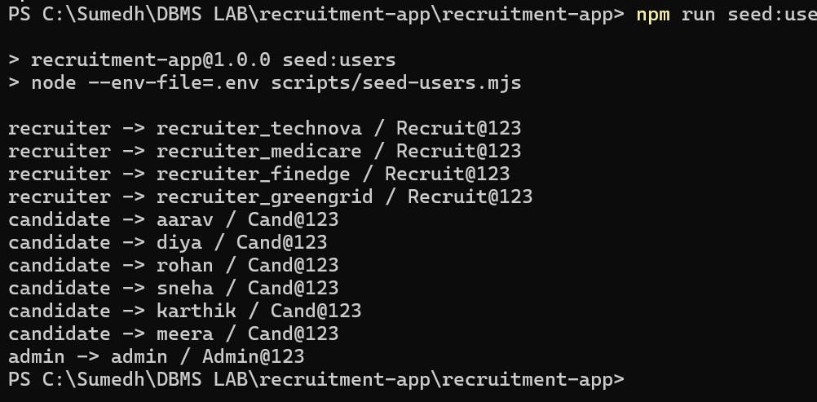
Figure 40: npm run seed:users: recruiter, candidate and admin accounts created
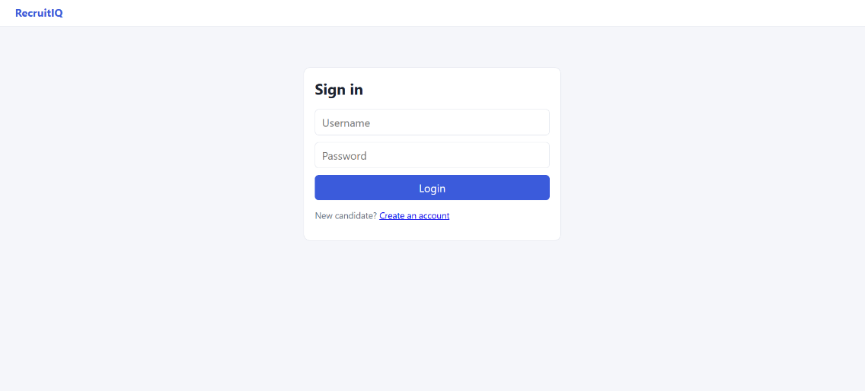
Figure 41: Login page

9.6 Recruiter flow
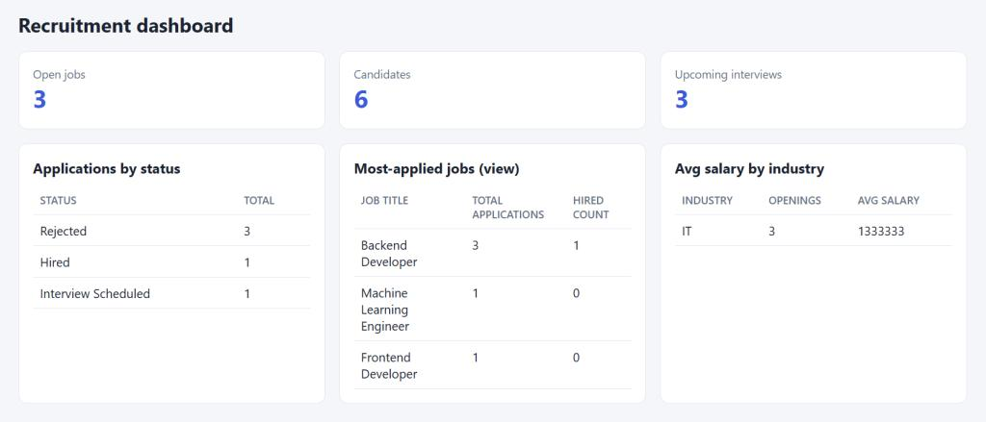
Figure 42: Recruiter dashboard: totals and applications by status
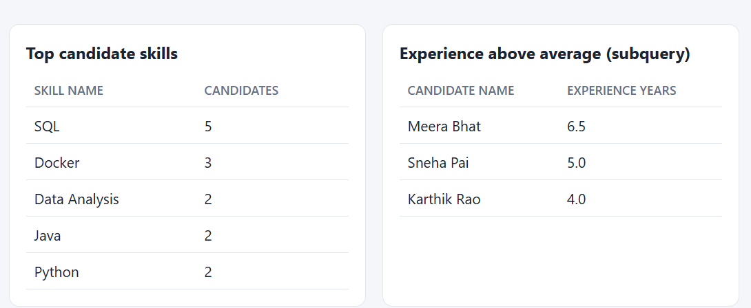
Figure 43: Recruiter dashboard: most-applied jobs (from vw_job_summary), average salary by industry, top skills
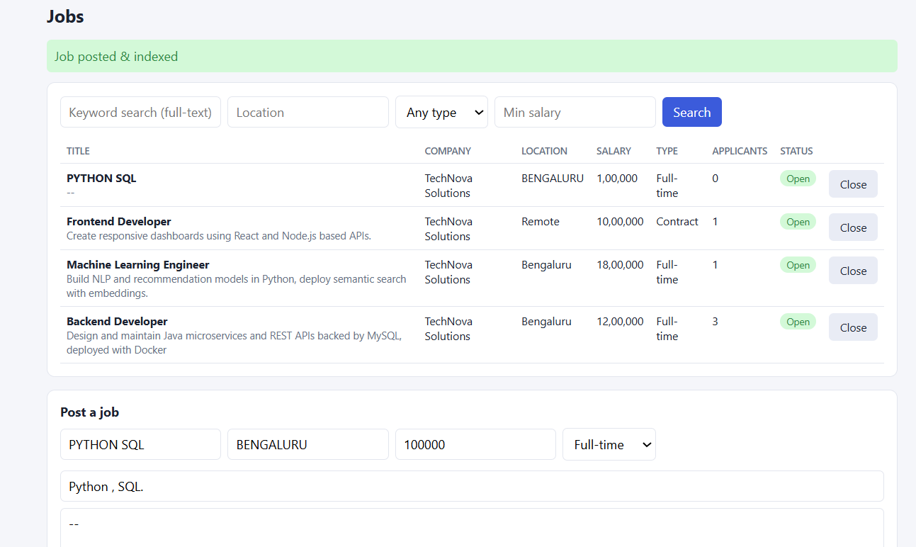
Figure 44: Posting a new job with required skills (job and Job_Skill rows inserted in one transaction, then indexed in Qdrant)
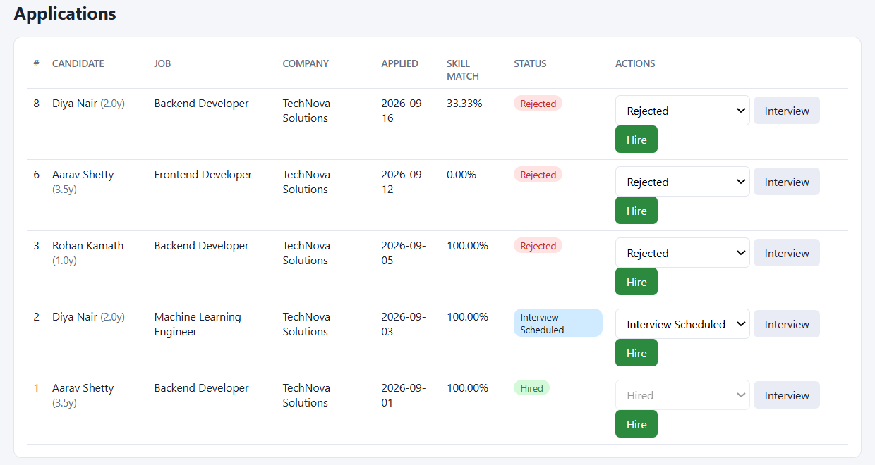
Figure 45: Applications screen with status, skill-match percentage and actions
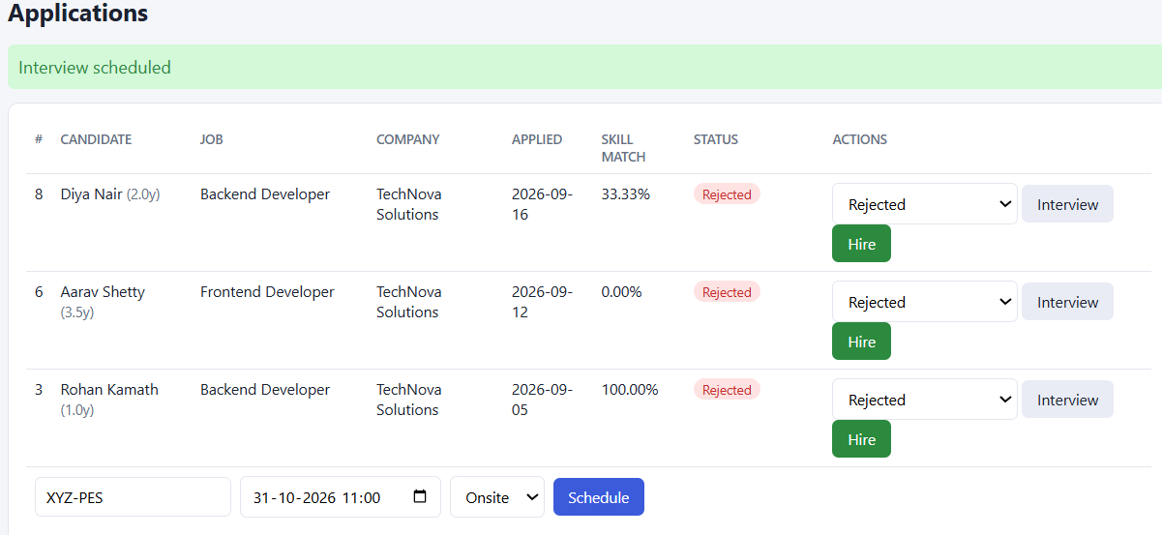
Figure 46: Scheduling an interview for an application
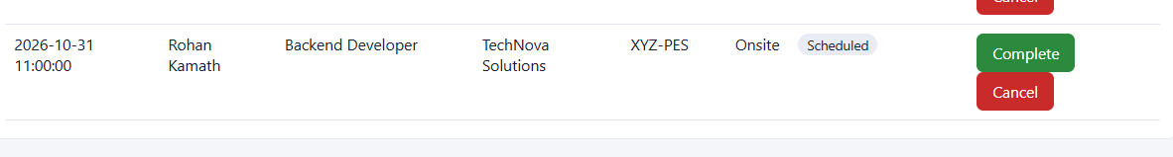
Figure 47: Interview schedule page
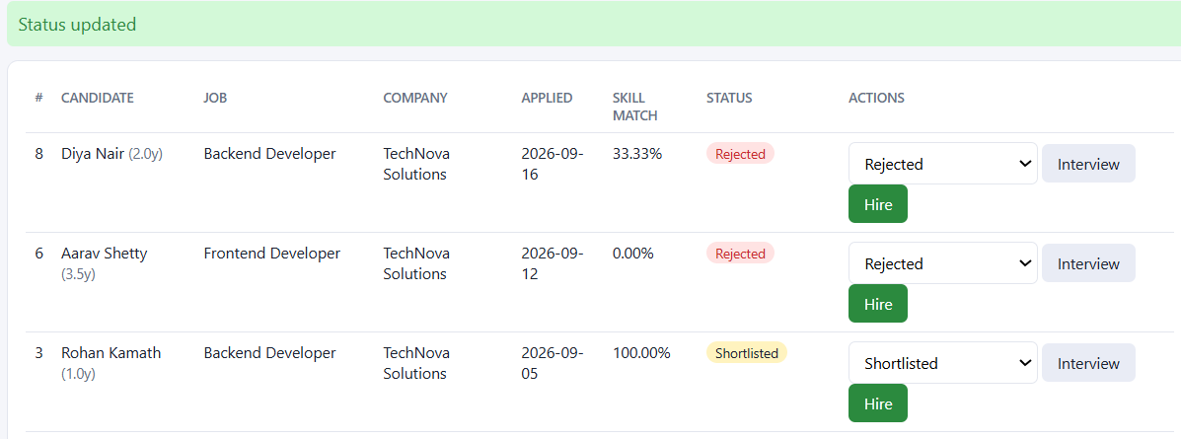
Figure 48: Status changed to Shortlisted; the trigger records the change in the audit log
Figure 49: Candidate hired through sp_hire_candidate
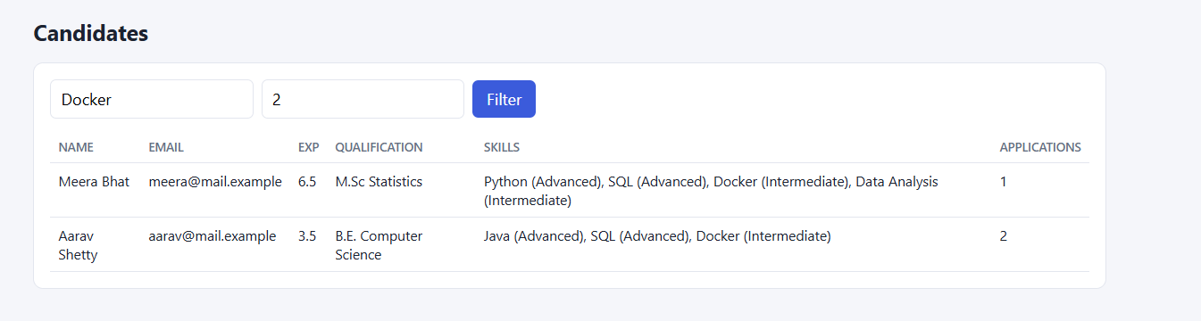
Figure 50: Filtering candidates by skill and experience

9.7 Candidate flow
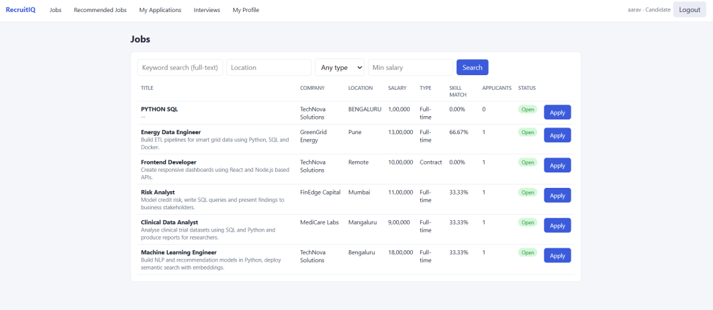
Figure 51: Jobs a candidate can apply to, with the skill-match percentage from fn_match_percentage
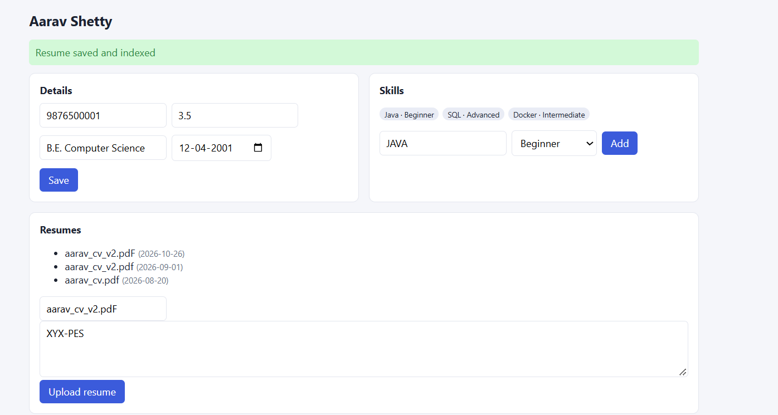
Figure 52: Candidate profile: details, skills and resume upload
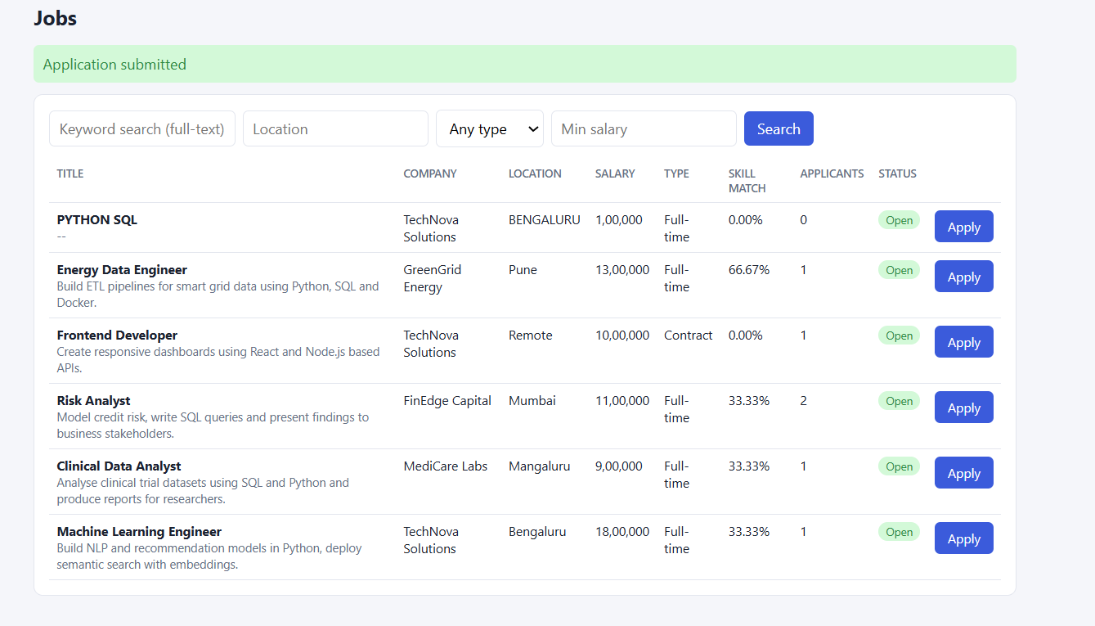
Figure 53: Applying to a job: application submitted
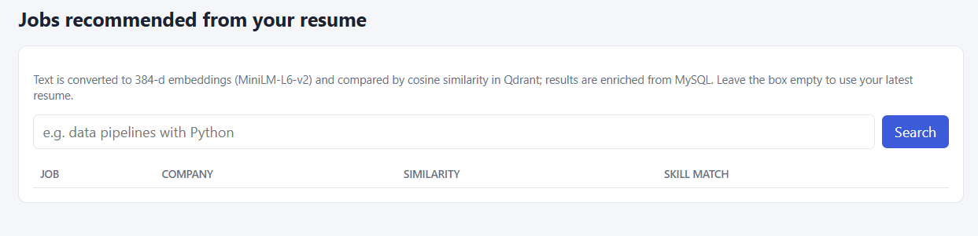
Figure 54: Recommended Jobs page (semantic search over the candidate’s resume)
Semantic search result evidence remains pending for the recruiter Semantic Match flow and the candidate Recommended Jobs search.
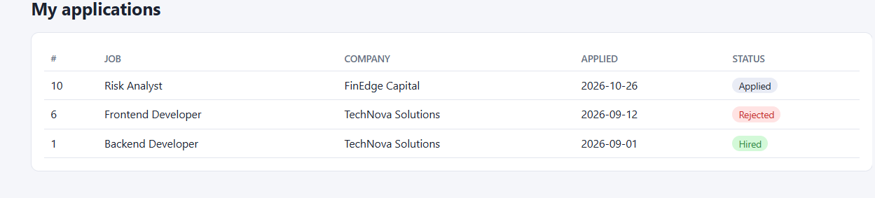
Figure 55: My applications

9.8 Security checks
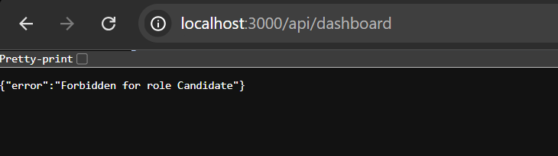
Figure 56: A candidate calling a recruiter-only API receives 403 Forbidden
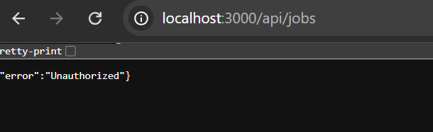
Figure 57: A logged-out request to a protected API receives 401 Unauthorized

9.9 Conclusion
The project delivers a recruitment platform that goes beyond CRUD. Relational data lives in MySQL, where constraints, triggers and transactions guarantee consistency regardless of the client, and unstructured resume and job text lives in a vector database, where semantic similarity adds value that keyword search cannot. The Next.js layer adds authentication, role-based access and a usable interface over the database features.

9.10 What was achieved
• A normalised 12-table schema with keys, CHECK/UNIQUE constraints and referential actions chosen per relationship.
• Six advanced SQL features: transactions, views, function and procedures, triggers, indexing and full-text search, plus vector similarity search.
• A hybrid search design in which Qdrant finds nearest neighbours and MySQL filters and enriches the results.
• Security by design: hashed passwords, JWT in HttpOnly cookies, role checks on every API, parameterised queries and secrets in environment variables.
• Systematic tests showing that invalid data is rejected by the database itself.

9.11 Limitations and future work
• Resumes are entered as text; PDF and DOCX parsing would remove manual copy-paste.
• Ranking could combine cosine similarity with the skill-match percentage into one score.
• Email notifications for status changes and interview invitations.
• Pagination and caching for large datasets; automated end-to-end tests.

9.12 Team contributions
Table 23: Team contributions
Member | Contribution
Sumedh B Rao | Schema extensions, views, functions, procedures and triggers, important queries, data dictionary; authentication, jobs, applications and interviews APIs and pages
Srujan Yalla | Seed data and test cases; Qdrant design, embedding pipeline and semantic search; dashboard, candidates, profile and match pages; documentation

Source code, SQL scripts and setup instructions are maintained in a Git/GitHub repository, with individual contributions visible in the commit history.

REFERENCES
[1] Team 10. Corporate Recruitment & Candidate Resume Indexing System. DBMS Experiential Learning – Level 3 Project Report. PES University, October 2026.
[2] Team 10. RecruitIQ source code, SQL scripts and setup instructions. GitHub repository.

GitHub Link
https://github.com/sumedh007rao-prog/DMBS-MINI-PROJECT-

APPENDIX A DEFINITIONS ACRONYMS AND ABBREVIATIONS
Term | Meaning
ACID | Atomicity, Consistency, Isolation and Durability
API | Application Programming Interface
BCNF | Boyce–Codd Normal Form
CRUD | Create, Read, Update and Delete
DBMS | Database Management System
DDL | Data Definition Language
DML | Data Manipulation Language
ER | Entity–Relationship
FK | Foreign Key
FULLTEXT | Text index used with MATCH … AGAINST
HNSW | Hierarchical Navigable Small World vector index
JWT | JSON Web Token
M:N | Many-to-many relationship
ONNX | Open Neural Network Exchange
PK | Primary Key
RBAC | Role-Based Access Control
SQL | Structured Query Language
UQ | Unique constraint
3NF | Third Normal Form

APPENDIX B TESTING RESULTS AND EVIDENCE
Database-level tests were executed from MySQL Workbench (script 07). Negative tests are expected to fail with the stated error; positive tests must succeed. Application-level tests were executed in the browser.

B.1 Summary of test cases
Table 24: Test case results
ID | Test | Expected | Actual | Result
T1 | Candidate inserted without a name | Rejected (NOT NULL) | Error 1364: Candidate_Name has no default value | Pass
T2 | Duplicate candidate email | Rejected (UNIQUE) | Error 1062: duplicate entry for key candidate.Email | Pass
T3 | Negative experience | Rejected (CHECK) | Error 3819: CHK_Experience violated | Pass
T4 | Phone shorter than 10 characters | Rejected (CHECK) | Error 3819: CHK_Phone violated | Pass
T5 | Negative salary | Rejected (CHECK) | Error 3819: CHK_Salary violated | Pass
T6 | Invalid job type | Rejected (CHECK) | Error 3819: CHK_Job_Type violated | Pass
T7 | Job for a non-existent company | Rejected (FK) | Error 1452: foreign key constraint fails | Pass
T8 | Same candidate applies twice to a job | Rejected (UNIQUE) | Error 1062: duplicate entry for UQ_Candidate_Job | Pass
T9 | Invalid application status | Rejected (CHECK) | Error 3819: CHK_App_Status violated | Pass
T10 | Apply without a resume | Rejected (trigger) | Error 1644: Upload a resume before applying | Pass
T11 | Interview dated before the application | Rejected (trigger) | Error 1644: Interview date cannot be before application date | Pass
T12 | Delete a company that has jobs | Rejected (FK RESTRICT) | Error 1451: cannot delete a parent row | Pass
T13 | Hire an application that is only Applied | Rejected, nothing changed | Error 1644: Only shortlisted / interviewed applications can be hired | Pass
T14 | Apply to a closed job | Rejected (trigger) | Error 1644: Cannot apply: this job is closed | Pass
P1 | Schedule an interview | Application moves to Interview Scheduled | Status of Application 2 became Interview Scheduled; log row added | Pass
P2 | Delete a candidate (ON DELETE CASCADE) | Resumes and skills removed | Counts returned 0 and 0; the DELETE affected 0 rows because @cid was not set | Re-run
P3 | Hire through sp_hire_candidate | Hired; others Rejected; job Closed | Application 1 Hired, Applications 3 and 8 Rejected, Job 1 Closed; 3 audit rows | Pass
A1 | Candidate calls the dashboard API | 403 Forbidden | Forbidden for role Candidate | Pass
A2 | Recruiter changes another company’s application | 404 Not found | Evidence pending | Pending
A3 | Logged-out request to a protected API | 401 Unauthorized | Unauthorized | Pass
A4 | Login with a wrong password | 401 Invalid credentials | Evidence pending | Pending
V1 | Recruiter semantic search “NLP recommendation” | Machine-learning resume ranked first | Evidence pending | Pending
V2 | Candidate Recommended Jobs from latest resume | Best-matching jobs on top | Evidence pending | Pending

Outcome: all 14 negative database tests were rejected with the intended error, and the integrity checks and triggers behave as designed. The remaining items marked Pending or Re-run need a screenshot or a repeat run before final submission.

B.2 Negative tests
Each pair shows the statement executed and the error returned by MySQL.

T1
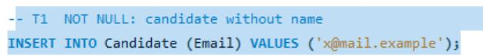
Figure 58: T1: statement
Figure 59: T1: error returned

T2
Figure 60: T2: statement
Figure 61: T2: error returned

T3
Figure 62: T3: statement
Figure 63: T3: error returned

T4
Figure 64: T4: statement
Figure 65: T4: error returned

T5
Figure 66: T5: statement
Figure 67: T5: error returned

T6
Figure 68: T6: statement
Figure 69: T6: error returned

T7
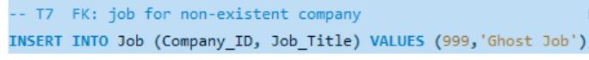
Figure 70: T7: statement
Figure 71: T7: error returned

T8
Figure 72: T8: statement
Figure 73: T8: error returned

T9
Figure 74: T9: statement
Figure 75: T9: error returned

T10
Figure 76: T10: a candidate without any resume is inserted (succeeds)
Figure 77: T10: insert output
Figure 78: T10: application for that candidate
Figure 79: T10: trigger error – resume required

T11
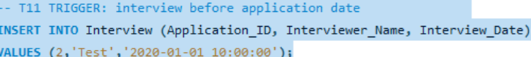
Figure 80: T11: statement
Figure 81: T11: error returned

T12

Figure 82: T12: statement
Figure 83: T12: error returned

T13
Figure 84: T13: statement
Figure 85: T13: error returned

T14
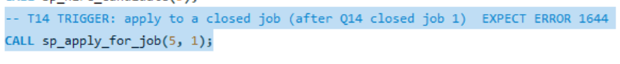
Figure 86: T14: statement
Figure 87: T14: error returned

B.3 Positive tests and audit log

P1: interview scheduling advances the application
Figure 88: P1: INSERT INTO Interview
Figure 89: P1: output
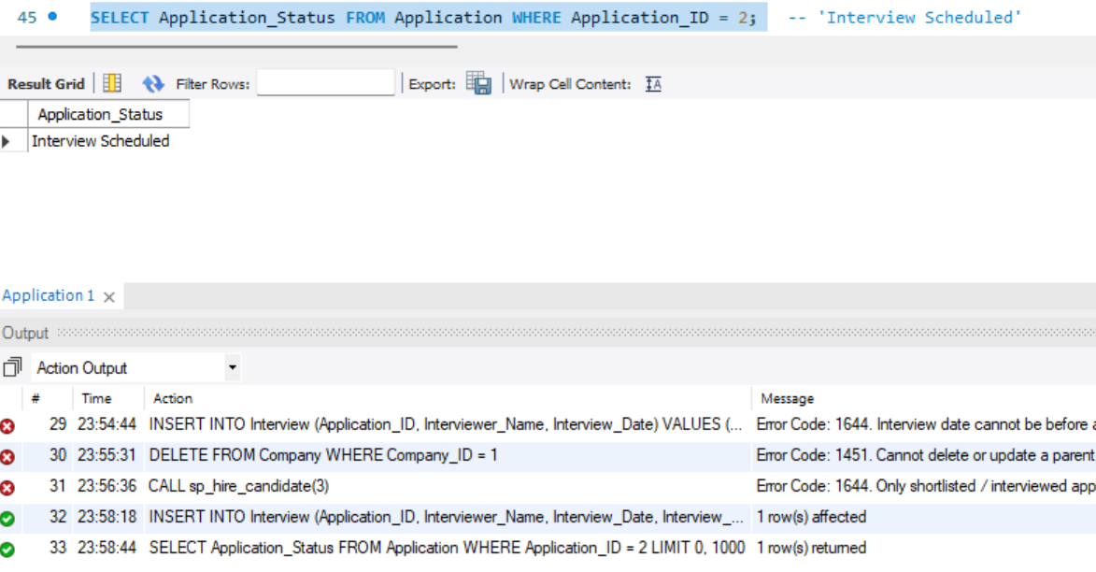
Figure 90: P1: Application 2 is now Interview Scheduled

P2: cascade delete inside a transaction
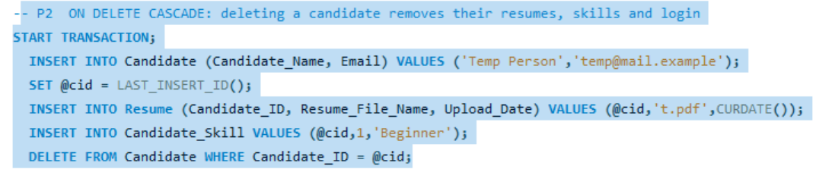
Figure 91: P2: transaction statements
Figure 92: P2: output
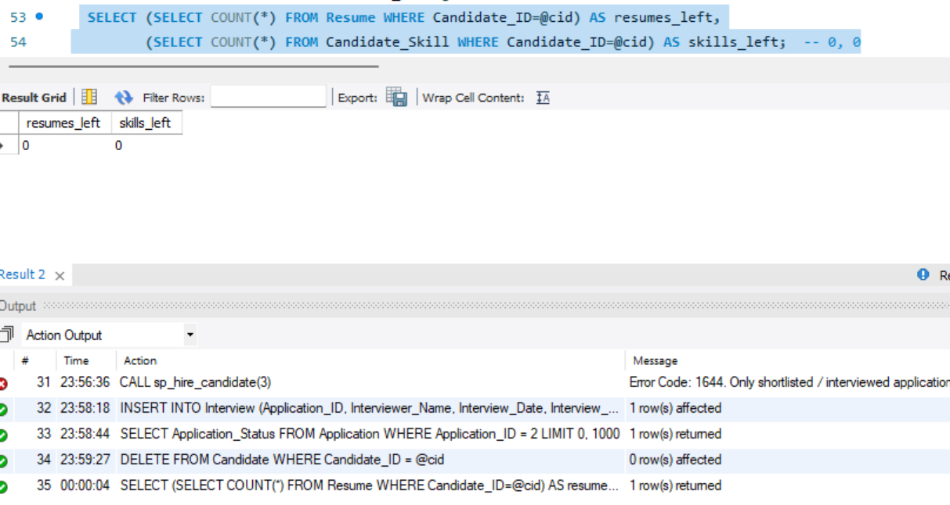
Figure 93: P2: result
P2 requires a repeat run with all transaction statements selected together so that @cid is set and the DELETE affects one row. The existing evidence is retained, and this test remains marked Re-run.

P3: audit log after hiring
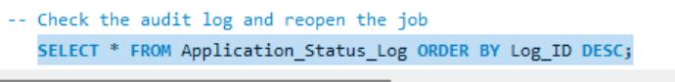
Figure 94: Audit log query
Figure 95: Audit log: output
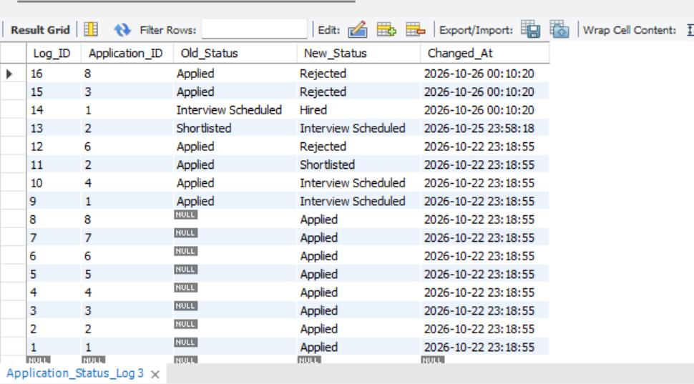
Figure 96: Audit log: the hire, the two automatic rejections and earlier changes
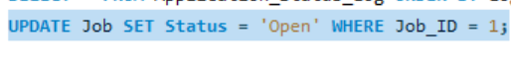
Figure 97: Job 1 reopened for the application demo
Figure 98: Reopen: output

