**SELFIE TOASTER**

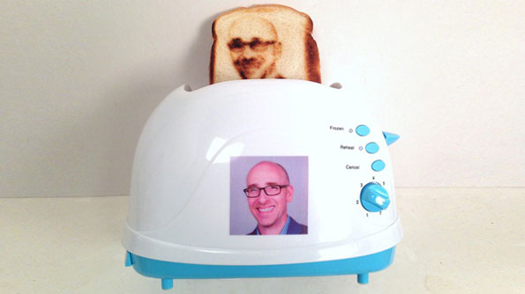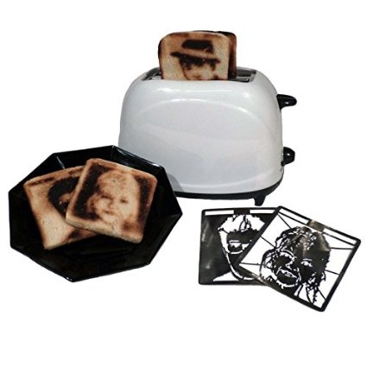

<http://incrediblethings.com/food/this-toaster-toasts-your-selfie-onto-bread/>

One of the coolest digital stuff I have ever seen. It creates your sandwich having your picture in it. You mail your picture to the company and the company is going to send a physical tray with your picture printed on it. Then you try making your bread as you usually do with a normal toaster and the sandwitch will be baked with your image on it.

**DIGITAL BED**

[**https://www.indiegogo.com/projects/balluga-the-world-s-smartest-bed--3#/**](https://www.indiegogo.com/projects/balluga-the-world-s-smartest-bed--3#/)

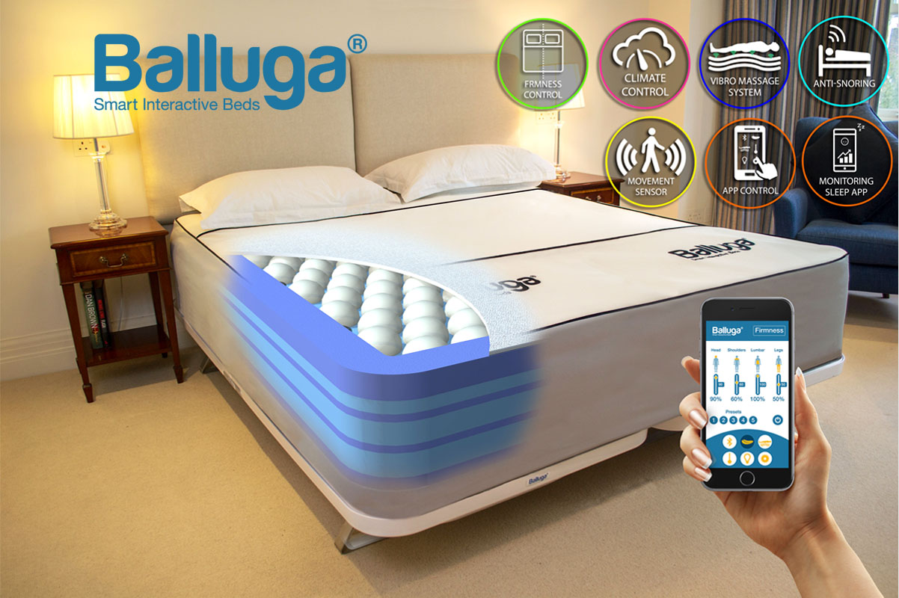

1. Balluga's active suspension system monitors the pressure that your body places in different zones of the mattress. The air pressure is automatically increased or decreased in each zone, to ensure that your body and spine are always correctly supported.
2. A steady stream of air will keep your body at its optimum temperature throughout the night. Individual temperature levels can be set for each side of the mattress so no more arguing with your partner about who might be hogging the sheets, or waking up to kick them off.
3. Our pressure point vibro massage system will relax your muscles and allow you to drift to sleep or gently vibrate to wake you up in the morning. The massage system can also be preset to automatically shut down at a number of preset times.
4. Our App is compatible for use on iOS and Android smartphones or tablets. Alternatively you can control the bed using our wireless touch screen control unit. Through our app, your preferred comfort and therapeutic settings can be saved and used on any other Balluga Bed worldwide.