- Signup details -individual/family
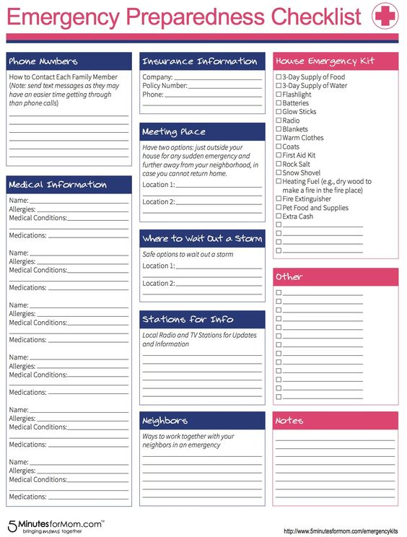
- Safety Checklist
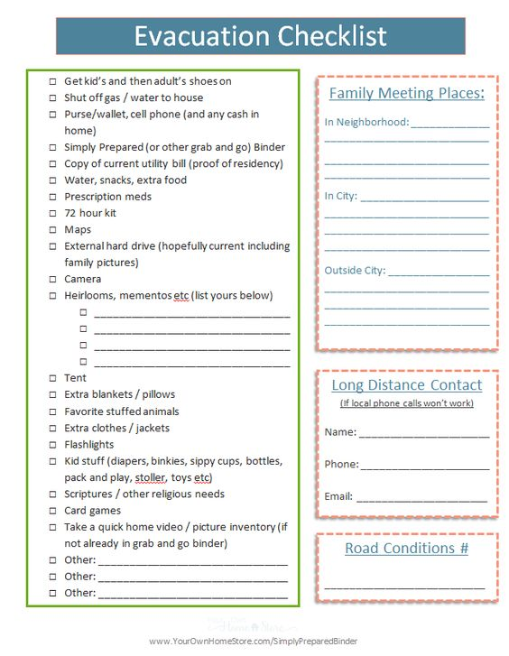
- Safety list/Evacuation list(virtual bag)
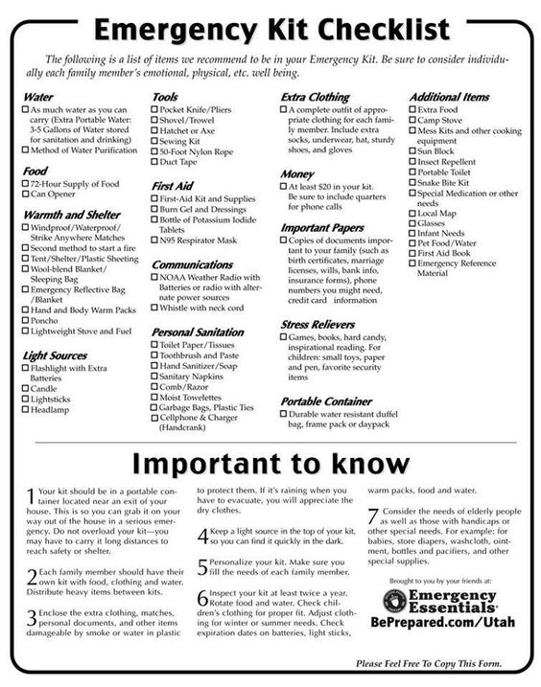
- Floods Tutorial
Here are some safety tips to prepare for rising water—and what to do once a flood has begun.
Before a Flood

• Avoid building in a floodplain.

• Construct barriers (levees, beams, floodwalls) to stop floodwater from entering your home.

• Seal walls in basements with waterproofing compounds to avoid seepage.

• If a flood is likely in your area, listen to the radio or television for information.

• Know the difference between a flood watch and a flood warning. A watch means flooding is possible. A warning means flooding is occurring or will occur soon.

When a Flood Is Imminent

• Be prepared! Pack a bag with important items in case you need to evacuate. Don't forget to include needed medications.
• If advised to evacuate your home, do so immediately.

• If there is any possibility of a flash flood, move immediately to higher ground.

• If possible, bring in outdoor furniture and move essential items to an upper floor.

• Turn off utilities at the main switches or valves if instructed to do so. Disconnect electrical appliances.

During a Flood

• Do not walk through moving water. As little as 6 inches (15 centimeters) of moving water can make you fall.

• If you have to walk in water, wherever possible, walk where the water is not moving. Use a stick to check the firmness of the ground in front of you.

• Do not drive into flooded areas. If floodwaters rise around your car, abandon the car and move to higher ground if you can do so safely.

• Do not touch electrical equipment if you are wet or standing in water.

After a Flood

• Listen for news reports to learn whether the community's water supply is safe to drink.

• Avoid floodwaters; water may be contaminated by oil, gasoline, or raw sewage. Water may also be electrically charged from underground or downed power lines.

• Avoid moving water.

• Be aware of areas where floodwaters have receded. Roads may have weakened and could collapse under the weight of a car.

• Stay away from downed power lines, and report them to the power company.

• Return home only when authorities indicate it is safe.

• Stay out of any building if it is surrounded by floodwaters.

• Service damaged septic tanks, cesspools, pits, and leaching systems as soon as possible. Damaged sewage systems are serious health hazards.

• Clean and disinfect everything that got wet. Mud left from floodwater can contain sewage and chemicals.

