

**Data Analysis**

**By**

**Nallamilli Sumedha**

**(25PGDM0106)**

**My approach**

**Data Cleaning Process and Techniques**

**1.⁠ ⁠Date Column Separation**

**Method:** Used the Split Column function with a delimiter to separate the date column.

**Purpose:** This step helped in isolating the date components for further analysis.

**2.⁠ ⁠Trimming Spaces**

**Method:** Applied the Trim option to remove left and right spaces.

**Purpose:** Ensured consistency and accuracy in text values by eliminating unnecessary whitespace.

**3.⁠ ⁠Value Replacement**

**Method:** Utilized the Replace Values feature to standardize categorical data:

L was replaced with Low

M was replaced with Medium

H was replaced with High

**Purpose:** Improved clarity and consistency of the data by converting shorthand notations into more descriptive labels.

**4.⁠ ⁠Extracting Date Components**

**Method:** Created custom columns to extract the Year and Month using:

DATE.YEAR() for the year component.

DATE.MONTH() for the month component.

**5.Implemented a DAX query with the following formula**

Text.Combine(List.RemoveItems(Text.Split(Text.Trim([product_name]), " "), {""}), " ")

**6.Null values**

With approximately 46,611 missing entries out of roughly 900,000 rows (about 5%), the missing rate is moderate. Dropping 5% of your data might lead to some loss of information.

1. **Identify trends in sales, customer behaviour, and campaign performance**

* Sales decline in Q3 (2020 & 2021) across all stores and states

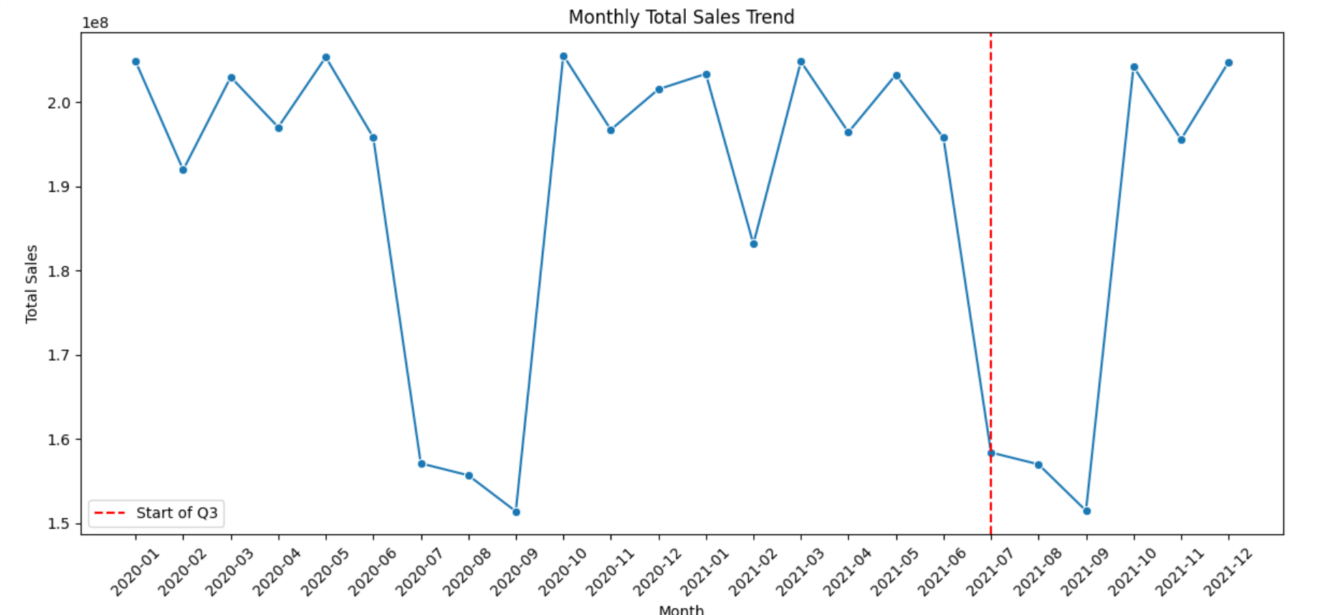

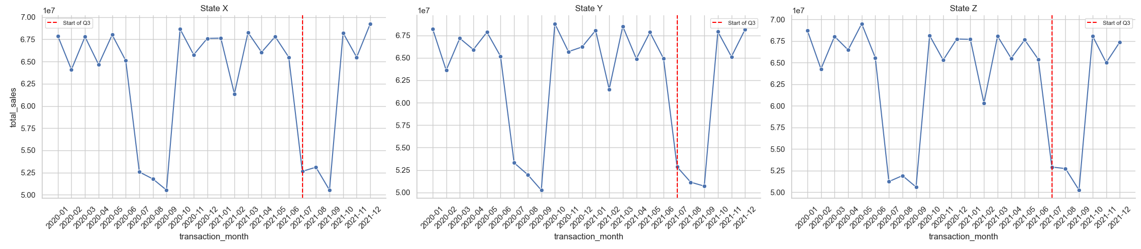

* Promotions & campaign performance is increasing each quarter, but sales are not

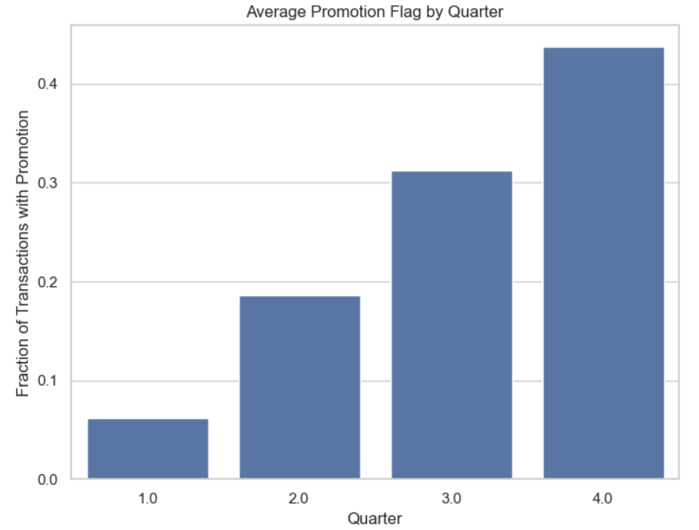

* Average transaction value & items per transaction remain constant across quarters

* Purchasing behaviour across income brackets in Q3 remains the same

* Highest-selling product category shifted from toys (2020) to furniture (2021) in Q3

* Loyalty program enrolment is similar across below shown parameters.

* Number of customers in Q3 dropped by an average of 25k compared to other quarters

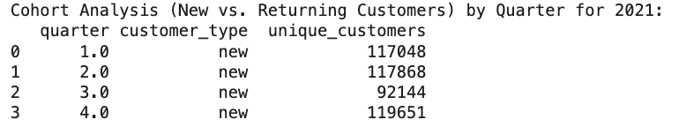

* No difference in purchase between vacationing & non-vacationing customers in Q3

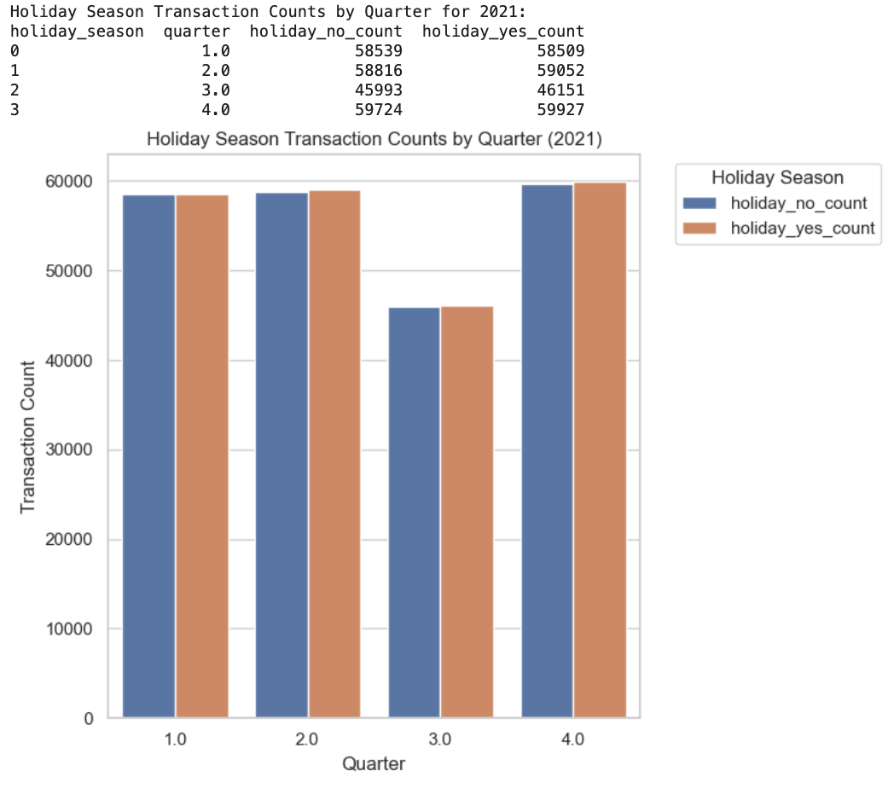

* Online & offline purchases are equal in Q3.

* Conversion rate, avg. customer support calls, and promotion type usage remain constant across quarters

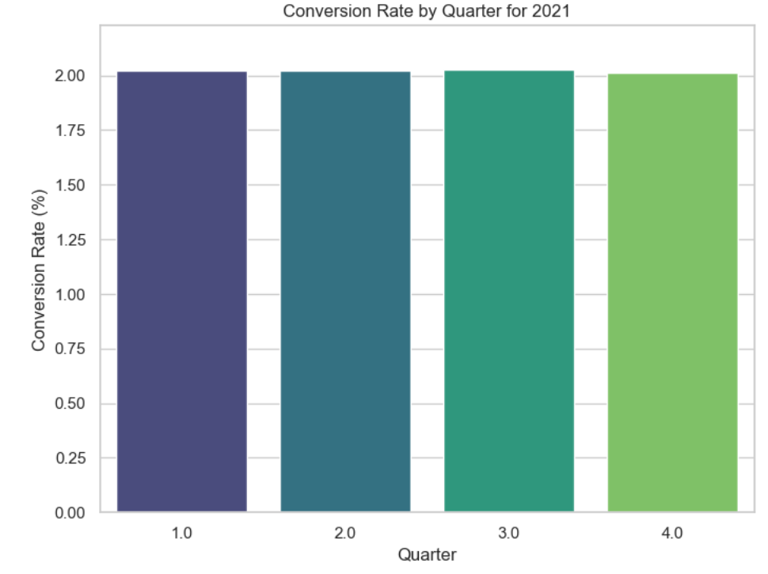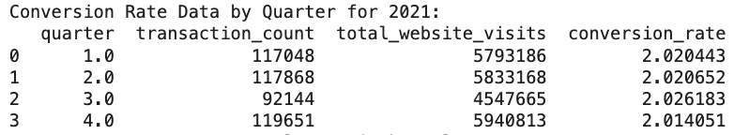

* Consumers contributing to significant sales have an average age of 48
* Customers who purchase less frequently (monthly/yearly shoppers) have decreased their spending more than weekly/daily shoppers.
* Some high-margin product categories (e.g., electronics) have seen reduced purchases, while lower-margin categories (e.g., groceries) remain stable.

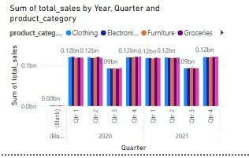

1. **Pin point possible reasons for the declining sales**

* Seasonal consumer behaviour leads to lower spending in Q3 as customers save for major Q4 holiday sales.
* External economic factors, such as inflation or uncertainty, may have led to cautious spending.
* A decrease of approximately 25,000 customers in Q3 indicates reduced foot traffic.
* Customers have become accustomed to frequent promotions, reducing the urgency to purchase.
* Marketing efforts may not be effectively targeting the right audience segments, leading to low conversion.
* The type of promotions offered remains unchanged, leading to **diminishing effectiveness** over time.
* Upselling and cross-selling strategies are not being utilized effectively.
* Price-sensitive customers continue to shop within their budget despite ongoing promotions.
* The absence of income-specific promotions means all income groups receive similar offers, leading to uniform purchasing behaviour.
* Economic stability during Q3 ensures that spending habits do not fluctuate significantly across income groups.
* During the pandemic in 2020, families spent more on entertainment for children, leading to higher toy sales.
* In 2021, with the shift toward remote work and home improvement, demand for furniture increased.
* The loyalty program does not offer tiered benefits that would attract different income segments differently.
* The program is marketed uniformly to all customers, leading to equal participation across income levels.
* Competitive offerings from other retailers may have drawn customers away.
* A well-established omnichannel strategy ensures that online and offline sales are balanced.
* Customers are purchasing a fixed number of essential or routine items per transaction.
* The absence of strong bundling or volume-based discount incentives keeps the item count stable.
* Marketing campaigns and store operations have not introduced significant changes to impact conversion rates.
* Customers exhibit a predictable shopping pattern, unaffected by external promotions or incentives.
* Customer concerns and service issues remain stable, indicating no major changes in product quality or service expectations.
* Customers in the loyalty program are not necessarily spending more. Long-term members show **purchase fatigue**, meaning their engagement has plateaued.
* Younger customers (18-30) have lower repeat purchase rates.
* Higher-income customers have lower engagement, possibly due to competition from premium retailers.
* Families with children have reduced spending, likely due to inflation or changing preferences.

1. **Correlate loyalty program with performance indicators.**

* **More Years ≠ More Spend:** Customers with **3+ years in the loyalty program** are not spending significantly more than new members.
* **New Loyalty Members' Low Conversion:** Many customers sign up but do not increase spending, indicating a lack of strong incentives.
* **Best-Performing Loyalty Members:** Medium-income, middle-aged (30-45) customers show the highest engagement, especially in categories like clothing and groceries.

1. **Identify key segments that need targeted action.**

* **Dormant Customers: Shoppers who made large purchases before but have reduced their frequency.**
* **Loyalty Fatigue Customers: Long-term members who are no longer actively engaging with the program.**
* **High-Value Shoppers (Churning): Customers with high single-purchase values but fewer repeat transactions.**
* **Younger Audience (18-30): Less engagement with loyalty programs, need tailored campaigns.**
* **High-Income Customers: Lower retention, possibly due to a need for premium product offerings.**

1. **Suggest data-backed strategies to improve sales and engagement.**

* Since Q3 is consistently weak, the company should introduce **early holiday sales, exclusive discounts, and limited-time offers** to counteract the seasonal dip.
* Identify **dormant** customers (who purchased heavily in Q2 but not in Q3) and send **personalized re-engagement offers**.
* **Shift from blanket promotions to personalized promotions** – Use purchase history to **recommend relevant deals** instead of offering **generic** discounts to everyone.
* Track whether **loyalty program members or new customers** respond better to discounts and adjust campaigns accordingly.
* If certain **promotion channels (e.g., online ads) generate better engagement than in-store posters**, increase digital investment.
* If customers are spending the same amount, **bundle complementary products** to increase transaction value (e.g., "Buy Laptop, Get a Free Accessory").
* Offer **threshold-based discounts** (e.g., "Spend $100, Get 10% Off") to encourage **higher-value transactions**.
* Offer **members-only pricing** for bulk purchases.
* Since sales are declining in every store/state, analyze **which stores are impacted the most** and introduce location-specific incentives.
* **Customer re-engagement campaigns** targeting previous high-spenders to encourage purchases before Q4.
* Develop **customized campaigns** for high-income vs. low-income groups (e.g., premium experiences vs. budget-friendly bulk deals).
* Predict **upcoming category trends** and allocate more inventory to high-growth segments.
* **Introduce tiered loyalty benefits** where higher spenders receive premium perks (e.g., early access to sales, VIP customer service).
* **Personalize loyalty rewards** to encourage engagement among different segments.
* **Win-back campaigns** targeting lapsed customers with exclusive Q3 offers.
* Enhance **omnichannel strategies**, offering seamless transitions between online and in-store purchases (e.g., in-store pickup for online orders) based on location to avoid delivery charges.

1. **Three key recommendations for business action.**

* Introduce **"Q3 Revival Bundles"** where frequently bought products are packaged together at a slightly discounted price to **increase the overall transaction value.** Implement **"Progressive Discounts"** where customers **unlock higher savings as they add more items to their cart.** Use AI-driven recommendations based on past purchase behaviour to offer **personalized bundles per customer segment** (e.g., high-income customers get premium bundles, while budget-conscious shoppers get value bundles).
* Introduce **"Dynamic Promotion Tiers"**, where customers receive different discount levels based on their past spending behaviour.
  + **Example:** Returning customers get **"Loyalty Boost Discounts"**, while new customers get **"Welcome Incentives."**
* Launch a **"Shop & Share" community engagement program** where **customers can review, recommend, and share their favourite purchases** in exchange for **non-monetary perks** like early product access, exclusive events, or recognition as a "brand ambassador." Integrate **social proof into the shopping experience**—for example, highlight **top-rated products, real customer testimonials, or user-generated content** directly on the website or in-store. Offer **personalized content experiences** such as "Customer Picks" sections, expert-curated lists, or **community-driven product guides.**

**These strategic initiatives will transform Q3 into a high-engagement sales period by introducing exclusive product experiences, personalizing the shopping journey, and fostering community-driven advocacy. By focusing on customer retention and experience rather than price reductions, the business can boost revenue, strengthen brand loyalty, and stay ahead of competitors.**