**Story Narrative Template**

**Story Description**

As an Admin , I want to log in so that I can start using the system.

**Business Context**

The administrator is going to handle all the operations and give rights to other users to Zombie dash.

**Entitlements**

Profile should be secure.

**Assumptions**

Change password option provided. The password strength should be more than 6 char in which one should be number, one in upper case , one in lower case and one special char.

**Out of Scope**

Cannot change username .Remember me option not provided and the forgot password also not provided.

**Dependencies**

Create admin user.

**Acceptance Criteria**

|  |  |  |
| --- | --- | --- |
| **Given** | **When** | **Then** |
| * That the admin user is on login page | User enters correct username and password and click on login | The system should login to home page of the admin and show the homepage to the user |
| * That the admin user is on the login page | User enters correct username but incorrect password and click on login | The system should show message stating incorrect username or password and the user should not be able to login. |
| * That the admin user is on the login page | User enters incorrect username but enters correct password and click on login | The system should show message stating incorrect username or password and the user should not be able to login. |
| * That the admin user is on the login page | User enters incorrect username and password and click on login | The system should show message stating incorrect username or password and the user should not be able to login. |
| * That the admin is logged in and is on home page | The admin clicks on change password | The system should direct to the change password page where all the fields should be blank. |
| * That the admin is on change password page | Admin enters correct current password and new password which is more than 6 characters and includes one or special character , one or more uppercase and one or more lowercase character and clicks on change password | System should show a message/pop up “password changed successfully” with ok button and initiation of that will redirect to admin home page. |
| * That the admin is on change password page | The admin enters correct current password but enters different passwords in new password and renter password field and clicks on change password | The system should display message ”Renter new password ” and all the fields should go blank. |
| * That the admin is on change password page | Admin enters correct current password but enters new password that is not inclusive of the special char, upper case , lower case or less than 6 chars and clicks on change password | The system should display message ”Renter new password ” and all the fields should go blank. |
| * That the admin is on change password page | Admin enters incorrect current password and anything in the new password field and clicks on change password | The system should show message “enter correct current password” and all the fields should go blank. |
| * That the admin is on change password page | Admin clicks on back at any point of time | The system should redirect to admin homepage and the password should not get changed. |
| * That the admin is on change password page with some data entered in the different fields | The admin clicks on refresh button or presses F5 | The system should show message box with message”Are you sure , you want to refresh? All your data is going to be lost” with yes or no option. |
| * That the Admin is on change password page with some details entered and has clicked on refresh or F5 and is being shown the message box with yes and no option | The admin clicks on yes | The system should reload the same page with all the fields empty and changes should not persist. |
| * That the Admin is on change password page with some details entered and has clicked on refresh or F5 and is being shown the message box with yes and no option | The admin clicks on no | The system should remove the message box and the data inputted in the fields should be there. |

**UI**  
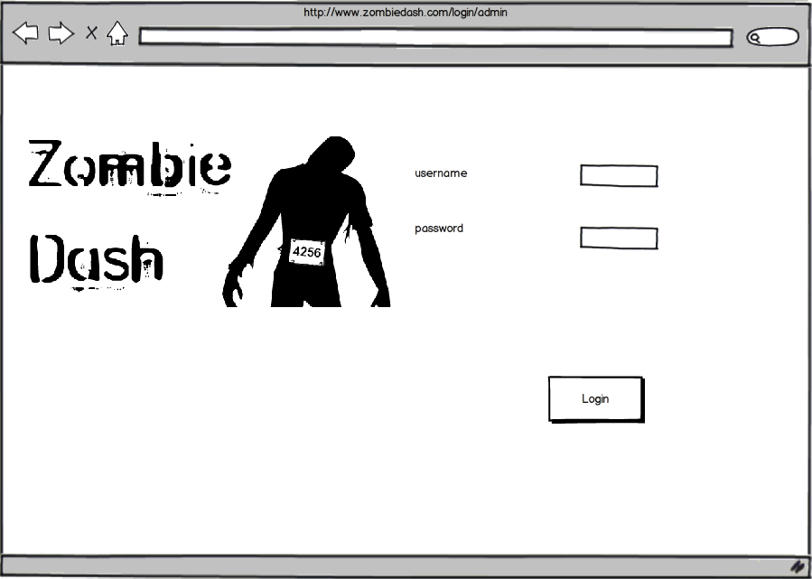

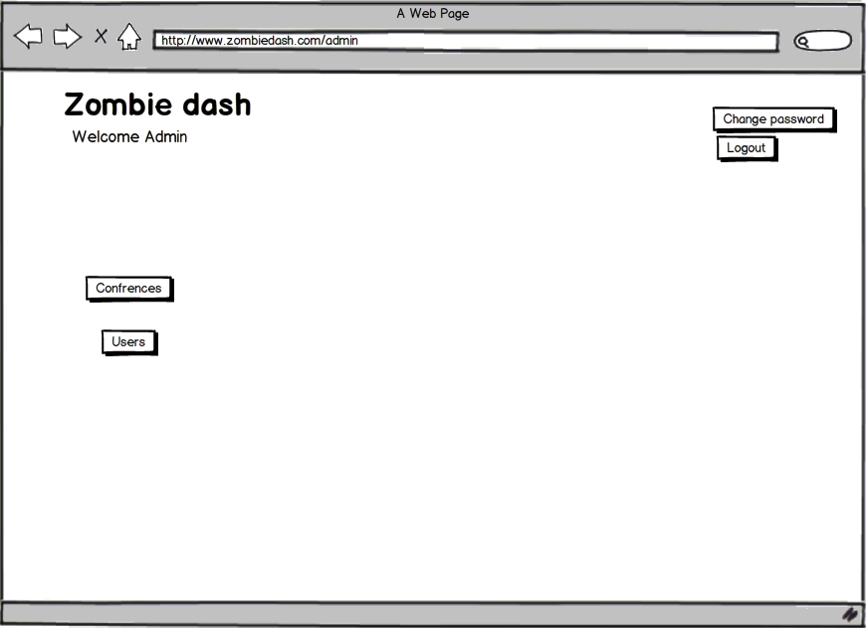

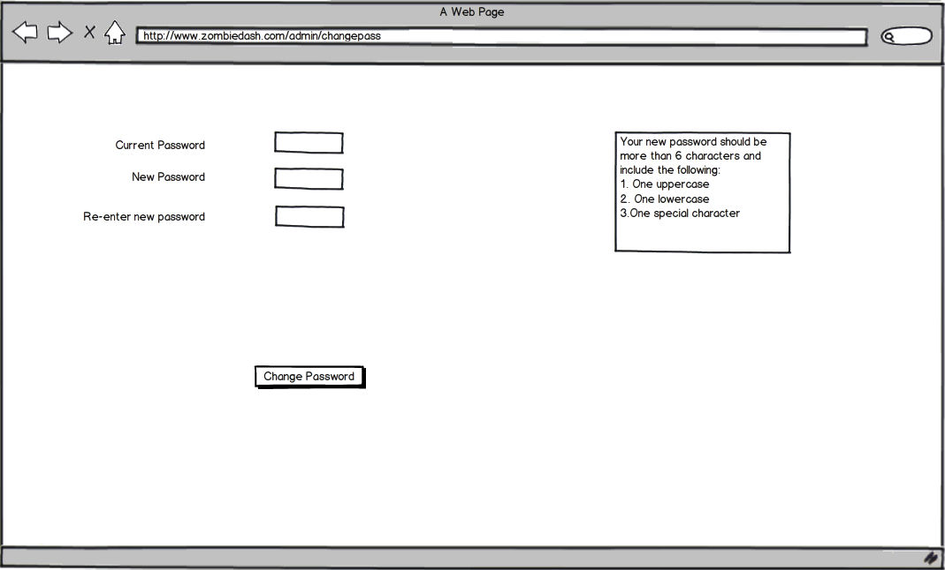

**Story Questions / Issues** A history of the issues raised and resolved during story narrative development. Sometimes helpful as an audit trail of the evolution of the story requirements

|  |  |
| --- | --- |
| Question / Issue | Response |
| Question for SME or PO | Answer from SME or PO |

**Story Narrative Template**

**Story Description**

As an admin, I want to Create and read a conference in the system, So that I can start to configure a conference.

**Business Context**

The conference page has to be created so that info can be read and made available to the game designer. The game designer can be added to these pages.

**Entitlements**

Include special security requirements here.

**Assumptions**

Admin logged in and has all these options on his home page. Save button is provided.

**Out of Scope**

No autosave option provided on the create page.

**Dependencies**

Create admin and Admin login.

**Acceptance Criteria**

|  |  |  |
| --- | --- | --- |
| **Given** | **When** | **Then** |
| * That the admin is on the homepage | Admin clicks on conference | The system should show the conference page with Create new conference option and list of existing conferences with their names. |
| * That the admin user is on the conference page | The admin clicks on create new conference | System should show create page where user can enter information about the conference. |
| * Admin is on create conference page | User enters all the information and clicks on save | System should save all the conference information and redirect to the conference page with the newly saved conference name in the list of existing conferences. |
| * Admin is on create conference page | User clicks on cancel at any point of time | The system should show a message box showing message “are you sure you want to cancel” with yes and no options. |
| * That the admin is on the create conference page and has clicked cancel and is being shown the message box with yes and no option | Admin clicks on yes | System should redirect to conference page and changes should not persist. |
| * That the admin is on the create conference page and has clicked cancel and is being shown the message box with yes and no option | Admin clicks on no | System should be on the same page with the text entered for the conference information not gone. |
| * Admin is on create conference page | The admin misses some field in the information and clicks on save | The system should show message “All fields compulsory”. |
| * Admin is on create conference page | Admin enters some text other than number in the phone no. field or no. is less than 10 digits and moves focus from the phone no. field | The system should show error message “invalid data” right next to the phone no. field. |
| * Admin is on create conference page | Admin enters some text other than number in the no. of attendees field and moves focus from this field | The system should show error message “invalid data” right next to the no. of attendees field. |
| * Admin is on create conference page | Admin enters invalid email in the email field and moves focus from this filed. | The system should show error message “invalid data” right next to the email field. |
| * Admin is on conference page | Admin clicks on a conference name in the existing conference list | The system should show information about that conference in a new page(conference info page). |
| * Admin is on conference info page | Admin clicks on back | The system should redirect the user to conference page. |
| * That the Admin is on create conference page with some details entered | The admin clicks on refresh button or presses F5 | The system should show message box with message”Are you sure , you want to refresh? All your data is going to be lost” with yes or no option. |
| * That the Admin is on create conference page with some details entered and has clicked on refresh or F5 and is being shown the message box with yes and no option | The admin clicks on yes | The system should reload the same page with all the fields empty and changes should not persist. |
| * That the Admin is on create conference page with some details entered and has clicked on refresh or F5 and is being shown the message box with yes and no option | The admin clicks on no | The system should remove the message box and the data inputted in the fields should be there. |
| * Admin is on conference page | Admin clicks on back | The system redirects to homepage of admin. |

**UI**  
Usually a low-fi prototype or hyperlink to low-fi prototype

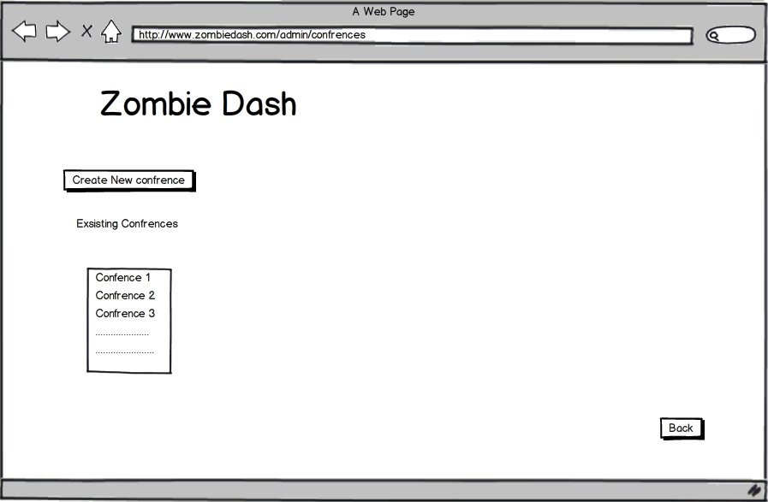

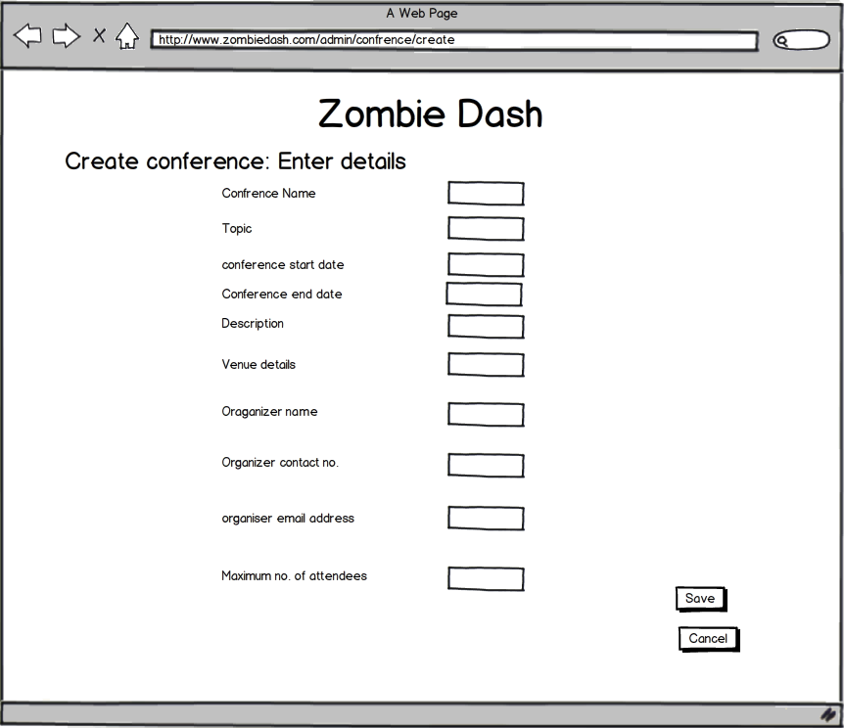

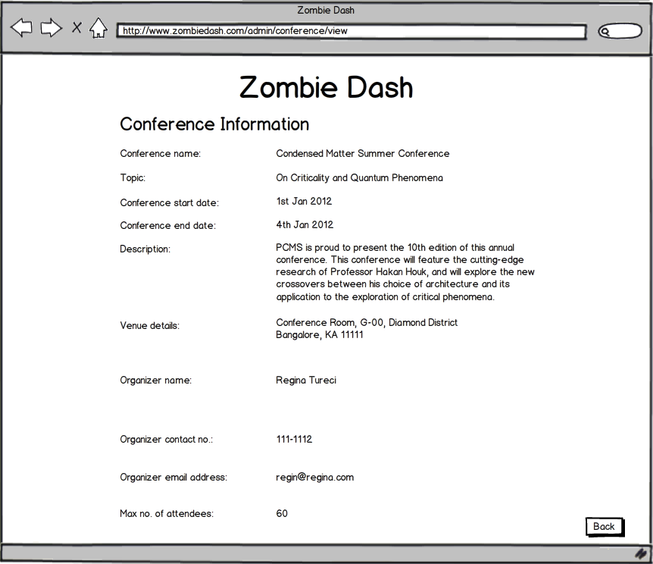

**Story Questions / Issues** A history of the issues raised and resolved during story narrative development. Sometimes helpful as an audit trail of the evolution of the story requirements

|  |  |
| --- | --- |
| Question / Issue | Response |
| Question for SME or PO | Answer from SME or PO |

**Story Narrative Template**

**Story Description**

As an attendee I want to play the game selected so that I am involved in it and can win

**Business Context**

The game will keep the players engrossed and interested in the conference. This will increase the customer base for zombie. The whole concept behind zombie dash is the playing of game.

**Entitlements**

Include special security requirements here.

**Assumptions**

Game/s should be selected and available to play. Attendee is logged in.

**Out of Scope**

Call out anything that is explicitly not included in the story that might be inferred by the team.

**Dependencies**

Selection of a Game, Choosing mode of gameplay, Attendee Registration, Attendee Login, View Homepage, Game designer activity.

**Acceptance Criteria**

|  |  |  |
| --- | --- | --- |
| **Given** | **When** | **Then** |
| * That the customer/attendee is logged in | s/he selects a new trivia game/task from the list of tasks | The system should open new game page where all the answer options are deselected |
| * That the attendee is on the game page | The attendee tries to answer a question by selecting an option | An option should get selected for that question |
| * That the attendee is on the game page | The attendee tries to select another option for an answered question | The new option should get selected and the old option deselected |
| * That the attendee is on the game page | The attendee clicks cancel or back | The system should show message box with message “are you sure you want to cancel” with yes or no option. |
| * The attendee is on the game page and has clicked cancel or back and is being shown the message box with yes and no option | The attendee clicks on yes | System should redirect to attendee home page and changes should not persist. |
| * The attendee is on the game page and has clicked cancel or back and is being shown the message box with yes and no option | The attendee clicks no | System should be on the same page (game page) with the options selected for questions not gone. |
| * That the attendee is on the game page | The attendee selects options for all the questions and clicks on submit | The system should go to a dummy page to show test completed test completed. |
| * That the attendee is on the game page | The attendee does not select options for some or all the questions and clicks on submit | The system should go to a dummy page to show test completed test completed. |

**UI**  
Usually a low-fi prototype or hyperlink to low-fi prototype

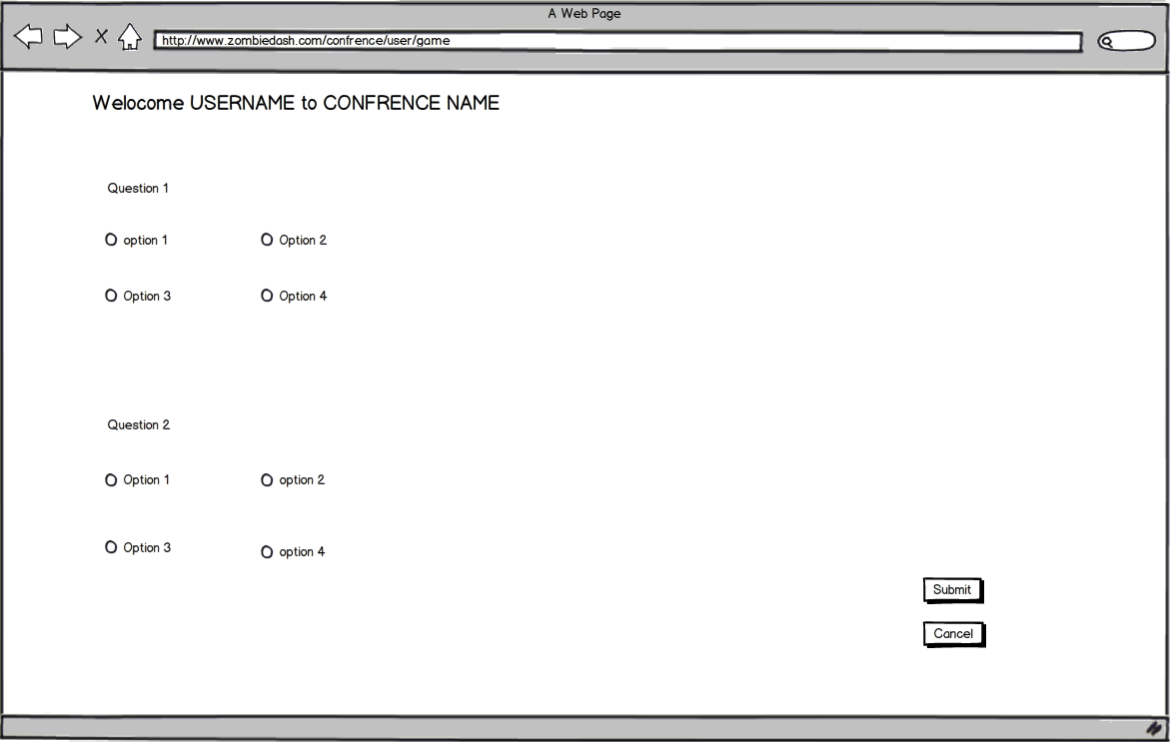

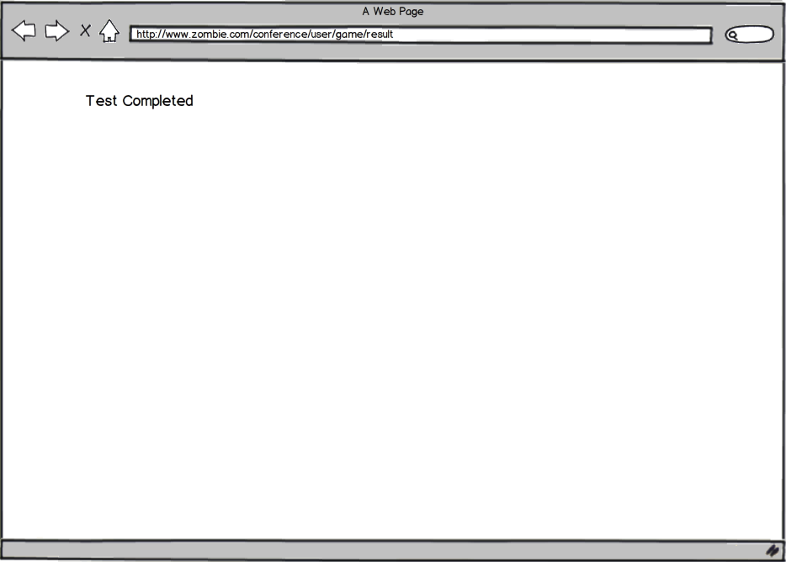**Story Questions / Issues** A history of the issues raised and resolved during story narrative development. Sometimes helpful as an audit trail of the evolution of the story requirements

|  |  |
| --- | --- |
| Question / Issue | Response |
| Question for SME or PO | Answer from SME or PO |