How to create maven project in eclipse-servlet and jsp
1)eclipse-file-project-maven project-do not click on skip archtype selection
2)click on org.apache.maven.archtypes maven-archtype-webapp 1.4

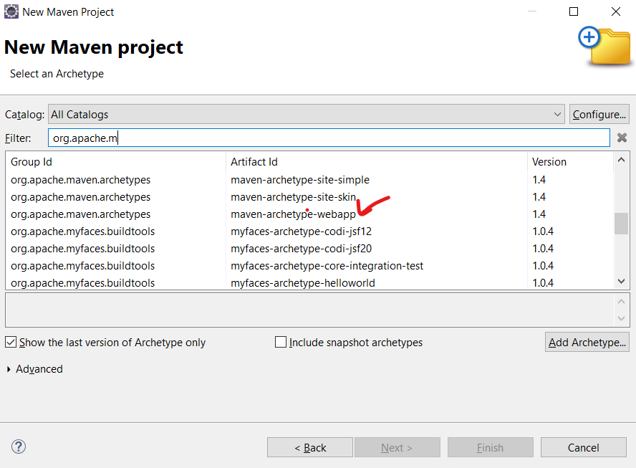
3) Artifact id –add project name.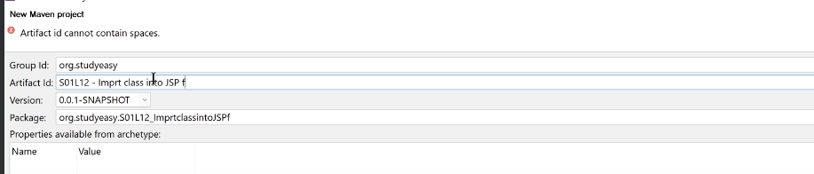
4)project is create- if you get error like then go to google and add bellow jar file
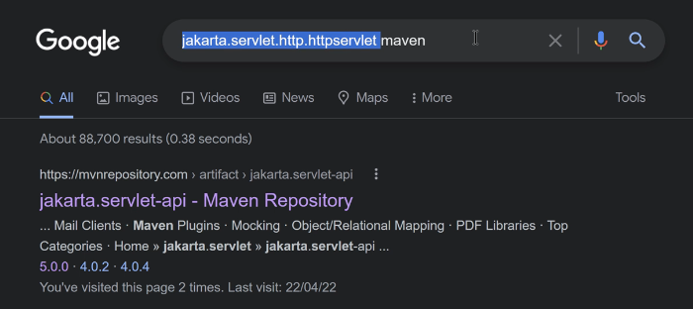
5)
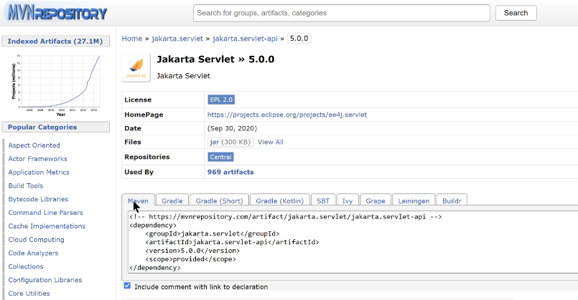
6)go to pomxml
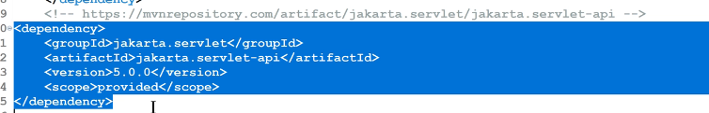
7)update the maven project
8)if you still get the error in index.jsp then update/add tag and remove same tag.save the page.

How to import the class in jsp file
Bellow is project structure
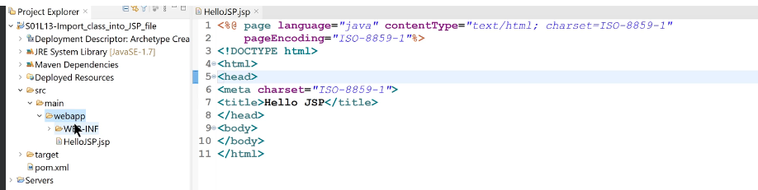
- Go to main folder- new-create java folder-give name “java”
- Your project structure looks like bellow, when you add the folder called “java”
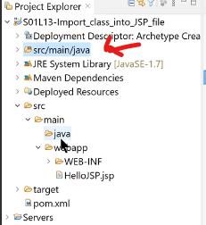
- Optional step-If you want to give different folder name rather than “java” then,right click on main-build path-use a source folder-source-add folder
- Right click on java folder-new-class-other-serach for class-choose java class-package-org.studyeasy-give class name-“HelloClass”
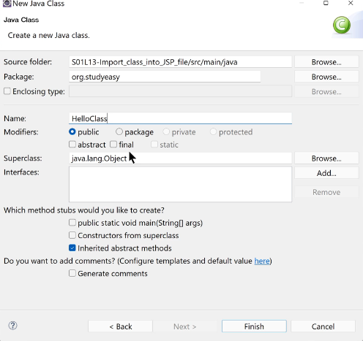
- Write bellow code in HelloClass.java
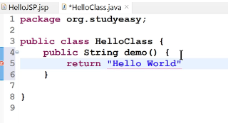
- Write bellow code in Hello.jsp
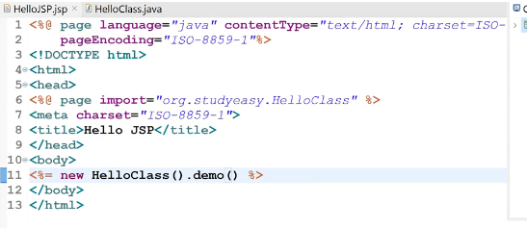
- Run the code-right click –.run as-run on server-select the local host-select the tomcat-ok
- Add some code
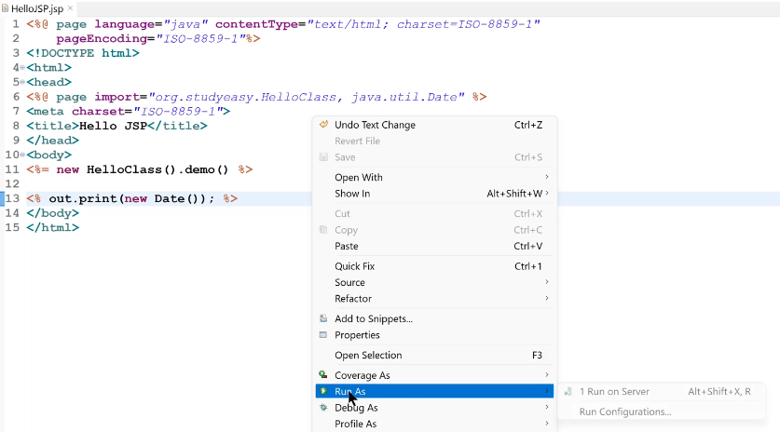
- Run the above code

Forward and redirect Method

- Add 3 jsp file -1) demo.jsp 2)forward.jsp 3) redirect.jsp
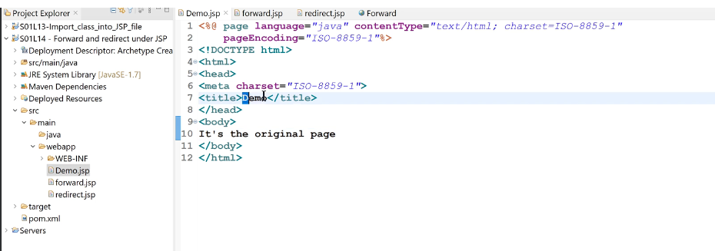
- See the code .just add sample line all 3 jsp pages
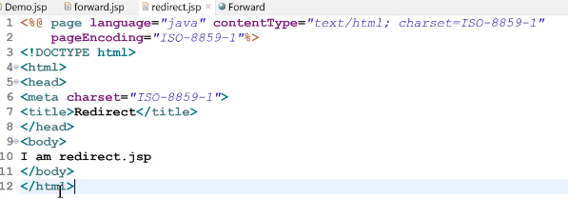
- Redirect –means we redirect the page not update the path.write a bellow code in demo.jsp
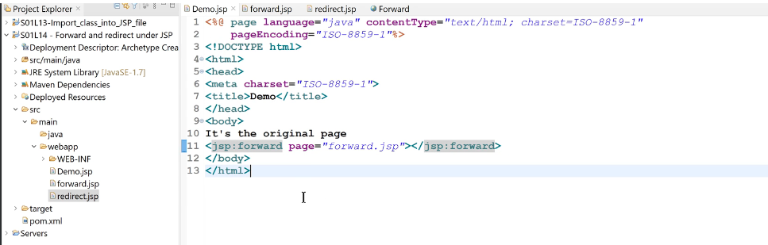
- Run the code
- If you want to write the servlet code in jsp file then we use scriptlet<% %> . first remove the jsp code. That Is line no 11.and add servlet code. see the bellow code
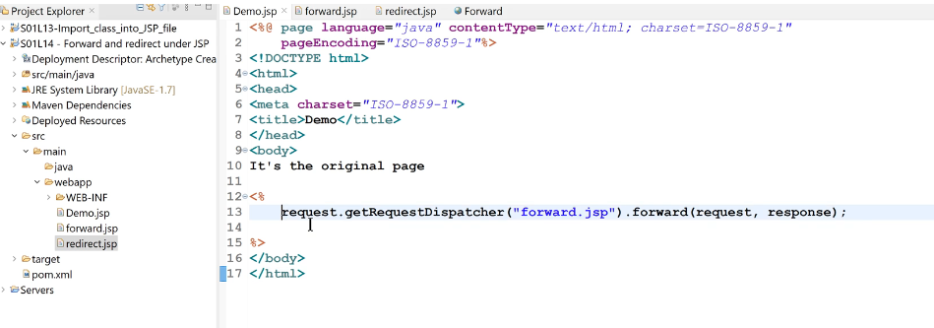
- Run the code
- Bellow code for sendRedirect
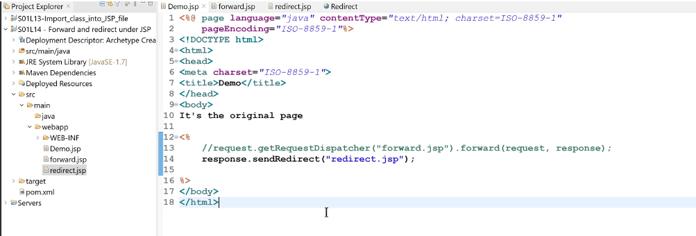
- Run the code.
Note- difference between forward and Redirect is- forward will forward the request but url path will not change and send Redirect will also send the request and also change the URL path.
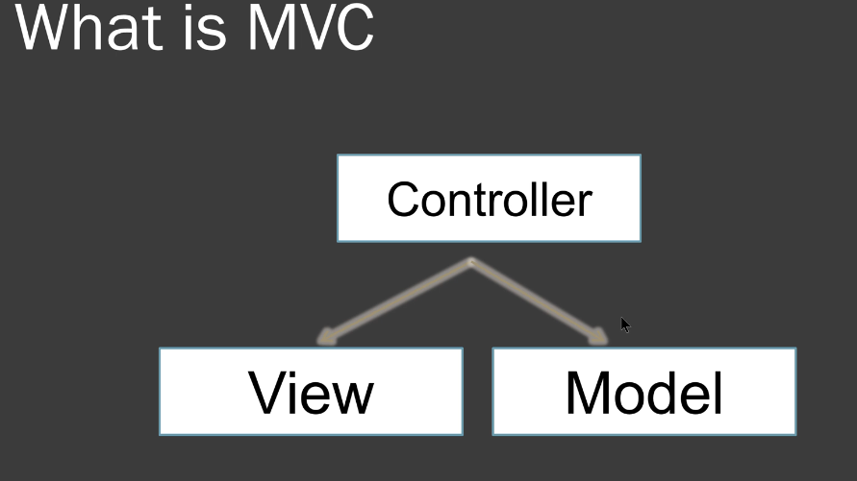
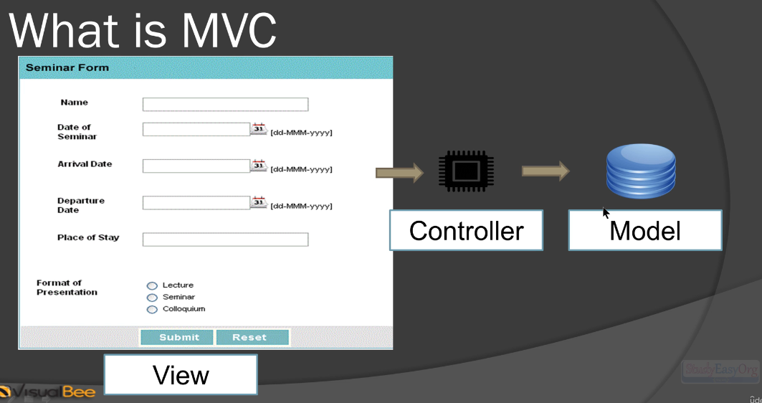

Problem statement-see 3 link –Login,Sign-up-About
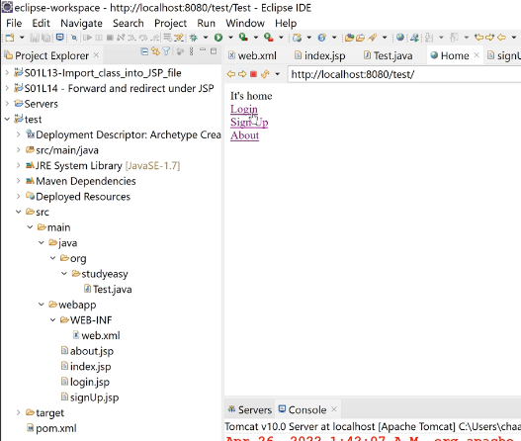

When you click on Sign-up page- it will display sige-up text and when on login-display you login –when you click on About –it will diplay about message.
See the bellow code Test.java
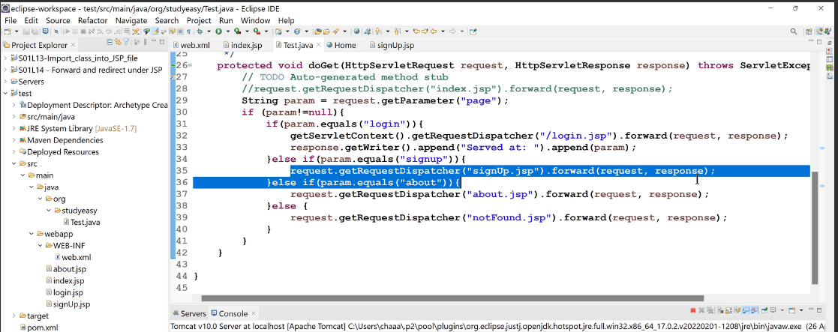
Index.jsp page
Web.xml-contain the default page which will display
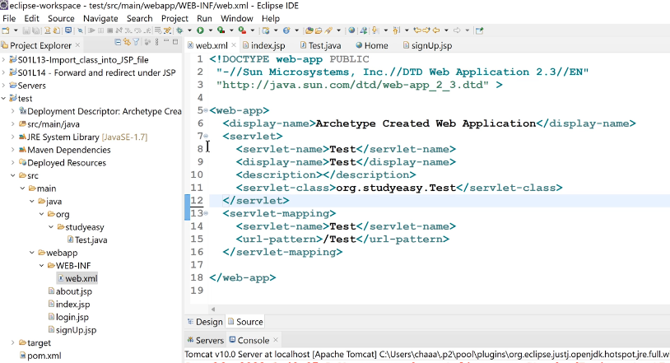
create a dynamic project for jsp and servlet
1)create dynamic web project-project name-if you have install tomcate then chose the runtime -
2)if not then create a project and we can add tomcate at runtime.for that window-pref-server-runtime env-add-choose the server"tomcat"-next-browse-dwonload the apache
---------
1)start your eclipse -as run administratot
2) create folder in c:/program file -"Apache Tomcat Foundation"
3)create folder called in Tomcat folder inside Apache Tomcat Foundation

4)go window-preference-runtime env-add-select apache-Tomcat10-next-Download and install
5) check/click on the browser path is c:/program file/Apache Tomcat Foundation/tomcat
5)click apply and close
6)go to eclipse -click on server tab-click on link-
7)Optional step-you dont see the server tab in eclipse-window-show view- server
7)click on link-click on apache-tomcat10-next-finishe-you will see the new tomcat server is created

---------
once your project is ready
1)go to -src-main-java-create servlet-package name-com.studyeasy-class name-Hello_Servlet-next-uncheck the doPost-next-finish
Note-if you are using 16+ then you have to use the jakarta as super package.
write the code in doPost()
response.getWriter().append("served at").append(request.getContextPath());
2) run the project-localhost:8080/Hello_Servlet/HelloServlet
------------

