
Department of Computer Engineering and Technology
MINI PROJECT REPORT
Computer Networks Laboratory
(CSE20110)
Laboratory Continuous Assessment 3

HTTP Proxy Server with Intelligent Caching

Submitted by
Sr. No. | Student Name | PRN
1 | Archita Agarwal | 1262243769
2 | Sumedh Nilawar | 1262250022
3 | Swarali Lokare | 1262243762
4 | Soumya Kumari | 1262243783

Group No. 3
Third Year B.Tech. Computer Engineering and Technology
Under the guidance of
Dr. Swati
Academic Year 2026–2027
Submission Date 22/10/26

Department of Computer Engineering and Technology
CERTIFICATE

This is to certify that the mini-project entitled “HTTP Proxy Server with Intelligent Caching” has been carried out by the following students of Third Year B.Tech. Computer Science and Engineering, Panel E, Batch E1, Group No. 3, under my guidance during the academic year 2026–2027.
Student Name | PRN
Archita Agarwal | 1262243769
Sumedh Nilawar | 1262250022
Swarali Lokare | 1262243762
Soumya Kumari | 1262243783

The report is submitted towards the mini-project component of Laboratory Continuous Assessment 3 for the Computer Networks Laboratory course.

Faculty Signature __________________________
Dr. Swati
Project Guide and Course Faculty
Date ____________________ Place: Pune

Acknowledgement
We would like to express our gratitude to the faculty of the Department of Computer Engineering and Technology for providing the opportunity to undertake this Computer Networks mini-project. We acknowledge the use of Python networking libraries and Streamlit documentation that helped us understand socket communication, request handling and dashboard development. The project work and report should be reviewed by all group members, and any guidance received from the project faculty should be acknowledged accurately before final submission.
Group No. 3

Abstract
This project implements an HTTP proxy server with Least Recently Used (LRU) caching using Python TCP sockets. The proxy accepts HTTP GET requests from a client, parses the target URL, generates an MD5-based cache key and checks an in-memory cache. If the requested resource is present, the stored response is returned directly; otherwise, the proxy connects to the origin server, forwards a GET request and relays the response. Successful HTTP 200 OK responses are stored in the cache. The LRU policy updates the recency of accessed entries and removes the least recently used entry when capacity is reached. The project includes a standalone terminal proxy and a Streamlit monitoring application. The dashboard displays request totals, cache hits and misses, hit ratio, estimated bandwidth saved, recent request logs and active cache entries. The standalone cache capacity is 20 entries, while the dashboard version uses 15. The implementation demonstrates HTTP request-response handling over TCP, URL parsing, multithreading, cache replacement and basic performance monitoring. Testing should confirm cache-hit behaviour, cache misses, unsupported-method handling and eviction under capacity pressure. No measured performance results are claimed in this report; actual observations and screenshots should be added after running the tests.
Keywords: HTTP, Proxy Server, TCP Sockets, LRU Cache, Multithreading, Streamlit, Cache Hit Ratio

Report Navigation
Table of contents: 1 Introduction and Project Objectives; 2 Proposed Design and Requirements; 3 Implementation and Technical Working; 4 Testing and Results; 5 Discussion and Conclusion; References; AI Usage Declaration; Appendices.

Table of Contents

Update the table of contents in Microsoft Word after final pagination. Main sections are listed above as a text guide.

List of Figures
List of Figures: Figure 2.1 Client–Proxy–Origin Architecture; Figure 3.1 Streamlit dashboard in its initial state; Figures 4.1–4.3 Dashboard telemetry, cache activity log, and observed upstream connection errors.

List of Tables
Table 1.1 Objectives; Table 2.1 Tools and Requirements; Table 2.2 Addressing; Table 4.1 Test Plan; Table 4.2 Objective Achievement; Table 5.1 Troubleshooting.

Formatting Note
Formatting follows the supplied college template. Review pagination and update the table of contents before submission.

1 Introduction and Project Objectives

1.1 Introduction and Background
HTTP uses a request–response model in which a client requests a resource and a server returns a response. TCP provides a reliable, ordered byte stream for communication between the client, proxy and origin server. A proxy server acts as an intermediary: it receives a client request, decides whether a cached response can be reused, and contacts the origin server when necessary. Caching is useful when the same resource is requested repeatedly because a valid stored response can avoid another upstream transfer. The project applies these concepts to plain HTTP GET requests and makes the process observable through request logs and cache statistics. HTTP semantics and caching behaviour are described in RFC 9110 and RFC 9111Python socket and threading facilities provide the transport and concurrency mechanisms.

1.2 Problem Statement
Repeated requests for the same HTTP resource can cause unnecessary communication with the origin server, increasing network traffic and potentially increasing response time. A local cache can reuse previously received responses, but its storage is limited and therefore needs a replacement policy. The project addresses this by forwarding cache misses to the origin server and using an LRU policy to manage stored responses.

1.3 Scope
The system is a localhost demonstration intended for learning and testing HTTP proxy behaviour. It listens at 127.0.0.1:8888, supports plain HTTP GET requests, uses an 8192-byte socket read buffer and stores responses in bounded in-memory caches. HTTPS tunnelling, persistent cache storage, broad production deployment and full HTTP cache validation are outside the implemented scope.

1.4 Objectives
Objectives are to implement TCP-based request handling, parse URLs, cache successful responses using LRU replacement, forward misses to the origin server, handle unsupported methods and expose cache activity through the dashboard. The verification methods are listed in Table 1.1.
Objective ID | Objective | Verification Method
O1 | Implement an HTTP proxy using TCP sockets and parse HTTP GET requests. | Send a plain HTTP GET through the proxy and inspect the response.
O2 | Use an in-memory LRU cache to serve repeated successful responses. | Request the same cacheable URL twice and inspect HIT/MISS logs.
O3 | Provide visibility into request and cache behaviour. | Inspect dashboard telemetry, request log and cache table.

2 Proposed Design and Requirements

2.1 Architecture and Network Topology
Figure 2.1 represents the client–proxy–origin arrangement. The client sends a GET request to the local proxy. The proxy computes a URL-based key and checks the LRU cache. A hit returns the stored response; a miss opens a TCP connection to the origin server, forwards the request and stores the response only when it begins with HTTP/1.1 200 OK. The Streamlit dashboard displays the cache and request activity.
Client / Test Client → HTTP Proxy (127.0.0.1:8888) → Origin Web Server
↘ LRU Cache + Streamlit Dashboard
Client / Test Client → HTTP Proxy (127.0.0.1:8888) → Origin Web Server
↘ LRU Cache + Streamlit Dashboard

2.2 Tools and System Requirements
The implementation uses Python, the socket and threading modules, OrderedDict, hashlib, Streamlit and Pandas. Exact package versions and the development machine specification were not provided in the source report, so they should be recorded from the actual environment rather than guessed.
Tool or Resource | Version or Specification | Purpose
Python | Python 3; exact version not specified in report | Proxy logic, sockets, threading and cache implementation
Streamlit | Version not specified | Monitoring dashboard and test client
TCP sockets / HTTP | Local proxy 127.0.0.1:8888; HTTP GET | Client-proxy and proxy-origin communication
OrderedDict / hashlib / Pandas | Python standard library and Pandas | LRU ordering, MD5 URL keys and dashboard tables

2.3 Addressing and Protocol Selection
The proxy uses TCP sockets. The client connects to 127.0.0.1 on port 8888. The target origin host and port are parsed from the requested URL, with port 80 used for plain HTTP when no port is specified. Requests are HTTP/1.1 GET messages. Gateway addressing is not applicable to this localhost socket demonstration.
Device / Interface | IP / Prefix | Gateway | Role
Client / test client | 127.0.0.1 (loopback) | Not applicable | Sends HTTP GET requests to the local proxy
Proxy listener | 127.0.0.1:8888 | Not applicable | Accepts client TCP connections
Origin web server | Host and port parsed from requested URL | Not applicable | Supplies resources on cache misses

TCP was selected because it provides reliable, ordered delivery of bytes for the request and response streams. HTTP GET is the only supported method in the implementation. Connection: close is sent to the origin so the response can be read until the connection closes. MD5 is used as a compact cache-key digest of the target URL; it is an indexing choice, not a security mechanism.

3 Implementation and Technical Working

3.1 Methodology
The workflow is: start the proxy listener; accept a client connection; read and validate the request line; reject unsupported methods; parse the target URL; calculate the MD5 key; check the LRU cache; return a cached response on a hit or contact the origin on a miss; store only successful 200 OK responses; relay the response; and update counters and logs. A worker thread handles each accepted connection. A lock protects shared cache operations and statistics.

3.2 Configuration or Code Implementation
The standalone implementation is in proxy_server.py and the dashboard application is in app.py. Both use Python sockets, threading, OrderedDict and URL parsing. The standalone cache capacity is 20 entries; the dashboard cache capacity is 15. Both use port 8888, a buffer size of 8192 bytes and a listen backlog of 50. The standalone origin timeout is 5 seconds and the dashboard version uses 6 seconds. The cache key is generated by hashing the target URL with MD5. Full source code should be attached in Appendix A.

3.3 Protocols and Technical Working
The client sends a request to the proxy over TCP. The request line supplies the method, URL and protocol. The proxy supports GET and returns 501 Not Implemented for other methods. On a cache miss, it opens a TCP socket to the origin host, sends a constructed HTTP/1.1 GET containing Host, User-Agent and Connection: close headers, and collects response chunks until the origin closes the connection. It caches the response only if it begins with HTTP/1.1 200 OK. Origin connection failures are subject to a timeout and are logged or printed by the respective implementation.

3.4 Execution Procedure
Prerequisites: Python and the dependencies used by the project, including Streamlit and Pandas. Keep app.py and proxy_server.py in the project directory. For the dashboard version, install the dependencies used by the source project, then run `streamlit run app.py`. For the standalone version, run `python proxy_server.py`. Confirm that port 8888 is available. In the dashboard, enter a plain HTTP URL in the test-client field and select Send Request. Repeat the same URL to check cache-hit behaviour. Exact dependency versions should be taken from the environment used for the demonstration.
The following screenshot from the supplied report shows the Streamlit dashboard before requests were submitted, including the proxy status, telemetry cards, test-client input, request log and active LRU cache.
Figure 3.1. Streamlit dashboard in its initial state.
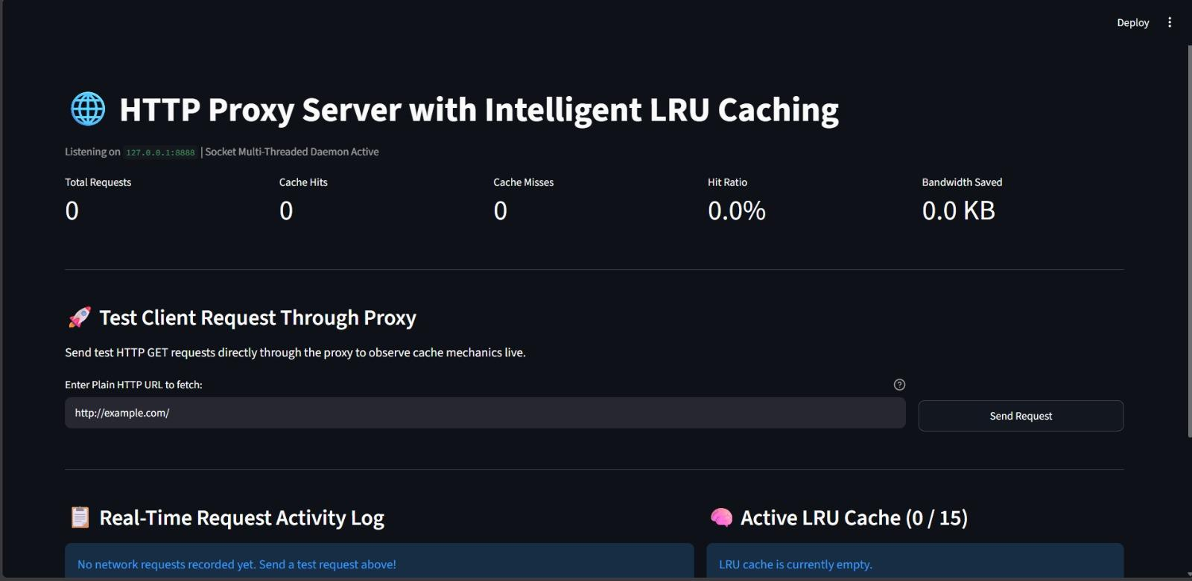
Figure 3.1 Proxy request-processing flow: Receive GET → Parse URL → MD5 cache key → Cache lookup → HIT: return stored response / MISS: contact origin → Cache 200 OK → Relay response → Update logs and metrics.
Replace this text with a genuine implementation screenshot before submission.

4 Testing and Results

4.1 Test Plan
The test plan covers first-time requests, repeated requests, a different URL, unsupported HTTP methods, cache-capacity overflow and dashboard monitoring. The success criteria are that a first cacheable request is recorded as a miss, a repeated request is recorded as a hit, unsupported methods return 501, LRU eviction removes the least recently used item and the dashboard displays the resulting counters and cache state. The table records expected behaviour; observed results should be completed after running each test.
Test ID | Test and Input | Expected Result | Observed Result | Status
T1 | First GET for a URL not in cache | MISS; origin contacted; a 200 OK response is stored | To be recorded during execution | Pending
T2 | Repeat the same cacheable GET | HIT; response returned from memory | To be recorded during execution | Pending
T3 | Send an unsupported method such as POST | 501 Not Implemented | To be recorded during execution | Pending
T4 | Exceed configured cache capacity | Least recently used item is evicted | To be recorded during execution | Pending
T5 | Use dashboard test client and inspect telemetry | Response time, size, hit/miss counts and cache state are visible | To be recorded during execution | Pending

4.2 Results and Execution Evidence
Add actual output from the running application here. Recommended evidence includes the first request marked MISS, the repeated request marked HIT, the response status, cache entries and dashboard metrics. Explain each screenshot in one or two sentences. The source report defines the expected outcomes but does not provide measured execution results, so no test is marked as passed without evidence.
The screenshots below are reproduced from the original report. They document dashboard telemetry, cache activity and a failed upstream request observed during testing. The screenshots are evidence of the displayed states; they should not be interpreted as a complete benchmark or proof that every planned test passed.
Figure 4.1. Dashboard telemetry after request activity (4 total requests, 1 cache hit, 3 cache misses).
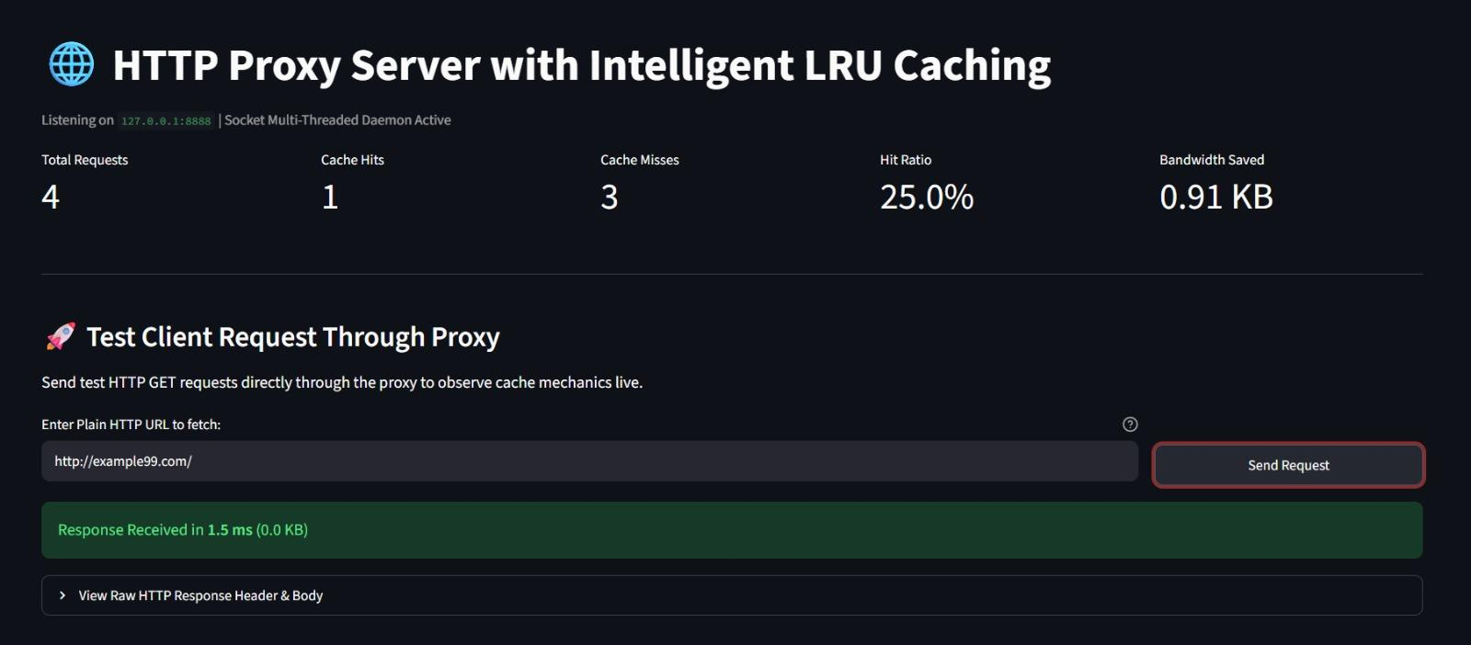
Figure 4.2. Request activity log showing cache-hit and cache-miss entries.
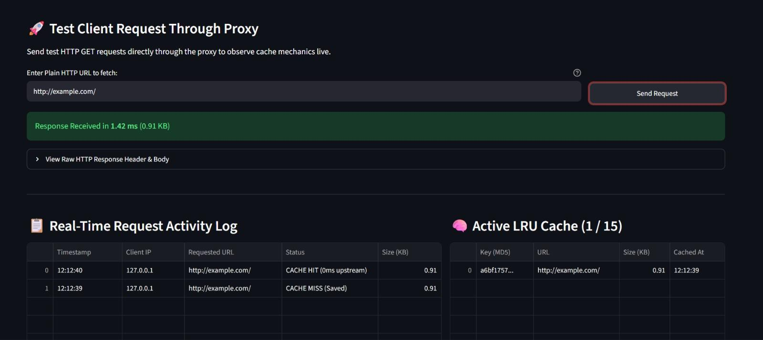
Figure 4.3. Request log containing upstream connection errors; this is recorded as an observed failure state.
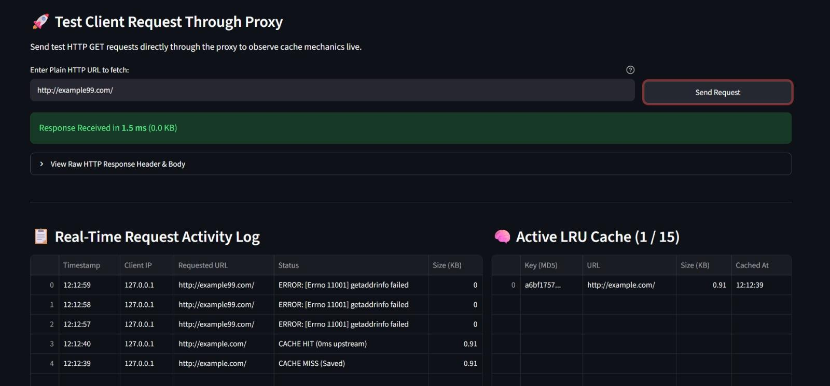
The execution evidence is shown in Figures 4.1–4.3 above.

4.3 Objective Achievement
Table 4.2 maps the objectives to the relevant test cases. The implementation includes the required code paths, but final achievement should be confirmed with real execution evidence. Replace the provisional notes with the observed results after the test run.
Objective ID | Evidence or Test ID | Outcome
O1 | T1 and request/response logs | Implementation described; attach execution evidence before claiming a pass
O2 | T1, T2 and T4 | Expected LRU behaviour; verify with actual run
O3 | T5 and dashboard screenshot | Dashboard features are implemented; attach screenshot

5 Discussion and Conclusion

5.1 Discussion and Comparative Analysis
On a cache miss, the proxy must contact the origin server; on a cache hit, it can return the stored response without a new origin request. Therefore, a repeated cacheable request is expected to have lower latency in many cases, although actual timings depend on the origin server, network and response size. The dashboard records elapsed time for test-client requests and estimates bandwidth saved from response sizes served on hits. No numerical speed-up or throughput result is claimed without measured data.

5.2 Advantages and Applications
The project demonstrates how a proxy can reduce repeated upstream requests, how LRU replacement manages a limited cache, and how threading can handle multiple client connections. The dashboard helps learners observe hits, misses, response sizes and cache occupancy. Similar concepts are used in web gateways, content delivery systems and network performance experiments, although this project is a local educational prototype.

5.3 Limitations
The implementation supports plain HTTP GET requests only and caches responses identified as 200 OK. The cache is in memory and is lost when the process stops. The dashboard and standalone versions use different capacities (15 and 20). The implementation does not enforce TTL or full HTTP Cache-Control freshness validation, does not provide HTTPS CONNECT tunnelling, and is designed primarily for localhost demonstration. Production security, authentication, access controls and broad load testing are not established by the supplied report.

5.4 Challenges and Troubleshooting
The supplied report does not document specific development incidents, so this section lists common implementation conditions rather than claiming they occurred. Confirm the details against the group’s actual troubleshooting history before submission.
Issue | Cause or Diagnosis | Solution and Verification
Unsupported HTTP method | Implementation intentionally supports GET only | Return 501 Not Implemented; verify with an unsupported-method test
Origin server delay or failure | Origin connection may not complete within timeout | Connection timeout is 5 seconds in standalone version and 6 seconds in dashboard version; inspect logs
Cache capacity reached | Bounded in-memory cache is full | LRU eviction removes the least recently used entry

5.5 Future Scope
Future improvements include HTTPS CONNECT tunnelling, standards-based Cache-Control and TTL handling, cache-policy comparisons with LFU and FIFO, cache prioritisation using access frequency and response size, authentication and request filtering, persistent storage, richer response-time and hit-ratio graphs, and tests using multiple clients and larger workloads.

5.6 Conclusion
The project implements a Python TCP-based HTTP proxy with URL-derived cache keys, LRU replacement, multithreaded client handling and a Streamlit monitoring dashboard. It supports GET requests, serves cache hits from memory, forwards misses to an origin server and caches successful 200 OK responses. The implementation provides a practical demonstration of HTTP request-response communication, proxy architecture, cache replacement and network telemetry. Final performance conclusions should be based on actual test outputs and screenshots.

References

[1] Python Software Foundation, “socket — Low-level networking interface,” Python documentation. https://docs.python.org/3/library/socket.html (accessed 15 Oct. 2026).
[2] Python Software Foundation, “threading — Thread-based parallelism,” Python documentation. https://docs.python.org/3/library/threading.html (accessed 15 Oct. 2026).
[3] R. Fielding, M. Nottingham, and J. Reschke, “HTTP Semantics,” RFC 9110, Internet Engineering Task Force, Jun. 2022.
[4] M. Nottingham, “HTTP Caching,” RFC 9111, Internet Engineering Task Force, Jun. 2022.
[5] Streamlit, “Streamlit documentation.” https://docs.streamlit.io/ (accessed 15 Oct. 2026).
[6] J. F. Kurose and K. W. Ross, Computer Networking: A Top-Down Approach. Pearson.
[7] A. S. Tanenbaum and D. J. Wetherall, Computer Networks. Pearson.

AI Usage Declaration
Declaration: We take responsibility for the accuracy of this report and understand the submitted implementation and results. Sources and assistance used have been acknowledged.
Student Name | PRN | Signature
Archita Agarwal | 1262243769
Sumedh Nilawar | 1262250022
Swarali Lokare | 1262243762
Soumya Kumari | 1262243783

Appendices

Appendix A Code and Configuration
The project source files are app.py (Streamlit dashboard and proxy engine) and proxy_server.py (standalone proxy). Attach the final source files here or include readable listings in the submitted report. Do not include passwords, tokens or other secrets.

Appendix B Additional Evidence
Attach genuine screenshots of the running dashboard, request logs, cache hit/miss sequence and any packet captures or terminal output collected during testing. Label each item and explain what it demonstrates.

Appendix C Individual Contributions
Complete Table C.1 with the actual contribution of each group member. Do not use assumed or identical contribution statements without confirming them with the group.
Student Name and PRN | Work Completed | Evidence or Deliverable
Archita Agarwal - 1262243769 | Complete according to actual contribution; confirm before submission | Code/report section to be identified by group
Sumedh Nilawar - 1262250022 | Complete according to actual contribution; confirm before submission | Code/report section to be identified by group
Swarali Lokare - 1262243762 | Complete according to actual contribution; confirm before submission | Code/report section to be identified by group
Soumya Kumari - 1262243783 | Complete according to actual contribution; confirm before submission | Code/report section to be identified by group

