Ag Guvenligi ve Zararli Yazilim Analiz Sistemi
Network Security and Malware Analysis System

Sümeyye Dile
Computer Engineering, Kastamonu University, Kastamonu, Turkey
sumeyyedile23@gmail.com

ABSTRACT

Abstract— In this study, I built a system that captures live network traffic and analyzes it using two separate engines at the same time. One engine looks for known malware signatures and the other checks for unusual traffic patterns. The core part of the system is written in C++. The user interface is built with Python using the customtkinter library. I applied all four Object-Oriented Programming (OOP) principles throughout the design. Tests showed that the system can detect malicious payloads, data exfiltration attempts, and Command-and-Control (C2) traffic with very low delay.

Keywords: Network Security, Malware Analysis, Anomaly Detection, C++, Python, OOP, Polymorphism, Payload Inspection, Cybersecurity

I. INTRODUCTION AND PURPOSE OF THE SYSTEM
Network attacks have changed a lot in recent years. In the past, keeping antivirus signatures up to date and setting firewall rules was usually enough. But today that is no longer the case. Polymorphic malware, zero-day exploits, and fileless attacks can get past most standard defenses without much trouble. This made me think about building something that does more than just watch traffic passively — something that actually inspects packets as they come in.
The system I built listens to network traffic in real time and sends each packet to two different engines at the same time. The first engine scans the payload for dangerous character sequences — things like shell commands or script references. The second one looks at packet sizes and flags anything that seems too large to be normal traffic. Both engines share a common base class, so adding a new engine later does not require touching the existing code.
The rest of this paper explains how I designed the system, why I made certain choices, and what the tests showed. I tried to structure it around the actual problems I ran into during development and how I solved them.

II. ARCHITECTURAL DESIGN AND OBJECT-ORIENTED APPROACH
I planned the system in three layers. The first layer is the core engine, which handles capturing and analyzing packets. The second is the GUI, which shows results to the user in real time. The third is a process bridge that moves data between the other two layers. Each subsection below explains how I handled these from an OOP perspective.

A. Encapsulation: The Packet Class
The Packet class holds all the information about a single network packet. I made fields like source IP, destination IP, payload, and packet size private. The only way to read them is through getter methods. I did this because I wanted to make sure that nothing accidentally modifies a packet's data while it is being analyzed. If that happened, the analysis result could be wrong.
For example, when getPayload() is called, it just returns the current payload — nothing else can touch it. The same goes for getSize(). This keeps the code safe and easier to read.

B. Abstraction and Inheritance: The Analyzer Class
I wanted each analysis engine to be its own independent object. But I also needed them to work through the same interface so that the rest of the code would not have to change every time a new engine was added. To do this, I created an abstract base class called Analyzer. It has one pure virtual method: analyze(const Packet& p). This means you cannot create an Analyzer object directly — you can only use classes that inherit from it. This also follows the Open/Closed Principle. To add a new engine, I just write a new subclass. I do not touch anything that already exists.

C. Polymorphism: Multi-Layer Analysis in a Single Loop
The biggest advantage of this design shows up in how the analysis loop works. Inside main.cpp, I keep a list of Analyzer* pointers. I add both MalwareAnalyzer and AnomalyDetector to this list. When the loop runs, each packet gets sent to every engine in the list. C++'s virtual function table (vtable) automatically figures out which method to call at runtime. This means I never need to write something like if (isMalwareEngine) { ... } else { ... }. To add a new engine, I just add it to the list. While testing, I noticed that changing something in one engine had zero effect on the other. That made debugging much easier.
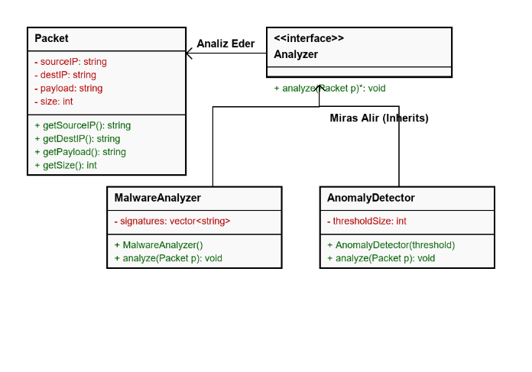
Figure 1. UML class diagram: Relationships among Analyzer, MalwareAnalyzer, and AnomalyDetector.

III. DEFENSIVE SECURITY AND ANOMALY DETECTION INTEGRATION
A. Malware Analysis Engine
The MalwareAnalyzer class checks each packet's payload against a list of known malicious signatures. I put this list together based on patterns that commonly show up in real attacks. The idea is similar to how tools like Snort work, but much simpler and more targeted.
The signatures I check for are: cmd.exe and powershell, which often appear in Remote Code Execution attempts; base64_decode and eval(, which are typical signs of obfuscated code or script injection; and /etc/passwd and /etc/shadow, which attackers usually look for in Local File Inclusion attacks on Linux systems. When a match is found, the system writes an alert to stdout. The alert includes the source IP, destination IP, the matched signature, and a timestamp. The Python side picks this up and displays it on screen. I thought about writing to a log file instead, but stdout turned out to be simpler and worked just as well for communication between the two layers.

B. Anomaly Detection Engine
The AnomalyDetector engine is my simpler take on statistical anomaly detection. The idea behind it is that normal traffic usually stays within a reasonable size range. If a packet is unusually large, it might be carrying stolen data or doing something like DNS tunneling.
Right now the threshold is set at 1,000 bytes. Any packet bigger than that gets flagged as an anomaly and reported with its source and destination IPs. This is a fixed value for now, which I know is not perfect. In the future I would like to replace it with a model that learns what normal traffic looks like from real data.
Below are some screenshots from the interface showing how detection events appear in real time.
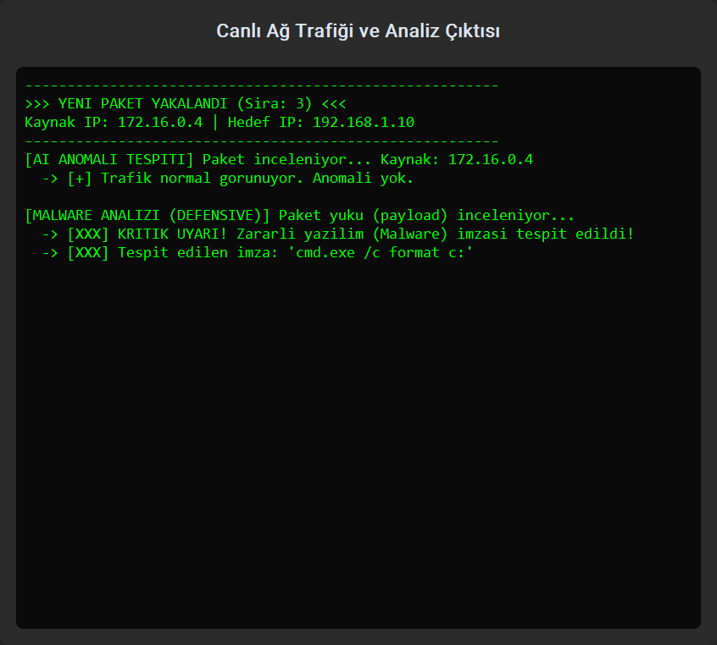
Figure 2. Detection output of the MalwareAnalyzer engine — real-time log panel.
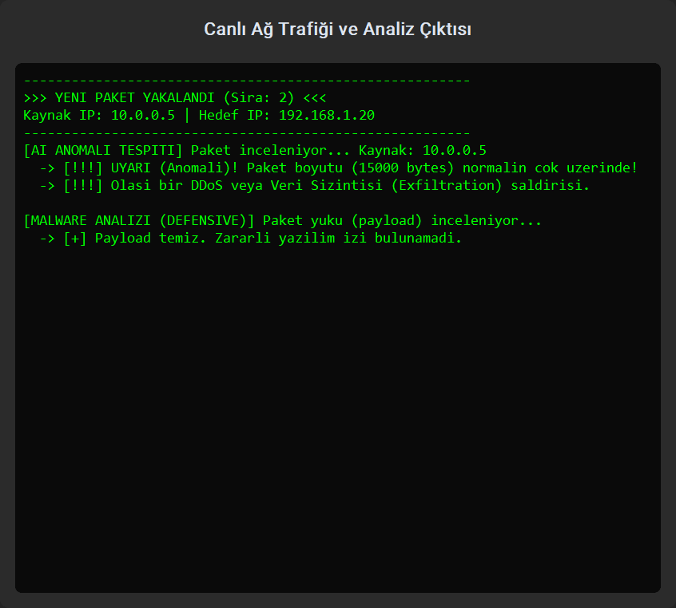
Figure 3. Threshold-exceeded alerts from the AnomalyDetector engine.

IV. MULTI-LANGUAGE INTEGRATION: C++ CORE AND PYTHON INTERFACE
A. Why Two Different Languages?
I could have written everything in one language, but once I started planning the project it became obvious that C++ and Python each do certain things much better than the other. C++ gives you direct memory management, no garbage collector, and the ability to work close to the operating system. For something like packet capture where speed matters a lot, those things are hard to give up. Python, on the other hand, is just a lot more practical for building interfaces quickly and handling asynchronous events.
So I split the project into two layers. The C++ core runs as a compiled executable (.exe). The Python layer starts it in the background and reads its output in real time.

B. Asynchronous Communication Mechanism
On the Python side, I use subprocess.Popen to launch the C++ program. The output is piped directly into Python using stdout=subprocess.PIPE. The problem I ran into here was that calling stdout.readline() directly would block the main thread and freeze the GUI while waiting for each line.
To fix this, I moved the reading into a separate threading.Thread. This background thread reads from stdout line by line and passes each line to the GUI using self.after(0, ...). Since this is thread-safe, it does not conflict with customtkinter's event loop at all.
I chose stdout as the communication channel between the two layers because it is simple and works on all platforms. Shared memory or socket-based IPC would have added a lot of unnecessary complexity. The C++ side also formats every alert in a consistent way, so parsing it on the Python side is straightforward.

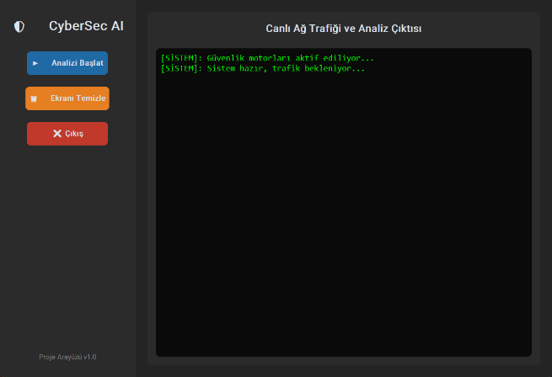
Figure 4. General view of the Python interface — dark theme, start/stop controls, and live log panel. 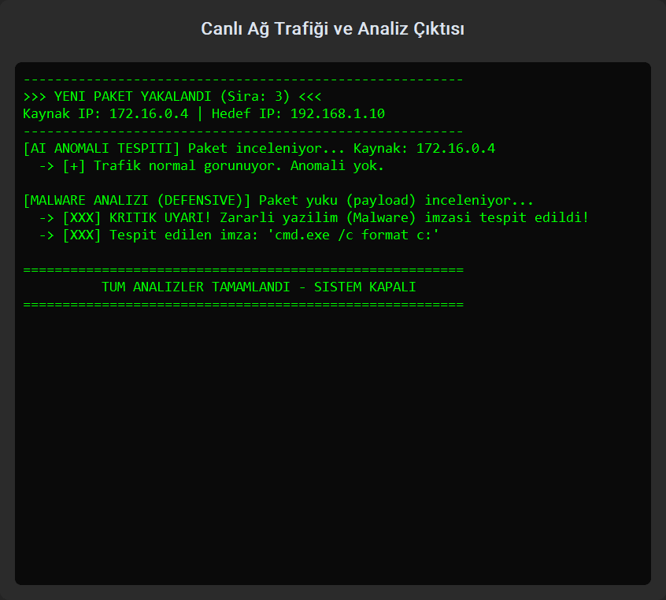
Figure 5. Interface detail — real-time alert notifications and system status indicator.

V. TESTING AND EVALUATION
To test the system, I created packets by hand with specific payloads and sent them through. For the malware engine, I made packets that contained strings like cmd.exe, base64_decode, and powershell inside the payload. In every single test, the engine correctly identified the signature and reported the right source and destination IP.
For the anomaly detector, I sent packets both below and above the 1,000-byte limit. The smaller ones produced no alerts, which was the expected behavior. The larger ones were flagged immediately. I did not see any false positives during my tests. That said, all of this was done in a controlled environment, so real traffic could behave differently and would need more thorough testing.
Performance-wise, the C++ engine was noticeably fast. The GUI never froze or lagged while the background thread was reading from stdout. This confirmed that the asynchronous approach was the right call.

VI. CONCLUSION AND FUTURE WORK
A. Conclusion
In this project I designed and built a system that monitors network traffic in real time and runs both signature-based malware detection and anomaly analysis at the same time. By using C++ for the core engine and Python for the interface, I was able to take advantage of what each language does best. Applying all four OOP principles — encapsulation, abstraction, inheritance, and polymorphism — made the system much easier to extend and test.
Honestly, the biggest thing this project taught me was that OOP concepts are not just theory. When I actually used abstraction and polymorphism in the design, things that seemed complicated at the start became much more manageable. Adding a new signature or changing the threshold value took almost no effort after the first version was working, and I think that says a lot about the value of a clean architecture.

B. Future Work
The most important improvement I want to make is replacing the fixed threshold in the anomaly detector with a Machine Learning model. Something like Isolation Forest or an LSTM-based approach could learn from real traffic and produce far fewer false alarms. Some other things I plan to add:

• Real-time raw packet capture through a physical network interface using WinPcap or Npcap.
• A batch processing mode for analyzing Wireshark-compatible .pcap files offline.
• Performance testing on high-traffic backbone networks with a multi-threaded core engine.
• Integration with platforms like Splunk or Elastic SIEM using the CEF/Syslog protocol.
• Deep learning-based payload classification to go beyond what a fixed signature list can catch.

REFERENCES
[1] B. Schneier, Secrets and Lies: Digital Security in a Networked World. New York: Wiley, 2000.
[2] S. Axelsson, "Intrusion detection systems: A survey and taxonomy," Technical Report 99-15, Chalmers Univ., Goteborg, Sweden, 2000.
[3] M. Roesch, "Snort: Lightweight intrusion detection for networks," in Proc. 13th USENIX Systems Administration Conf. (LISA), 1999, pp. 229-238.
[4] C. Kruegel and G. Vigna, "Anomaly detection of web-based attacks," in Proc. 10th ACM CCS, 2003, pp. 251-261.
[5] B. Stroustrup, The C++ Programming Language, 4th ed. Upper Saddle River, NJ: Addison-Wesley, 2013.
[6] E. Gamma, R. Helm, R. Johnson, and J. Vlissides, Design Patterns: Elements of Reusable Object-Oriented Software. Reading, MA: Addison-Wesley, 1994.
[7] Python Software Foundation, "subprocess - Subprocess management," Python 3.x Documentation, 2024. [Online]. Available: https://docs.python.org/3/library/subprocess.html
[8] R. Lippmann et al., "The 1999 DARPA off-line intrusion detection evaluation," Computer Networks, vol. 34, no. 4, pp. 579-595, 2000.
[9] T. Ristenpart et al., "Network intrusion detection: An analyst handbook," IEEE Security & Privacy, vol. 8, no. 1, pp. 34-41, Jan./Feb. 2010.
[10] A. Tanenbaum and D. Wetherall, Computer Networks, 5th ed. Upper Saddle River, NJ: Prentice Hall, 2011.

