Churn Reduction

Sumeet Patel

08 October 2018

Contents
Chapter 1 3
Introduction 3
1.1 Problem Description 3
1.2 Problem Statement 3
1.3 Data 3
Chapter 2 5
Methodology 5
2.1 Pre Processing 5
2.1.1 Missing value analysis 11
2.1.2 Outlier analysis 11
2.1.3 Feature Selection 17
2.1.4 Feature Scaling 19
2.1.5 Sampling 19
2.2 Modeling 19
2.2.1 Model Selection 19
Chapter 3 20
Conclusion 20
3.1 Model Evaluation 20
3.1.1 Decision tree 20
3.1.1 Random forest 20
3.1.1 Logistic regression 21
3.1.1 Naïve Bayes 21
3.1.1 KNN 21
Appendix A - Extra Figures 22
Appendix A – Python codes 24
References 28

Chapter 1

Introduction

Problem Description
Churn (loss of customers to competition) is a big problem for companies because it is more expensive to acquire a new customer than to keep the existing one from leaving. This problem statement is targeted at enabling churn reduction using analytics concepts.

Problem Statement
The objective of this case is to predict customer behaviour. We have a dataset that has customer usage pattern and if the customer has moved or not. We will develop an algorithm to predict the churn score based on usage pattern.

Data
Data consist of two files – train and test. Both contains different number of observations but same number of variables. As the test file also contains target variable values so we will combine both the files in order to do pre-processing of the data. Later we will create a test file for prediction.
After combining both the files there were 5000 observations and 21 variables. Following is the sample of the combined data set.
Table 1.1 Churn data (columns 1-7)
State | Account length | Area code | Phone number | International plan | Voice mail plan | Number vmail messages
KS | 128 | 415 | 382-4657 | No | yes | 25
OH | 107 | 415 | 371-7191 | No | Yes | 26
NJ | 137 | 415 | 358-1921 | No | No | 0
OH | 84 | 408 | 375-9999 | yes | No | 0

Table 1.1 Churn data (columns 8-14)
Total day minutes | Total day calls | Total day charge | Total eve minutes | Total eve calls | Total eve charge | Total night minutes
265.1 | 110 | 45.07 | 197.4 | 99 | 16.78 | 244.7
161.6 | 123 | 27.47 | 197.5 | 103 | 16.62 | 254.4
243.4 | 114 | 41.38 | 121.2 | 110 | 10.3 | 162.6
299.4 | 71 | 50.9 | 61.9 | 88 | 5.26 | 196.9

Table 1-3 Churn data (columns 15-21)
Total night calls | Total night charge | Total intl minutes | Total intl calls | Total intl charge | Number customer service calls | Churn
91 | 11.01 | 10 | 3 | 2.7 | 1 | False
103 | 11.45 | 13.7 | 3 | 3.7 | 1 | False
104 | 7.32 | 12.2 | 5 | 3.29 | 0 | False
89 | 8.86 | 6.6 | 7 | 1.78 | 2 | False

Following are the given 20 independent variables

- state
- account length
- area code
- phone number
- international plan
- voicemail plan
- number of voicemail messages
- total day minutes
- day calls made
- total day charge
- total evening minutes
- total evening calls
- total evening charge
- total night minutes
- total night calls
- total night charge
- total intl minutes
- total intlcalls
- total intlcharge
- number customer service calls

And the target variable is ‘Churn’ which we have to predict after developing model.

Chapter 2

Methodology

2.1 Pre Processing
Let’s have a look at all the variables and their description.

Table 2.1 Summary before treating outliers
Variables | Std | Mean | Median | Min | Max | Count | Type | Unique
State | - | - | - | - | - | 5000 | Object | 51
Account length | 39.69456 | 100.2586 | 100 | 1 | 243 | 5000 | Integer | 218
Area code | 42.209182 | 436.9114 | 415 | 408 | 510 | 5000 | Integer | 3
Phone number | - | - | - | - | - | 5000 | Object | 5000
Voicemail plan | - | - | - | - | - | 5000 | Object | 2
International plan | - | - | - | - | - | 5000 | Object | 2
Vmail messages | 13.546393 | 7.7552 | 0 | 0 | 52 | 5000 | Integer | 48
Total day min | 53.894699 | 180.2889 | 180.1 | 0 | 351.5 | 5000 | Float | 1961
Total day calls | 19.831197 | 100.0294 | 100 | 0 | 165 | 5000 | Integer | 123
Total day charge | 9.162069 | 30.649668 | 30.62 | 0 | 59.76 | 5000 | Float | 1961
Total eve min | 50.551309 | 200.63656 | 201 | 0 | 363.7 | 5000 | Float | 1879
Total eve calls | 19.826496 | 100.191 | 100 | 0 | 170 | 5000 | Integer | 126
Total eve charge | 4.296843 | 17.054322 | 17.09 | 0 | 30.91 | 5000 | Float | 1659
Total night min | 50.527789 | 200.39162 | 200.4 | 0 | 395 | 5000 | Float | 1853
Total night calls | 19.958686 | 99.9192 | 100 | 0 | 175 | 5000 | Integer | 131
Total night charge | 2.273763 | 9.017732 | 9.02 | 0 | 17.77 | 5000 | Float | 1028
Total intl min | 2.761396 | 10.26178 | 10.3 | 0 | 20 | 5000 | Float | 170
Total intl calls | 2.456788 | 4.4352 | 4 | 0 | 20 | 5000 | Integer | 21
Total intl charge | 0.745514 | 2.771196 | 2.78 | 0 | 5.4 | 5000 | Float | 170
No. cust serv calls | 1.306363 | 1.5704 | 1 | 0 | 9 | 5000 | Integer | 10
Churn | - | - | - | - | - | 5000 | Object | 2

Before moving towards the data pre-processing let’s have a look at the data distribution across all variables. First we will check the distribution of target variable.
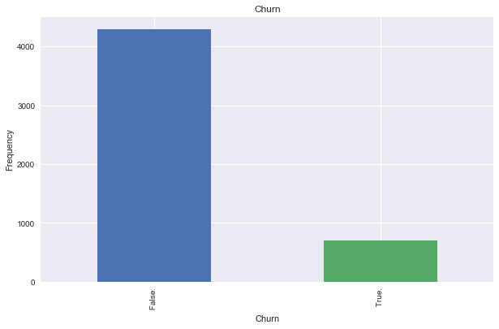
So our target variable contains two classes true and false which shows whether the customer has moved or not respectively. About 85% of the customers has not moved while the remaining has moved.

Now let’s see the Churn count w.r.t. all the predictive variables.
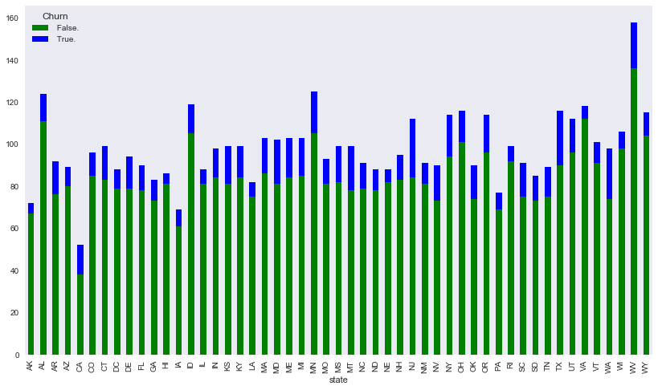
There are 51 categories in the state and looking at the graph it seems that all of them have approximately similar percentage of churning.

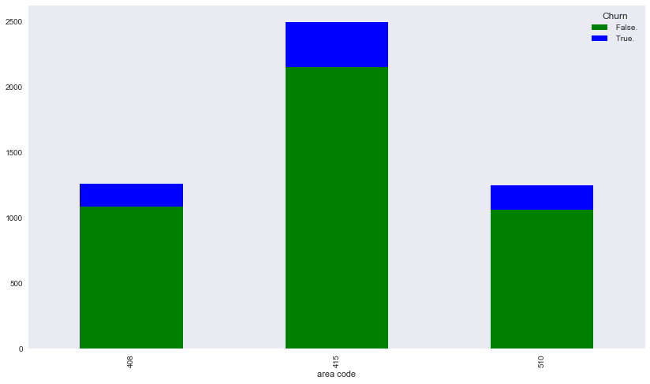

Although the area code is numeric, we have converted it into object as there are only three categories. And the mean, median will not be useful as it is categorising the areas. Percentage of churn rate is looking similar in area 408 and 510 while it is a bit higher in area code 415.

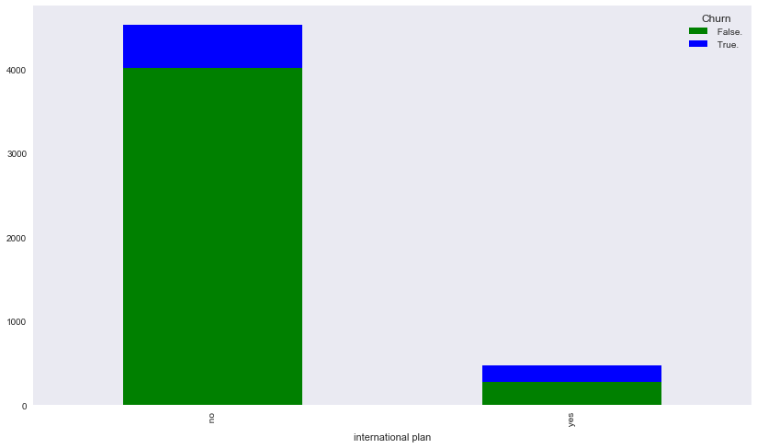
Another categorical variable is international plan which has two categories. Majority of the customers don’t have international plan. And graph says that those who doesn’t have international plan are more likely to churn than those who have.

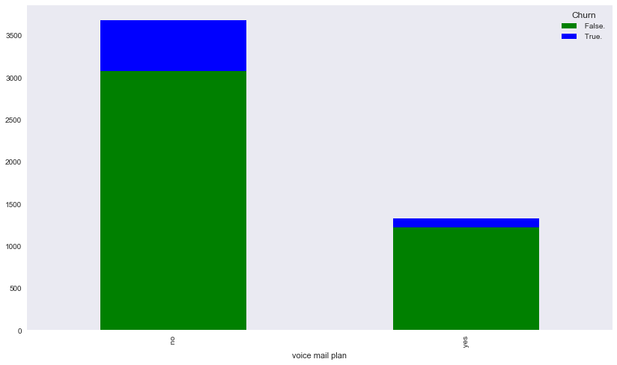

Likewise international plan, similar is the interpretation in voice mail plan. Those customers who don’t have voice mail plan are likely to churn.

Let’s plot the histogram to see the distribution of continuous variables:
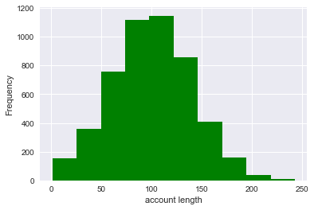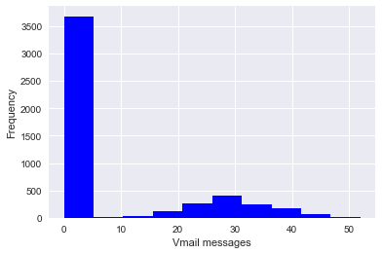

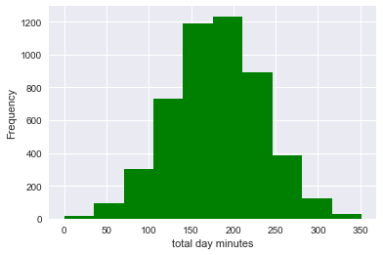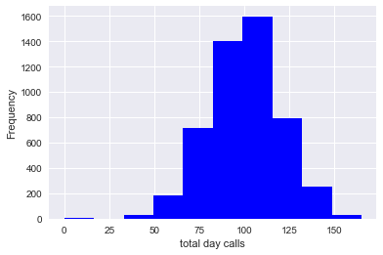
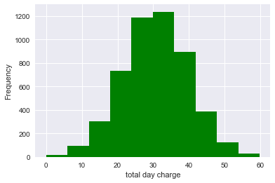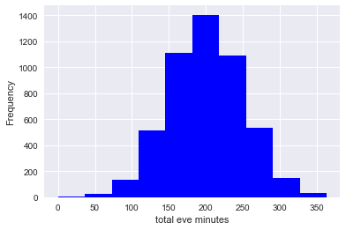
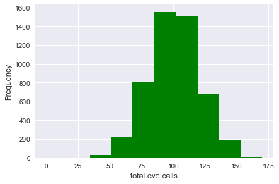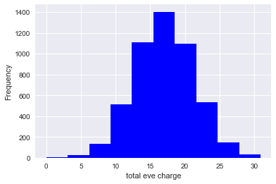
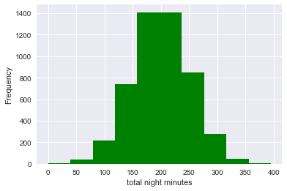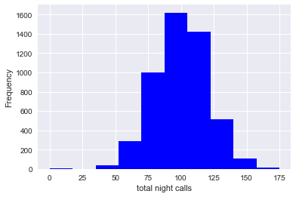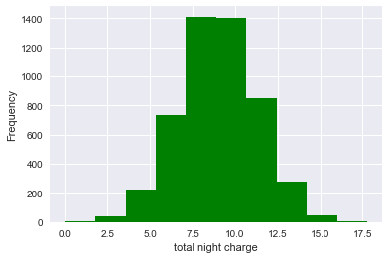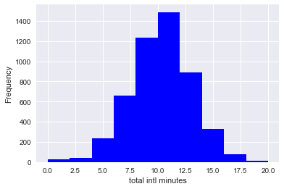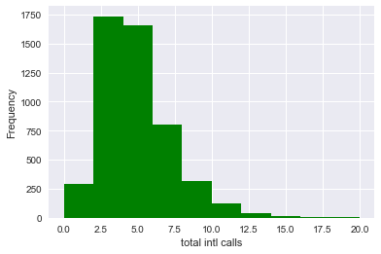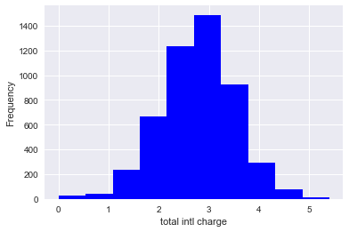
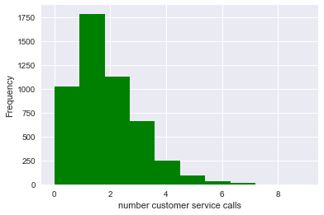

After looking at the plots we can conclude that most of the variables are skewed due to presence of outliers. A few of them looks evenly distributed but still we will check those while performing outlier analysis.
One variable ‘phone number’ has been dropped as it contains all the unique values. So it is of no use.

2.1.1 Missing value analysis
As we have seen in the description (Table 2.1) that all the variables have the count of 5000. It means there are no missing value in any variable.

2.1.2 Outlier analysis

We can see the distribution of continuous variables from histograms plotted above. Most of them are skewed seems carry more outliers and a few normally distributed and also possess outliers. We have used the percentile capping method to treat the outliers. Values below 1st percentile are replaced by the value at 1st percentile, and values that are greater than the value at 99th percentile are replaced by the value at 99th percentile. In a couple of variables values above upper extreme are capped by 97th percentile as the outliers were still present after capping with 99th percentile.
Following is the summary in the form of boxplot of the dataset before and after treating the outliers.

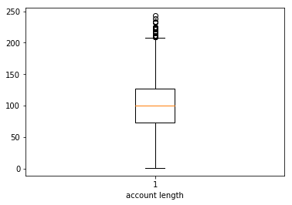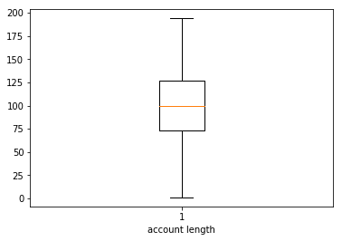

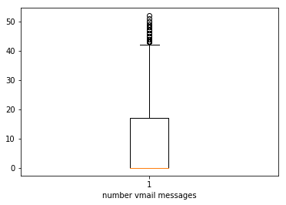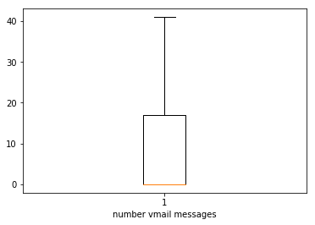

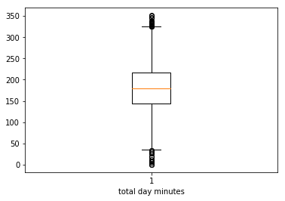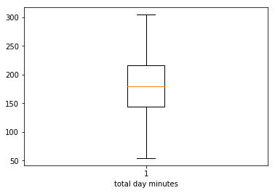

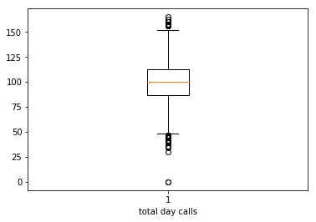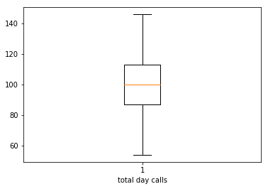

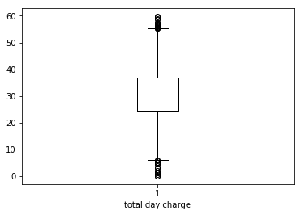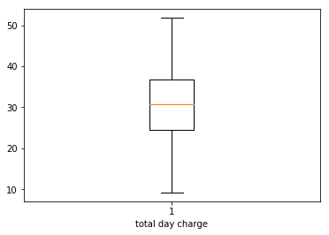

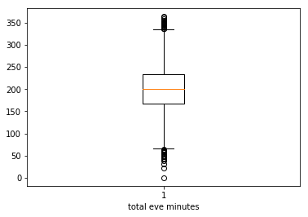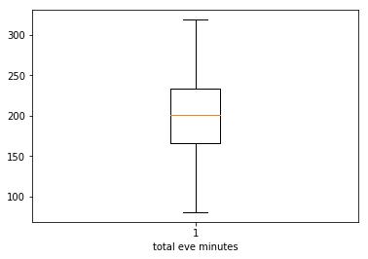

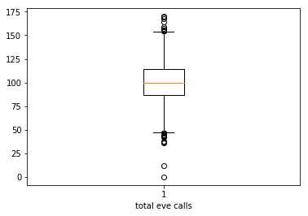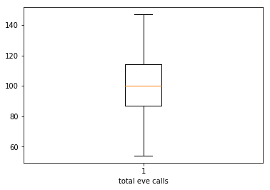

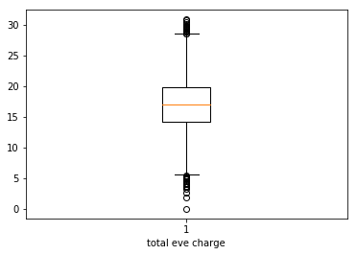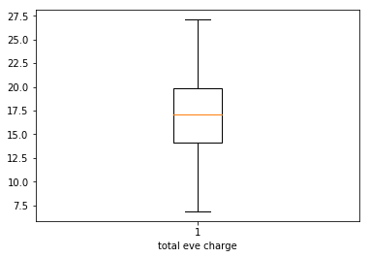

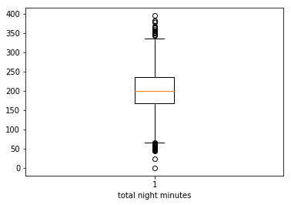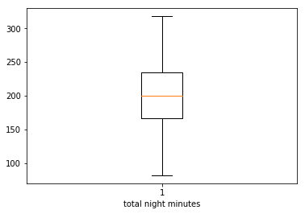

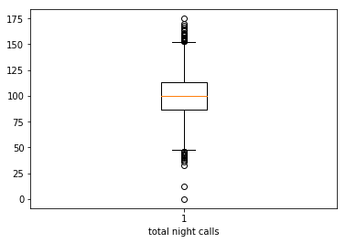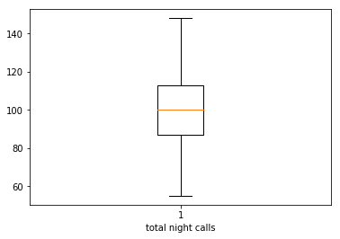

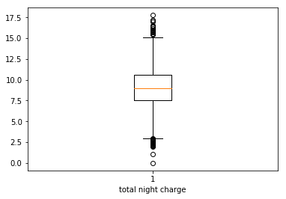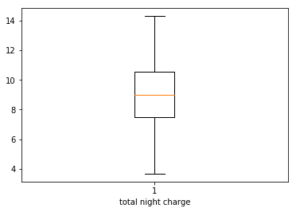

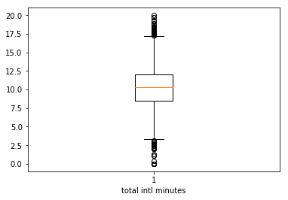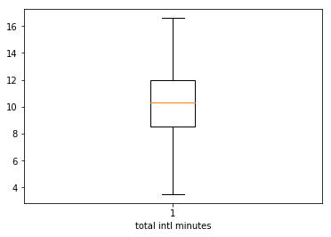

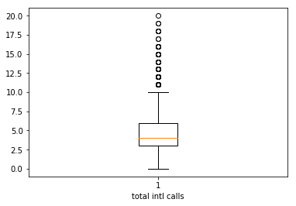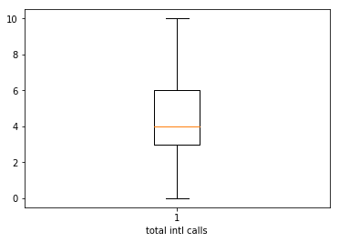

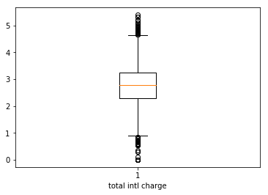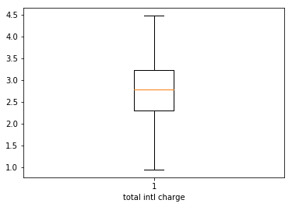
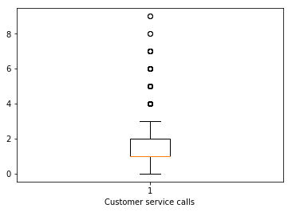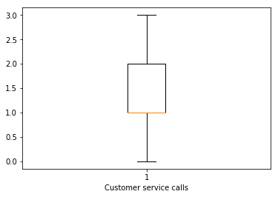

After treating the outliers there is a drop in the mean and the standard deviation of all the variables but that is very minute.

Table 2.2 Summary after treating outliers
Variables | Std | Mean | Median | Min | Max | Count | Type
Account length | 39.273954 | 100.1032 | 100 | 1 | 194 | 5000 | Integer
Vmail messages | 13.394899 | 7.6984 | 0 | 0 | 41 | 5000 | Integer
Total day min | 52.985183 | 180.30014 | 180.1 | 54.2 | 304.61 | 5000 | Float
Total day calls | 19.441226 | 100.0688 | 100 | 54 | 146 | 5000 | Integer
Total day charge | 9.007677 | 30.65139 | 30.62 | 9.2 | 51.78 | 5000 | Float
Total eve min | 49.622327 | 200.65356 | 201 | 80.6 | 318.8 | 5000 | Float
Total eve calls | 19.474736 | 100.2052 | 100 | 54 | 147 | 5000 | Integer
Total eve charge | 4.217951 | 17.055766 | 17.09 | 6.85 | 27.1 | 5000 | Float
Total night min | 49.50321 | 200.35092 | 200.4 | 81.6 | 318 | 5000 | Float
Total night calls | 19.538941 | 99.9371 | 100 | 54.99 | 148 | 5000 | Integer
Total night charge | 2.227705 | 9.015876 | 9.02 | 3.67 | 14.31 | 5000 | Float
Total intl min | 2.665299 | 10.27316 | 10.3 | 3.5 | 16.6 | 5000 | Float
Total intl calls | 2.23395 | 4.3686 | 4 | 0 | 10 | 5000 | Integer
Total intl charge | 0.719408 | 2.774294 | 2.78 | 0.95 | 4.48 | 5000 | Float
No. cust serv calls | 1.040261 | 1.4464 | 1 | 0 | 3 | 5000 | Integer

2.1.3 Feature Selection

Here we will now check the correlation within the continuous variables through correlation plot. If the continuous predictive variables are correlated to any other than we will try to eliminate in between those variables which are highly correlated.

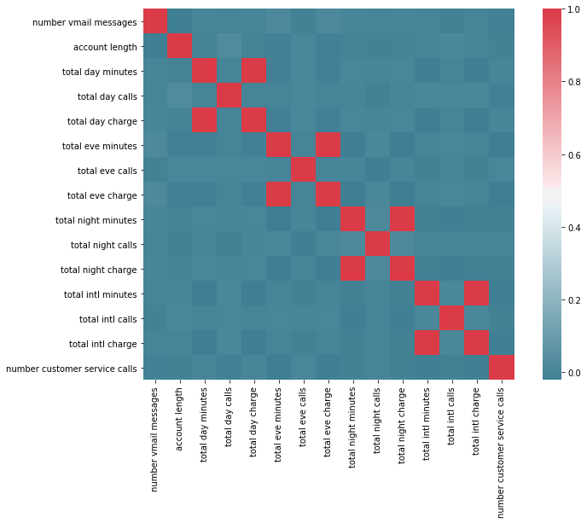
From the above plot we can see that total day minutes – total day charge, total eve minutes – total eve charge, total night minutes – total night charge and total intl minutes – total intl charge are highly positively correlated. No any other variable is correlated according to correlation plot. Out of two we will drop one variable from each set of the variables which are highly correlated to avoid the redundancy in the dataset.
For categorical variables we have done the chi-square test separately.

Categorical variable | P-value
State | 7.850836224371827e-05
Area code | 0.7546581385329686
Voice mail plan | 1.9443947474998577e-74
International plan | 7.164501780988496e-15

For the area code, the p-value is greater 0.05(assuming 95%confidence level). So we will reject the alternate hypothesis stating that the two variables (area code and target variable) are independent of each other. We will drop this variable from the dataset.

From the continuous variable we are dropping following variables:
- total day minutes
- total eve minutes
- total night minutes
- total intl minutes

2.1.4 Feature Scaling
As the values are comparatively low in magnitude, we will not scale the data. Also the histogram plot (see Appendix) after treating the outliers shows a normal distribution in most of the variables.

2.1.5 Sampling
We will use the stratified sampling method and create two datasets out of the existing data namely – train and test. It will be divided so that train will contain 70% of the dataset. On train dataset we will train the algorithm and test dataset we will perform the test.

2.2 Modeling

2.2.1 Model Selection
After all the pre-processing of the data now we will build our model using different machine learning algorithms. The dependent variable is Nominal, so the predictive analysis that we can perform is Classification. We will use following machine learning algorithms to develop our model.

- Decision tree – it is a decision support tool that uses a tree-like graph or model of decisions and their possible consequences, including chance event outcomes, resource costs, and utility.

- Random Forest – it operates by constructing a multitude of decision trees

- Logistic regression – it is used to describe data and to explain the relationship between one dependent binary variable and one or more nominal, ordinal, interval or ratio-level independent variables.

- Naïve Bayes - It is a classification technique based on Bayes’ Theorem with an assumption of independence among predictors.
- KNN – it is classification by finding the most similar data points in the training data, and making an educated guess based on their classifications.

Chapter 3

Conclusion

3.1 Model Evaluation

Now that we have a few models for predicting the target variable, we need to decide which one to choose. There are several criteria that exist for evaluating and comparing models. We can compare the models using any of the following classification matrix:

- Confusion matrix – describes the performance of classification model
- Accuracy – the proportion of the total number of predictions that are correct
- Misclassification error – it is the error rate i.e. (1- accuracy)

- Precision – when the model predicts default: how often is correct?

- Recall – the proportion of actual positives that the model will correctly predict
- Specificity – the proportion of actual negatives which are correctly identified
- False positive rate – wrongly positive
- False negative rate – wrongly negative

We will use the ‘Confusion matrix’ to develop the contingency table between actual and predicted values and then check the accuracy of the model.
 |  | Predicted
 |  | False | True
Actual | False | TN | FP
Actual | True | FN | TP

3.1.1 Decision tree

 |  | Predicted
 |  | False | True
Actual | False | 1204 | 95
Actual | True | 77 | 124

3.1.1 Random forest
 |  | Predicted
 |  | False | True
Actual | False | 1290 | 9
Actual | True | 99 | 102

3.1.1 Logistic regression
 |  | Predicted
 |  | False | True
Actual | False | 1220 | 29
Actual | True | 152 | 33

3.1.1 Naïve Bayes
 |  | Predicted
 |  | False | True
Actual | False | 1216 | 83
Actual | True | 140 | 61

3.1.1 KNN
 |  | Predicted
 |  | False | True
Actual | False | 1297 | 2
Actual | True | 194 | 7

3.2 Model Selection

We will compare all the models on different parameters.

Parameter | Decision tree | Random Forest | Logistic regression | Naïve Bayes | KNN
Accuracy | 0.885 | 0.928 | 0.835 | 0.851 | 0.869
Sensitivity | 0.617 | 0.617 | 0.178 | 0.303 | 0.034
FNR | 0.383 | 0.492 | 0.821 | 0.696 | 0.965
FPR | 0.073 | 0.007 | 0.023 | 0.063 | 0.001
Specificity | 0.926 | 0.993 | 0.976 | 0.936 | 0.998

Accuracy = (TP+TN)/All observations
Specificity = TN/(TN+FP)
Sensitivity = TP/(TP+FN)
FNR = FN/(FN+TP)
FPR = FP/(FP+TN)

As per the above results, we will select the Random forest model according to the Sensitivity and Accuracy. It is necessary to know in the present scenario that who all customers are going to churn out so as to work on the areas to stop churning. In Sensitivity we get to know the true positive rate. Positive here means that the customer is going to churn.

Appendix A - Extra Figures

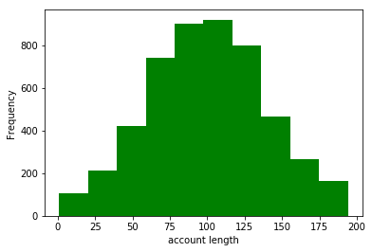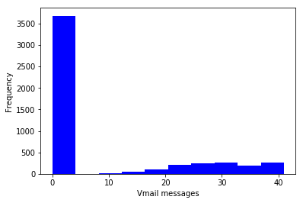

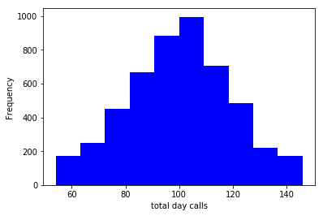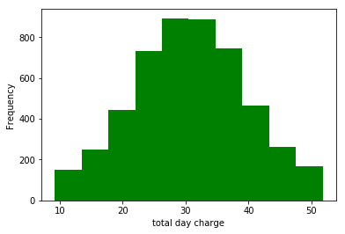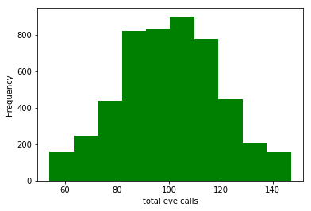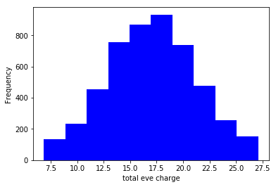
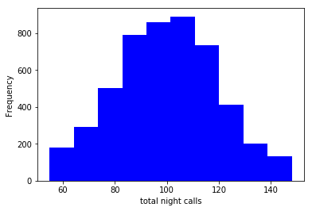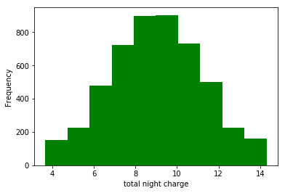
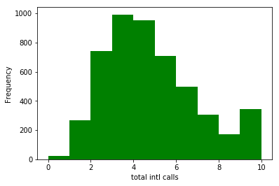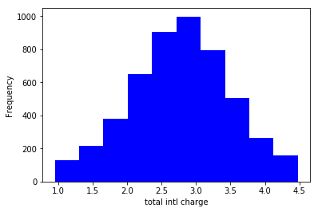
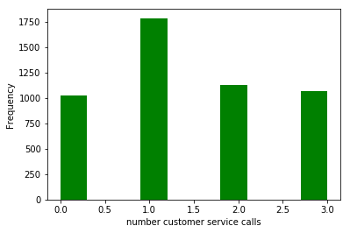

Appendix A – Python codes
#import libraries
import os
import pandas as pd
import numpy as np
import matplotlib.pyplot as plt
from scipy.stats import chi2_contingency
import seaborn as sns
from random import randrange, uniform

#set directory
os.chdir("G:\edwisor")

#Check current working directory
os.getcwd()

#load data
train = pd.read_csv("Train_data.csv", sep = ',')
test = pd.read_csv("Test_data.csv", sep = ',')

#combine datasets
data = train.append(test)
data = data.reset_index(drop=True)

#check the first five observations of the dataset
data.head()

#information of variables
data.info()

#check summary of all continuous variables
data.describe()

#Count of unique values in all variables
data.nunique()

#convert area code
data['area code'] = data['area code'].astype(object)

#delete variable
del data['phone number']

#plot bar graph
ax = data['Churn'].value_counts().plot(kind='bar',
figsize=(10,6),
title="Churn")
ax.set_xlabel("Churn")
ax.set_ylabel("Frequency")
plt.show()

var = data.groupby(['state','Churn']).Churn.count()
var.unstack().plot(kind='bar',stacked=True, figsize=(14,8), color=['green','blue'], grid=False)

#plot histogram of the continuous variables
plt.hist(data['account length'], color = "green")
plt.xlabel('account length')
plt.ylabel("Frequency")

#create a copy of data
df = data.copy()

#boxplot for outliers
plt.boxplot(data['account length'])
plt.xlabel('account length')

#calculating 1st and 99th %ile
a = np.array(data['total day minutes'])
q = np.percentile(a, 1)
p = np.percentile(a, 99)
print(q)
print(p)

#replace values in variables
for i in range(len(data)):
if data["total day minutes"].loc[i]<54.2:
data["total day minutes"].loc[i]=54.2
if data["total day minutes"].loc[i]>304.61:
data["total day minutes"].loc[i]=304.61

#storing column names
cnames = ['number vmail messages', 'account length', 'total day minutes',
'total day calls', 'total day charge', 'total eve minutes',
'total eve calls', 'total eve charge', 'total night minutes',
'total night calls', 'total night charge', 'total intl minutes', 'total intl calls','total intl charge',
'number customer service calls']

#correlation
df_corr = data.loc[:,cnames]

#correlation plot
f, ax = plt.subplots(figsize=(12,8))

#Generate correlation matrix
corr = df_corr.corr()

#Plot using seaborn library
sns.heatmap(corr, mask=np.zeros_like(corr, dtype=np.bool), cmap=sns.diverging_palette(220, 10, as_cmap=True),
square=True, ax=ax)

#Chisquare test of independence #Save categorical variables
cat_names = ['state', "area code", "international plan", "voice mail plan"]

#loop for chi square values
for i in cat_names:
print(i)
chi2, p, dof, ex = chi2_contingency(pd.crosstab(data['Churn'], data[i]))
print(p)
#drop variables
data = data.drop(['area code', 'total day minutes', 'total eve minutes', 'total night minutes','total intl minutes'], axis=1)

#Import Libraries for decision tree
from sklearn import tree
from sklearn.metrics import accuracy_score
from sklearn.cross_validation import train_test_split

#replace target categories with Yes or No
data['Churn'] = data['Churn'].replace(0, 'No')
data['Churn'] = data['Churn'].replace(1, 'Yes')

#Divide data into train and test
X = data.values[:, 0:14]
Y = data.values[:,14]

X_train, X_test, y_train, y_test = train_test_split( X, Y, test_size = 0.3)

#Decision Tree
C50_model = tree.DecisionTreeClassifier(criterion='entropy').fit(X_train, y_train)

#predict new test cases
C50_Predictions = C50_model.predict(X_test)

#build confusion matrix
CM = pd.crosstab(y_test, C50_Predictions)
print (CM)

#Create dot file to visualise tree #http://webgraphviz.com/
dotfile = open("pt.dot", 'w')
df = tree.export_graphviz(C50_model, out_file=dotfile, feature_names = data.columns)

#accuracy of model
accuracy_score(y_test, C50_Predictions)*100
((TP+TN)*100)/(TP+TN+FP+FN)

#False Negative rate
(FN*100)/(FN+TP)

#Random Forest
from sklearn.ensemble import RandomForestClassifier

RF_model = RandomForestClassifier(n_estimators = 20).fit(X_train, y_train)
RF_Predictions = RF_model.predict(X_test)

#build confusion matrix
CM = pd.crosstab(y_test, RF_Predictions)
#Naive Bayes
from sklearn.naive_bayes import GaussianNB

#Naive Bayes implementation
NB_model = GaussianNB().fit(X_train, y_train)

#predict test cases
NB_Predictions = NB_model.predict(X_test)

#Build confusion matrix
CM = pd.crosstab(y_test, NB_Predictions)

#KNN implementation
from sklearn.neighbors import KNeighborsClassifier

KNN_model = KNeighborsClassifier(n_neighbors = 9).fit(X_train, y_train)

#predict test cases
KNN_Predictions = KNN_model.predict(X_test)

#build confusion matrix
CM = pd.crosstab(y_test, KNN_Predictions)

#Let us prepare data for logistic regression #replace target categories with Yes or No
data['Churn'] = data['Churn'].replace('No', 0)
data['Churn'] = data['Churn'].replace('Yes', 1)

#Create logistic data. Save target variable first
data_logit = pd.DataFrame(data['Churn'])

#Add continous variables
data_logit = data_logit.join(data[cnames])

##Create dummies for categorical variables
cat_names = ["state", "voice mail plan", "international plan"]

for i in cat_names:
temp = pd.get_dummies(data[i], prefix = i)
data_logit = data_logit.join(temp)

Sample_Index = np.random.rand(len(data_logit)) < 0.7

train = data_logit[Sample_Index]
test = data_logit[~Sample_Index]

#select column indexes for independent variables
train_cols = train.columns[1:67]

#Built Logistic Regression
import statsmodels.api as sm

logit = sm.Logit(train['Churn'], train[train_cols]).fit()

logit.summary()

#Predict test data
test['Actual_prob'] = logit.predict(test[train_cols])

test['ActualVal'] = 1
test.loc[test.Actual_prob < 0.5, 'ActualVal'] = 0

#Build confusion matrix
CM = pd.crosstab(test['Churn'], test['ActualVal'])

References

https://edwisor.com/

https://www.analyticsvidhya.com/

http://www.statisticssolutions.com/

https://en.wikipedia.org/wiki/

https://towardsdatascience.com/

https://github.com/

https://www.datacamp.com/

https://stackoverflow.com/

https://www.khanacademy.org/

https://www.listendata.com/

