**“FREQUENTO”**

Submitted by-

Sumeet Agarwal (12BCE0010)

Laxay Jain (12BCE0241)

Abhinaav Singh (12BCE0143)



An Android Application

“Frequento”

Abstract

Frequento is an app which will run multiple apps within it like Search Engine, Maps, Camera, Calculator, To-do list, counter and many more. It will be like a dummy Operating System which will run multiple apps.

The Frequento Web Browser is a basic browser which can be used for browsing internet. It contains options like go forward, go backward clear history etc.

Through Frequento Maps users can search any location in the world.. It will be sync with Google Maps. Users can use navigate facility along with searching places.

Frequento calculator preforms basic mathematical operations like addition, subtraction, division and multiplication.

Frequento camera can be used for taking pictures. It has a unique feature of setting the picture directly as the wallpaper from the application itself.

Frequento to-do list is like a database to store tasks. It takes name, date and details about the task. It includes features of create a task, view a task, delete a task, view by id or name or date. It also includes the feature of deleting all tasks at once.

Frequento count-down timer is a sequence of backward counting app to indicate the time remaining before an event is scheduled to occur.

Requirements

Hardware requirements

* An android phone (latest version kitkat)
* A laptop (3rd gen i5, 4GB RAM, 500GB Hard disk)

Software requirements

* Eclipse
* Bluej
* Photoshop (CS6)

Camera

A camera is an optical instrument that records images that can be stored directly, transmitted to another location, or both. The functioning of camera is very similar to the functioning of the human eye.

Through this application user can take pictures. It include various options like re-take, cancel and done. It shows the picture after capturing as a preview. The unique feature of this application is to directly set the picture as Wallpaper of the android device.

Web browser

A web browser (commonly referred to as a browser) is a software application for retrieving, presenting and traversing information resources on the World Wide Web. Although browsers are primarily intended to use the World Wide Web, they can also be used to access information provided by web servers in private networks or files in file systems.

With this application user can browse the internet. It includes features of going forward through the list of recently visited websites, going backward to the back pages. It also includes the feature of clearing history and refreshing page.

Maps

A map is a visual representation of an area – symbolic depiction highlighting relationships between elements of that space such as objects, regions, and themes.

Through this application, the user can view any geographical location on the device. It includes options like finding the details, if one has to navigate between two locations.

Calculator

An electronic calculator is a small, portable electronic device used to perform both basic and complex operations of arithmetic.

The calculator will allow the user to perform addition, subtraction, multiplication, division and a sequence of these operations together.

To-do list

This application basically acts as a data-base to store tasks. It accepts name, date and details about the task. It includes various options to modify the stored entries like view, edit and delete. It includes features of create a task, view a task, delete a task, view by id or name or date. It also includes the feature of deleting all tasks at once.

Count-down Timer

Count-down timer is a sequence of backward counting app to indicate the time remaining before an event is scheduled to occur.

Screenshots

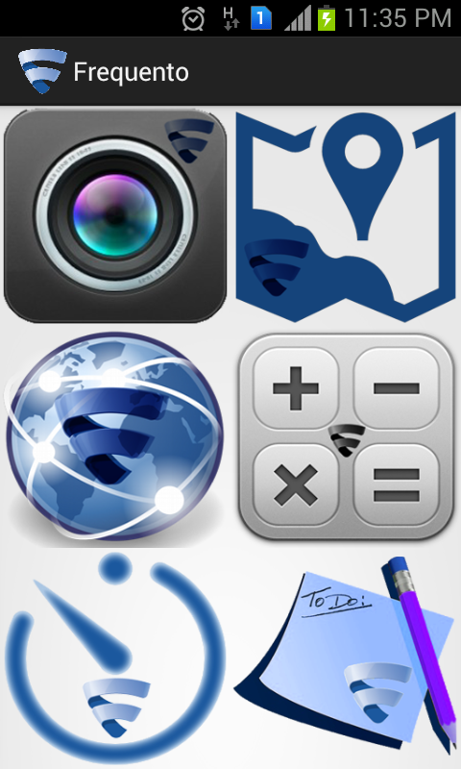 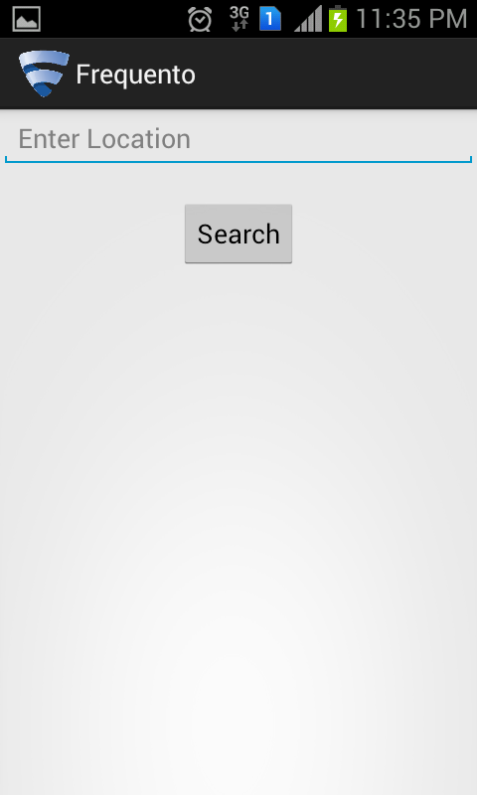

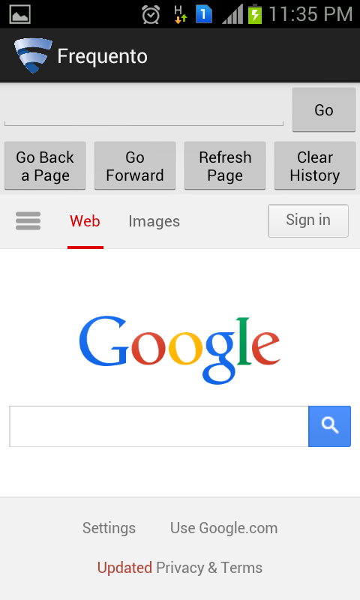 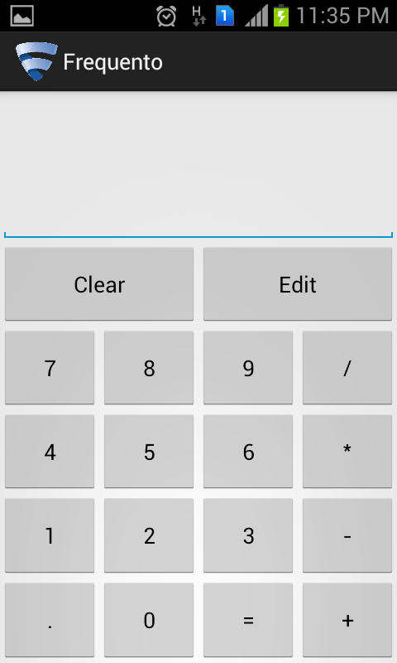

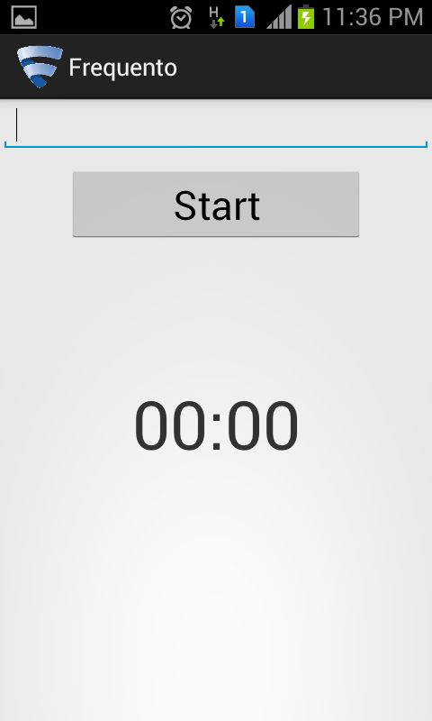 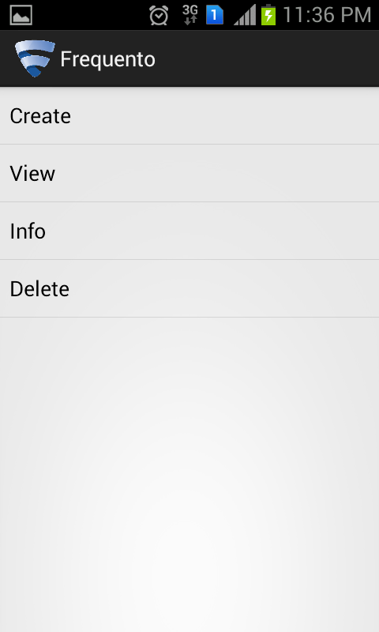

Work Done By Each Member

Sumeet Agrawal: Watched video lectures from New Boston and referred the website stack overflow, androiddeveloper.com, and Google for reference. Build the application using eclipse software.

Laxay Jain: Watched video lectures from New Boston and referred Google for reference. Designed logos and wallpaper for the application. Prepared documents.

Abhinaav Singh: Prepared documents.

Reference

<http://developers.android.com>

<http://www.google.com>

<http://stackoverflow.com>

Video lectures from New Boston and Lynda.