21BCM061

Object Oriented Application Development

*// Write a java program that takes string in a loop from the user until user enters stop and displays each line in upper*

*// case(Use ByfferedReader*

*// class).Also handle appropriate exceptions*

import java.io.BufferedReader;

import java.io.IOException;

import java.io.InputStreamReader;

import java.util.\*;

public class p2q1 {

public static void main(String[] *args*) throws IOException {

Scanner sc = new Scanner(System.in);

String stringss = "";

String ab = "";

BufferedReader R = new BufferedReader(new InputStreamReader(System.in));

System.out.println("Enter a string ");

do {

stringss = R.readLine();

if ("stop".equals(stringss))

break;

else {

ab = ab + " " + stringss;

ab = ab.toUpperCase();

}

} while (!"stop".equals(stringss));

System.out.println(" " + ab);

}

}

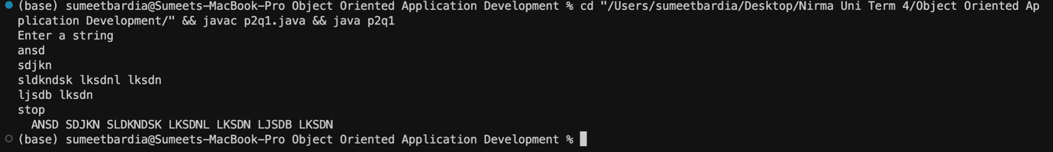

*//Write a java program that demonstrates user of PrintWriter class to display the output on console.*

import java.io.File;

import java.io.PrintWriter;

public class p2q2 {

public static void main(String[] *args*) {

PrintWriter p = new PrintWriter(System.out);

p.write("Hey, this is the Answer of question2b");

p.close();

try {

PrintWriter p1 = new PrintWriter(new File("file.txt"));

p1.println("Hey, this is the Answer of question2b");

p1.flush();

p1.close();

} catch (Exception *E*) {

System.out.print(E);

}

}

}

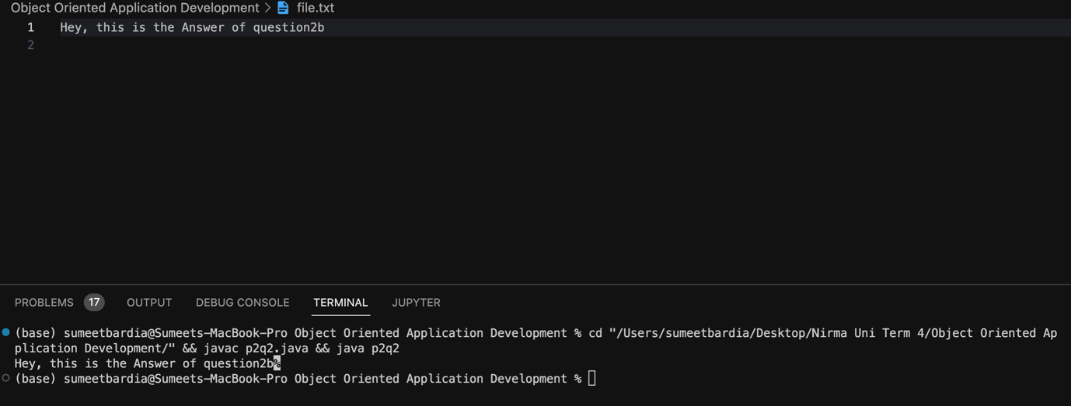

*// c) Write a java program that copies a file using*

*// FileInputStream and FileOutputStream class. Ensure*

*// source file should be valid existing one.*

import java.io.File;

import java.io.FileInputStream;

import java.io.FileNotFoundException;

import java.io.FileOutputStream;

public class p2q3 {

public static void main(String[] *args*){

File f=new File("source.txt");

File f1=new File("destination.txt");

FileInputStream fp1=null;

FileOutputStream fp2=null;

try

{

fp1=new FileInputStream(f);

fp2=new FileOutputStream(f1);

}

catch (FileNotFoundException *ex*) {

System.out.println(ex);

}

try

{

fp1.available();

int length;

while((length=fp1.read())!=-1)

{

fp2.write(length);

}

fp1.close();

fp2.close();

System.out.println("File Copied Successfully");

}

catch(Exception *e*)

{

System.out.println(e);

}

}

}

