# Project Report – Milestone 1

# Under Prof. Jan-Willem van de Meent

Done by: Sumeet Dubey, Harshdeep Singh, Zhiguang Yu

# Exploratory Analysis Over Dataset

## Top companies in the gaming industry

* We calculated total Global sales for each publisher over all the games they have released and took the top 10 publishers.

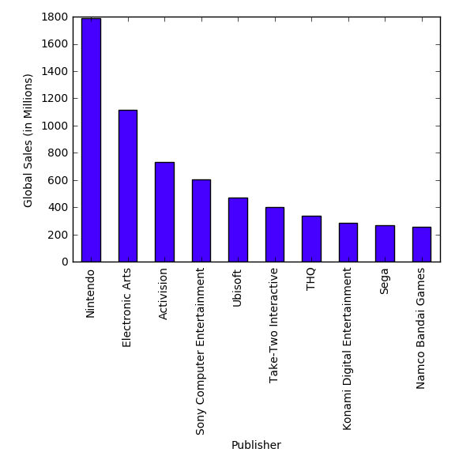

Conclusion:

Nintendo seems to be a leader in sales with a good margin. All of the top companies are amongst the current big video game manufacturers, which was expected.

* We calculated the number of games released by each publisher and took the top 10 publishers with the maximum number of releases

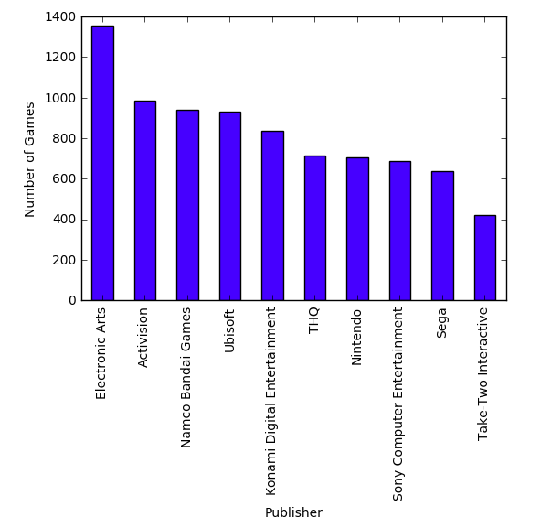

Conclusion:

Interestingly, Nintendo has produced about half as many games as EA though it beats EA in global sales. Activision and Namco Bandai have released almost same number of games, but there is a considerable difference in their sales.

Also note that both graphs contain the same set of companies in different order.

## Popular Genres

Below is the graph for total sales for games grouped by genres

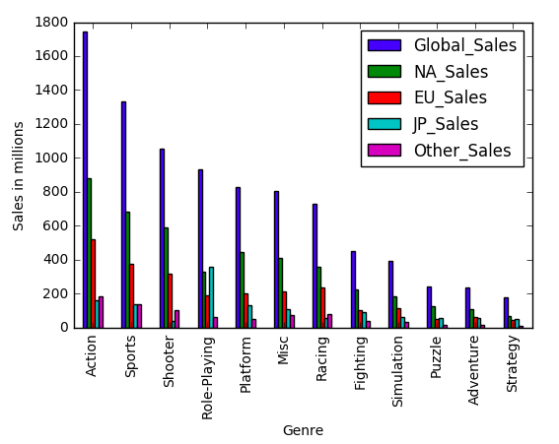

Conclusion:

Action games have dominated gaming industry for a long time and have the maximum number of sales. Sales in Japan though for action games is the lowest compared to other places. But we can see a nice bump in Japan sales for Role-Playing games (in-fact the highest). We could say that the Japanese gaming industry prefers story-telling and role oriented games than genres like Action and Shooters

## User/Critic Scores for top publishers

We calculated the mean User and Critic scores for each of our top 10 publishers.

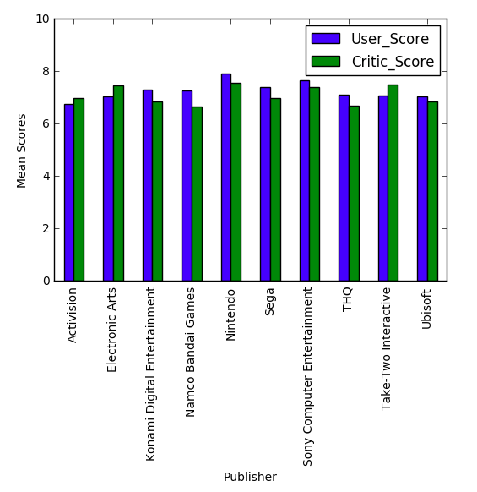

Conclusion:

Nintendo seems to have the highest mean User/Critic rating which should explain it’s top global sales. Also 7/10 have higher mean scores given by Users rather than Critics.

## Distribution of Game Ratings:

The two bar chats below show the number of games released grouped by their ESRB ratings, and their total sales. ERSB ratings are given according to the content of the game to filter the users suitable for playing it. The popular ones are:

* E – Everyone
* E10+ - Everyone above 10
* T – Teen
* M - Mature

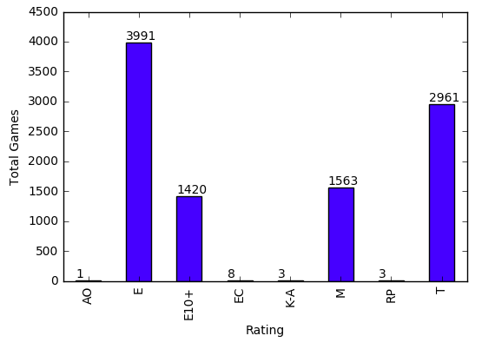 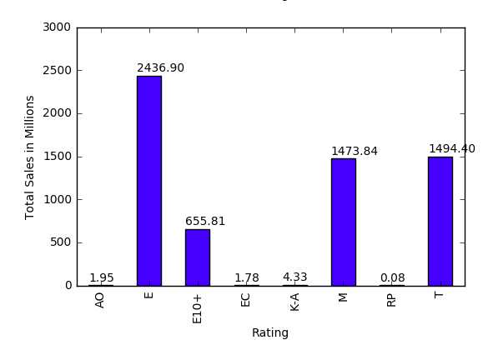

Conclusion:

Games rated E are the most made and most sold games. This is expected as many users of the gaming industry are kids and there are many genres that do not require unnecessary explicit content (sports, strategy, puzzles). Rated-M games have great sales compared to their strengh. Many of the Action and Role-playing games are often rated M and hence they are popular. Equally popular are Teen rated games, though their number is higher.

Note that only one game in our dataset has the AO rating (Adults Only). Interestinly it can be noted it the second graph that this game generated a profit of $1.95 million. It is the popular and critically aclaimed game by Take Two Interactive and Rockstar, Grand Theft Auto: San Andreas.

## 

Above is a plot of sales per game for each rating. The bump for AO is because of GTA: San Andreas as we figured.

## Sales Distributions for different Genres across different regions

Find top 5 publishers in the database based on global sales and then find out sales distributions for each genre across North America, Europe, Japan, Rest of the world(Others).

## Plots:

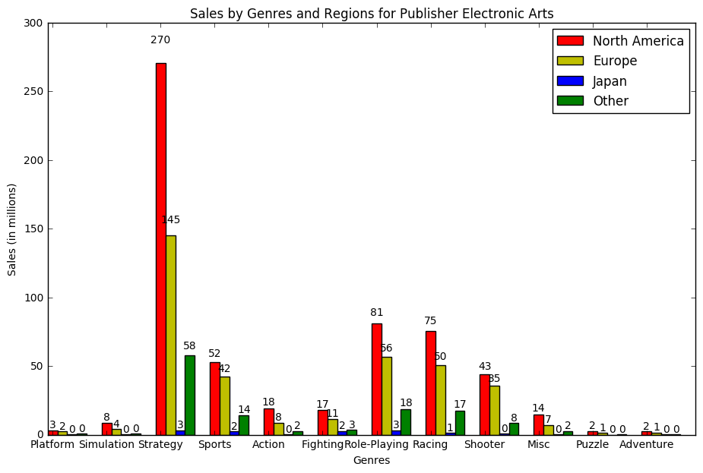

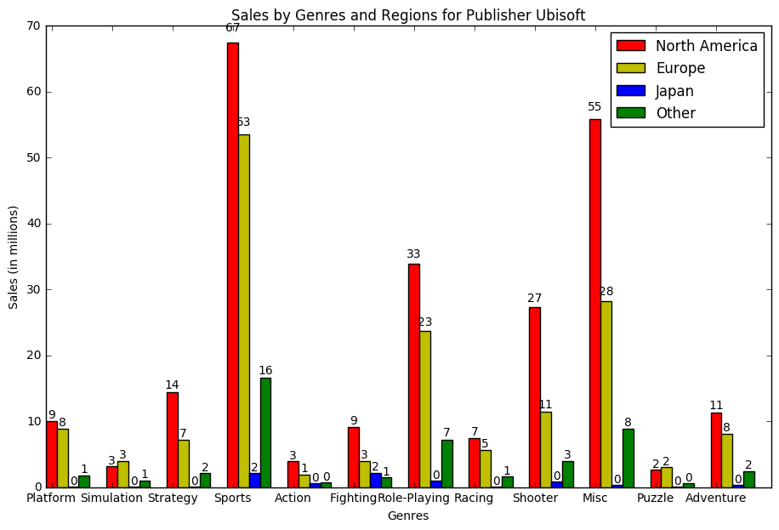

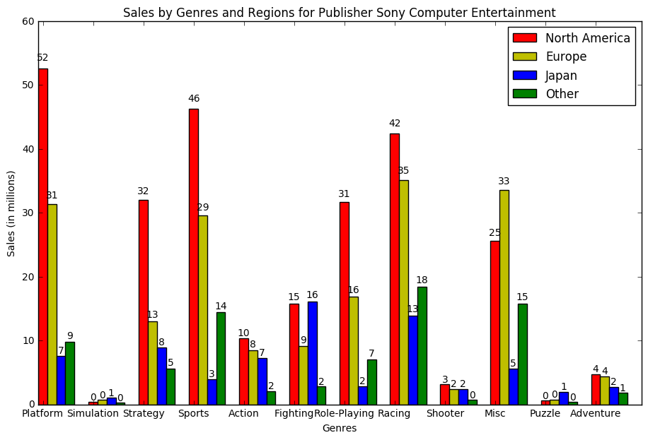

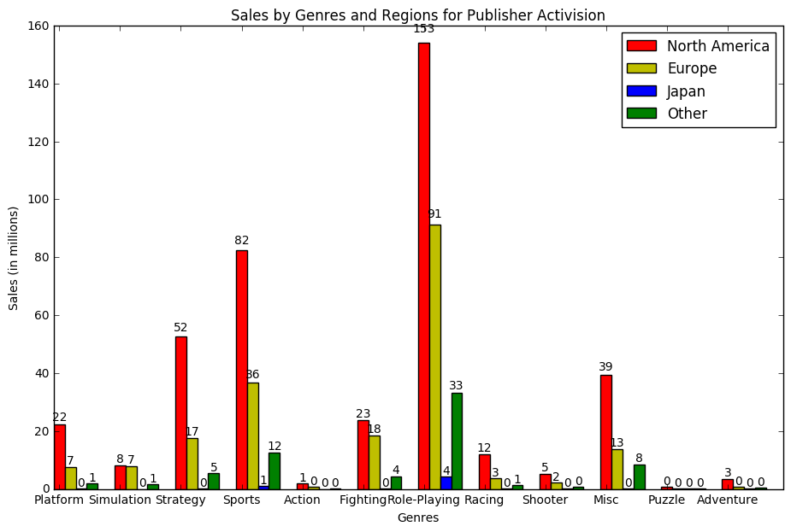

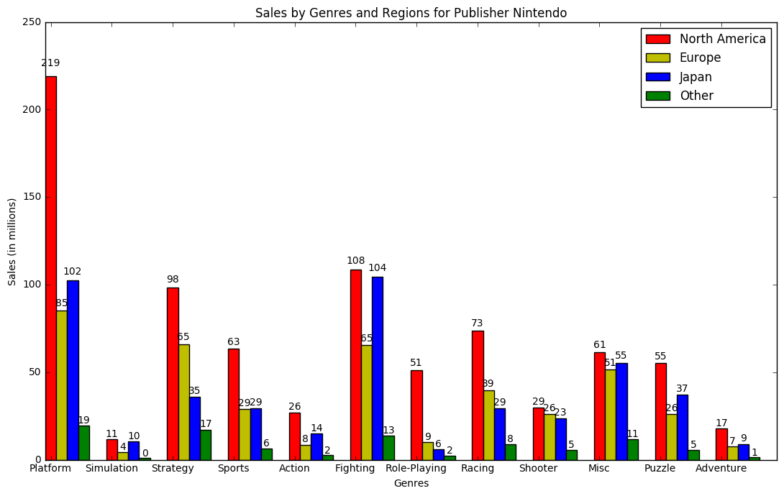

## Conclusion

Top 5 publishers based on the global sales are: Electronic Arts, Ubisoft, Sony Computer Entertainment, Activision and Nintendo.

From the above plots, we can see that:

1. North America is the biggest market for games in Platform genre followed by Strategy Genre. With Electronic arts and Nintendo being the major publishers.
2. Nintendo is has done better sales in Japan (based on sales) as compared to the other regions.
3. Nintendo has sales for almost all its genres whereas other publishers are bit inconsistent across the genres and have sales for one or two specific genres.
4. But overall North America and Europe is the main hub for video games sales in the world.

## Trends for Sales per year for top 5 publisher

For different regions plot trends for sales over the years for each of the top 5 publishers based on global sales. We have considered years as buckets of 5 years, tried to plot total sales for each of those buckets in North America, Europe, Japan and Rest of the world (Other).

## Plots:

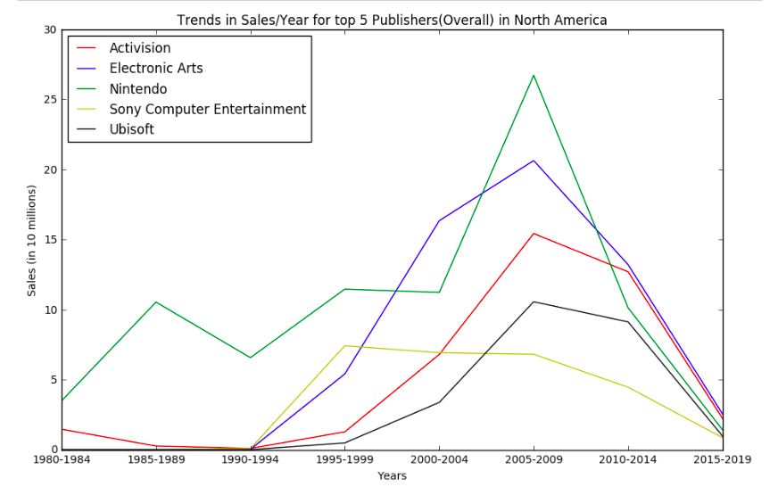

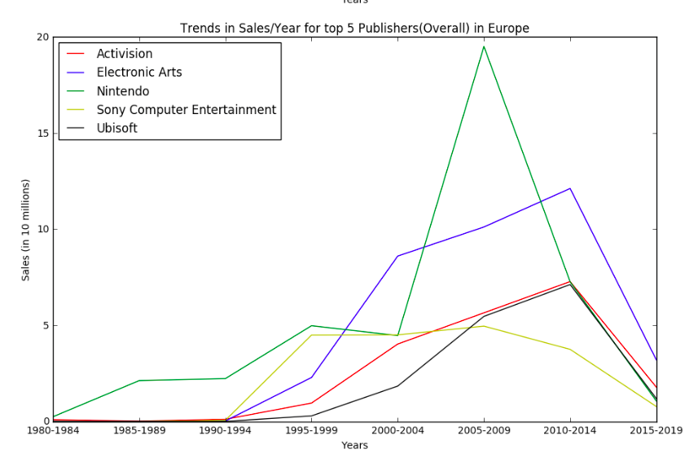

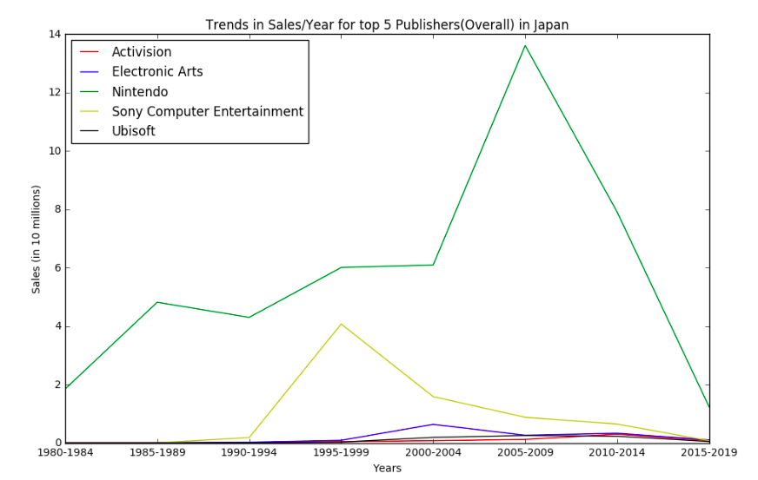

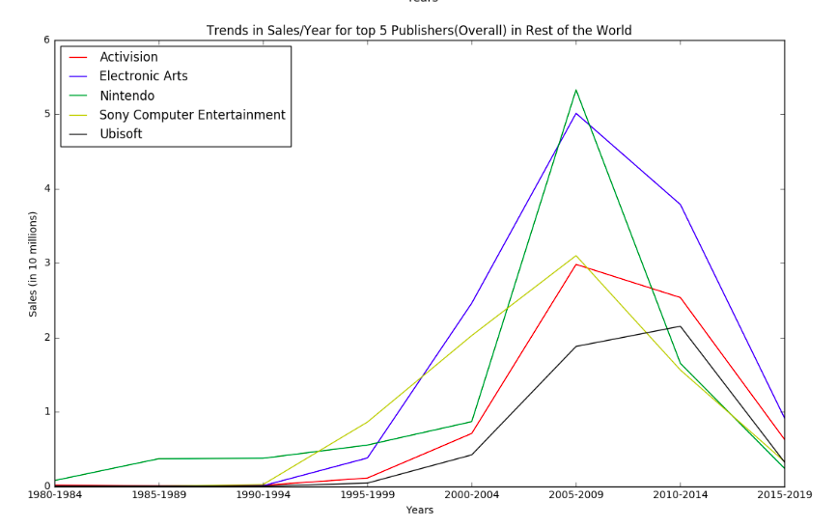

## Conclusion

Top 5 publishers based on the global sales are: Electronic Arts, Ubisoft, Sony Computer Entertainment, Activision and Nintendo.

From the plots above, we can see that:

1. There has been a sharp rise(increase) in sales for Nintendo for all regions in period 2005-2009.
2. Nintendo has been the oldest publisher in the world, accompanied by Activision whereas the other three publishers came into the market at later stages.
3. Sony Computer Entertainment had good sales in first 10 years but then it has seen continuous decline in sales across all regions.
4. We can also see that all the publishers had highest number of sales during the years 2005-2009 and sales fell drastically for each the publisher in all the regions for the corresponding period (2010- 2014).
5. Also, third plot strengthens our claim in previous objective that Nintendo has performed exceptionally in Japan as compared to other publishers.

## Most Selling Genre Each Year

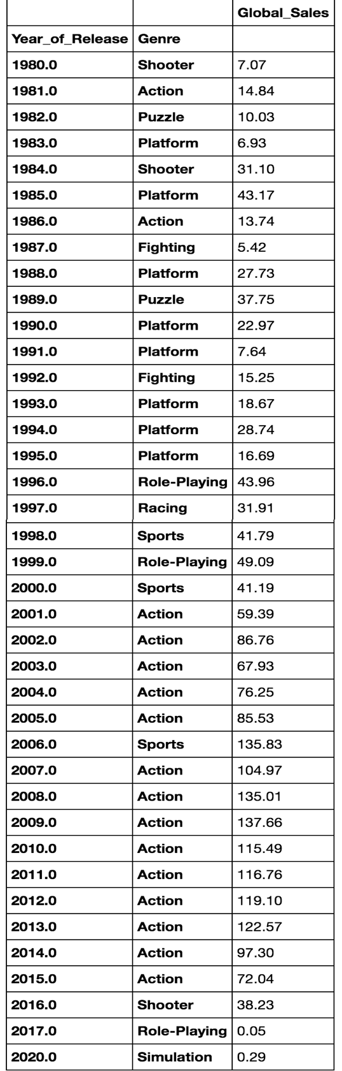

## Most Selling Console Each Year:

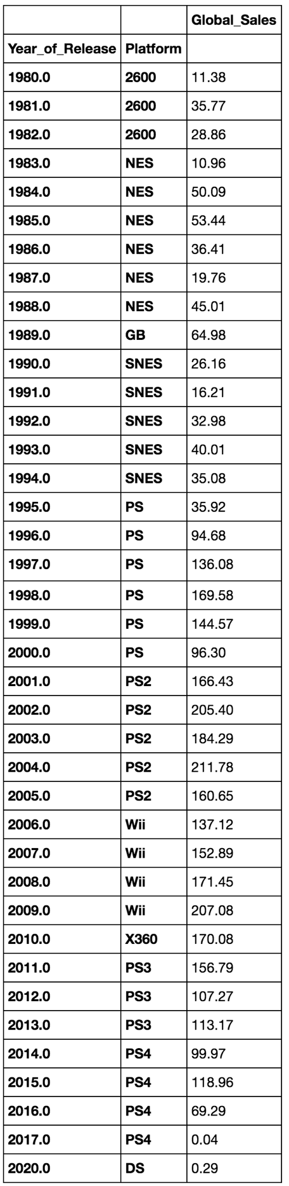

Below is the plot which displays the trend of the selling trend per genre each year

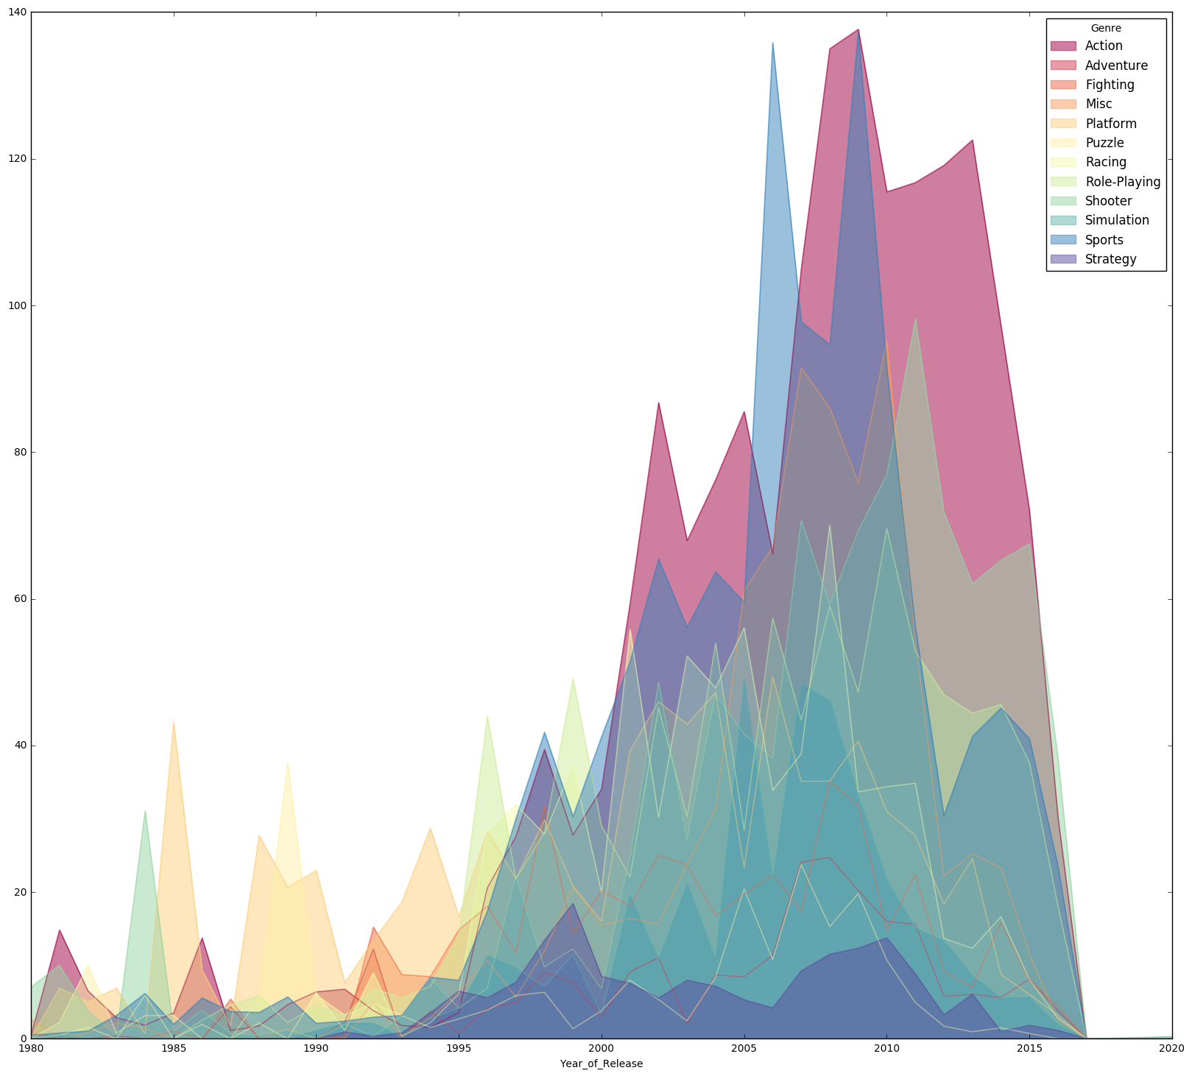

Conclusion: People from 1995 to 2015 prefer action games.

Below is is the plot which displays selling trends per platform each year

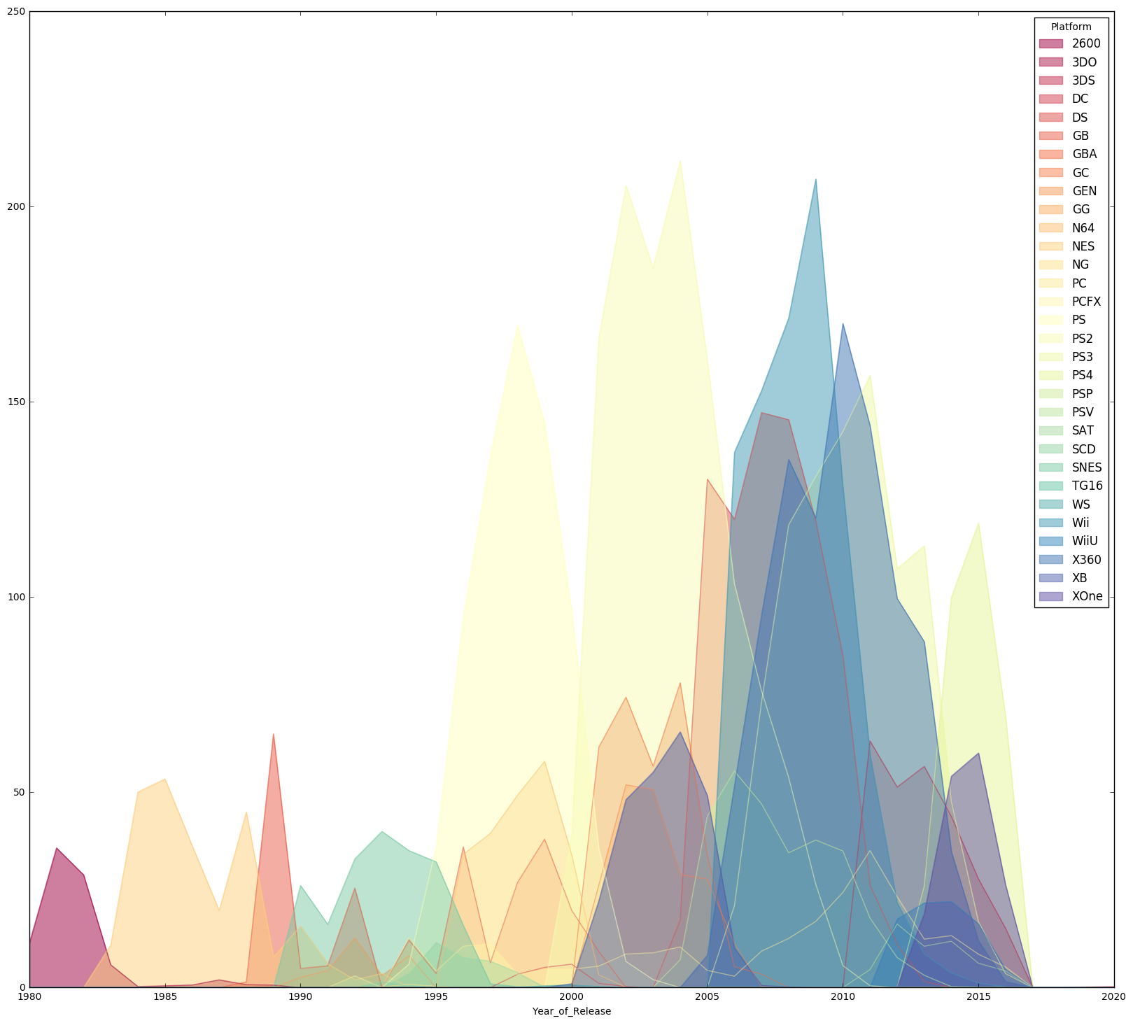

Conclusion:

PlayStation series is the most selling platform. From 2005 to 2010, the wii and X-BOX 360 take the place of most selling. However, from 2012 to 2015, the Playstation comes back to the most selling position.