**Lead_ Case_Study_Assignment_Question**

1. **Which are the top three variables in your model which contribute most towards the probability of a lead getting converted?**

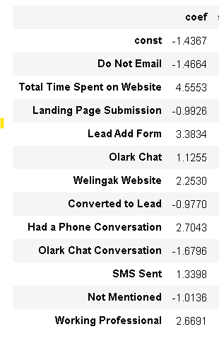

As we can see from the screenshot based on the coefficient values the top variables are

1. Total Time Spend on Website.
2. Lead Add Form.
3. Had a Phone Conversion.
4. **What are the top 3 categorical/dummy variables in the model which should be focused the most on in order to increase the probability of lead conversion?**

Again based on the screenshot have we the top 3 dummy variables are

1. Lead Add Form (from Lead Origin)
2. Had a Phone Conversion ( from Last Notable Activity)
3. Working Professional ( from What is your current occupation)
4. **X Education has a period of 2 months every year during which they hire some interns. The sales team, in particular, has around 10 interns allotted to them. So during this phase, they wish to make the lead conversion more aggressive. So they want almost all of the potential leads (i.e. the customers who have been predicted as 1 by the model) to be converted and hence, want to make phone calls to as much of such people as possible. Suggest a good strategy they should employ at this stage.**

In the below screenshot, the final prediction is calculated based on a optimal cut off value of 0.36.

In order to make the sales aggressive, the company may contact all the leads which have a conversion probability (value = 1) under a cut off column 0.3.

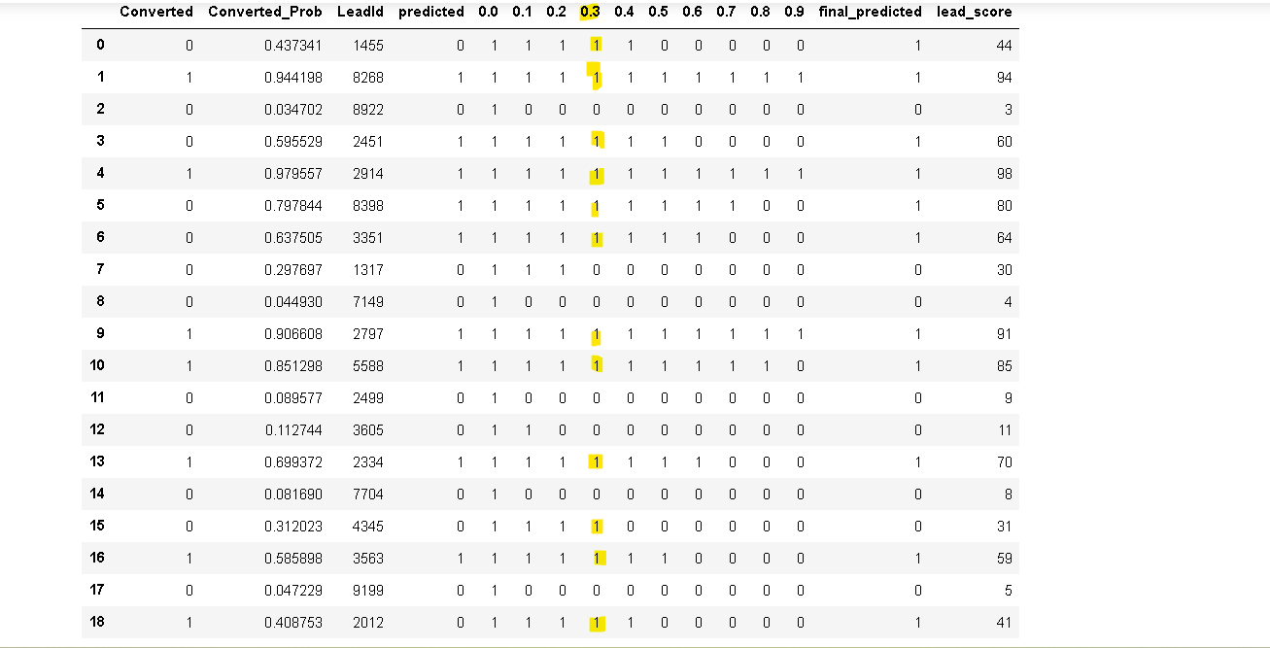

1. **Similarly, at times, the company reaches its target for a quarter before the deadline. During this time, the company wants the sales team to focus on some new work as well. So during this time, the company’s aim is to not make phone calls unless it’s extremely necessary, i.e. they want to minimize the rate of useless phone calls. Suggest a strategy they should employ at this stage.**

In order to minimize the rate of useless phone calls, the company may contact all the leads which have a conversion probability (value = 1) under column 0.7.

