|  |  |  |
| --- | --- | --- |
| **ITEM** | **ITEM NAME** | **ITEM Tags (Key Value)** |
| IAM | Sumeet_CourseAssignment | EC2:S3Full |
| Security Group | SG_Sumeet | Name:WebServer Sec |
| EC2 | Web Server | Name: Web Server |
| S3 | upgrad-sumeet |  |

Git Repository: https://github.com/sumeetkumar05/AWS_CourseAssignment

IAM Role

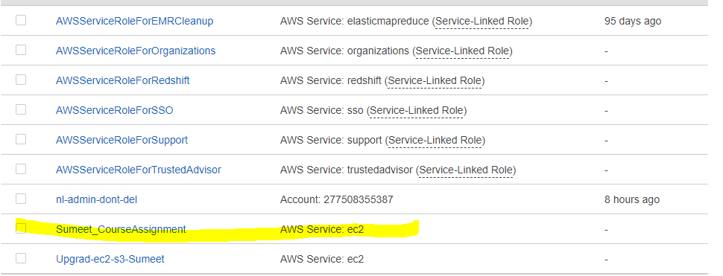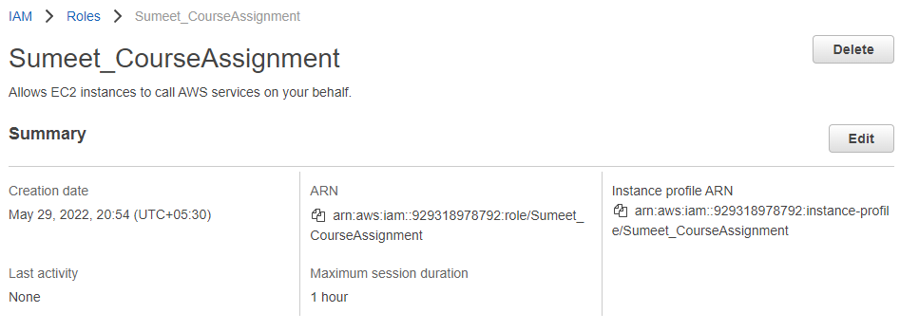

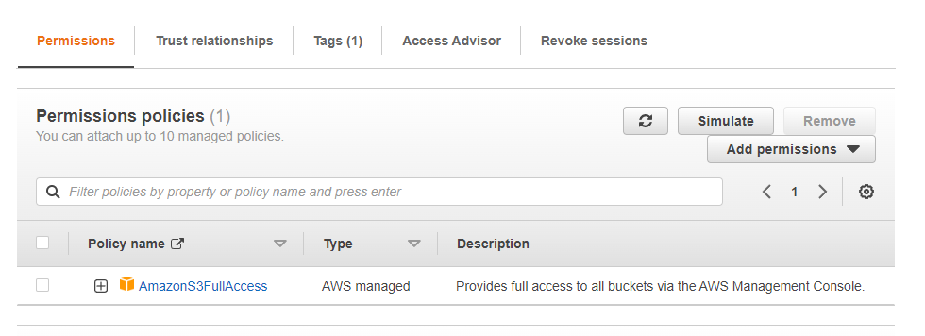

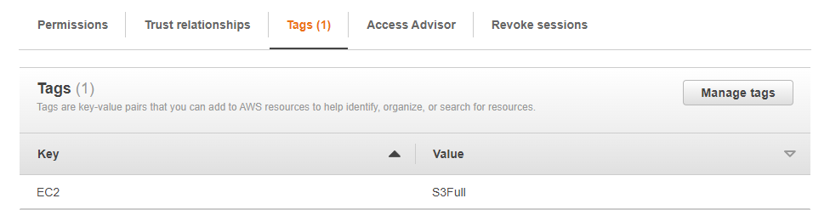

Security Group

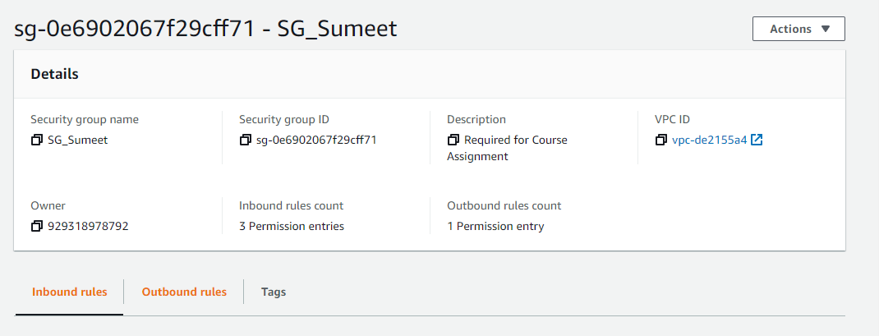

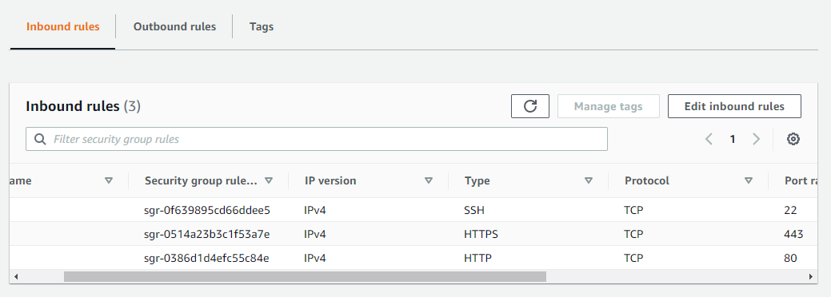

EC2 Instance

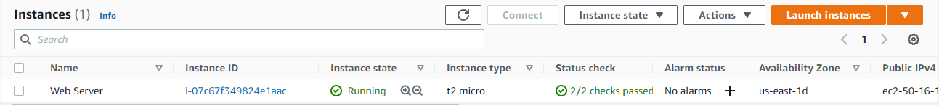

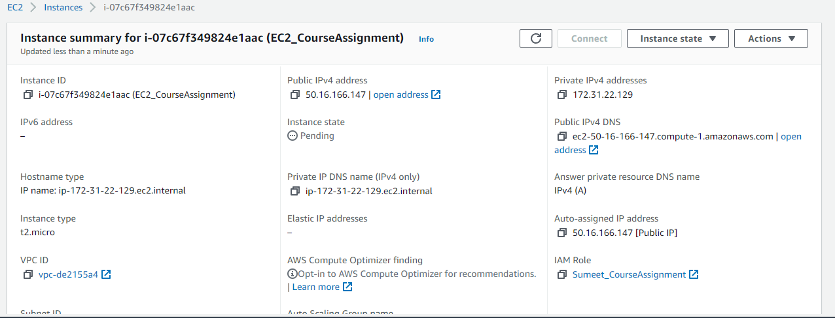

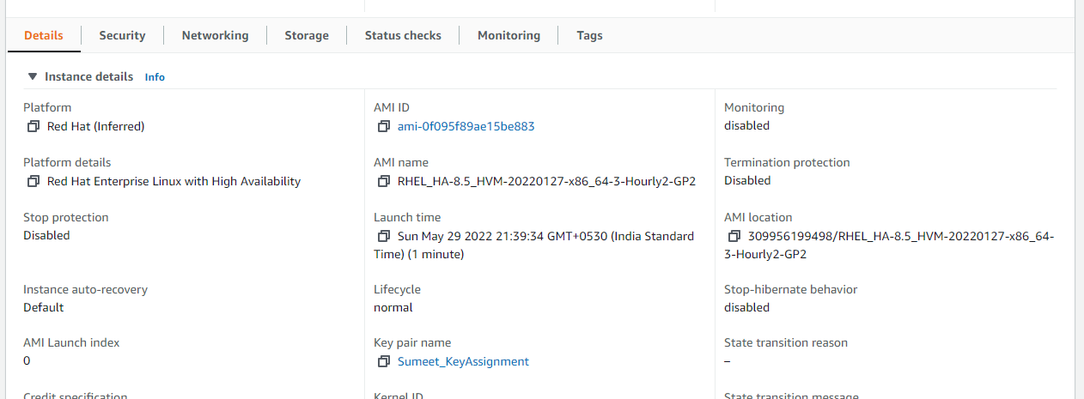

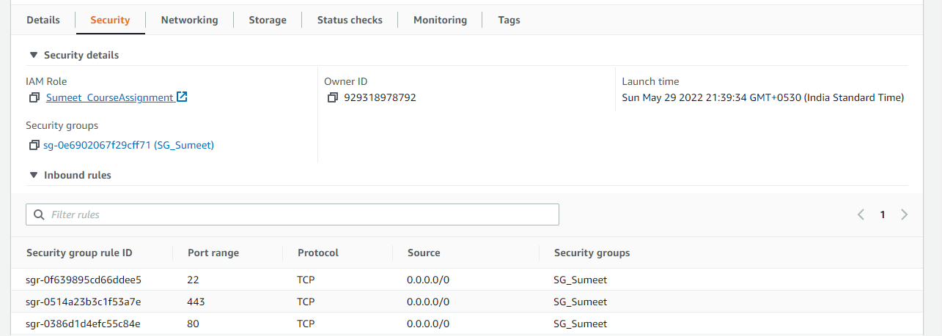

S3 STORAGE

