Updated version 2017 - <https://www.cdc.gov/nchs/data-visualization/drug-poisoning-mortality/>

Olga Scrivner 05/14/19

Obtained from <https://www.cdc.gov/nchs/data-visualization/drug-poisoning-mortality/>

States

By Olga Scrivner, 1/17/19

County

By Kosali Simon, 8/1/2018

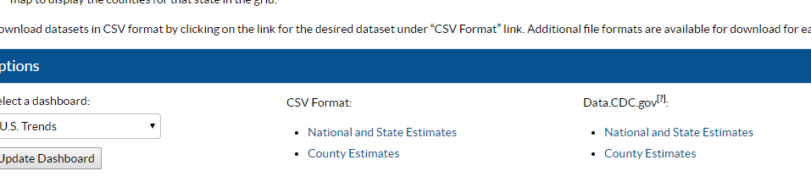

The excel file here comes from that link (cvs formal county).

I also saved a screenshot of county health rankings, they take it from this source.

There is a modelled version that fills in the missing estimates. County health rankings does not point to easy download location for the actual cdc wonder data, it just gives the details if we wish to do that later..

