FINANCIAL INTELLIGENCE ENGINE
Application Architecture
Phase 1 System Design, Class Flow, RAG, ML, and Deployment Path
Purpose
A mentor-ready technical guide to the implemented Phase 1 application and the architecture that allows it to evolve into a cloud financial intelligence product.

Field | Value
Document status | Phase 1 implementation baseline
Prepared for | Mentor and academic review
Implementation date | 28 June 2026
Application scope | US equities, 10K-company universe
Decision support only. The application does not provide regulated financial advice.

Executive Snapshot
The Financial Intelligence Engine is a local-first, cloud-ready research and decision-support prototype. It combines document retrieval, persistent vector search, baseline machine-learning inference, specialist agents, transparent decision scoring, and an explainable final report.
Architecture in one sentence
A browser question is routed through a Python API to an orchestrator, grounded with RAG evidence, enriched with sentiment and trained risk/forecast signals, scored by a decision agent, and rendered as an explainable report.

Current Evidence of Implementation
Capability | Current result | Implementation
US equity universe | 10,000 tickers | Cached Nasdaq Trader and SEC source files
ML feature table | 10,000 rows x 20 columns | Deterministic Phase 1 feature contract
RAG vector index | 478 chunks | Persistent ChromaDB collection
Risk model | 80.05% accuracy; 0.8039 macro F1 | Low / Medium / High classifier
Forecast model | 68.95% accuracy; 0.5914 macro F1 | Down / Flat / Up classifier
Frontend | 5 views and 6 API routes | Local dashboard at 127.0.0.1:8000

Contents
- 1. System architecture overview
- 2. Runtime query and agent flow
- 3. Persistent RAG architecture
- 4. Machine-learning training and inference
- 5. Runtime and build-time class flow
- 6. Data, storage, frontend, and API contracts
- 7. Deployment evolution and Phase 2 path
- 8. Current boundaries and mentor demo runbook

1. System Architecture Overview
The application follows a layered architecture. The browser and API form the interaction boundary; the orchestrator controls workflow; specialist agents produce evidence and predictions; the decision and explainability layers turn those signals into an auditable response.
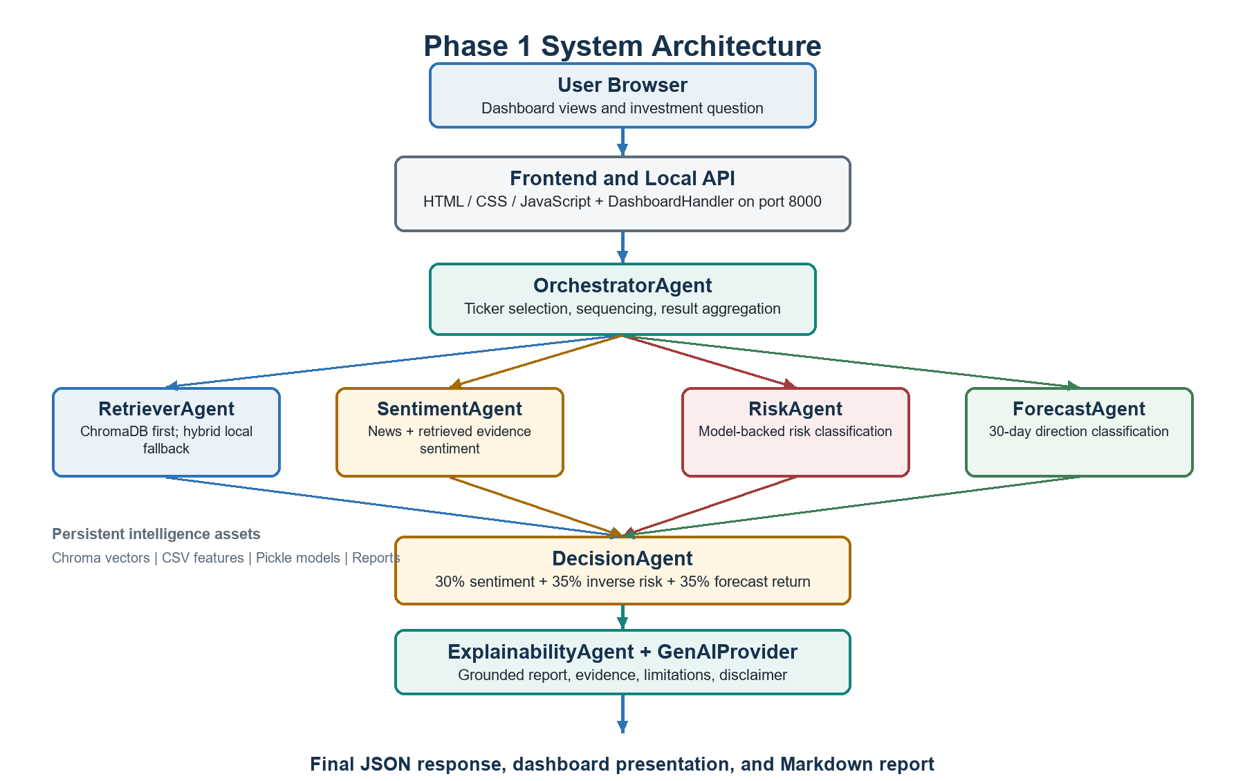
Figure 1. Implemented Phase 1 end-to-end architecture.

Key Design Decisions
- Local-first operation: the complete demo works without a cloud API key.
- Persistent intelligence assets: vectors, features, models, metrics, and reports survive process restarts.
- Provider abstraction: GenAI can switch from deterministic local mode to OpenAI through environment configuration.
- Stable agent contract: every specialist returns AgentResult with status, data, evidence, confidence, and warnings.
- Transparent scoring: the decision layer exposes its input weights and recommendation thresholds.

2. Layered Component Architecture
Layer | Primary classes/files | Responsibility
Presentation | frontend/index.html, app.js, styles.css | Dashboard, query form, universe, analysis, outputs
HTTP/API | DashboardHandler | Routes GET endpoints, handles POST /api/ask, serves files
Application | OrchestratorAgent | Selects tickers and executes one coordinated workflow
Specialist agents | Retriever, Sentiment, Risk, Forecast | Produce evidence and structured analytic signals
Decision | DecisionAgent | Combines signals into score and recommendation
Explainability | ExplainabilityAgent | Produces grounded report, caveats, evidence, and disclaimer
RAG | DocumentLoader, HashingEmbedder, VectorRetriever, RAGSystem | Indexing, persistent vectors, retrieval, answer synthesis
ML | Phase1ModelTrainer, RiskScorer, PricePredictor | Training, evaluation, persistence, prediction
Data/storage | USEquityUniverseBuilder, Phase1DataPipeline, DataStore | Universe, features, labels, layered artifacts
Configuration | AppSettings | Environment, paths, provider, model, database URL

Control Versus Data Flow
Control flow is owned by OrchestratorAgent. Data flow is carried through AgentResult objects, EvidenceItem objects, Pandas DataFrames, persisted CSV/JSON files, Chroma documents and embeddings, and serialized PKL models.
Important implementation detail
The conceptual diagram shows specialist agents as a group. In the current Python implementation, calls are sequential: retrieval -> sentiment -> risk -> forecast -> decision -> explanation. Forecast is logically independent and can be parallelized later.

3. Runtime Query and Agent Flow
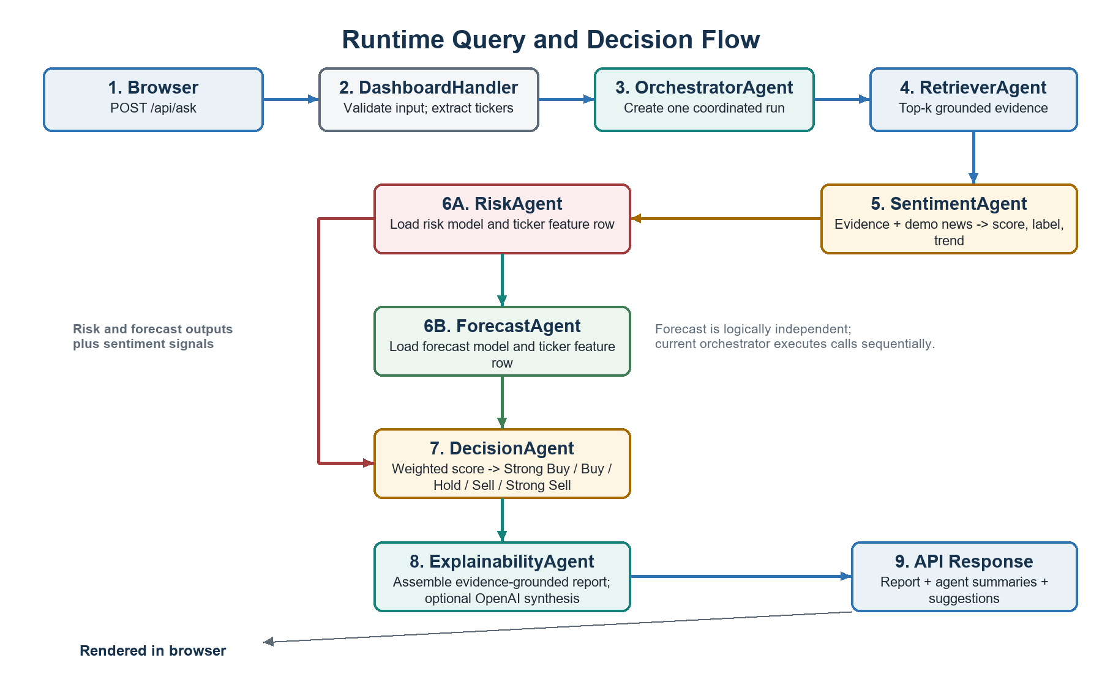
Figure 2. Runtime request path from browser question to explainable response.

Request Sequence
- The browser submits a question to POST /api/ask.
- DashboardHandler validates the payload and extracts valid ticker symbols from the cached universe.
- OrchestratorAgent creates the specialist agents and begins one coordinated run.
- RetrieverAgent queries ChromaDB; if the index is absent or unavailable, it falls back to local hybrid retrieval.
- SentimentAgent combines generated news indicators with sentiment from retrieved evidence.
- RiskAgent and ForecastAgent load trained artifacts and select the requested ticker feature row.
- DecisionAgent applies transparent weights and maps the score to Strong Buy, Buy, Hold, Sell, or Strong Sell.
- ExplainabilityAgent creates a grounded prompt and delegates to the configured GenAIProvider.
- The API returns the report, suggestions, agent summaries, and educational disclaimer.

4. Persistent RAG Architecture
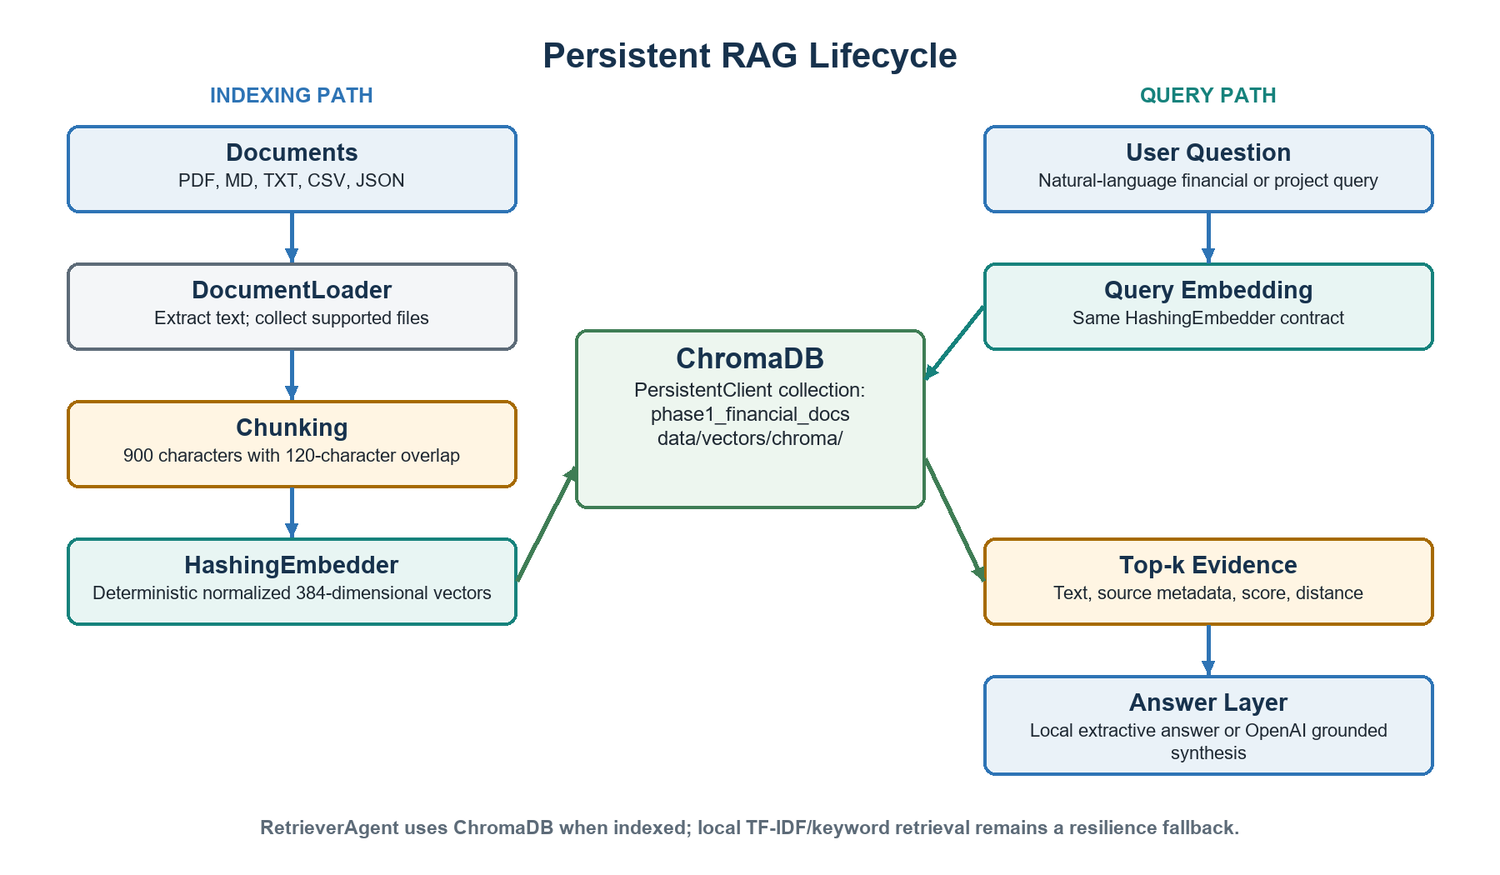
Figure 3. Indexing and query paths for the Phase 1 RAG subsystem.
RAG concern | Current implementation
Supported input | PDF, Markdown, text, CSV, and JSON
Chunking | 900 characters with 120-character overlap
Embedding | Local deterministic token hashing; normalized 384-dimensional vectors
Vector database | ChromaDB PersistentClient
Persistence path | data/vectors/chroma/
Collection | phase1_financial_docs
Retrieval output | Text, source metadata, chunk ID, distance, and normalized relevance score
Generation | Local extractive fallback or OpenAI Responses API synthesis
Why RAG and ML both exist
RAG supplies source-grounded context and explains why. ML supplies learned numerical risk and direction signals and estimates what is likely. The decision agent combines both forms of intelligence.

5. Machine-Learning Architecture
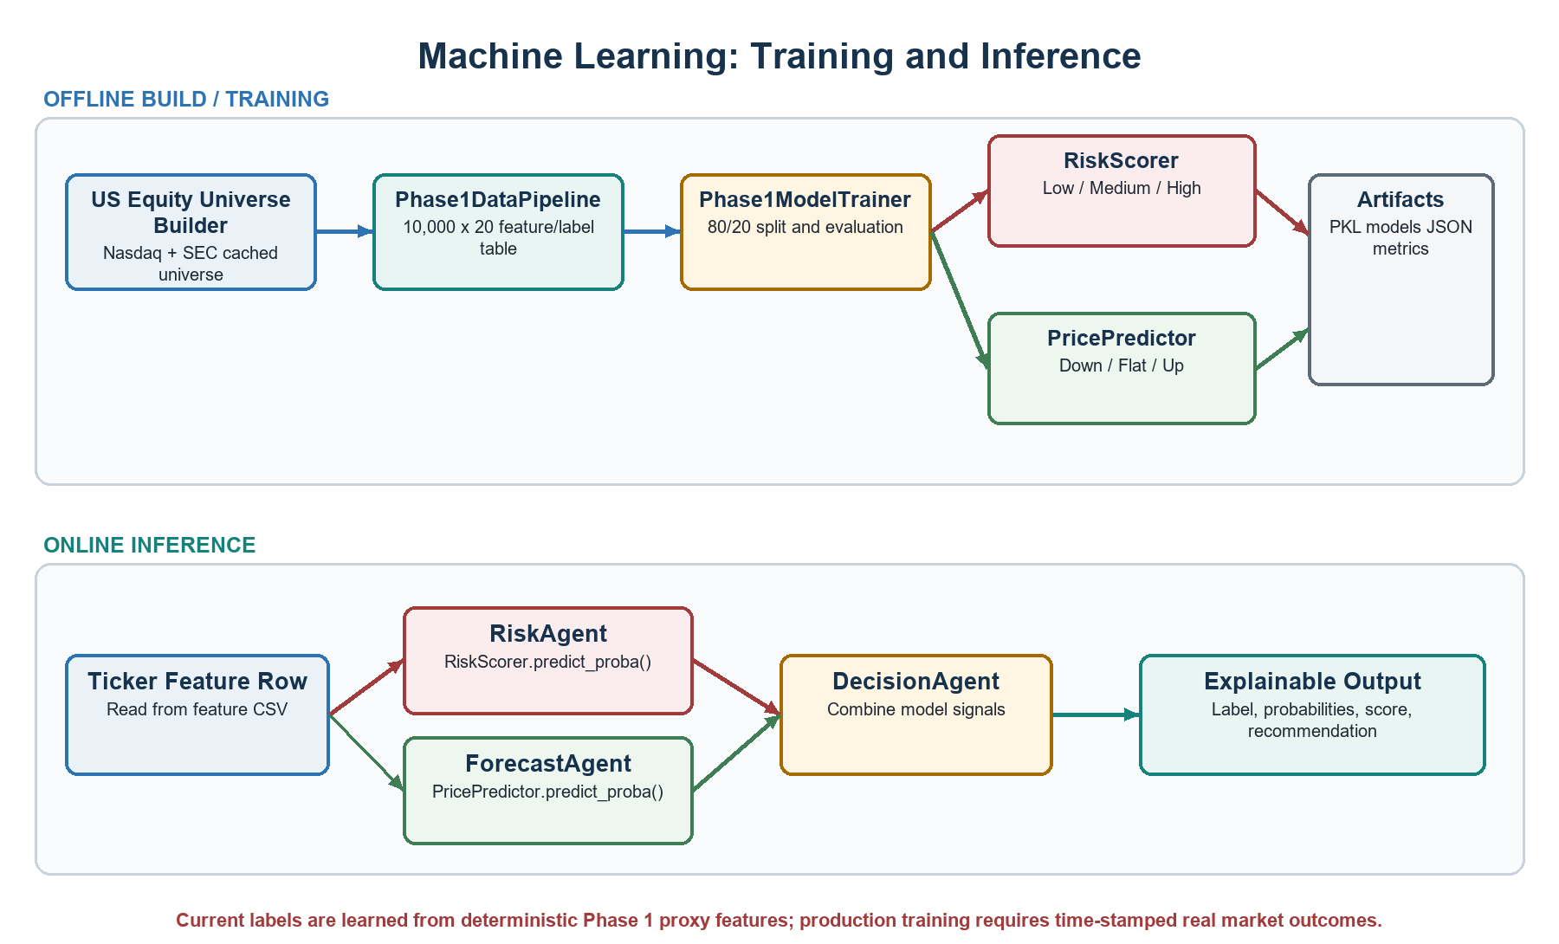
Figure 4. Separate build-time training and runtime inference paths.

Model Contracts
Class | Input | Output | Persistence
RiskScorer | 10 numeric features | Low / Medium / High | phase1_risk_model.pkl
PricePredictor | 8 numeric features | Down / Flat / Up | phase1_forecast_model.pkl
CentroidClassifier | Standardized numeric matrix | Nearest class centroid probabilities | Embedded in both PKL files

Training Method
- Feature data is shuffled with random_state=42 and split 80% training / 20% testing.
- Features are standardized using training-set mean and standard deviation.
- Each class centroid is learned in standardized feature space.
- Prediction probabilities are derived from exponentiated negative distances.
- Accuracy, macro F1, weighted F1, and per-class precision/recall/F1 are persisted as JSON.
Scientific boundary
The current 10K feature table and labels are deterministic Phase 1 proxies designed to prove the pipeline at scale. They are not yet a backtested production market dataset. Phase 2 should replace proxies with point-in-time OHLCV, fundamentals, filings, and news while preventing look-ahead bias.

6. Runtime Class Flow
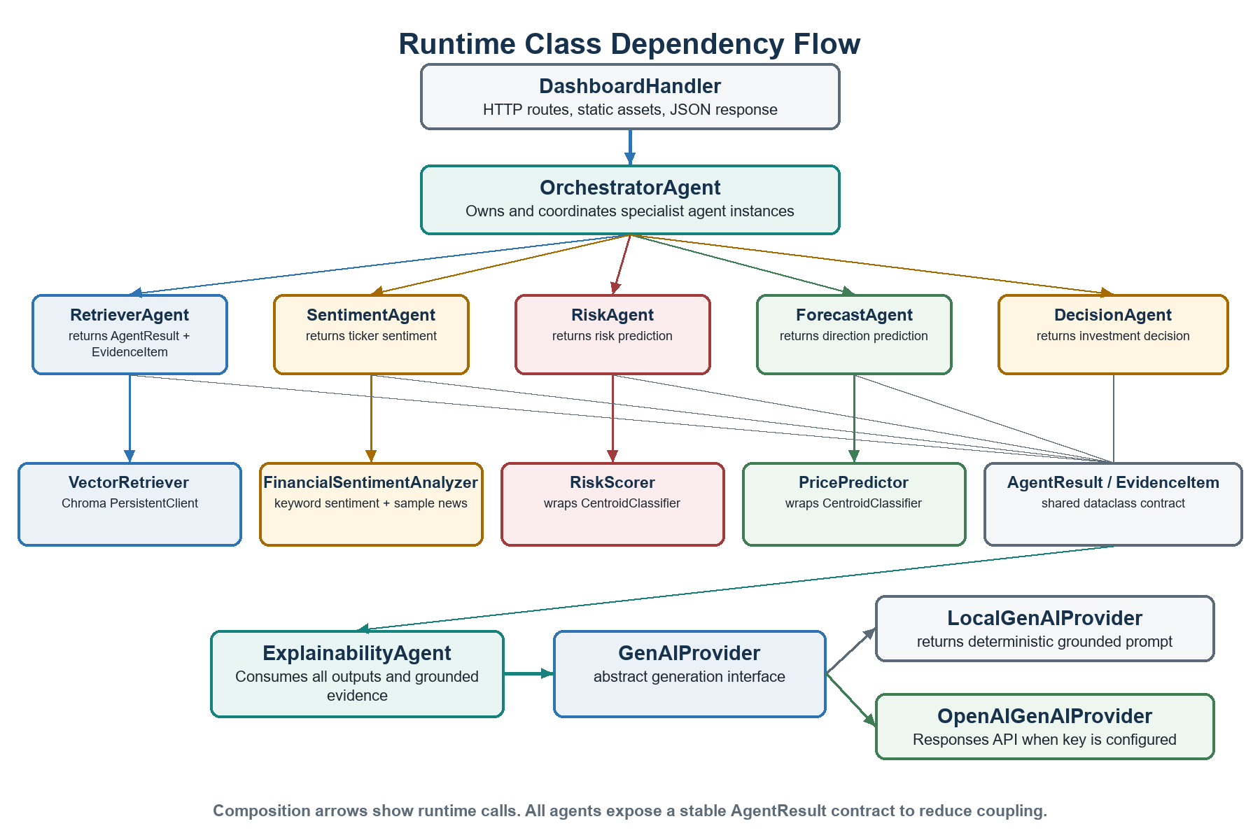
Figure 5. Runtime class composition and dependency flow.

Shared Result Contract
EvidenceItem holds source, text, score, and metadata. AgentResult standardizes agent_name, status, summary, data, evidence, confidence, and warnings. This contract lets the orchestrator combine specialist outputs without depending on each agent's internal implementation.

7. Data, Training, and RAG Build Classes
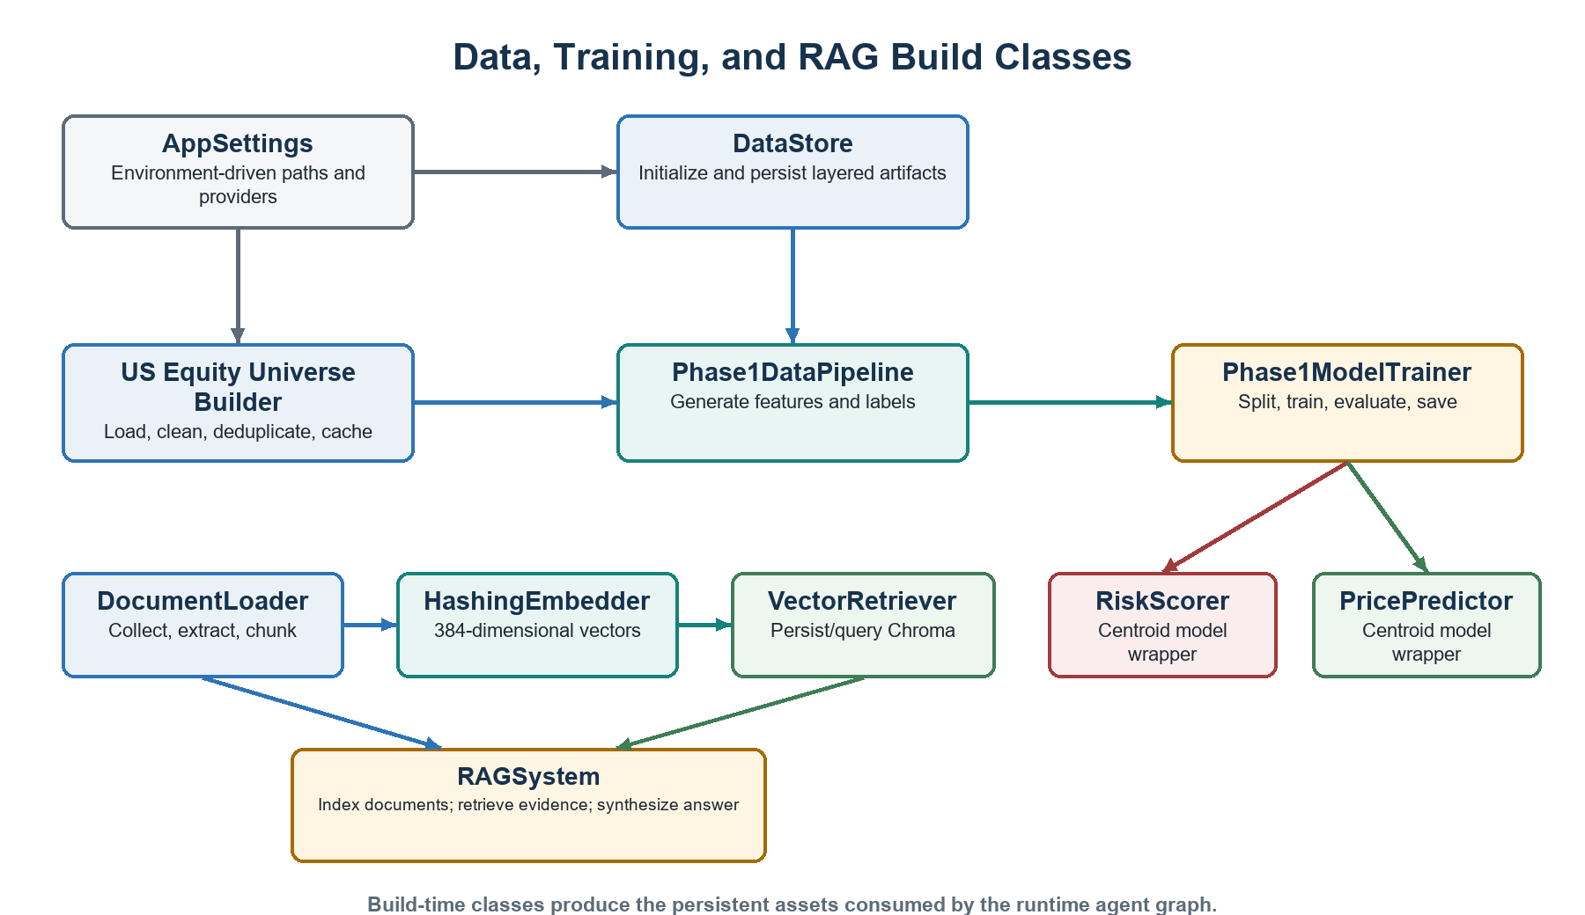
Figure 6. Build-time classes and the persistent assets they create.
Class | Module | Role
AppSettings | config/settings.py | Resolves local/cloud configuration
DataStore | storage/data_store.py | Owns raw, processed, feature, vector, model, and report paths
USEquityUniverseBuilder | data_layer/company_universe.py | Builds and caches the US ticker universe
Phase1DataPipeline | data_layer/phase1_data_pipeline.py | Creates model-ready features and labels
Phase1ModelTrainer | ml_models/phase1_trainer.py | Trains, evaluates, and saves both classifiers
RAGSystem | rag_layer/rag_system.py | Provides standalone index and query API
VectorRetriever | rag_layer/retriever.py | Owns Chroma collection and similarity operations
GenAIProvider | genai_layer/provider.py | Abstracts local and OpenAI report generation

8. Data, Storage, Frontend, and API Contracts

Storage Layout
Location | Responsibility
data/raw/ | Unchanged Nasdaq Trader / SEC source downloads
data/processed/ | Cleaned 10K universe, summaries, and manifests
data/features/ | ML-ready phase1_model_features.csv
data/vectors/chroma/ | Persistent ChromaDB collection
models/ | Risk and forecast PKL artifacts plus metrics JSON
reports/ | Generated Markdown reports
data/*.csv / *.json | Dashboard analysis and demonstration outputs

Frontend API
Method | Route | Purpose
GET | /api/summary | Counts, model metrics, recommendations, files
GET | /api/universe | Search and list cached US equity universe
GET | /api/recommendations | Rank investment report rows
GET | /api/sentiment | Return sentiment leaders
GET | /api/news | Return latest demo news rows
POST | /api/ask | Run the complete multi-agent workflow

Configuration Boundary
- FIE_ENV selects local or cloud-oriented behavior.
- FIE_DATA_ROOT and related variables redirect storage without changing business logic.
- FIE_GENAI_PROVIDER selects local or openai.
- FIE_GENAI_MODEL selects the hosted model.
- OPENAI_API_KEY must be injected as a secret and must never be committed.
- FIE_DATABASE_URL is prepared for a future SQLite/PostgreSQL transition.

9. Deployment Evolution

Current Phase 1 Deployment
Concern | Current implementation
Client | Browser on the demonstration machine
Application | Python ThreadingHTTPServer at 127.0.0.1:8000
Persistence | Local folders, ChromaDB, CSV/JSON, PKL artifacts
GenAI | Local fallback; OpenAI optional through environment variables
Operations | Manual indexing, training, and server startup scripts

Startup-Grade Target Architecture
Layer | Recommended evolution
Frontend | React or Next.js behind CDN
Backend | FastAPI service in a Docker container
Data | PostgreSQL plus object storage for filings and market datasets
Vector search | Managed Qdrant, Pinecone, Weaviate, or cloud-persistent Chroma
Model serving | Versioned model registry and dedicated inference service
Async work | Queue and workers for SEC ingestion, indexing, training, and alerts
Security | Identity, authorization, secret manager, encryption, audit logging
Observability | Request traces, agent latency, retrieval quality, model drift
Recommended progression
First package the existing application in Docker with a persistent volume. Then separate the API and frontend, move structured data to PostgreSQL, move documents to object storage, introduce managed vector search, and finally add multi-tenant security and billing.

Phase 2 Research Priorities
- Point-in-time market and fundamental dataset with reproducible lineage.
- Real 10-K, 10-Q, earnings-call, and news ingestion with ticker/date/page metadata.
- Finance-specific embeddings, hybrid retrieval, reranking, and retrieval evaluation.
- Walk-forward model validation, calibration, drift monitoring, and ablation studies.
- Agent routing, parallel execution, confidence gating, and citation verification.
- Portfolio-level risk, personalization, alerts, and analyst workflow features.

10. Current Boundaries and Demo Runbook

What Is Implemented Now
Status | Capability or boundary
Implemented | 10K US ticker universe and layered local storage
Implemented | 10K x 20 Phase 1 feature and label table
Implemented | Trained risk and forecast baseline models with metrics
Implemented | Persistent ChromaDB with 384-dimensional local embeddings
Implemented | Retriever, Sentiment, Risk, Forecast, Decision, Explainability agents
Implemented | Provider-agnostic GenAI layer and OpenAI adapter
Implemented | Local frontend, REST-style endpoints, and generated reports
Boundary | Most feature values and news are deterministic demo proxies
Boundary | RAG corpus is project/research material, not yet a broad filing corpus
Boundary | HTTP server has no authentication, HTTPS, quotas, or tenant isolation
Boundary | The decision score is educational and not a trading recommendation

Mentor Demo Sequence
Step | Action | Command
1 | Initialize storage | python setup_phase1_storage.py --min-count 10000
2 | Build features | python build_phase1_data.py --min-count 10000
3 | Train models | python train_phase1_models.py
4 | Index RAG | python index_phase1_rag.py
5 | Test RAG | python query_phase1_rag.py "What is implemented in Phase 1?"
6 | Run agent demo | python demo_phase1_agents.py
7 | Start frontend | python frontend/server.py
8 | Open dashboard | http://127.0.0.1:8000

Suggested Mentor Explanation
Thirty-second summary
Phase 1 proves an end-to-end financial intelligence workflow at 10K-company scale. Persistent RAG grounds the answer in documents, trained baseline models provide risk and forecast signals, specialist agents keep responsibilities modular, and the explainability layer produces a traceable report. Phase 2 replaces proxy data with point-in-time financial data and evaluates retrieval, models, and agents rigorously.

