PHASE 1 FINAL PROJECT REPORT
Financial Intelligence Engine
Multi-Agent RAG and Machine Learning for Explainable Investment Decision Support
A local-first, cloud-deployed academic prototype combining a 10,000-company universe, real market observations, SEC filing retrieval, trained risk and forecast models, multi-agent orchestration, and evidence-grounded GenAI.
Prepared by Sumeet Panda
Repository: sumeetpanda-source/Financial_Intelligence_Engine

Executive Summary
What was built, why it matters, and what the evidence shows
The Financial Intelligence Engine is an educational decision-support application that demonstrates how structured market data, unstructured financial documents, machine learning, retrieval-augmented generation (RAG), and specialized agents can be combined into one explainable workflow. A user asks a company or investment question; the system retrieves evidence, computes sentiment, risk, and forecast signals, combines the signals into a recommendation, and produces a cited explanation for the dashboard.
Phase 1 thesis: A credible financial AI prototype must show evidence provenance, model limitations, reproducible data flow, and a working interface - not only an LLM-generated answer.

Evidence | Verified Phase 1 result
Universe | 10,000 US equity ticker/company metadata records
Real history | 25,480 daily observations across 20 diversified companies
Training set | 23,880 point-in-time rows with observed forward labels
RAG | ChromaDB with 511 source-aware chunks before live SEC bootstrap
Agents | Retriever, sentiment, risk, forecast, decision, explainability
Quality | 14 automated tests passing and health/API verification
Cloud | Docker application deployed through GitHub to Render

The prototype is intentionally honest about its limits. The risk model adds signal above its majority baseline; the forecast model improves balanced accuracy over random but does not yet beat the majority-class accuracy baseline. Therefore, outputs are presented as educational decision support rather than financial advice.

1. Problem, Purpose, and Scope
Investment research requires analysts to combine price history, company fundamentals, news, regulatory filings, technical signals, and risk considerations. These inputs arrive in different formats and at different frequencies. Manual analysis is slow, difficult to reproduce, and vulnerable to missed evidence or unsupported conclusions.

Project purpose
- Provide a single interface for company screening and investment research questions.
- Ground narrative answers in retrieved source evidence.
- Separate retrieval, analysis, decision, and explanation responsibilities.
- Train transparent baseline models before introducing deep learning.
- Expose confidence, citations, warnings, and limitations to the user.
- Create a foundation that can evolve from an academic project into a startup platform.

Phase 1 boundary
Phase 1 implements market-standard capabilities that can be demonstrated and evaluated now: local/cloud storage, a broad company universe, a real-data pilot, baseline machine learning, persistent vector retrieval, a multi-agent workflow, configurable GenAI, and a browser dashboard. Novel research features such as adaptive agent selection, contradiction detection, analyst memory, finance-specific embeddings, and advanced time-series models are reserved for Phase 2.
Audience: The immediate audience is the academic examiner and mentor. The longer-term audience is an analyst, student, or retail investor who needs traceable research assistance rather than an opaque trading signal.

2. Research Foundation and Idea Origins
The project is inspired by published work and open-source financial agent systems, but it is not a direct copy of one repository. The implementation adapts architectural ideas to a smaller, examiner-friendly Phase 1 scope.
Source | Idea adopted | How this project differs
FinRobot (AI4Finance Foundation) | Layered DataOps, financial agents, configurable LLMOps, report generation | Uses a leaner local-first agent workflow and independent code contracts
MimirRAG (Samuelsen et al., 2026) | Metadata-aware financial retrieval and agentic RAG | Implements hashing vectors plus lexical/metadata reranking; table-aware parsing remains future work
FundaPod (Zhu et al., 2026) | Evidence provenance and human-centered fundamental research | Uses one converged decision report in Phase 1; persona debate and knowledge graphs are deferred
Lewis et al. (2020) | Retrieval-Augmented Generation pattern | Applies RAG to project documents, research papers, and official SEC filings
AI-Powered Sustainable Finance taxonomy (2026) | Broader view of ML, NLP, optimization, and ESG decision support | Current scope focuses on financial research architecture; ESG expansion is a future direction

FinRobot was especially useful as an architectural reference because it demonstrates the value of separating financial data operations, task-specific agents, LLM provider operations, and human-readable research output. The project preserves those boundaries while avoiding a large dependency on FinRobot internals.
Academic attribution: The report and repository identify external papers and repositories explicitly. Original project code connects the selected ideas through its own data contracts, storage layout, agents, frontend, tests, and deployment.

3. Design Requirements and Engineering Principles
- Scale the discovery universe to at least 10,000 US equity records.
- Keep local development functional without paid API keys.
- Use persistent retrieval so indexing does not repeat for every query.
- Ground generated explanations in retrieved evidence and structured model outputs.
- Train models on observed time-based outcomes and prevent future-label leakage.
- Keep every agent output structured, inspectable, and suitable for JSON APIs.
- Provide graceful fallbacks when market data, SEC, vector, model, or GenAI services are unavailable.
- Run the same application locally and in the cloud through environment-driven paths.

Complexity that an examiner can inspect
Complexity comes from integration rather than an unnecessary number of frameworks. The application combines multiple data sources, time-series feature engineering, persistent vector storage, retrieval reranking, model persistence, agent coordination, confidence propagation, source citations, an HTTP API, a responsive frontend, containerization, cloud secrets, and automated tests.
Engineering concern | Phase 1 treatment
Reproducibility | Cached raw/processed/features/models and deterministic proxy fallback
Data leakage | Chronological 80/20 split; future labels excluded from inference
Reliability | Fallbacks plus health and capability checks
Explainability | Driver scores, model probabilities, evidence snippets, limitations
Security | Secrets in environment variables; no API key committed
Scalability | Broad metadata universe, limited real-data cohort, batch-ready modules

4. System Architecture
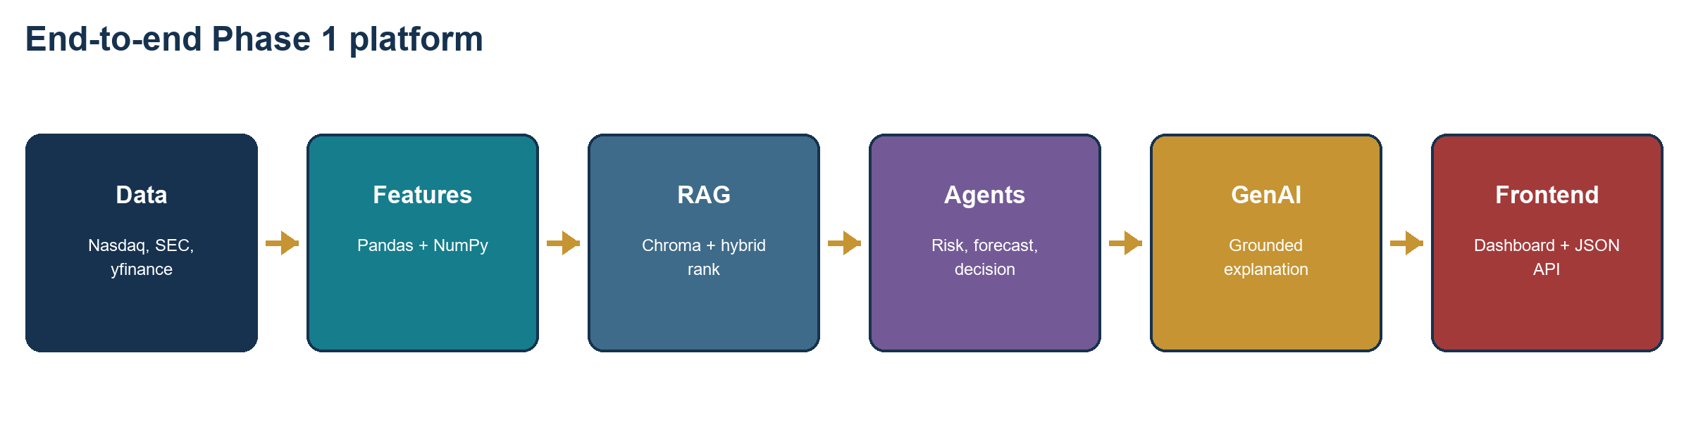
Figure 1. Layered architecture from data acquisition to the user-facing report.
The system is divided into replaceable layers. Data acquisition and storage do not depend on the frontend. The RAG layer can change its embedding or vector backend without changing agent contracts. Models expose a stable predict/predict_proba interface. The orchestrator consumes structured results and passes them to the decision and explainability stages.
Layer | Primary modules | Responsibility
Configuration | config/settings.py | Environment, data roots, providers, ports, secrets
Storage | storage/data_store.py | Raw, processed, feature, vector, model, report paths
Data | data_layer/* | Universe, market history, fundamentals, feature engineering
RAG | rag_layer/* | Parsing, chunking, embeddings, ChromaDB, SEC ingestion
ML | ml_models/* | Risk/forecast training, persistence, probability inference
Agents | agents/* | Retrieve, analyze, decide, explain
Presentation | frontend/* | Dashboard, API, output routes, health endpoints

5. Data Layer, Storage, and Scale
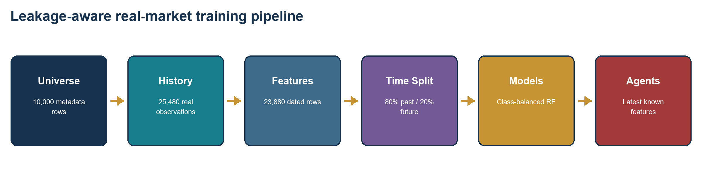
Figure 2. Real-data feature and training pipeline with chronological separation.
The application maintains two complementary scales. The discovery universe contains 10,000 real ticker and company metadata records from Nasdaq/SEC files. A diversified 20-company cohort supplies real OHLCV and selected fundamentals for model training. This distinction avoids claiming that synthetic proxy features are real market history for all 10,000 companies.
Storage area | Content | Example
data/raw | Original downloaded/cached sources | Ticker files, yfinance caches, SEC filing text
data/processed | Clean analysis-ready tables | Universe, real market history, summaries
data/features | ML-ready point-in-time rows | Training and latest inference features
data/vectors | Persistent retrieval index | Chroma SQLite and vector segments
models | Serialized trained models and metrics | Risk/forecast pickle files
reports | Human-readable output | Agent Markdown report

Use of Pandas and NumPy
Pandas performs CSV ingestion, cleaning, grouping, rolling windows, time alignment, tabular persistence, and API response preparation. NumPy supports returns, volatility, drawdown, RSI calculations, deterministic proxy generation, probability operations, and the dependency-light centroid fallback.

6. Retrieval-Augmented Generation and SEC Ingestion
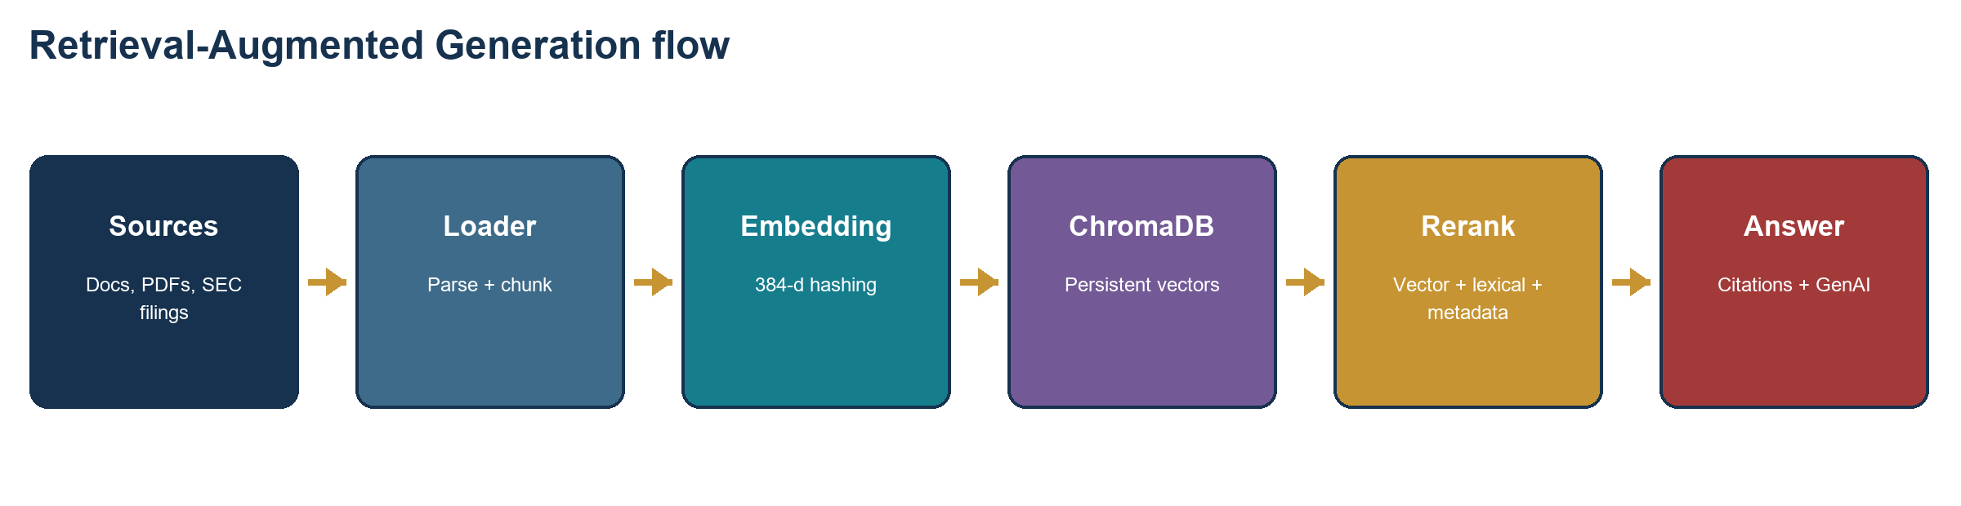
Figure 3. Persistent hybrid RAG path used by direct queries and the Retriever Agent.
Documents are parsed into overlapping 900-character chunks. A deterministic 384-dimensional hashing embedder creates local vectors without a model download. ChromaDB stores the chunks and metadata persistently. At query time the retriever obtains vector candidates and reranks them using 55% vector similarity, 35% lexical query coverage, and 10% metadata overlap.
RAG component | Implementation | Reason
Vector database | ChromaDB PersistentClient | Local persistence and simple cloud packaging
Embeddings | 384-d hashing vectors | Deterministic, offline, inexpensive Phase 1 baseline
Metadata | Source, type, page, ticker, date, year | Traceability and query-specific reranking
Generation | Local extractive or OpenAI Responses API | Offline reliability plus cloud synthesis
SEC ingestion | Submissions JSON + official filing archive | Official 10-K/10-Q evidence

SEC access: Live SEC ingestion requires FIE_SEC_USER_AGENT with an application name and contact email. The downloaded filing sidecar stores ticker, CIK, form, filing/report dates, accession, primary document, and official URL.

7. Multi-Agent Architecture and Class Flow
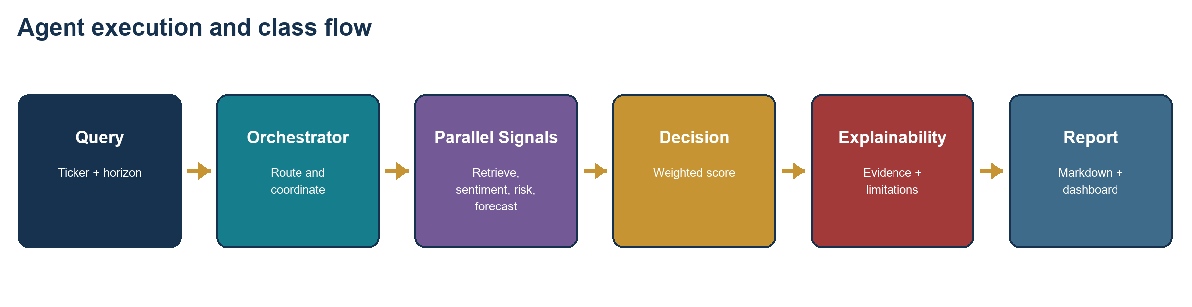
Figure 4. Runtime sequence from a user question to the final explainable report.
Agent/class | Input | Output
OrchestratorAgent | Question, optional tickers/documents | Coordinated AgentResult objects
RetrieverAgent | Question | Top-k evidence with metadata and scores
SentimentAgent | Tickers and evidence | Sentiment label, score, trend, warnings
RiskAgent | Latest features and sentiment | Risk class, score, probabilities
ForecastAgent | Latest features and horizon | Direction, expected return, volatility
DecisionAgent | Sentiment, risk, forecast | Investment score and recommendation
ExplainabilityAgent | All signals and evidence | Grounded Markdown report

All agents return a shared AgentResult schema containing agent name, status, summary, data, evidence, confidence, and warnings. This contract makes the workflow inspectable and enables the frontend to display agent traces without parsing free-form text.
Presentation simplification: The demo can describe three logical roles - Retrieval/Data, Financial Analysis, and Decision/Explainability - while the code retains specialized modules for maintainability.

8. Machine Learning Training and Evaluation
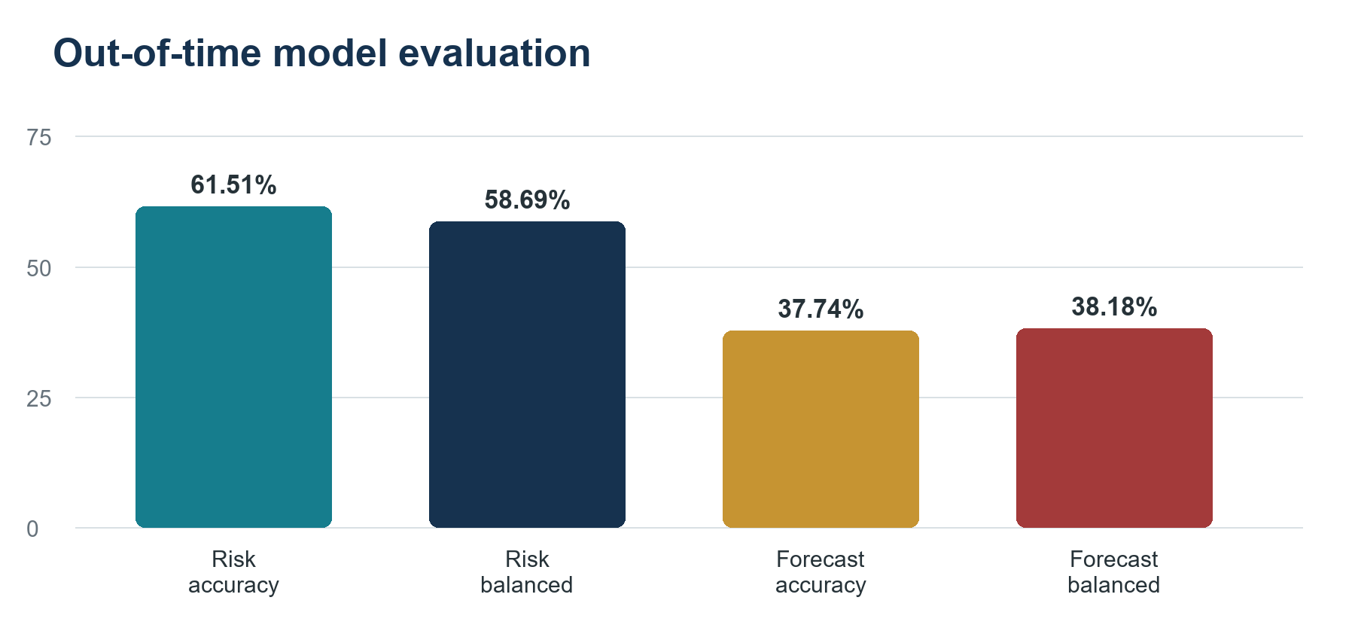
Figure 5. Out-of-time evaluation on the latest 20% of feature dates.
The real-market pipeline creates trailing features at each historical date and labels each row only from future observed outcomes. Forecast labels use the next 20 trading-day adjusted return: Down at or below -2.5%, Up at or above +2.5%, otherwise Flat. Risk labels use forward 20-day annualized realized volatility: Low below 20%, High at or above 40%, otherwise Medium.
Metric | Risk | Forecast
Algorithm | Class-balanced random forest | Class-balanced random forest
Training rows | 19,100 | 19,100
Test rows | 4,780 | 4,780
Accuracy | 61.51% | 37.74%
Balanced accuracy | 58.69% | 38.18%
Macro F1 | 56.63% | 37.26%
Lift | +4.94 points vs majority | +4.85 points balanced vs random

The forecast model does not beat the majority-class accuracy baseline. This is reported explicitly because financial direction prediction is difficult and a Phase 1 prototype should not convert weak predictive evidence into a strong investment claim. TensorFlow and PyTorch are deferred until walk-forward evaluation, calibration, and stronger data lineage are available.

9. GenAI and Explainability
The GenAI layer is provider-agnostic. Local mode returns a deterministic grounded report, allowing the entire system to run without an API key. OpenAI mode uses the Responses API to rewrite the grounded prompt into a concise report while instructing the model to use only the supplied agent outputs and evidence.
Concern | Implementation control
Hallucination | Generation receives retrieved evidence and structured agent results
Traceability | Evidence snippets include source, type, page, ticker, and retrieval score
Provider failure | Local deterministic report remains available
Secrets | OPENAI_API_KEY is read from environment and excluded from Git
Overconfidence | Model probability confidence and limitations are displayed
Financial safety | Every response states that it is educational, not financial advice

Decision logic
The Decision Agent calculates a transparent investment score using 30% sentiment, 35% inverse risk, and 35% forecast return contribution. Thresholds map the score to Strong Buy, Buy, Hold, Sell, or Strong Sell. This rule-based combination is deliberately visible so examiners can inspect the relationship between inputs and recommendation.
Current OpenAI status: The code path is implemented. Cloud operation depends on OPENAI_API_KEY, FIE_GENAI_PROVIDER=openai, and a supported model configured in Render.

10. Frontend and API Workflow
The frontend is the actual working experience rather than a marketing landing page. A lightweight Python HTTP server exposes static assets and JSON endpoints. The browser dashboard supports Overview, Ask, Universe, Analysis, and Outputs views.
Endpoint | Purpose | Evidence shown
/health | Deployment readiness | Universe, features, models, vector store, capabilities
/api/summary | Dashboard metrics | 10K universe, real rows, model metrics, SEC count
/api/universe | Ticker/company search | Paginated/filterable metadata
/api/ask | Run full agent workflow | Recommendation, trace, confidence, citations
/api/news | Display sentiment input | Date, headline, source, sentiment label
/outputs/* | Open generated artifacts | CSV, text, and model metric files

Ask workflow
- The user submits a natural-language question.
- The server validates tickers against the cached universe.
- The orchestrator runs retrieval and analytical agents.
- The decision agent combines scores into a recommendation.
- The explainability agent creates the final grounded response.
- The browser renders suggestion cards, agent signals, evidence, and disclaimer.
Current dashboard evidence: The Overview distinguishes broad universe scale from real training scale. The Ask view displays every agent summary and the retrieved source snippets used for explanation.

11. Cloud Deployment and Operational Flow
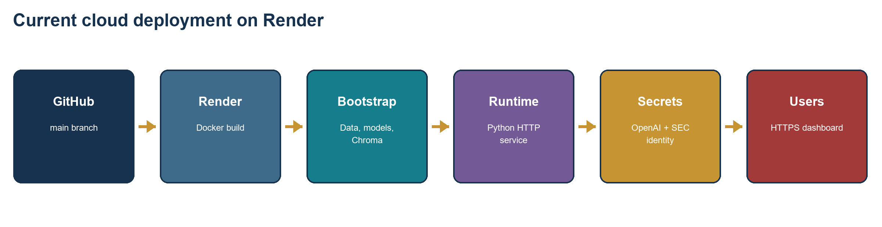
Figure 6. GitHub-connected Render deployment with packaged reproducible assets.
The GitHub repository is connected to a Render Blueprint. Each push to main triggers a Docker build. The image installs cloud dependencies, builds the 10K universe and proxy baseline, attempts the real 20-company data pipeline, trains models, indexes RAG documents, and stores bootstrap assets inside the image. If live market data is unavailable during build, the application keeps the reproducible proxy fallback.
Variable | Purpose
FIE_ENV=cloud | Enable cloud environment reporting
FIE_DATA_ROOT=/var/data | Writable runtime data root
FIE_MODEL_DIR=/var/data/models | Model artifact location
FIE_GENAI_PROVIDER | Select local or OpenAI generation
OPENAI_API_KEY | Secret for hosted generation
FIE_SEC_USER_AGENT | SEC application identity and contact email
PORT | Render-provided web service port

The current Render Free service has ephemeral storage and can spin down after inactivity. Bootstrap assets make the demonstration reproducible after restart. Production deployment should move durable vectors and app state to managed storage such as Supabase pgvector/object storage or a paid persistent disk.

12. Testing, Verification, and Application Complexity
Verification area | Current evidence
Automated suite | 14 pytest tests passing
Setup verification | Imports, files, cached assets, feature engineering: 5/5
Live market pilot | 20 tickers, prices and fundamentals, no failed tickers
Model provenance | real_yfinance_ohlcv in metrics and API summary
RAG query | Persistent Chroma retrieval with component scores and citations
Agent smoke test | Risk/forecast agents select real_market_trained_model
HTTP/API | Health ok and summary counts verified locally
Git | Clean main branch synchronized with GitHub

Why this application is technically complex
- Heterogeneous structured and unstructured data with separate freshness and quality constraints.
- Rolling time-series features and future outcome labels with leakage prevention.
- Persistent vector retrieval plus lexical and metadata reranking.
- Multiple agent outputs coordinated through typed result contracts.
- Model artifact loading, probability confidence, and fallback behavior.
- One codebase for local development, Docker, and cloud execution.
- Traceable outputs spanning CSV, JSON, Markdown, browser UI, and API responses.
Quality position: Passing tests prove selected contracts, not investment profitability. Retrieval benchmarks, model calibration, security testing, and production monitoring remain separate acceptance gates.

13. Known Limitations and Responsible Use
Limitation | Impact | Planned treatment
Real cohort covers 20 companies | Models do not represent the full 10K universe | Expand with licensed, point-in-time data
Forecast is below majority accuracy | Direction signal is weak | Walk-forward tuning and calibration
Hashing embeddings | Limited semantic understanding | Evaluate finance-specific embeddings
Sentiment is keyword/demo based | Misses nuance and context | FinBERT evaluation
Free Render storage | Runtime changes can disappear | Supabase/pgvector or paid disk
No authentication/rate limits | Not safe for public production use | Identity, authorization, quotas
No retrieval benchmark | Citation quality is not quantified | FinanceBench/FinDER-style evaluation
Educational recommendations | Not suitable as financial advice | Human review and compliance controls

The system separates facts from predictions wherever possible. A filing excerpt is source evidence; a risk class is a model output; a recommendation is a weighted decision-support result. These categories should not be presented as equally certain.
Responsible-use rule: A user should validate source documents, understand model uncertainty, and make the final investment decision. The application must not promise returns or replace regulated advice.

14. Phase 2 Roadmap and Startup Direction
Workstream | Phase 2 improvement | Expected value
Data | Licensed point-in-time prices, fundamentals, filings, news | Coverage, freshness, reproducibility
RAG | Finance embeddings, table-aware chunking, retrieval evaluation | Higher evidence precision
Agents | Adaptive routing, reliability scoring, contradiction checks | Lower cost and safer decisions
ML | Walk-forward validation, calibration, drift, temporal models | More defensible predictive claims
Memory | Analyst preferences and knowledge graph provenance | Reusable research context
Platform | Supabase pgvector, object storage, observability | Durable multi-user service
Governance | Authentication, audit logs, policy controls | Startup and institutional readiness

Potential startup value proposition
The strongest startup direction is not an autonomous stock picker. It is an evidence-grounded research workspace that reduces the time required to assemble a company view, preserves citations, exposes disagreements between signals, and generates an auditable investment memo. This positioning is more defensible because it supports human judgment instead of hiding uncertainty.
- Initial users: students, independent analysts, advisors, and small research teams.
- Core workflow: company search -> evidence retrieval -> signal analysis -> cited memo.
- Differentiation: provenance, confidence, reproducibility, and modular provider choice.
- Commercial gates: licensed data, compliance review, security, monitoring, and cost control.

15. Demonstration Script
Step | Action | What it proves
1 | Open the Render dashboard URL | Cloud deployment and responsive frontend
2 | Show Overview metrics | 10K universe vs real training scale
3 | Search AAPL in Universe | Cached company metadata and API filtering
4 | Ask an AAPL/MSFT/NVDA question | Full multi-agent workflow
5 | Open evidence citations | RAG provenance and source metadata
6 | Explain agent confidence | Model probabilities and structured trace
7 | Open /health and /api/summary | Operational readiness and model provenance
8 | Show GitHub and tests | Reproducibility, code ownership, and verification

Local commands
Command | Purpose
python fetch_real_market_data.py --years 5 | Refresh real OHLCV and fundamentals
python train_real_market_models.py --years 5 | Train and evaluate chronological models
python index_phase1_rag.py | Rebuild ChromaDB
python ingest_sec_filings.py --tickers AAPL MSFT NVDA | Download and index SEC filings
python -m pytest -q | Run automated tests
python frontend/server.py | Start local dashboard

Demo caution: Wake the Render Free service before the review. Keep local mode available as a fallback and never display an API key in the terminal, slides, logs, or screen share.

16. Conclusion
Phase 1 demonstrates a complete path from data acquisition to an explainable cloud-delivered answer. The project stores and processes a broad company universe, trains baseline models on real observed outcomes, retrieves evidence through a persistent vector database, coordinates specialized agents, optionally uses OpenAI for grounded synthesis, and presents results through a usable dashboard.
The main contribution of Phase 1 is integration discipline. Each layer has an explicit responsibility and fallback. The result is complex enough to demonstrate software architecture, machine learning, RAG, agents, GenAI, cloud deployment, and testing without claiming novelty or production investment performance.
Final assessment: The application is ready for academic demonstration as an evidence-backed baseline. Phase 2 should be judged by measurable gains in retrieval quality, calibration, data coverage, reliability, and analyst usefulness.

References
- AI4Finance Foundation. FinRobot: An Open-Source AI Agent Platform for Financial Applications. GitHub: https://github.com/AI4Finance-Foundation/FinRobot
- Yang, H. et al. FinRobot: An Open-Source AI Agent Platform for Financial Applications using Large Language Models. arXiv:2405.14767, 2024.
- Lewis, P. et al. Retrieval-Augmented Generation for Knowledge-Intensive NLP Tasks. NeurIPS, 2020.
- Samuelsen, M. et al. MimirRAG: A Multi-Agent RAG Framework for Financial Data Retrieval with Metadata Integration. arXiv:2605.25030, 2026.
- Garrido-Merchan, E. C. et al. AI-Powered Sustainable Finance: An Integrative Taxonomy and Framework. arXiv:2605.26076, 2026.
- Zhu, D., Zheng, L., and Chen, Z. FundaPod: A Multi-Persona Agent Pod Platform with Knowledge Graph Memory. arXiv:2605.27864, 2026.
- U.S. Securities and Exchange Commission. EDGAR Application Programming Interfaces. https://www.sec.gov/search-filings/edgar-application-programming-interfaces
- yfinance project documentation. https://ranaroussi.github.io/yfinance/
- Chroma documentation. https://docs.trychroma.com/
- OpenAI API documentation. https://platform.openai.com/docs/

