1. At <https://wordpress.org/plugins/buddypress-media/>  
     
   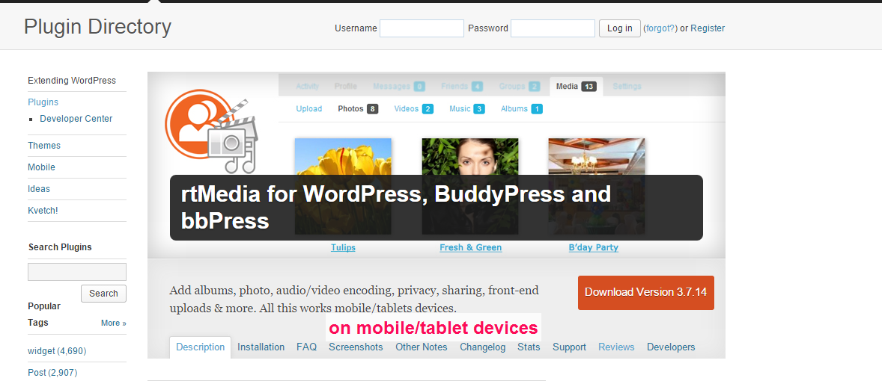
2. We need to update this : <https://rtcamp.com/rtmedia/support/>