**Client Side**

* HTML – Presentation of DOM
* Javascript – Language: used for DOM manipulation
* jQuery – Javascript Library: Used to handle DOM manipulation
* Reast js – Javascript Library: Used to design single page application

**Challenges in Modern Web Development**

* Majority of modern web users are using internet from smart devices.
* We need a good Unified UX
* Good Fluid UX

Javascript -> DOM  
jQuery -> DOM [Heavy, Slow, Events]

Developed by Facebook: It uses Virtual DOM (Replication of Actual Dom)

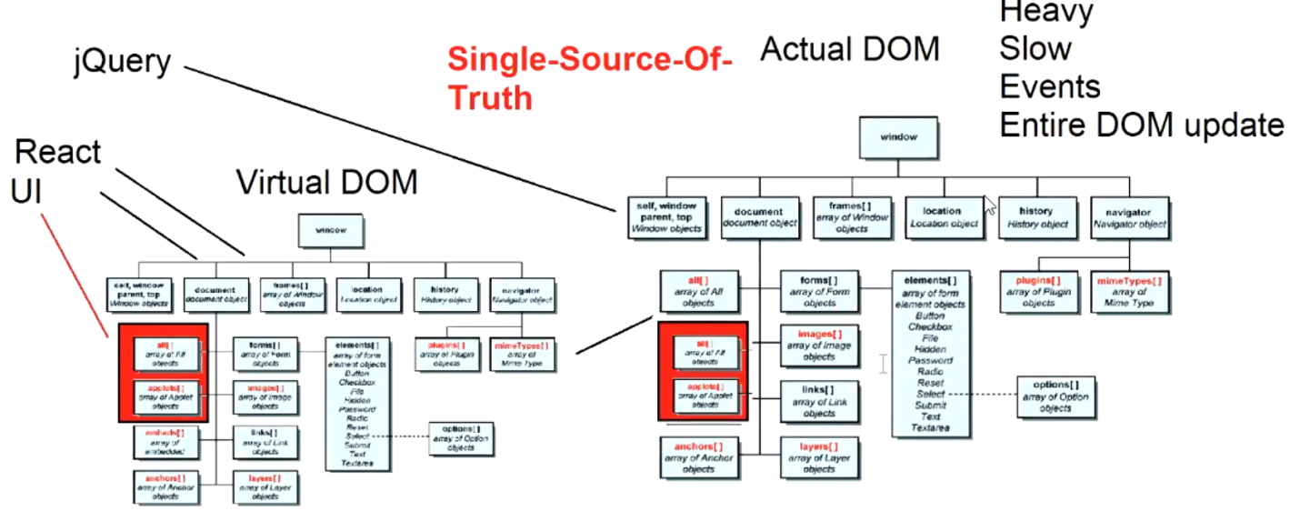

React don’t have everything – It uses external Library (for cross-platform, routing, etc)

Poor Documentation - Version tracking is difficult

Business  
Server Side, API -> UI

Angular – Framework – Dedicated Library to interact with API

React- Various Library to interact with API

Language: Medium of communication  
eg: Language- Javascript, Typescript, coffeescript

Library: Provides a predefined functionality which can be a collection of classes, methods etc.  
 eg: jQuery, RxJS, ReactJs