**Problem Statement:** In this project we are required to load the customers data (csv file provided) into the MySql and then loading the data to Hive using Sqoop.

**Solution:**

Step 1: Login into SQL in your VM using below commands

mysql -u root -p

password cloudera

Step 2: Create a Data base using below commands

create database antwak;

use antwak;

Step 3: Create the table in MySql

CREATE TABLE customers (customer_id INT NOT NULL , customer_fname VARCHAR(255) NOT NULL, customer_lname VARCHAR(255) NOT NULL, customer_street VARCHAR(255) NOT NULL,customer_city VARCHAR(255) NOT NULL,customer_state VARCHAR(255) NOT NULL,PRIMARY KEY (customer_id));

Step 4: Insert records into MySql

LOAD DATA LOCAL INFILE '/home/cloudera/Desktop/customers.csv' INTO TABLE customers FIELDS TERMINATED BY ',' LINES TERMINATED BY '\n' (customer_id, customer_fname, customer_lname, customer_street, customer_city,customer_state);

Now we need to import the data from the MySql to Hive using Sqoop import command.

Command used:

sqoop import --connect "jdbc:mysql://quickstart.cloudera:3306/antwak" \

--username root \

--password cloudera \

--table customers \

--target-dir /user/cloudera/ingest/raw/antwak_customers \

--fields-terminated-by "," \

--hive-import \

--create-hive-table \

--hive-table sqoop_workspace.antwak_customers

Sqoop job processing:

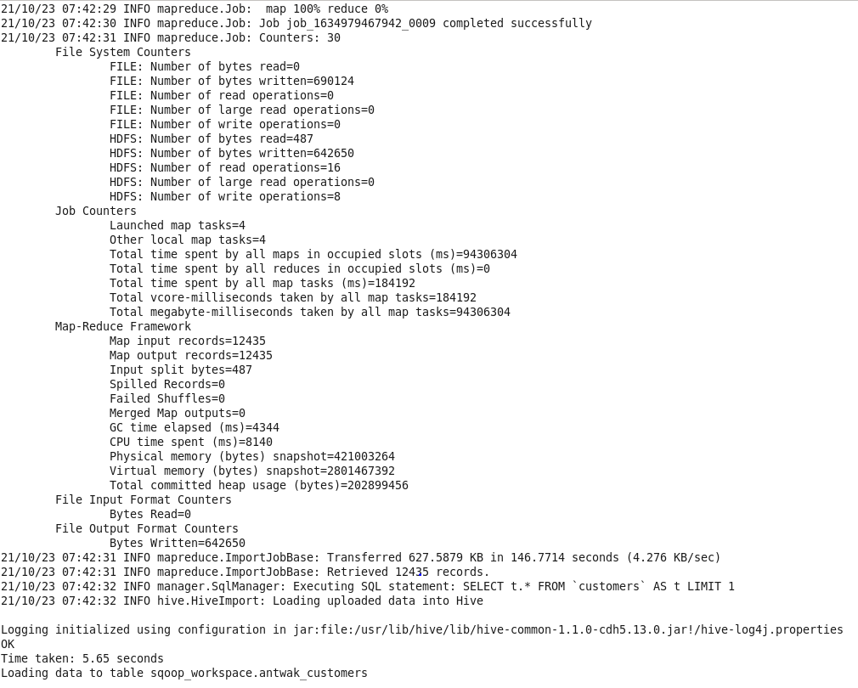

Check the files created in Hive Storage: Since there were 4 mappers so number of part files created is 4.

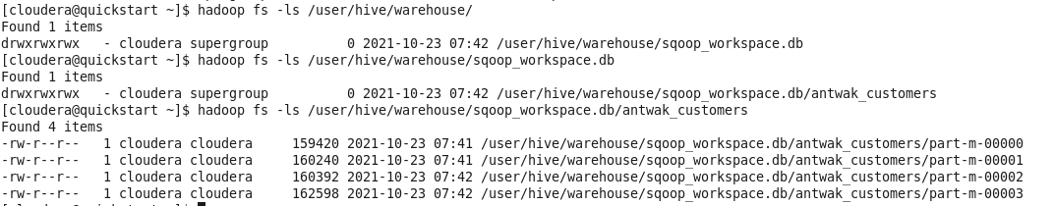

To query this Hive table, we can access having Hive using Beeline interface.

Step 1:

Command used: beeline -u jdbc:hive2://

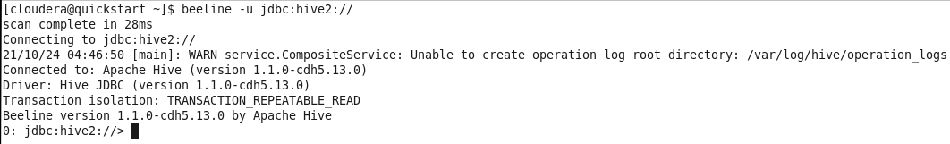

Now we can start writing the HQL queries to get the data.

1. How many records are present?

Query:

select count(1) as NUM_RECORDS from sqoop_workspace.antwak_customers;



Output:

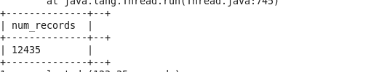

1. How many customers stay in the state TX

Query:

select count(1) as NUM_RECORDS from sqoop_workspace.antwak_customers where customer_state = 'TX';



Output:

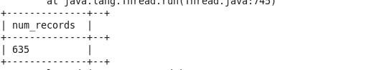

1. Which state has the lowest customer count?

Query:

select count(1) as NUM_RECORDS, customer_state from sqoop_workspace.antwak_customers group by customer_state order by NUM_RECORDS asc limit 1;



Output:

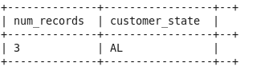

1. Which state has the highest customer count?

Query:

select count(1) as NUM_RECORDS, customer_state from sqoop_workspace.antwak_customers group by customer_state order by NUM_RECORDS desc limit 1;



Output:

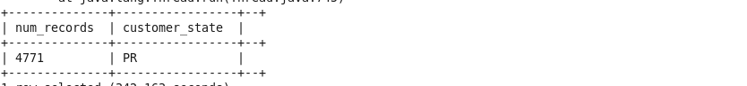

1. How many customers are present with the First Name 'Mary'?

Query:

select count(1) as NUM_RECORDS, customer_fname from sqoop_workspace.antwak_customers where customer_fname ='Mary' group by customer_fname;



Output:

