**Creation of ComosDB and uploading items:**

**Step 1:** Go to portal.azure.com, click on create new resource and search Azure Cosmos DB. From there click on create and select **“Core (SQL) - Recommended”**

After completion of the above process, we can perform the following tasks.

**Step-2:** We can start uploading the JSON data through the upload item option.

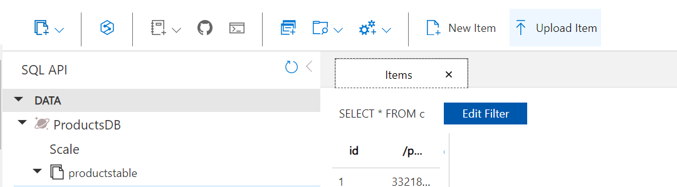

**Step 3:** Also, created the Stored Procedure named **“insertingData”** in JavaScript to upload items through it.

Stored Procedure script:

 function createDocument(doc) {

     var context = getContext();

     var collection = context.getCollection();

     var accepted = collection.createDocument(

         collection.getSelfLink(),

         doc,

         function (err, newDoc) {

             if (err) throw new Error('Error' + err.message);

             context.getResponse().setBody(newDoc);

         }

     );

     if (!accepted) return;

 }

Click on execute and provide input params:

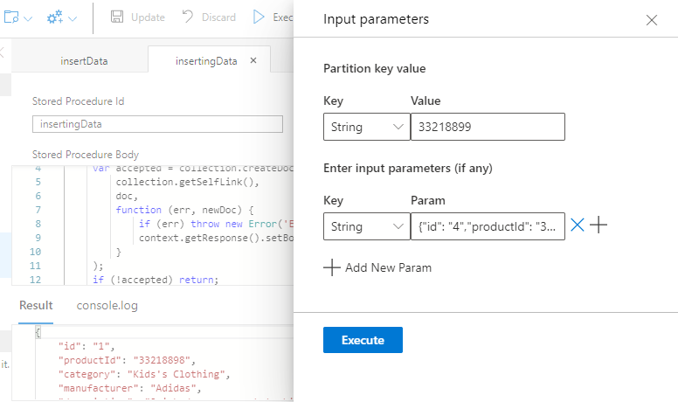

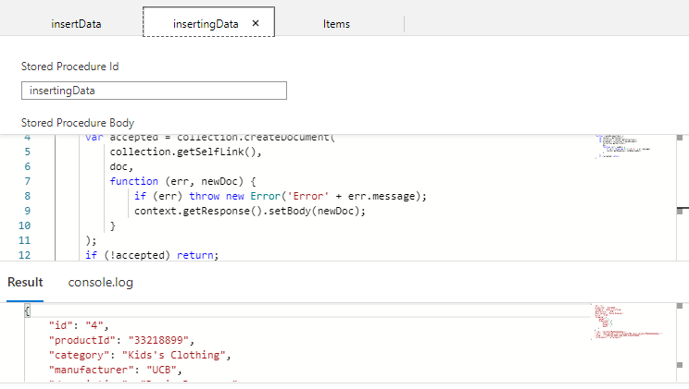

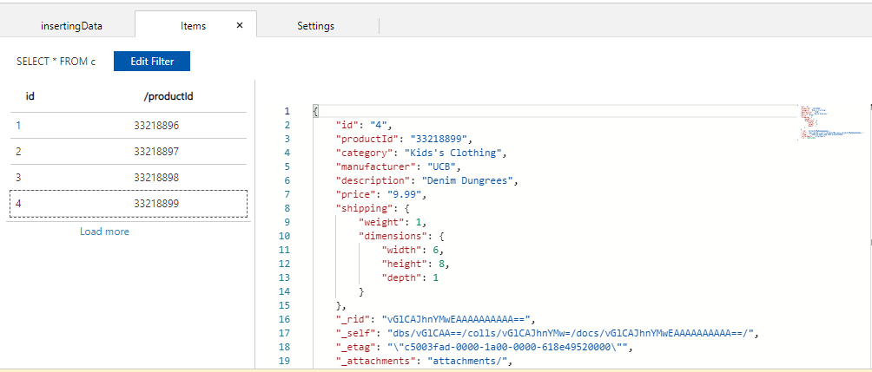

**Step-4: Creation of UDF for calculation of tax**

**UDF script**

function getTax(price) {

        if(price == undefined)

            throw 'no input';

        if (price < 100)

            return price * 0.1;

        else

            return price * 0.2;

}

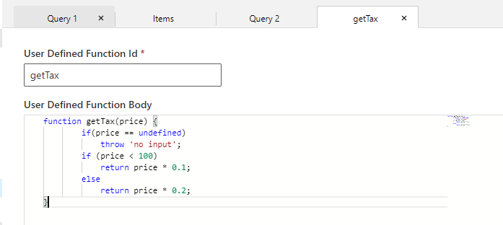

**Execution of UDF:**

