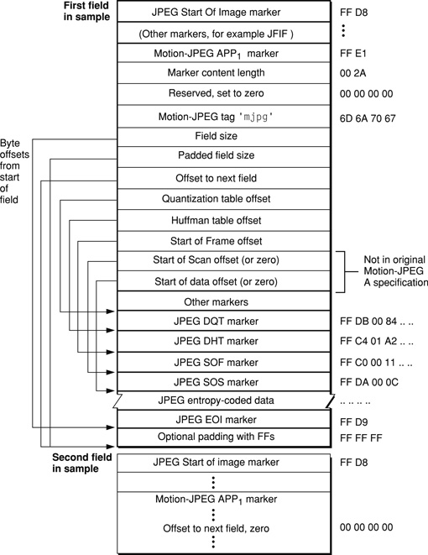
Figure 4-11 Motion-JPEG A dual-field sample data

http://developer.apple.com/mac/library/documentation/QuickTime/QTFF/QTFFChap3/qtff3.html

