Project #: 3

Hotel management Project (cisco)

As a part of your end year networking project, you are required to design and implement Vic modern Hotel Network. The hotel as three floors, in first floor there are three departments (reception, store and logistics) in2nd floor three departments are ( Finance, HR and sales/marketing) and 3rd floor hosts the IT and Admin. Therefore the following are part of the consideration during design and implementation:

1: There should be three routers connecting each floor (all placed in server room in IT department)

2: All routers should be connected to each other’s using DCE cable

3: The network between routers should be 10.10.10.0/30, 10.10.10.4/30, 10.10.10.8/30

3: Each floor is expected to have switch (placed in the respective floor)

5: Each floor is expected to have WIFI networks connected to laptops and phones

6: each department is expected to have printer

7: Each department is expected to be in different VLAN with following details

1st floor:

+ Reception VLAN 80, Network of 192.168.8.0/24

+ Store VLAN 70, network o 192.168.7.0/24

+ Logistics VLAN 60, network of 192.168.6.0/24

2nd floor

+ Finance VLAN 50, network of 192.168.4.0/24

+ HR VLAN 40, network of 192.168.4.0/24

3rd floor

+ Admin VLAN 20, network of 192.168.2.0/24

+ IT VLAN 10, network 192.168.1.0/24

8 use OSPF as the routing protocol to advertise routes

9. All devise in network are expected to obtain IP address dynamically with their respective router configured as the DHCP server

10. All the devices in network are expected to communicate with each other

11. Configure SSH in all the routers for remote login

12. In IT department, add PC called test-PC to port fa0/1 and use it to test remote login

13. Configure port of security to IT-department switch to allow only Test-PC to access port fa0/1 (use sticky method to obtain mac-address with violation mode of shutdown)

Configuration of routers

Configuring router of 3rd floor by CLI

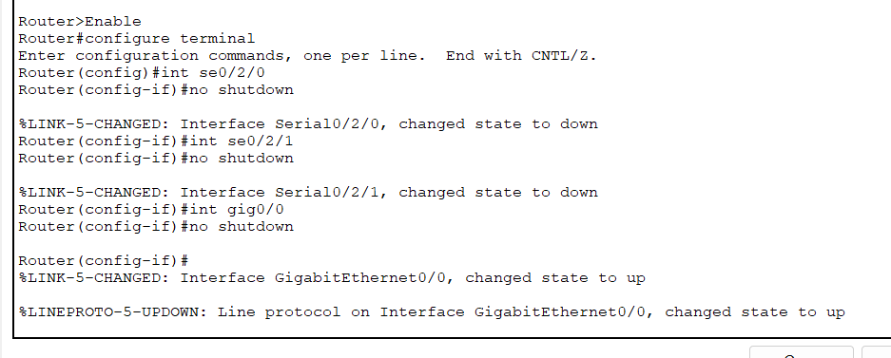

FOR 1ST Floor router:

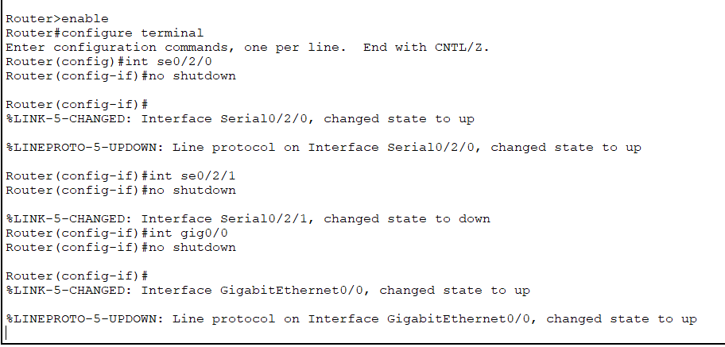

For 2nd floor router:

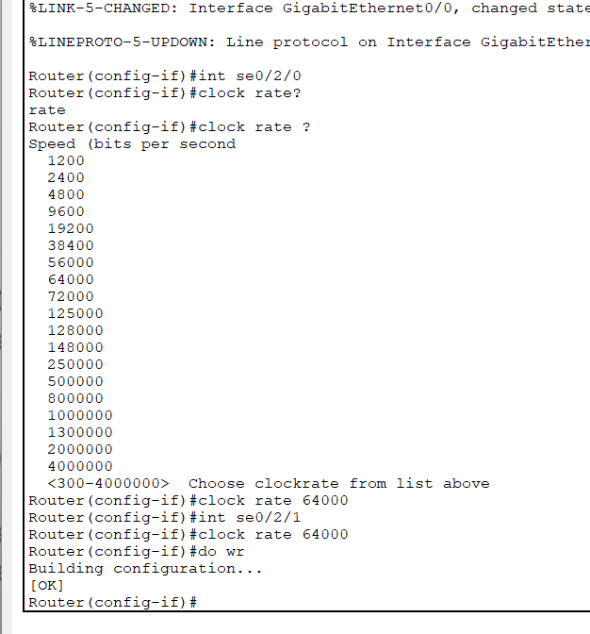

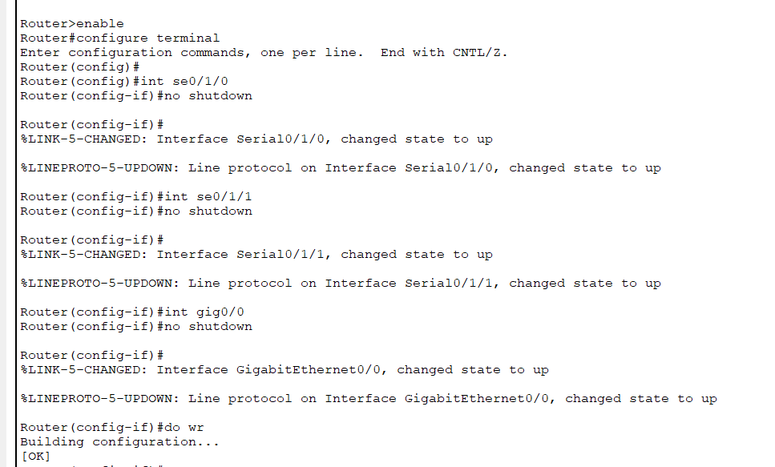

Configuring VLANS

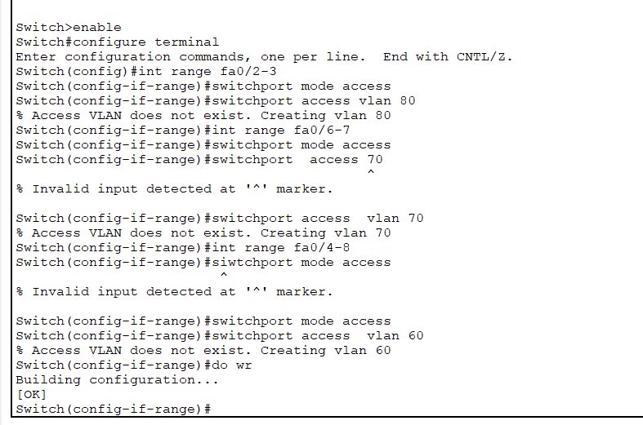

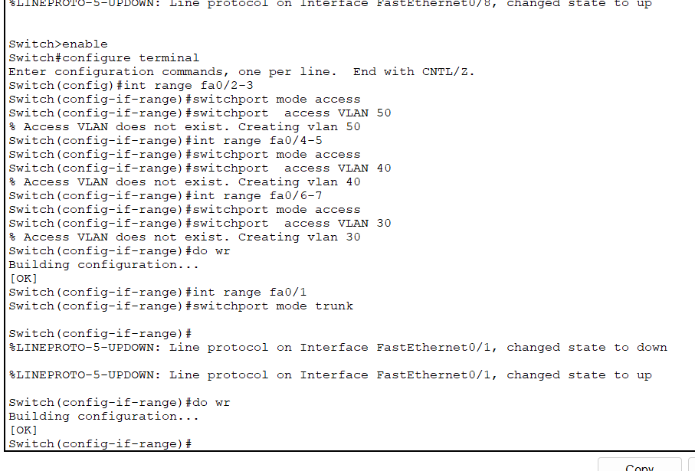

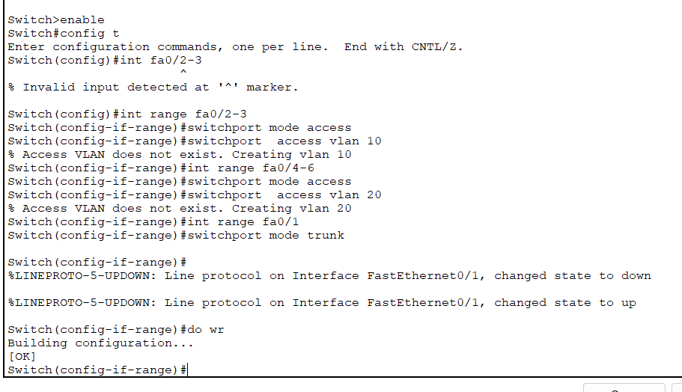

Sub netting for Router

For 1st router:

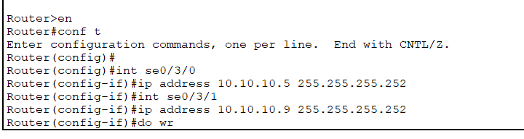

For 2nd router:

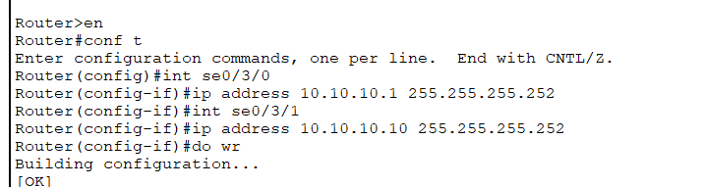

For 3rd router:

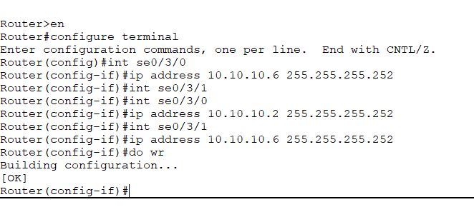

Now according to 3rd statement of designing

Use OSPF as the routing protocol to advertise routes

All devise in network are expected to obtain IP address dynamically with their respective router configured as the DHCP server

Now our task is to allocate IP addresses dynamically. For this

I am going to configure router as DHCP server.

In 1st floor:

Reception DHCP:

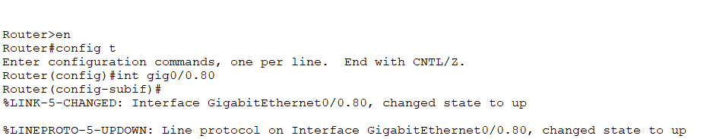

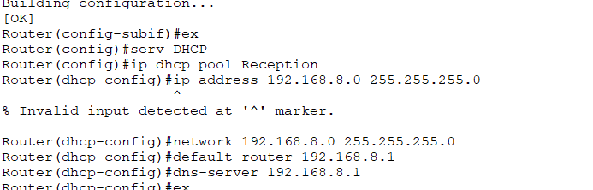

Store”

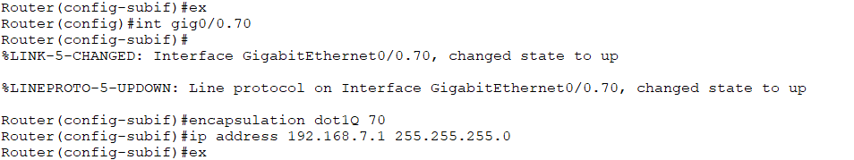

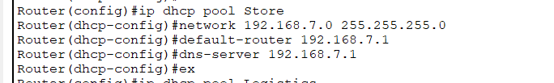

Logistics:

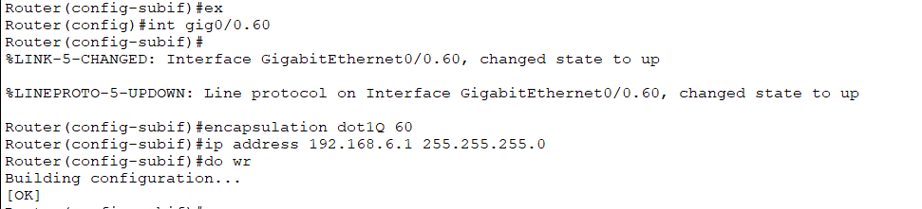

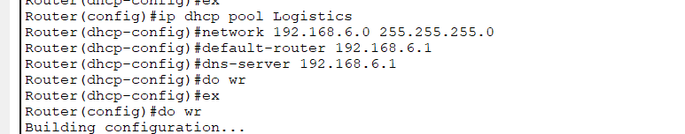

Testing if devices are allocated IP address:

PC from Reception;

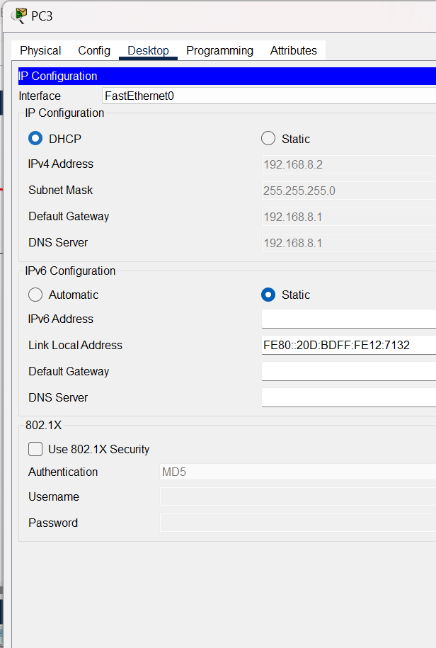

PC from store:

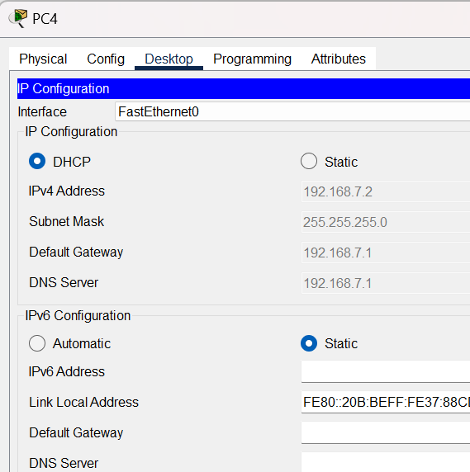

Pc from logistics:

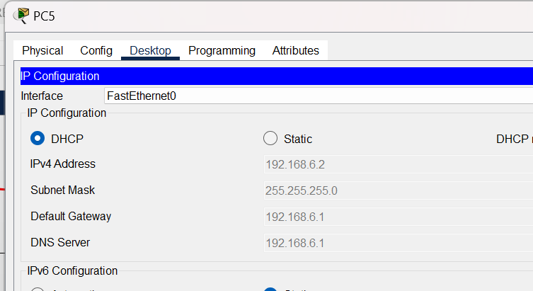

Testing PC1

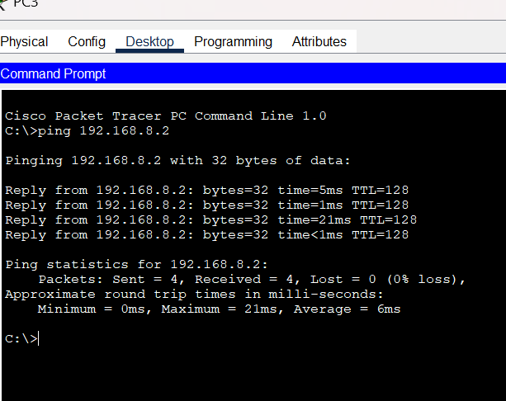

Message is sent successfully

Hence Router: 1 is successfully configured (DHCP)

Configuring 2nd Router:

For Finance

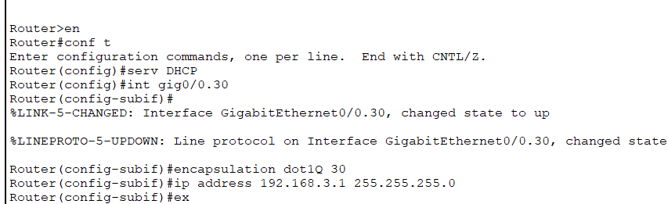

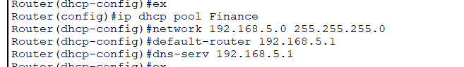

For HR

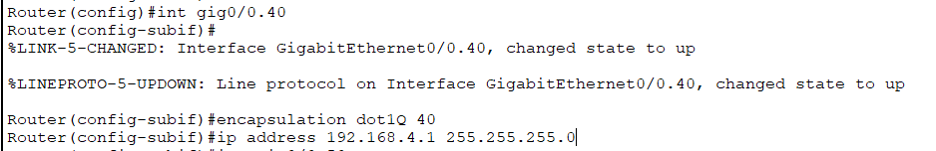

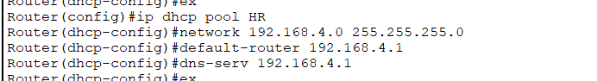

For sales:

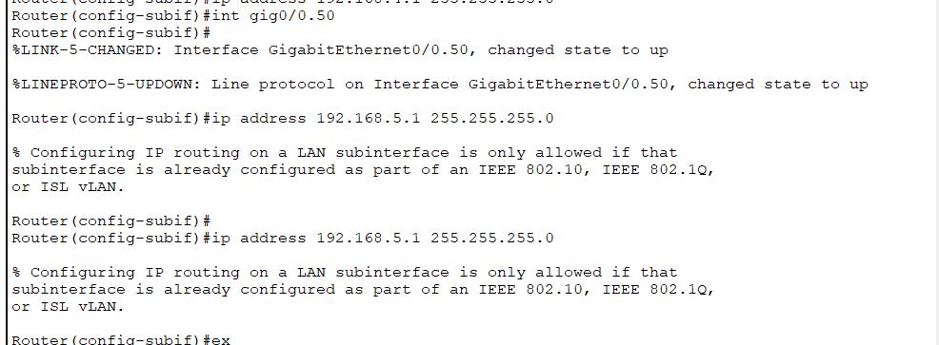

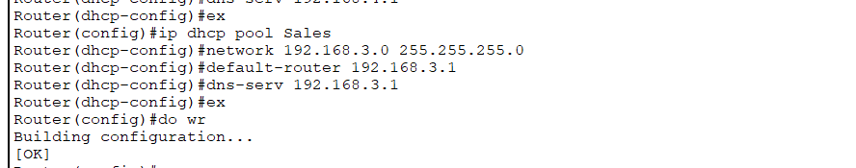

Testing if IP address is assigned successfully

PC of sales

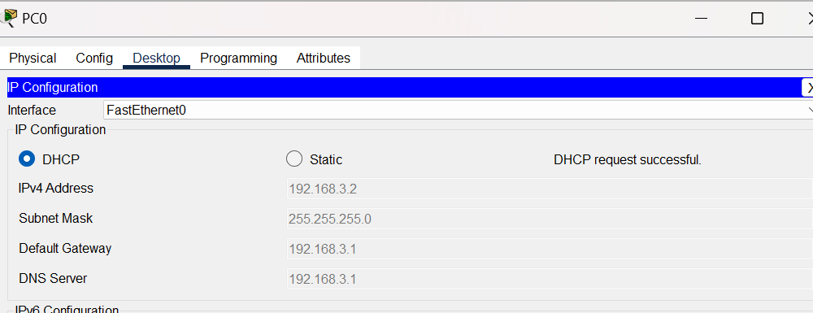

PC of HR

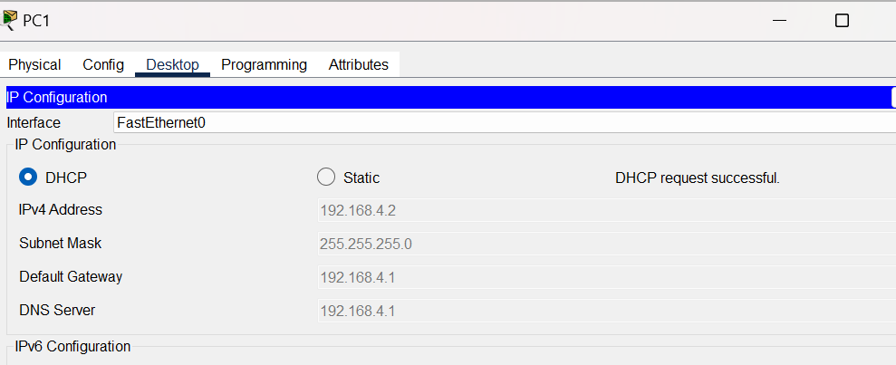

PC of Finance:

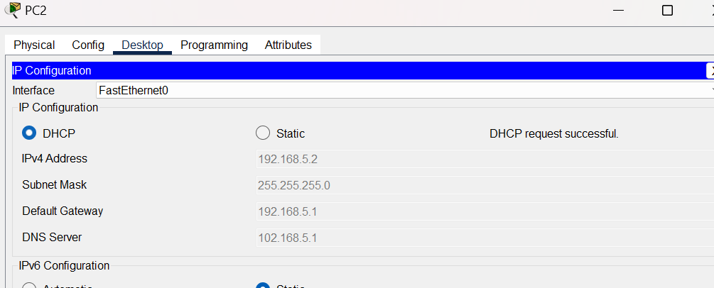

For 3rd floor router:

FOR IT:

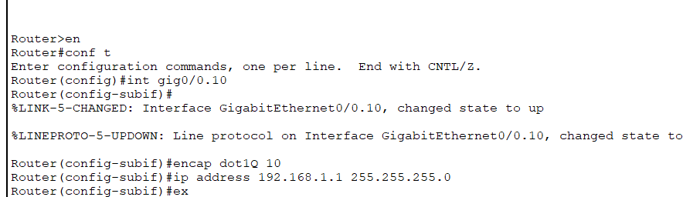

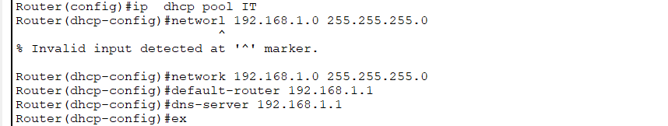

For admin :

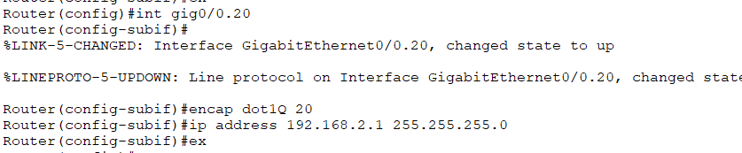

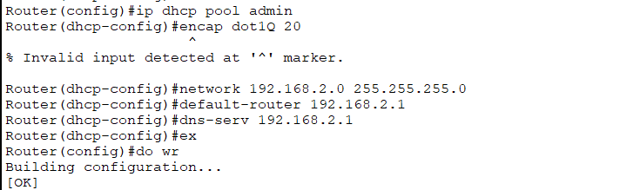

Testing:

PC OF IT:

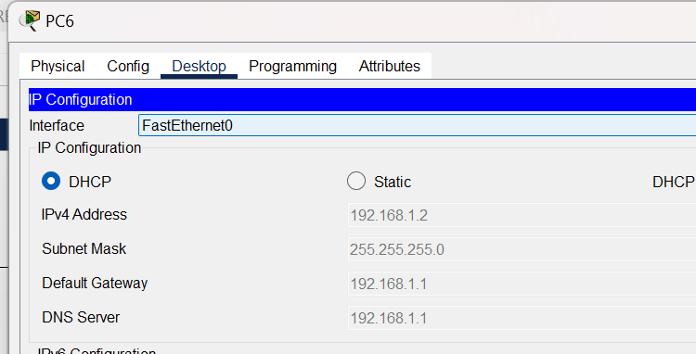

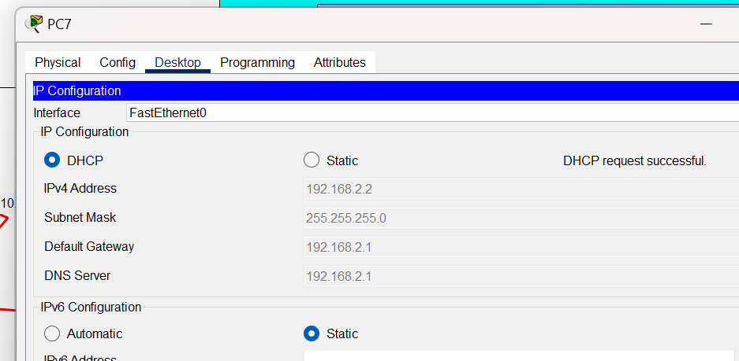

Ping:

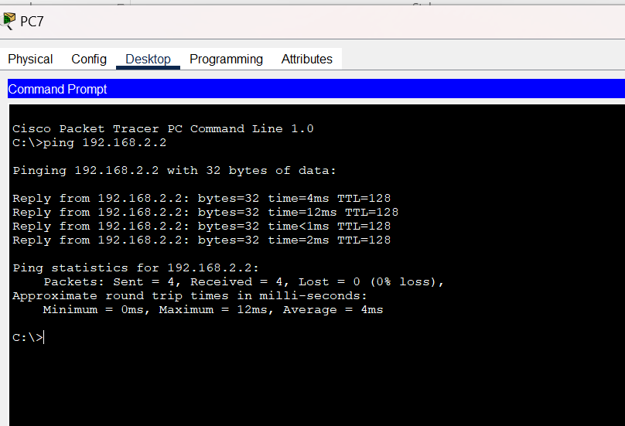

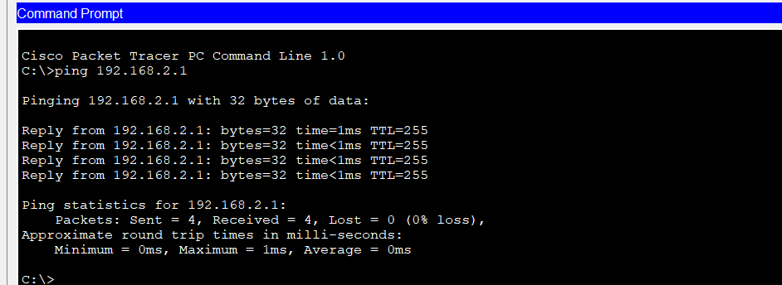

OSPF configuration in router 1

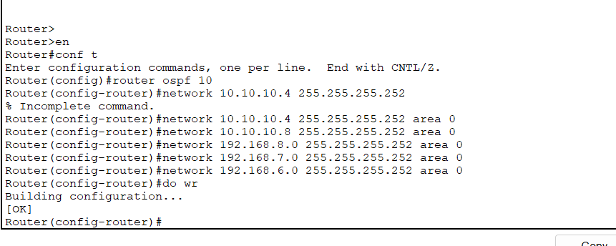

OSPF configuration in router 2

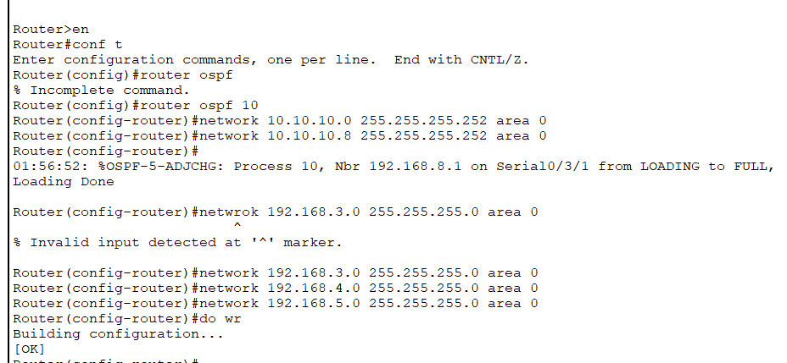

OSPF configuration for router 3

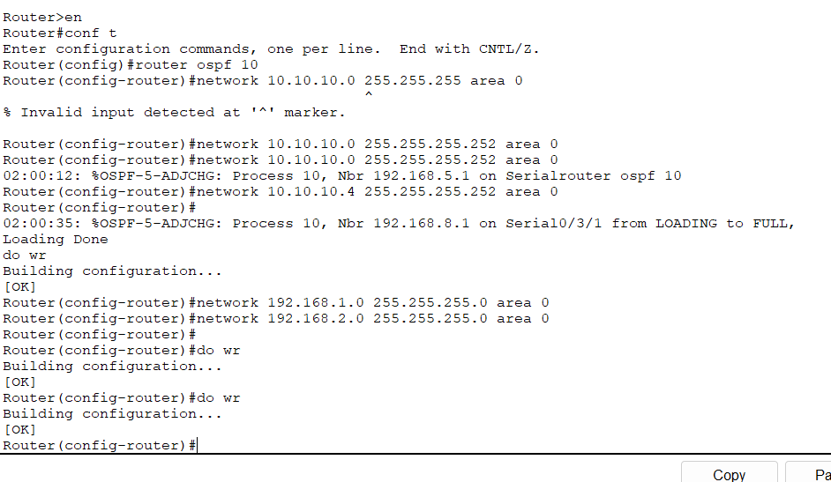PC of 3rd floor communication to pc of floor 1st

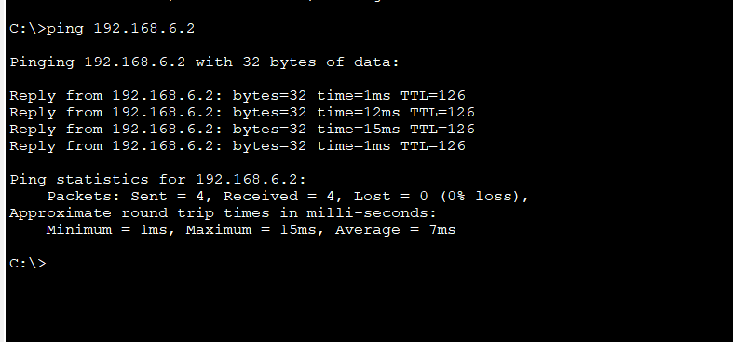

Successfully message is transferred

Printer of sales communicating to IT

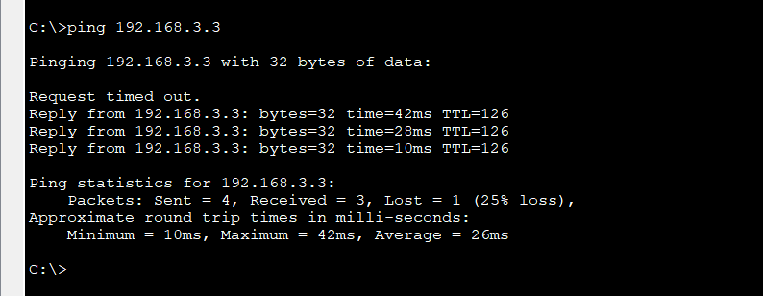

Providing WIFI in each department:

In 1st floor

Access point’ settings

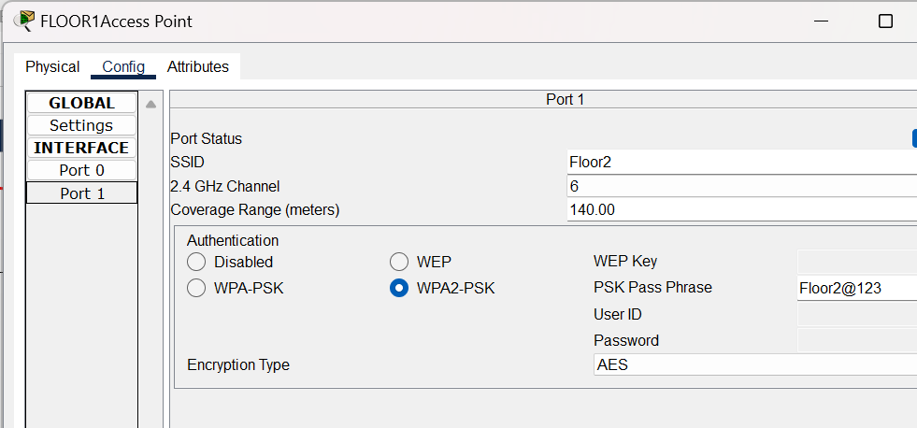

Laptop settings

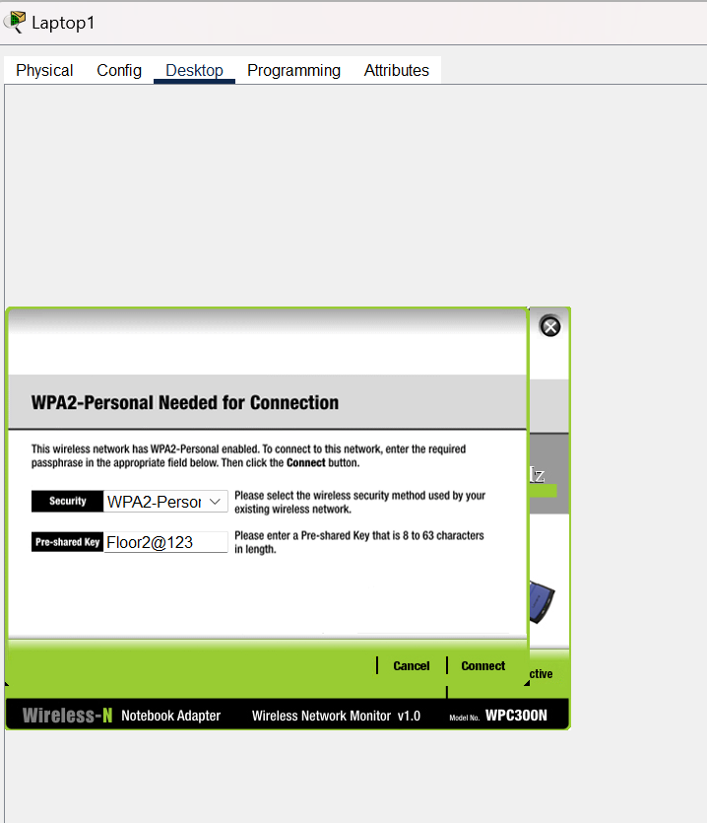

Phone settings

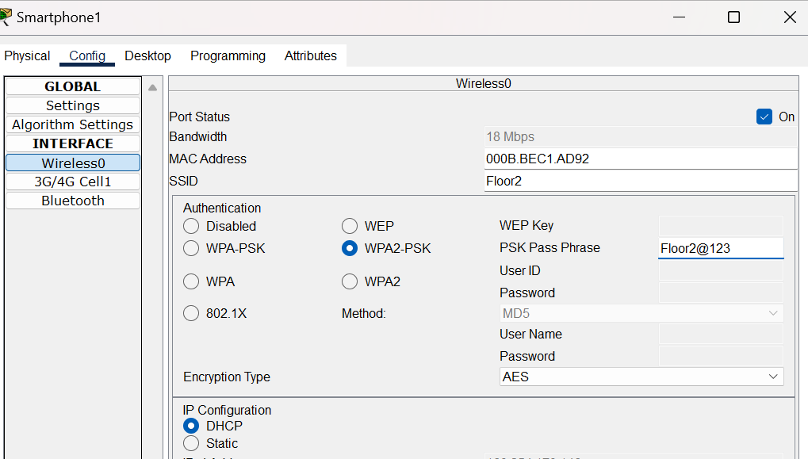

Tablet setting

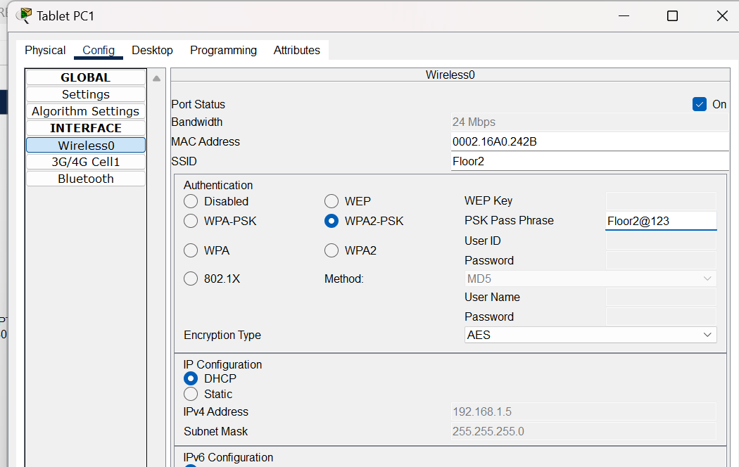

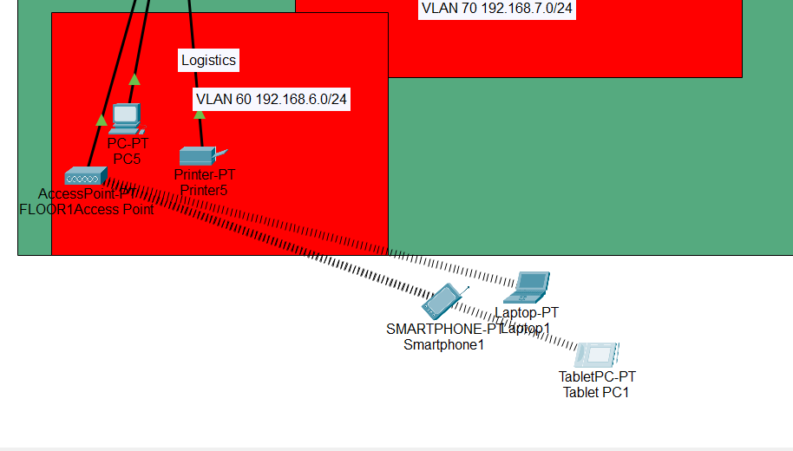

2ND floor access point settings

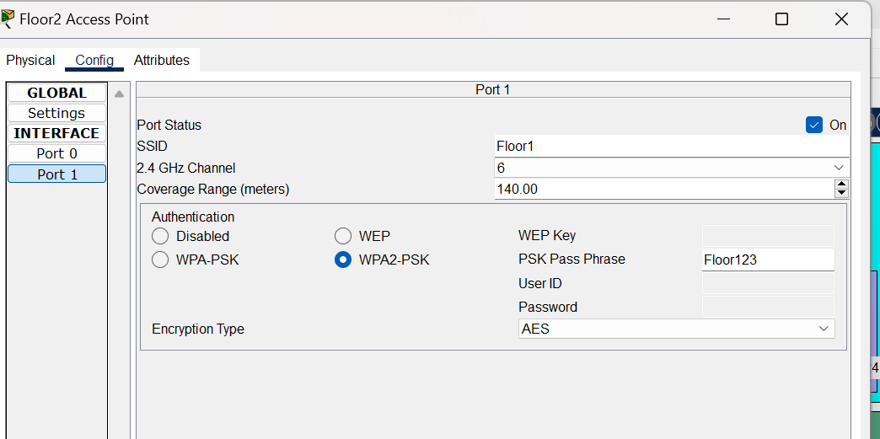

Laptop settings

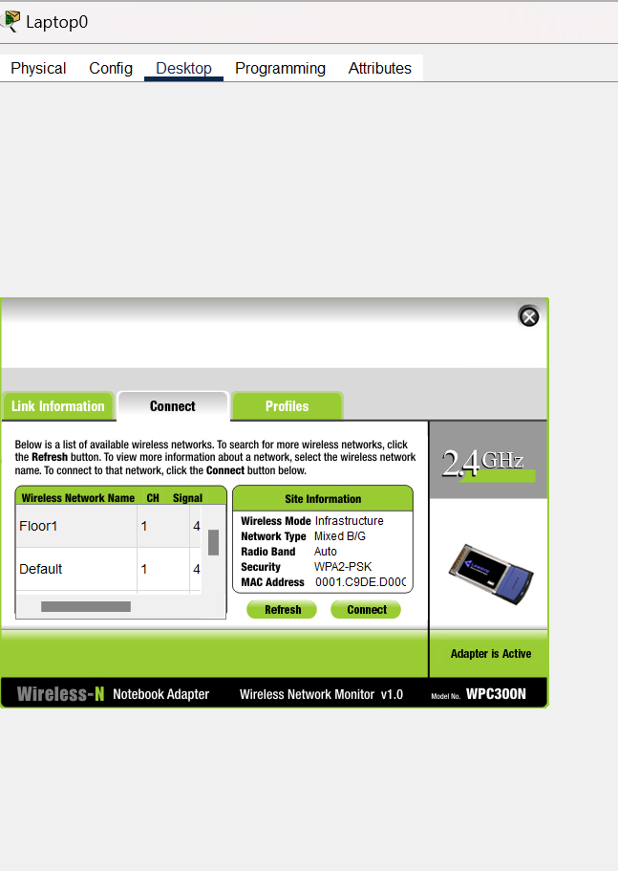

Phone setting

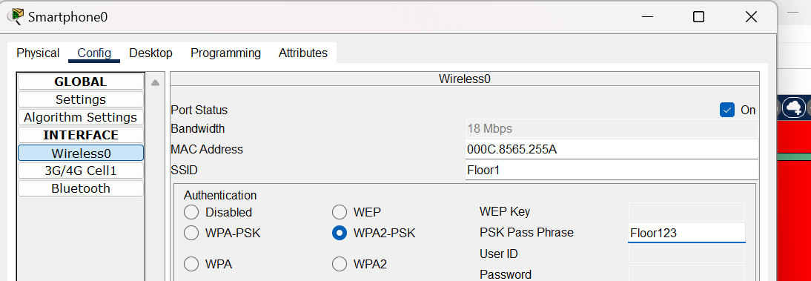

Tablet setting

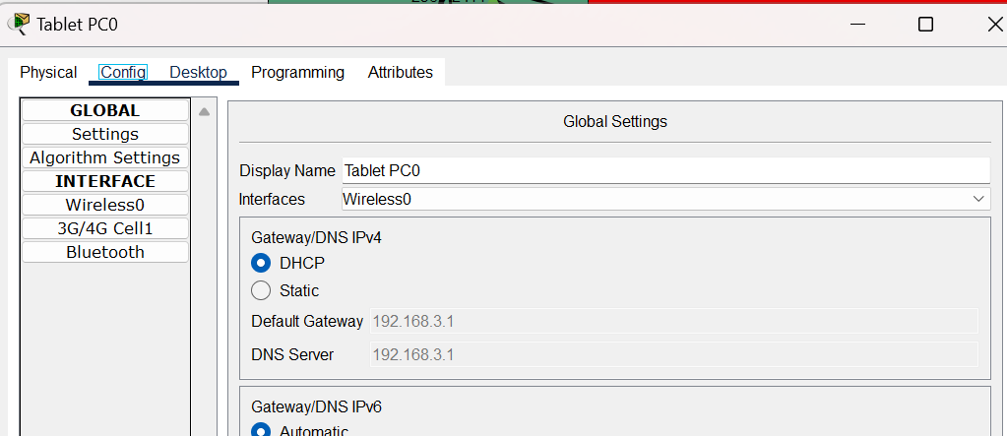

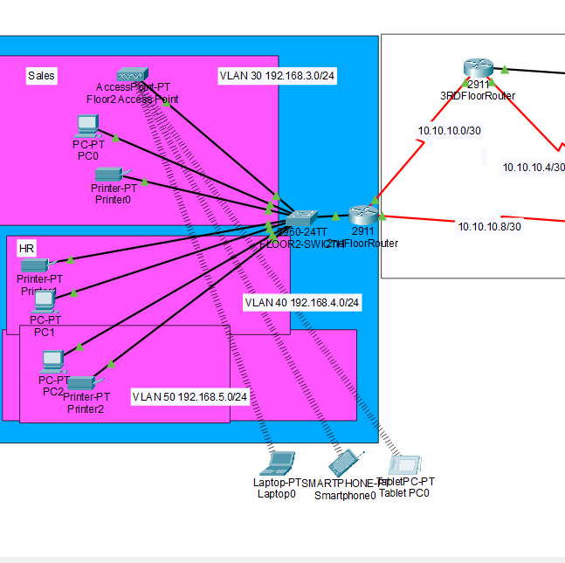

For 3rd floor

Access point setting

Laptop setting

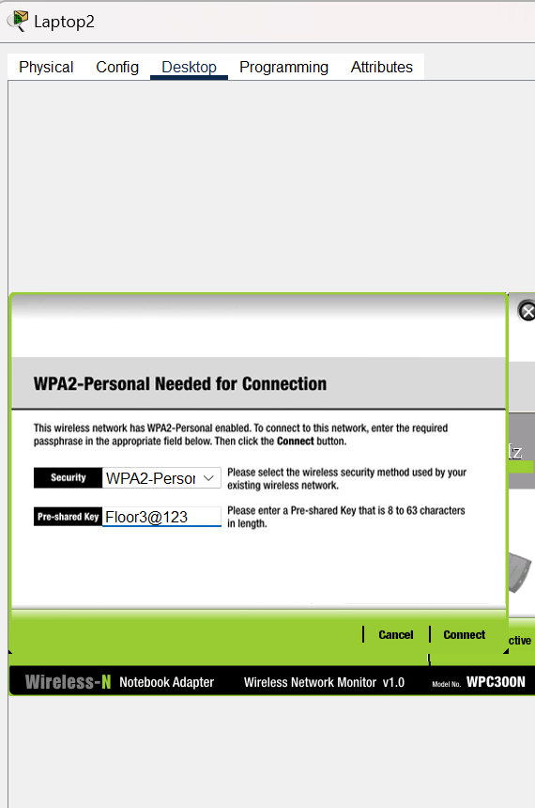

Phone setting

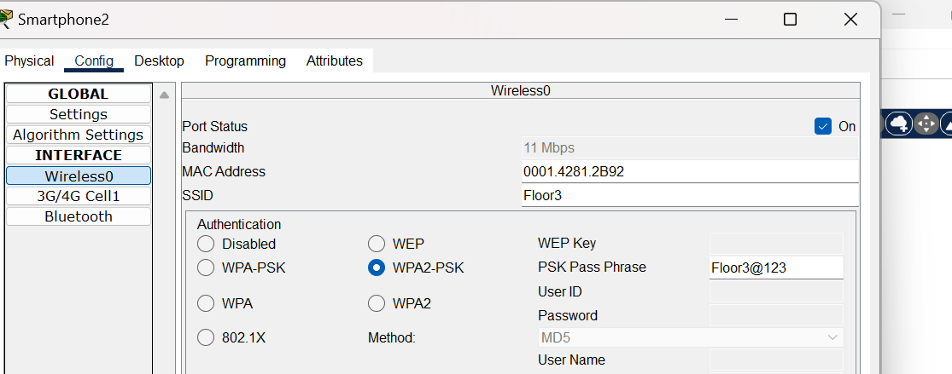

Tablet setting

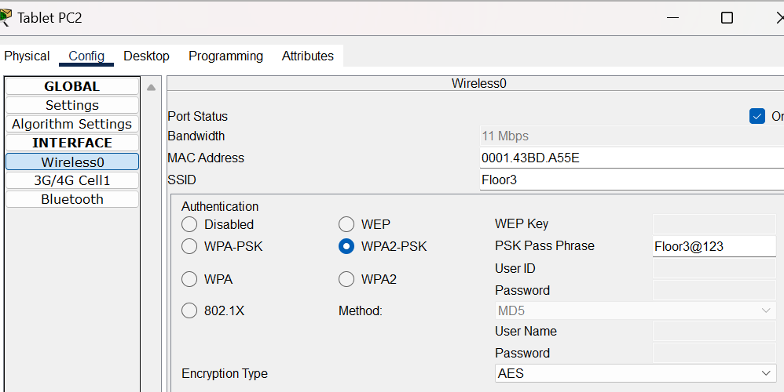

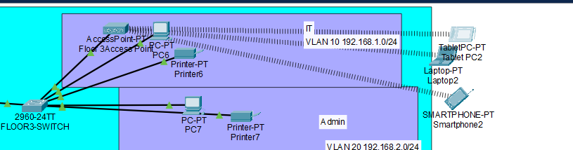

SSH configuration for remote login

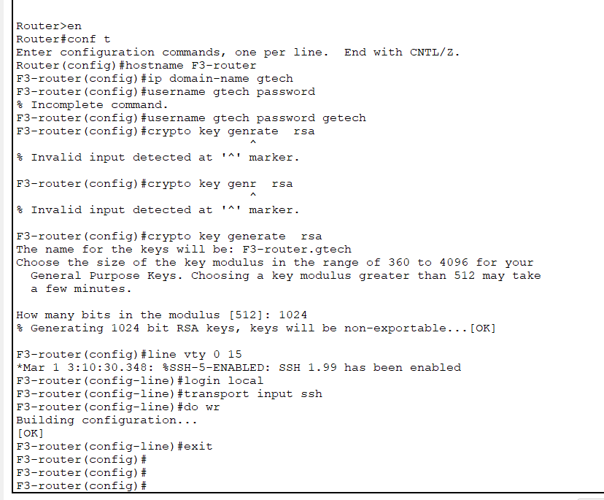

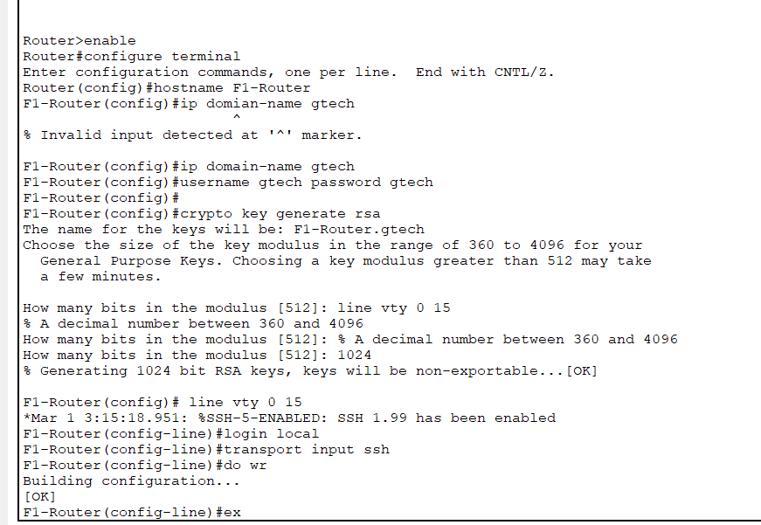

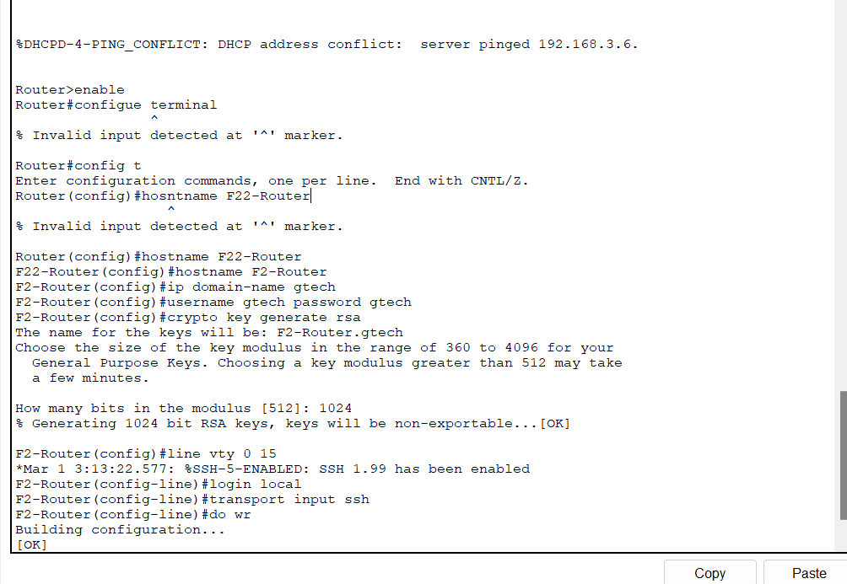

In IT department, add PC called test-PC to port fa0/1 and use it to test remote login

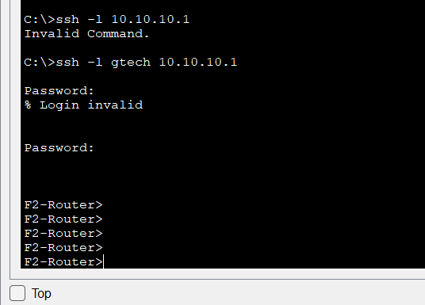

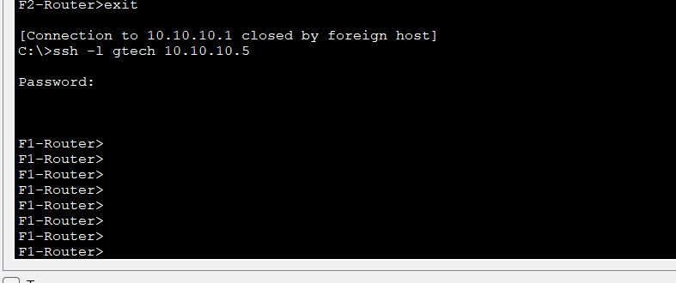

. Configure port of security to IT-department switch to allow only Test-PC to access port fa0/1 (use sticky method to obtain mac-address with violation mode of shutdown)

