Numerical methods

Project 1

By Andrii Tochylin

In this paper we will compare the efficiency of Newton’s and Multipoint algorithm in approximating the algebraic and non-algebraic functions.

Multipoint method used:

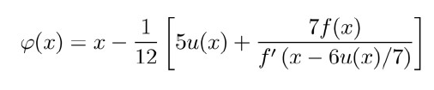

Non-algebraic equation used:

  
  
  
Algebraic equation used:

x^2 + 6x + 9 = 0

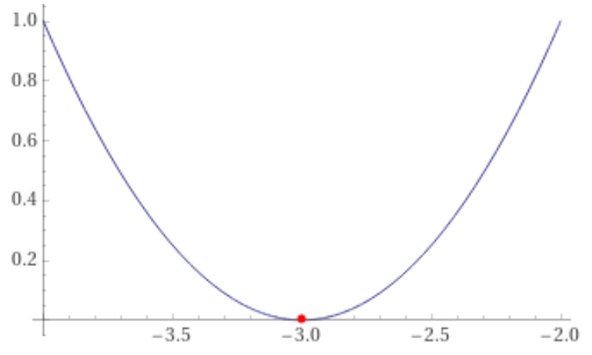 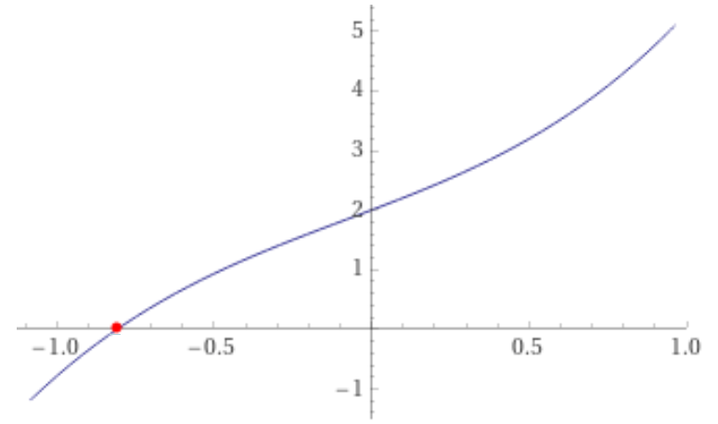

**Plot 1: Algebraic plot****Plot 2: Non-Algebraic plot**

The plot & result of comparison of these two methods:

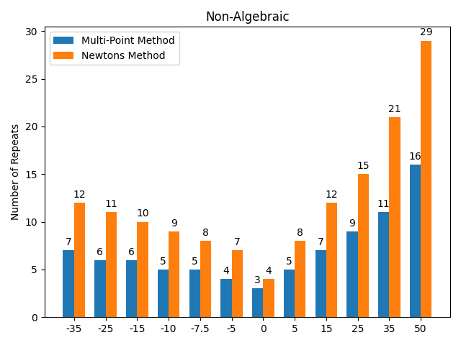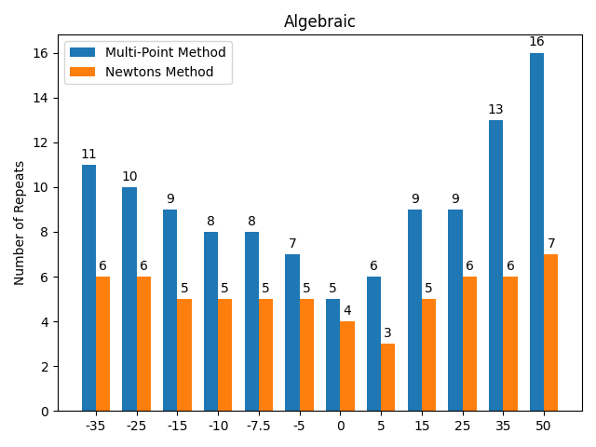

Description

A general trend is observed. In the case of non-algebraic equations, the closer the initial assumption is to the true root, the fewer operations are required to approximate it by Newton's method, while the opposite is true for the multipoint method, as can be seen from the graph.

The graph above shows the dependence of the number of steps required to approximate the root equation with constant accuracy on the initial assumptions.

Usually, Multi-Point is faster than Newton’s Method on the non-algebraic equations, but slower on the algebraic equations,

this can be seen, for example, from the fact that it takes 13 times fewer repeats to approximate an initial estimate of 50. However, for algebraic equations Newton's method is better and faster.

In conclusion, we can say that the multipoint method is superior to Newton's method for non-algebraic equations, but for algebraic equations their efficiency differs not much, and in some cases Newton's method is slightly faster than the multipoint method.