Hello World
This is a sample text.
This text is bold
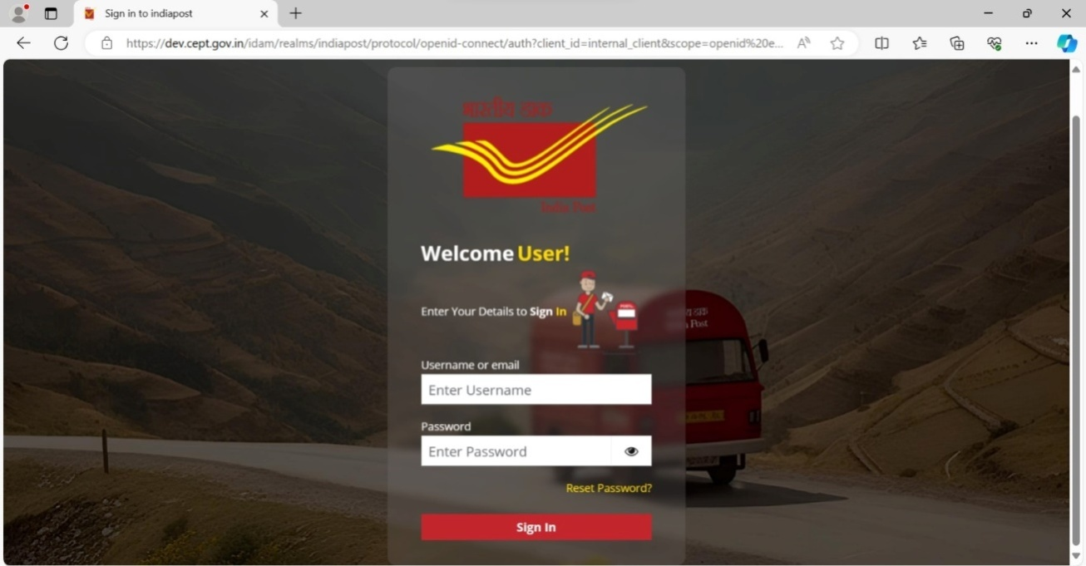
- This is item One
- This is item Two
- This is item Three
- This is item Four
Name | Age | Job
John | 46 | programmer
Mary | 55 | Chef
Bob | 23 | Accountant

