*Data Analysis*

**By Sumer Shinde and Sathvik Yadanaparthi**

# **Tables and Graphs**

## Test for 60-70 Decibels

### Table 1. Variables of Alert and Alert Level for a sound level between 60 decibels(dB) to 70 decibels(dB).

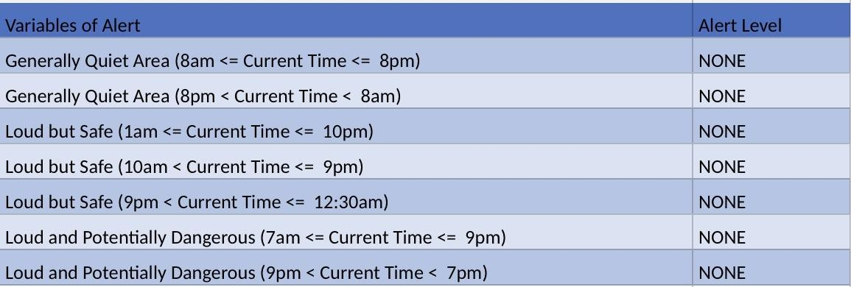

This data table represents the alert level activated when a sound between 60 dB - 70 dB is detected. It is also based on time and location.

Figure 1.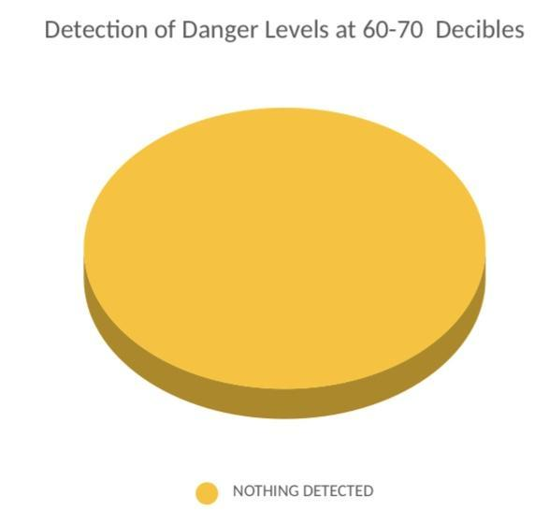

This pie chart displays the detection of each alert level when a 60-70 dB sound is detected.

## Test for 70-80 Decibels

### Table 2. Variables of Alert and Alert Level for a sound level between 70 decibels(dB) to 80 decibels(dB).

### This data table represents the alert level activated when a sound between 70 dB - 80 dB is detected. It is also based on time and location.

Figure 2.

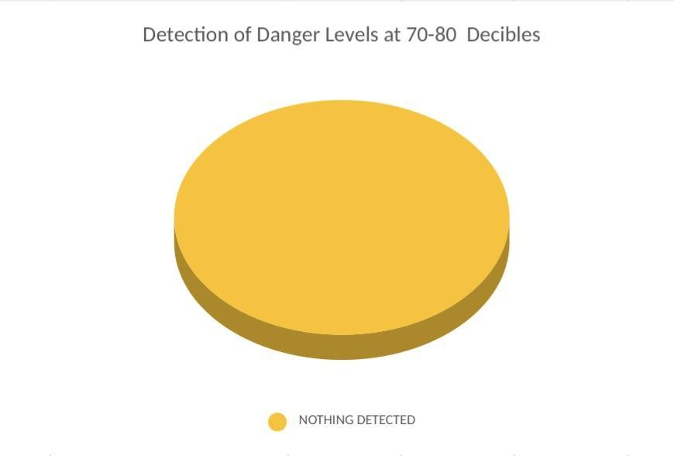

This pie chart displays the detection of each alert level when a 70-80 dB sound is detected.

## Test for 80-90 Decibels

### Table 3. Variables of Alert and Alert Level for a sound level between 80 decibels(dB) to 90 decibels(dB).

### 

### This data table represents the alert level activated when a sound between 80 dB - 90 dB is detected. It is also based on time and location.

Figure 3.

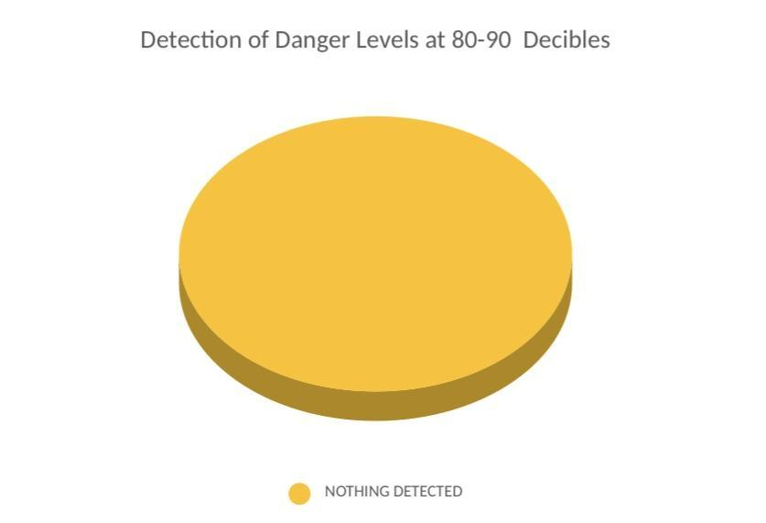

This pie chart displays the detection of each alert level when a 80-90 dB sound is detected.

## Test for 90-100 Decibels

### Table 4. Variables of Alert and Alert Level for a sound level between 90 decibels(dB) to 100 decibels(dB).

### 

### This data table represents the alert level activated when a sound between 90 dB - 100 dB is detected. It is also based on time and location.

Figure 4.

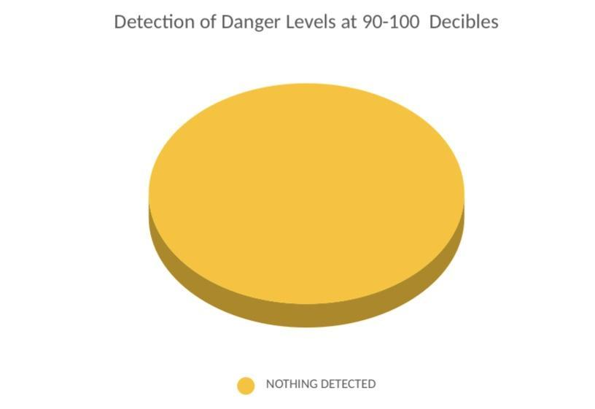

This pie chart displays the detection of each alert level when a 90-100 dB sound is detected.

## Test for 100-105 Decibels

### Table 5. Variables of Alert and Alert Level for a sound level between 100 decibels(dB) to 105 decibels(dB).

### 

### This data table represents the alert level activated when a sound between 100 dB - 105 dB is detected. It is also based on time and location.

Figure 5.

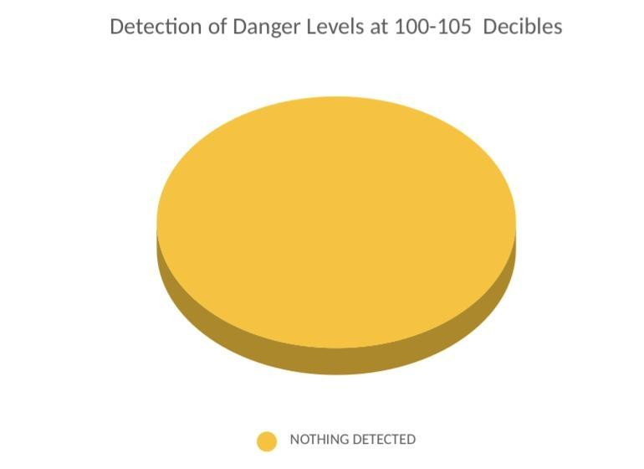

This pie chart displays the detection of each alert level when a 100-105 dB sound is detected.

## Test for 105-110 Decibels

### Table 6. Variables of Alert and Alert Level for a sound level between 105 decibels(dB) to 110 decibels(dB).

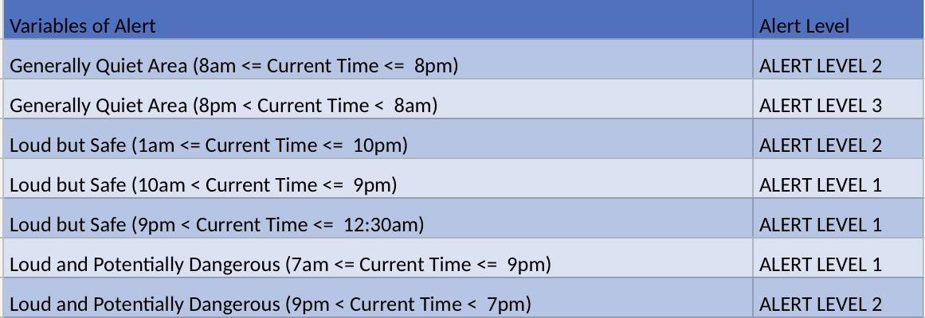

### This data table represents the alert level activated when a sound between 105 dB - 110 dB is detected. It is also based on time and location.

Figure 6.

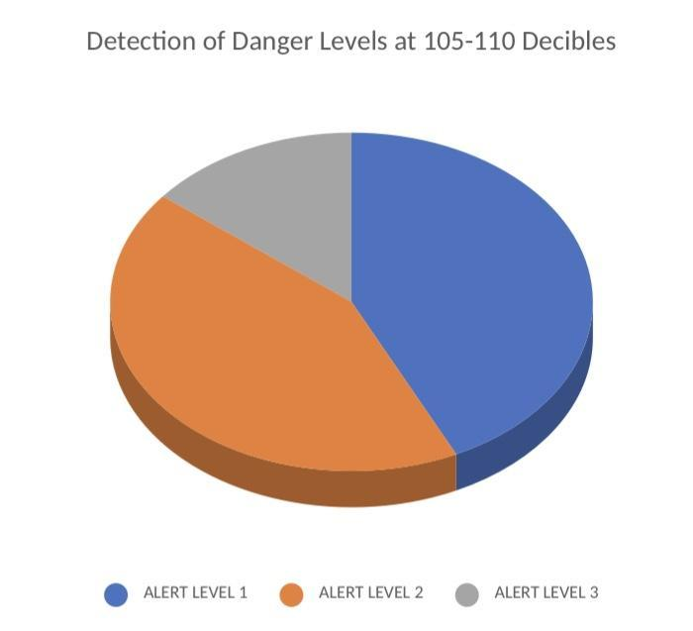

This pie chart displays the detection of each alert level when a 105-110 dB sound is detected.

## Test for 110-120 Decibels

### Table 7. Variables of Alert and Alert Level for a sound level between 110 decibels(dB) to 120 decibels(dB).

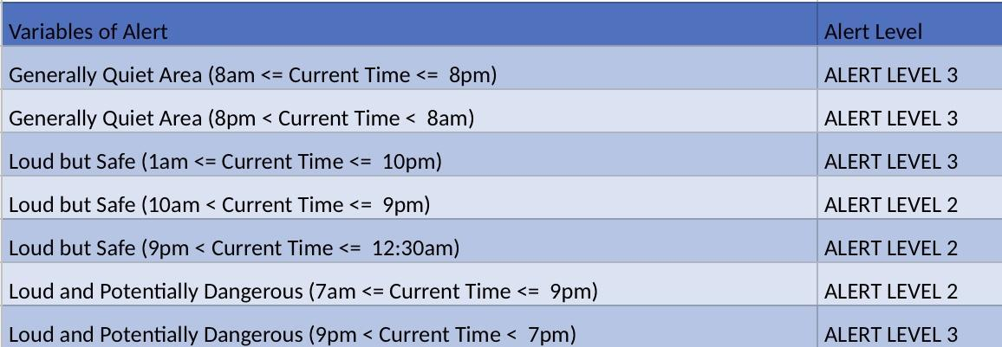

### This data table represents the alert level activated when a sound between 110 dB - 120 dB is detected. It is also based on time and location.

Figure 7.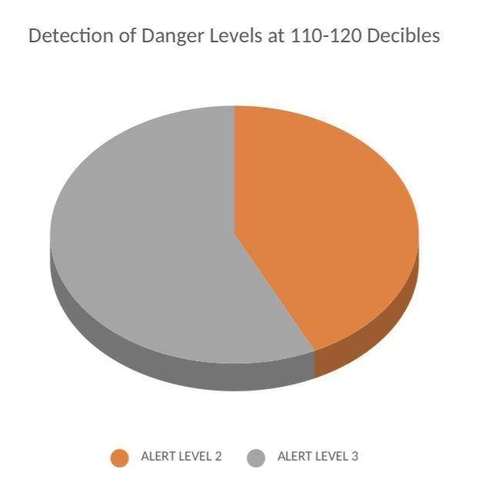

This pie chart displays the detection of each alert level when a 110-120 dB sound is detected.

## Test for 120+ Decibels

Table 8. Variables of Alert and Alert Level for a sound level 120+ decibels(dB).

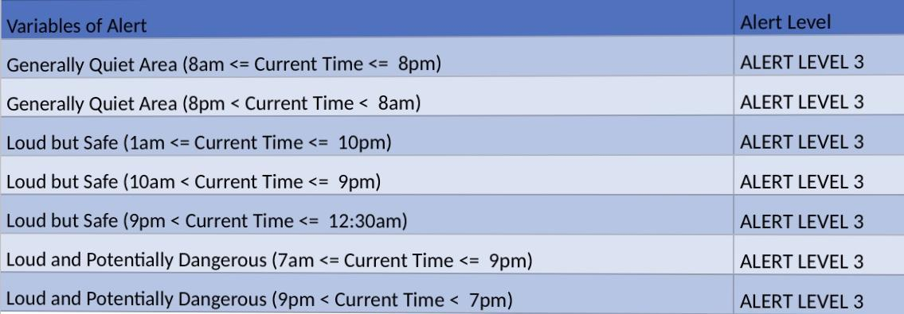

### This data table represents the alert level activated when a sound 120+ dB is detected. It is also based on time and location.

Figure 8.

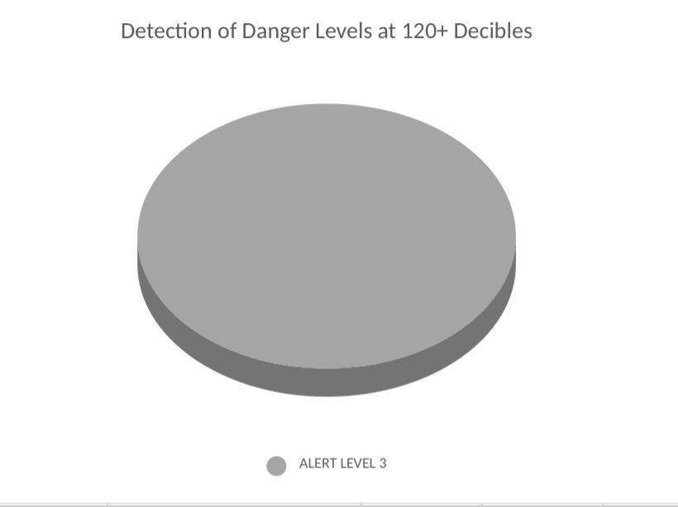

This pie chart displays the detection of each alert level when a 120+ dB sound is detected.

## Combined Data

Table 9. Percentage of Alert Levels per Decibel range

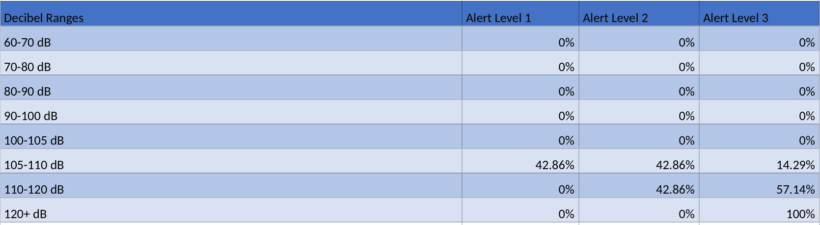

# **Written Analysis:**

## 60-70 Decibel:

The test where a range of 60-70 decibels were experimented with, as is shown in Table 1. For the three different types of locations(Generally Quiet, Loud but Safe, Loud and Dangerous), it was shown that the device did not alert the user to any of the three alert levels.

Because of the fact that 0% of the time there was an alarm sounded, the pie chart showed 0% of the levels of alarms possible.

## 70-80 Decibel Levels:

The test where a range of 70-80 decibels were experimented with, as is shown in Table 2. For the three different types of locations(Generally Quiet, Loud but Safe, Loud and Dangerous), it was shown that the device did not alert the user to any of the three alert levels.

Because of the fact that 0% of the time there was an alarm sounded, the pie chart showed 0% of the levels of alarms possible.

## 80-90 Decibel Levels:

The test where a range of 80-90 decibels were experimented with, as is shown in Table 3. For the three different types of locations(Generally Quiet, Loud but Safe, Loud and Dangerous), it was shown that the device did not alert the user to any of the three alert levels.

Because of the fact that 0% of the time there was an alarm sounded, the pie chart showed 0% of the levels of alarms possible.

## 90-100 Decibel Levels:

The test where a range of 90-100 decibels were experimented with, as is shown in Table 4. For the three different types of locations(Generally Quiet, Loud but Safe, Loud and Dangerous), it was shown that the device did not alert the user to any of the three alert levels.

Because of the fact that 0% of the time there was an alarm sounded, the pie chart showed 0% of the levels of alarms possible.

## 100-105 Decibel Levels:

The test where a range of 100-105 decibels were experimented with, as is shown in Table 5. For the three different types of locations(Generally Quiet, Loud but Safe, Loud and Dangerous), it was shown that the device did not alert the user to any of the three alert levels.

Because of the fact that 0% of the time there was an alarm sounded, the pie chart showed 0% of the levels of alarms possible.

## 105-110 Decibel Levels:

The test where a range of 105-110 decibels were experimented with, as is shown in Table 6. For the three different types of locations(Generally Quiet, Loud but Safe, Loud and Dangerous), it was shown that the device alerted user to an alert Level 2 at a Generally Quiet Area, Loud but Safe area, and Loud but Potentially Dangerous area. The device also alerted the user to the alert level 3 during irregular times of the Generally Quiet Areas. For every other time for the three types of locations, the device alerted to alert level 1.

In Figure 6 as well as Table 9, it states that 42.86% of the time it called Alert Level 1, 42.86% of the time it called Alert Level 2, and 14.29% of the test Alert Level 3 was called.

## 110-120 Decibel Levels:

The test where a range of 110-120 decibels were experimented with, as is shown in Table 7. For the three different types of locations(Generally Quiet, Loud but Safe, Loud and Dangerous), it was shown that the device alerted user to an alert Level 2 at Loud but Safe areas, and a Loud but Potentially Dangerous area. The device also alerted the user to the alert level 3 during all times of the Generally Quiet Areas, a Loud but Safe area, as well as an area that is Loud but potentially Dangerous.

In Figure 7 as well as Table 9, it states that 42.86% of the time it called Alert Level 2, and 57.14% of the test Alert Level 3 was called.

## 120+ Decibel Levels:

The test where a range of 120+ decibels were experimented with, as is shown in Table 8. For the three different types of locations(Generally Quiet, Loud but Safe, Loud and Dangerous), it was shown that the device alerted the user to all of the types of locations as well as times.

In Figure 8 as well as Table 9, it states that 100% of the test Alert Level 3 was called