A Thermoelectric Generator in Your Lap

Sumer M. Shinde

Shrewsbury High School

# Author Note

First Section: Introduction to Topic

Second Section: What is Thermoelectricity?

Third Section: How to Extort Electricity from Heat

Fourth Section: Storing Electricity

Fifth Section: Past Research

Sixth Section: Variables

Seventh Section: Conclusion

# Abstract

This paper is about an invention that could change the way people look at renewable energy. Thermoelectricity will be thoroughly explained in the interest of the amount of knowledge necessary to make the consumable device. It also explains how the hot air that is blown out of the PC could be used as a way to make electricity on day to day basis by only using our laptops. It will define and explore the processes and functions necessary to produce a device so that people can utilize the levels of electricity generated. Once electricity is produced, the essay will disclose how this energy will be stored and then reused for running another device. This paper suggests that people look around and be more mindful about their surroundings which could help them resolve problems in day to day life.

*Keywords:* Thermoelectricity, renewable energy

**A Thermoelectric Generator in Your Lap**

**Introduction to Topic**

My topic is to create a device that attaches to a PC, laptop, or desktop and starts producing electricity once the device begins emitting heat out of the exhaust of the computer. This paper will be talking about what thermoelectricity is, how electricity will be extracted, the storage of this electricity, and the usage of the generated electricity. Additionally, discussing the past research done on this topic and discussing variables involved will be very important. There is a fear over many that one day, an unfortunate generation will run out of oil, coal, and natural gas because of the limited resources this planet has to offer. By that time, humans must find a way to make sure the world keeps on running. Although there are known renewable power sources like the wind, sun, and geothermal gas, humankind could be more aware and create additional energy resources and find alternate ways to generate electricity. One idea is to explore how we could harness electricity from a device that millions of people use everyday: computers! There will be a relationship between how heat consumed by the device relates to the amount of watts stored. This research is important because the human race is overpopulating and using too much of the earth’s fuel at a high rate. If people don’t find a new source of power soon, technology may as well travel back to the Stone Ages. Without power, almost every industry would be impacted, transportation and communication would come to halt, stocks would drop and life would be terrible for every person on the planet due to the amount of dependency people have on devices powered by electricity in day to day life. Wind, solar, hydro, and geothermal power resources might not be the most efficient and sufficient. So as an additional source, why not use a form of energy that everyone has the ability to use and is cost efficient? This could be a revolutionary concept where people could empower themselves and lead the world to a cleaner future by utilizing and maintaining the amount of energy there is remaining.

**What is Thermoelectricity?**

**The Heat Transfer**

To understand what thermoelectricity is, it is necessary to know what happens during the heat transfer process. Heat is transferred when two materials have thermal contact, and then the high energy material (hotter material) is put in thermal contact with a lower energy material until they are at the same level of energy (Cobb & Fetterolf, 2010, p. 194). This can happen through 3 ways of transfer: conduction, radiation, and convection. Conduction is when two materials are touching and thermal energy is being transferred through the materials. One example of this would be a hot cooking stove surface with a pot on it. The outcome would be: the pot gets hot after some time due to the conduction of thermal energy from one material to another. Radiation is the transfer of waves (of thermal energy) from a source heating a material that comes in contact with those waves. An example of this would be when there is a spoon left outside during a clear sunny day. After a few hours, if you tried to touch it, you would most likely burn your hand because of the amount of heat transferred from the sun. Lastly, convection is the most difficult one to understand. Convection is the flow of heat through a bulk movement of matter from a hot region to a cool region, as opposed to the transfer of heat between atoms involved with conduction. Consider heating up a local region of air. As this air heats, the molecules spread out, causing this region to become less dense than the surrounding, unheated air ("Convection," 1999). An example of this would be heating a pot up which contains water. The water inside starts creating convection currents which transfer energy inside the pot. The type of heat transfer I would most likely be using would be conduction because I am using extracted energy out of the object that is relatively hot, so I would need to create an object to come in contact with that source in order to generate electricity.

**The Definition of Thermoelectricity**

Thermoelectricity is also called Peltier-Seebeck effect; direct conversion of heat into electricity or electricity into heat through two related mechanisms.("Thermoelectricity," 2018). The Seebeck Effect is the temperature difference that can produce voltage which can drive an electric current in a closed circuit ("Brief History," 2018). The Peltier effect is when the heat absorbed or created at the junction is proportional to the electrical current. The proportionality constant is known as the Peltier coefficient("Brief History," 2018).

**How to Extort Electricity from Heat**

**Thermoelectric Material**

To understand how to extort electricity from heat, one must be familiar with the use of thermoelectric materials. MIT News states,”When a thermoelectric material is exposed to a temperature gradient — for example, one end is heated, while the other is cooled — electrons in that material start to flow from the hot end to the cold end, generating an electric current. The larger the temperature difference, the more electric current is produced, and the more power is generated. The amount of energy that can be generated depends on the particular transport properties of the electrons in a given material”(Chu, 2018). Also, heat is transported from one part of the thermoelectric material (a positive semi-conductor) because at first there are positive charges in the bar. But when the same side is heated, those charges are diffused to the cold end of the bar and set up an electric field which opposes the diffusion (1981, pp. 159-160).

**How to obtain Heat from this Material**

Heat can be obtained from a material by heating one end of a thermoelectric material which causes the electrons to move away from the hot end toward the cold end. When the electrons go from the hot side to the cold side this causes an electrical current, which the device will harness. The larger the temperature difference, the more electrical current is produced and therefore more power generated. The way this power can be generated is by getting a good thermoelectric material like bismuth telluride, make a thermoelectric module and make a system out of it.

**Type of Thermoelectric Material**

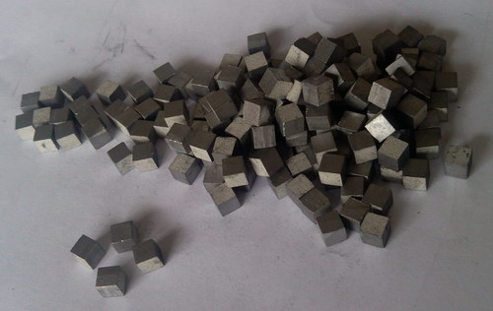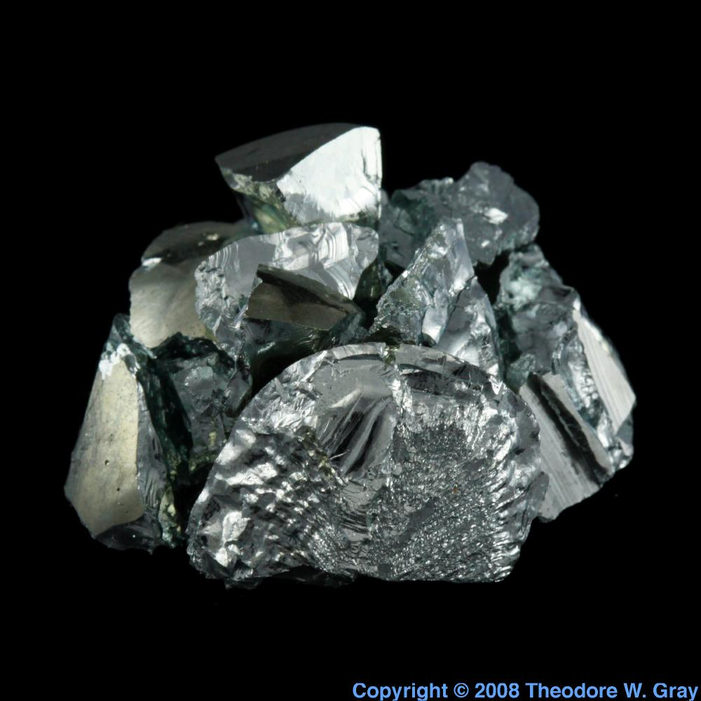

Left:(Thermoelectric Bismuth, n.d.) Right:(Lead Telluride, n.d.)

In order to generate an amount of electricity to be efficient, the first material that is necessary for the creation of a device like this is having both high electrical conductivity and low thermal conductivity to be a good thermoelectric material. Having low thermal conductivity ensures that when one side is made hot, the other side stays cold, which helps to generate a large voltage while in a temperature gradient ("Thermoelectric Generator," n.d.). Electrical conductivity is the measure of the amount of electrical current a material can carry or it's ability to carry a current (Helmenstine, 2018). Additionally, thermal conductivity is the cumulative effect from all collisions results in a net flux of heat from the hot body to the colder body. We call this transfer of heat between two objects in contact thermal conduction ("What Is Thermal," n.d.). The types of materials that have both of these qualities could be bismuth telluride (Bi2Te3), lead telluride (PbTe), and silicon germanium (SiGe).

**Thermoelectric Module**

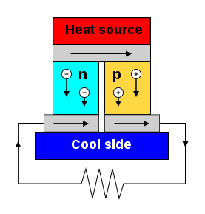

("Thermoelectric Generator," n.d.)

A thermoelectric module is a circuit containing thermoelectric materials which generates electricity from heat directly. A thermoelectric module consists of two dissimilar thermoelectric materials joined at their ends: an n-type (negatively charged), and a p-type (positively charged) semiconductor. A direct electric current will flow in the circuit when there is a temperature difference between the ends of the materials ("Thermoelectric Generator," n.d.).

**Thermoelectric System**

Using thermoelectric modules, a thermoelectric system generates power by taking in heat from a source such as a hot exhaust flue. In order to do that, the system needs a large temperature gradient, which is not easy in real-world applications. The cold side must be cooled by air or water. Heat exchangers are used on both sides of the modules to supply this heating and cooling ("Thermoelectric Generator," n.d.).

**Storing Electricity**

**Storing Energy in Battery**

To store energy into a battery, the project requires the use of a rechargeable battery. The way that rechargeable batteries work is that the recharge process is the reverse of the discharge process. An external source of direct electrical current supplies electrons to the anode and removes them from the cathode, forcing the chemical reactions into reverse until the cell is recharged ("How Do Batteries," n.d.). This means that the electricity is transformed into chemical energy back into the battery to be used elsewhere.

**Past Research**

**PowerPot**

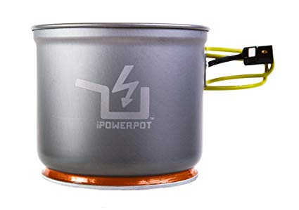

("How Do Thermoelectrics," 2018)

The PowerPot is a device that,”[I]is a thermoelectric generator that uses heat to generate electricity. The PowerPot has no moving parts or batteries, and since the thermoelectric technology is built into the bottom of the pot it can produce electricity from a wide variety of heat sources. Simply add water and place the PowerPot on a fire (e.g. wood, propane, butane, alcohol, gas) and it will start generating electricity within seconds. Just plug in the high temperature cable to the back of the pot and watch your USB devices safely charge from a fire”(How Do Thermoelectrics," 2018). This project will be displaying the same concept which this PowerPot has displayed because this idea will now be applied to a computer which will then create electricity for each person.

**Variables**

**Independent and Dependant Variables**

The independent variable is the difference between the temperature of the cool and hot side of the material and the dependent variable is the amount of electricity created. This is because the heat could differ between each use. If one side was colder, there would be more electricity for a longer period of time. Also, if there was more heat on one side, the electricity would be generated faster. Thus, the speed of the generation of electricity and the volts created depend on the difference of temperatures on the thermoelectric material.

**Conclusion**

Ultimately, people are concerned that energy sources will run out in near future, and our human civilizations’ technology will be useless because of how much our species relies on electricity. Energy is crucial for living in these modern times. That is the sole purpose of creating this new technology, for people to help themselves in the struggle for what is last left of fuel on this planet and wherever possible keep energy cycle renewing with no wastage. To sum up, thermoelectricity is made up of the Peltier-Seebeck effects to create electricity. These processes are extremely important to the understanding of thermoelectricity. Next, I can extort electricity by getting a good thermoelectric material, making a thermoelectric module, and making a system out of it. Lastly, storing the energy will be carried out by accumulating electricity inside a battery for further use in another battery powered item. As a result, if the difference in temperature of one part of a thermoelectric material and the other is large, then the volts the system creates will be larger and will accumulate faster. This happens because as the positive charged protons move from one side to the other, the higher the difference is, the longer the electric current will last and the more electricity will be generated. This technology has future scope for research in transforming the thermal energy into electricity since there are many heat emitting devices around us.

References

Goff, J. [Special issue]. (1981). *Thermoelectricity: The New Transport Phenomenon*, *71*(3).

*Basic electricity*. (1970). New York, United States of America: Dover Publications.

Brief history of thermoelectrics. (2018). Retrieved October 21, 2018, from Thermoelectrics Caltech Materials Science website: <http://www.thermoelectrics.caltech.edu/thermoelectrics/history.html>

Chu, J. (2018, January 16). Turning heat into electricity. Retrieved October 21, 2018, from MIT News website: <http://news.mit.edu/2018/topological-materials-turning-heat-electricity-0117>

Cobb, C., & Fetterolf, M. (2010). *The joy of chemistry*. Prometheus Books.

Convection. (1999, September 29). Retrieved October 21, 2018, from <https://theory.uwinnipeg.ca/mod_tech/node76.html>

Helmenstine, A. M. (2018, July 6). Electrical conductivity definition. Retrieved October 28, 2018, from ThoughtCo. website: <https://www.thoughtco.com/definition-of-electrical-conductivity-605064>

How do batteries store and discharge electricity? (n.d.). Retrieved October 28, 2018, from Scientific American website: <https://www.scientificamerican.com/article/how-do-batteries-store-an/>

How do thermoelectrics work? (2018). Retrieved October 21, 2018, from Power Practical website: <https://powerpractical.com/pages/how-do-thermoelectrics-work>

Lead telluride, a sample of the element lead in the periodic table [Lead Telluride]. (n.d.).

Thermoelectric bismuth telluride material [Bismuth Telluride]. (n.d.).

Thermoelectric generator. (n.d.). Retrieved October 28, 2018, from Wikipedia website: <https://en.wikipedia.org/wiki/Thermoelectric_generator>

Thermoelectricity. (2018). Retrieved October 21, 2018, from Encyclopedia Britannica website: <https://www.britannica.com/science/thermoelectricity>

What is thermal conductivity? (n.d.). Retrieved October 28, 2018, from Khanacademy website: <https://www.khanacademy.org/science/physics/thermodynamics/specific-heat-and-heat-transfer/a/what-is-thermal-conductivity>