PET – Personal Expense Tracker

Demo with Screen shots

Sumesh Gopalakrishnan

2025

Table of Contents

Launch the program 2

Add Expense: 3

View the list of existing expenses 5

Track Budget 6

Save Expenses 8

Exit 9

## Launch the program

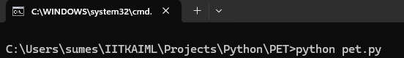

* The menu launched
* Loads Budget data from a file. As the file is not present, defaults budget as 0.00
* Loads Expenses data from a file. As the file is not present, defaults expenses as 0.00
* If the total expenses is below budget, prints as “Remaining” else prints as “overspend”

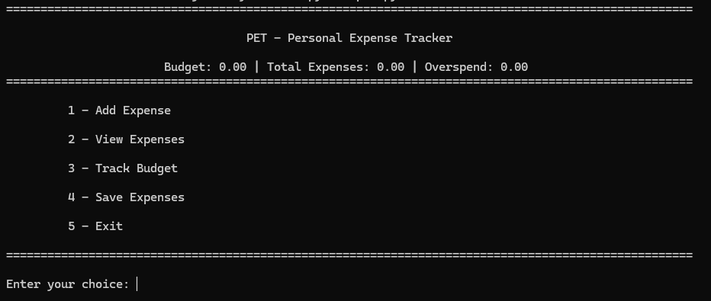

## Add Expense:

* Validates all input values given for expense
* Adds expense when valid values are given
* Checks against budget and informs if you have overspent.
* As the budget is still not set, it consider any expense as overspent.

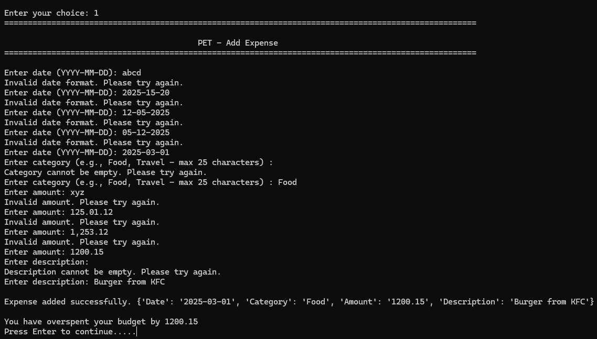

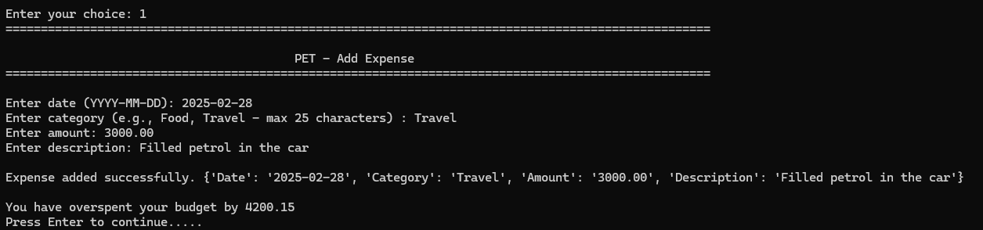

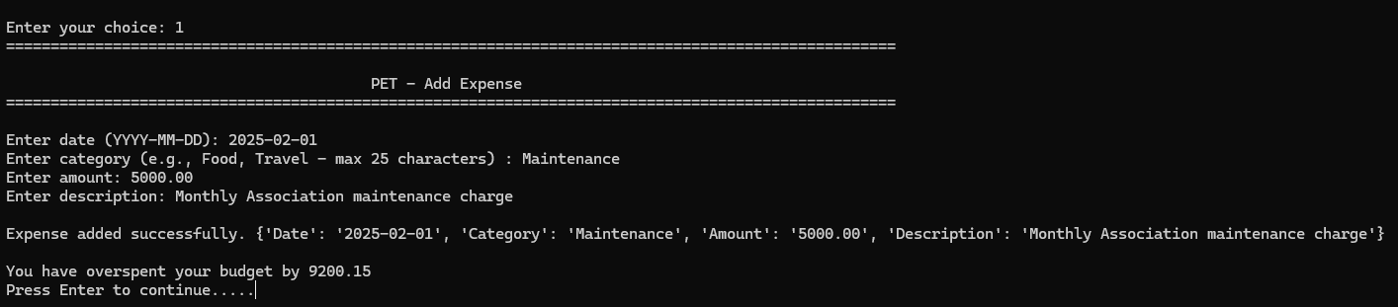

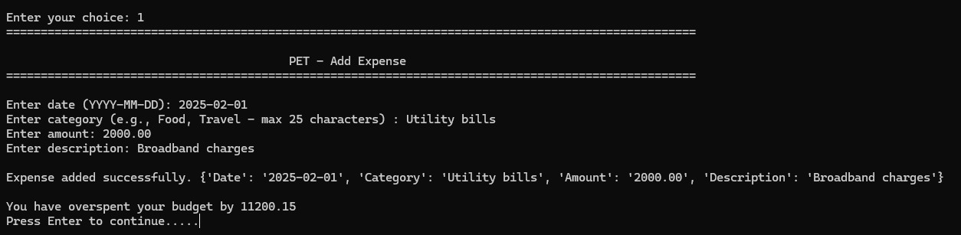

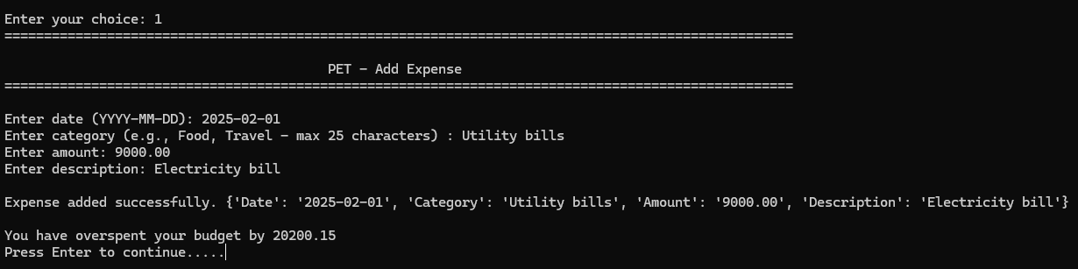

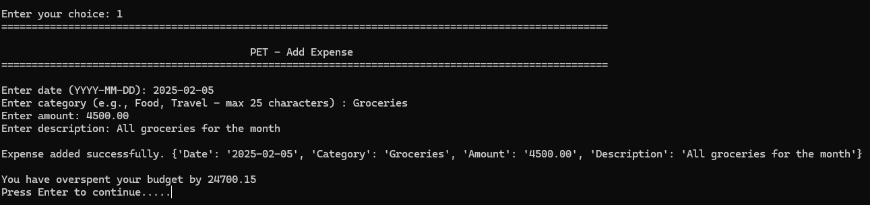

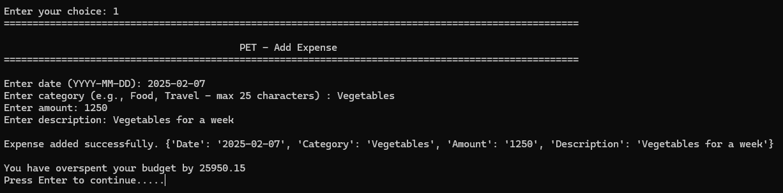

## View the list of existing expenses

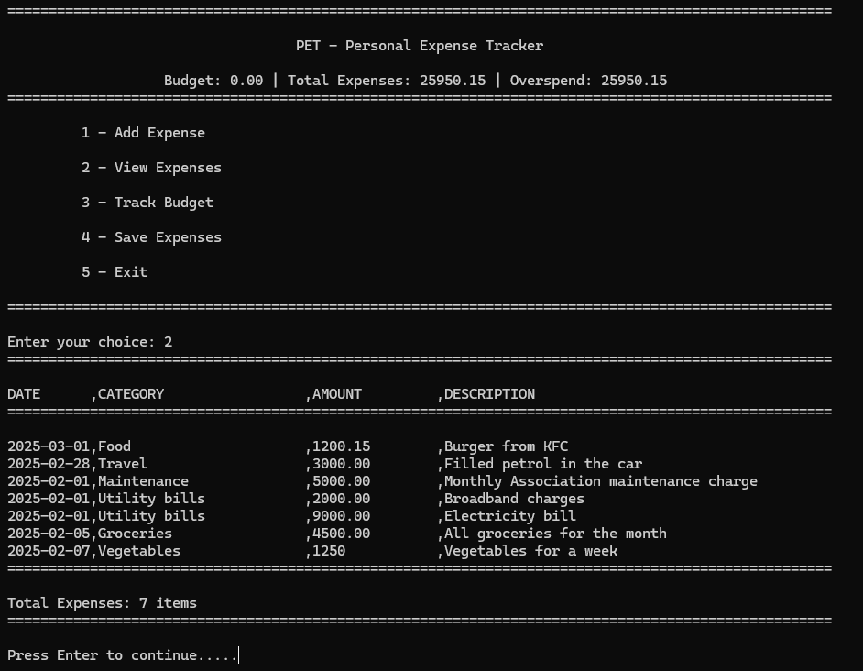

## Track Budget

* Shows what the current budget is. As no budget is set so far, it shows as 0
* Accepts new budget amount – Provide an amount less that the total expenses
* Validate the budget input is a valid amount
* Updates new Budget
* Displays the new budget
* As the budget is less that the total expenses, it states that you have exceeded your budget
* Saves the budget to a file

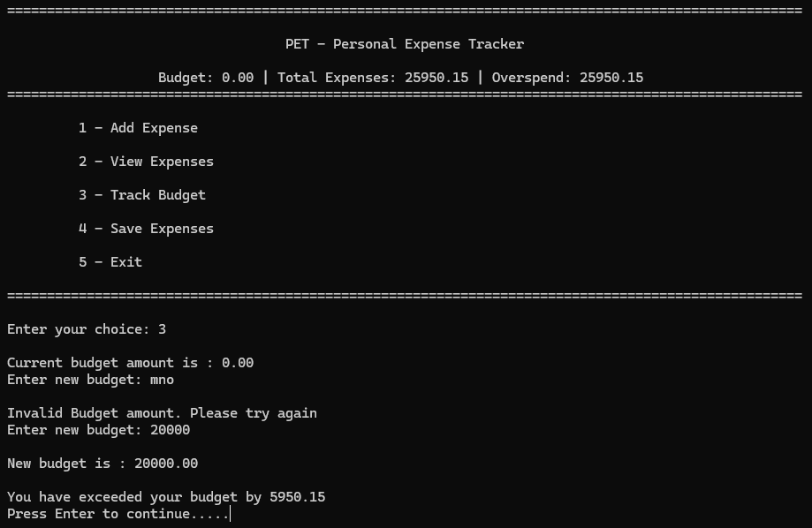

* Text file to which budget is stored

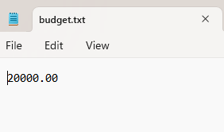

* Set the Budget again such that the budget is more than the expenses
* It shows the amount left in your budget still for expense

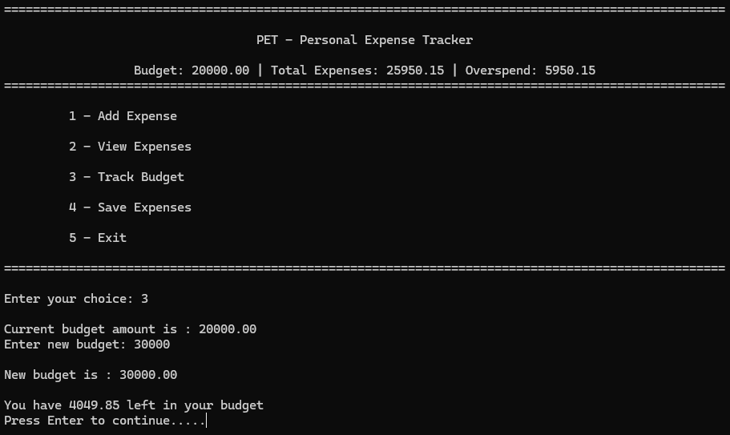

* The title also shows Remaining amount instead of overspend now

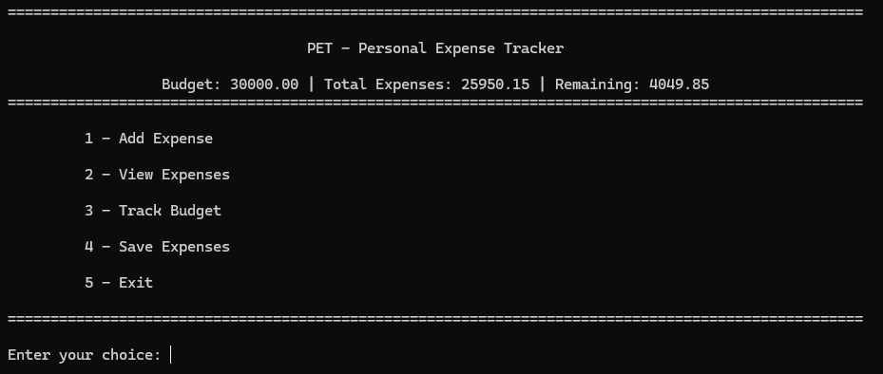

* Since the budget is now more than expense, when you add expense, it does not state you have overspent

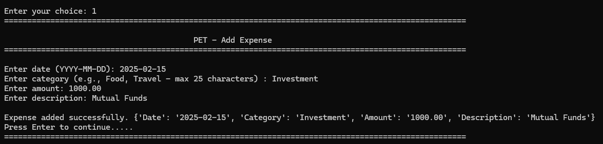

## Save Expenses

* Saves the expense to a text file as csv
* Gives a message that expenses are saved.

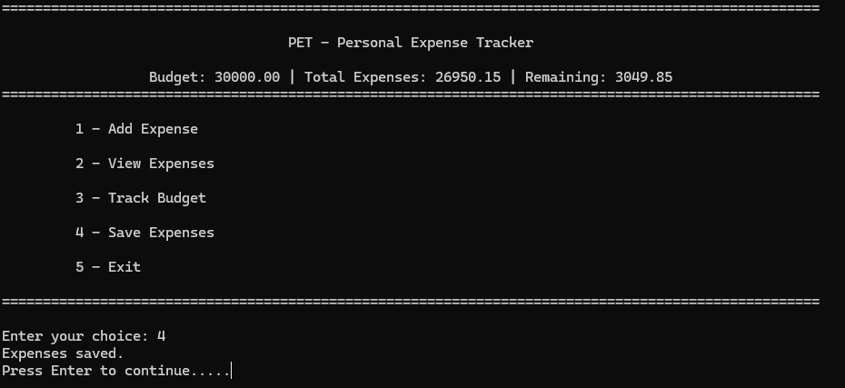

* The text file content will be as below

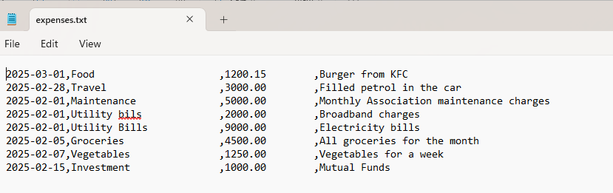

## Exit

* Prints a thank you message
* Exits the application

