JIMMA INSTITUTE OF TECHNOLOGY
FACULTY OF COMPUTING AND INFORMATICS
SOFTWARE ENGINEERING - PROGRAM
FINAL YEAR PROJECT-1 (FYPr 4211)

“Garage Management System”
GROUP MEMBERS ID NO
- Entisar Kasim RU0761/14
- Husna Kheyru RU0232/14
- Mubarek Teyb RT10041/15
- Sumeya Muhammed RU0093/14
- Sumeya Muhidin RU0109/14

A Final Year Project Document
Submitted to Faculty of Computing and Informatics, Jimma Institute of Technology, Jimma University, in Partial fulfillment of the requirement of the Degree of Bachelor of Science in Software Engineering.

Jimma, Ethiopia
December , 2025

Acknowledgment

Abstract
This project, titled Garage Management System represents a transformative initiative designed to modernize the fragmented and largely manual processes that govern vehicle repair operations. In many cities, customers struggle to locate reliable garages, mechanics depend on traditional verbal communication, and garage managers face difficulties coordinating tasks, managing inventory, and maintaining accurate service records. These inefficiencies not only disrupt workflow and reduce customer satisfaction but also hinder the ability of supervising agencies to ensure quality and accountability across the sector. In response to these challenges, this project introduces a comprehensive, technology-driven solution that brings together customers, garages, mechanics, and regulatory bodies into a unified digital ecosystem.
At the center of this system is an intuitive Android customer application that enables users to find nearby garages, view services and customized pricing, request assistance, and track repair progress in real time. The platform also integrates modern conveniences such as digital payments through Chapa, emergency live-location sharing, multilingual support, and an in-app notification system that keeps customers informed at every stage of the repair process. Complementing the customer-facing experience is a robust garage manager web dashboard, designed to streamline operations by allowing managers to approve service requests, assign tasks to mechanics, oversee repairs, and efficiently manage spare-parts inventory through automated quantity tracking and restock alerts.
Mechanics are supported through a dedicated mobile interface that provides clear task assignments, status updates, and the ability to document repair activities, ensuring transparency and accountability. Meanwhile, the agency administration portal plays a critical oversight role by enabling government or regulatory bodies to register and approve garages, address complaints, and monitor overall performance within the industry. Through these integrated modules, the system enhances operational accuracy, fosters trust, and elevates the quality of services provided to vehicle owners.
Accessibility, usability, and reliability form the foundation of the platform’s design. The user interfaces are crafted to be intuitive for individuals of varying technical backgrounds, while the system’s architecture ensures data security, real-time communication, and dependable performance. Reviews, ratings, and garage ranking features contribute to a culture of continuous improvement, empowering customers with informed choices and motivating garages to maintain high service standards.
Ultimately, this project seeks not merely to digitalize existing processes but to redefine the vehicle repair experience by fostering connection, efficiency, and transparency. It envisions a future where customers no longer struggle to find trustworthy assistance, where garages operate with organized precision, and where agencies uphold service quality with clear oversight. By integrating modern technology into everyday automotive service interactions, the system stands as a forward-looking solution that enhances convenience, accountability, and satisfaction for all stakeholders involved.

Chapter One

Introduction and Background

1.1. Introduction

1.1.1. Overview of the topic
The automotive service sector plays a crucial role in supporting transportation systems and enabling economic productivity. However, in many regions, particularly in developing countries, vehicle repair and maintenance services remain largely unstructured, unreliable, and predominantly manual. Customers frequently struggle to locate credible garages, mechanics face communication challenges, and garage managers rely on outdated processes that hinder efficiency. These issues contribute to long waiting times, inconsistent pricing, poor service documentation, and a general lack of transparency and accountability within the sector. As the demand for professional vehicle repair continues to rise, the traditional system characterized by informal networks and limited technological integration fails to meet the expectations of modern consumers. This project addresses the pressing need to digitalize garage operations by introducing an integrated technological solution that improves communication, operational coordination, and service quality in the automotive repair ecosystem.

1.1.2. Description of the project
This project, titled Garage Management System aims to design and develop an innovative system that streamlines the entire workflow of vehicle repair services. The proposed system consists of multiple coordinated modules: a customer-facing Android application, a web-based garage management dashboard, a mechanic mobile interface, and an administrative portal for regulatory agencies. Through these interconnected components, the platform facilitates service booking, real-time repair tracking, task assignment, inventory management, and secure digital payments using Chapa. Additional features such as emergency request handling with live location sharing, customer reviews and ratings, multilingual support, and a real-time notification system enhance the user experience and bring greater transparency to the sector. By integrating these functionalities into a single platform, the project aims to modernize service delivery and ensure smooth communication among all stakeholders: customers, mechanics, garage managers, and agency administrators.

1.1.3. Solution to be explored
The project explores a technologically advanced solution that leverages mobile computing, web technologies, geolocation services, and digital financial systems to address the inefficiencies of the current garage service landscape. At its core, the system will implement real-time communication mechanisms that allow garages to receive and respond to customer requests promptly, assign mechanics to tasks efficiently, and update service statuses dynamically. The customer application will feature a GPS-enabled garage discovery tool that shows nearby repair centers along with their prices, service lists, and ratings. The mechanic interface will streamline task workflows, allowing mechanics to update diagnosis results, repair progress, and completion details. Additionally, the inclusion of inventory management tools ensures that garages maintain accurate stock levels and receive automated restock alerts. The administrative portal will empower regulatory agencies to monitor garage performance, approve or suspend garage accounts, and oversee customer complaints. By integrating all these modules, the solution will provide a centralized, real-time system capable of transforming the traditional repair process into a more organized and efficient digital experience.

1.1.4. Importance of the project
The importance of this project lies in its ability to fill a long-standing gap in the automotive repair industry by providing a holistic, technology-based solution that enhances service quality, transparency, and operational efficiency. Traditional garage operations often suffer from miscommunication, lack of standardized pricing, poor record keeping, and limited accessibility for customers seeking timely support. This system directly addresses these challenges by enabling customers to make informed decisions, track their repair status, and receive assistance quickly especially during emergencies. For garages, the platform introduces structured workflow management, better coordination between managers and mechanics, and improved inventory control, all of which contribute to higher productivity and reliability. From a regulatory perspective, the system creates an avenue for agencies to oversee garages, ensuring compliance with standards and improving consumer protection. The project also supports broader national goals related to digital transformation, service modernization, and sustainable economic development. By focusing on accessibility, multilingual support, and user-friendly design, the system ensures usability even for individuals with limited technological exposure, making it an impactful contribution to underserved communities and the automotive service industry as a whole.

1.2. Background information of the organization

1.2.1. Vision of the organization
The organization envisions a future where vehicle repair services are accessible, efficient, and transparent for all customers. By leveraging digital technologies, the organization aims to modernize garage operations, enhance customer satisfaction, and create a seamless connection between customers, garage managers, mechanics, and supervising agencies. The vision emphasizes inclusivity, ensuring that both urban and rural communities can benefit from structured, technology-driven automotive services.

1.2.2. Mission of the organization
The mission of the organization is to utilize technology-driven solutions to bridge the gaps in traditional garage service operations. By integrating mobile applications, web dashboards, real-time tracking, and digital payments, the organization seeks to provide a comprehensive platform that improves operational efficiency, enhances communication between stakeholders, and ensures transparency in service delivery. The organization is committed to fostering collaboration among garage managers, mechanics, customers, and supervising agencies to deliver impactful solutions. Furthermore, the organization prioritizes scalability, ensuring that its platform can adapt to various garages and automotive service environments.

1.3. Background of the project

1.3.1. Global context
Vehicle repair and maintenance services worldwide have traditionally relied on manual processes, which often result in inefficiencies, communication gaps, and limited customer satisfaction. Customers face challenges in finding reliable garages, tracking repair progress, and making secure payments, while garage managers struggle to monitor mechanics, manage inventory, and generate reports efficiently. The emergence of digital platforms, mobile applications, and web dashboards in service industries has transformed customer expectations, emphasizing real-time updates, transparency, and convenience. This project seeks to address these challenges by creating an integrated system that streamlines garage operations and enhances the experience for all stakeholders.

1.3.2. Local context
In Ethiopia, many garages operate manually, with limited digital tools to support customer service or operational efficiency. Customers often face delays, unclear pricing, and a lack of real-time updates, while garage managers and mechanics struggle to coordinate tasks, maintain inventory, and track performance. Additionally, emergency services are difficult to provide efficiently due to poor communication channels and lack of location tracking. This project aims to fill these gaps by developing a digital platform that supports service requests, real-time repair tracking, inventory management, digital payments, and emergency assistance. By incorporating local language support (Amharic, Afaan Oromo, English) and culturally relevant features, the system ensures usability and relevance in the Ethiopian context.

1.3.3. Academic perspective
This project is undertaken as part of the academic requirements at Jimma Institute of Technology. It represents an opportunity to apply software engineering, mobile and web development, and system design expertise to a real-world problem. The project demonstrates how technology can improve efficiency, communication, and customer satisfaction in the automotive service sector. Additionally, it aligns with academic goals of fostering interdisciplinary research and creating solutions that have tangible societal impact. By collaborating with local garages, mechanics, and customers, this project serves as a model for how academic institutions can contribute to technological development and operational improvements in Ethiopia’s service industry.

1.5. Statement of the problem
Vehicle repair garages face numerous challenges that affect both operational efficiency and customer satisfaction. Despite the critical role they play in maintaining transportation reliability, many garages operate using manual processes that are prone to delays, errors, and miscommunication. These challenges can be categorized into the following key areas:

1.5.1. Access to reliable and timely service information
Customers often struggle to find accurate information about garage locations, available services, and pricing. Without a centralized platform, they may rely on word-of-mouth or outdated sources, which can lead to poor decision-making and dissatisfaction. Similarly, garages lack real-time data about incoming service requests, part availability, and mechanic schedules, making it difficult to optimize operations efficiently.

1.5.2. Communication gaps between stakeholders
Effective communication between customers, garage managers, and mechanics is critical for timely service delivery. However, in most garages, communication is fragmented and relies on phone calls, physical visits, or paper records. This often results in delays in assigning tasks, updating customers on repair progress, or notifying managers about urgent issues, which ultimately affects service quality.

1.5.3. Inventory and resource management challenges
Managing spare parts, tracking usage, and ensuring timely restocking are major challenges in manual garage operations. Without digital inventory management, garages risk running out of critical parts, overstocking unnecessary items, or misallocating resources. These inefficiencies not only increase operational costs but also prolong repair times, reducing customer satisfaction.

1.5.4. Payment and transaction inefficiencies
Payment processing in many garages is often manual and lacks proper tracking. Customers may have limited options for digital payments, and garages may struggle to issue receipts, record transactions, or reconcile payments efficiently. These limitations increase administrative workload and can lead to disputes or delays in payment settlements.

1.5.5. Emergency service limitations
In urgent situations, customers may require immediate assistance, but traditional garages lack mechanisms to prioritize or respond to emergency requests promptly. Without GPS-based tracking or real-time task assignment, response times are slow, and customers experience frustration and delays.
These interconnected problems highlight the urgent need for a holistic, technology-driven solution that integrates customer requests, garage management, mechanic workflows, inventory tracking, and payments. By creating a centralized platform, garages can improve operational efficiency, enhance customer satisfaction, and ensure a faster, more transparent vehicle repair experience.

1.6. Objectives of the study

1.6.1. General objective
The primary objective of this study is to design and implement a comprehensive Garage Management System that integrates Android mobile applications, web dashboards, and an admin portal. The system will streamline garage operations, enhance customer experience, and improve communication between customers, garage managers, mechanics, and supervising agencies.

1.6.2. Specific objectives
To achieve this goal, the following specific objectives will guide the development of the system:
- Identify Key Challenges: Conduct research to identify and define operational, logistical, and customer service challenges faced by garages in Ethiopia.
- Requirement Gathering: Collect and analyze system requirements, including features such as service request tracking, inventory management, digital payments, emergency assistance, and reporting dashboards.
- System Design: Develop a user-friendly, secure, and scalable system architecture that accommodates multiple stakeholders, including customers, garage managers, mechanics, and agency administrators.
- Software Development: Implement and integrate necessary software components, including Android and web applications, push notifications, GPS-based tracking, and payment gateway integration.
- Testing and Validation: Conduct extensive testing to ensure system performance, security, and usability meet the required standards.
- User Training and Feedback: Provide training for garage staff and customers, and gather user feedback to refine the system for optimal efficiency and satisfaction.
- Post-Implementation Maintenance: Establish a framework for ongoing updates and maintenance to ensure the system evolves with user needs and technological advancements.

1.7. Feasibility Analysis
A feasibility analysis was conducted to evaluate the practicality of the proposed Garage Management System. This analysis encompasses operational, technical, behavioral, market, schedule, and economic feasibility.

1.7.1. Operational Feasibility
The operational feasibility of the system is high due to its focus on addressing the specific needs of garages and customers. Key features include:
- Real-Time Task Tracking: Mechanics and managers can update repair statuses, providing transparency and accountability.
- Inventory Management: Automated tracking of spare parts, restock alerts, and usage logs streamline garage operations.
- Digital Payments: Integration with Chapa and cash options simplifies transactions and reduces errors.
- Emergency Assistance: Real-time GPS location sharing enables fast response for urgent vehicle repairs.
- Scalability: The modular design allows the system to expand to additional garages and cities as needed.

1.7.2. Technical Feasibility
The system leverages modern and proven technologies:
Mobile Applications: Android apps for customers and mechanics, designed with React Native.
Web Dashboards: Garage manager and agency admin portals built using React.
Backend Services: REST API developed using Node.js for authentication, business logic, and notifications.
Database: MySQL for storing user, garage, service, inventory, and payment data.
External Integrations: Google Maps for location services, Firebase Cloud Messaging for push notifications, and Chapa Payment API for digital payments.

1.7.3. Behavioral/Political Feasibility
The system aligns with digital transformation initiatives in Ethiopia and globally, promoting transparency, efficiency, and accountability in service industries. By securing data and ensuring role-based access control, it builds trust among users and stakeholders. The focus on customer experience, emergency response, and operational efficiency meets the growing demand for technology-driven service solutions.

1.7.4. Market Feasibility
The market for digital garage management solutions is promising, particularly in urban areas where customers demand reliable and transparent services. Potential beneficiaries include:
- Customers: Seeking convenient and reliable garage services with real-time updates.
- Garage Owners and Managers: Interested in optimizing operations, inventory, and workforce management.
- Mechanics: Looking for structured task assignment and efficient workflow management.
- Investors and Agencies: Aiming to support scalable, innovative service solutions in the automotive sector.

1.7.5. Schedule Feasibility
The project schedule has been designed to ensure timely completion, with clear milestones for each phase. The total estimated time required is 700 hours, distributed over the following phases:
Phase / Task | Start Date | End Date | Estimated Hours | Milestone
Project Planning & Initial Research | Dec 02, 2025 | Dec 16, 2025 | 40 | Finalizing goals & scope
Requirements Gathering | Dec 17, 2025 | Dec 27, 2025 | 60 | Requirement Specification Document (SRS)
System Analysis & Design | Dec 28, 2025 | Jan 18, 2026 | 80 | System Design Document
Development Environment Setup | Jan 19, 2026 | Jan 23, 2026 | 40 | Development tools & server setup
System Design & Prototyping | Jan 24, 2026 | Feb 10, 2026 | 80 | UI/UX prototype completed
Development of Core Features | Feb 11, 2026 | Mar 11, 2026 | 150 | Core system functionality implemented
Integration of Payment & Notifications | Mar 12, 2026 | Mar 25, 2026 | 80 | Digital payment and push notifications functional
Testing & Quality Assurance | Mar 26, 2026 | Apr 10, 2026 | 100 | Unit & user acceptance testing completed
Pre-Implementation Review & Final Adjustments | Apr 11, 2026 | Apr 17, 2026 | 40 | Final review and adjustments
System Deployment | Apr 18, 2026 | Apr 25, 2026 | 40 | Deployed on cloud
Post-Implementation Support | Apr 26, 2026 | May 06, 2026 | 40 | Bug fixing and user support
Final Report & Presentation | May 07, 2026 | May 12, 2026 | 30 | Report & presentation completed

1.7.6. Economic Feasibility

1.7.6.1. Cost-Benefit Analysis
The economic feasibility is supported by leveraging open-source tools and free-tier services, reducing development costs. Benefits include improved garage efficiency, faster service delivery, better customer satisfaction, and reduced operational errors. These improvements translate into higher revenue potential and a strong return on investment, estimated at 9,000 ETB.

1.7.6.2. Cost of the Project
The total estimated cost of the project is 9,000 ETB, including:
- External storage (64GB flash drive): 1,500 ETB
- Internet connection (6-month subscription): 6,000 ETB
- Documentation, printing, and other materials: 1,500 ETB

1.7.6.3. Cost Breakdown
- Recurrent Costs:
  - Internet connection – 6,000 ETB
- One-time Costs:
  - External storage – 1,500 ETB
  - Documentation & materials – 1,500 ETB

1.8. Scope of the Project
The Garage Management System aims to provide a comprehensive solution to address the operational, logistical, and customer service challenges faced by vehicle repair garages. The scope of the project is defined across multiple dimensions, ensuring a clear focus on its functionalities, target users, and deliverables.
The system includes an Android mobile application for customers to search for garages, request services, track repair progress, make payments, and provide reviews. Garage managers have access to a web dashboard to manage service requests, assign tasks to mechanics, monitor repair statuses, track inventory, and generate reports. Mechanics are provided with a mobile application update task progress, log part usage, and communicate with managers. Supervising agencies can oversee all garages, approve or suspend accounts, monitor complaints, and generate performance analytics.
The platform also supports emergency service requests through GPS-based live location sharing, digital payments via Chapa, and multilingual support (English, Amharic, Afaan Oromo). By integrating real-time notifications, inventory management, and reporting tools, the system ensures efficiency, transparency, and enhanced customer satisfaction.

1.9. Significance of the Project
The Garage Management System represents a significant innovation in the automotive service industry by combining digital technologies with a user-centered approach.
For customers, the system ensures access to reliable and timely information about nearby garages, available services, pricing, and repair progress. This empowers them to make informed decisions, reduces waiting times, and enhances trust in garage services. Emergency service functionality further ensures that customers receive prompt assistance during critical situations.
For garage managers and mechanics, the platform streamlines task assignments, inventory management, and performance monitoring, leading to operational efficiency and better resource utilization. Automated reporting and analytics allow managers to identify service trends, optimize workforce allocation, and enhance overall garage performance.
For supervising agencies, the system provides a holistic oversight mechanism, enabling effective regulation, performance evaluation, and quality assurance across garages.
Ultimately, the project bridges the gap between traditional manual garage operations and modern, technology-driven service solutions. It offers a scalable, cost-effective, and impactful platform that has the potential to transform vehicle repair services, making them more efficient, transparent, and customer-oriented.

1.10. Target Beneficiaries of the System
The primary beneficiaries of the Garage Management System include:
- Customers: Who will benefit from timely access to service information, real-time repair tracking, digital payment options, and emergency assistance.
- Garage Managers: Who will gain tools to efficiently manage service requests, monitor mechanics, control inventory, generate reports, and handle customer complaints.
- Mechanics: Who will have a streamlined interface for task updates, part usage tracking, and communication with managers.
- Supervising Agencies: Who will benefit from oversight capabilities, performance monitoring, complaint management, and the ability to regulate and improve the overall garage ecosystem.

1.11. Limitation of the Project
The Garage Management System may face several limitations that could affect its overall performance and adoption. Technical constraints, such as limited computational resources, could impact the responsiveness of features like service tracking and reporting. User adoption may present a challenge, as some garage staff and customers who are less familiar with digital platforms might require training to use the system effectively. Additionally, the planned mobile application is expected to be limited to the Android platform and rely on internet connectivity for real-time functionalities, which could restrict accessibility in areas with poor network coverage. Finally, the system’s performance and accuracy of reports may be limited by the availability of real-world garage data during development and testing.

1.12. Risks, Assumptions, and Constraints

Risks
- Data Privacy Risks: Handling sensitive customer and garage data requires compliance with data protection regulations to avoid breaches or misuse.
- Technical Downtime: Server outages, connectivity issues, or system crashes could affect service delivery and user trust.
- Operational Resistance: Users may resist transitioning from manual to digital workflows, delaying adoption.

Assumptions
- Users (customers, garage managers, mechanics, and agency staff) will have internet access and compatible devices.
- Garage managers and mechanics will actively engage with the system to ensure timely service updates and inventory management.
- Supervising agencies will oversee the platform to maintain operational compliance and quality standards.

Constraints
- The project operates under limited time and budget, restricting the scope of advanced features and cross-platform support.
- Legal and regulatory requirements for handling customer and financial data constrain flexibility in system design and implementation.
- The platform is initially restricted to Android devices and web dashboards, limiting iOS mobile adoption in the first phase.

1.13. Team Composition
Project Title | Garage Management System
Prepared By | S.No | Full Name | Id No | Email/Mobile | Responsibility
 |  | Entisar Kasim | RU0761/14 | entisarkasim23@gmail.com | Backend Developer
 |  | Husna Kheyru | RU0232/14 | husskheyru@gmail.com | Mobile App Developer
 |  | Mubarek Teyb | RT10041/15 | mubarakteyib46@gmail.com | Frontend developer
 |  | Sumeya Muhammed | RU0093/14 | sumenaweya@gmail.com | Backend Developer
 |  | Sumeya Muhidin | RU0109/14 | sumsum8336@gmail.com | UI/UX designer
Advisors’ Name | Mr. Latera Tesfaye  Mr. Yonas Gido
Date | / 12 / 2025

Chapter 2

Requirement Analysis and Specification

2.1. Existing System

2.1.1. Description of the Existing System
Currently, vehicle repair garages in Ethiopia and many other regions largely rely on manual, paper-based operations or partially digitized systems to manage their services. For example:
- Manual Service Logs: Garages record customer information, vehicle details, and service history in physical registers, making tracking and retrieval cumbersome.
- Communication Methods: Customers contact garages via phone calls or in-person visits to request services or inquire about progress.
- Inventory Tracking: Spare parts are often tracked manually, leading to stock discrepancies and delayed restocking.
- Payment Systems: Payments are primarily cash-based, which increases the risk of errors and reduces transaction transparency.
These existing systems are functional at a basic level but are inefficient, error-prone, and lack real-time updates, which affects both customer satisfaction and garage operations.

2.1.2. Problems of the Existing System
The current garage management processes face several challenges that hinder operational efficiency and customer service quality. The major problems include:
- Lack of Integration: Customer management, mechanic assignments, inventory, and payment systems operate independently, causing fragmentation and inefficiencies.
- Limited Real-Time Updates: Customers and managers cannot track service progress in real time, leading to uncertainty and delays.
- Inefficient Task Assignment: Mechanics often rely on verbal or manual instructions, which can result in miscommunication and delayed repairs.
- Inventory Management Issues: Manual tracking leads to inaccurate stock levels, unplanned shortages, and overstocking.
- Payment Inefficiencies: Cash-only systems or untracked digital payments increase errors and reduce financial transparency.
- Neglect of Customer Experience: The existing system lacks features such as GPS-based garage search, service ratings, emergency assistance, or notification systems.

2.1.3. Players in the Existing System
The key stakeholders involved in the existing garage system include:
- Customers: Individuals seeking vehicle repair and maintenance services.
- Garage Managers: Responsible for coordinating mechanics, service schedules, and inventory.
- Mechanics: Perform vehicle repairs and maintenance tasks.
- Garage Owners / Supervisors: Oversee multiple garage operations and ensure compliance with standards.

2.1.4. Bottlenecks Using the PIECES Framework
The PIECES framework can be used to evaluate the limitations of the current garage systems:
- Performance: Slow service due to manual processes and lack of real-time tracking reduces efficiency and customer satisfaction.
- Information / Input & Output: Redundant data entry for service records and inventory, coupled with inaccurate reporting, creates operational inefficiencies.
- Control / Security: Physical records and cash payments are prone to errors, theft, and unauthorized access.
- Efficiency: Fragmented systems force managers, mechanics, and customers to juggle multiple processes, wasting time and resources.
- Services / Functionality: Limited features restrict customer engagement, such as the inability to rate services, request emergency assistance, or track repair progress digitally.
- Other / Scalability: Current methods cannot easily scale to accommodate multiple garages or higher customer volumes.

2.2. Business Rules
BR01 – User Registration and Authentication
- BR01.1 All users (customers, garage managers, mechanics, agency admins) must register with a valid email/phone number and secure password.
- BR01.2 Garage managers must provide verification documents during registration for approval by the agency.
- BR01.3 The system requires authentication before granting access to any features.
BR02 – Data Access and Privacy
- BR02.1 Customer and garage data can only be accessed by authorized users according to their roles.
- BR02.2 Mechanics can only view assigned tasks and related vehicle/service information.
- BR02.3 The system adheres to data protection regulations to ensure user privacy and secure financial transactions.
BR03 – Service Requests and Assignments
- BR03.1 Customers can request services only for registered vehicles.
- BR03.2 Garage managers are responsible for approving or rejecting service requests.
- BR03.3 Mechanics can only be assigned to one active task at a time.
BR04 – Inventory Management
- BR04.1 Only garage managers can update spare parts inventory, including quantity and pricing.
- BR04.2 Low-stock alerts are automatically generated to prompt restocking.
- BR04.3 Mechanics must request parts for approval when stock is insufficient.
BR05 – Emergency Assistance
- BR05.1 Customers can trigger emergency requests, sharing live GPS location with nearby garages.
- BR05.2 Garage managers must assign the nearest available mechanic to respond immediately.
BR06 – Payment Handling
- BR06.1 Customers can pay via Chapa or cash, but service is only marked complete after payment confirmation.
- BR06.2 Payment records are stored securely for auditing and reporting purposes.
BR07 – Notifications
- BR07.1 The system sends notifications for new service requests, mechanic assignments, status updates, low inventory alerts, and completed payments.
- BR07.2 Customers are notified about emergency response updates and service completion.
BR08 – Feedback and Analytics
- BR08.1 Customers can leave ratings and reviews after completing a service.
- BR08.2 Garage managers and agency admins can access analytics dashboards to monitor performance, customer satisfaction, and service trends.

2.3. Proposed System

2.3.1. Proposed System Description
The proposed system Garage Management System is designed to address the limitations of current manual or fragmented garage operations. The system integrates modern digital tools to provide a holistic, real-time, and user-centric solution for vehicle service management.
Key Components of the System:
- 1. Customer Mobile Application
- Allows customers to register, search for nearby garages using GPS, view available services and pricing, request services, track progress in real-time, and make payments via Chapa or cash.
- Supports multiple vehicles per customer and provides emergency assistance features with live location sharing.
- 2. Garage Manager Web Dashboard
- Enables garage managers to approve or reject service requests, assign tasks to mechanics, update service progress, manage spare parts inventory, generate invoices, and handle complaints.
- Provides reporting and analytics on revenue, most requested services, mechanic performance, and customer satisfaction trends.
- Mechanic Mobile Interface
- Receives assigned tasks with detailed service instructions.
- Updates service status (Diagnosis → In Progress → Completed), logs part usage, and communicates with garage managers.
- Agency Admin Portal
- Provides oversight across all garages, approves or suspends garage accounts, monitors complaints, reviews performance metrics, and generates system-wide analytics.
- Notification System
- Push notifications keep customers, mechanics, and managers updated on service requests, task assignments, status changes, payments, and emergency responses.
- Inventory Management Module
- Tracks spare part quantity, pricing, low-stock alerts, and restock reminders.
- Supports part usage logging and approval workflows for new purchases.
- Security and Data Protection
- Role-based access control ensures data is only accessible by authorized users.
- Payments, service logs, and customer information are securely stored and encrypted to protect user privacy.
The proposed system is modular, scalable, and extensible, allowing future enhancements such as, chat between customers and mechanics, iOS support.By combining real-time service tracking, inventory management, and analytics with user-centered design, the system aims to improve operational efficiency, customer satisfaction, and overall service quality in garages.

2.4. Requirements of the Proposed System

2.4.1. Functional Requirements
1. Performance Requirements
- Supports 50 concurrent users (customers, mechanics, garage managers, and admins) with minimal delays.
- Service request updates and task assignments reflect in real time (<5 seconds).
- Notifications for emergency requests and service progress are delivered with <5 second delay.
- User login/authentication completes within 5 second.
2. Process Requirements
- Users can complete key actions (registration, service request, task assignment, payment) within three clicks.
- Notifications for service updates, payments, and inventory alerts are sent automatically.
- Role-based access control ensures only authorized users modify service records, inventory, or payments.
- Emergency requests override normal workflow to prioritize immediate response.
3. Input-Related Requirements
- Customers can input vehicle details, service requests, and location information.
- Garage managers input service availability, task assignments, and inventory updates.
- Mechanics update task status, part usage, and service notes in real time.
- Error-handling mechanisms guide users to correct invalid entries.
4. Output-Related Requirements
- Real-time notifications for service progress, emergency dispatch, and completed payments.
- Visual dashboards display garage performance, mechanic productivity, and inventory status.
- PDF invoices and service reports are generated within 5 seconds.
- Customer feedback and ratings are collected and displayed in analytics dashboards.
5. Storage-Related Requirements
- Securely stores over 3,000 vehicle and user records using database-level encryption.
- Logs of service requests, mechanic actions, and payments are retained for 6 months for reporting and analytics.
- Automated daily backups ensure data protection and recovery.
- Database queries retrieve service, inventory, and payment records in <5 seconds for real-time access.

2.4.2. Non-Functional Requirements
Non-functional requirements ensure the system’s performance, reliability, usability, and security, creating a seamless experience for all users while safeguarding sensitive data.
Performance
- Supports high concurrent users with 99.9% uptime.
- Real-time updates and notifications respond within 2 seconds.
User Interface
- Accessible with screen reader support and keyboard navigation.
- Consistent design across Android apps, web dashboards, and admin portals.
- Multi-language support including English, Amharic, and Afaan Oromo.
Security and Access Permissions
- Encrypted storage for sensitive customer, vehicle, and payment data.
- Multi-factor authentication for user verification.
- Role-based access control to ensure users can only access authorized modules.
Backup and Recovery
- Automated backups prevent data loss and ensure quick recovery.
- Disaster recovery plan enables system restoration within 24 hours.
System Analysis and Reliability
- Load testing ensures system performance under high traffic, including multiple simultaneous service requests and emergency dispatches.
- Code and database optimization maintain efficiency and minimize latency.
- Usability testing across devices ensures responsive design and smooth experience for customers, garage managers, and mechanics.

2.5. System Analysis

2.5.1. System Requirement Specifications (SRS)
The System Requirement Specifications (SRS) provide a detailed description of the functional and non-functional requirements for the Garage Management System (GMS). The SRS forms a comprehensive foundation for the development of a digital platform that connects customers, garage managers, mechanics, and administrators in a seamless and efficient environment. By clearly defining the system requirements, the SRS ensures that the final platform delivers a reliable, secure, and user-friendly solution for managing garage operations, vehicle services, and customer interactions.
The primary purpose of the SRS is to bridge the gap between user needs and technical implementation. It documents functional, behavioral, and design requirements while serving as a reference for developers, stakeholders, and system administrators. The SRS facilitates clear communication among all parties involved, reduces ambiguity, and ensures that the system aligns with its objectives of providing an integrated, automated, and scalable garage management solution.
To support a structured and effective design and development process, several analysis models are employed within the SRS. These models provide structured and visual representations of the system’s requirements, helping to clarify complex interactions and operational workflows. The models include Use Case Models, Activity Diagrams, Sequence Diagrams, and State Chart Diagrams.
Use case models capture the functional requirements of the system, illustrating interactions between users such as customers, mechanics, garage managers, and administrators, and the system itself. Each use case describes a specific functionality, ensuring that all user requirements, from service booking to inventory management, are accurately captured and documented.
Activity diagrams represent the workflow and sequence of operations within the system, highlighting decision points, branching paths, and the overall flow of tasks. These diagrams assist in visualizing processes such as vehicle service scheduling, invoice generation, spare parts tracking, and real-time communication between customers and service providers.
Sequence diagrams illustrate interactions between objects or components in a time-ordered sequence. They provide a detailed understanding of how system modules, like the customer booking module, mechanic assignment module, and payment processing system, collaborate to perform specific functions. By showing message exchanges and operational order, sequence diagrams help developers implement dynamic system behavior efficiently.
State chart diagrams model the dynamic behavior of system objects, capturing the different states a component can occupy and the transitions triggered by events. For example, a vehicle service request can transition from pending to assigned, then to in progress, completed, and finally payment processed. These diagrams ensure that state-dependent behaviors are properly handled, providing a robust framework for managing system operations.
By leveraging these analysis models, the SRS delivers a comprehensive and detailed narrative of the system’s requirements, ensuring that all functional and non-functional aspects are well-documented, visualized, and understood by stakeholders. This structured approach ensures that developers, administrators, and users share a common understanding of the system, reducing the risk of miscommunication and supporting a smooth development lifecycle.
Ultimately, the SRS ensures that the platform effectively addresses the operational, managerial, and customer-centric needs of the garage environment. It provides a clear roadmap for building a system that is scalable, efficient, and capable of improving service delivery, resource management, and customer satisfaction. By detailing both the technical and functional requirements, the SRS guides the implementation of a fully integrated platform that optimizes garage operations while enhancing the user experience for customers and service providers alike.

2.5.1.1. Use Case Diagram
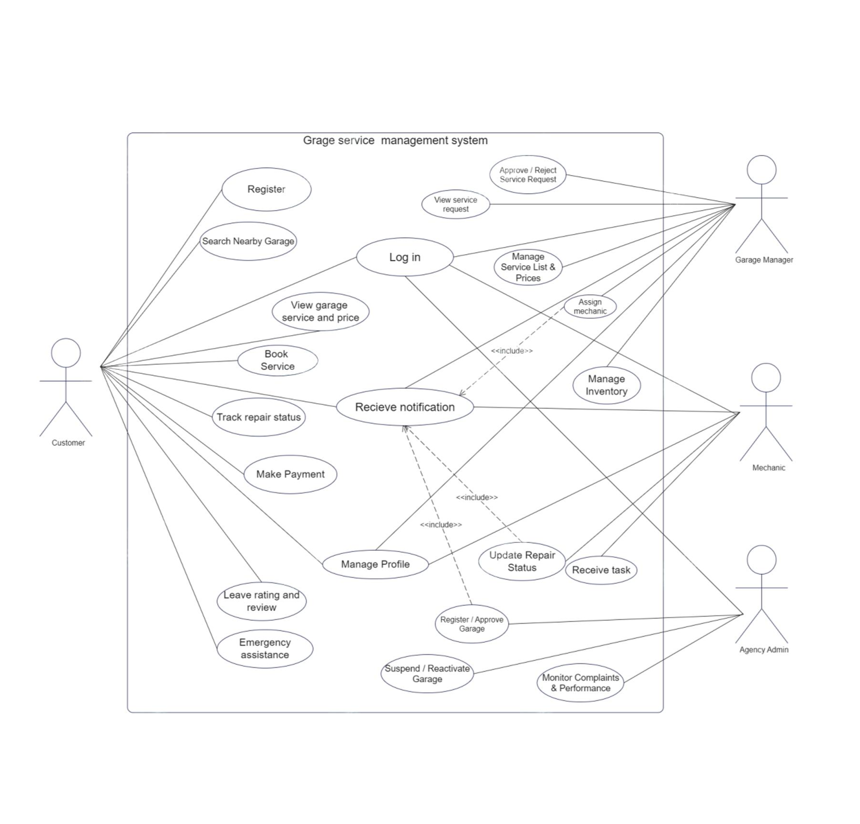
Figure 1 Use case diagram

2.5.1.2. Use case documentation

- Use Case Scenario: Login
Field | Description
Use Case Name | Login
Participating Actor | Customers, Garage Managers, Mechanics, System Administrators
Description | All users who want to access system features must authenticate with their registered email/phone and password.
Entry Condition | User must already be registered and have valid login credentials.
Flow of Events | - The user opens the app/web system  - User selects "Login".  - System displays login page.  - User enters email/phone and password.  - User clicks "Login".  - System validates credentials and redirects user to the appropriate dashboard.
Alternative Flow | If credentials are incorrect, system displays an error message and provides "Retry" or "Forgot Password" options.
Quality Requirements | Secure authentication, encrypted passwords, fast login (<5 seconds), protection against unauthorized access.

Table 1 Security Login
2. Use Case Scenario: Registration
Field | Description
Use Case Name | Registration
Participating Actor | Customers, Garage Managers, Mechanics
Description | New users register by providing required personal and role-based information.
Entry Condition | User opens registration page.
Flow of Events | 1. User opens app/system and selects "Register".  2. System displays registration form.  3. User fills name, phone, email, password, role, and optional garage details (for managers).  4. User submits the form.  5. System validates data and creates an account.  6. Confirmation message is displayed.
Alternative Flow | If mandatory fields are missing or invalid, system prompts the user to correct the data.
Quality Requirements | Phone/email must be validated. Data stored securely. Proper role-based registration.

Table 2. Registration
- Use Case Scenario: Book a Service
Field | Description
Use Case Name | Book Service
Participating Actor | Customers
Description | Customers book repair or maintenance services from registered garages.
Entry Condition | User must be logged in.
Flow of Events | 1. Customer logs in.  2. Navigates to "Book Service".  3. Selects garage, service type (oil change, diagnosis, etc.).  4. Chooses appointment date and time.  5. Submits booking request.  6. System notifies garage manager.
Alternative Flow | If selected time is unavailable, system suggests alternative times.
Quality Requirements | Real-time availability check, fast booking processing, accurate scheduling.
Table 3. Book Garage Service

- Use Case Scenario: Approve or Reject Service Booking
Field | Description
Use Case Name | Approve/Reject Service Booking
Participating Actor | Garage Manager
Description | Garage manager reviews and approves incoming customer service requests.
Entry Condition | Manager must be logged in.
Flow of Events | 1. Manager logs in.  2. Navigates to "Pending Requests".  3. Reviews booking details.  4. Approves or rejects the request.  5. Customer receives notification.
Alternative Flow | If manager rejects, system sends rejection message with reason.
Quality Requirements | Real-time notifications, clear communication, secure access.
Table 4. Booking Approval
- Use Case Scenario: Assign Mechanic
Field | Description
Use Case Name | Assign Mechanic
Participating Actor | Garage Manager
Description | Manager assigns a mechanic to handle an approved service request.
Entry Condition | Booking must already be approved.
Flow of Events | 1. Manager opens the approved bookings list.  2. Selects a booking.  3. Views list of available mechanics.  4. Assigns a mechanic.  5. Mechanic receives notification.
Alternative Flow | If mechanic unavailable, system displays alternative options.
Quality Requirements | Real-time mechanic availability, accurate assignment, quick notifications.
Table 5. Assign Mechanic to Job
- Use Case Scenario: Update Job Status
Field | Description
Use Case Name | Update Job Status
Participating Actor | Mechanics
Description | Assigned mechanics update the progress of the repair job.
Entry Condition | Mechanic must be logged in and assigned a job.
Flow of Events | 1. Mechanic logs in.  2. Navigates to "Assigned Jobs".  3. Selects a job.  4. Updates status (In progress, Waiting for parts, Completed).  5. System logs updates and notifies customer.
Alternative Flow | If system fails to update due to connectivity, mechanic retries.
Quality Requirements | Updates must appear instantly for transparency.
Table 6. Update Service Status
- Use Case Scenario: View Service History
Field | Description
Use Case Name | View Service History
Participating Actor | Customers
Description | Customers can view records of all completed services.
Entry Condition | User must be logged in.
Flow of Events | 1. User logs in.  2. Navigates to "Service History".  3. System displays completed jobs with dates and details.  4. User selects a job for more details.
Alternative Flow | If no history exists, system displays a message "No services found".
Quality Requirements | Data must be accurate, securely stored, available anytime.
Table 7. Customer Service History
- Use Case Scenario: Manage Garage Information
Field | Description
Use Case Name | Manage Garage Info
Participating Actor | Garage Manager
Description | Manager updates garage details (services, prices, business hours).
Entry Condition | Manager must be logged in.
Flow of Events | 1. Manager navigates to "Garage Profile".  2. Updates services, pricing, images, opening hours.  3. Saves changes.  4. System validates and updates info.
Alternative Flow | If invalid data entered, system prompts correction.
Quality Requirements | Updates appear instantly and accurately.
Table 8. Manage Garage Profile
- Use Case Scenario: Reset Password
Field | Description
Use Case Name | Reset Password
Participating Actor | All users
Description | Users reset forgotten passwords through email verification.
Entry Condition | User selects "Forgot Password".
Flow of Events | 1. User clicks "Forgot Password".  2. Enters email.  3. System sends reset link.  4. User opens link and sets new password.  5. System updates password.
Alternative Flow | If email not found, system displays error message.
Quality Requirements | Secure password reset, verification required, strong password rules.
Table 9. Reset Password
- Use Case Scenario: Make Payment
Field | Description
Use Case Name | Make Payment
Participating Actor | Customers
Description | Customers pay for the service using digital or cash options.
Entry Condition | Service must be completed or approved for billing.
Flow of Events | 1. Customer opens invoice.  2. Chooses payment method.  3. Confirms payment.  4. System completes the transaction.  5. Receipt is generated.
Alternative Flow | If payment fails, system notifies customer and allows retry.
Quality Requirements | Secure payment gateway, fast processing, auto-generated receipt.
Table 10. Payment Processing
- Use Case Scenario: Admin Manage Users
Field | Description
Use Case Name | Manage Users
Participating Actor | System Administrator
Description | Admin manages customer, manager, and mechanic accounts.
Entry Condition | Admin logged into admin panel.
Flow of Events | 1. Admin logs in.  2. Opens "User Management".  3. Views list of users.  4. Edits, deactivates, or deletes accounts.  5. Saves changes.
Alternative Flow | If system error occurs, admin retries.
Quality Requirements | Admin actions must be logged, secure, traceable.
Table 11. User Management
- Use Case Scenario: Analytics Dashboard
Field | Description
Use Case Name | View Analytics Dashboard
Participating Actor | System Administrator
Description | Admin views system analytics (number of bookings, revenue, active garages).
Entry Condition | Admin logged in.
Flow of Events | 1. Admin opens dashboard.  2. System displays charts and graphs.  3. Admin filters by date, garage, or service type.  4. Downloads reports if needed.
Alternative Flow | If data unavailable, system shows error and logs issue.
Quality Requirements | Fast loading, data accuracy, auto-updated charts.
Table 12. Admin Analytics
- Use Case Scenario: Manage Inventory
Field | Description
Use Case Name | Manage Inventory
Participating Actor | Garage Manager
Description | Garage manager adds, updates, or removes spare parts and monitors inventory levels.
Entry Condition | Garage manager is logged in.
Flow of Events | 1. Manager logs in.  2. Navigates to “Inventory Management”.  3. Views current inventory list.  4. Selects Add Item, Update Item, or Remove Item.  5. Enters or edits item details (item name, quantity, unit price).  6. Saves changes.  7. System validates and updates inventory records.
Alternative Flow | If invalid data is entered, system displays an error message and requests correction.
Exit Condition | Inventory data is successfully updated and stored.
Table 13. Manage Inventory Use Case

- Use Case Scenario: Submit Review
Field | Description
Use Case Name | Submit Review
Participating Actor | Customer
Description | Customer submits feedback and rating for a completed service.
Entry Condition | Customer is logged in and service is completed.
Flow of Events | 1. Customer logs in.  2. Navigates to “Service History”.  3. Selects a completed service.  4. Enters rating and comment.  5. Submits review.  6. System stores review and links it to the garage.
Alternative Flow | If customer submits empty or invalid data, system prompts for correction.
Exit Condition | Review is saved successfully.
Table 14. Submit Review Use Case
2.5.1.3 Sequence Diagram
Sequence diagrams model the interactions between system components for key workflows in the Garage Management System. They capture the order of operations for processes such as user login, service booking, mechanic assignment, job status updates, and payment processing. By illustrating message exchanges between actors (customers, garage managers, mechanics, and administrators) and system modules, sequence diagrams provide a clear view of dynamic system behavior, ensuring workflows are well-structured, efficient, and correctly implemented. These diagrams help developers understand how different components communicate dynamically.
Login Sequence Diagram
Registration Sequence Diagram
Book Service / Appointment Sequence Diagram
Approve Booking & Assign Mechanic Sequence Diagram
Payment & Invoice Generation Sequence Diagram

2.5.1.4. Activity Diagram
An activity diagram is a UML diagram that represents the flow of control and decision-making within a system. It provides a graphical overview of the sequence of activities involved in a process, helping to understand how different components interact to achieve specific goals.
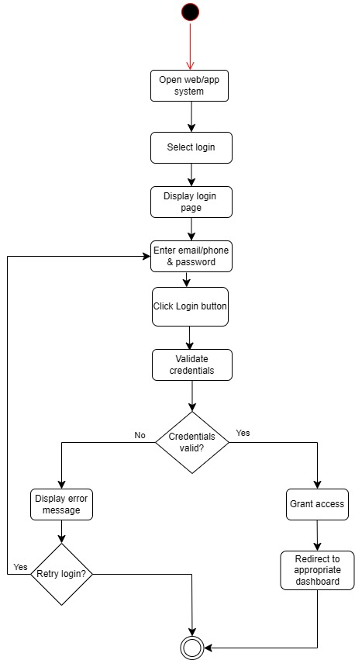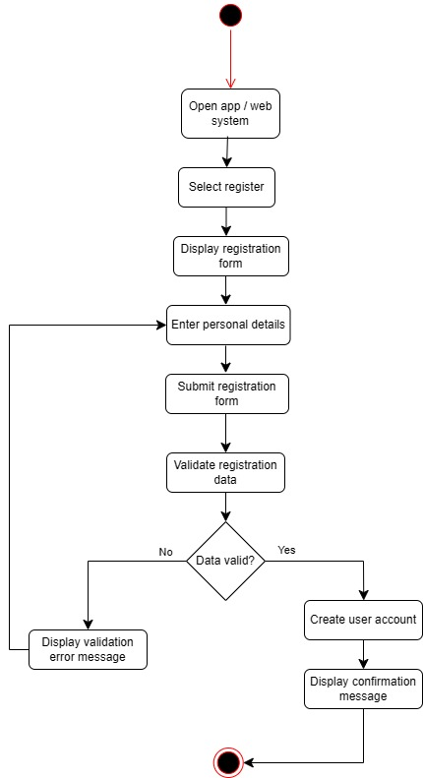
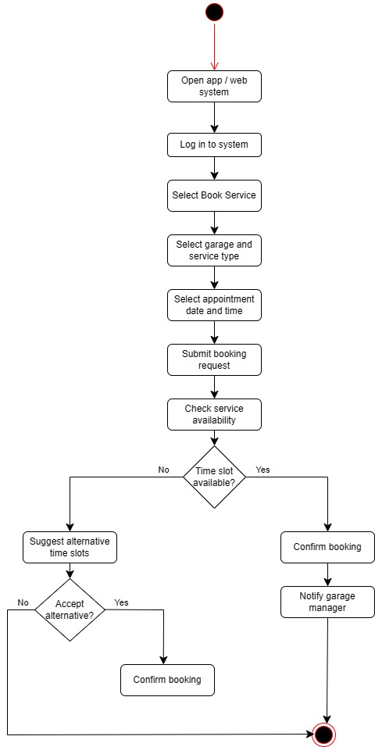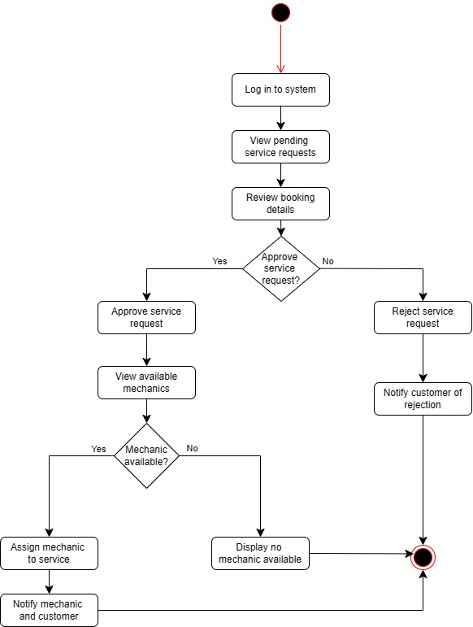
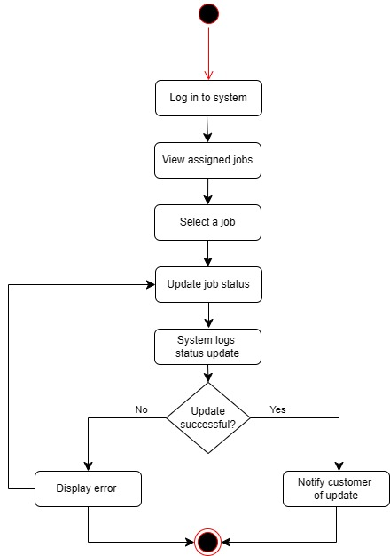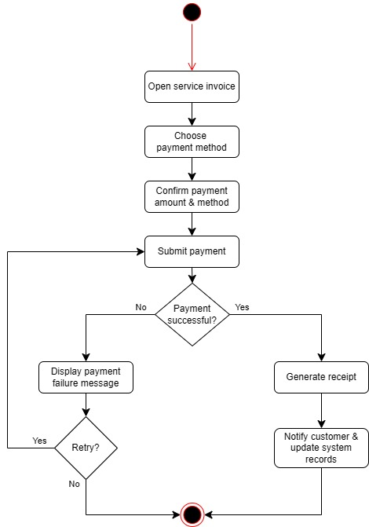

2.5.1.5. Class Diagram
Class diagrams are a type of static structure diagram in the Unified Modeling Language (UML) that describe the structure of a system by showing its classes, attributes, operations (or methods), and the relationships among the objects. They are crucial for object-oriented design and serve multiple purposes throughout the software development process.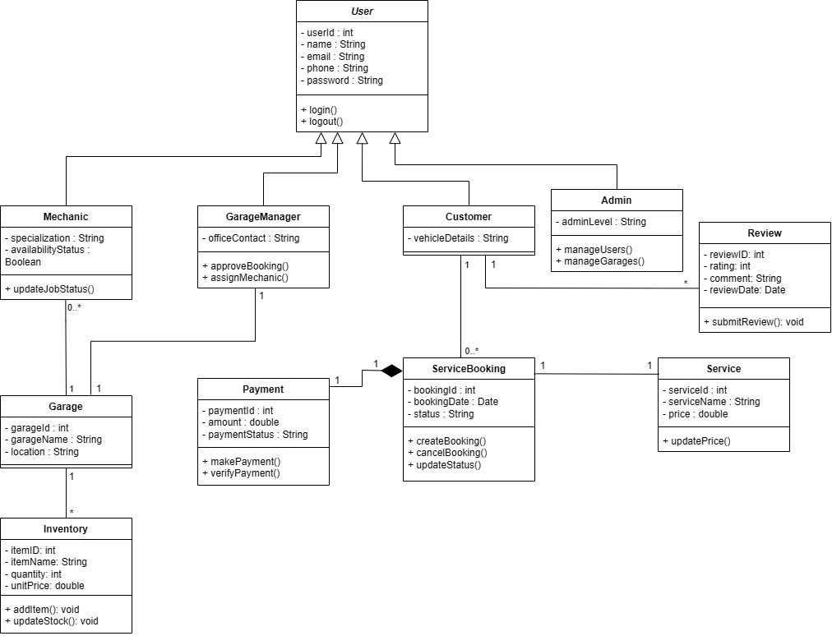

2.5.1.6. State Chart Diagram
State chart diagrams are useful to model the dynamic behavior of a system by illustrating the various states an object or interaction can be in, and the transitions between these states in response to different events.
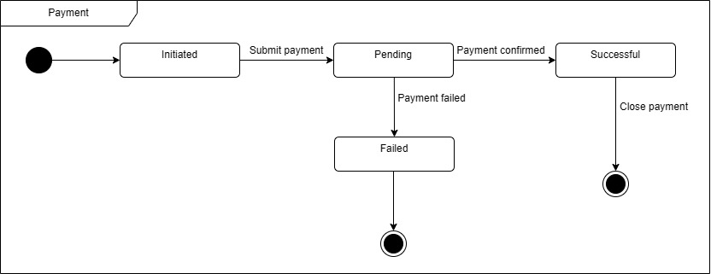
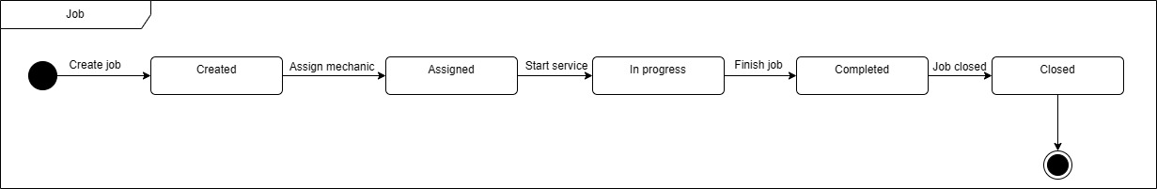
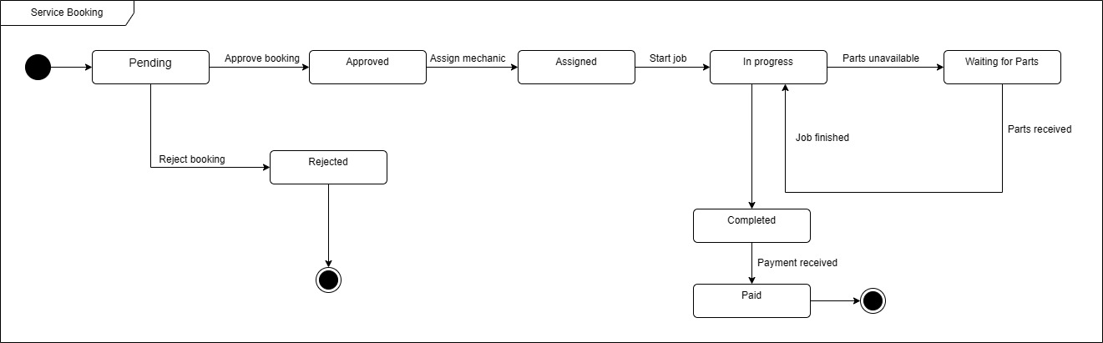

2.5.1.7. User interface prototyping
The user interface prototype for the Garage Management System was developed to visualize the interaction between users and the system before implementation. The prototype includes key screens such as login, service booking, dashboards for customers, managers, and mechanics, and job assignment interfaces. It illustrates navigational flow, layout structure, and core UI components, enabling early evaluation of usability and workflow efficiency.
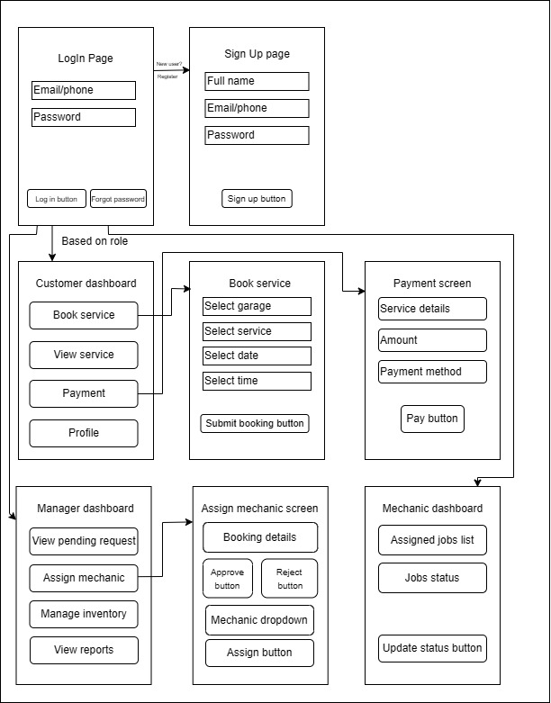

Chapter Three

System Design

3.1. Introduction
The design phase of the Garage Management System (GMS) is a critical step in transforming conceptual requirements into a fully functional platform that optimizes garage operations and enhances customer satisfaction. System design acts as the bridge between identifying user needs, operational requirements, and technical specifications, and implementing a reliable, user-friendly solution. This chapter outlines the methodologies, tools, and processes employed to ensure the system is efficient, accessible, and scalable for garage managers, mechanics, and customers.
To create a robust and intuitive system, the design phase employed user-centered design principles, iterative development cycles, and stakeholder feedback. Detailed wireframes and interactive prototypes were developed using tools such as Figma to visualize key interfaces including service booking, vehicle management, and inventory tracking. Documentation and collaborative work were managed using Microsoft Word, Google Docs, and Notion, ensuring consistent version control. Additionally, tools like Edrawmax and Draw.io were used to design system architecture diagrams, workflow charts, and process flows, helping to map out interactions between customers, garage staff, and administrative functions. These methodologies and tools were selected to balance usability, performance, and operational efficiency, ensuring the system meets the practical needs of garages while providing a seamless digital experience for users.

3.2. Purpose of the System
The primary purpose of the Garage Management System is to provide a comprehensive, automated platform that streamlines garage operations and improves the customer experience. The system addresses multiple dimensions of garage management, including service scheduling, resource allocation, vehicle tracking, and customer communication. Its purpose can be categorized into operational, managerial, and customer-focused support.
Operational Support
The system enhances day-to-day garage operations by enabling staff to efficiently manage service requests, track ongoing repairs, and maintain inventory records. Mechanics can view assigned tasks, update progress in real time, and receive notifications for urgent repairs or service deadlines. The platform also includes tools for managing spare parts, service history, and equipment availability, helping garages operate smoothly and minimize downtime.
Managerial Support
Garage managers can access dashboards that provide insights into performance metrics, such as revenue, completed services, mechanic efficiency, and inventory levels. The system facilitates decision-making by providing real-time analytics, automated reports, and predictive insights to optimize resource allocation and reduce operational bottlenecks. Additionally, managers can oversee staff scheduling, approve service requests, and maintain overall workflow efficiency through a centralized interface.
Customer Support
The system improves the customer experience by offering an intuitive platform for booking vehicle services, tracking repair status, and receiving notifications for service completion. Customers can view their service history, make payments online, and submit service-related inquiries through the system.. Multi-language support ensures accessibility for diverse user groups, while integrated feedback tools allow customers to provide input on service quality, enabling continuous improvement.
By addressing these purposes, the system aims to enhance the operational efficiency of garages, provide transparent communication with customers, and facilitate better resource management. The GMS integrates all aspects of garage management into a single platform, offering a scalable, reliable, and user-friendly solution that modernizes traditional garage operations while meeting the needs of both staff and customers.

3.3. Design Goals
The Garage Management System (GMS) is designed with key goals of scalability, security, usability, and efficiency to ensure seamless functionality, adaptability, and long-term reliability for both garage staff and customers.
Scalability
The system is built to handle an increasing number of users, including multiple garages, mechanics, and customers, without performance degradation. A modular architecture allows easy expansion to add new features such as advanced inventory management, multiple branches, or loyalty programs. Cloud-based infrastructure ensures secure and reliable data storage, enabling the system to grow alongside the business.
Security
Data security and privacy are central to the system design. Sensitive information, such as customer details, vehicle records, and service histories, is protected through encryption and secure authentication protocols. Access control mechanisms ensure only authorized users can modify critical data. Regular system updates, security patches, and monitoring prevent unauthorized access and potential cyber threats, safeguarding the integrity of both operational and customer data.
Usability
The system is designed to be intuitive and accessible, minimizing the learning curve for garage staff and customers. Interfaces are user-friendly, with clear navigation, real-time notifications, and interactive dashboards. Cross-platform compatibility ensures smooth access from smartphones, tablets, and desktops, while responsive design principles guarantee consistent performance across devices. User testing and feedback loops inform iterative improvements, enhancing overall user satisfaction.
Efficiency
Operational efficiency is a primary goal, achieved through optimized workflows for service scheduling, vehicle tracking, and inventory management. Real-time updates allow mechanics and managers to monitor progress, allocate resources effectively, and respond quickly to urgent requests. Automated notifications, reporting dashboards, and data analytics streamline decision-making, while proactive maintenance and monitoring minimize system downtime and operational disruptions.
By adhering to these design goals, the GMS provides a robust, adaptable, and efficient solution that enhances garage operations, improves customer experience, and ensures secure, reliable management of all services and resources.

3.4. Architectural Design
The architectural design of the Garage Management System (GMS) follows a layered architecture approach, which separates the system into distinct layers based on responsibility. This design improves maintainability, scalability, and reliability by ensuring that changes in one layer do not directly affect others. Each layer communicates with the adjacent layer through well-defined interfaces, enabling clear data flow and controlled interaction across the system.
Presentation Layer
The presentation layer represents the user interface of the system and is responsible for all user interactions. It provides web-based and mobile-accessible interfaces for customers, garage managers, mechanics, and agency administrators. Through this layer, users can register and authenticate, submit service requests, manage appointments, track service progress, view notifications, and access relevant information based on their roles. The presentation layer does not process business logic directly; instead, it communicates with the backend application services through secure API requests and responses, ensuring data integrity and privacy.
Application Layer
The application layer consists of the backend application services, which act as the core processing unit of the system. This layer handles all business logic and system operations, including authentication and role-based access control, service workflow management, vehicle tracking, inventory updates, payment processing, and notification handling. Requests received from the presentation layer are validated, processed, and routed appropriately within this layer. By centralizing business logic in the application layer, the system ensures consistent behavior, secure processing of sensitive data, and efficient coordination between different functional operations.
Data Layer
The data layer is responsible for data storage and retrieval through a database management system. It stores persistent system data such as user profiles, vehicle information, service records, inventory details, payment transactions, and historical logs. The application layer interacts with the data layer to read and write information as required, ensuring data consistency and reliability. This separation allows the database structure to evolve without impacting user interfaces or business logic directly.
Cloud Infrastructure Layer
The cloud infrastructure layer provides the underlying computing and storage environment required to run the system reliably. It supports database hosting, application deployment, data backups, and replication mechanisms to ensure high availability and fault tolerance. This layer enables scalability by allowing system resources to be adjusted based on user demand and ensures continuous system operation through backup and recovery mechanisms. Security controls at the infrastructure level further protect system data and services from unauthorized access or failures.
Overall Architectural Interaction
In this layered architecture, user actions originate at the presentation layer and are transmitted to the application layer via secure APIs. The application layer processes these requests and interacts with the data layer to store or retrieve required information. The cloud infrastructure supports all layers by providing scalable resources, backup services, and reliable system availability. This structured separation of concerns results in a robust, adaptable, and efficient system architecture that supports current garage operations while allowing future enhancements without significant redesign.

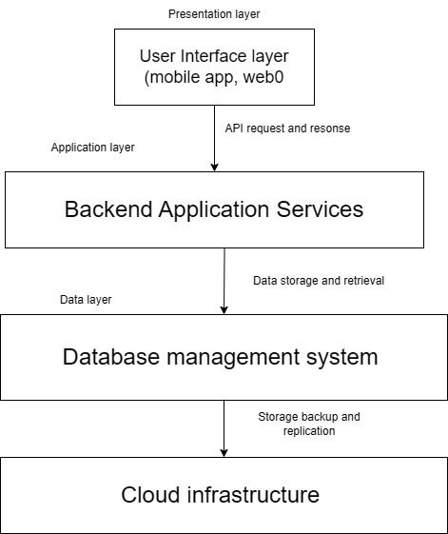

3.4.1. Subsystem Decomposition
1. User Interface Subsystem
The User Interface Subsystem represents the front-facing layer of the Garage Management System. It enables customers, garage managers, mechanics, and agency administrators to access core functionalities such as user registration and login, service request submission, task assignment viewing, inventory monitoring, payment status checking, and feedback submission. The interface is designed to be responsive and accessible across mobile and web platforms, ensuring ease of use for both technical and non-technical users. Secure communication is maintained through HTTPS to protect user data during interactions.
2. Authentication and User Management Subsystem
This subsystem is responsible for managing user authentication, authorization, and role-based access control. It ensures that only registered and verified users can access the system and that each user can only perform actions permitted by their role. For example, customers can request services, mechanics can view assigned tasks, and garage managers can approve requests and manage inventory. The subsystem also handles session management and password security, ensuring safe and reliable access to the platform.
3. Service Management Subsystem
The Service Management Subsystem handles all service-related operations within the system. This includes service request creation by customers, approval or rejection by garage managers, assignment of mechanics, service status updates, and service completion tracking. It ensures a structured workflow from service initiation to completion, reducing delays and improving operational efficiency within the garage.
4. Inventory and Payment Management Subsystem
This subsystem manages spare parts inventory and service payments. Garage managers can update inventory levels, pricing, and availability, while the system automatically generates low-stock alerts. The payment component supports transactions through Chapa and cash confirmation, ensuring that services are marked as completed only after successful payment verification. All inventory and payment records are stored securely for reporting and auditing purposes.
5. Cloud Infrastructure and Database Subsystem
The Cloud Infrastructure and Database Subsystem provides the foundation for data storage, system availability, and scalability. It stores user profiles, vehicle information, service records, inventory data, payment history, and feedback. The cloud-based environment ensures reliable performance, real-time data access, automated backups, and system recovery mechanisms, supporting uninterrupted garage operations.
Integration of Subsystems
Each subsystem operates independently while being seamlessly integrated to ensure smooth system functionality. The User Interface Subsystem sends user requests to the Authentication and User Management Subsystem for validation before forwarding them to the Service Management or Inventory and Payment Management Subsystems. All processed data is stored and retrieved through the Cloud Infrastructure and Database Subsystem. This modular integration allows efficient communication between subsystems, supports scalability, and simplifies maintenance and future enhancements.

3.4.2. Component diagram
The component diagram illustrates the system’s modular architecture using lollipop notation, showing the interactions between the core components of the Garage Management System. The User Interface Component interacts with the Authentication and User Management Component, Service Management Component, and Inventory and Payment Component to ensure secure access, structured service workflows, and accurate transaction handling. The Database Management Component serves as the central backbone of the system, securely managing data storage and facilitating reliable data exchange among all components.
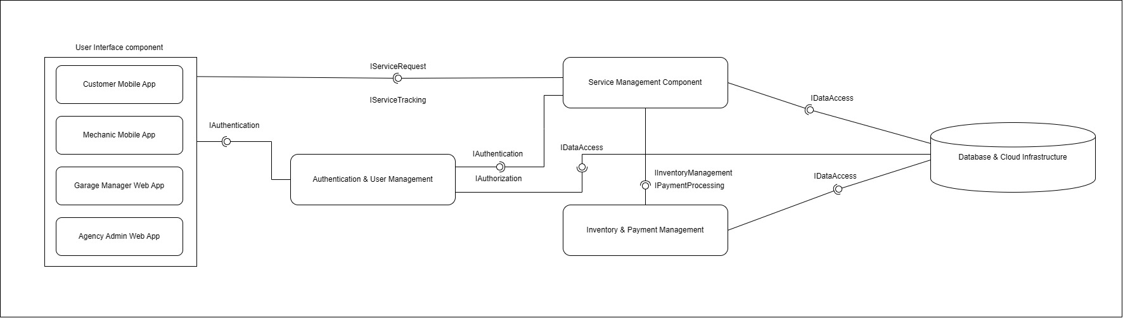

3.4.3. Deployment Diagram
The deployment diagram illustrates the physical hardware and software distribution of the Garage Management System (GMS). The architecture is organized into a distributed client-server model, ensuring secure communication and data integrity across all user touchpoints.
Client Tier: Customers, garage managers, and mechanics interact with the system via the client device node. This supports both a mobile app and a web browser, which communicate with the backend via API requests.
Application Tier: The central Application Server acts as the system's logic hub. It hosts several critical artifacts, including the backend API, the authentication module for secure access, and the notification system. The booking and payment module manages the core business workflows and coordinates with an external system (External payment gateway) to process financial transactions securely.
Data Tier: System persistence is managed by a dedicated database server hosting the GMS Database. A secure database connection ensures that data remains consistent and synchronized across all modules.
This deployment structure enables the system to operate efficiently across multiple locations. By decoupling the application logic from the database and external payment services, the system ensures high availability, scalability, and streamlined performance for real-time service updates and inventory management.
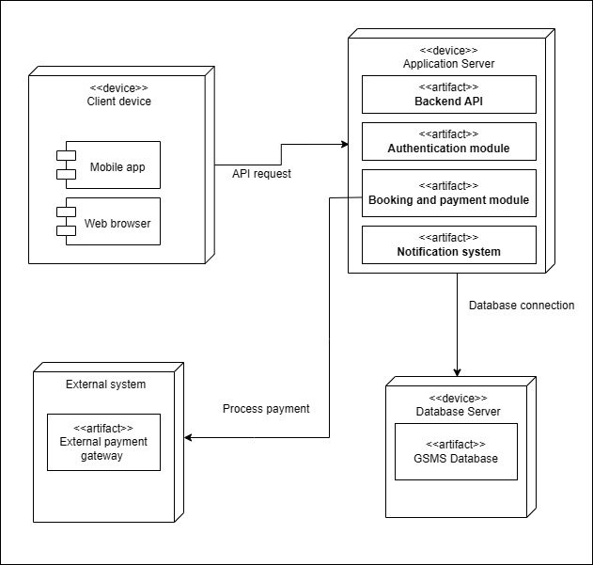

3.4.4. Persistent Modeling
Persistent modeling ensures that system data is stored, managed, and maintained consistently across sessions, providing a reliable foundation for the Garage Management System. This approach guarantees that user data, service records, payments, and system-generated information remain accurate, available, and secure over time.

Entities in Persistent Storage
User Data
- Stores personal information such as full name, phone number, email address, and login credentials.
- Passwords are securely hashed before storage.
- Role-based attributes define whether the user is a Customer, Mechanic, Garage Manager, or Agency Administrator.
Vehicle Data
- Stores vehicle details including plate number, model, brand, and year.
- Each vehicle is linked to its registered customer.
- Service history is maintained for reference and reporting.
Service Requests
- Records customer service requests including service type, description, request date, and status.
- Tracks service progress (Pending, Approved, In Progress, Completed).
- Links each request to assigned mechanics and garages.
Inventory Records
- Stores spare part details such as part name, quantity, unit price, and supplier information.
- Tracks part usage during repairs.
- Maintains low-stock alerts and restock history.
Payment Records
- Stores transaction details such as payment ID, service ID, customer ID, payment method (cash or Chapa), amount paid, payment status, and transaction date.
- Supports invoice generation and financial reporting.
Feedback and Ratings
- Stores customer ratings and reviews after service completion.
- Links feedback to specific garages and services.
- Supports service quality analysis and garage ranking.

Approach to Data Consistency
1. Relational Database Design
- Data is stored in normalized tables to minimize redundancy and ensure efficient data management.
2. Foreign Key Constraints
- Relationships between entities (e.g., ServiceID in Payments referencing the Service Requests table) enforce referential integrity.
3. Transaction Management
- Database transactions are atomic, ensuring that operations such as payments, service updates, and inventory changes are completed fully or rolled back in case of failure.
4. Data Backup and Recovery
- Automated backups ensure data recovery in case of system failure, data corruption, or accidental loss.

3.4.5. Access Control and Security
Access control and security mechanisms are implemented to protect sensitive system data and prevent unauthorized access. These measures ensure secure operations, data privacy, and trust among customers, garages, and regulatory agencies.

Authentication and Authorization
Authentication
- Secure login using hashed passwords and phone/email-based verification.
- Optional multi-factor authentication (MFA) for administrators and garage managers.
Authorization
- Role-Based Access Control (RBAC):
- Customers can request services, track repairs, make payments, and submit feedback.
- Mechanics can view assigned tasks, update service status, and log part usage.
- Garage Managers can manage services, assign mechanics, update inventory, and view reports.
- Agency Administrators can approve garages, monitor performance, and handle complaints.
- Fine-grained access policies ensure users only access features relevant to their role.

Data Privacy Measures
Encryption
- Sensitive data is encrypted at rest and during transmission using industry-standard encryption (e.g., AES-256).
- Secure key management ensures protection of encryption keys.
Secure Communication
- HTTPS ensures encrypted communication between mobile apps, web dashboards, and backend servers.
- Secure certificates are used to maintain data integrity and trust.
Auditing and Logging
- System logs record user activities such as logins, service updates, and payment transactions.
- Logs support monitoring, troubleshooting, and auditing purposes.
System Monitoring and Alerts
- Real-time monitoring detects system failures, unauthorized access attempts, or abnormal activities.
- Alerts notify administrators of critical system events to ensure quick response.

Security Functionality | Customers | Mechanics | Garage managers | Agency admins
Secure Login | ✅ | ✅ | ✅ | ✅
Role-Based Access Control (RBAC) | ✅ | ✅ | ✅ | ✅
View Assigned Tasks | ❌ | ✅ | ✅ | ❌
Manage Inventory | ❌ | ❌ | ✅ | ❌
Encrypt Data at Rest & In Transit | ✅ | ✅ | ✅ | ✅
Make Payments | ✅ | ❌ | ❌ | ❌
View Reports & Analytics | ❌ | ❌ | ✅ | ✅
Audit Logs & Monitoring | ❌ | ❌ | ✅ | ✅

3.5. User Interface Design
The User Interface (UI) for the Garage Management System is designed for simplicity, clarity, and efficiency, ensuring smooth interaction for all user roles: customers, garage managers, mechanics, and administrators. Consistent layouts, standardized buttons, and clear messages guide users through the system while minimizing errors.
The Login Page provides secure access with email or phone login options. The Sign-Up Page allows new users to register by providing personal information, vehicle details (for customers), or garage verification documents (for managers), ensuring a smooth registration process.
The Customer Dashboard enables users to request services, track vehicle repair status, view payment history, and provide feedback. The Garage Manager Dashboard allows managers to approve or reject service requests, assign mechanics, update inventory, and monitor garage performance.
The Mechanic Dashboard displays assigned tasks, allows progress updates, and facilitates parts requests. Administrators can access system-wide analytics, monitor user activities, and manage all operational processes.
The Service Request and Feedback Pages let customers submit requests, monitor status, rate completed services, and report issues. Upvoting and reporting features ensure reliable and safe communication between users and garages.
The Profile Page serves as a personal hub where users can update account details, view service history, manage appointments, and monitor participation in forums or feedback systems.
Overall, the UI ensures consistency across all modules, including dashboards, service requests, and authentication. Clear labels, uniform button styles, actionable error messages, and intuitive navigation enhance usability, providing a responsive and engaging experience for both mobile and web users.
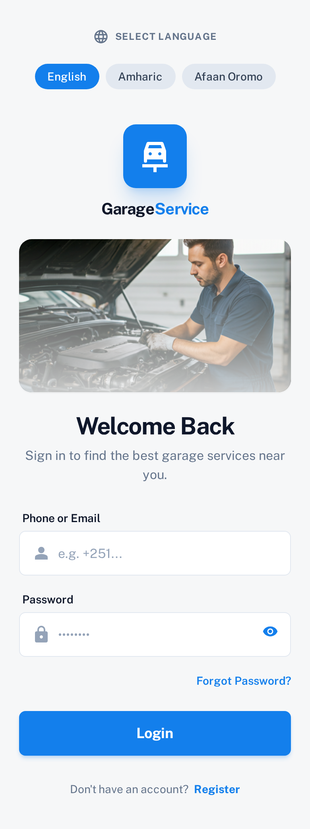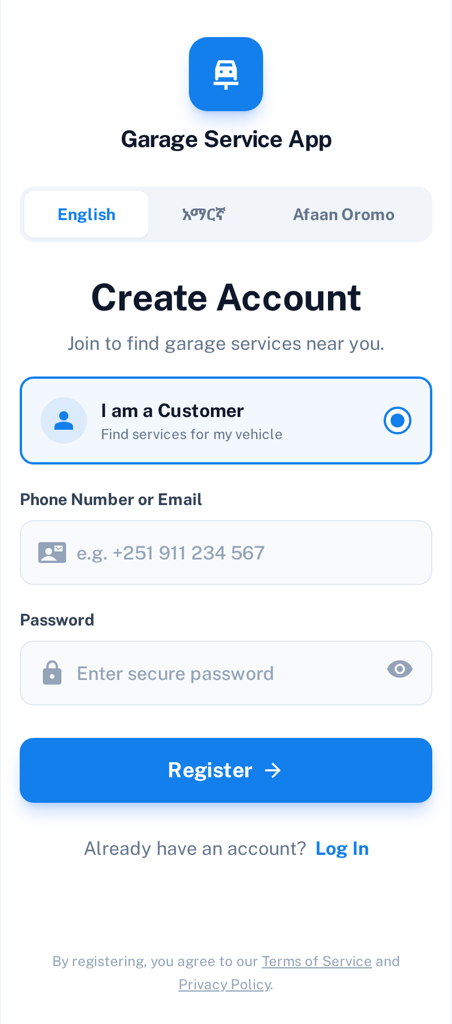
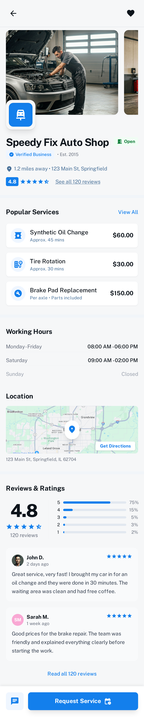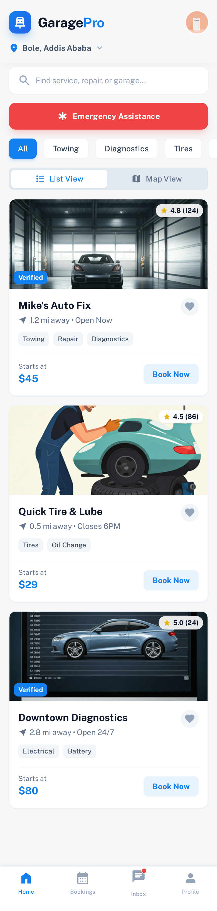

3.6. Database Design
The database design of the Garage Management System is structured to ensure efficient data storage, integrity, scalability, and secure access. A relational database model is adopted, following normalization principles to minimize redundancy and maintain consistency. The system supports multiple garages, customers, mechanics, managers, and administrators while enforcing strict role-based responsibilities.

3.6.1 User and Role Modeling
The system applies a disjoint and total specialization of users. Every user belongs to exactly one role, and no user can have multiple roles simultaneously. Common user information is stored in a single parent entity, while role-specific data is stored in separate child entities.
Users (Parent Entity)
- Attributes: UserID (Primary Key), FullName, Email, PhoneNumber, PasswordHash, Status, CreatedAt
- Description: Stores authentication and profile information common to all users.
Role-Specific Entities
Customers
- Attributes: UserID (Primary Key, Foreign Key → Users)
- Description: Represents system users who request garage services and own vehicles.
Mechanics
- Attributes: UserID (Primary Key, Foreign Key → Users), GarageID (Foreign Key)
- Description:Represents mechanics assigned to garages and responsible for service execution.
Managers
- Attributes: UserID (Primary Key, Foreign Key → Users), GarageID (Foreign Key)
- Description: Represents garage managers responsible for overseeing operations.
Admins
- Attributes:UserID (Primary Key, Foreign Key → Users)
- Description:Represents system administrators with full system privileges.

3.6.2 Core Operational Entities
Garages
- Attributes: GarageID (Primary Key), GarageName, Location, ContactNumber, Status, ManagerID (Foreign Key → Managers.UserID)
- Description: Represents registered garages managed by a designated garage manager.
Vehicles
- Attributes: VehicleID (Primary Key), PlateNumber, VehicleType, Model, CustomerID (Foreign Key → Customers.UserID)
- Description: Represents customer-owned vehicles that can be serviced by garages.
ServiceRequests
- Attributes: RequestID (Primary Key), ServiceType, Description, RequestDate, Status, VehicleID (Foreign Key), GarageID (Foreign Key)
- Description: Represents service requests submitted for vehicle maintenance or repair.
MechanicAssignments
- Attributes: AssignmentID (Primary Key), RequestID (Foreign Key), MechanicID (Foreign Key → Mechanics.UserID), AssignedDate, CompletionDate, Status
- Description: Manages the assignment of mechanics to service requests.
Inventory
- Attributes: ItemID (Primary Key), ItemName, Quantity, UnitPrice, GarageID (Foreign Key)
- Description: Represents spare parts and materials used during vehicle repairs.
Payments
- Attributes: PaymentID (Primary Key), Amount, PaymentMethod (Chapa/Cash), PaymentStatus, PaymentDate, RequestID (Foreign Key)
- Description: Stores payment transactions associated with completed service requests.
Reviews
- Attributes: ReviewID (Primary Key), Rating, Comment, ReviewDate, CustomerID (Foreign Key → Customers.UserID), GarageID (Foreign Key)
- Description: Stores customer feedback for garages after service completion.
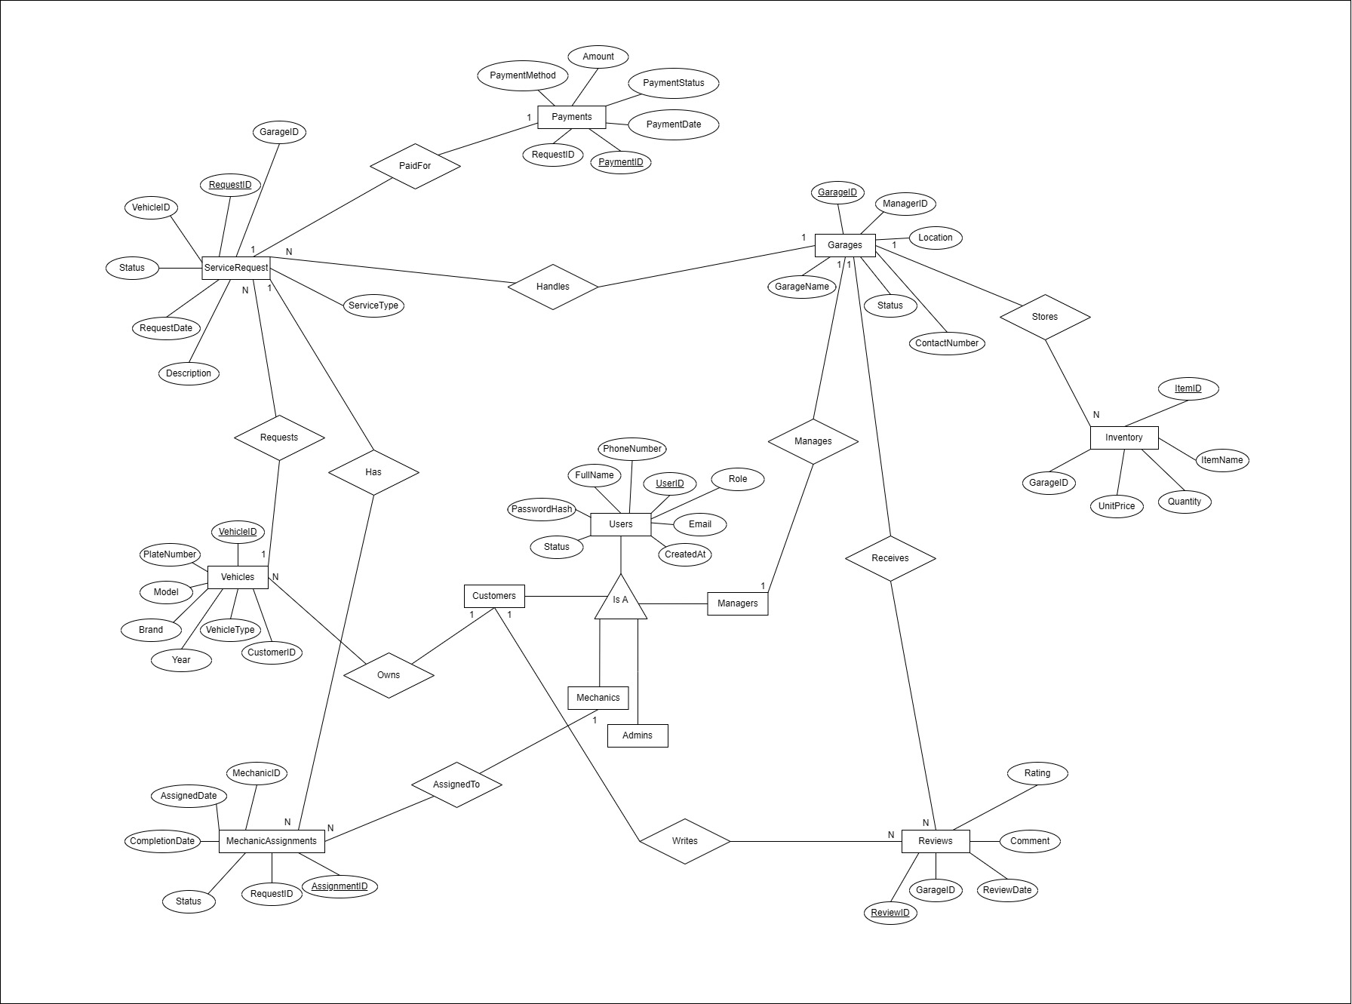

3.6.3 Normalization and Integrity

Normalization
The database schema follows Third Normal Form (3NF) to eliminate redundancy and ensure functional dependency consistency. Common attributes are stored once in the Users table, while role-specific data is separated into specialized entities.

Referential Integrity
Foreign key constraints are enforced across all related tables to maintain consistent relationships between entities and prevent orphan records.

3.6.4 Indexing Strategy
Indexes are created on frequently accessed attributes, including:
- UserID
- GarageID
- RequestID
- VehicleID
These indexes improve query performance and system responsiveness.

3.6.5 Security and Access Control
- User passwords are stored using secure hashing techniques.
- Role-based access control ensures users can only access authorized system functions.
- Sensitive operations are restricted based on user role.

3.6.6 Backup, Recovery, and Scalability
- Automated daily backups are maintained with secure off-site storage.
- Periodic recovery testing ensures data availability in case of system failure.
- The database design supports horizontal and vertical scaling, allowing future system expansion without schema restructuring.

3.7. Summary
This chapter presented the complete system design for the Garage Management System, focusing on creating a scalable, secure, and user-friendly platform that improves the management of garage operations and enhances customer experience. The design phase translated system requirements into structured architectural, database, and interface models that guide effective system implementation.
The system architecture follows a modular approach, dividing the platform into independent but interconnected components such as user interfaces, backend services, database management, and third-party integrations. This design ensures flexibility, ease of maintenance, and the ability to scale as the number of users, garages, and service requests increases. Deployment and component diagrams were used to illustrate how system components interact and how services are hosted and accessed by different user devices.
A detailed database design was developed to support efficient data storage and retrieval. Core entities such as users, garages, vehicles, service requests, mechanic assignments, inventory, payments, and reviews were defined along with their relationships. Normalization techniques, indexing strategies, and backup mechanisms were incorporated to ensure data integrity, performance, and reliability. Scalability and recovery considerations were also addressed to support future growth.
User interface design principles emphasized simplicity, consistency, and accessibility. Role-specific dashboards were designed for customers, mechanics, garage managers, and administrators to ensure efficient interaction with the system. Standardized layouts, clear navigation, and responsive design were applied to deliver a seamless experience across mobile and web platforms.
Security and access control mechanisms were integrated into the design to protect sensitive information. Authentication, role-based access control, encrypted communication, and system monitoring were incorporated to ensure data privacy and prevent unauthorized access.Overall, the design phase establishes a solid foundation for the implementation phase. By combining a well-structured architecture, robust database design, intuitive user interfaces, and strong security measures, the Garage Management System is well-prepared to deliver efficient, reliable, and scalable garage management services.

