Assignment1-2017555012

Sümeyra Çam

21 01 2022

## Q1: How many characters do have at least one starship?

| n |
| --- |
| 20 |

| name | num_starships |
| --- | --- |
| Obi-Wan Kenobi | 5 |
| Anakin Skywalker | 3 |
| Padmé Amidala | 3 |
| Chewbacca | 2 |
| Han Solo | 2 |
| Luke Skywalker | 2 |
| Arvel Crynyd | 1 |
| Biggs Darklighter | 1 |
| Boba Fett | 1 |
| Darth Maul | 1 |
| Darth Vader | 1 |
| Gregar Typho | 1 |
| Grievous | 1 |
| Jek Tono Porkins | 1 |
| Lando Calrissian | 1 |
| Nien Nunb | 1 |
| Plo Koon | 1 |
| Poe Dameron | 1 |
| Ric Olié | 1 |
| Wedge Antilles | 1 |

## Q2: Get the frequencies of the eye color of the characters

## Ranked data:

| eye_color | n |
| --- | --- |
| brown | 21 |
| blue | 19 |
| yellow | 11 |
| black | 10 |
| orange | 8 |
| red | 5 |
| hazel | 3 |
| unknown | 3 |
| blue-gray | 1 |
| dark | 1 |
| gold | 1 |
| green, yellow | 1 |
| pink | 1 |
| red, blue | 1 |
| white | 1 |

## Q3: According to the data available, what are the mean (average) age values across each species? Find the 3 oldest species.

## # A tibble: 15 x 2  
## species mean_birth  
## <chr> <dbl>  
## 1 Cerean 92   
## 2 Droid 53.3  
## 3 Ewok 8   
## 4 Gungan 52   
## 5 Human 53.4  
## 6 Hutt 600   
## 7 Kel Dor 22   
## 8 Mirialan 49   
## 9 Mon Calamari 41   
## 10 Rodian 44   
## 11 Trandoshan 53   
## 12 Twi'lek 48   
## 13 Wookiee 200   
## 14 Yoda's species 896   
## 15 Zabrak 54

## # A tibble: 3 x 2  
## species mean_birth  
## <chr> <dbl>  
## 1 Yoda's species 896  
## 2 Hutt 600  
## 3 Wookiee 200

## Q4: A new data set by adding a new observation to this data

| name | height | mass | hair_color | skin_color | eye_color | birth_year | sex | gender | homeworld | species | films | vehicles | starships |
| --- | --- | --- | --- | --- | --- | --- | --- | --- | --- | --- | --- | --- | --- |
| Sümeyra Çam | 164 | 80 | brown | warm ivory | brown | 23 | female | feminine | Stewjon | Human | The Clone Wars | T-47 Airspeeder | Luxury 3000 |

## Q5: Calculate the body mass index (BMI)

| name | height | mass | hair_color | skin_color | eye_color | birth_year | sex | gender | homeworld | species | films | vehicles | starships | bmi | bmi_result |
| --- | --- | --- | --- | --- | --- | --- | --- | --- | --- | --- | --- | --- | --- | --- | --- |
| Luke Skywalker | 172 | 77 | blond | fair | blue | 19 | male | masculine | Tatooine | Human | The Empire Strikes Back, Revenge of the Sith , Return of the Jedi , A New Hope , The Force Awakens | Snowspeeder , Imperial Speeder Bike | X-wing , Imperial shuttle | 26.02758 | overweight |

## Q6: Plot the distribution of ages less than 100 by BMI groups

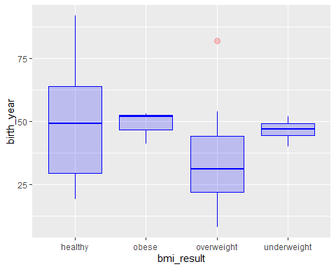

## Q7: By plotting a graph, show the relationship between age and BMI values.Re-plot the same graph after filtering the data as both age and BMI less than 100.

## `geom_smooth()` using method = 'loess' and formula 'y ~ x'

## Warning: Removed 51 rows containing non-finite values (stat_smooth).

## Warning: Removed 51 rows containing missing values (geom_point).

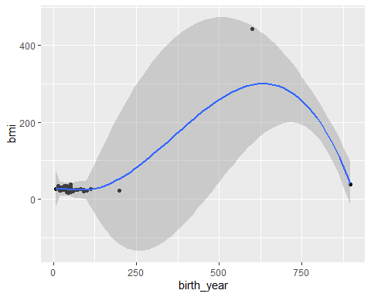

## `geom_smooth()` using method = 'loess' and formula 'y ~ x'

