**CS 240 PROJECT**

**Sümeyye Sena Eminmollaoğlu**

**SECTION 1**

* Is there any relationship between players’ education levels and their scores?
* What is the relationship between players’ heights and their teams’ won counts?
* What is the relationship between teams’ won counts and awards of those teams’ coaches?

I selected the 3rd question which is **“What is the relationship between teams’ won counts and awards of those teams’ coaches?”.**

I chose this question becauese i want to see if there is a relation between winning times and coaches awards. There can be teams which play well but can’t win. So i will see if the coaches are awarded acording to their teams’ winning times or there are different things effect the coaches’ awards.

**SECTION 2**

1. **2-**

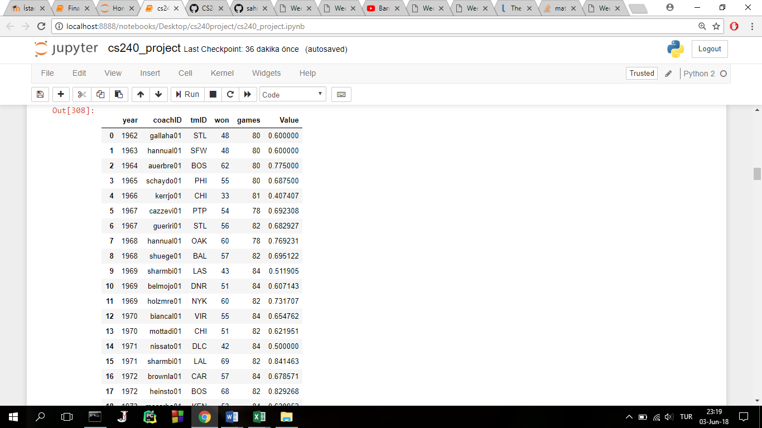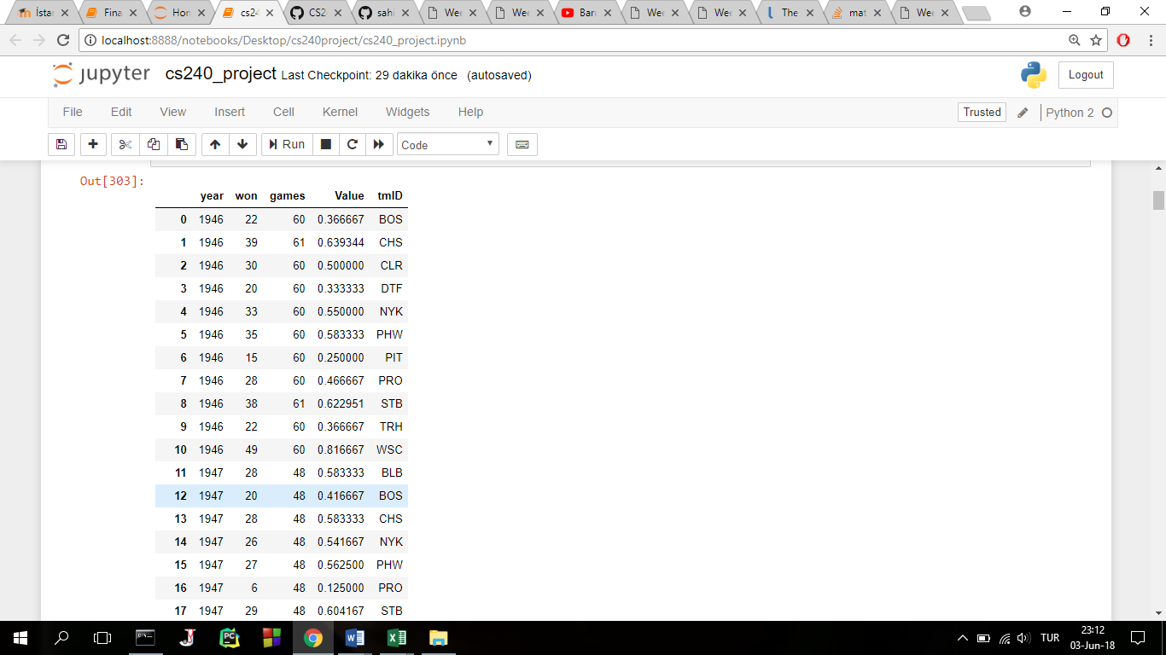

basketball_teams dataframe coach_award_team dataframe

I took the year, won and games columns and coach_awards, coach and then convert them to numeric values. Then I basketball_teams dataframes are calculated the winning ratio which is won/games. merged

Then tmID column is added.

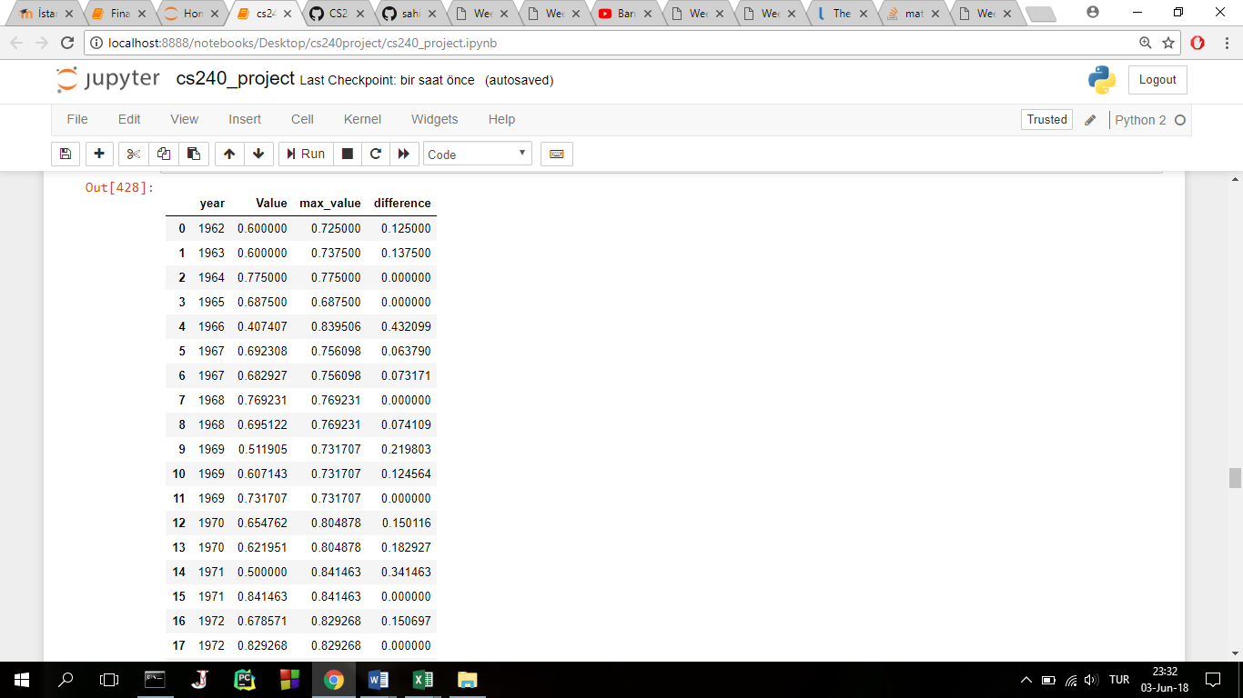**3-**Final dataframe which contains year, teams winning ratio that year by training that awarded coach, the max winning ratio of that year and difference between winning ratio and max winning ratio

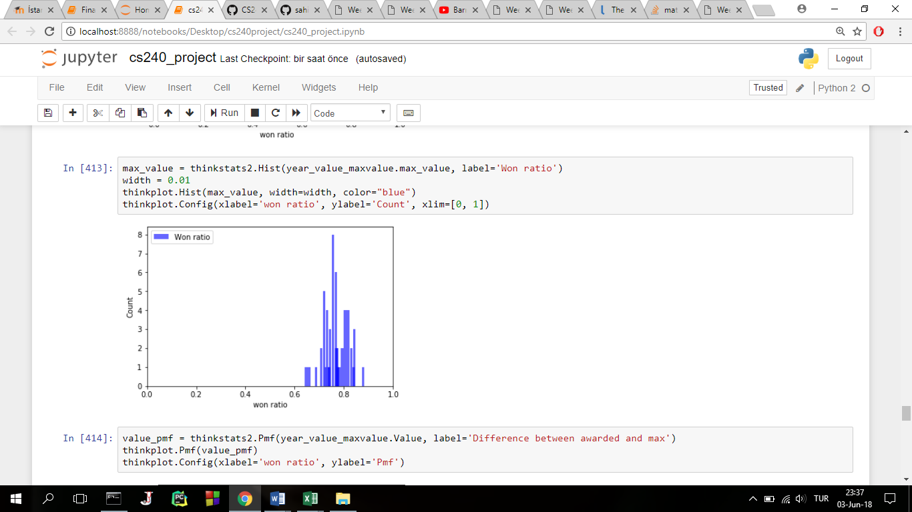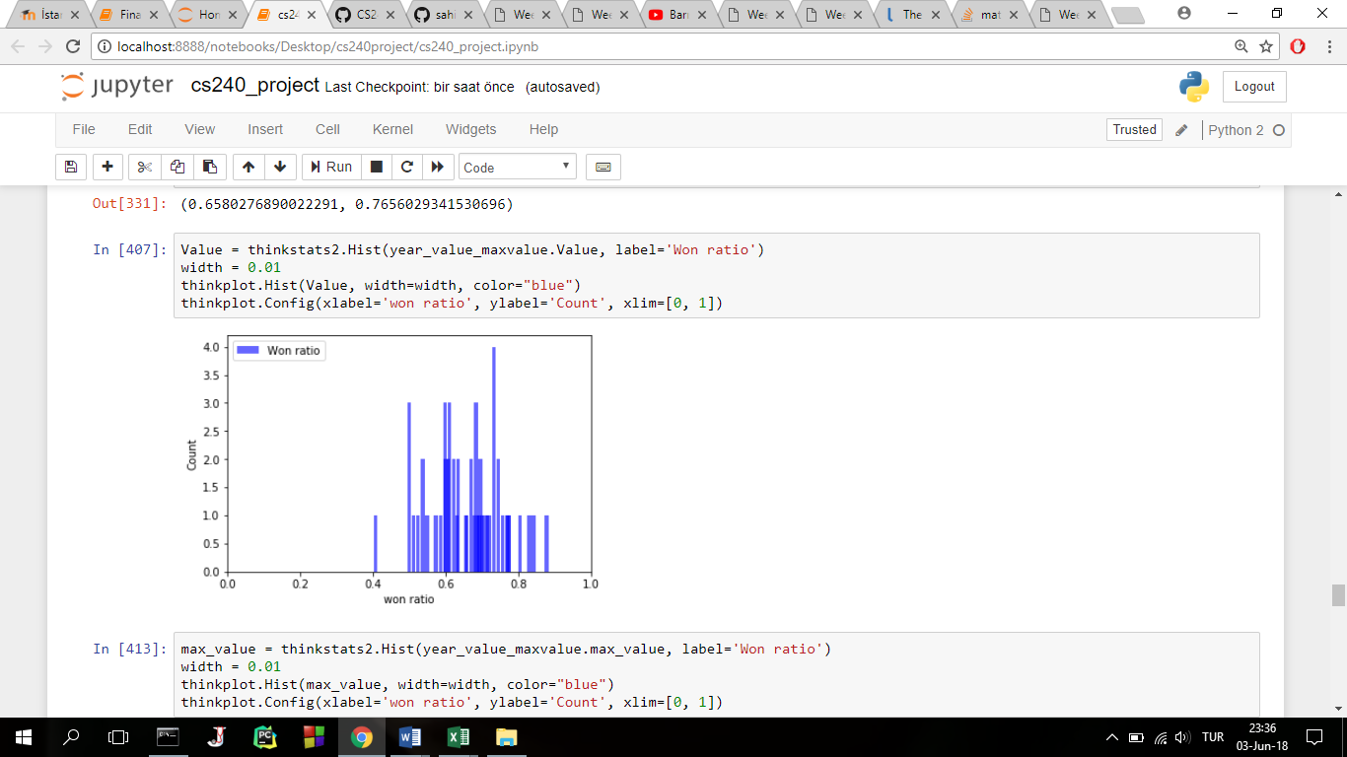**SECTION 3**

Histogram of the max winning ratio

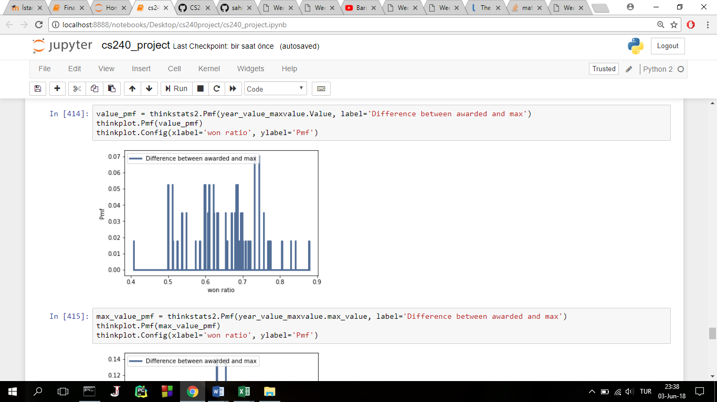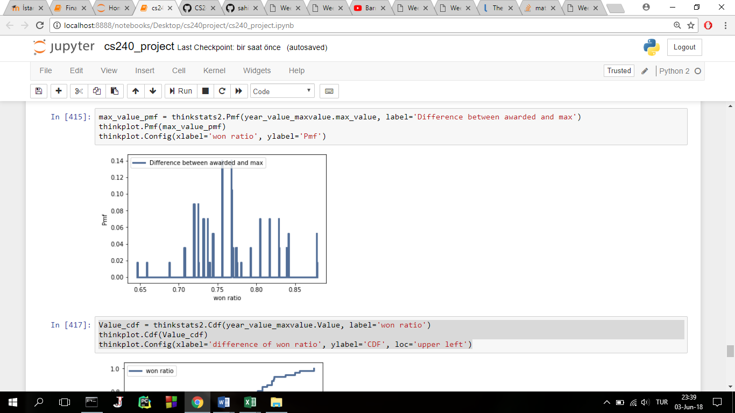Histogram of the awarded winning ratio

Pmf of the awarded winning ratio Pmf of the max winning ratio

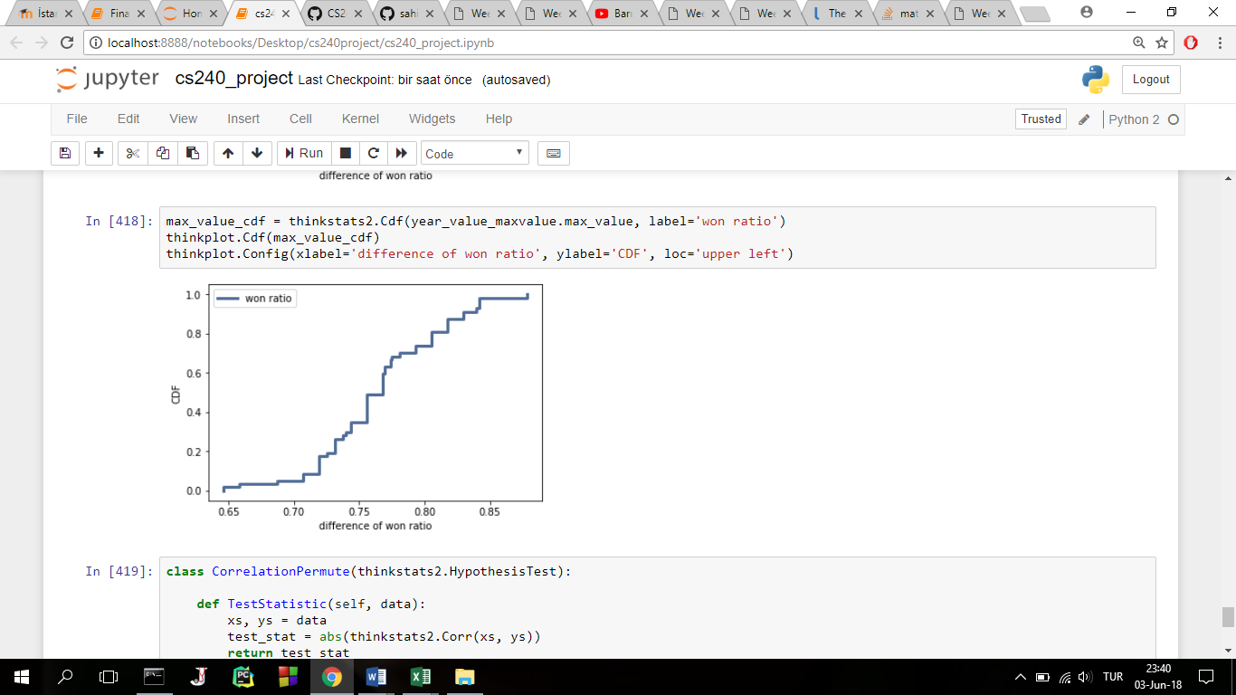

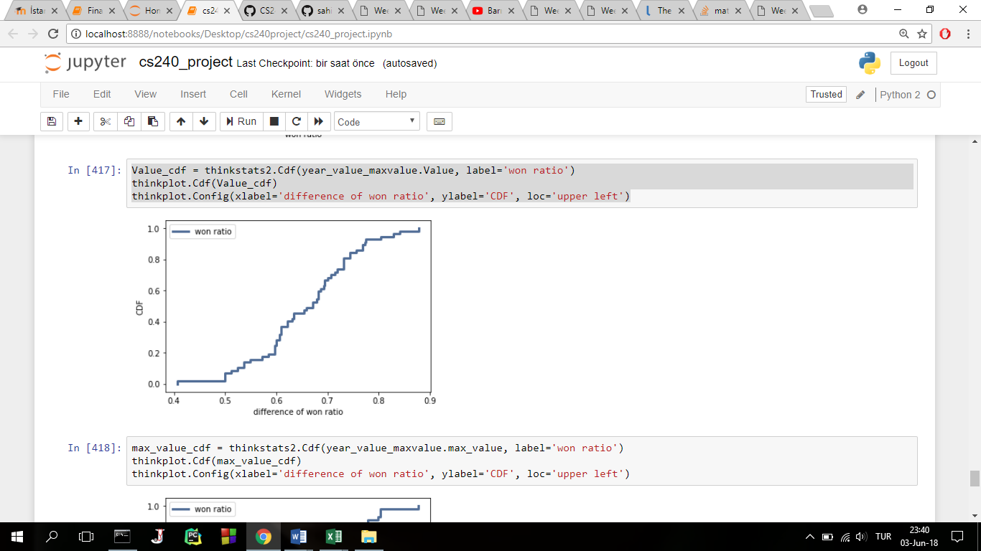

Cdf of awarded winning ratio Cdf of the max winning ratio

**SECTION 5**

Correlation for awarded winning ratio and max winning ratio is 0.165.

**SECTION 7**

In my project I wanted to see if a coach is awarded by winning ratio of his team or not. I found the maximum winning raito of years and compared them wtih awarded winning ratios in same years, I saw that a coach is not awarded by winning ratio of his team usually, there are other things that effect awards.