Project3 candy crush

F74036190 張瑜真

1. 遊戲相關

規則和原版candycrush一樣

但過關條件改為10步內>500分

遊戲結束時沒到500分會有叉叉出現

其他分數依高低分成一顆或兩顆或三顆星星

bluebomb.jpg 消九宮格炸彈

bluev.jpg 消除直排

bluer.jpg 消除橫排

pushstar.jpg 消除相同顏色的石頭

二、UML圖

(箭頭為繼承關係)

|  |
| --- |
| Mainwindow |
| -isclicked:bool  -indexv:int  -indexh:int  -record_c:int  -record_r:int  -lbomb:int  -temnum:int  -over:int  -step:int  -score:int  -c:int  -re[10][10]:int  *b[10][10]:blank |
| +setclickpic(b:blank*b):void  +gamestart():void  +judge(r1:int,c1:int):bool  +renewpic():void  +bomb(r:int,c:int):int  +record(r:int,c:int):int  +drop():int  +trychange(r:int,c:int):bool  +lasttest():bool  +producenewpic():int  +clearstar(r:int,c:int):int  Slot:  +button_clicked(row:int,column:int):void  +zerovanish:void |

|  |
| --- |
| blank |
| +row:const int  +column:const int  +*time:QTimer  +*button:QPushButton  +shift:int  +number:int |
| +setnumber():void  +setbuttonpic():void  +blank(R:int,C:int,*parent:QWidget)  +operator-(b:blank*):void  +operator|(b:blank*):void  Slot:  +click():void  +moveleft():void  +moveright():void  +moveup():void  +movedown():void  Signals:  movedone():void  Click(row:int,column:int):void |

|  |
| --- |
| Destroy |
|  |
| +eliminate(*b[10][10]:blank,*clicked:blank):virtual void=0  <<constructor>>Destroy()  <<destructor>>~ Destroy() |

|  |
| --- |
| horizontal |
|  |
| +eliminate(*b[10][10]:blank,*clicked:blank):virtual void  <<constructor>>horizontal()  <<destructor>>~ horizontal () |

|  |
| --- |
| nineblock |
|  |
| +eliminate(*b[10][10]:blank,*clicked:blank):virtual void  <<constructor>>nineblock()  <<destructor>>~ nineblock () |

|  |
| --- |
| star |
|  |
| +eliminate(*b[10][10]:blank,*clicked:blank):virtual void  <<constructor>>star()  <<destructor>>~ star () |

|  |
| --- |
| vertical |
|  |
| +eliminate(*b[10][10]:blank,*clicked:blank):virtual void  <<constructor>>vertical ()  <<destructor>>~vertical() |

三、遊戲截圖:

遊戲開始的畫面

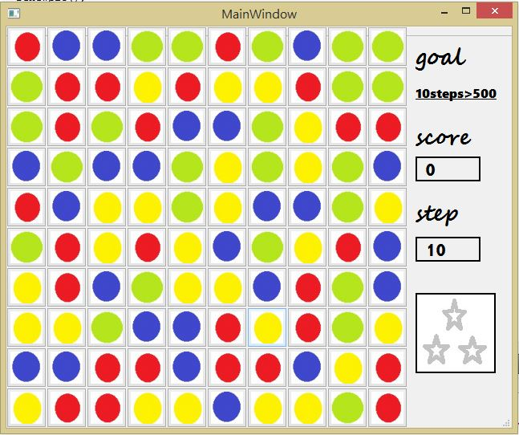

遊戲失敗的畫面

