**FAKE NEWS DETECTION USING NLP**

**Name:A.Sumithra**

**Reg.no:912421104045**

**INNOVATION:**

**Detecting fake news using natural language processing (NLP) in artificial intelligence is a critical and ongoing area of research and development. Innovations in this field are essential to combat the spread of misinformation and disinformation. Here are some innovative approaches and techniques for fake news detection using NLP in AI:**

**1.Deep Learning Models:**

**. Utilize state-of-the-art deep learning models like Transformers (e.g., BERT, GPT-3) to improve the understanding of context and semantics in text, making it easier to identify inconsistencies and fake news indicators.**

**2.Multimodal Analysis:**

**. Combine NLP with image and video analysis to detect fake news across different media types, as misinformation can spread through images and videos as well.**

**3.Stance Detection:**

**. Develop models that analyze the stance of a piece of news or social media post in relation to known facts or credible sources. A change in stance can be an indicator of fake news.**

**4.Fine-Tuning Pre-trained Models:**

**. Fine-tune pre-trained models on a specific dataset that contains labeled examples of fake and real news articles to improve performance for the specific task.**

**5.Semantic Analysis:**

**. Incorporate semantic analysis to understand the meaning and context of sentences, enabling the detection of subtle forms of misinformation that may not rely on blatant falsehoods.**

**6.Network Analysis:**

**. Analyze the network of users and sources spreading information to identify patterns of disinformation and flag accounts or sources with suspicious activity.**

**7.Cross-lingual Detection:**

**. Extend fake news detection to multiple languages by training models that can understand and analyze text in different languages.**

**8.Explainability and Interpretability:**

**. Develop methods to provide explanations for the model's decisions, making it easier for users to understand why a piece of news is classified as fake or real.**

**9.Real-time Monitoring:**

**. Create systems that can continuously monitor news and social media platforms to identify and flag potential fake news stories in real-time.**

**10.User Behavior Analysis:**

**. Consider user behavior, such as engagement and sharing patterns, to identify accounts or posts that may be involved in spreading fake news.**

**11.Data Augmentation and Adversarial Attacks:**

**. Employ data augmentation techniques to generate synthetic examples of fake news, and use adversarial training to make the model more robust against adversarial attacks.**

**12.Collaboration with Fact-Checkers:**

**. Collaborate with fact-checking organizations to gather labeled data and improve the accuracy of fake news detection models.**

**13.Privacy-Preserving Solutions:**

**. Develop methods that can detect fake news without compromising user privacy, especially when analyzing data from social media platforms.**

**14.Human-in-the-Loop Systems:**

**. Combine AI with human expertise to create hybrid systems where AI helps flag potential fake news, and humans make the final judgment.**

**15.Behavioral Analysis:**

**. Analyze the behavior of users who consistently share fake news and identify patterns that can be used to detect fake news sources.**

**16.Continuous Learning:**

**. Innovation in fake news detection using NLP in AI is an ongoing process, and researchers and practitioners are continually exploring new approaches and techniques to stay ahead of those who spread misinformation. Collaboration between the AI community, fact-checkers, and social media platforms is essential to effectively combat fake news.**

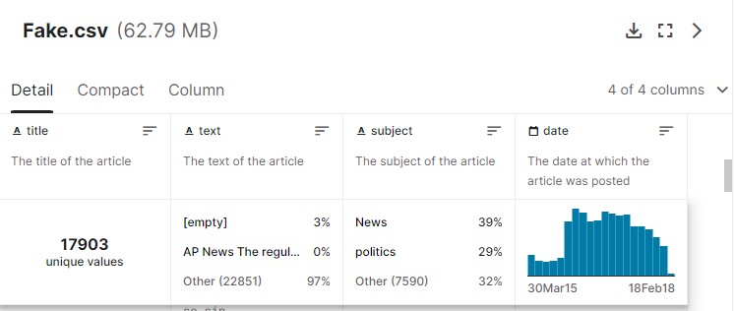

**Importing the dataset:**

**The CSV file fake__or__real__news.csv is now being read. We'll utilize this dataset to attempt to determine if a piece of news is authentic or not. It has three columns-id, title, text, and label-and 20800 columns, or the number of entries. program code:**

**#Reading the data nlp = spacy.load('el__core__news__md') df1 = pd.read__csv('../data/jtp__fake__news.csv') df1.shape df1.info() df1.head() import nltk nltk.download(‘stopwords’) nltk.download(‘wordnet’) news_d = pd.read_csv(“train.csv”) print(“Shape of News data:”, news_d.shape) print(“News data columns”, news_d.columns)** output:

Shape of News data: (20800, 5) News data columns Index(['id', 'title', 'author', 'text', 'label'], dtype='object')

Program:

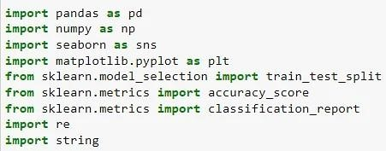

Result:



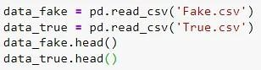

Output:



Output:



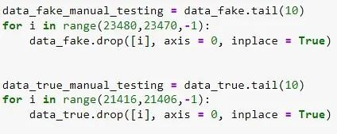





Output:



Text preprocessing:

Text preprocessing is an essential step in [natural language processing](https://www.analyticsvidhya.com/blog/2017/01/ultimate-guide-to-understand-implement-natural-language-processing-codes-in-python/) (NLP) that involves cleaning and transforming unstructured text data to prepare it for analysis. It includes [tokenization,](https://www.analyticsvidhya.com/blog/2020/05/what-is-tokenization-nlp/) [stemming,](https://www.analyticsvidhya.com/blog/2021/11/an-introduction-to-stemming-in-natural-language-processing/) lemmatization, stop-word removal, and part-ofspeech tagging. In this article, we will introduce the basics of text preprocessing and provide Python code examples to illustrate how to implement these tasks using the [NLTK library.](https://www.analyticsvidhya.com/blog/2021/07/nltk-a-beginners-hands-on-guide-to-natural-language-processing/) By the end of the article, readers will better understand how to prepare text data for NLP tasks.

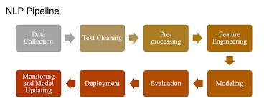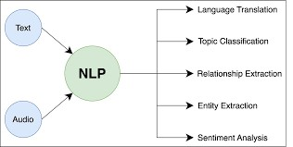

feature extraction:

In natural language processing (NLP), feature extraction is a fundamental task that involves converting raw text data into a format that can be easily processed by machine learning algorithms. There are various techniques available for feature extraction in NLP, each with its own strengths and weaknesses.

What are the three types of feature extraction methods in NLP?

At present, there are three typical feature extraction methods, namely bag-of-words (BoW), word2vec (W2V) and large pre-trained natural language processing (NLP) models. BoW is widely used in traditional machine learning.



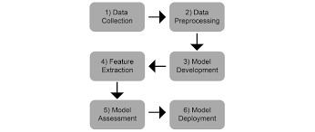

Model training:

What is Model Training?

Model training is the phase in the data science development lifecycle where practitioners try to fit the best combination of weights and bias to a machine learning algorithm to minimize a loss function over the prediction range.

What are steps in model training?

**3 steps to training a machine learning model**

* Step 1: Begin with existing data. Machine learning requires us to have existing data—not the data our application will use when we run it, but data to learn from. ...
* Step 2: Analyze data to identify patterns. ...
* Step 3: Make predictions.

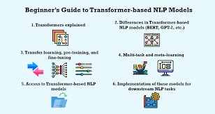

Evaluation:

Evaluation in NLP (Natural Language Processing) refers to the process of assessing the quality and performance of NLP models. It involves measuring how well a model is able to complete a specific NLP task, such as text classification, sentiment analysis, machine translation, or question answering.

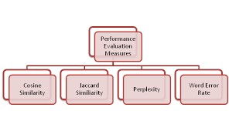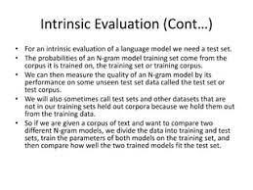

Conclusion:

The phase 5 submission about the fake new detection is done successfully.