DocWhisperer – Ask your files anything
Sample 1 – Single file upload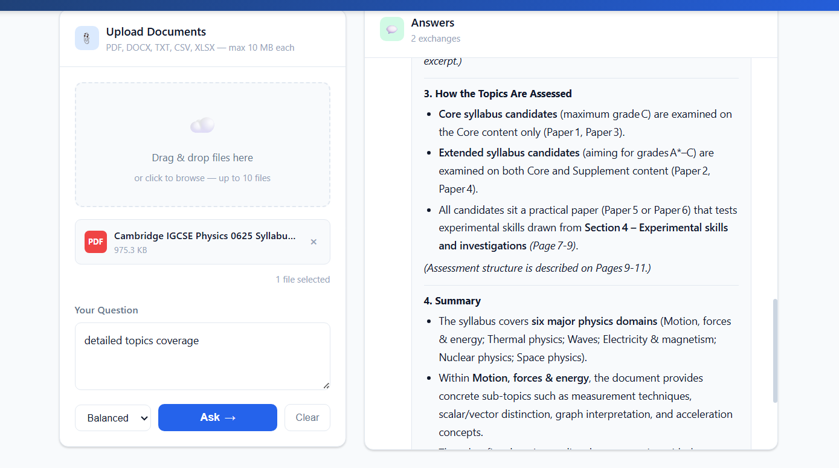

Fetching information from multiple files
