Load NO2 data for 2019 and 2020, calculate NO2 difference between 2019 and 2020, and export data as GeoTIFF.

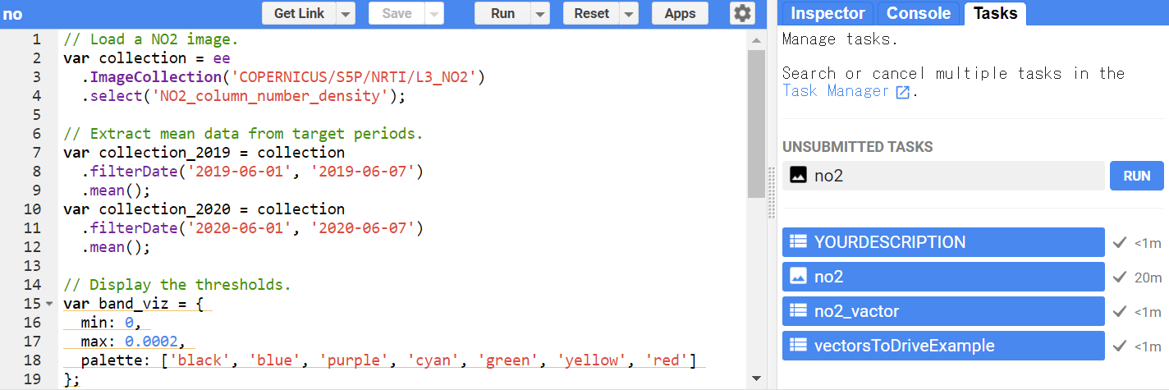

// Load a NO2 image.

var collection = ee

.ImageCollection('COPERNICUS/S5P/NRTI/L3_NO2')

.select('NO2_column_number_density');

// Extract mean data from target periods.

var collection_2019 = collection

.filterDate('2019-06-01', '2019-06-07')

.mean();

var collection_2020 = collection

.filterDate('2020-06-01', '2020-06-07')

.mean();

// Display the thresholds.

var band_viz = {

min: 0,

max: 0.0002,

palette: ['black', 'blue', 'purple', 'cyan', 'green', 'yellow', 'red']

};

// Draw on map UI.

Map.addLayer(collection_2019, band_viz, 'S5P N02 2019');

Map.addLayer(collection_2020, band_viz, 'S5P N02 2020');

Map.setCenter(138, 38, 5);

// Calculate NO2 difference between 2019 and 2020.

var diff = collection_2019.subtract(collection_2020);

// Draw on map UI.

Map.addLayer(diff, band_viz, 'S5P N02 2019');

// Export data as GeoTIFF

Export.image.toDrive({

image: diff,

folder: 'earth_engine_dev',

description: 'no2',

fileFormat: 'GeoTIFF',

maxPixels: 1000000000

});