Statistics of Image Regions. Source: https://developers.google.com/earth-engine/guides/reducers_reduce_regions

To get image statistics in multiple regions stored in a FeatureCollection, you can use image.reduceRegions() to reduce multiple regions at once. The input to reduceRegions() is an Image and a FeatureCollection. The output is another FeatureCollection with the reduceRegions() output set as properties on each Feature. In this example, means of the Landsat 7 annual composite bands in each feature geometry will be added as properties to the input features:

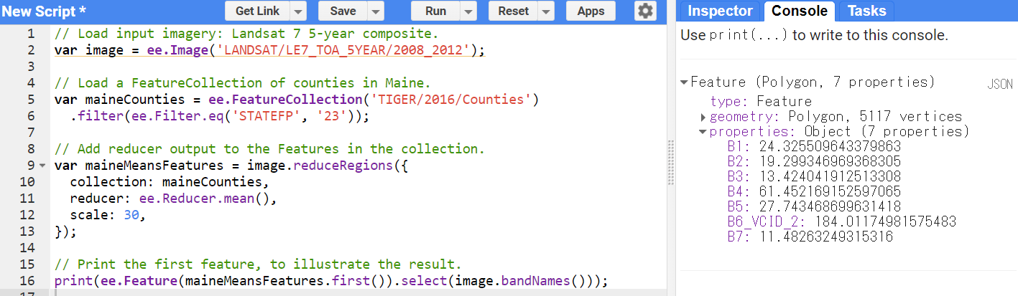

// Load input imagery: Landsat 7 5-year composite.

var image = ee.Image('LANDSAT/LE7_TOA_5YEAR/2008_2012');

// Load a FeatureCollection of counties in Maine.

var maineCounties = ee.FeatureCollection('TIGER/2016/Counties')

.filter(ee.Filter.eq('STATEFP', '23'));

// Add reducer output to the Features in the collection.

var maineMeansFeatures = image.reduceRegions({

collection: maineCounties,

reducer: ee.Reducer.mean(),

scale: 30,

});

// Print the first feature, to illustrate the result.

print(ee.Feature(maineMeansFeatures.first()).select(image.bandNames()));

*Observe that new properties, keyed by band name, have been added to the FeatureCollection to store the mean of the composite in each Feature geometry. As a result, the output of the print statement should look something like:

