**Oasis Infobyte**

**Batch -November Batch**

**Data Science Internship**

**Task 2: Unemployment Analysis in India**

**Intern Name: Sumit Dadarao Ingale**

**UNEMPLOYMENT ANALYSIS WITH PYTHON**

Unemployment is measured by the unemployment rate which is the number of people who are unemployed as a percentage of the total labour force. We have seen a sharp increase in the unemployment rate during Covid-19, so analysing the unemployment rate can be a good data science project

In [1]:

*#Importing all the Libraries*

**import** os

**import** numpy **as** np

**import** pandas **as** pd

**import** matplotlib.pyplot **as** plt

**import** seaborn **as** sns

**import** calendar

**import** plotly.express **as** px

**import** plotly.io **as** pio

pio**.**templates

**import** plotly.graph_objects **as** go

**import** plotly.figure_factory **as** ff

**from** IPython.display **import** HTML

**import** datetime **as** dt

**from** sklearn.cluster **import** KMeans

**import** warnings

warnings**.**filterwarnings('ignore')

C:\Users\User\anaconda3\Lib\site-packages\paramiko\transport.py:219: CryptographyDeprecationWarning: Blowfish has been deprecated

"class": algorithms.Blowfish,

In [2]:

*#Importing the dataset*

df **=** pd**.**read_csv("Unemployment_Rate_upto_11_2020.csv")

In [3]:

df**.**columns **=**["States", "Date", "Frequency", "Estimated Unemployment Rate", "Estimated Employed", "Estimated Labour Participation Rate", "Region", "Longitude", "Latitude"]

In [4]:

*#View Dataset*

df**.**head()

Out[4]:

|  | **States** | **Date** | **Frequency** | **Estimated Unemployment Rate** | **Estimated Employed** | **Estimated Labour Participation Rate** | **Region** | **Longitude** | **Latitude** |
| --- | --- | --- | --- | --- | --- | --- | --- | --- | --- |
| **0** | Andhra Pradesh | 31-01-2020 | M | 5.48 | 16635535 | 41.02 | South | 15.9129 | 79.74 |
| **1** | Andhra Pradesh | 29-02-2020 | M | 5.83 | 16545652 | 40.90 | South | 15.9129 | 79.74 |
| **2** | Andhra Pradesh | 31-03-2020 | M | 5.79 | 15881197 | 39.18 | South | 15.9129 | 79.74 |
| **3** | Andhra Pradesh | 30-04-2020 | M | 20.51 | 11336911 | 33.10 | South | 15.9129 | 79.74 |
| **4** | Andhra Pradesh | 31-05-2020 | M | 17.43 | 12988845 | 36.46 | South | 15.9129 | 79.74 |

In [5]:

*#View Shape of Dataset*

df**.**shape

Out[5]:

(267, 9)

In [6]:

*#View Size of Dataset*

df**.**size

Out[6]:

2403

**Exploratory Data Analysis**

In [7]:

df**.**info()

<class 'pandas.core.frame.DataFrame'>

RangeIndex: 267 entries, 0 to 266

Data columns (total 9 columns):

# Column Non-Null Count Dtype

--- ------ -------------- -----

0 States 267 non-null object

1 Date 267 non-null object

2 Frequency 267 non-null object

3 Estimated Unemployment Rate 267 non-null float64

4 Estimated Employed 267 non-null int64

5 Estimated Labour Participation Rate 267 non-null float64

6 Region 267 non-null object

7 Longitude 267 non-null float64

8 Latitude 267 non-null float64

dtypes: float64(4), int64(1), object(4)

memory usage: 18.9+ KB

In [8]:

df**.**describe()

Out[8]:

|  | **Estimated Unemployment Rate** | **Estimated Employed** | **Estimated Labour Participation Rate** | **Longitude** | **Latitude** |
| --- | --- | --- | --- | --- | --- |
| **count** | 267.000000 | 2.670000e+02 | 267.000000 | 267.000000 | 267.000000 |
| **mean** | 12.236929 | 1.396211e+07 | 41.681573 | 22.826048 | 80.532425 |
| **std** | 10.803283 | 1.336632e+07 | 7.845419 | 6.270731 | 5.831738 |
| **min** | 0.500000 | 1.175420e+05 | 16.770000 | 10.850500 | 71.192400 |
| **25%** | 4.845000 | 2.838930e+06 | 37.265000 | 18.112400 | 76.085600 |
| **50%** | 9.650000 | 9.732417e+06 | 40.390000 | 23.610200 | 79.019300 |
| **75%** | 16.755000 | 2.187869e+07 | 44.055000 | 27.278400 | 85.279900 |
| **max** | 75.850000 | 5.943376e+07 | 69.690000 | 33.778200 | 92.937600 |

In [9]:

df**.**corr()

Out[9]:

|  | **Estimated Unemployment Rate** | **Estimated Employed** | **Estimated Labour Participation Rate** | **Longitude** | **Latitude** |
| --- | --- | --- | --- | --- | --- |
| **Estimated Unemployment Rate** | 1.000000 | -0.245176 | -0.073540 | 0.149976 | -0.023976 |
| **Estimated Employed** | -0.245176 | 1.000000 | -0.047948 | -0.113664 | -0.119321 |
| **Estimated Labour Participation Rate** | -0.073540 | -0.047948 | 1.000000 | 0.080372 | 0.397836 |
| **Longitude** | 0.149976 | -0.113664 | 0.080372 | 1.000000 | 0.125895 |
| **Latitude** | -0.023976 | -0.119321 | 0.397836 | 0.125895 | 1.000000 |

In [10]:

df**.**columns

Out[10]:

Index(['States', 'Date', 'Frequency', 'Estimated Unemployment Rate',

'Estimated Employed', 'Estimated Labour Participation Rate', 'Region',

'Longitude', 'Latitude'],

dtype='object')

In [11]:

unemployment_df **=** df[['States','Region','Estimated Unemployment Rate','Estimated Employed','Estimated Labour Participation Rate']]

unemployment **=** unemployment_df**.**groupby(['Region','States'])['Estimated Unemployment Rate']**.**mean()**.**reset_index()

unemployment

Out[11]:

|  | **Region** | **States** | **Estimated Unemployment Rate** |
| --- | --- | --- | --- |
| **0** | East | Bihar | 19.471000 |
| **1** | East | Jharkhand | 19.539000 |
| **2** | East | Odisha | 6.462000 |
| **3** | East | West Bengal | 10.192000 |
| **4** | North | Delhi | 18.414000 |
| **5** | North | Haryana | 27.477000 |
| **6** | North | Himachal Pradesh | 16.065000 |
| **7** | North | Jammu & Kashmir | 16.477778 |
| **8** | North | Punjab | 11.981000 |
| **9** | North | Rajasthan | 15.868000 |
| **10** | North | Uttar Pradesh | 9.737000 |
| **11** | North | Uttarakhand | 11.156000 |
| **12** | Northeast | Assam | 4.856000 |
| **13** | Northeast | Meghalaya | 3.866000 |
| **14** | Northeast | Sikkim | 9.792500 |
| **15** | Northeast | Tripura | 25.055000 |
| **16** | South | Andhra Pradesh | 8.664000 |
| **17** | South | Karnataka | 7.668000 |
| **18** | South | Kerala | 9.434000 |
| **19** | South | Puducherry | 17.942000 |
| **20** | South | Tamil Nadu | 12.187000 |
| **21** | South | Telangana | 6.833000 |
| **22** | West | Chhattisgarh | 7.819000 |
| **23** | West | Goa | 12.167000 |
| **24** | West | Gujarat | 6.376000 |
| **25** | West | Madhya Pradesh | 6.854000 |
| **26** | West | Maharashtra | 7.979000 |

In [12]:

*#Checking whether there is any Missing Values in Dataset*

df**.**isnull()**.**sum()

Out[12]:

States 0

Date 0

Frequency 0

Estimated Unemployment Rate 0

Estimated Employed 0

Estimated Labour Participation Rate 0

Region 0

Longitude 0

Latitude 0

dtype: int64

In [13]:

df**.**isnull()**.**value_counts

Out[13]:

<bound method DataFrame.value_counts of States Date Frequency Estimated Unemployment Rate \

0 False False False False

1 False False False False

2 False False False False

3 False False False False

4 False False False False

.. ... ... ... ...

262 False False False False

263 False False False False

264 False False False False

265 False False False False

266 False False False False

Estimated Employed Estimated Labour Participation Rate Region \

0 False False False

1 False False False

2 False False False

3 False False False

4 False False False

.. ... ... ...

262 False False False

263 False False False

264 False False False

265 False False False

266 False False False

Longitude Latitude

0 False False

1 False False

2 False False

3 False False

4 False False

.. ... ...

262 False False

263 False False

264 False False

265 False False

266 False False

[267 rows x 9 columns]>

In [14]:

df **=** df**.**dropna()

In [15]:

*# Generating heatmap from correlation matrix*

fig,ax**=**plt**.**subplots(figsize**=**(10,6))

sns**.**heatmap(df**.**corr(),annot**=True**)**.**set(title**=**"\n\nHeatmap of correlated value")

plt**.**show()

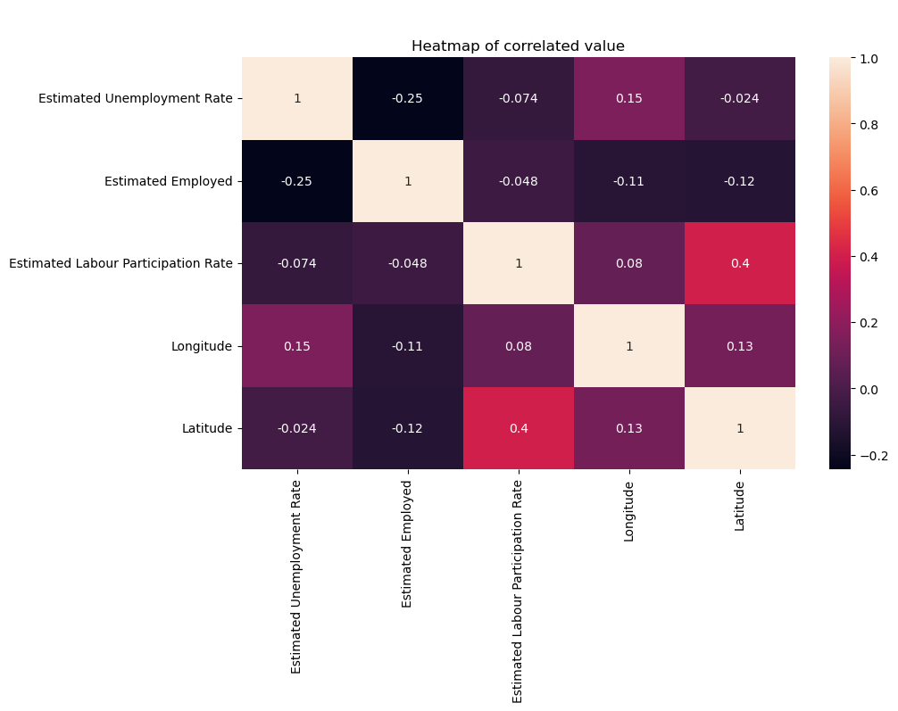

In [16]:

sns**.**pairplot(df)

Out[16]:

<seaborn.axisgrid.PairGrid at 0x1bbfe049e90>

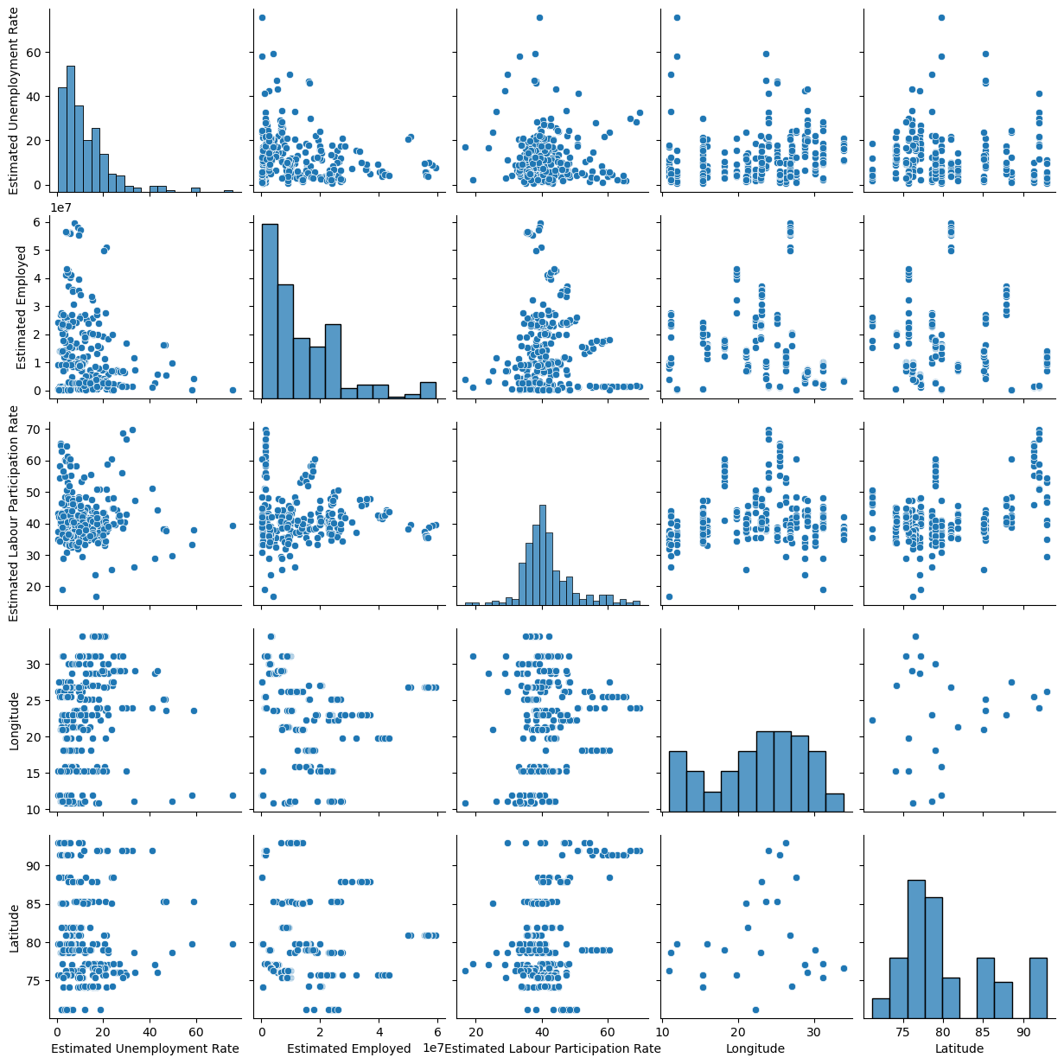

In [17]:

plot_ump **=** df[['Estimated Unemployment Rate','States']]

df_unemp **=** plot_ump**.**groupby('States')**.**mean()**.**reset_index()

df_unemp **=** df_unemp**.**sort_values('Estimated Unemployment Rate')

fig **=** px**.**bar(df_unemp, x**=**'States',y**=**'Estimated Unemployment Rate',color**=**'States',

title**=**'Average Unemployment Rate in each state',template**=**'plotly')

fig**.**show()

In [18]:

*#The below box shows unemployement rate in each state in India*

fig **=** px**.**box(df,x**=**'States',y**=**'Estimated Unemployment Rate',color**=**'States',title**=**'Unemployment rate',template**=**'plotly')

fig**.**update_layout(xaxis**=**{'categoryorder':'total descending'})

fig**.**show()

In [19]:

fg **=** px**.**histogram(df,x**=**'States',y**=**'Estimated Unemployment Rate',color**=**'Region',title**=**'Unemployment rate(State wise)',template**=**'plotly')

fg**.**update_layout(xaxis**=**{'categoryorder':'total descending'})

fg**.**show()

In [20]:

df**.**columns **=**["States", "Date", "Frequency", "Estimated Unemployment Rate", "Estimated Employed", "Estimated Labour Participation Rate", "Region", "Longitude","Latitude"]

plt**.**title("Indian Unemployment")

sns**.**histplot(x**=**"Estimated Employed",hue**=**"Region",data**=**df)

plt**.**show()

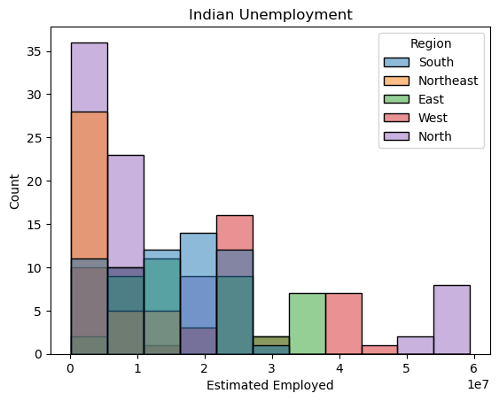

In [21]:

*# Unemployment rate according to different regions of India*

plt**.**figure(figsize**=**(12,10))

plt**.**title("Indian Unemployment")

sns**.**histplot(x**=**"Estimated Unemployment Rate",hue**=**"Region",data**=**df)

plt**.**show()

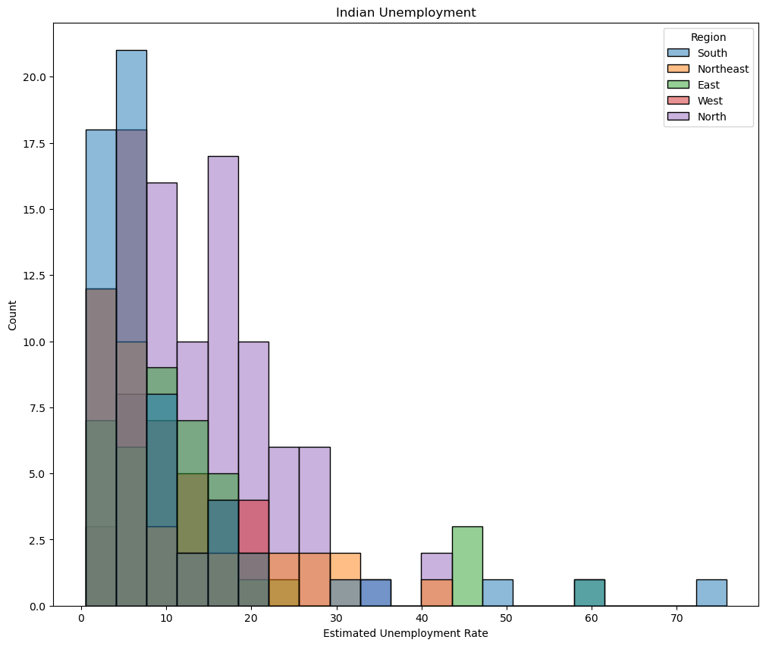

In [22]:

df**.**hist(bins**=**200,figsize**=**[15,8])

plt**.**show()

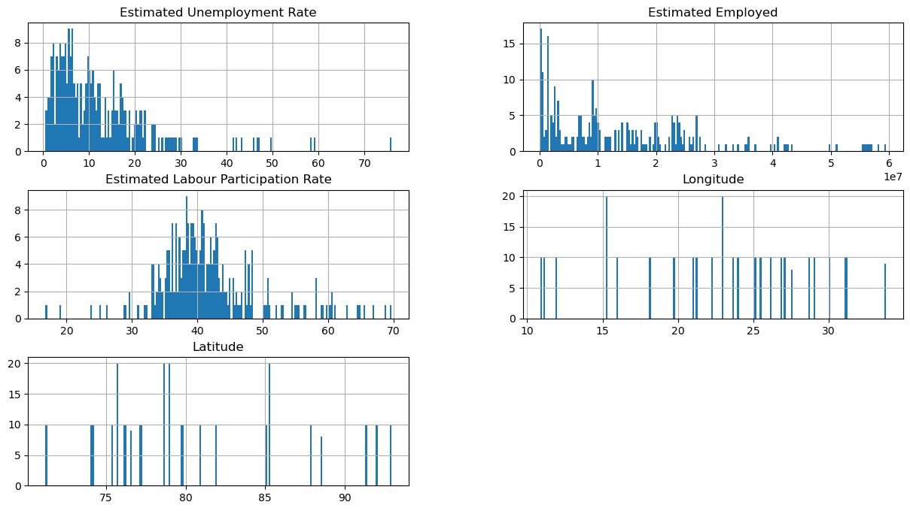

In [23]:

count_by_region**=**df['Region']**.**value_counts()**.**rename_axis('State')**.**reset_index(name**=**'Count')

count_by_region**.**style**.**background_gradient(cmap**=**'Blues')

Out[23]:

|  | **State** | **Count** |
| --- | --- | --- |
| **0** | North | 79 |
| **1** | South | 60 |
| **2** | West | 50 |
| **3** | East | 40 |
| **4** | Northeast | 38 |

In [24]:

sns**.**countplot(y**=**'Region',data**=**df)

Out[24]:

<Axes: xlabel='count', ylabel='Region'>

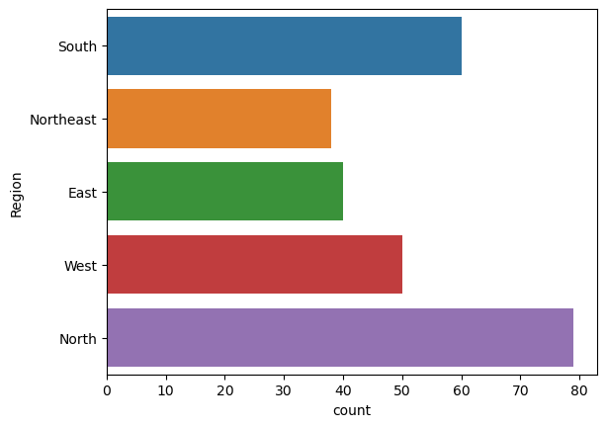

In [25]:

unemployment **=** df[["States","Region","Estimated Unemployment Rate"]]

figure **=** px**.**sunburst(unemployment,path**=**["Region","States"],

values**=**"Estimated Unemployment Rate",

width **=** 700,height**=**700, color_continuous_scale**=**"RdY1Gn",

title**=**"Unemployment Rate in Indian")

figure**.**show()

In [26]:

sns**.**barplot(x**=**"Region",y**=**"Estimated Unemployment Rate",hue**=**"Region",data**=**df)

plt**.**title("Indian Unemployment")

Out[26]:

Text(0.5, 1.0, 'Indian Unemployment')

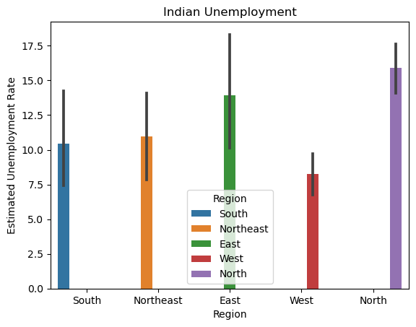

In [27]:

df['Date'] **=** pd**.**to_datetime(df['Date'],dayfirst**=True**)

In [28]:

df['Frequency']**=** df['Frequency']**.**astype('category')

In [29]:

df['Month'] **=** df['Date']**.**dt**.**month

In [30]:

df['Month_int'] **=** df['Month']**.**apply(**lambda** x : int(x))

In [31]:

df['Month_name'] **=** df['Month_int']**.**apply(**lambda** x: calendar**.**month_abbr[x])

In [32]:

df['Region'] **=** df['Region']**.**astype('category')

In [33]:

fig **=** px**.**bar(df, x**=**'Region',y**=**'Estimated Unemployment Rate',animation_frame **=** 'Month_name',color**=**'States',

title**=**'Unemployment rate across region from Jan.2020 to Oct.2020', height**=**700,template**=**'plotly')

fig**.**update_layout(xaxis**=**{'categoryorder':'total descending'})

fig**.**layout**.**updatemenus[0]**.**buttons[0]**.**args[1]["frame"]["duration"] **=** 2000

fig**.**show()

In [34]:

fig **=** px**.**scatter_matrix(df,template**=**'plotly',

dimensions**=**['Estimated Unemployment Rate','Estimated Employed',

'Estimated Labour Participation Rate'],

color**=**'Region')

fig**.**show()

In [35]:

**import** geopandas **as** gpd

*# initialize an axis*

fig, ax **=** plt**.**subplots(figsize**=**(8, 6))

*# plot map on axis*

countries **=** gpd**.**read_file(gpd**.**datasets**.**get_path("naturalearth_lowres"))

countries[countries["name"] **==** "India"]**.**plot(color**=**"green", ax**=**ax)

*# parse dates for plot's title*

first_month **=** df["Estimated Employed"]**.**min()

last_month **=** df["Estimated Employed"]**.**max()

region_df **=** df**.**groupby('Region')**.**sum()

*# plot points*

df**.**plot(x**=**"Latitude", y**=**"Longitude", kind**=**"scatter",

title**=**f"Unemployment Rate In India(Covid)",

ax**=**ax, s**=**10,color**=**'cyan')

ax**.**grid(visible**=True**, alpha**=**1)

plt**.**show()

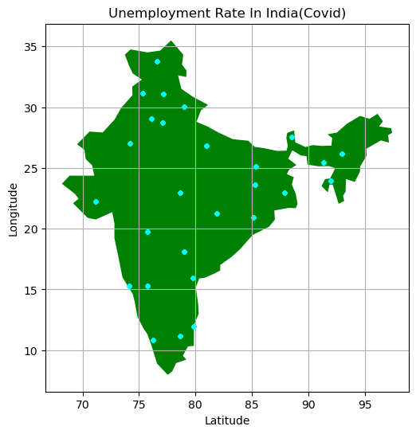

In [36]:

region_df **=** df**.**groupby('Region')**.**sum()

fig, ax **=** plt**.**subplots(figsize**=**(20, 8))

ax**.**pie(region_df['Estimated Unemployment Rate'], labels**=**region_df**.**index, autopct**=**'%1.1f%%', startangle**=**90,textprops**=**{'fontsize':8})

ax**.**legend(loc**=**'upper right', labels**=**[f'{l}: {s}' **for** l, s **in** zip(region_df, region_df['Estimated Unemployment Rate'])], prop**=**{'size': 5})

ax**.**set_title('Employment Distribution by Region')

plt**.**show()

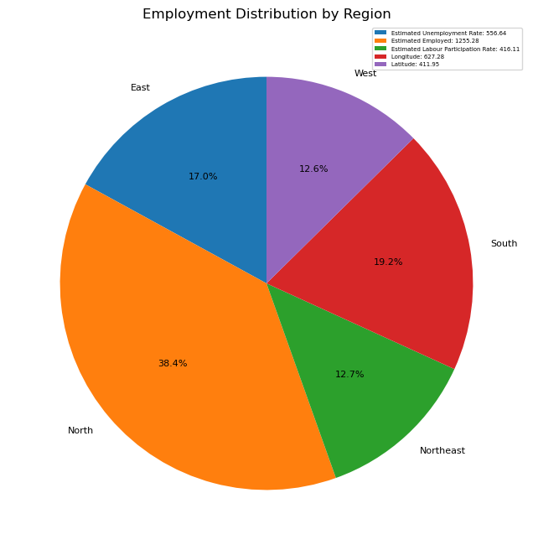

In [37]:

*# Group data by region and date*

grouped_df **=** df**.**groupby(["Region","Date"])**.**sum()

*# Create the stacked bar chart*

fig, ax **=** plt**.**subplots(figsize**=**(15,8))

grouped_df["Estimated Unemployment Rate"]**.**unstack()**.**plot**.**bar(stacked**=True**, ax**=**ax)

*# Label the plot*

ax**.**set_ylabel("Estimated Unemployment Rate")

ax**.**set_xlabel("Date")

plt**.**title('Estimate Unemployment rate in 2019 by Months')

*# Arrange legend to the right upper corner*

ax**.**legend(title**=**"Date", loc**=**'upper left', bbox_to_anchor**=**(1,1))

*# Show plot*

plt**.**show()

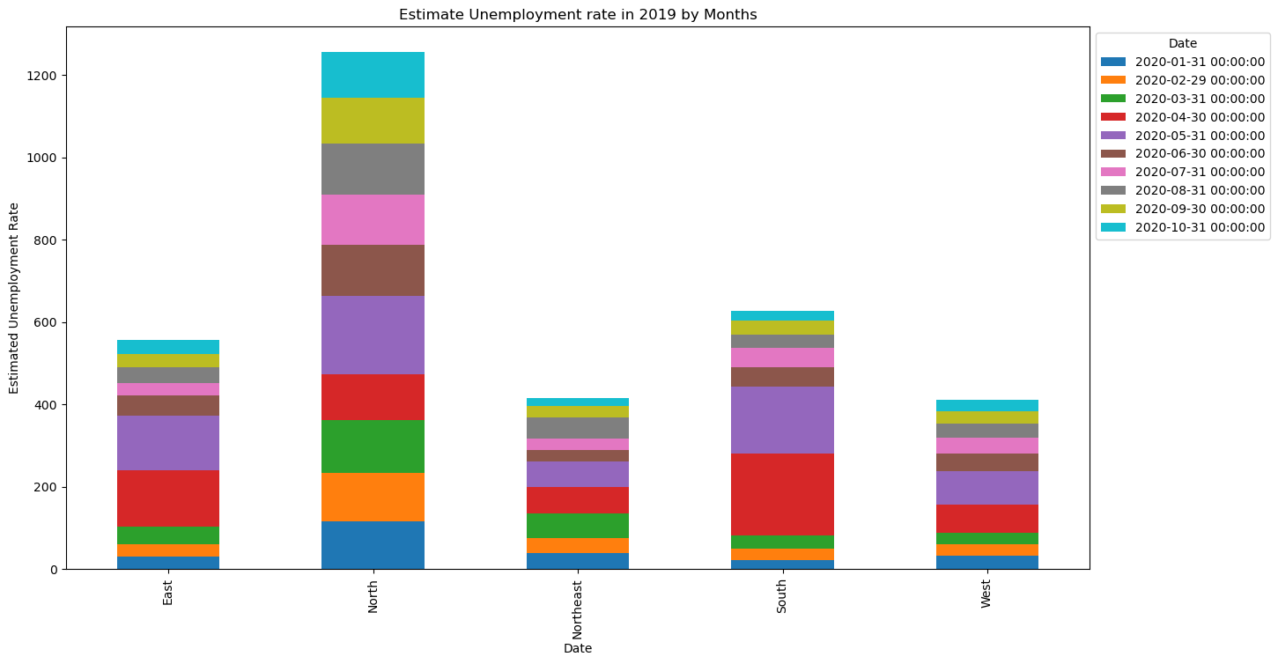

In [38]:

fig **=** plt**.**figure(figsize **=** (9, 6))

sns**.**lineplot(y**=**"Estimated Unemployment Rate", data**=**df, x**=**'Date',hue**=**"Region")

plt**.**title("Unemployment according to Dates in different Regions")

plt**.**xticks(rotation**=**90)

plt**.**show()

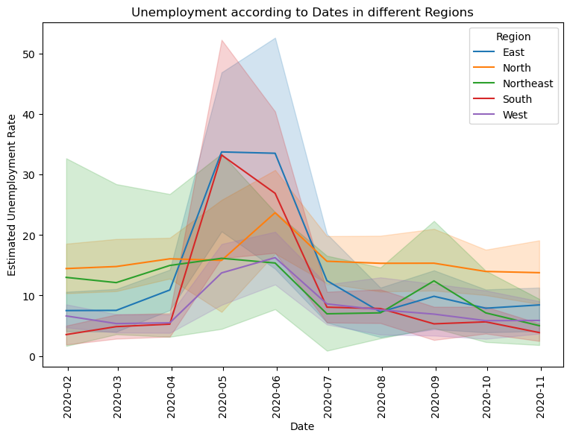

In [39]:

fig **=** plt**.**figure(figsize **=** (9, 7))

sns**.**lineplot(y**=**"Estimated Labour Participation Rate", data**=**df, x**=**'Date',hue**=**"Region")

plt**.**title("Unemployment according to Dates in different Regions")

plt**.**xticks(rotation**=**90)

plt**.**show()

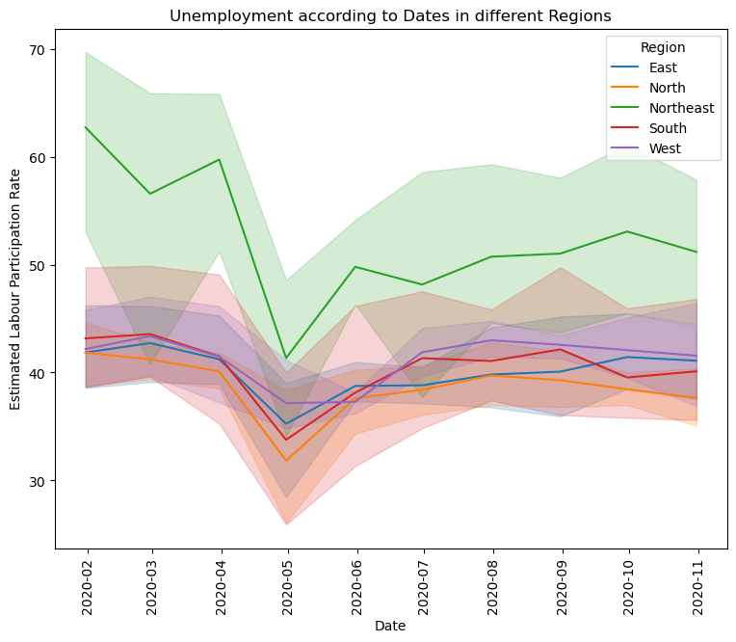

In [40]:

fig **=** plt**.**figure(figsize **=** (9, 6))

sns**.**lineplot(y**=**"Estimated Employed", data**=**df, x**=**'Date',hue**=**"Region")

plt**.**title("Unemployment according to Dates in different Regions")

plt**.**xticks(rotation**=**90)

plt**.**show()

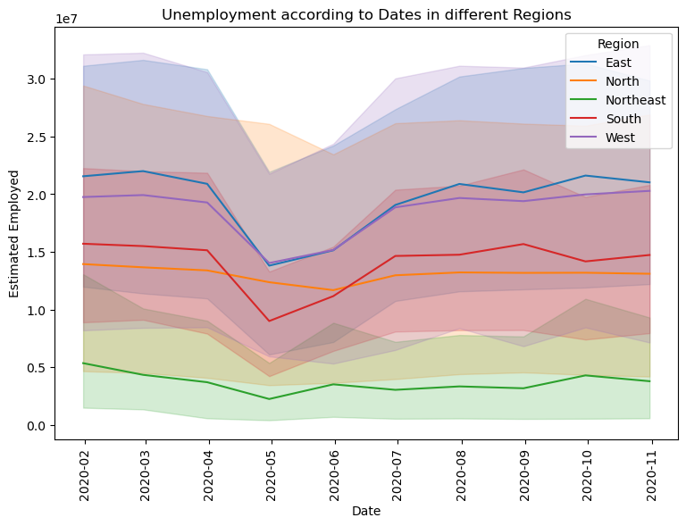

In [ ]: