Links to videos featuring people of determination discussing their views on self-employment

1. [Exploring Self-Employment Opportunities for Persons with Developmental Disabilities - YouTube](https://www.youtube.com/watch?v=PsF9fs5DFIc)
2. [Why Self-Employment Is A Good Option for Disabled or Chronically Ill People | Lucy's Light - YouTube](https://www.youtube.com/watch?v=a1q0lK40NFg)

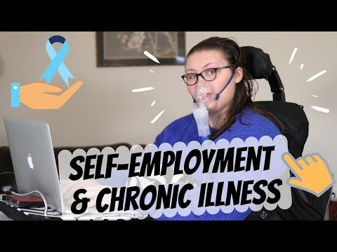

1. [Becoming Self-Employed: My Journey [Video Series] | Lucy's Light - YouTube](https://www.youtube.com/watch?v=otTR3SbgIP8)

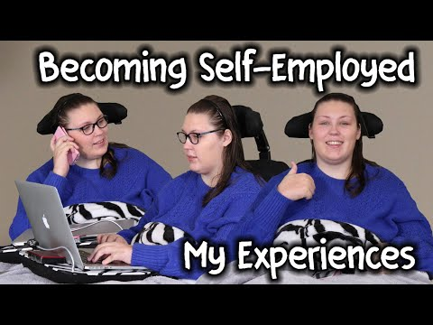

1. [Is employment equality working for disabled people? - YouTube](https://www.youtube.com/watch?v=202B9OiaXwo)

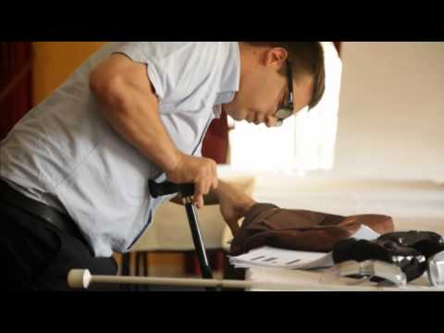

1. [Successful Self-Employment & Entrepreneurship for People with Disabilities - YouTube](https://www.youtube.com/watch?v=quLMxoVhZPM)

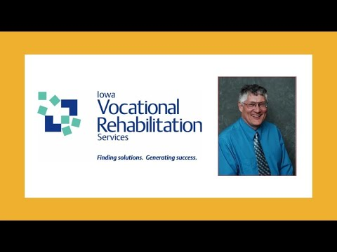

1. [WHY I'D RATHER BE SELF-EMPLOYED | RoyJonesOnWheels - YouTube](https://www.youtube.com/watch?v=1BSsrwSI__M)

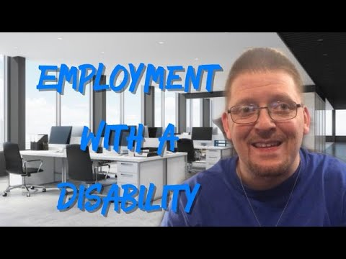

1. [Helping People with Disabilities Become Working Artists - YouTube](https://www.youtube.com/watch?v=_vSvWRMzSz4)

