**TERM PAPER/SEMINAR**

**On**

**Title:** **Convergence of Nanotechnology with Modern Biology and Medicine**

**Submitted to**

**Amity University, Noida**

**Guided By:**

**Ms. Shilpa Skukla**

**Submitted By:**

**Sumir Srivastava**

**A2305219685**

**AMITY UNIVERSITY UTTAR PRADESH**

**GAUTAM BUDDHA NAGAR**

# Declaration by the student

I, ……………………….., student of b.tech (….) Hereby declare that the project titled “……………………………………………..” Which is submitted by me to department of…………………………….(if applicable), name of the institute, noida, amity university uttar pradesh, in partial fulfillment of requirement for the award of the degree of bachelor of technology (….), has not been previously formed the basis for the award of any degree, diploma or other similar title or recognition. The author attests that permission has been obtained for the use of any copy righted material appearing in the report other than brief excerpts requiring only proper acknowledgement in scholarly writing and all such use is acknowledged.

Signature

Noida

Date:

**CERTIFICATE**

On the basis of report submitted by Name of student, student of B.Tech ( ), I hereby certify that the report “Convergence of Nanotechnology with Modern Biology and Medicine” which is submitted to Department of Computer Science Engineering, Amity School Of Engineering And Technology, Amity University Uttar Pradesh in partial fulfilment of requirement for the award of the degree of Bachelor of Technology (-) is an original contribution with existing knowledge and faithful record of work carried out by him/her under my guidance and supervision.

To the best of my knowledge this work has not been submitted in part or full for any Degree or Diploma to this University or elsewhere.

Date

Name of Guide

Department

**Acknowledgement**

The satisfaction that accompanies that the successful completion of any task would be

incomplete without the mention of people whose ceaseless cooperation made it possible, whose constant guidance and encouragement crown all efforts with success. I would like to thank Prof (Dr) Name, Head of Department-CSE, and Amity University for giving me the opportunity to undertake this project. I would like to thank my faculty guide Ms Faculty Name who is the biggest driving force behind my successful completion of the project. She has been always there to solve any query of mine and also guided me in the right direction regarding the project. Without her help and inspiration, I would not have been able to complete the project. Also, I would like to thank my batch mates who guided me, helped me and gave ideas and motivation at each step.

**Sumir Srivastava**

# INDEX

Contents

INDEX 1

Abstract 2

Introduction 3

Nanoparticles and their Types 4

Nanotechnology Tools in Medicine 5

Nanoparticulate Drug Delivery Systems 6

Algorithm for Medical Nanobots 8

Flow chart of a Medical Nanobot performing operation on cells 9

Basic C++ Programming for Nanobot Functions 10

Result 12

Conclusion 13

References 14

# Abstract

Nanotechnology is an ever-extending innovation with an immense capacity in significant fields of the cutting-edge or modern sciences. This paper investigates how standards of nanotechnology and profoundly designed nanodevices can help fix different sicknesses without leaving any symptoms or blunders in treatment. In this paper, we will concentrate on how Nanotechnology can fix malignant growth and different diseases. This paper likewise investigates how these nanodevices might be made and how a sheltered and productive drug delivery framework for the human body can be planned and executed and by improving is it than the conventional techniques. We will likewise create a stream outline delineating the course of a nanobot swarm performing procedure on tissues and cells and will likewise attempt to code some essential projects identified with the working and activity of the nanobot swarms inside the human body utilizing C++.

Keywords: nanotechnology, nano-device, drug delivery, nanobot swarm

Convergence of Nanotechnology with Modern Biology and Medicine

# Introduction

Authored by Tokyo science college teacher Norio Taniguchi, Nanotechnology is the investigation of nano measured articles (things that are around 100 nanometres over) and making gear dependent on it. Nanotechnology is viewed as a developing innovation since its disclosure in 1959 at an American Physical Society discussion held at Caltech. Anyway, nanostructured metals were in presence even before the cutting-edge time. Premodern models incorporate Lycurgus Cup from the mid-fourth century, energetic recoloured glass windows in European houses of God (south rose window of Notre Dame) and the sabre sharp edges from Damascus. Because of expanded logical comprehension and experimentation in the cutting-edge time, new degrees of improvement in nanotechnology were being watched. Michael Faraday discovered colloidal "ruby" gold, showing that nanostructured gold under specific degrees of light delivers distinctive shaded arrangements.“Louis Brus, a researcher from ringer labs uncovered that colloidal semiconductor nanocrystals which are otherwise called quantum dabs, for which he was granted the 2008 Kavli Prize in Nanotechnology. Wear Eigler and Erhard Schweizer, scientists at IBM's Almaden Research Centre worked 35 unmistakable xenon iotas to explain the IBM logo”. This presentation of the capacity to correctly work on molecules prompted the applied utilization of nanotechnology.

Nanotechnology has likewise supported the assembling of bio-chips and has a crucial part in green assembling (for example bio-similarity and bio-multifaceted nature viewpoints). Different usage has included the plan of instruments for space travellers and militaries, bio-ﬂuidics (for taking care of DNA and different atoms), in vitro treatment of steers, ﬁltration frameworks and detectability of hereditarily modiﬁed food.

Analytical degrees for nanotechnology will incorporate examination into the condition or potentially fix of the cerebrum and different zones for recovering discernment. It may likewise ﬁnd its use in structuring pharmaceuticals as an element of patient genotypes and in spreading synthetics to invigorate creation as a component of plant genotypes. The assembling of increasingly fruitful and biodegradable synthetic compounds for cultivating and farming and the creation of implantable sensors could be upheld by nanotechnology. Using this innovation, it should likewise be conceivable to create propelled techniques that can be utilized to recognize diseases utilizing human spit rather than blood.

The goal of nanotechnology may be characterized as the capacity to amass particles and convert them into matter of critical use, on a level plane and vertically along a few length scales, and to dismantle them changing over them once again into atoms. It is anticipated that nanotechnology can have a huge constructive outcome on human prosperity. Applicable movements of living life forms happen for the most part at the nanometre scale, rudimentary natural segments like DNA, proteins or cell layers are of this measurement. By the methods for nanotechnology, these natural segments will be better seen with the goal that they can be accurately guided or locked in.

# Nanoparticles and their Types

Different kinds of nanoparticles were made by gathering various atoms at the nanoscale. Each of the nanoparticles recorded has an extremely definite reason since they are made particularly and have explicit properties dependent on their globular structure and the nearness of inward holes. These, one of a kind properties might be utilized to make nano-sized ships, which because of their size would not be perceived by the human body and could undoubtedly travel through the cell films and go through the blood obstructions. They could convey high potential objective drugs in their inner cavities, accurately to its goal.   
  
• Quantum Dots   
  
Quantum dots are semiconductor nanocrystals with rich fluorescent property. They have remarkable optical and microelectronic properties that can be precisely adjusted by changing their measurements and arrangement, because of their exceptionally little size (2-10 nm). Because of their relatively minimal effort and basic combination, quantum dots are now being utilized for exploratory biomedical imaging applications. Quantum dots can be adjusted to transmit light at any frequency in the obvious and infrared ranges and can be embedded anyplace, including fluid arrangement like colours and so on. Quantum dots can be connected to an assortment of surface ligands and infused into an assortment of natural creatures for examination.   
  
• Carbon Nanotubes   
  
Carbon nanotubes of the distance across of 1-20 nm are nano-scale winding reverberating cylinders made out of carbon iotas. In any case, respected inorganic nanowires, they show shocking electric, optical, electronic, mechanical and warm properties, giving the electrical and electronic industry properties that couple of materials stages would never coordinate against. Carbon nanotubes, attractive iron oxide nanoparticles and gold-covered silica nano-shells can change over electro-attractive vitality into heat, causing a temperature increment that has the ability to murder malignant growth cells just by expanding the attractive field or by direct radiation with an outside laser wellspring of close infra-red frequency at the very position where these nanoparticles are focused on or straight inside tumour cells   
  
• Dendrimers   
  
Dendrimers are mind-boggling practically round macromolecules with measurement 1-10 nm. They have improved physical, concoction, and natural properties contrasted with the rest of the natural polymers. Some uncommon properties are identified with their round shape and the presence of inner voids offering the open door as restorative nano vehicles. Dendrimers have branches like a tree where an assortment of particles, including drugs can be appended toward the finish of the branches. Since they are under 5 nm in distance across, dendrimers are sufficiently little to sneak past open pores of cell layers and to go through tissues in a more effective manner than bigger polymer particles.   
  
Nanoparticles are the essential thing units of nanotechnology. The nanodevices can be made to communicate with cell layers and tissues at a quantum level, with a high level of utilitarian claim to fame, in this manner permitting a gigantic level of blend among innovation and organic frameworks that were not beforehand reachable. These nanoparticles can't fill in as drug/DNA delivery framework alone. They must be worked at the sub-atomic level to change over them into appropriate nanodevices or apparatuses that at that point can be utilized.

# Nanotechnology Tools in Medicine

Other propelled uses of small scaled nanotechnology in medication are microchip-based drug delivery frameworks, which are gadgets that incorporate micrometre scale siphons, valves and stream channels. Permit controlled arrival of at least one wanted drugs. Smaller-scale and nanotechnology-based techniques (e.g., UV-photolithography, particle carving, compound responses, electron pillar vanishing) can be utilized in the plan of these structures for silicon creation. There are various investigations accessible that utilization smaller scale and nanotechnologies on-chip particles for the conclusion of clinical atoms. Significant key models are DNA microarrays (quality chips), protein Micro (protein chips), lab-on-a-chip gadgets and cell chips. Fundamentally, these gadgets or frameworks are fabricated utilizing procedures roused from miniaturized scale/nanoscale manufactured techniques, utilized for preparing, control, delivery, investigation or working of natural and synthetic materials. Inkjet printing procedures are utilized by Microsoft microarrays in human genomics and protein microarrays (or proteins), valuable for sub-atomic testing. The accompanying investigation discoveries might be either fluorescence-or radionuclide-based markers or plasmon reverberation spectroscopy.   
  
To learn and assess these rich and complex frameworks, genuinely necessary test apparatuses, hypothetical instruments and models are required. Specifically, perception, perception, and engineered gadgets and gadgets require complex estimation methods and quantitative systems in spatial and fleeting arrangements at the request for 10-6 micron (red cell is 7 microns) and underneath to the phone level. Also, these methodologies are significant so as to comprehend the relationship and communication among nanoscopic and mesoscopic/naturally visible scales, a significant goal of organic and restorative applications. In that capacity, nanotechnological progress will require a reliable continuation of these flagging procedures.

# Nanoparticulate Drug Delivery Systems

While utilizing nanoparticle restorative items (NPM) is the utilization of the essential rules that as of now exist in the therapeutic item advertise like DoxilTM and AbraxaneTM (utilized nanotechnology to fix bosom malignant growth) There are some fundamental rules that are thought of:   
• Nanospheres and nano cases since it's the most popular and the most open strategy for drug transportation.   
• Use of nanoparticles covered with hydrophilic polymers, for example, polyethene glycol for simple entry and transference to the drug site.   
• Use of a biodegradable centre and a polymer envelope. The greater part of the exploration currently depends on this guideline.   
  
Traditional chemotherapy utilizes drugs that are designed to murder the disease cell adequately. Be that as it may, these cytotoxic drugs slaughter numerous sound, working cells notwithstanding the tumour cells which prompts a few reactions, for example, sickness, balding, neuropathy, weakness and an undermined resistant framework. Thus, on the off chance that we use nanoparticles as the drug transporters for chemotherapeutics, they can convey prescription straightforwardly to the tumour, saving the sound tissues. Nanocarriers additionally have a few additional favourable circumstances over traditional chemotherapy. They incorporate –   
• Drugs are not debased before they arrive at their objective since they are typified inside the nanospheres.   
• Enhanced drug retention into tumours and carcinogenic cells themselves.   
• They permit better command over the adequacy of the drugs for oncologists.

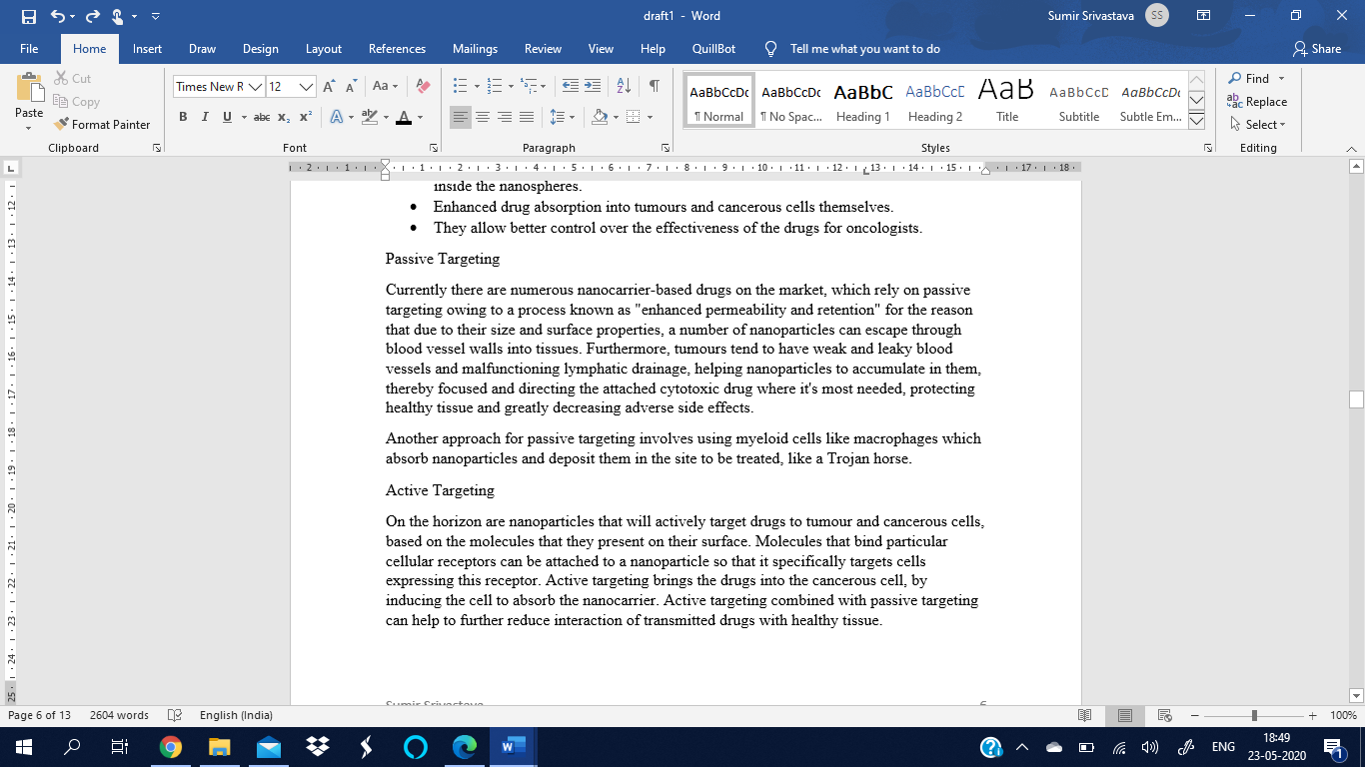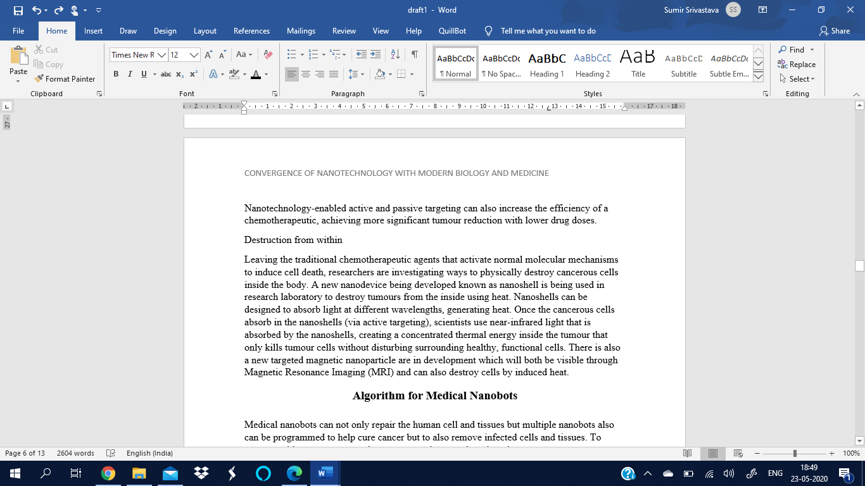

# Algorithm for Medical Nanobots

Clinical nanobots can fix the human cell and tissues as well as can be customized to help fix malignancy yet to likewise expel contaminated cells and tissues. To robotize this procedure, we need a program to distinguish and take a shot at it.

Special nanobots can be designed for a specific function. Not all nanobots perform the same function e.g. spherical nanobots with internal cavities can be used to carry and deliver the drug to the target site. Nanobots cannot function on their own unless they follow operational methodology of drugs they are meant to replace. So, they are given a certain set of instructions and principles so they can be sensitively be guided for their procedure. They can also be programmed with artificial intelligence to automatically detect the injury/ infected tissue and deliver drugs/ perform operation.

Hence, we here are setting an algorithm for nanobots to follow to perform basic functions and also tend to their own components. All the vital operations like navigation and clean-up to the tiny function like tilting and deviation of the nanobots can be controlled by programs.

Below is a flowchart describing the process of automated nanobots when they are first injected in a human body till the time they are deactivated and remain dormant in the human body acting as artificial white blood cells or getting ejected when the operation is completed. This flowchart displays the cell/tissue repair system of nanobots. They move within provided limits and function on the basis of the condition. In the case of any malfunction, the nanobot swarms can be controlled manually outside the body with the help of a nano solenoid.

# Flow chart of a Medical Nanobot performing operation on cells

# Basic C++ Programming for Nanobot Functions

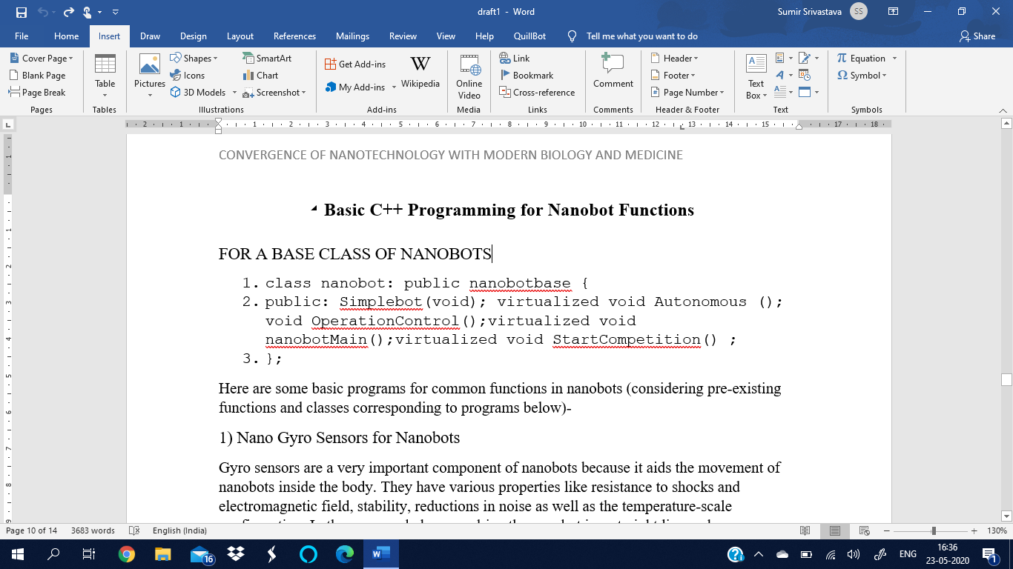FOR A BASE CLASS OF NANOBOTS

Here are some basic programs for common functions in nanobots (considering pre-existing functions and classes corresponding to programs below)-

1) Nano “Gyro Sensors” for Nanobots

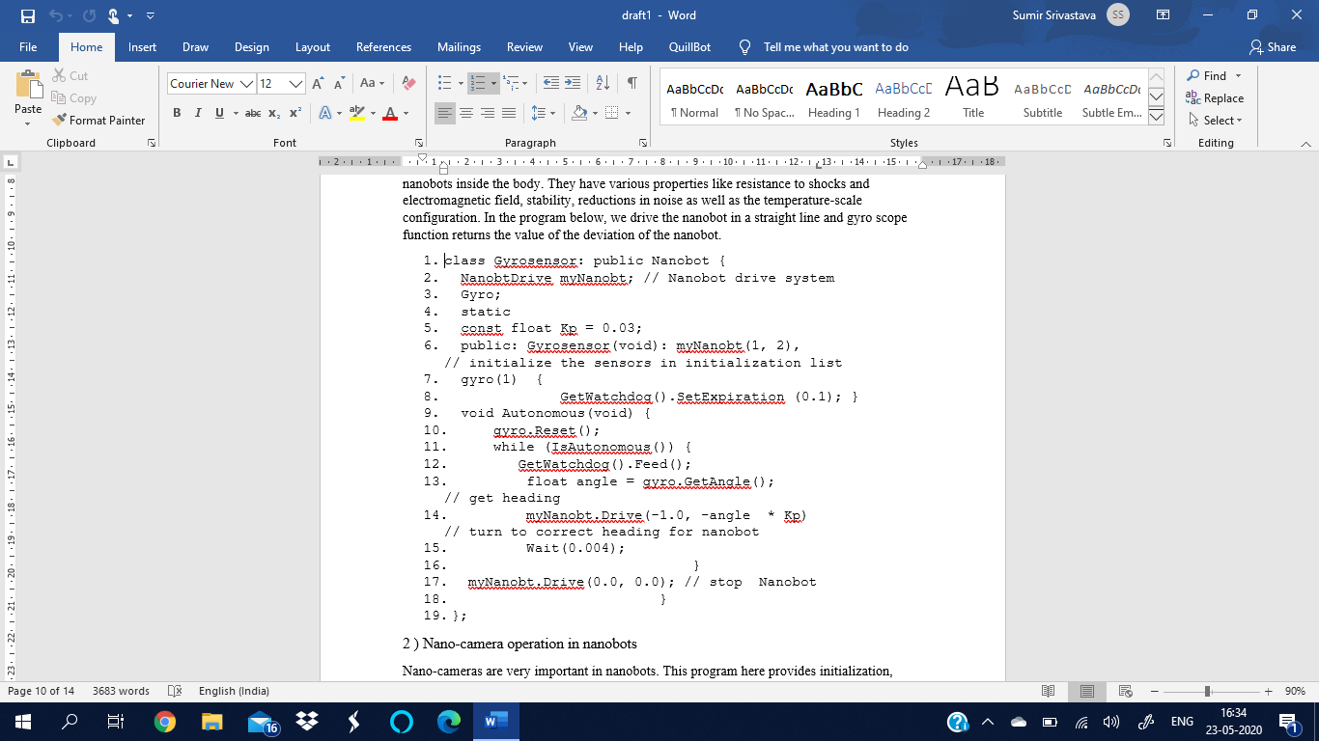Gyro sensors are a very important component of nanobots because it aids the movement of nanobots inside the body. They have various properties like resistance to shocks and electromagnetic field, stability, reductions in noise as well as the temperature-scale configuration. In the program below, we drive the nanobot in a straight line and gyro scope function returns the value of the deviation of the nanobot.

2 ) Nano-camera operation in nanobots

Nano-cameras are very important in nanobots. This program here provides initialization, control and image capturing functionality.

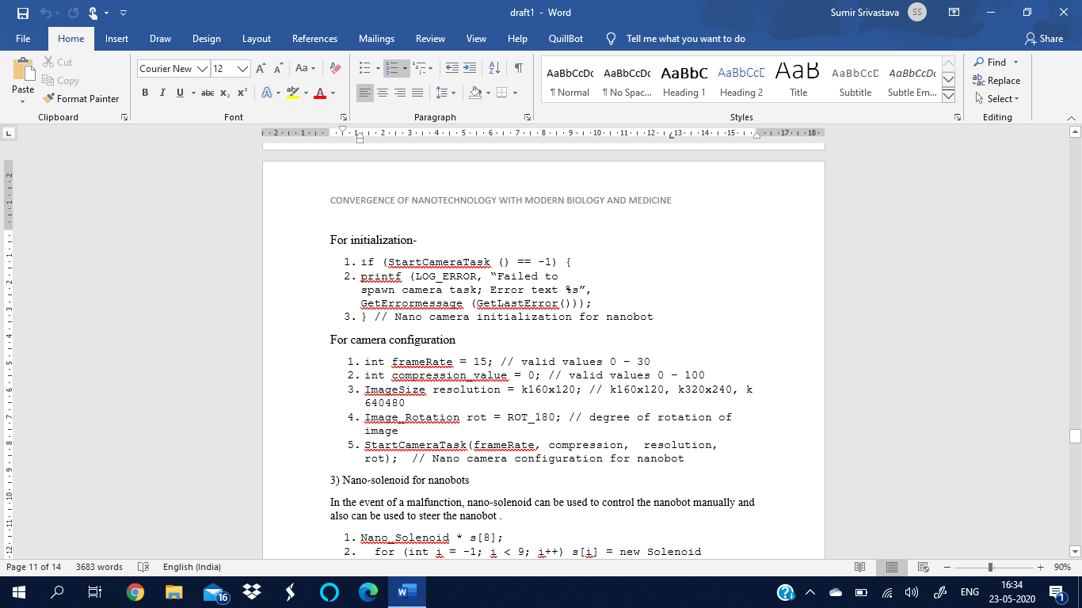For “initialization”-

For “camera configuration”



3) Nano-solenoid for nanobots

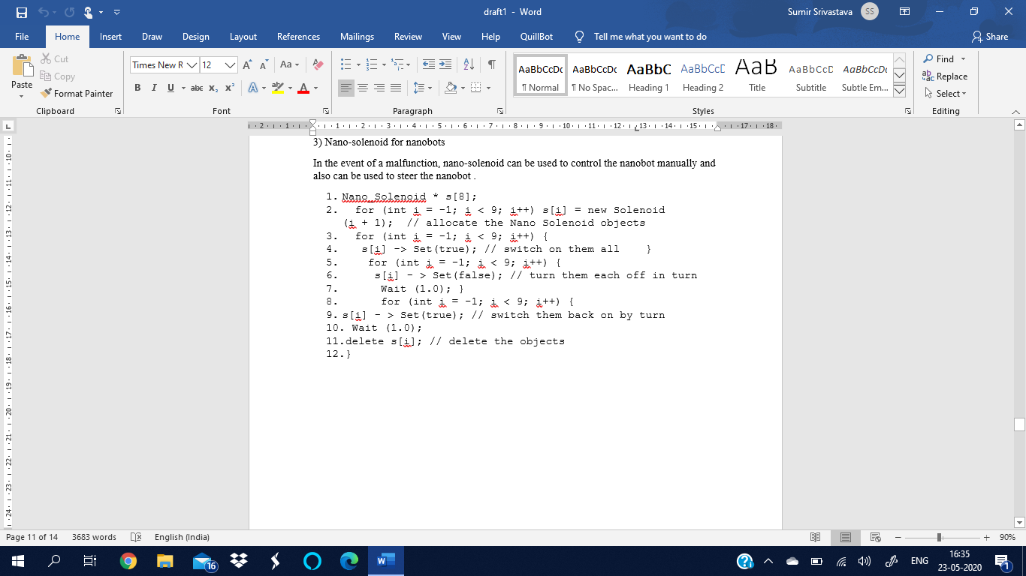In the event of a malfunction, nano-solenoid can be used to control the nanobot manually and also can be used to steer the nanobot .

# Result

Creation, advancement and the activity of nano bio-clinical robot swarms was concentrated in this paper. Nanoparticles existing in nature and man-made were additionally talked about. Any nanodevice can be made by collecting fundamental nanoparticles like dendrimers, carbon nano-cylinders or quantum dots, each having its particular reason. Nanobots can be utilized as a sheltered and productive drug delivery framework was additionally concentrated in this paper. A stream outline was likewise built to involve the fundamental nanobot activity inside the human body. Projects identified with the capacity and the utilization of nanobot swarms like strength, camera and nano-solenoid was formulated from a fundamental calculation by the utilization of C++ programming language. Since nanotechnology is an exceptional field, numerous progressions like those remember for the paper are being developed.

# Conclusion

Nanotechnology to be utilized in present-day science and medication is still in starting stages. Be that as it may, can enormously affect the advanced sciences in the 21st century. Because of the headway in nanomedical advancement, there has been a colossal advancement in understanding our natural highlights and structures. There are as of now 50 nano drugs affirmed by the food and drug organization (FDA). The vision is to make a productive and safe nanodevices and nanobots to improve wellbeing. Increment in the creation of the nanoparticles will prompt the advancement of more nano-gadgets and henceforth more nanorobot swarms. Enhancing the pre-set calculations to program nanodevices can likewise prompt improved measurements and upgraded nanorobotics. Headways on this likewise open the entryway for energizing new open doors for AI investigate, reusing and improving to reform the way to deal with the advancements of clinical medicines. Billion-dollar pharmaceutical organizations are building up the programmable nanobots for a restrictive and individual treatment that can be customized or custom-made to anybody's very own needs. It can fill in as an independent field in clinical research or can converge with significantly greater fields like AI and man-made consciousness for much further developed research that can't be yet fathomed.   
  
Since nanotechnology is a cutting-edge field, numerous headways like those remember for the paper are being developed. The greater part of the advancement is hypothetical however work and research are continually being finished by most significant nations of the world. It is said to alter the clinical field and can totally change the manner in which we work or even grasp the human body. It is said that it will end the wellbeing emergency and lead to the development of the up and coming age of the human species. Despite the fact that it is an old field, a large number of significant improvements in this field are yet to come.

# References

1. Patrick Boisseau, Bertrand Loubaton. *Nanomedicine, Nanotechnology in medicine*. Comptes rendus hebdomadaires des séances de l’Académie des sciences, Elsevier, 2011. hal-00598930
2. Bachrach et al., 2010] Jonathan Bachrach, Jacob Beal, and James McLurkin. *Composable continuous-space programs for robotic swarms. Neural Computing and Applications*, 19:825–847, 2010
3. Mitra M. *Algorithm for Medical Nanobots using C++*. Adv Comput Sci. 2018;1(3):112
4. Roco, Mihail C. "Nanotechnology: convergence with modern biology and medicine." *Current opinion in biotechnology* 14.3 (2003): 337-346.
5. Wiesel-Kapah, Inbal, et al. "*Rule-Based Programming of Molecular Robot Swarms for Biomedical Applications*." *IJCAI*. 2016.
6. Logothetidis, S. "Nanotechnology in medicine: the medicine of tomorrow and nanomedicine." *Hippokratia* 10.1 (2006): 7-21.