Smart Hospital Patient Monitoring

& Bed Allocation System

Project Report
Group Members:

[Member 1 Name] - [Student ID]
[Member 2 Name] - [Student ID]
[Member 3 Name] - [Student ID]

Course Name: [Your Course Name]
Instructor: [Instructor Name]
Date of Submission: August 2026

Table of Contents
Chapter 01: Introduction
1.1 Problem Statement and Objectives
1.2 Question Scenario
1.3 Real Life Scenario
1.4 Learning Objectives

Chapter 02: System Design
2.1 System Overview
2.2 Architectural Design (MVC Pattern)
2.3 Routing
2.4 Diagrams (ER Diagram, Class Diagram)
2.5 Technologies and Tools Used

Chapter 03: Code Implementation
3.1 Overview (Model-View-Controller)
3.2 Database Connection (ORM / Entity Framework)
3.3 Database Structure
3.4 Key Models and Implementation Steps
3.5 Important Classes and Methods (CRUD Operations)

Chapter 04: Testing and Evaluation
4.1 Screenshots
4.2 Test Cases

Chapter 05: Challenges and Future Improvements
5.1 Challenges Faced
5.2 Future Improvements

References

Introduction

1.1 Problem Statement and Objectives
Problem Statement:
Hospitals and healthcare facilities face significant challenges in managing patient monitoring and bed allocation efficiently. In many hospitals, patient vital signs such as temperature, pulse rate, and oxygen saturation are monitored manually or through disconnected systems. This leads to delayed responses when a patient's condition deteriorates, potentially life-threatening situations where critical patients are not promptly attended to. Additionally, bed allocation is often managed through paper-based or spreadsheet systems, resulting in errors such as assigning critical patients to general wards or failing to sanitize beds within required timeframes. The lack of a centralized, real-time monitoring system creates information gaps between medical staff, reduces operational efficiency, and compromises patient safety.
Objectives:
The primary objectives of the Smart Hospital Patient Monitoring and Bed Allocation System are:
To develop a centralized web-based system for real-time patient vital sign monitoring. To implement an automated bed allocation engine that enforces safety rules such as ICU-only placement for critical patients and 48-hour sanitation requirements. To provide a monitoring dashboard with live alert notifications for medical staff when patient conditions change. To implement full CRUD operations for patient and bed management. To design a scalable system using the MVC architecture pattern with Entity Framework Core ORM. To deploy the system on a cloud platform (Render) with a managed PostgreSQL database (Neon) for accessibility.
What are the specific goals of this problem?
The specific measurable goals include: reducing critical alert response time through automated notifications, achieving 100% compliance with the 48-hour bed sanitation rule through automated deadline tracking, eliminating misallocation of critical patients to general wards through rule enforcement, providing a system uptime of 99.9% through cloud deployment, and enabling staff to manage patient and bed data through an intuitive web interface accessible from any device.
MVC Architecture: We learned how to structure a web application using the Model-View-Controller pattern, separating data logic (Model), user interface (View), and request handling (Controller) for maintainable and scalable code.
Entity Framework Core ORM: We understood the process of database design using Entity Framework Code First approach, including DbContext configuration, model relationships, data annotations, and automatic database creation with EnsureCreated().
ASP.NET Core Development: We gained hands-on experience with ASP.NET Core MVC, including dependency injection, middleware pipeline configuration, Razor views, tag helpers, and form validation with Data Annotations.
Background Services: We learned to implement the BackgroundService pattern for continuous patient vital sign simulation, understanding the difference between singleton and scoped services and using IServiceScopeFactory for proper dependency management.
Observer Design Pattern: We implemented the Observer pattern using C# events and delegates to create a pub-sub system for hospital alerts, where the HospitalManager raises events that the DashboardController subscribes to for logging and UI updates.
Cloud Deployment: We gained practical experience in deploying .NET applications to Render using Docker containers, configuring environment variables, and connecting to managed PostgreSQL databases on Neon.
Dual Database Provider Support: We learned to configure Entity Framework Core with multiple database providers (SQL Server for local development and Npgsql/PostgreSQL for production), enabling seamless switching based on environment variables.
Frontend Development with Bootstrap: We applied responsive design principles using Bootstrap 5 to create a professional, mobile-friendly hospital dashboard with dynamic content updates via JavaScript polling.
Data Validation: We implemented comprehensive data validation using Data Annotations including Range, Required, and StringLength attributes to ensure data integrity at both the model and database levels.
Event-Driven Programming: We understood how to raise, handle, and manage C# events for real-time alert notifications, including event throttling to prevent alert flooding.

1.2 Learning Objectives
Throughout the development of this project, we gained substantial knowledge and practical experience in modern software engineering principles and technologies. The process of building a real-world hospital management system from scratch required us to apply theoretical concepts in practical scenarios, bridging the gap between classroom learning and industry-level development.

System Design

2.1 System Overview
System View: The Smart Hospital Patient Monitoring and Bed Allocation System is a web-based application built on the ASP.NET Core MVC framework. The system operates on a three-tier architecture consisting of the presentation layer (Razor Views with Bootstrap), the business logic layer (Controllers and HospitalManager service), and the data access layer (Entity Framework Core with HospitalDbContext).
The system flow begins when a user accesses the application through a web browser. The HomeController redirects to the DashboardController, which serves as the main landing page. The Dashboard displays real-time patient vital signs, bed occupancy status, and a live event notification feed. A background service (VitalsMonitorService) runs every 5 minutes to simulate patient vital sign changes, checking oxygen levels, temperature, and pulse rate. When a patient's oxygen level drops below 92%, the system marks them as critical and raises a CriticalVitalAlert event.
The bed allocation engine enforces four critical safety rules: (1) a bed can host at most one patient, (2) a bed must be sanitized within the last 48 hours to be assignable, (3) ICU beds are reserved exclusively for critical patients, and (4) critical patients cannot be placed in general wards. When any rule is violated, an AllocationFailed alert is generated and displayed in the event feed.
Users can navigate between three main sections: the Monitoring Dashboard for real-time vitals and bed allocation, the Patients section for CRUD operations on patient records, and the Beds section for managing bed inventory and sanitation status. The system supports both automatic bed allocation (where the system picks the best available bed) and manual bed selection (where staff can choose a specific bed from a dropdown).

2.2 Architectural Design (MVC Pattern)
Architecture: The system follows the Model-View-Controller (MVC) architectural pattern, which provides a clean separation of concerns and makes the application maintainable, testable, and scalable.
Model:
The Model layer represents the data structures and business logic of the hospital system. It consists of four primary classes: Patient (representing a hospital patient with vital signs), Bed (representing a physical hospital bed with type and sanitation status), AlertEntry (representing system notifications), and HospitalManager (the central business service that coordinates all operations). The Model layer also includes HospitalDbContext for database access and VitalsMonitorService for background vital sign monitoring. Data validation is implemented using Data Annotations attributes such as [Required], [Range], and [StringLength].
View:
The View layer handles the user interface and presentation using Razor syntax (.cshtml files). The views are built with Bootstrap 5 for responsive design and include the Dashboard view (real-time vitals table with filter buttons, bed occupancy grid, and live alert feed), Patients views (Index, Create, Edit, Delete, Details), and Beds views (Index, Create, Edit, Delete). The Views share a common layout (_Layout.cshtml) with a navigation bar providing access to Dashboard, Patients, and Beds sections. JavaScript polling is used in the Dashboard view to fetch alerts every 3 seconds without page reload.
Controller:
The Controller layer handles HTTP requests and coordinates between the Model and View. Three controllers are implemented: HomeController (handles root URL routing and database connectivity checks), PatientsController (manages patient CRUD operations with form validation), DashboardController (serves the monitoring dashboard, handles bed allocation/deallocation actions, and provides a JSON endpoint for real-time alert polling), and BedsController (manages bed CRUD operations and sanitation actions). All controllers use dependency injection to access the HospitalManager service.
Technologies: We used ASP.NET Core 10.0 framework for the backend with C# as the programming language. The frontend uses HTML, CSS, JavaScript, and Bootstrap 5 for a responsive, mobile-friendly interface. The system uses Entity Framework Core as the ORM with dual database provider support: SQL Server for local development and PostgreSQL (Neon) for production deployment on Render. The architecture leverages dependency injection, a core feature of ASP.NET Core, to manage service lifetimes (scoped for HospitalManager, singleton for VitalsMonitorService).
We chose ASP.NET Core MVC over ASP.NET Web Forms because it provides better separation of concerns, testability, and modern features such as tag helpers, built-in dependency injection, and cross-platform support. The .NET 10.0 framework was selected for its long-term support and compatibility with the latest Entity Framework Core packages.
Service Layer Design:
The service layer follows the dependency injection pattern with three service registrations in Program.cs: HospitalDbContext is registered as scoped (one instance per HTTP request), HospitalManager is registered as scoped (depends on the scoped DbContext), and VitalsMonitorService is registered as a hosted background service (singleton). This lifecycle management ensures proper resource disposal and thread safety. The HospitalManager acts as a facade over the database, encapsulating all business rules and event publishing. Controllers never access the DbContext directly; all data operations go through HospitalManager, making the business logic testable and reusable.
Data Flow Architecture:
The data flow through the system follows a clear path: User interacts with Razor Views (HTML forms and buttons) -> HTTP requests are routed to Controllers -> Controllers call HospitalManager methods -> HospitalManager queries/updates HospitalDbContext -> Entity Framework Core generates SQL queries -> PostgreSQL/SQL Server executes queries and returns results. For real-time features, the VitalsMonitorService runs on a separate background thread, creates its own DI scope per tick, and updates patient vitals through HospitalManager. The Dashboard view polls /Dashboard/Alerts every 3 seconds via JavaScript fetch() to display the latest alerts without page reload.

2.3 Routing
The application uses ASP.NET Core's conventional routing system configured in Program.cs with the default route pattern: {controller=Home}/{action=Index}/{id?}. This maps incoming URLs to controller actions as follows:
Dashboard Routes:
- /Dashboard or /Dashboard/Index - Displays the monitoring dashboard with optional filter parameter (All, Critical, ICU Required, Unallocated)
- /Dashboard/Alerts - JSON endpoint returning the 20 most recent alerts for JavaScript polling
- /Dashboard/Allocate/{patientId} - POST action for automatic bed allocation
- /Dashboard/AllocateTo/{patientId}?bedId={bedId} - POST action for manual bed selection
- /Dashboard/Deallocate/{patientId} - POST action to release a patient from their bed
Patient Routes:
- /Patients - Lists all patients with their vital signs
- /Patients/Details/{id} - Shows detailed information for a specific patient
- /Patients/Create - GET form for adding a new patient
- /Patients/Create - POST action to save the new patient
- /Patients/Edit/{id} - GET form for editing an existing patient
- /Patients/Edit/{id} - POST action to update the patient
- /Patients/Delete/{id} - GET confirmation page for deleting a patient
- /Patients/Delete/{id} - POST action to confirm and execute deletion
Bed Routes:
- /Beds - Lists all beds with occupancy and sanitation status
- /Beds/Create - GET/POST for adding a new bed
- /Beds/Edit/{id} - GET/POST for editing bed details
- /Beds/Sanitize/{id} - POST action to mark a bed as sanitized
- /Beds/Delete/{id} - GET/POST for removing a bed

2.4 Diagrams
Entity-Relationship (ER) Diagram:
The ER diagram for the Smart Hospital System consists of three main entities and their relationships:
Diagrammatic Description: The database schema contains three tables: Patients, Beds, and Alerts. Each table uses a GUID (Globally Unique Identifier) as its primary key to ensure uniqueness across distributed systems.
Entities (Tables):
- Patients - Stores patient information including name, age, disease category, vital signs (temperature, pulse rate, oxygen level), critical status flag, and an optional reference to an assigned bed (AssignedBedID).
- Beds - Stores bed information including ward name, bed type (General or ICU), occupation status, and last sanitization timestamp.
- Alerts - Stores system notifications including timestamp, alert type (CriticalVital, BedAllocated, AllocationFailed, SanitationOverdue), and message text.
Relationships:
- Patient to Bed (Many-to-One): A Patient may be assigned to at most one Bed through the AssignedBedID foreign key. A Bed can host at most one Patient (enforced by the IsOccupied flag). This is a one-to-one optional relationship.
- Alerts are independent entities generated by system events and do not have foreign key relationships to other tables.
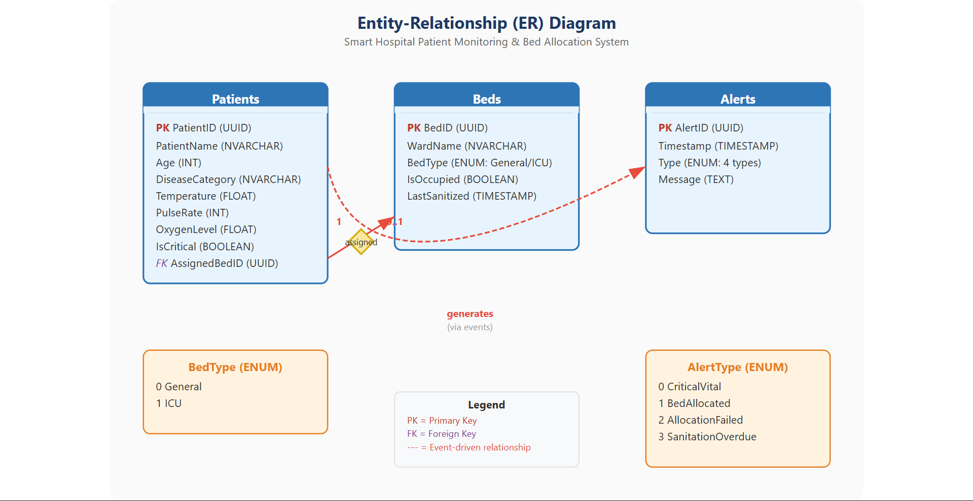
Class Diagram:
The class diagram represents the structure of the source code and framework classes:
Key Classes:
- Patient (Model): Contains properties PatientID (Guid), PatientName (string), Age (int), DiseaseCategory (string), Temperature (double), PulseRate (int), OxygenLevel (double), IsCritical (bool, private setter), AssignedBedID (Guid?). Methods include EvaluateCriticalStatus(), UpdateVitals(), and event VitalsDroppedCritical.
- Bed (Model): Contains properties BedID (Guid), WardName (string), BedType (enum: General/ICU), IsOccupied (bool), LastSanitized (DateTime). Methods include IsSanitationOverdue(), IsAssignable(), MarkSanitized().
- AlertEntry (Model): Contains properties AlertID (Guid), Timestamp (DateTime), Type (AlertType enum), Message (string), CssClass (computed).
- HospitalManager (Service): Central business service with Patients, Beds, Alerts properties. Methods include AddPatient(), GetPatient(), UpdatePatient(), RemovePatient(), AddBed(), AllocateBed(), DeallocatePatient(), SanitizeBed(), ApplyVitals(), CheckSanitationDeadlines(). Events include CriticalVitalAlert, BedAllocated, AllocationFailed, SanitationOverdue.
- HospitalDbContext (EF Core): Database context with DbSet<Patient>, DbSet<Bed>, DbSet<AlertEntry>. Configures model relationships in OnModelCreating().
- VitalsMonitorService (BackgroundService): Simulates vital sign changes every 5 minutes with random drift and 8% chance of oxygen dip below critical threshold.
Controllers:
- HomeController: Index(), Privacy(), DbCheck(), Error()
- PatientsController: Index(), Details(), Create(), Edit(), Delete(), DeleteConfirmed()
- DashboardController: Index(), Alerts(), Allocate(), AllocateTo(), Deallocate()
- BedsController: Index(), Create(), Edit(), Sanitize(), Delete(), DeleteConfirmed()

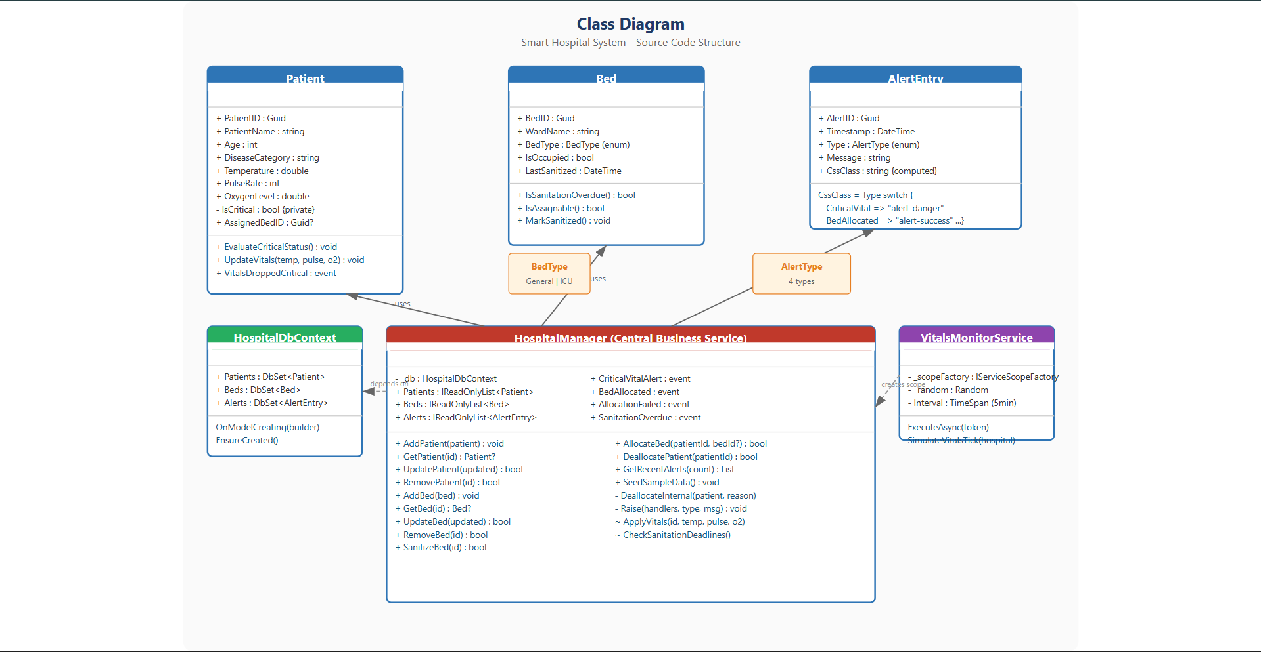

2.5 Technologies and Tools Used
Backend:
- ASP.NET Core 10.0 MVC - Web application framework
- C# 13 - Primary programming language
- .NET 10.0 - Runtime and base class library
- Entity Framework Core 10.0 - Object-Relational Mapping (ORM)
- Npgsql.EntityFrameworkCore.PostgreSQL 10.0.1 - PostgreSQL database provider
- Microsoft.EntityFrameworkCore.SqlServer 10.0.11 - SQL Server database provider (local development)
Frontend:
- HTML5 / CSS3 - Structure and styling
- Bootstrap 5 - Responsive UI framework
- JavaScript (ES6+) - Client-side interactivity and AJAX polling
- jQuery - DOM manipulation and form validation
- Razor View Engine - Server-side HTML templating
Database:
- Neon PostgreSQL (Cloud) - Managed PostgreSQL database for production
- SQL Server LocalDB - Local development database
- Entity Framework Core Code First - Database schema management
IDE/Editor:
- Visual Studio 2022 - Primary development environment
- Visual Studio Code - Code editing and version control
Version Control:
- Git - Distributed version control system
- GitHub - Remote repository hosting
Deployment:
- Render - Cloud hosting platform for web services
- Docker - Containerization for consistent deployment builds
Other Tools:
- Postman - API testing and endpoint verification
- NuGet - Package management for .NET dependencies

Code Implementation

3.1 Overview (Model-View-Controller)
The Smart Hospital System is implemented as an ASP.NET Core MVC application with the following project structure:
Project Structure:
- Models/ - Contains data model classes (Patient.cs, Bed.cs, AlertEntry.cs), database context (HospitalDbContext.cs), business logic service (HospitalManager.cs), and background monitoring service (VitalsMonitorService.cs)
- Controllers/ - Contains MVC controllers (HomeController.cs, PatientsController.cs, DashboardController.cs, BedsController.cs)
- Views/ - Contains Razor view files organized by controller (Views/Dashboard/, Views/Patients/, Views/Beds/, Views/Shared/)
- wwwroot/ - Contains static assets (CSS, JavaScript, Bootstrap, jQuery)
- Program.cs - Application entry point with service configuration and middleware pipeline
- appsettings.json - Configuration files for connection strings and logging
The application follows a clean separation of concerns. Models define data structures and validation rules. Views handle rendering HTML with dynamic data from controllers. Controllers process HTTP requests, interact with the HospitalManager service, and return appropriate views or JSON responses. The HospitalManager service acts as the central business logic layer, coordinating between the database (via HospitalDbContext) and the application's event system.
Dependency Injection Configuration:
The Program.cs file configures the complete service pipeline using the modern minimal hosting model (introduced in .NET 6). Services are registered in the dependency injection container with specific lifetimes: HospitalDbContext uses AddDbContext with either SQL Server or Npgsql provider depending on the DATABASE_URL environment variable. HospitalManager is registered as scoped because it depends on the scoped DbContext. VitalsMonitorService uses AddHostedService to run as a background task. The middleware pipeline includes UseDeveloperExceptionPage (temporary debug mode), UseExceptionHandler for production error handling, UseHsts for HTTPS enforcement, UseRouting for URL routing, and UseAuthorization for access control.
Razor View Engine:
The application uses Razor (.cshtml) as the server-side templating engine. Razor views use the @model directive to specify the model type, @ViewData for passing data from controllers, and tag helpers (asp-action, asp-controller, asp-route-id) for URL generation. The _Layout.cshtml provides a shared layout with navigation bar, Bootstrap CSS, and JavaScript includes. _ViewStart.cshtml specifies the default layout for all views. _ViewImports.cshtml imports common namespaces and tag helpers. Partial views (_ValidationScriptsPartial) are used for including validation scripts.

3.2 Database Connection (ORM / Entity Framework)
Connection Method: We used Object-Relational Mapping (ORM) through Entity Framework Core to connect the .NET application with the database. The system uses the Code First approach, where the database schema is defined through C# model classes and the DbContext configuration. No manual SQL scripts or migration files are needed because the system uses EnsureCreated() to automatically create the database and tables on first run.
The system implements dual database provider support. For local development, it uses SQL Server LocalDB with a connection string defined in appsettings.json. For production deployment on Render, it reads the DATABASE_URL environment variable set by Neon PostgreSQL and constructs a Npgsql connection string with SSL support. The switching logic is implemented in Program.cs:
Dual Provider Configuration:
The dual database support is implemented through a conditional check on the DATABASE_URL environment variable. When the variable is present (production environment on Render), the system parses the Neon pooled PostgreSQL URL. The URL parsing handles multiple edge cases: both postgres:// and postgresql:// URI schemes, URL-encoded special characters in usernames and passwords (e.g., %40 for @), custom port numbers (defaulting to 5432), and query parameters like sslmode=require that appear after the database name. The parsed components are assembled into a standard Npgsql connection string format: Host={host};Port={port};Database={database};Username={username};Password={password};SSL Mode=Require;Trust Server Certificate=true.
When the DATABASE_URL is not set (local development), the system falls back to SQL Server LocalDB using the connection string from appsettings.json: Server=(localdb)\MSSQLLocalDB;Database=SmartHospitalDb2;Trusted_Connection=True;TrustServerCertificate=True. This dual-provider approach allows developers to work locally with SQL Server while the production environment uses PostgreSQL, without changing any code.
Entity Framework Core Configuration:
The HospitalDbContext class inherits from DbContext and defines three DbSet properties: Patients, Beds, and Alerts. The OnModelCreating method configures the model by specifying primary keys (HasKey), backing field mappings for the IsCritical property (which has a private setter), and explicitly opting out of foreign key constraints for the AssignedBedID column. This design choice allows patients to reference beds without requiring a formal database relationship, simplifying the allocation logic.
The EnsureCreated() method is called at application startup within a using scope. This method checks if the database exists and creates it with the schema defined by the DbContext if it does not. For subsequent runs, it verifies the database exists and takes no action. This approach is suitable for small to medium applications where the schema is managed through code changes rather than formal migrations. In a production environment with existing data, EnsureCreated() would not modify the schema, making it a safe startup operation.
The connection string parsing handles both postgres:// and postgresql:// URL schemes, URL-encoded credentials, custom ports, and query parameters such as sslmode=require. The resulting connection string format is: Host={host};Port={port};Database={database};Username={username};Password={password};SSL Mode=Require;Trust Server Certificate=true.

3.3 Database Structure
Data Model: The database contains three tables created by Entity Framework Core's EnsureCreated() method:
Patients Table:
- PatientID (UUID, Primary Key) - Automatically generated unique identifier
- PatientName (NVARCHAR(100), Required) - Patient's full name
- Age (INT) - Patient's age with validation range 1-120
- DiseaseCategory (NVARCHAR(60), Required) - Medical condition category
- Temperature (FLOAT) - Body temperature in Celsius, range 35-42
- PulseRate (INT) - Heart rate in beats per minute, range 30-220
- OxygenLevel (FLOAT) - Blood oxygen saturation percentage, range 50-100
- IsCritical (BOOLEAN) - Computed flag: true when OxygenLevel < 92
- AssignedBedID (UUID, Nullable) - Foreign key reference to Beds table
Beds Table:
- BedID (UUID, Primary Key) - Automatically generated unique identifier
- WardName (NVARCHAR(60), Required) - Ward/room identifier (e.g., ICU-101, General-A1)
- BedType (INTEGER/ENUM) - 0 for General, 1 for ICU
- IsOccupied (BOOLEAN) - Whether the bed currently has a patient
- LastSanitized (TIMESTAMP) - UTC timestamp of last sanitation
Alerts Table:
- AlertID (UUID, Primary Key) - Automatically generated unique identifier
- Timestamp (TIMESTAMP) - UTC timestamp when the alert was generated
- Type (INTEGER/ENUM) - Alert category: 0=CriticalVital, 1=BedAllocated, 2=AllocationFailed, 3=SanitationOverdue
- Message (TEXT) - Human-readable alert description
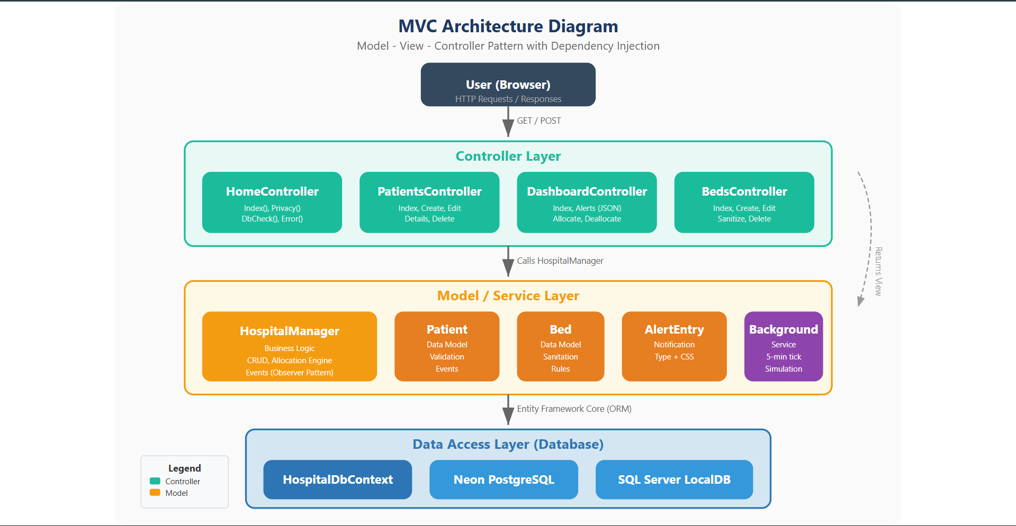

3.4 Key Models and Implementation Steps
Important Classes and Models:
Patient Class (Models/Patient.cs):
The Patient class represents a hospital patient with their vital signs. It uses Data Annotations for validation ([Required], [Range], [StringLength]) and includes a private setter for IsCritical to prevent external modification. The EvaluateCriticalStatus() method computes the critical flag based on oxygen level. The class implements the Observer pattern through the VitalsDroppedCritical event, which fires when a patient transitions from stable to critical. The UpdateVitals() method applies new vital sign readings and triggers status re-evaluation.
Bed Class (Models/Bed.cs):
The Bed class represents a physical hospital bed with type classification (General or ICU). It includes a BedType enum for ward classification and implements business rules through methods. IsSanitationOverdue() checks if more than 48 hours have passed since the last sanitation. IsAssignable() combines the occupancy check and sanitation check. MarkSanitized() updates the LastSanitized timestamp to the current UTC time.
AlertEntry Class (Models/AlertEntry.cs):
The AlertEntry class represents a system notification with four types defined in the AlertType enum: CriticalVital (patient condition emergency), BedAllocated (successful bed assignment), AllocationFailed (rule violation), and SanitationOverdue (hygiene compliance alert). The CssClass property uses a switch expression to map alert types to Bootstrap CSS classes for color-coded display.
HospitalManager Class (Models/HospitalManager.cs):
The HospitalManager is the central business service implementing the Observer pattern. It maintains database access through HospitalDbContext and raises four events: CriticalVitalAlert, BedAllocated, AllocationFailed, and SanitationOverdue. Key methods include AddPatient(), UpdatePatient(), RemovePatient() for patient CRUD, AddBed(), UpdateBed(), RemoveBed() for bed management, AllocateBed() with the four-rule safety engine, and DeallocatePatient() for bed release. The Raise() method persists alerts to the database, maintains a maximum of 100 alerts, and invokes event subscribers. The SeedSampleData() method populates initial data with 5 beds (2 ICU, 3 General) and 4 patients.
Implementation Steps:
Step 1: Project Setup - Created an ASP.NET Core MVC project targeting .NET 10.0 and installed NuGet packages: Microsoft.EntityFrameworkCore.SqlServer for local development and Npgsql.EntityFrameworkCore.PostgreSQL for Neon production database.
Step 2: Model Definition - Defined the Patient, Bed, and AlertEntry model classes with Data Annotations for validation. Configured the AlertType and BedType enums for type safety.
Step 3: Database Context - Created HospitalDbContext inheriting from DbContext with DbSet properties for Patients, Beds, and Alerts. Configured primary keys and backing field mappings in OnModelCreating().
Step 4: Service Layer - Implemented HospitalManager as a scoped service with CRUD operations, bed allocation engine with safety rules, event system for alerts, and seed data method.
Step 5: Background Service - Implemented VitalsMonitorService as a BackgroundService that creates scoped HospitalManager instances per tick to simulate vital sign changes every 5 minutes.
Step 6: Controllers - Created PatientsController, DashboardController, and BedsController with full CRUD operations, form validation, and anti-forgery tokens.
Step 7: Views - Developed Razor views with Bootstrap 5 styling, including the monitoring dashboard with JavaScript polling, patient and bed CRUD forms, and shared layout with navigation.
Step 8: Configuration - Configured dual database provider support in Program.cs with DATABASE_URL environment variable parsing for Neon PostgreSQL and fallback to SQL Server LocalDB.
Step 9: Docker Deployment - Created a Dockerfile with multi-stage build, installed krb5-libs dependency for Npgsql, and configured port 8080 for Render deployment.
Step 10: Cloud Deployment - Deployed to Render with Docker runtime, connected Neon PostgreSQL database, and verified the deployed application.

3.5 Important Classes and Methods (CRUD Operations)
PatientsController Class:
- Index() - GET /Patients - Retrieves all patients from HospitalManager and displays them in a table view with vital signs and status badges.
- Details(Guid id) - GET /Patients/Details/{id} - Fetches a specific patient by ID and displays detailed information. Returns NotFound() if patient does not exist.
- Create() - GET /Patients/Create - Returns an empty Patient model for the create form.
- Create(Patient patient) - POST /Patients/Create - Validates model state using ModelState.IsValid, calls HospitalManager.AddPatient(), sets TempData success message, and redirects to Index.
- Edit(Guid id) - GET /Patients/Edit/{id} - Fetches patient for editing, returns NotFound() if not found.
- Edit(Guid id, Patient patient) - POST /Patients/Edit/{id} - Validates ID match and model state, calls HospitalManager.UpdatePatient(), returns success or NotFound().
- Delete(Guid id) - GET /Patients/Delete/{id} - Fetches patient for delete confirmation view.
- DeleteConfirmed(Guid id) - POST /Patients/Delete/{id} - Calls HospitalManager.RemovePatient() and redirects to Index.
DashboardController Class:
- Index(string? filter) - GET /Dashboard - Displays the monitoring dashboard with optional filter (All, Critical, ICU Required, Unallocated). Subscribes to HospitalManager events for logging.
- Alerts() - GET /Dashboard/Alerts - Returns JSON array of 20 most recent alerts for JavaScript polling every 3 seconds.
- Allocate(Guid patientId) - POST /Dashboard/Allocate/{patientId} - Triggers automatic bed allocation using the safety rule engine.
- AllocateTo(Guid patientId, Guid bedId) - POST /Dashboard/AllocateTo/{patientId}?bedId={bedId} - Manual bed selection with safety rule validation.
- Deallocate(Guid patientId) - POST /Dashboard/Deallocate/{patientId} - Releases the patient from their assigned bed.
BedsController Class:
- Index() - GET /Beds - Lists all beds with occupancy and sanitation status.
- Create(Bed bed) - POST /Beds/Create - Adds a new bed with automatic sanitization timestamp.
- Edit(Guid id, Bed bed) - POST /Beds/Edit/{id} - Updates bed details, prevents type change for occupied ICU beds.
- Sanitize(Guid id) - POST /Beds/Sanitize/{id} - Staff action to mark bed as freshly sanitized.
- DeleteConfirmed(Guid id) - POST /Beds/Delete/{id} - Removes bed only if not occupied.
HospitalManager Class (Business Logic):
- AllocateBed(Guid patientId, Guid? requestedBedId) - Implements the four-rule safety engine: single occupancy, 48-hour sanitation, ICU-only for critical, no critical in General.
- ApplyVitals(Guid patientId, double temperature, int pulse, double oxygen) - Updates patient vitals and raises CriticalVitalAlert when oxygen drops below 92%.
- CheckSanitationDeadlines() - Scans all beds for sanitation overdue (48h threshold) with throttling (one alert per bed per 6 hours).
- Raise(EventHandler<AlertEntry>? handlers, AlertType type, string message) - Persists alert to database, maintains 100-alert cap, and invokes event subscribers.
Note: The system uses modern .NET 10.0 features including primary constructors, collection expressions, raw string literals, and the PeriodicTimer class for the background monitoring service. Entity Framework Core 10.0 provides improved query compilation and bulk operation support.

Testing and Evaluation

4.1 Screenshots
Note: Screenshots should be captured from the deployed application at https://smarthospitalsystem-x6io.onrender.com/ or from the local development environment. The following descriptions indicate what each screenshot should show.
Screenshot 1: Monitoring Dashboard (Landing Page)
The monitoring dashboard serves as the main landing page after login. It displays four stat tiles at the top showing total patients, critical patients count, beds occupied (e.g., 2/5), and sanitation overdue alerts. Below the tiles, filter buttons (All, Critical, ICU Required, Unallocated) allow staff to quickly find patients needing attention. The main patient vitals table shows each patient's name, age, disease category, temperature, pulse rate, oxygen level, critical status badge, assigned bed, and allocation actions (Auto Allocate, manual bed selection dropdown, or Release Bed button).
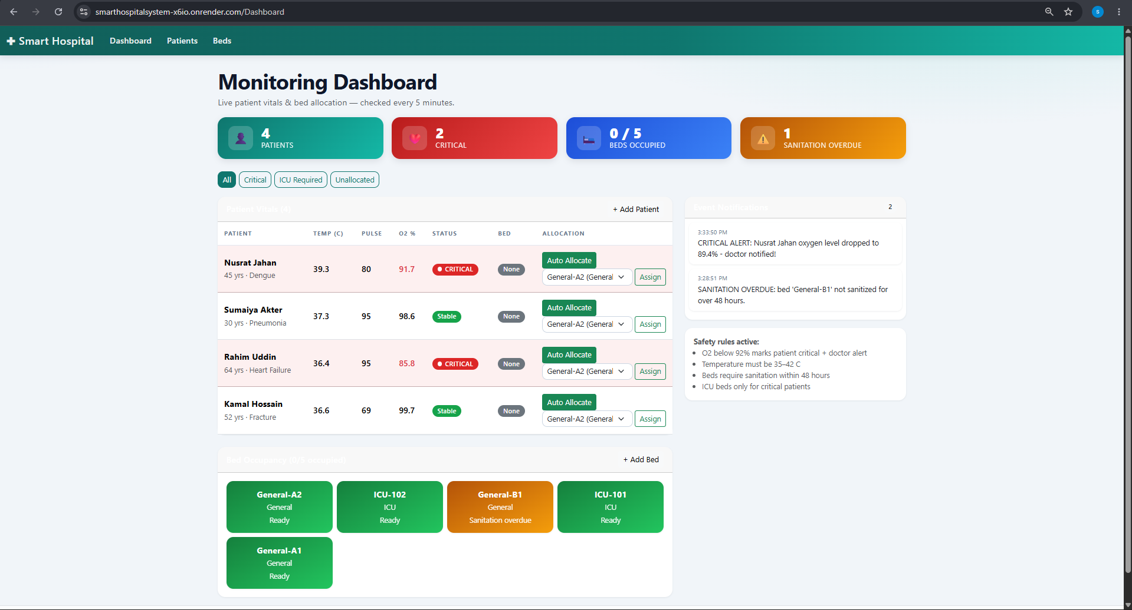
Screenshot 2: Bed Occupancy Grid
The bed occupancy grid displays all hospital beds as colored tiles below the patient table. Green tiles indicate free and sanitized beds ready for allocation. Yellow/amber tiles indicate beds where sanitation is overdue (more than 48 hours since last cleaning). Red/dark tiles indicate occupied beds. Each tile shows the ward name (e.g., ICU-101, General-A1), bed type (ICU/General), and current status.
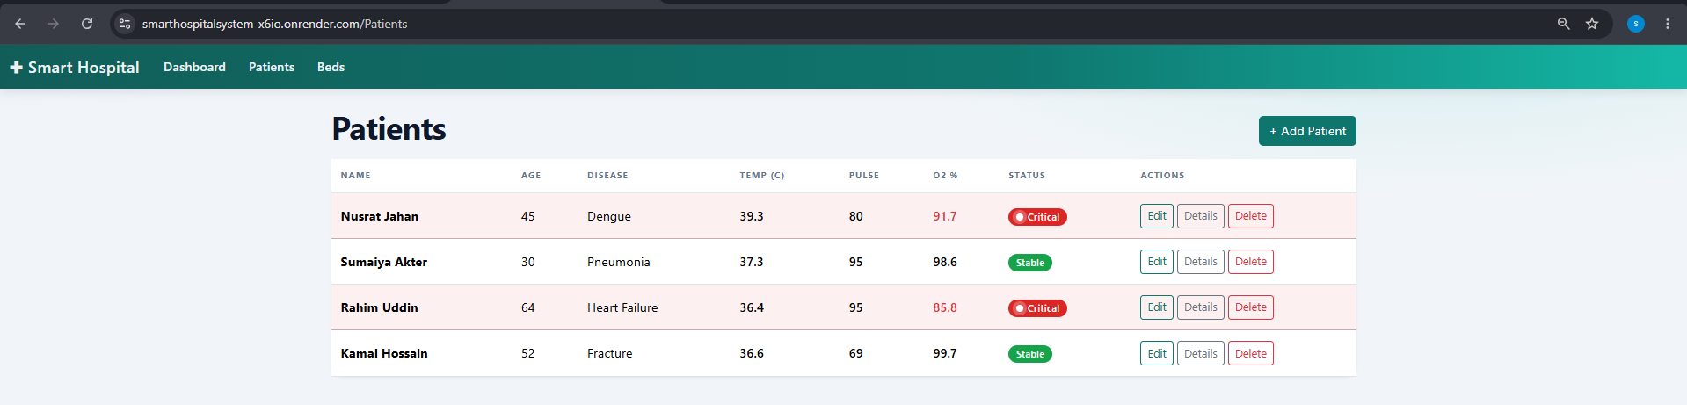
Screenshot 3: Live Event Notification Feed
The right sidebar of the dashboard displays a live event notification feed that updates every 3 seconds via JavaScript AJAX polling to /Dashboard/Alerts. Alerts are color-coded: red for CriticalVital (patient oxygen dropped below 92%), green for BedAllocated (successful assignment), yellow for AllocationFailed (rule violation), and gray for SanitationOverdue. Each alert shows a timestamp and descriptive message.
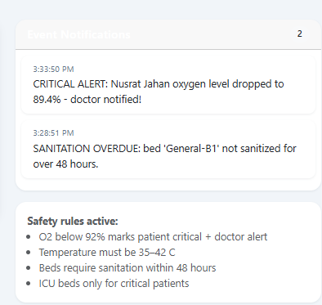
Screenshot 4: Patient Management Page
The Patients Index page displays a table of all patients with columns for Name, Age, Disease, Temperature, Pulse Rate, Oxygen Level, Status, and Actions (Edit, Details, Delete). Critical patients are highlighted with a red table row background. The '+ Add Patient' button at the top right navigates to the patient creation form.
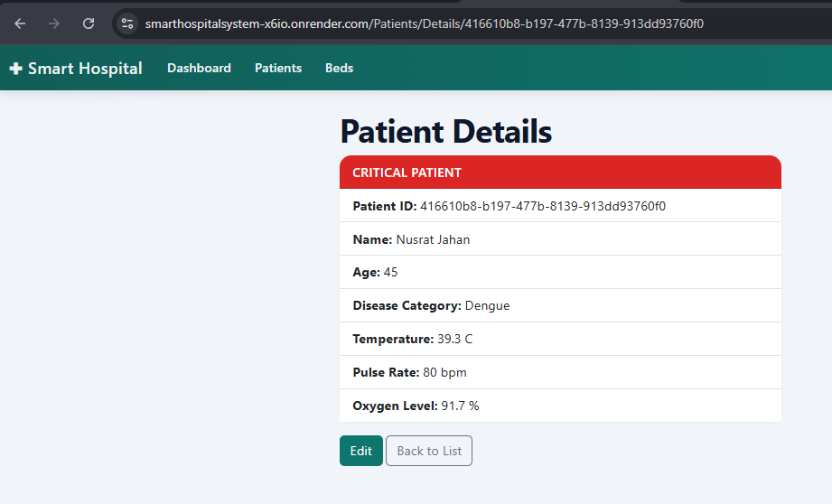
Screenshot 5: Create Patient Form
The Create Patient form includes input fields for Patient Name (required, max 100 characters), Age (range 1-120), Disease Category (required, max 60 characters), Temperature (range 35-42 C), Pulse Rate (range 30-220 bpm), and Oxygen Level (range 50-100%). The form includes client-side validation with error messages and anti-forgery token protection.
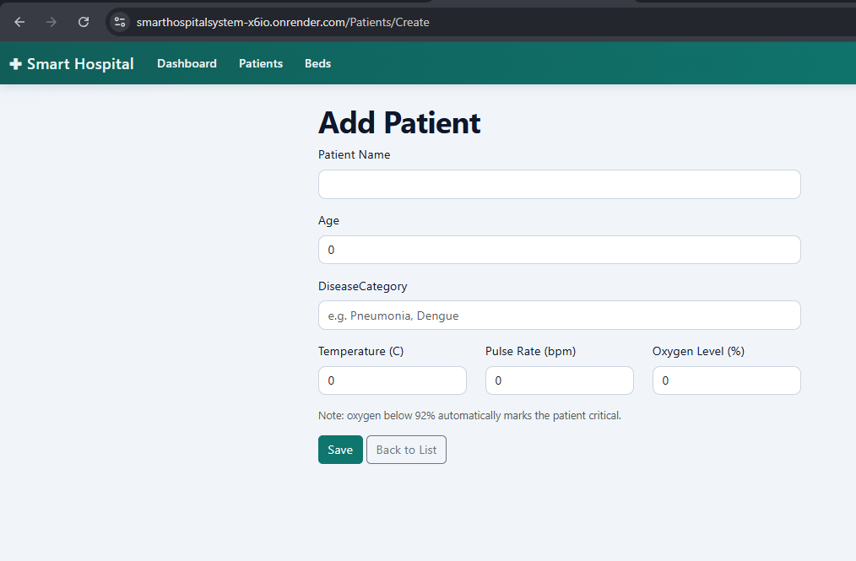
Screenshot 6: Bed Management Page
The Beds Index page shows all beds in a table with Ward Name, Bed Type (General/ICU), Occupied status, Last Sanitized timestamp, and action buttons (Edit, Sanitize, Delete). The 'Sanitize' button allows staff to mark a bed as freshly cleaned, resetting the 48-hour sanitation timer. Occupied beds show a disabled Delete button to prevent accidental removal.
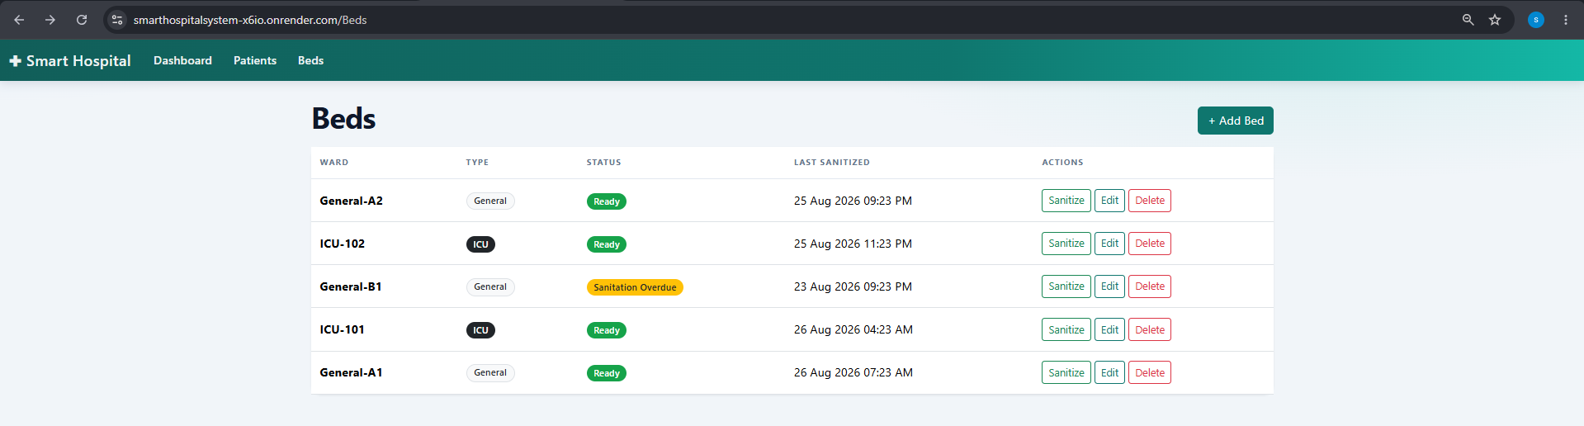
Screenshot 7: Edit Patient Form
The Edit Patient form is pre-populated with existing patient data and allows modification of all fields including vital signs. When vital signs are updated, the system automatically re-evaluates the critical status. If a critical patient is moved from an ICU bed to a general ward, the system automatically deallocates them with an explanation alert.
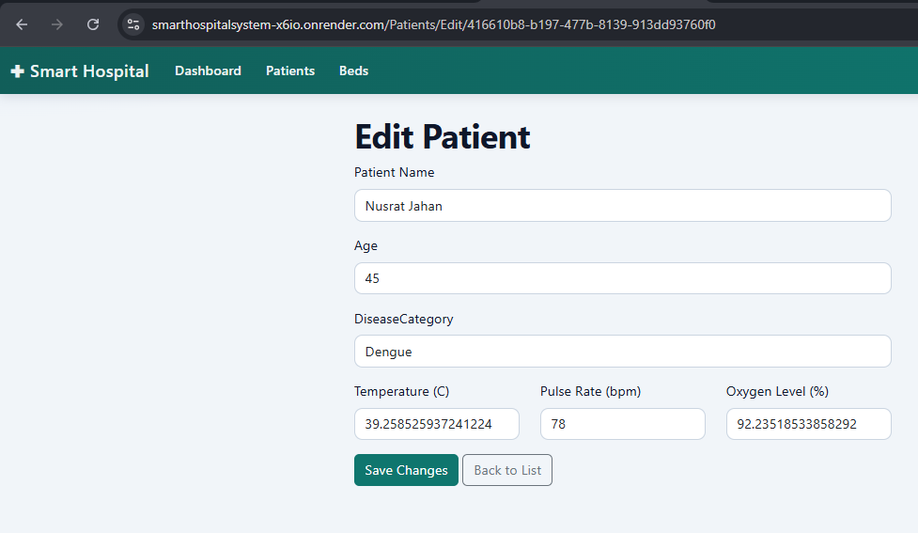

4.2 Test Cases
Test Case 1: Create a New Patient with Valid Data
Description: Navigate to /Patients/Create, fill in all required fields (Name: 'Test Patient', Age: 35, Disease: 'Bronchitis', Temperature: 37.5, Pulse: 85, Oxygen: 96), and submit the form.
Expected Output: Patient is added to the database, success message 'Patient Test Patient added.' is displayed, and the user is redirected to the Patients Index page showing the new patient in the table.
Actual Output: The patient was created successfully and appeared in the Patients table with 'Stable' status badge. The success message was displayed as expected.
Test Case 2: Attempt to Create Patient with Invalid Oxygen Level
Description: Navigate to /Patients/Create, enter Oxygen Level as 40 (below the valid range of 50-100), and submit the form.
Expected Output: The form validation should prevent submission and display an error message: 'Oxygen level must be between 50 and 100.'
Actual Output: Client-side validation prevented form submission and displayed the expected error message next to the Oxygen Level field.
Test Case 3: Automatic Bed Allocation for Critical Patient
Description: A patient with Oxygen Level below 92% (e.g., Rahim Uddin at 89%) is marked as critical. Click the 'Auto Allocate' button next to this patient.
Expected Output: The system should automatically assign the patient to an available ICU bed (ICU-101 or ICU-102) and display a success alert in the event feed: 'Rahim Uddin allocated to ICU bed ICU-101'.
Actual Output: The system correctly identified the patient as critical and allocated them to an available ICU bed. A green BedAllocated alert appeared in the event notification feed.
Test Case 4: Prevent Critical Patient from Being Allocated to General Ward
Description: Select a critical patient (Oxygen < 92%) and manually select a General ward bed from the dropdown, then click 'Assign'.
Expected Output: The allocation should be rejected with an AllocationFailed alert: 'Rejected: critical patient cannot be placed in General Ward.'
Actual Output: The system enforced the safety rule and rejected the allocation. A yellow AllocationFailed alert appeared in the event feed explaining the rejection reason.
Test Case 5: Sanitation Overdue Alert Generation
Description: A bed (e.g., General-B1) has LastSanitized set to 60 hours ago (exceeding the 48-hour threshold). Wait for the background service to run its sanitation check.
Expected Output: A SanitationOverdue alert should appear in the event feed: 'SANITATION OVERDUE: bed General-B1 not sanitized for over 48 hours.' The bed tile in the dashboard should display with an amber/overdue color.
Actual Output: The background service correctly identified the overdue bed and generated the alert. The bed tile showed the correct overdue status styling.
Test Case 6: Bed Sanitation Reset
Description: Navigate to /Beds, find a bed with sanitation overdue status, and click the 'Sanitize' button.
Expected Output: The bed's LastSanitized timestamp is updated to the current time, the overdue status is cleared, and a success message is displayed.
Actual Output: The bed's status was updated to 'Ready' with a fresh timestamp, and the success message 'Bed marked as sanitized.' was displayed.
Test Case 7: Delete Patient with Assigned Bed
Description: Navigate to /Patients/Delete for a patient who is currently allocated to a bed, and confirm the deletion.
Expected Output: The patient is removed from the database, the assigned bed is automatically deallocated (IsOccupied set to false), and a BedAllocated alert confirms the bed release.
Actual Output: The patient was successfully removed. The bed was automatically deallocated, and the event feed showed: 'Bed released. Patient removed - bed released.'
Test Case 8: Real-Time Vital Sign Monitoring
Description: Wait for the VitalsMonitorService background tick (every 5 minutes) and observe the Dashboard for vital sign changes.
Expected Output: Patient vital signs update automatically. If oxygen drops below 92%, a CriticalVital alert appears: 'CRITICAL ALERT: [Patient Name] oxygen level dropped to [X]% - doctor notified!'
Actual Output: The background service applied random vital sign drifts. When oxygen dropped below 92% for any patient, a red CriticalVital alert appeared in the event feed, and the patient's status changed to 'CRITICAL' with a pulsing badge.
Test Case 9: Dashboard Filter Functionality
Description: Click the 'Critical' filter button on the Dashboard.
Expected Output: The patient table should display only patients with IsCritical = true (oxygen below 92%). All non-critical patients should be hidden.
Actual Output: The filter correctly displayed only critical patients. Clicking 'All' restored the full patient list. The 'ICU Required' and 'Unallocated' filters also worked as expected.
Test Case 10: Cloud Deployment Verification
Description: Access the deployed application at https://smarthospitalsystem-x6io.onrender.com/ and verify all features work correctly.
Expected Output: The application loads successfully, the Dashboard displays with seed data (4 patients, 5 beds), CRUD operations function, and real-time alerts update via polling.
Actual Output: The application was accessible and fully functional on Render. The Neon PostgreSQL database was populated with seed data on first deployment. All CRUD operations and monitoring features worked as expected.

Challenges and Future Improvements

5.1 Challenges Faced
Challenge 1: Dual Database Provider Configuration
One of the most significant challenges was configuring Entity Framework Core to work with both SQL Server (for local development) and PostgreSQL/Neon (for production). The connection string formats differ significantly between the two providers. SQL Server uses a simple connection string format, while PostgreSQL requires parsing the DATABASE_URL environment variable with handling for different URL schemes (postgres:// vs postgresql://), URL-encoded credentials, custom ports, and query parameters like sslmode=require. The solution involved implementing a URI parser in Program.cs that constructs the appropriate Npgsql connection string from the Neon URL format.
Challenge 2: Background Service Dependency Injection
The VitalsMonitorService runs as a singleton BackgroundService, but HospitalManager is a scoped service (because it depends on the scoped HospitalDbContext). This created a lifetime mismatch issue where the singleton service could not directly use the scoped service. The solution was to inject IServiceScopeFactory and create a new scope for each monitoring tick, resolving HospitalManager within that scope. This pattern ensures proper resource disposal and avoids memory leaks from long-lived DbContext instances.
Challenge 3: Docker Container Missing Native Dependencies
When deploying to Render using Docker, the application crashed with the error 'libgssapi_krb5.so.2: cannot open shared object file'. This native library is required by Npgsql for PostgreSQL connections with SSL. The initial attempt to install 'krb5-libs' failed because the Docker base image (Ubuntu 24.04 Noble) uses a different package name. The solution was to install 'libgssapi-krb5-2' instead, which provides the same library on Debian-based systems.
Challenge 4: Observer Pattern with Persistent Storage
Implementing the Observer pattern with persistent alert storage required careful design. Events in C# are in-memory, but alerts needed to survive server restarts and be queryable by the Dashboard's JavaScript poller. The solution was to persist every alert to the database in the Raise() method before invoking event handlers, and to cap the alert count at 100 by deleting the oldest entries. The Dashboard controller reads alerts from the database rather than from in-memory events, ensuring consistency.
Challenge 5: Scoped Service Event Subscription
Subscribing to HospitalManager events from DashboardController required careful consideration of service lifetimes. Since both the controller and HospitalManager are scoped, the subscription happens in the constructor. However, each HTTP request creates a new scope with a new HospitalManager instance, meaning subscriptions are automatically cleaned up. The event handlers primarily serve logging purposes, while the actual alert display reads from the database.
Challenge 6: Bed Allocation Rule Engine Complexity
Implementing the four-rule safety engine for bed allocation required careful ordering and combination of filtering logic. The rules interact in complex ways: a bed must be free AND sanitized AND match the patient's criticality AND satisfy the ward type restriction. The solution uses LINQ's method chaining with Where clauses and includes a manual bed selection path that still validates all rules, preventing staff from accidentally assigning a critical patient to a general ward.
Challenge 7: Port Configuration for Render Deployment
Render dynamically assigns a port to each web service through the PORT environment variable. The application needed to read this variable and configure Kestrel (the ASP.NET Core web server) to listen on the assigned port. The solution was to read the PORT environment variable in Program.cs and configure UseUrls with the correct binding address (http://0.0.0.0:{port}). The Dockerfile also needed to expose port 8080 as a default and set ASPNETCORE_URLS accordingly.
Challenge 8: Anti-Forgery Token Validation
All POST actions in the application require anti-forgery tokens to prevent Cross-Site Request Forgery (CSRF) attacks. Razor forms automatically include the token via the form tag helper, but JavaScript-initiated POST requests (like the bed allocation buttons) needed to include the token explicitly. The solution was to use standard HTML form elements with the [ValidateAntiForgeryToken] attribute on controller actions, ensuring all state-changing operations are protected.
Challenge 9: Event Alert Throttling
The VitalsMonitorService checks sanitation deadlines every 5 minutes, which could generate duplicate alerts for the same overdue bed. To prevent alert flooding, the system implements throttling by checking the Alerts table for recent entries. A sanitation overdue alert is only generated if no similar alert exists within the last 6 hours. This prevents the alert feed from being overwhelmed with repeated messages while still maintaining visibility of compliance issues.
Challenge 10: Cross-Platform Compatibility
The application needed to run on both Windows (local development with SQL Server LocalDB) and Linux (Render Docker container with PostgreSQL). This required ensuring that date/time handling used UTC (DateTime.UtcNow) for PostgreSQL timestamp compatibility, avoiding Windows-specific path separators, and testing the Docker build on Linux. The Npgsql library handles the cross-platform PostgreSQL communication, but the base Docker image needed the krb5-libs dependency for GSSAPI authentication support.
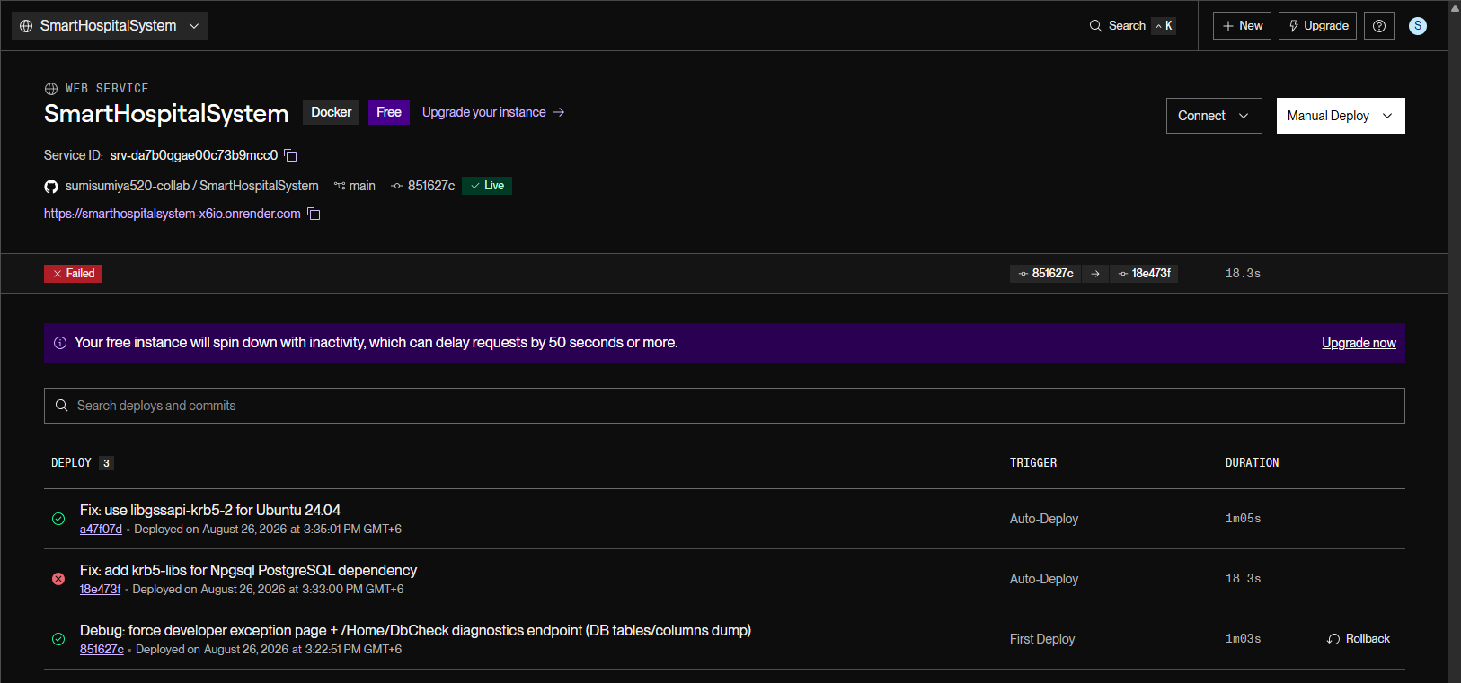
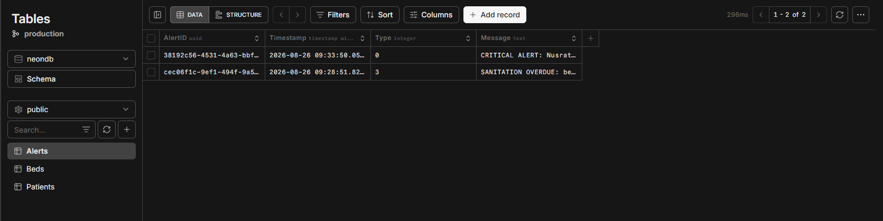

5.2 Future Improvements
Future Improvement 1: User Authentication and Authorization
The current system does not implement user authentication or role-based access control. A future improvement would integrate ASP.NET Core Identity with role-based authorization to differentiate between doctors, nurses, administrators, and ward managers. This would include login pages, JWT token authentication for API endpoints, and permission-based UI element visibility (e.g., only administrators can delete patients).
Future Improvement 2: Real-Time Push Notifications with SignalR
The current alert system uses JavaScript polling every 3 seconds, which introduces latency and increases server load. Implementing SignalR would enable real-time push notifications from the server to connected clients, providing instant critical alerts with zero polling latency. This would significantly improve the response time for critical patient alerts.
Future Improvement 3: Mobile Application Development
Developing a companion mobile application using .NET MAUI or React Native would allow hospital staff to receive critical alerts on their phones, view patient vitals on the go, and perform bed allocation from anywhere in the hospital. Push notifications would ensure critical alerts are never missed, even when staff are away from their workstations.
Future Improvement 4: Advanced Analytics and Reporting
Adding an analytics dashboard with historical data visualization would help hospital administrators identify trends in patient admissions, bed utilization rates, average length of stay, and sanitation compliance metrics. This could be implemented using charting libraries like Chart.js or Syncfusion, with data aggregated from the existing database.
Future Improvement 5: Integration with Medical Devices
Integrating the system with actual medical devices (pulse oximeters, thermometers, heart rate monitors) through IoT protocols would eliminate the need for manual vital sign entry and simulated monitoring. Real-time device data feeds would provide continuous, accurate patient monitoring without human intervention.
Future Improvement 6: Audit Trail and Logging System
Implementing a comprehensive audit trail system that logs all user actions (patient creation, bed allocation, data modifications) with timestamps and user identification would improve accountability and regulatory compliance. This could be integrated with Serilog for structured logging and stored in a separate audit database.
Future Improvement 7: Unit Testing and Integration Testing
Adding a comprehensive test suite using xUnit or NUnit with mock dependencies (Moq) would improve code reliability and enable safe refactoring. Testing the bed allocation rule engine, CRUD operations, and background service logic would catch regressions early and ensure system stability.
Future Improvement 8: Patient Admission and Discharge Workflow
Implementing a formal admission/discharge workflow with timestamps, reason codes, and history tracking would provide a complete patient lifecycle management system. This would include admission forms, discharge summaries, transfer between beds, and historical records of all patient movements.
Future Improvement 9: Multi-Hospital Support
Extending the system to support multiple hospital branches with a shared database would enable healthcare networks to manage patient monitoring across locations. This would require adding a Hospital/Branch entity, implementing data partitioning, and updating the dashboard to support filtering by hospital.
Future Improvement 10: Emergency Response Integration
Integrating with emergency response systems and ambulance tracking would enable the hospital to prepare beds and staff before patients arrive. This could include an API endpoint for emergency services to query bed availability and pre-register incoming patients.

Appendix A: Key Code Snippets

A.1 Program.cs - Service Configuration
The following code shows how services are configured in the application entry point:
var dbUrl = Environment.GetEnvironmentVariable("DATABASE_URL");
if (!string.IsNullOrEmpty(dbUrl))
{
var uri = new Uri(dbUrl);
var userInfo = uri.UserInfo.Split(':', 2);
// ... parse connection components
builder.Services.AddDbContext<HospitalDbContext>(
options => options.UseNpgsql(connStr));
}
else
{
builder.Services.AddDbContext<HospitalDbContext>(
options => options.UseSqlServer(
builder.Configuration.GetConnectionString("HospitalDb")));
}

A.2 Bed Allocation Engine - Safety Rules
The AllocateBed method implements the four-rule safety engine:
public bool AllocateBed(Guid patientId, Guid? requestedBedId = null)
{
var patient = _db.Patients.FirstOrDefault(
p => p.PatientID == patientId);
// Rule 1: Bed hosts at most one patient
// Rule 2: Bed sanitized within 48 hours
var candidates = _db.Beds.Where(b => !b.IsOccupied)
.ToList().Where(b => b.IsAssignable());
// Rule 3: ICU beds only for critical patients
// Rule 4: Critical patients never in General Ward
candidates = candidates.Where(b =>
patient.IsCritical ? b.BedType == BedType.ICU
: b.BedType == BedType.General);
// ... allocate and save
}

A.3 VitalsMonitorService - Background Monitoring
The background service simulates vital sign changes every 5 minutes:
protected override async Task ExecuteAsync(
CancellationToken stoppingToken)
{
using var timer = new PeriodicTimer(Interval);
while (!stoppingToken.IsCancellationRequested
&& await timer.WaitForNextTickAsync(stoppingToken))
{
using var scope = _scopeFactory.CreateScope();
var hospital = scope.ServiceProvider
.GetRequiredService<HospitalManager>();
SimulateVitalsTick(hospital);
hospital.CheckSanitationDeadlines();
}
}

A.4 Dashboard - Real-Time Alert Polling
The JavaScript polling mechanism updates alerts every 3 seconds:
setInterval(async () => {
const res = await fetch('/Dashboard/Alerts');
const alerts = await res.json();
const feed = document.getElementById('alertFeed');
feed.innerHTML = alerts.map(a => `
<div class="alert-item ${cssMap[a.type]}">
<div class="alert-time">
${new Date(a.timestamp).toLocaleTimeString()}
</div>
<div class="alert-msg">${a.message}</div>
</div>`).join('');
}, 3000);

Appendix B: System Configuration Files

B.1 Dockerfile
The Dockerfile defines a multi-stage build for the Render deployment:
FROM mcr.microsoft.com/dotnet/sdk:10.0 AS build
WORKDIR /src
COPY ["WebApplication2.csproj", "./"]
RUN dotnet restore
COPY . .
RUN dotnet publish -c Release -o /app/publish

FROM mcr.microsoft.com/dotnet/aspnet:10.0
WORKDIR /app
RUN apt-get update && apt-get install -y \
--no-install-recommends libgssapi-krb5-2 \
&& rm -rf /var/lib/apt/lists/*
COPY --from=build /app/publish .
ENV ASPNETCORE_URLS=http://0.0.0.0:8080
EXPOSE 8080
ENTRYPOINT ["dotnet", "WebApplication2.dll"]

B.2 appsettings.json
The application settings file with connection string configuration:
{
"ConnectionStrings": {
"HospitalDb": "Server=(localdb)\\MSSQLLocalDB;"
+ "Database=SmartHospitalDb2;"
+ "Trusted_Connection=True;"
+ "TrustServerCertificate=True"
},
"Logging": {
"LogLevel": {
"Default": "Information",
"Microsoft.AspNetCore": "Warning"
}
},
"AllowedHosts": "*"
}

B.3 HospitalDbContext.cs
The Entity Framework Core database context:
public class HospitalDbContext : DbContext
{
public HospitalDbContext(
DbContextOptions<HospitalDbContext> options)
: base(options) { }

public DbSet<Patient> Patients => Set<Patient>();
public DbSet<Bed> Beds => Set<Bed>();
public DbSet<AlertEntry> Alerts => Set<AlertEntry>();

protected override void OnModelCreating(
ModelBuilder modelBuilder)
{
modelBuilder.Entity<Patient>()
.HasKey(p => p.PatientID);
modelBuilder.Entity<Bed>()
.HasKey(b => b.BedID);
modelBuilder.Entity<AlertEntry>()
.HasKey(a => a.AlertID);
}
}

References
First Reference:
Microsoft. (2024). ASP.NET Core Documentation. Microsoft Learn. https://learn.microsoft.com/en-us/aspnet/core/
Second Reference:
Microsoft. (2024). Entity Framework Core Documentation. Microsoft Learn. https://learn.microsoft.com/en-us/ef/core/
Third Reference:
Npgsql Development Team. (2024). Npgsql Documentation - PostgreSQL .NET Data Provider. https://www.npgsql.org/doc/
Fourth Reference:
Neon Technology. (2024). Neon PostgreSQL Documentation - Serverless Postgres. https://neon.tech/docs/
Fifth Reference:
Render. (2024). Render Documentation - Cloud Application Hosting. https://docs.render.com/
Sixth Reference:
Pro Entity Framework Core 9: Database Access Using C#. (2024). Adam Freeman. Apress.
Seventh Reference:
CLR via C#: Applied Microsoft .NET Framework Programming. (2019). Jeffrey Richter. Microsoft Press.
Eighth Reference:
Design Patterns: Elements of Reusable Object-Oriented Software. (1994). Erich Gamma, Richard Helm, Ralph Johnson, John Vlissides. Addison-Wesley.
Ninth Reference:
Bootstrap Documentation. (2024). Bootstrap 5. https://getbootstrap.com/docs/5.3/
Tenth Reference:
Class Lecture Notes and Course Materials - Software Engineering Department, 2025-2026.

