Priority 1

**What’s my style button (or through package selection on homepage) -> fill survey -> get result -> are you ready to create your dream space? -> create account/ log in flow -> show the 3 package options in popup ->**

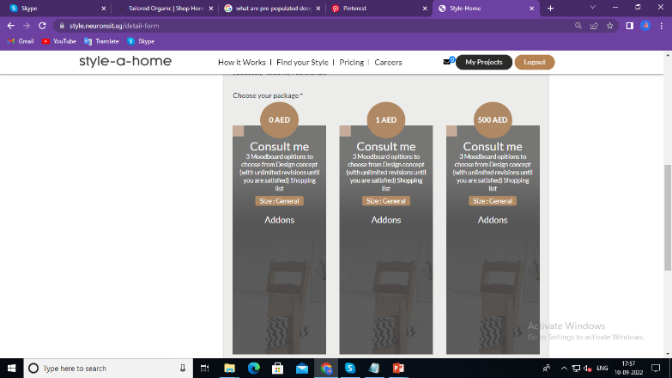

**A)- Decorate Me -> takes customer to a e-commerce page in which pre-populated designs and furniture lists -> customer selects design -> goes through purchase flow (typical ecommerce) -> once purchase completed -> customer can now download the layout and shopping list + customer gets an email notification of purchase confirmation with a link to where they can download the layout and the shopping list**

* **Customer Website:**

Prepopulated design **filters**: [ I will send the link and image to you on the basis of example]

1. **Style type**: modern, etc.… (The ones in the style form)

2. **Room layout**: square or rectangular shape

1. **Room type**: bedroom, balcony, etc.…
2. **Budget:** high end, low to mid end
3. **Country**
4. **Color Scheme**

* **CMS:**

1. I need a place to upload the stock list, prices , upload the documents, etc.… and update content, write item descriptions, assign the filters to the items, etc.…(product)
2. Ability to add additional filter types in the future (xyz)
3. Customer’s style survey should be saved as well

(Costumer project-> listing **+ survey**)

1. I need a place to show me purchases , with customer name and what was purchased to help me with insight

(customer project-> listing-> view .here we can also what filters they buy)

1. Creating and Managing vouchers
2. Ability to change the package names

Priority 1

**B) Furnish Me (existing flow) -> takes customer to detailed form page to select rooms, etc.… except we only show the furnish me package at the bottom with option to select the add ons -> proceed to checkout -> existing flow continues**

In the detail form everything will be the same, just below only the bottom Aed will show like that-

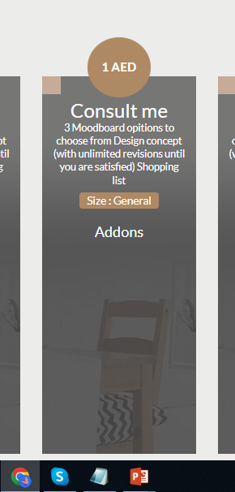

Priority 2

**C) Renovate me -> takes customer to a renovation request form to fill up**

* + Form gets sent to info@style-a-home and responses uploaded on CMS
  + Customer gets a message on the website that their responses has been submitted and someone will get back to them within 24 hours
  + An email gets triggered to the customer that that their responses has been submitted and someone will get back to them within 24 hours
  + **CMS:**
    - Ability to change the form questions, add and delete questions
    - Ability to view the customer details and the form submission