**Style-A- Home Feedbacks**

1. (Customer website) Login page image- change the image on the login and logout page

Use this image:

https://drive.google.com/file/d/1ROBeG97sYSa9472h0MOjhw3KTaYLRAFP/view?usp=sharing

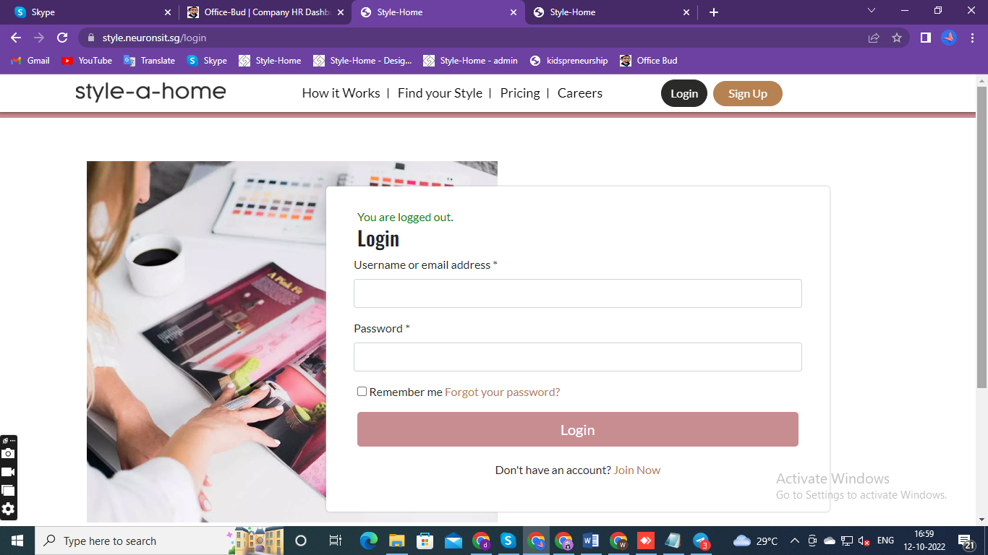

1. (Customer website)- last banner background- change the background image

Use this image:

<https://drive.google.com/file/d/1KIWOlT6cdUf82ArvchT-vQKTr21CkEem/view?usp=sharing>

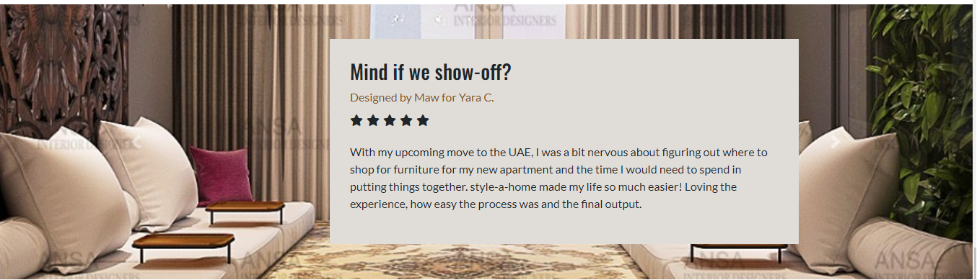

1. (Customer website)-> quiz -> package popup-> select first package-> View product- the image is small and far away
2. (Customer website)->quiz -> customer selects the package on popup, and they go to the next page, whether it's the detail form or the ecommerce page, if they press back, they get taken back to the home page and not the package selection page.
3. (Admin website)-> users-> designer payment-> Here add project name as well

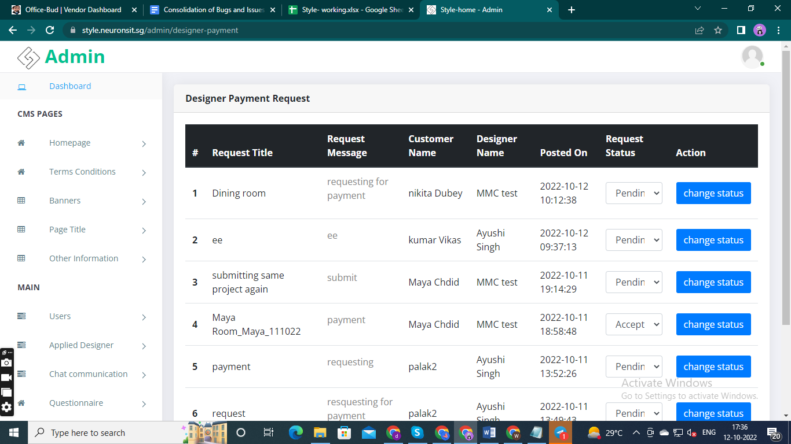

1. (Admin website)-> Customer project-> user-> action-> view. Here we have implement a section named as “product detail”- Shows what products customers buy.



1. (Admin website)-> Product-> add ->product document- Product documents, once I submit them on CMS (by admin), I cannot see as admin what I uploaded.

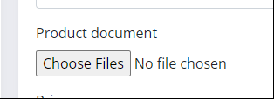

1. CMS (Admin website) -> product-> add. Here designed by section - can we hide this for now Also it's not on the CMS to be able to edit in the future
2. CMS (Admin website) -> on package popup-> select first package-> Here on product "view products" button should be "Add to Cart”. When we click on image then, open the product page.

The item description summary and item picture should be clickable to take them to the product detailed page (see amazon company for reference)

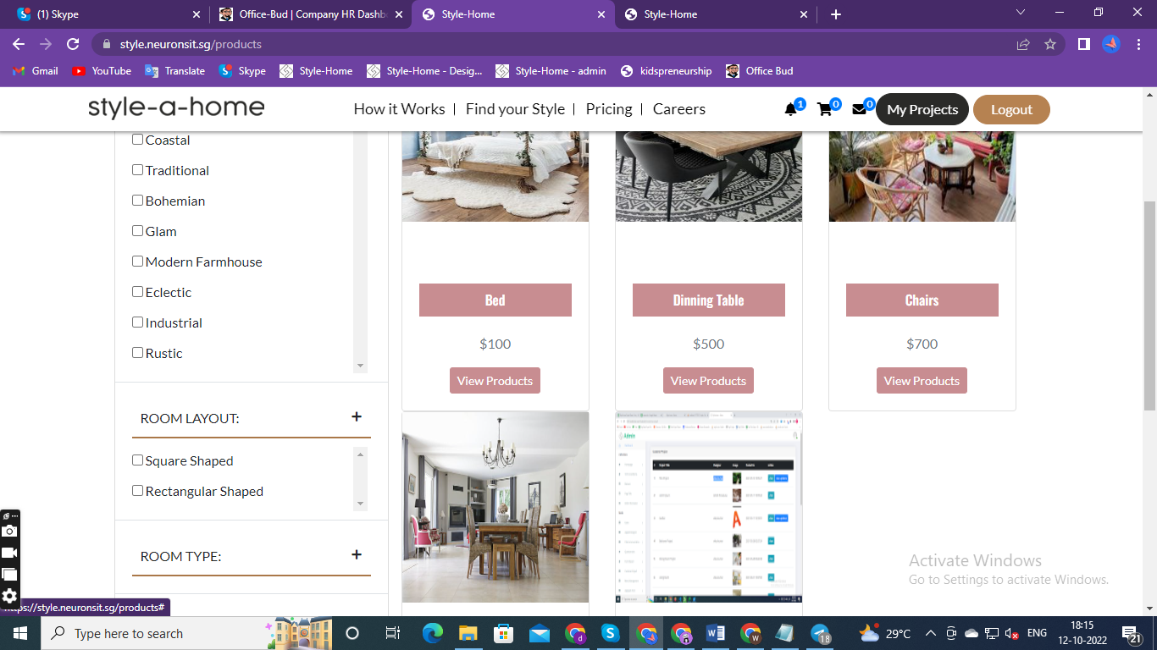

1. (Customer website)->bell notification-> always notification are showing
2. (Customer website)->homepage package. From this package remove size, addons
3. 10% discount calculation – I will be share a document
4. If a designer is unable to complete the project, and i have to reassign it to someone else, how can I do that.