NAME: SUMIT NAGARAJ BALI
SRN: PES1UG24AM453
SECTION : H

Req ID | Type | Description | Priority | Acceptance Criteria | Rationale
FR-001 | Functional | The system shall apply a dynamic diagonal overlay watermark to all draft illustrations uploaded by artists before displaying them to the client. | High | Pass: Every WIP draft displayed in the client portal contains the diagonal watermark. Fail: Any draft is displayed without the watermark. | Protects unfinished artwork from unauthorized use.
FR-002 | Functional | The system shall allow a client to submit a visual creative brief containing project requirements, references, and milestone details. | High | Pass: A completed brief is assigned a unique project ID and becomes available to the assigned artist. Fail: An incomplete brief is accepted. | Provides the artist with the information needed to complete the commission.
FR-003 | Functional | The system shall allow an artist to upload WIP progress drafts associated with a specific commission and milestone. | High | Pass: The uploaded draft is associated with the selected commission and milestone and is displayed to the client with a watermark. Fail: The draft is associated incorrectly or displayed without a watermark. | Enables milestone-based progress review.
FR-004 | Functional | The system shall process milestone payments and record the payment status for the corresponding commission milestone. | High | Pass: A successful payment response changes the milestone status to "Paid" and stores the transaction ID. Fail: A milestone is marked "Paid" without payment confirmation. | Ensures payment is properly tracked.
FR-005 | Functional | The system shall unlock final high-resolution source files only after successful confirmation of the final milestone payment. | High | Pass: The client can access the final source files only after confirmed final payment. Fail: The client can access the files before final payment. | Protects the artist's final deliverables.
NFR-001 | Nonfunctional — Performance & Security | The system shall generate expiring signed S3 URLs for final high-resolution asset downloads, with each URL valid for no longer than 60 minutes. | High | Pass: The generated URL becomes invalid after 60 minutes. Fail: The URL remains usable after 60 minutes. | Limits unauthorized access to final assets.
NFR-002 | Nonfunctional — Security | The system shall prevent clients from accessing original high-resolution source files through direct storage URLs before the final milestone payment is confirmed. | High | Pass: A pre-payment access attempt returns an authorization error and does not expose the file. Fail: The original file can be retrieved before payment confirmation. | Prevents payment bypass and protects intellectual property.

UML DIAGRAM :
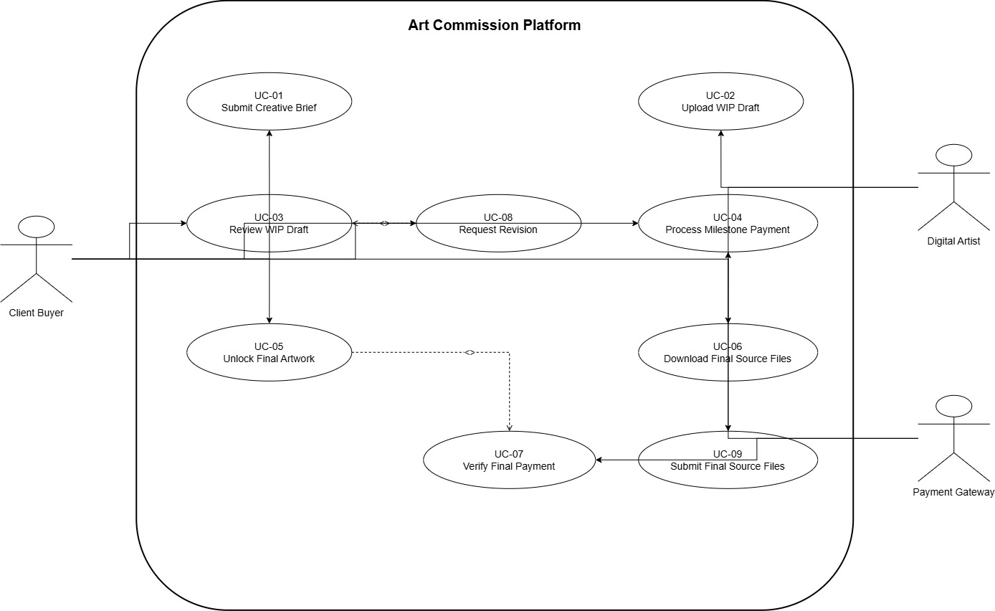

USE-CASE SPECIFICATION
Use Case: UC-05 – Unlock Final Artwork
Primary Actor: Client Buyer
1. Preconditions
- The commission project exists in the Art Commission Platform.
- The Digital Artist has uploaded the final high-resolution source files.
- The Client Buyer has completed the final milestone payment.
- The final payment status is available for verification.
2. Postconditions
- The final artwork is marked as Unlocked.
- The Client Buyer is authorized to access the final high-resolution source files.
- The system generates a temporary signed download URL valid for 60 minutes.
- The system records the download event.
3. Main Success Scenario
- The Client Buyer opens the completed commission project.
- The system displays the final milestone and its payment status.
- The Client Buyer selects "Unlock Final Artwork."
- The system verifies that the final milestone payment has been successfully completed.
- The system confirms that the final high-resolution source files are available.
- The system changes the artwork status from Locked to Unlocked.
- The system generates a signed download URL valid for 60 minutes.
- The system displays the download option to the Client Buyer.
- The Client Buyer downloads the final high-resolution source files.
- The system records the download event.
- The use case ends successfully.
4. Alternate Flow – Final Payment Not Confirmed
Trigger: At Step 4
4a. The system determines that the final milestone payment has not been confirmed.
4a1. The system keeps the final artwork in the Locked state.
4a2. The system displays a message informing the Client Buyer that final payment is required to access the source files.
4a3. The system does not generate a download URL.
4a4. The system provides the Client Buyer with an option to complete the final milestone payment.
4a5. The use case ends without unlocking the final artwork.

