**Artifactory-Jenkins-Integration**

**Login to Jfrog artifactory with free trail for 15 days.**

## Configuration in artifactory:

**Ref:**

https://www.youtube.com/watch?v=k3_byI8Eql4

https://www.youtube.com/watch?v=4PX3LCVjAEA

**Create a user in Artifactory:**

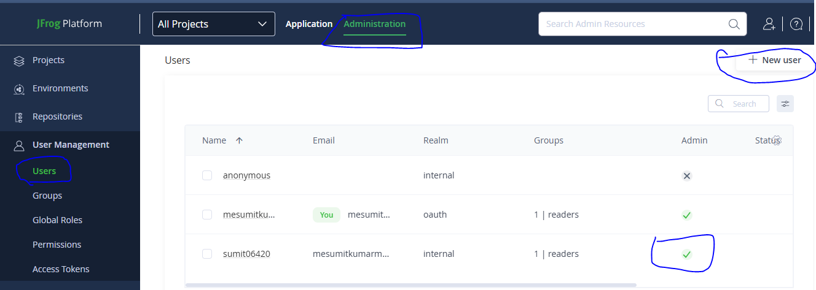

**Create Repository:**

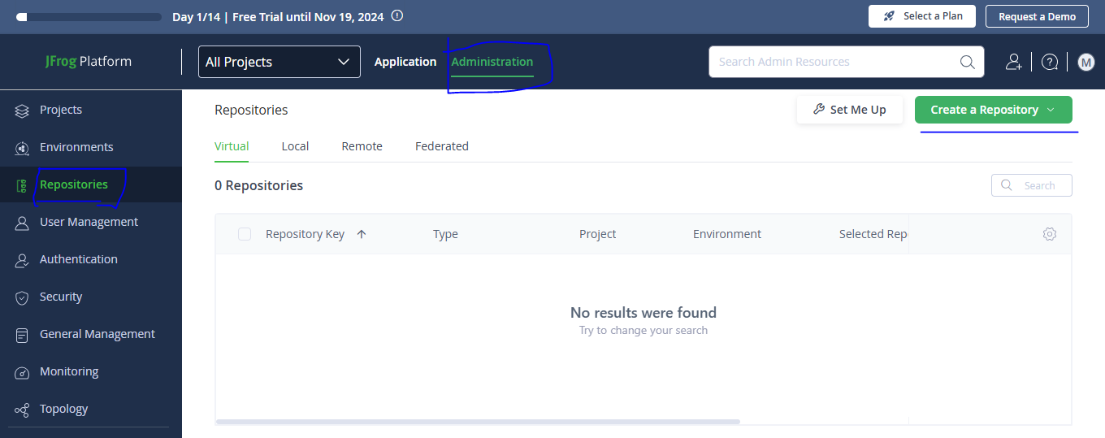

Create a local repository and just mention repository key:

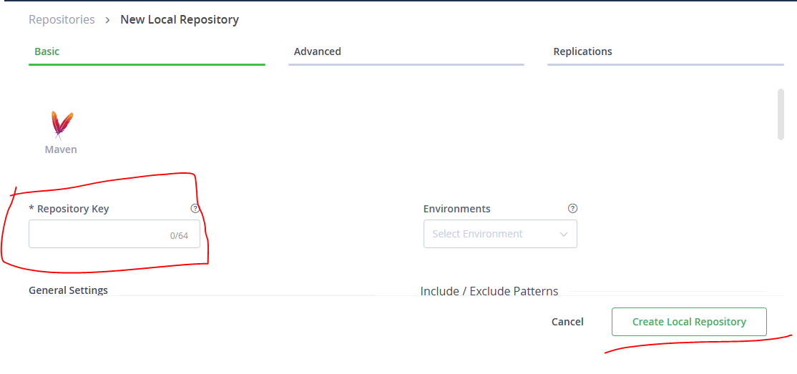

**Jenkins Configuration:**

**Install below plugins:**

1. JFrog
2. Artifactory

**Below configuration required in jenkins:**

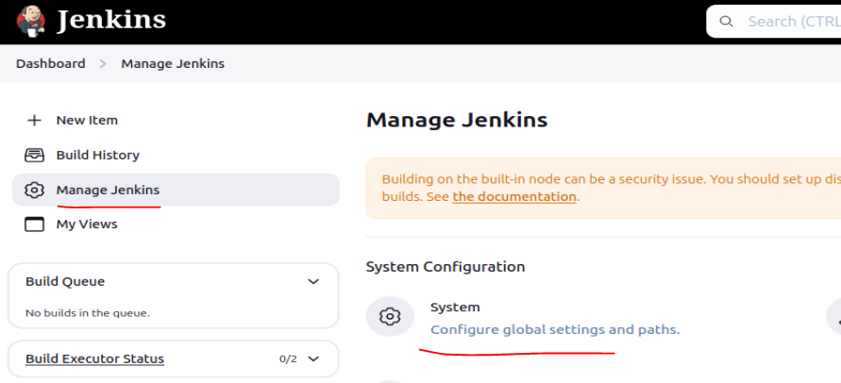

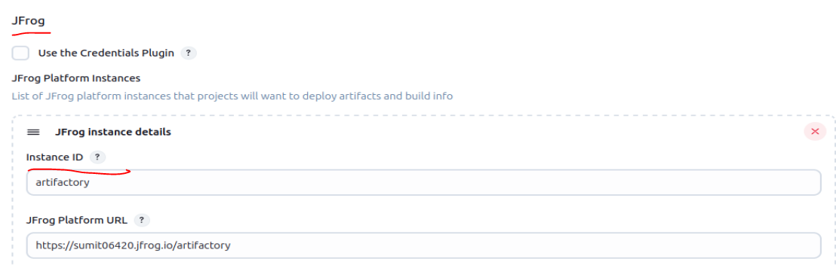

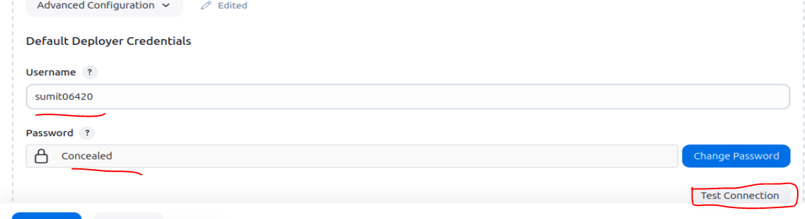

**Jenkinsfile configuration:**

---->

artifactoryServer: https://sumit06420.jfrog.io  
artifactoryCredentialId: artifactory  
artifactoryRepo: results

--->

stage('Upload to Artifactory') {

steps {

script {

//"${env.ARTIFACTORY_SERVER}"

def artifactoryServer = Artifactory.newServer url: 'https://sumit06420.jfrog.io/artifactory', credentialsId: 'artifactory'

def uploadSpec = """{

"files": [

{

"pattern": "target/*.jar",

"target": "${env.REPO}/"

}

]

}"""

artifactoryServer.upload spec: uploadSpec

}

}

}