***DOCKER***

**Difference between Docker container and Images:**

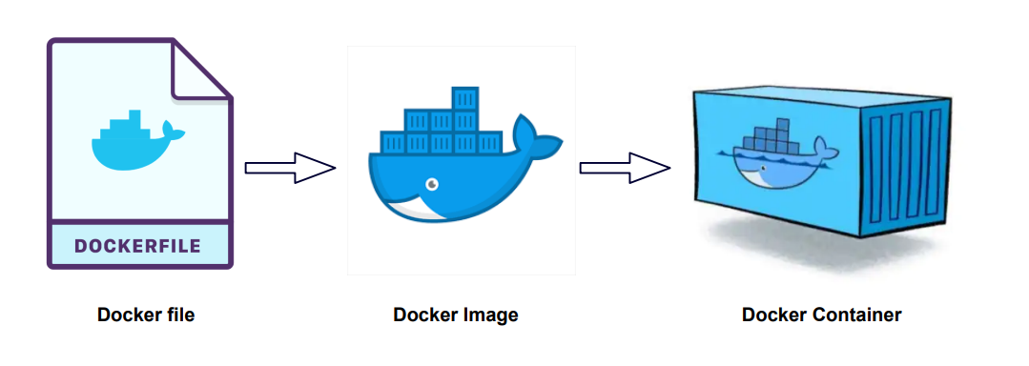

We create docker file which contains all the command to build that specific image. It will execute and when we will **build** the docker file it will produce Docker image.

When we **run** the docker images inside container, the application will start.

**NOTE:**

1. Docker Images are used to package up applications and pre-configured server environments where here as Containers use server information and a file system provided by an image in order to operate.
2. To use a programming metaphor, if an image is a class, then a container is an instance of a class—a runtime object.
3. Images are read-only templates containing instructions for creating a container.

Docker Images

Mvn 3.5

Jdk 8

First-app.jar

Do

Build

So Docker images contains different aspect of application into single bundle.

**Images are portable:**

If we have to run the above application in any system windows/linux anywhere, we don’t need to install mvn , jdk at all, we just have to run the image.

**Container Registry:**

It is just like a maven Repository; we keep the images in container registry and pull it from there. It can be public/private.

JDK-11

Gradle-8

Kafka

My-first-app.jar

Python-3

My-first-image.img

If we have to run the my-first-app in

any machine we just have to run the above image. It will pull the dependency from docker registry.