**Jenkins-Sonar-Integration**

Steps:

Step1: Install sonar server using sonarqube docker images.

Step2: run the sonar on

<http://localhost:9000>

Step3: default user and pass will be admin

Step4: Setup new rule type inside Quality Gate and Quality Profiles.

Refer to below video:

<https://www.youtube.com/watch?v=gsjJnByBfpM&t=426s>

<https://www.youtube.com/watch?v=r2UVTDpIUj8&t=1537s>

Step5: Generate a token.

Steps6: Setup Sonar Server and secret in jenkins.

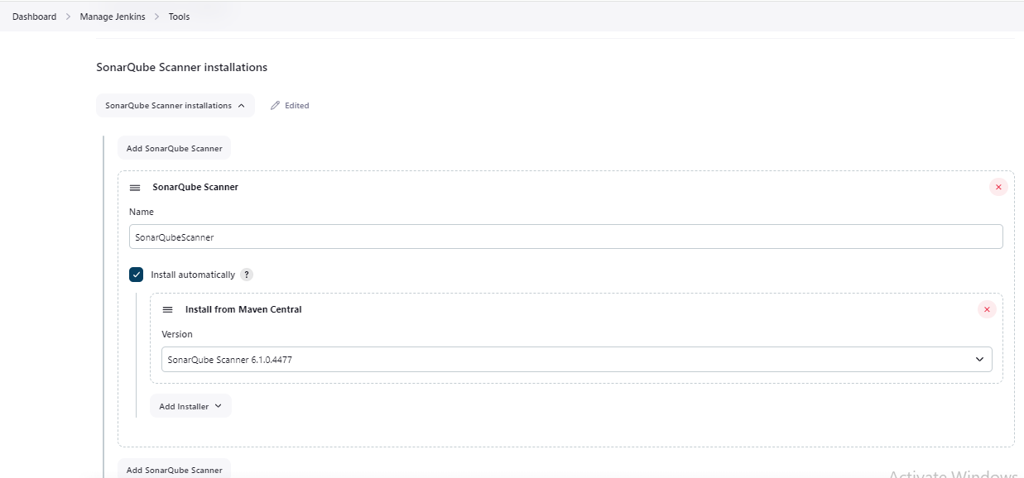

Step7: Setup token with Secret Text:

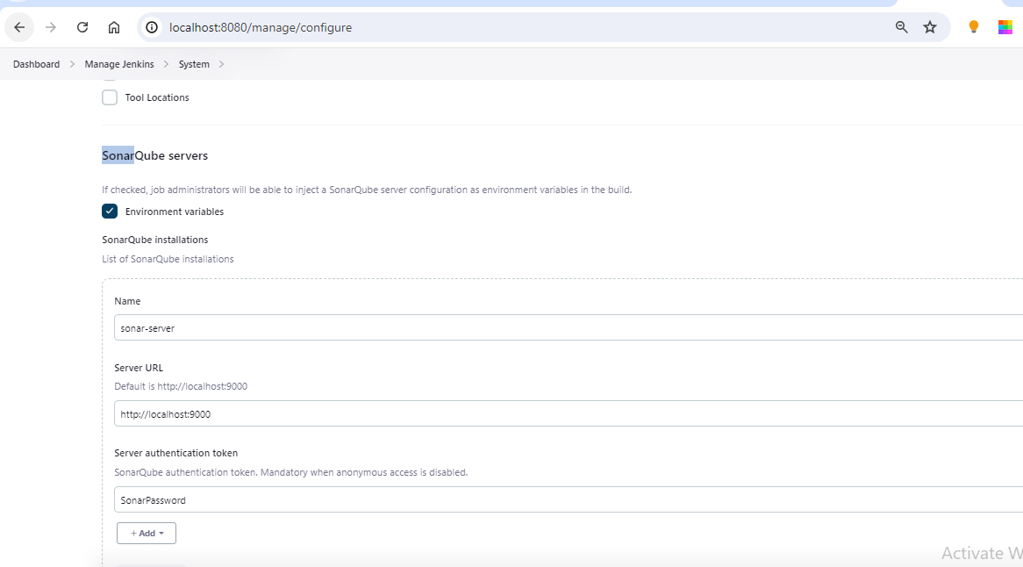

Step8:

Add sonar plugins in build.gradle and modify jenkins file.( refer to GitHub project)