Jenkins-Assignment-1

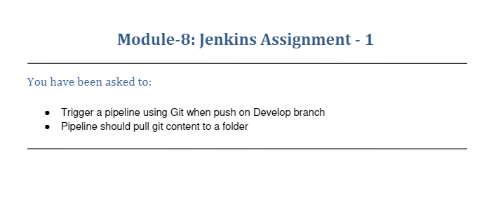

Code Used

* [/var/lib/jenkins/workspace/jenkins-assignment-1](http://104.198.255.29:8080/job/jenkins-assignment-1/1/execution/node/3/ws/)